Quranic Chatbot
Code Guide
How the app’s code works, explained step by step
Flutter app + FastAPI backend | Version 1.0.0
Table of Contents
1. The code in one minute 3
2. Architecture: five layers 3
3. How the app starts 4
4. Connecting everything together 5
5. State management 7
6. Data models 8
7. Services: talking to the backend safely 8
8. Feature walk-through: AI chat 10
9. Feature walk-through: Recite & Recognize 11
10. Recitation audio 12
11. Auto Play and the highlighted card 14
12. Local storage 15
13. Navigation 16
14. Language and themes 16
15. The backend in detail 16
16. Glossary 17
17. Where do I look when… 17
How to use this guide. It explains what each part of the code does and why, with diagrams and annotated code pictures. You do not need to read it in order: every section starts with a one-line summary, and section 17 lists “where do I look when I want to change X”. File names refer to the project zip (flutter_app/lib/... and backend/api/index.py).

1. The code in one minute
The project has two programs that talk to each other:
Program | Language | Lives in | Job
The app | Dart (Flutter) | flutter_app/lib/ | Everything the user sees and touches on the phone. Stores bookmarks, history and settings on the phone.
The backend | Python (FastAPI) | backend/api/index.py | Holds the secret API keys, asks Groq / Gemini for chat answers, transcribes speech, and matches a recitation to a real verse.
The app never talks to Groq, Gemini or the speech service directly. It only talks to the backend (and downloads verse audio from everyayah.com). That is why no secret key is inside the APK.
How the Dart code is split into files. main.dart lists every other file with a part line, and each of those files starts with part of '../main.dart';. Together they form one Dart library, so they share the same imports and can use each other’s classes without import lines. Files whose names start with an underscore (for example _pickKey) are private to that library, not to a file. Splitting the code into folders changes how it is organised, not how it behaves.

2. Architecture: five layers
The code is arranged in layers. Each layer only uses the layer below it, which keeps changes local: you can replace how audio is played without touching any screen.
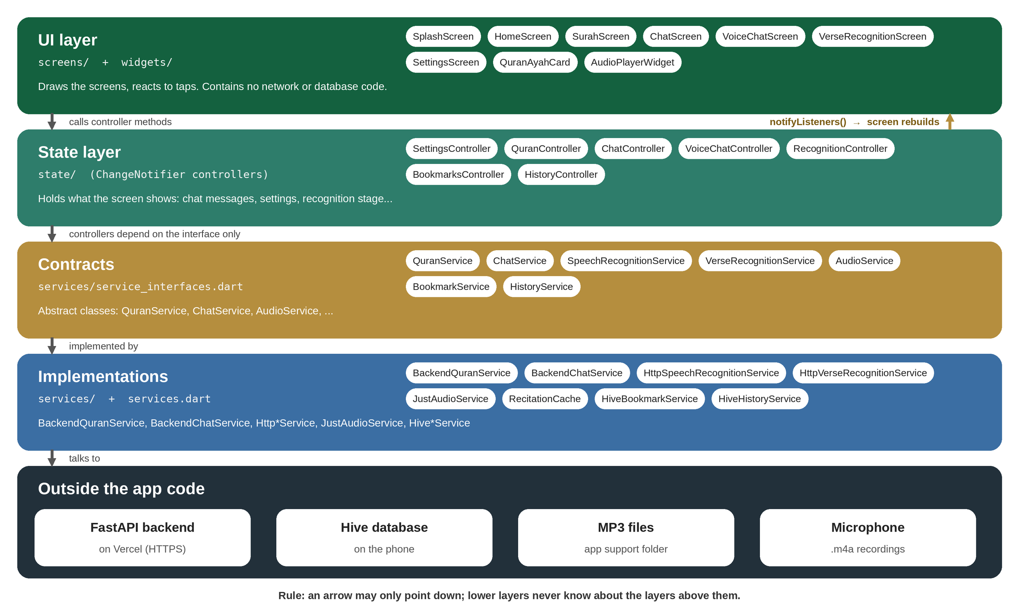
Figure 1: The five layers of the app, from what the user sees down to the outside world
Layer | Folder | Rule of thumb
UI | screens/, widgets/ | Draws things and reacts to taps. Never calls the network or the database itself.
State | state/ | Controllers (ChangeNotifier) hold what a screen shows and expose methods such as send() or setLanguage().
Contracts | services/service_interfaces.dart | Abstract classes that describe what a service can do, not how.
Implementations | services/, services.dart | The real code: HTTP calls, Hive storage, audio player, file cache.
Outside | backend, Hive, files, microphone | Things the app talks to.
Supporting folders: models/ (data classes), data/ (built-in Surah names and sample verses), utils/ (helper functions), l10n/ (all text in three languages), theme/ (colours and the 12 themes), app/ (app root and routes).

3. How the app starts
Summary: main() prepares the local database, unpacks the offline Quran once, then starts the UI. The first screen decides where to go next.
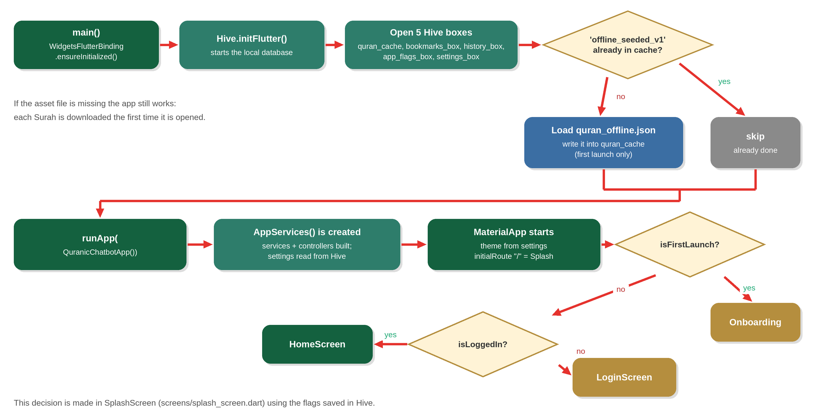
Figure 2: Start-up sequence, from main() to the first screen
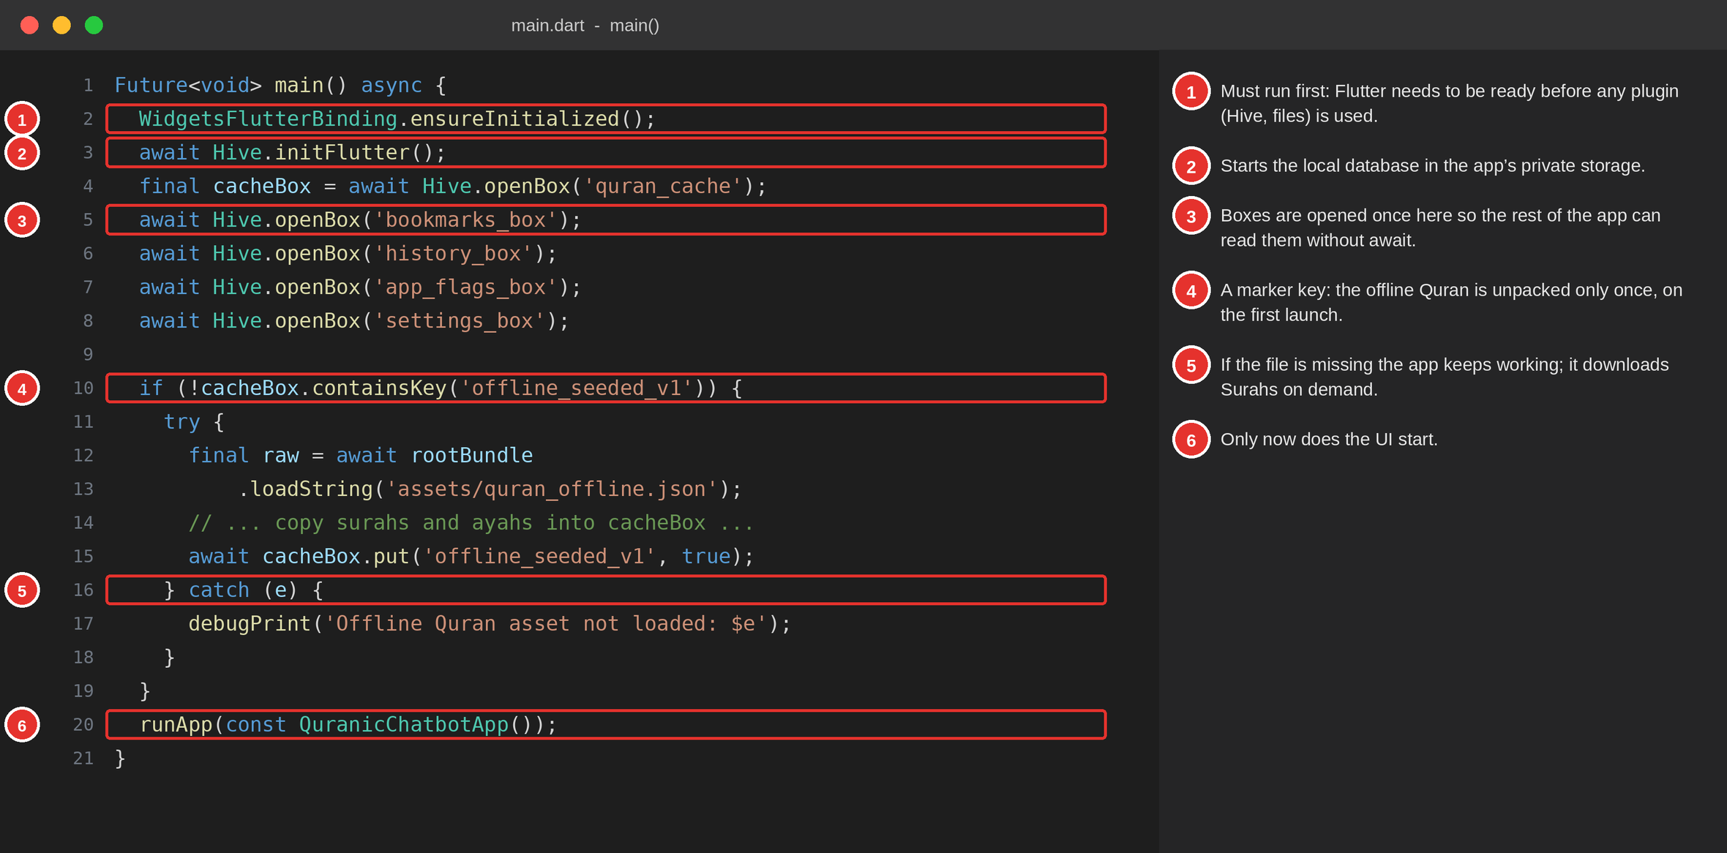
Figure 3: main() in main.dart, annotated
Points worth knowing:
- WidgetsFlutterBinding.ensureInitialized() is required whenever main() is async and uses plugins before runApp.
- Five Hive boxes are opened up front (await Hive.openBox(...)). After that, any code can call Hive.box('name') synchronously. That is why controllers can read settings in their constructors.
- Offline seeding. If assets/quran_offline.json exists, the whole Quran is copied into the quran_cache box once. The key offline_seeded_v1 marks that it has been done. If the asset is missing, the catch prints a message and the app carries on; Surahs are then downloaded on first open and cached.
- Where the user lands. SplashScreen reads two flags saved in Hive: isFirstLaunch (go to Onboarding) and isLoggedIn (Home if true, Login if false).

4. Connecting everything together
Summary: AppServices creates every service and controller once. AppScope hands them to any widget through context.
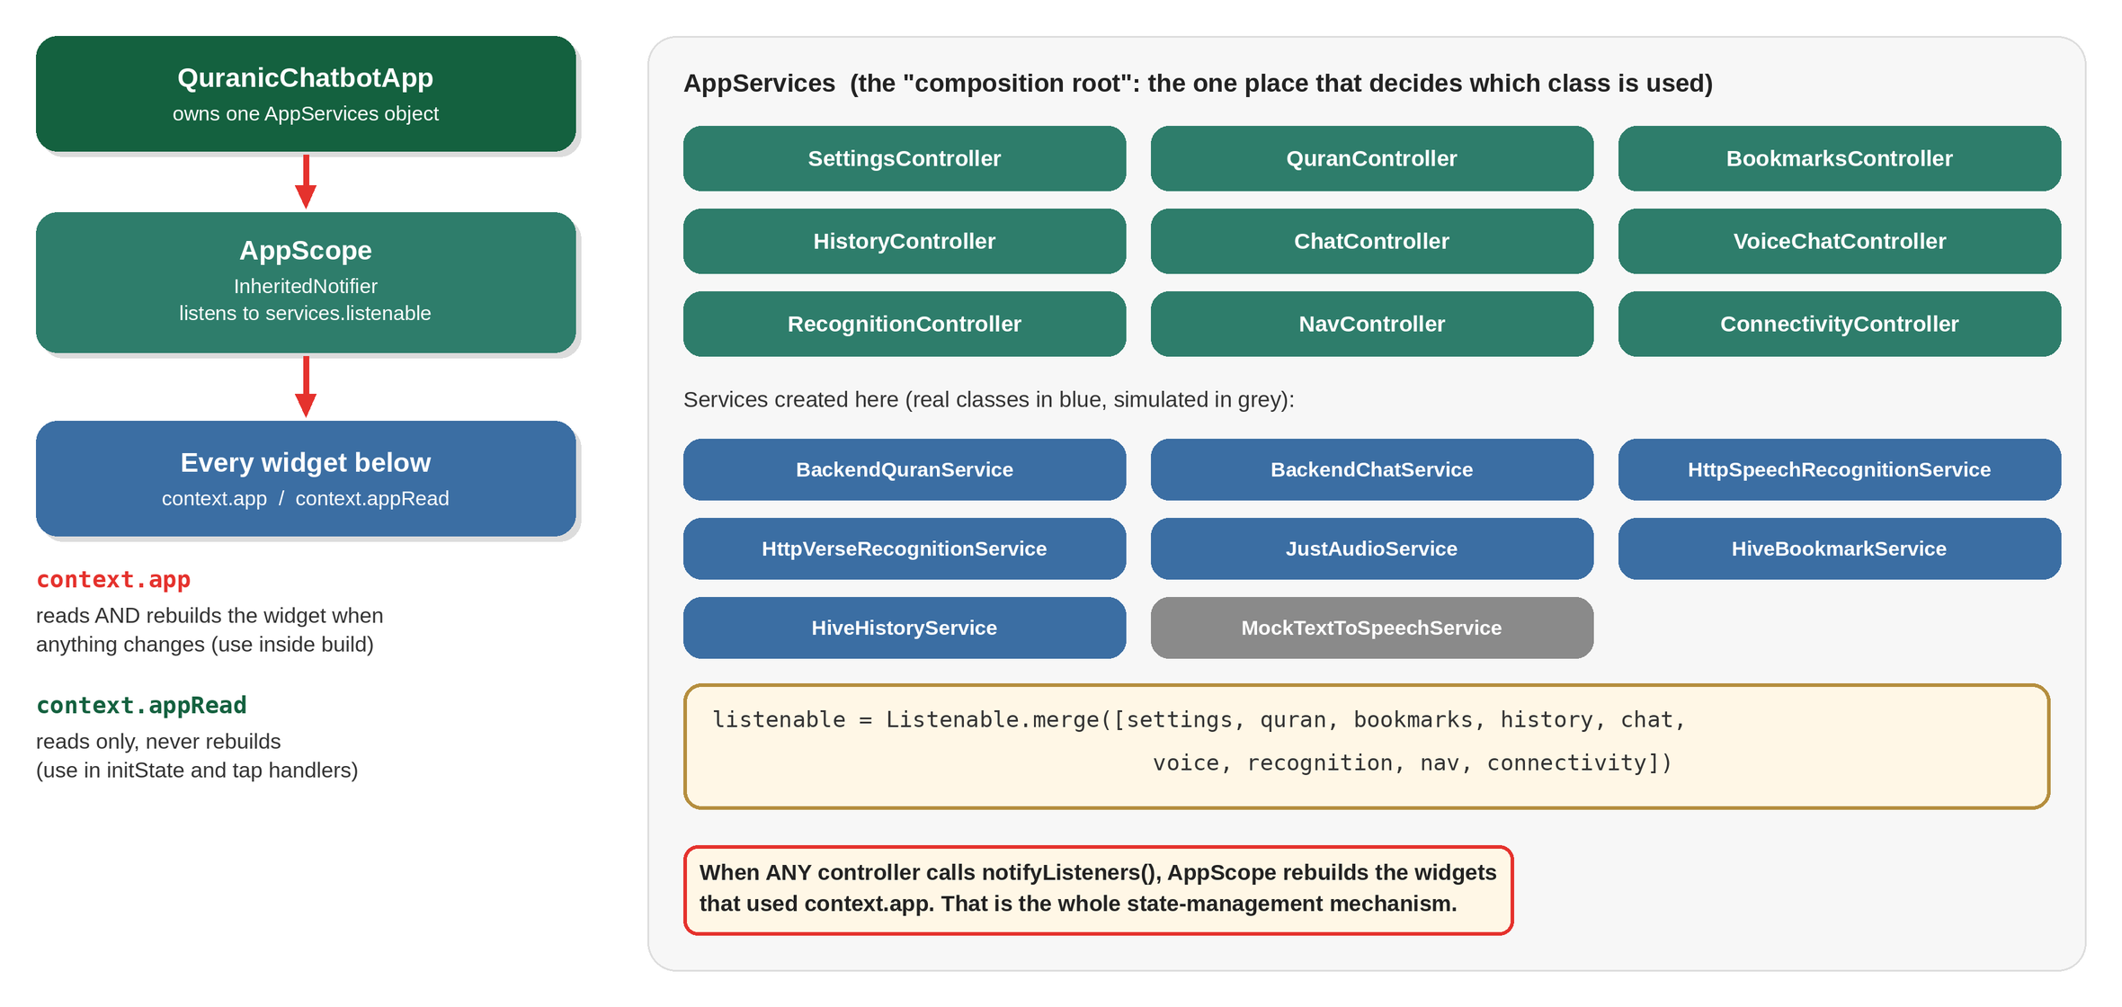
Figure 4: AppServices (composition root) and AppScope
AppServices (in app/app.dart) is called the composition root: it is the one place that decides which class is used for each job. For example:
late final ChatService chatService =
BackendChatService(httpChat, quranService);
final AudioService audio = JustAudioService();
final BookmarkService bookmarkService = HiveBookmarkService();
To switch a feature back to fake data for UI experiments you change one line here (for example use MockAudioService()), and nothing else in the app changes. The mock classes in services/mock_services.dart exist for that purpose. Text-to-speech is still a mock (MockTextToSpeechService), so voice replies are shown as text.
Reading services from a widget. AppScope is an InheritedNotifier, and app/app.dart adds two shortcuts:
Shortcut | Behaviour | Use it in
context.app | Reads and rebuilds the widget whenever any controller changes | build() methods
context.appRead | Reads only, never rebuilds | initState, button handlers
AppServices.listenable merges all controllers with Listenable.merge([...]). When any of them calls notifyListeners(), AppScope notifies the widgets that used context.app.
The root widget (QuranicChatbotApp) also wires three app-wide things:
- Theme. An AnimatedBuilder watches settings. If the theme is system it uses Classic light and dark and follows the phone; otherwise it pins the chosen theme.
- Right-to-left. It wraps the app in Directionality using settings.isRtl, so Urdu and Arabic mirror the layout without reversing any strings.
- Audio stop on back. AudioStopObserver is a NavigatorObserver that stops recitation when a full page is closed (dialogs and bottom sheets do not count).

5. State management
Summary: widgets never change data. They call a controller method; the controller changes its fields and calls notifyListeners(); the screen rebuilds.
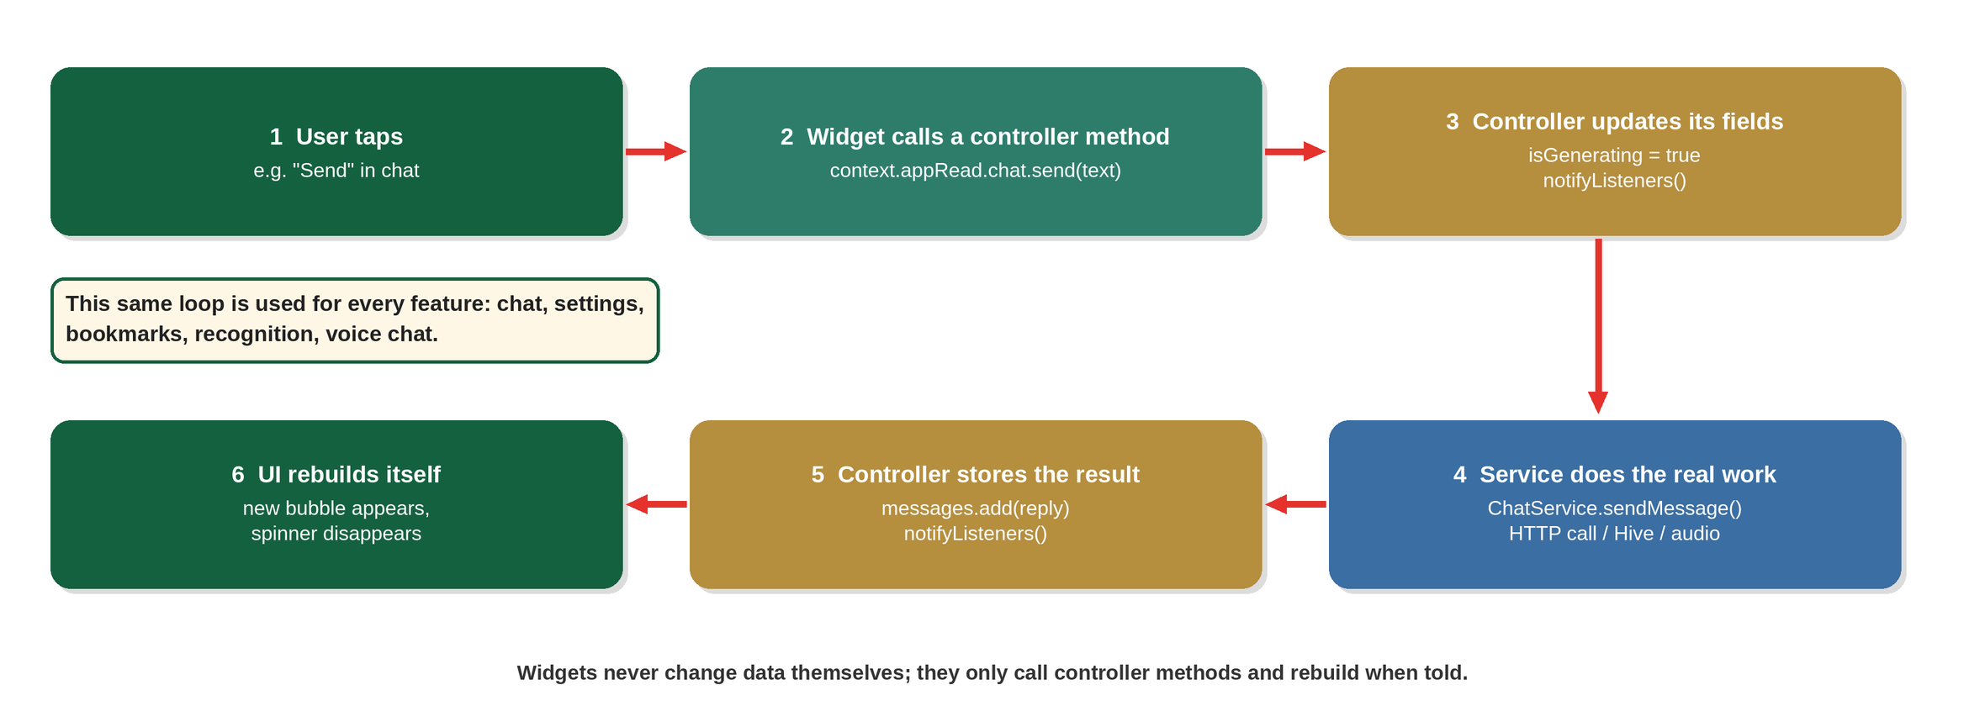
Figure 5: The loop used by every feature
The controllers in state/:
Controller | Holds | Main methods
SettingsController | Theme, language, font size, translation, reciter, speed, autoPlay, last read position, first-launch/login flags | setThemeId, setLanguage, setAutoPlay, … (each saves to Hive and notifies)
QuranController | Surah list and load state (loading / loaded / empty / error); caches verses per Surah and Juz in memory | loadSurahs, getAyahs, getJuz
ChatController | Current conversation, isGenerating, hasError | send, retry, newConversation, startWithAyah
VoiceChatController | Voice state (idle, listening, processing, speaking, error), timer, transcript, reply | start, send, cancel
RecognitionController | Recognition stage, timer, result or error | start, stop, reset
BookmarksController, HistoryController | Saved verses and past chats | load, add/remove/save/delete
NavController, ConnectivityController | Selected bottom tab; offline banner flag | go, setOffline
A setting works like this: SettingsController reads every value from Hive in its constructor (with defaults, for example autoPlay defaults to false), and each setter does two things:
void setAutoPlay(bool v) {
_box.put('autoPlay', v); // 1. save on the phone
_u(() => autoPlay = v); // 2. change the field and notifyListeners()
}

6. Data models
Summary: small immutable classes in models/. The important one is Ayah.
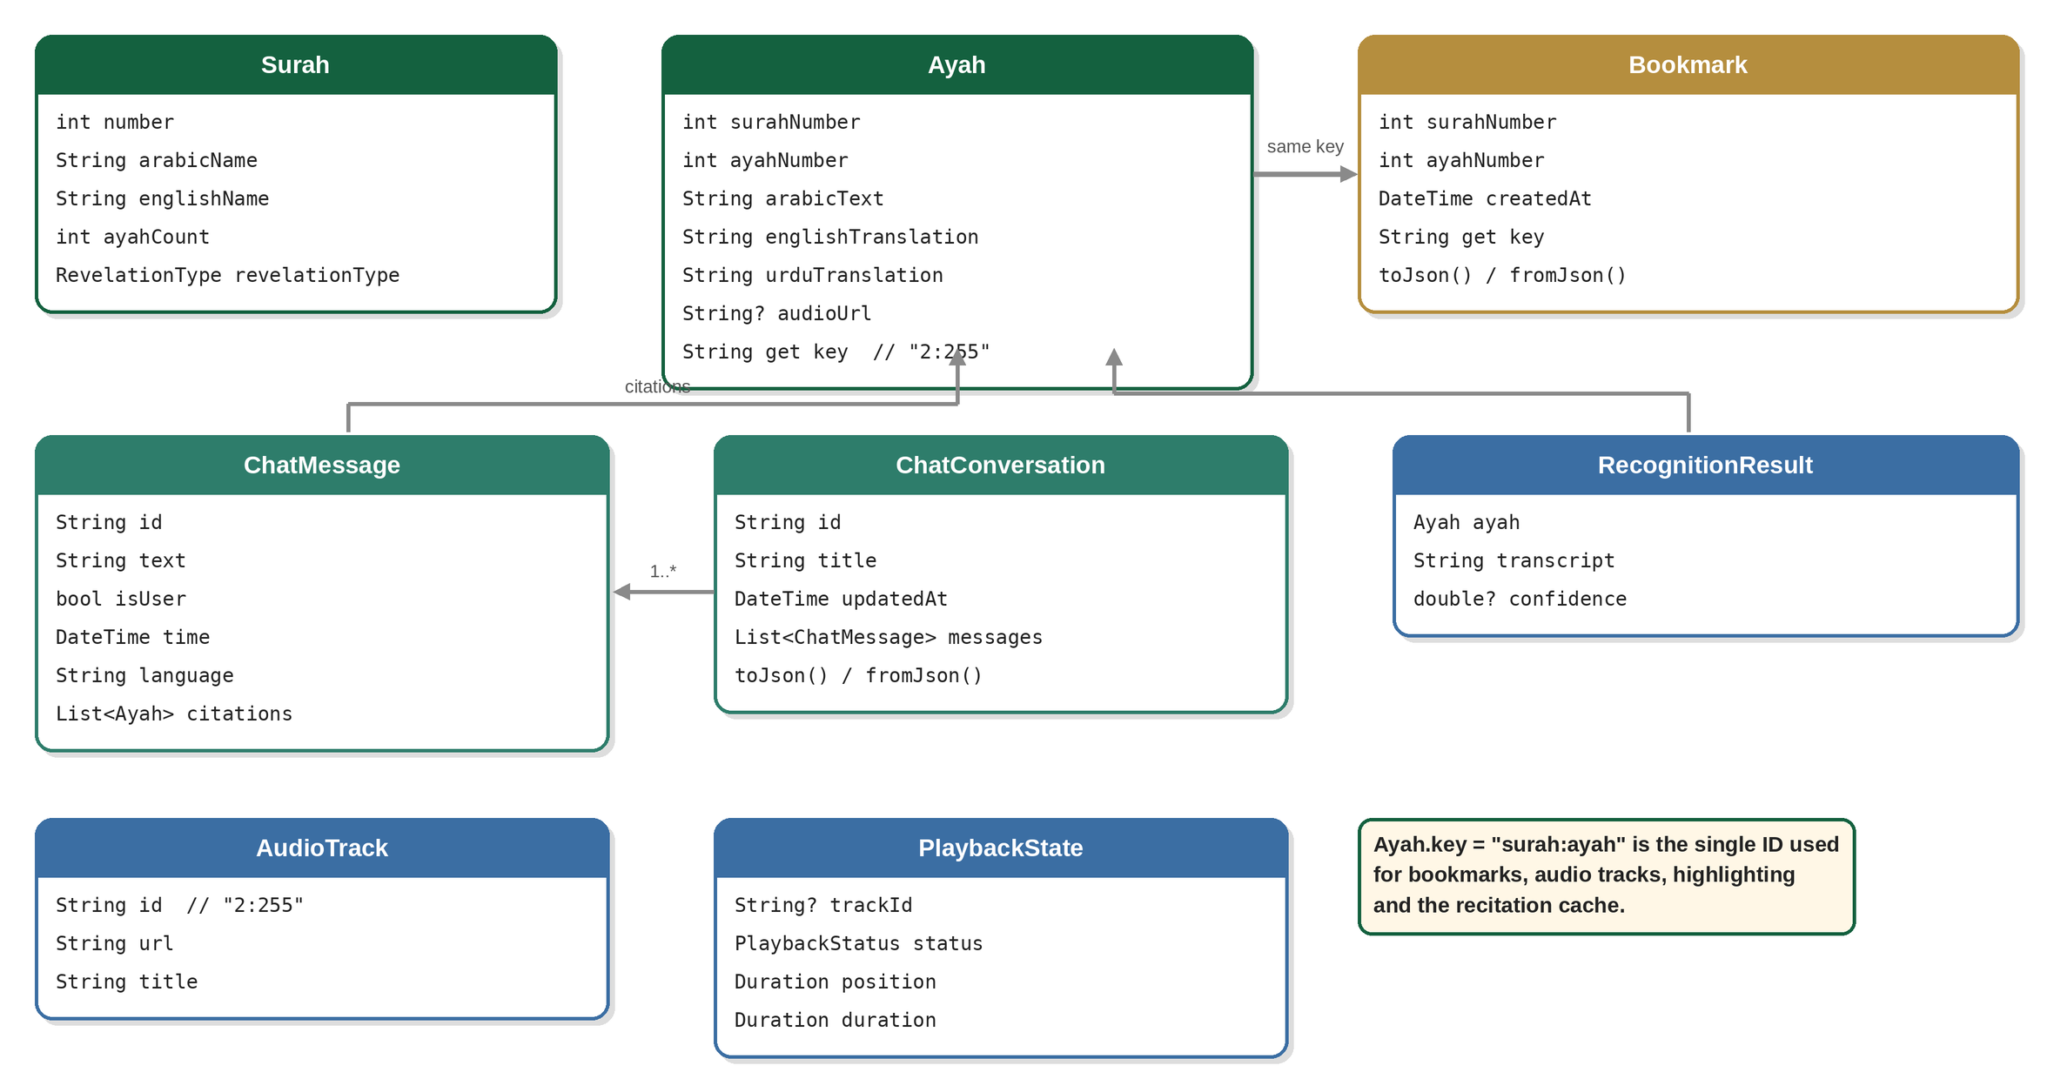
Figure 6: The main data classes
- Ayah.key is "surah:ayah" (for example "2:255"). The same string identifies a verse for bookmarks, audio tracks, card highlighting and the recitation cache.
- Ayah, Bookmark, ChatMessage and ChatConversation have toJson() / fromJson() so they can be stored in Hive as JSON text.
- Ayah.translation('ur') returns the Urdu text, anything else returns English.
- RecognitionResult.confidence is nullable (the backend sends it, the mock does not).

7. Services: talking to the backend safely
Summary: a service interface says what can be done; the Backend* and Http* classes do it by calling the backend, and cope with imperfect data.
Interface | Real implementation | What it does
QuranService | BackendQuranService | Surahs, verses, Juz, search, featured verse. Falls back to built-in sample data for the Surah list and featured verse.
ChatService | BackendChatService | Sends the question, turns the reply into a ChatMessage with real Ayah citations.
SpeechRecognitionService | HttpSpeechRecognitionService | Records a .m4a file and sends it to /stt.
VerseRecognitionService | HttpVerseRecognitionService | Records, sends to /recognize, converts errors to friendly types.
AudioService | JustAudioService | Plays recitation (section 11).
BookmarkService, HistoryService | HiveBookmarkService, HiveHistoryService | Save JSON in Hive.
TextToSpeechService | MockTextToSpeechService | Simulated.
The HTTP layer (lib/services.dart). It holds the constant kBackendBaseUrl and two classes:
- HttpQuranService fetches /surahs, /surahs/{id}/ayahs, /juz/{id} and /search. Quran text never changes, so responses are stored in the quran_cache box and reused. This is the same cache the offline Quran file fills.
- HttpChatService sends /chat, /stt and /recognize (audio is sent as a multipart file). Any non-2xx response throws an error whose text contains the status code and body. The rest of the app recognises words such as 404 or no_match in that text to show a friendly message.
Note. The services.dart in the project zip was written to match exactly how the rest of the app calls it (same class and method names, same return types). If you replace it with your own version, keep those names and types and everything described here still works.
Tolerant parsing. _parseAyah accepts several possible field names for each value, so a small change in the backend’s JSON does not break the screens.
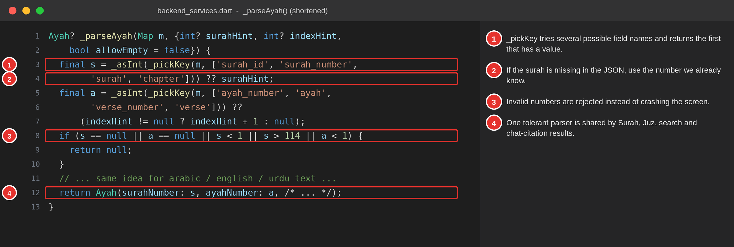
Figure 7: _parseAyah tries several field names and rejects invalid numbers
Chat citations. The backend returns citations as strings such as "2:153". BackendChatService finds the numbers with the pattern (\d{1,3})\s*[:\-]\s*(\d{1,3}), then loads the real verse text with QuranService.getAyahs, so the citation cards show verified Quran text, not text written by the AI. Duplicate citations are removed.

8. Feature walk-through: AI chat
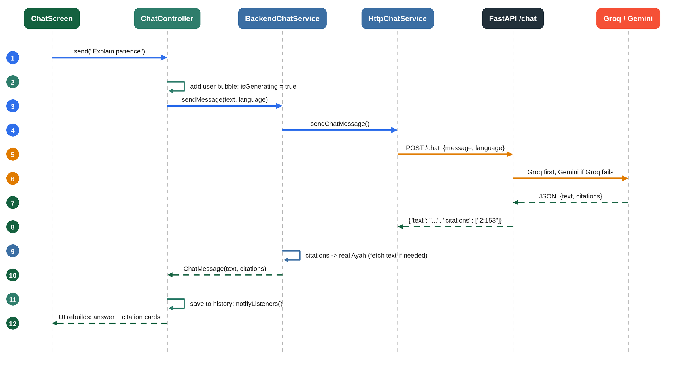
Figure 8: One chat message from tap to answer
- ChatController.send() ignores empty text and ignores taps while a reply is already being generated (isGenerating).
- It creates the conversation on first use (title = first 40 characters), adds the user bubble, sets isGenerating = true and notifies.
- BackendChatService calls the backend with the response language setting, not the interface language.
- On success the reply is added and the conversation is saved to Hive (HistoryController.save).
- On failure hasError = true; the screen shows an error bar with Retry, which calls retry() with the last user message.
startWithAyah starts a new chat with the text “Explain Surah X, Ayah N”, which is what the “ask about this verse” action uses.
Voice chat reuses the same path. VoiceChatController records audio (start), and on send uploads it to /stt, then passes the returned text to ChatController.send. Its states are idle → listening → processing → idle (or error). There is no live partial transcript because speech-to-text is request/response, not streaming.

9. Feature walk-through: Recite & Recognize
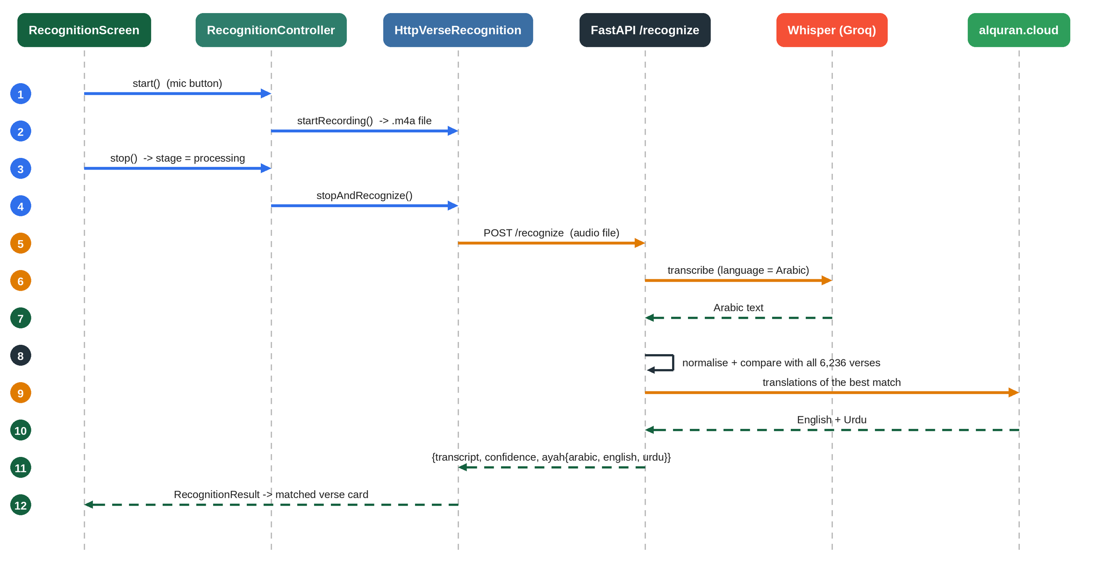
Figure 9: From microphone to matched verse
RecognitionController is a small state machine with these stages: initial → recording → processing → result or failure. Recording is limited to 30 seconds; a timer stops it automatically.
HttpVerseRecognitionService turns failures into typed errors so the screen can show the right message:
Situation | Error type shown
Microphone permission denied | microphonePermission
Network failure (socket, timeout, host lookup) | network
Backend says 400 / no_speech | noSpeech
Backend says 404 / no_match | noMatch
Anything else | serviceUnavailable
The network check comes first on purpose: a dropped connection can produce an error text that happens to contain digits, and it must not be mistaken for a status code.
On success the service builds an Ayah from the backend’s answer. If the Arabic, English or Urdu text is missing, it looks the verse up itself with QuranService.getAyahs, so all three languages always appear.
On the backend the matching is plain text comparison, not AI:
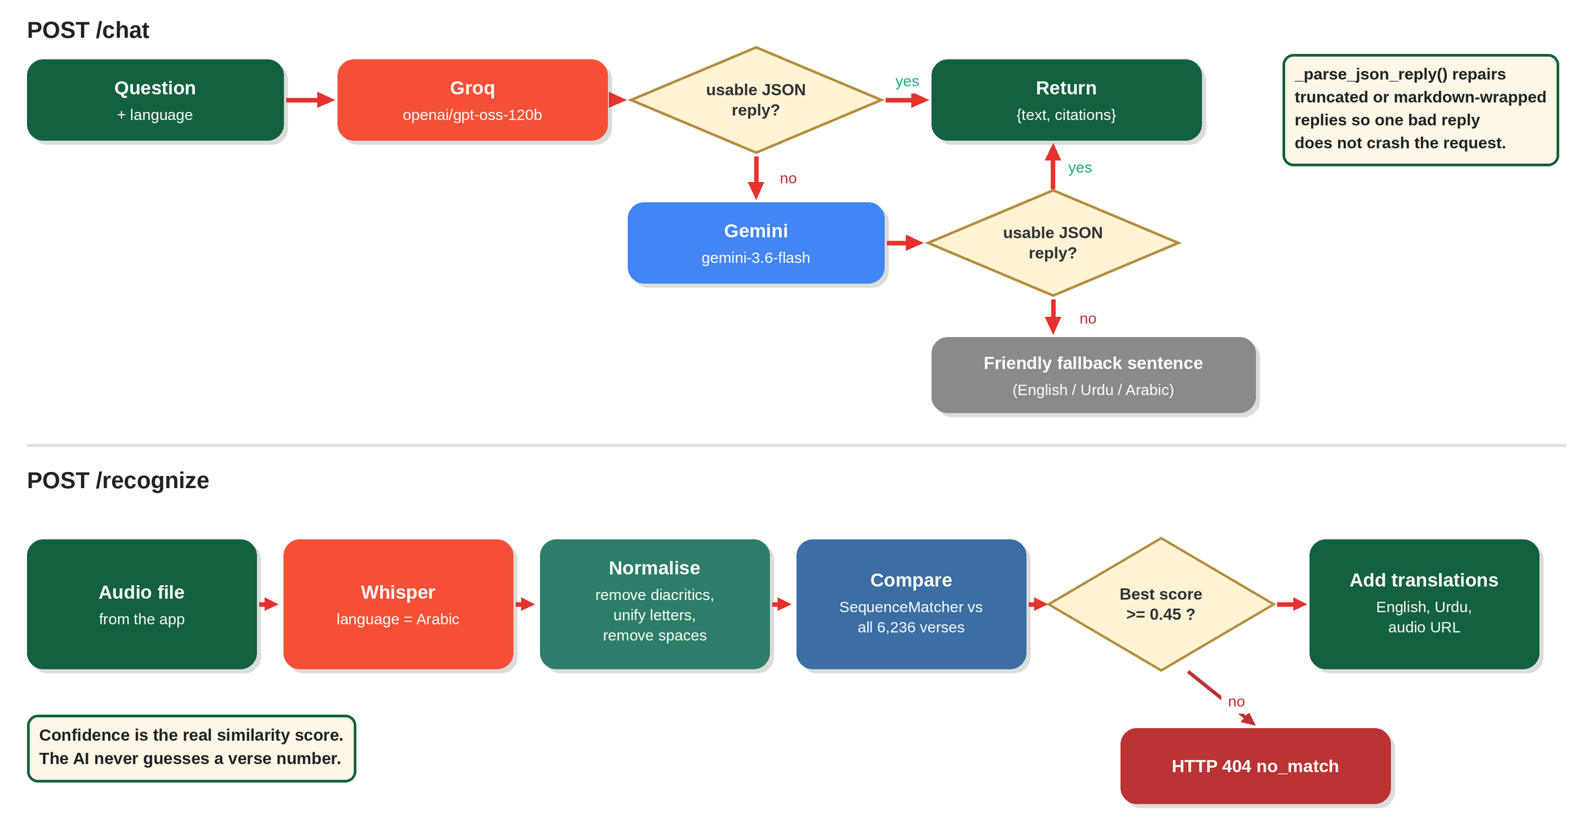
Figure 10: The two backend flows: /chat and /recognize
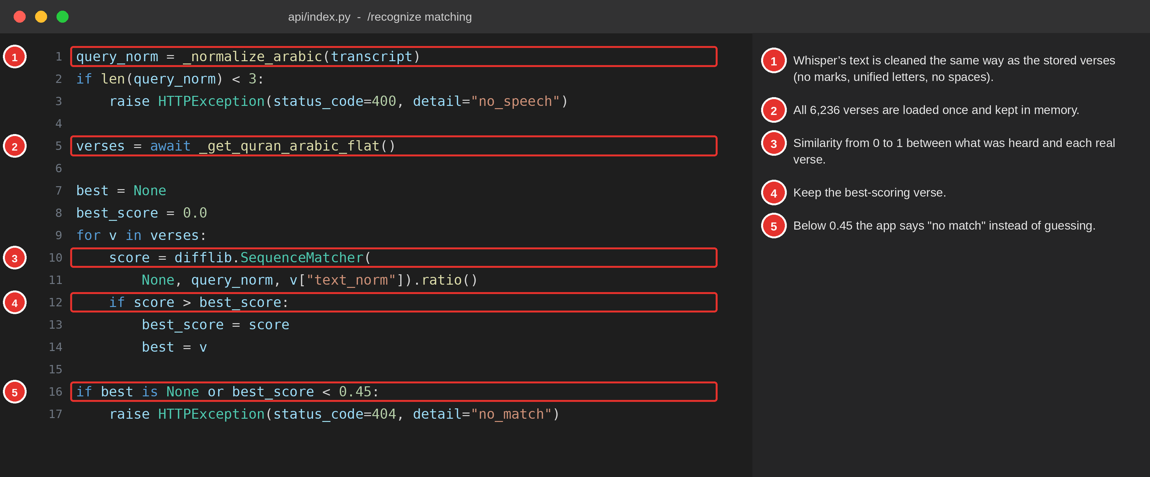
Figure 11: The matching loop in api/index.py
_normalize_arabic removes diacritics, unifies letter variants (for example the different forms of alef) and removes spaces, because the speech model’s spelling and spacing rarely match the Uthmani script exactly. The same function is applied to all 6,236 stored verses once, so both sides are comparable. The returned confidence is the real similarity score.

10. Recitation audio
Summary: JustAudioService maps the just_audio player onto the app’s own PlaybackState, so the UI does not depend on the player package.
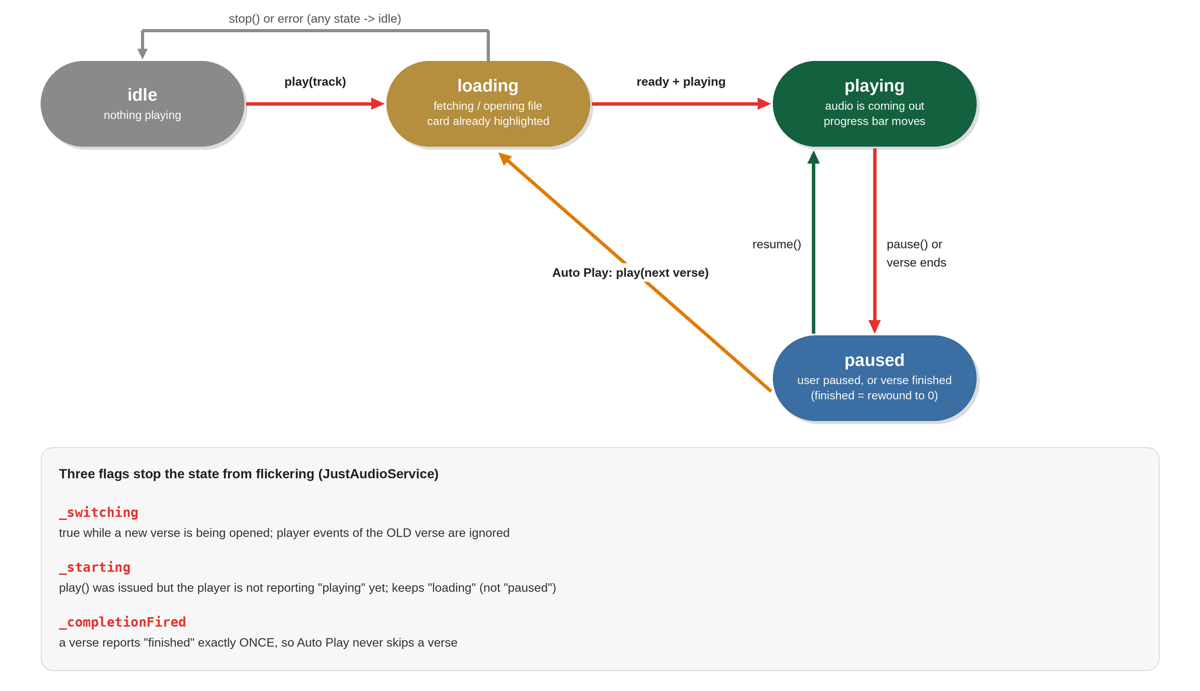
Figure 12: Playback states
PlaybackState holds trackId (the verse key), status (idle / loading / playing / paused), position and duration. Widgets listen to audio.state (a ValueListenable) to draw the play/pause button, the progress bar and the highlighted card.
The trickiest part is _onPlayerState. The player emits many events, some of them belonging to the previous verse. Three flags protect the UI:
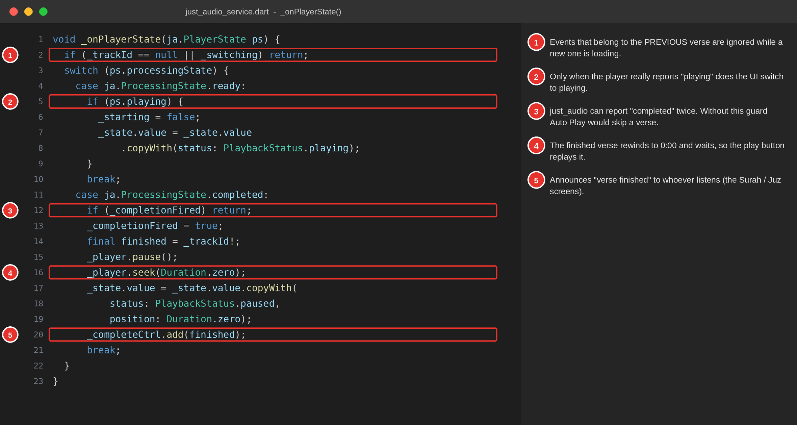
Figure 13: Handling player events safely
play(track) also decides where the sound comes from:
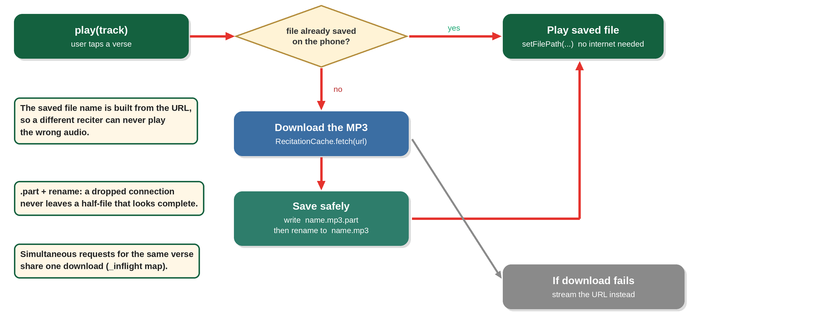
Figure 14: Play from a saved file, otherwise download once
RecitationCache stores files in the app’s private support folder under recitations/. The file name is built from the last two parts of the URL, so different reciters or bitrates never collide. Settings reads stats() to show how many files are saved and their total size.

11. Auto Play and the highlighted card
Summary: when a verse ends, the reader screen starts the next one, lights its card and scrolls to it.
JustAudioService announces the end of a verse on onTrackComplete. SurahScreen and JuzScreen each listen to that stream and run _onTrackComplete:
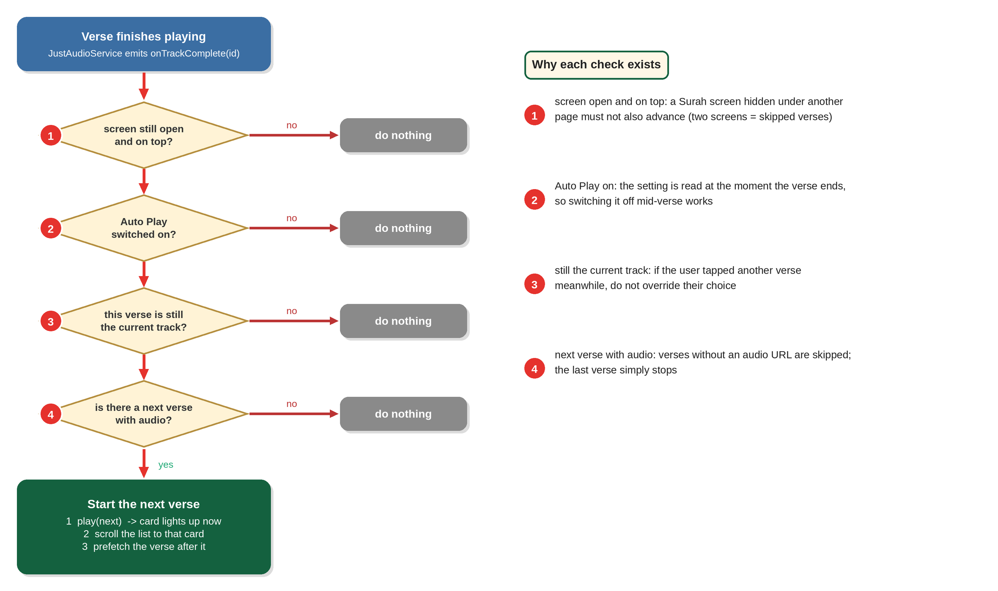
Figure 15: The four checks before the next verse starts
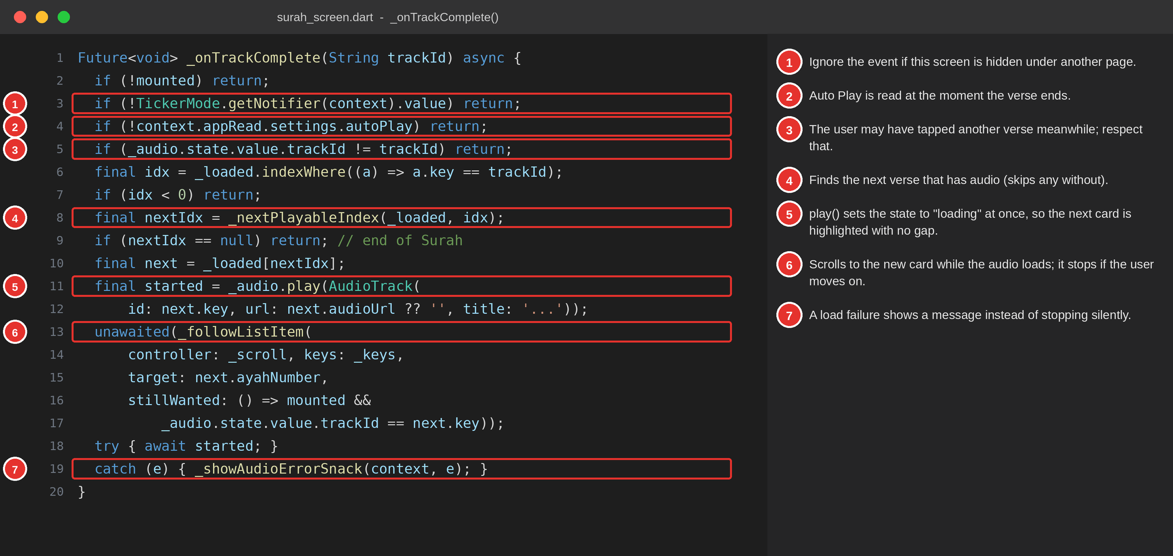
Figure 16: _onTrackComplete in surah_screen.dart
Supporting pieces:
- _nextPlayableIndex returns the next verse that has an audio URL (verses without one are skipped).
- Prefetching. While a verse plays and Auto Play is on, _onAudioState downloads the following verse in the background (_prefetchRecitation), so the hand-off has no waiting.
- _followListItem scrolls to the new card. A ListView.builder only builds cards near the screen, so the target card may not exist yet; the helper scrolls a screenful at a time towards it until it appears, then eases it into view. It stops if the user starts another verse (stillWanted).
- Highlight. QuranAyahCard compares the card’s ayah.key with audio.state.trackId and highlights it while the status is playing, loading, or paused part-way through. AppCard draws the gold tint, thick border and glow when highlight is true.
- Speed. The chosen playback speed is applied to each new verse.

12. Local storage
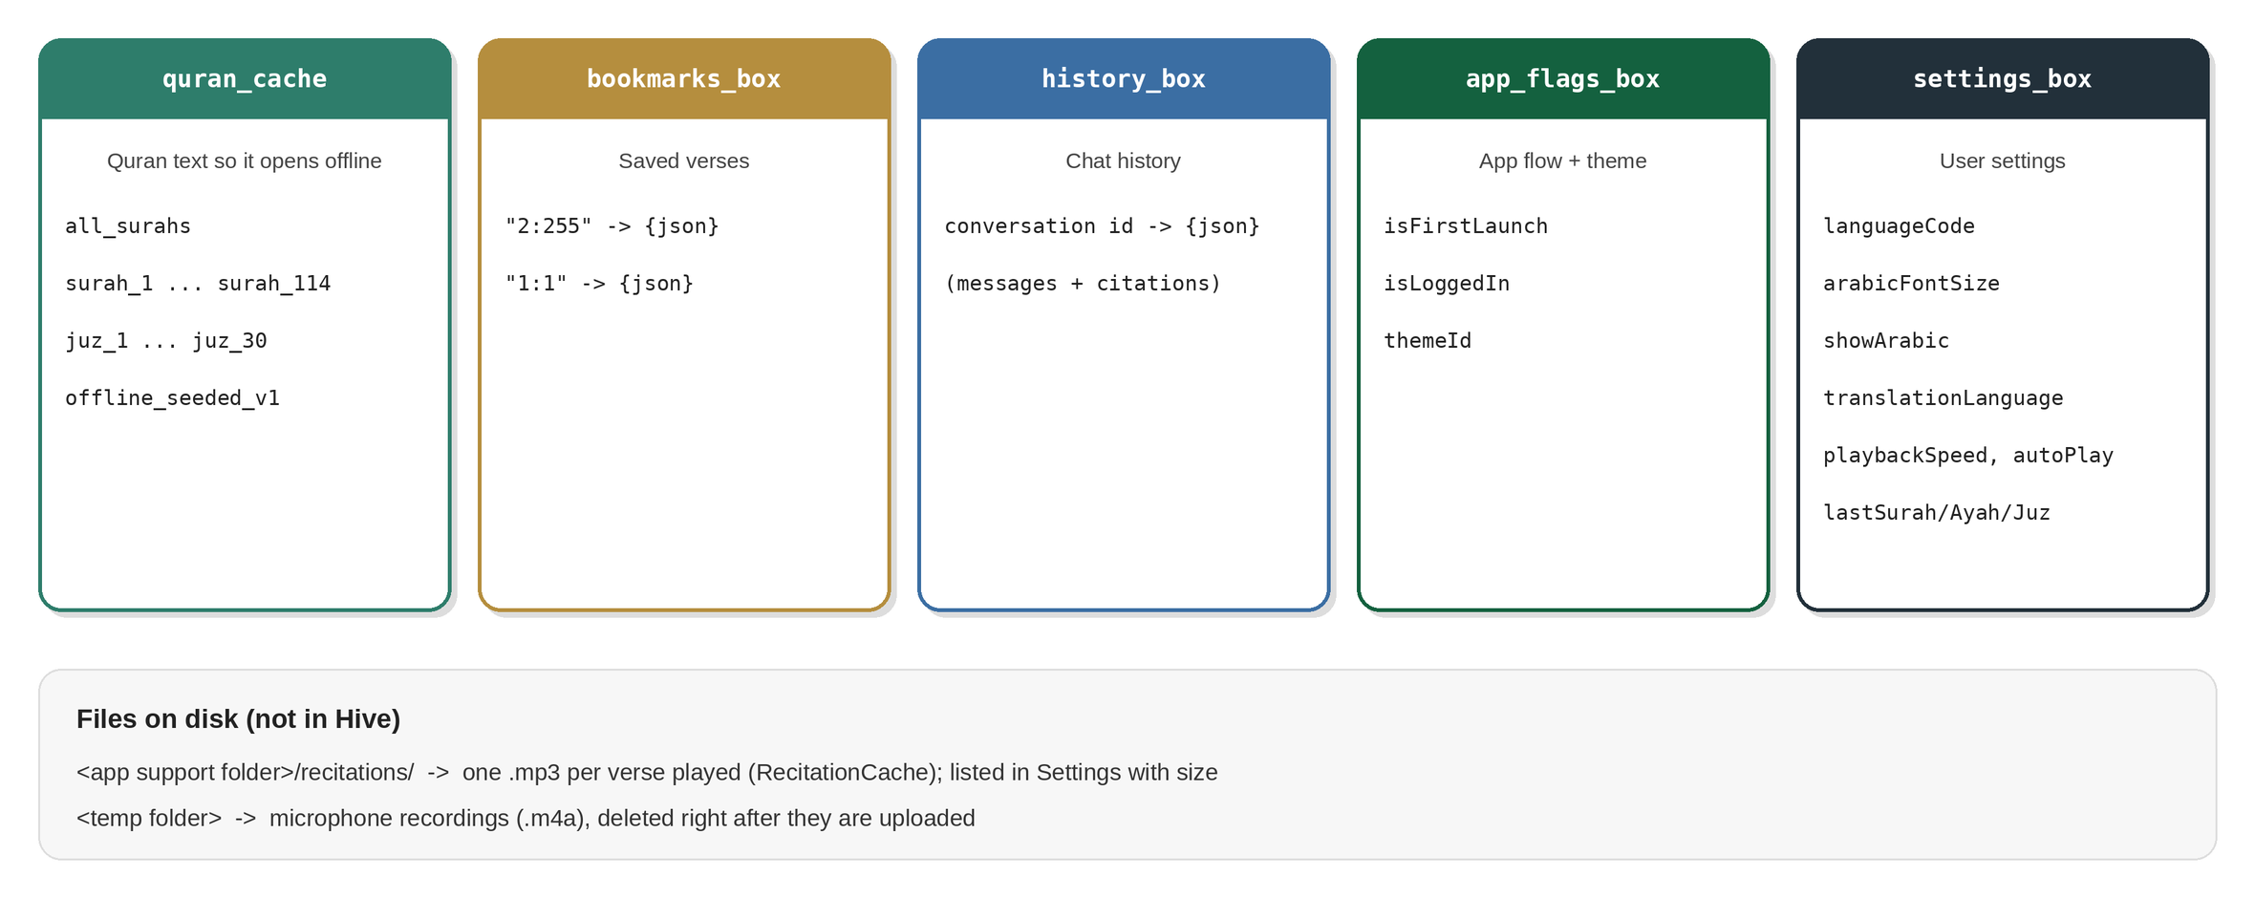
Figure 17: What is stored on the phone
Hive stores plain values by key. Bigger objects are saved as JSON text (jsonEncode(object.toJson())) and read back with fromJson. Nothing is sent to a server: bookmarks, history, settings and login flags exist only on the device. Uninstalling the app deletes them.
The Login and Signup screens are local accounts that decide the app flow only; they are not real authentication (the backend has no login endpoints).

13. Navigation
app/routes.dart defines the route names in AppRoutes (for example /surah, /verse-recognition) and a single onGenerateRoute that maps each name to a screen. Routes with data use small argument classes: SurahArgs(surahNumber, [initialAyah]) and JuzArgs(juzNumber). AppPageRoute gives every page the same fade-and-slide transition; it slides from the left in right-to-left languages.
The bottom tabs are handled by MainShell, driven by NavController.index. AppNav.goToTab changes the tab and pops back to the first route. PermissionFlow.ensureMicrophone shows an explanation dialog before asking for the microphone permission.

14. Language and themes
- Text. Every visible string lives in l10n/strings.dart in three maps (en, ur, ar). context.tr('key') looks up the current language and falls back to English, then to the key itself. To add text, add the same key to all three maps.
- Direction. settings.isRtl is true for every language except English; the root Directionality mirrors the layout.
- Themes. AppThemeCatalog defines 12 themes (Classic light and dark, Blossom, Serika Dark, Dracula, Nord, Gruvbox, Catppuccin Mocha, Solarized Dark, Monokai, Tokyo Night, Rosé Pine) as colour specs. AppTheme.build(spec) turns a spec into Flutter’s ThemeData. Widgets use context.accentGold, context.cardColor and similar shortcuts instead of fixed colours, which is why a theme change restyles every screen.

15. The backend in detail
File: backend/api/index.py (run by Vercel through vercel.json).
Part | What it does
Start-up | Creates the FastAPI app with permissive CORS; reads GROQ_API_KEY and GEMINI_API_KEY from environment variables and stops with an error if either is missing
Caches | Python dictionaries keep the Surah list, each Surah, each Juz and the whole Quran text in memory while the function is warm
/surahs, /surahs/{id}/ayahs, /juz/{id}, /search | Fetch from alquran.cloud (Arabic quran-uthmani, English en.sahih, Urdu ur.jalandhry) and return simple JSON; each verse includes an everyayah.com audio_url
/chat | Groq first, then Gemini, then a fixed fallback sentence; _parse_json_reply repairs damaged JSON
/stt | Whisper transcription of an uploaded file
/recognize | Section 9: transcribe, normalise, compare, attach translations
The chat prompt tells the model to answer in the requested language with 2 to 3 sentences and to return only JSON of the form {"text": "...", "citations": ["surah:ayah"]}. The app then verifies each citation against the real Quran text (section 7).
Because Vercel runs the backend as a serverless function, the memory caches survive only while the function stays warm, which is why the first request after a quiet period is slower.

16. Glossary
Term | Meaning in this project
Widget | A piece of UI in Flutter (a button, a card, a whole screen).
StatefulWidget | A widget that can change while it is on screen (for example the Surah reader).
ChangeNotifier | A Flutter class that can tell listeners “I changed” with notifyListeners(). All controllers extend it.
InheritedNotifier | A widget that makes an object available to everything below it (used by AppScope).
Future / async / await | A value that arrives later (a network reply). await waits for it without freezing the screen.
Stream | A series of values over time (for example “verse finished” events).
Hive | The small on-device database. A box is like a named dictionary.
Interface (abstract class) | A list of methods that any implementation must provide.
part / part of | Dart’s way of spreading one library over several files.
Composition root | The single place where objects are created and connected (AppServices).
Serverless | Code that runs only when a request arrives (Vercel), with no server to manage.
CORS | A browser rule about which websites may call an API; set to allow all here.

17. Where do I look when…
I want to… | Open
Change the backend address | lib/services.dart
Change or add text in any language | lib/l10n/strings.dart
Change colours or add a theme | lib/theme/theme_catalog.dart
Change how a verse card looks or is highlighted | lib/widgets/verse_widgets.dart and AppCard in lib/widgets/ui_primitives.dart
Change Auto Play | lib/screens/surah_screen.dart, lib/screens/juz_screen.dart, lib/services/just_audio_service.dart
Change how audio is saved offline | lib/services/recitation_cache.dart
Change a default setting | lib/state/settings_controller.dart
Switch a feature between real and mock data | AppServices in lib/app/app.dart
Add a screen | New file in lib/screens/, a part line in main.dart, a route in lib/app/routes.dart
Change the chat prompt or AI models | SYSTEM_PROMPT, GROQ_CHAT_MODEL, GEMINI_CHAT_MODEL in backend/api/index.py
Change how strict verse matching is | The 0.45 threshold in /recognize
Debug a network problem | The Backend Test screen (/backend-test) and the [audio] / Backend ... failed lines in the flutter run console

