Quranic Chatbot
Code Guide (Simple Edition)
The main things about how the app works
Read time: about 10 minutes

1. What is in the project
The project has two parts that talk to each other.
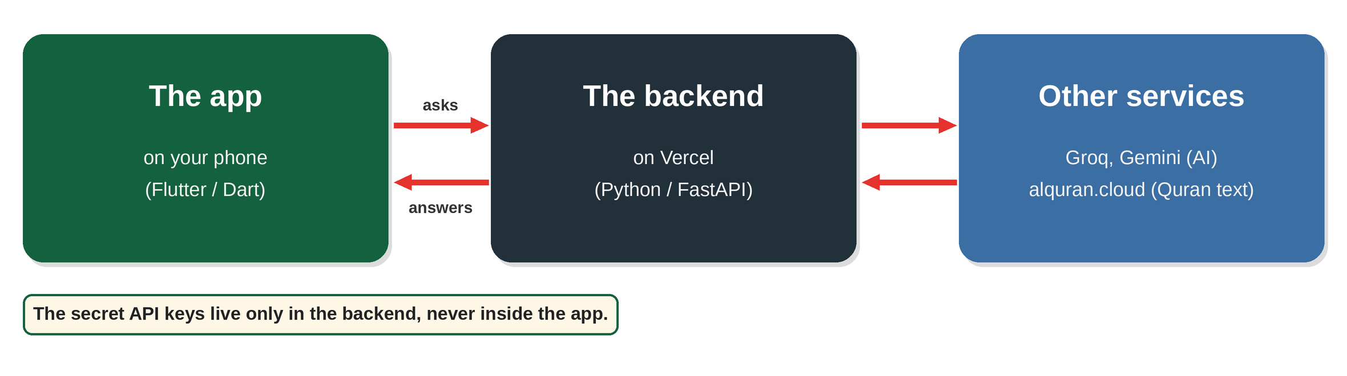
Part | Where | What it does
The app | flutter_app/lib/ | Everything you see and tap on the phone
The backend | backend/api/index.py | Keeps the secret keys, talks to the AI, matches recitations to verses

2. The app’s folders
All app code is inside lib/. Each folder has one clear job.
Folder | What is inside
screens/ | The pages you see (Home, Surah reader, Chat, Settings…)
widgets/ | Small reusable pieces (verse card, buttons, audio bar)
state/ | The “controllers” that remember data (settings, chat, bookmarks)
services/ | The code that talks to the outside: backend, audio, saved files
models/ | Simple data shapes: Surah, Verse (Ayah), Chat message
l10n/ | All text in English, Urdu and Arabic
theme/ | Colours and the 12 themes
main.dart | The starting point. It also lists every other file.
services.dart | The backend address (you must edit this)

3. How a tap becomes a change on screen
Every feature works the same way.
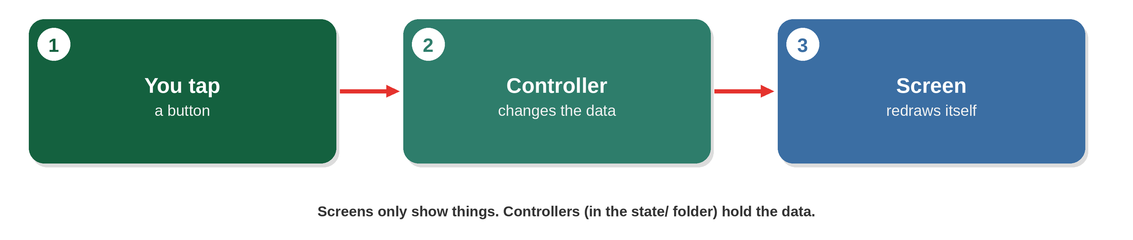
For example, when you change the language in Settings, the controller saves it and the whole app redraws in the new language.

4. The main features

AI chat
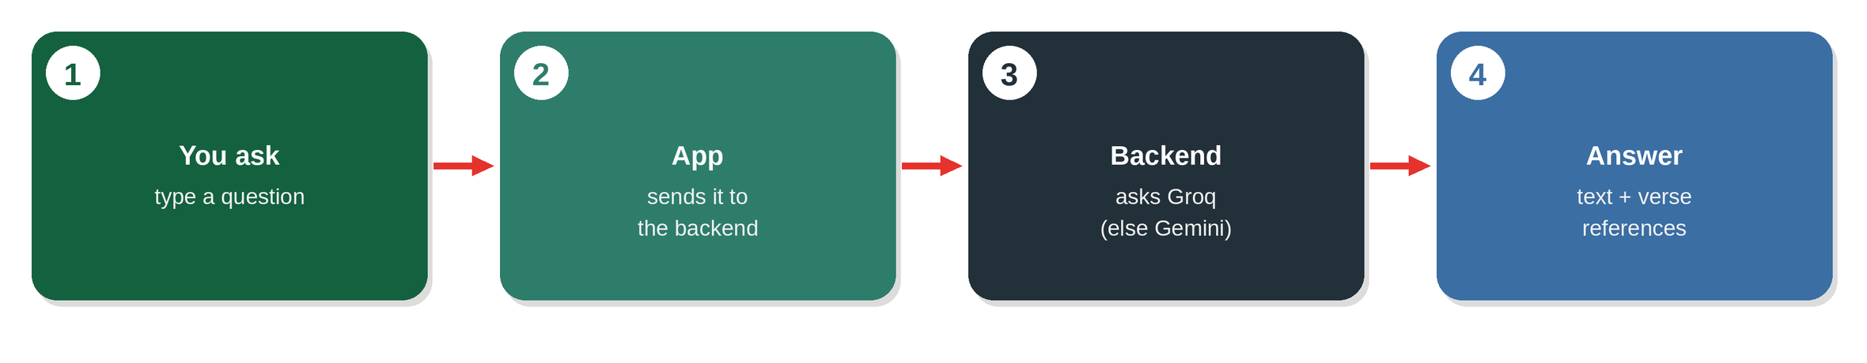
The answer comes with verse references. The app looks up each reference and shows the real Quran text, not text written by the AI.

Recite & Recognize
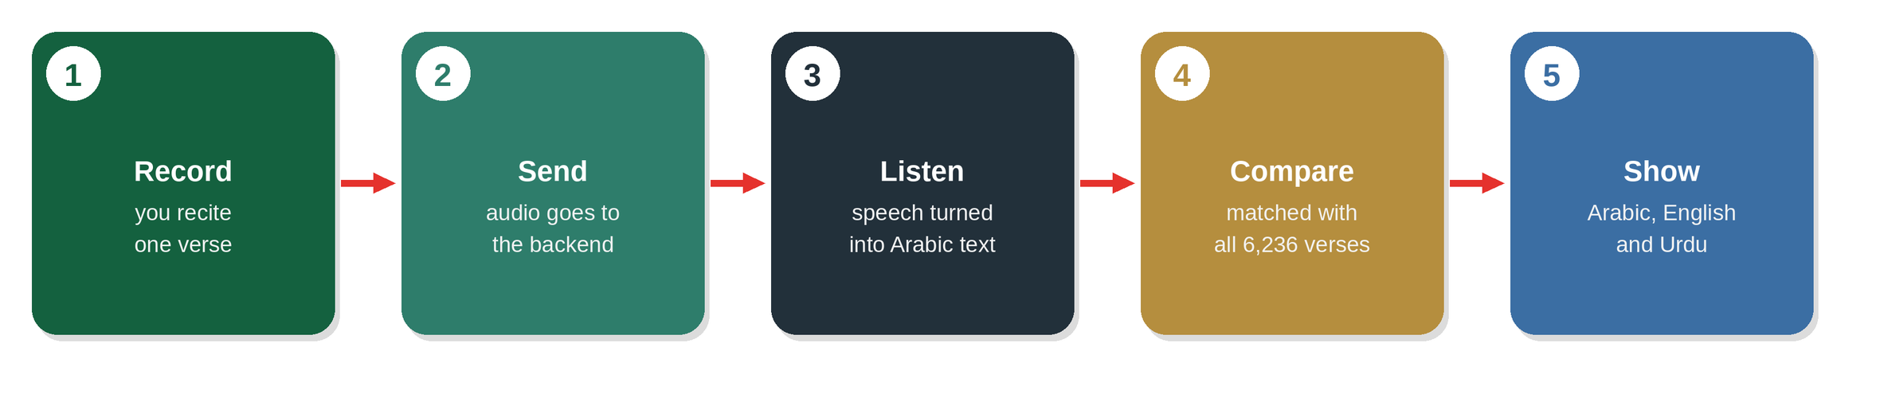
This is not an AI guess. The backend compares what it heard with the real Quran text. If the match is weak, it says “no match”.

Auto Play
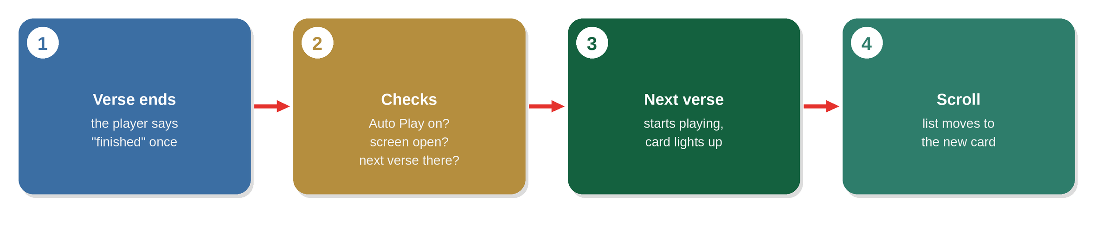
Auto Play is off by default. Turn it on in Settings.

Offline use
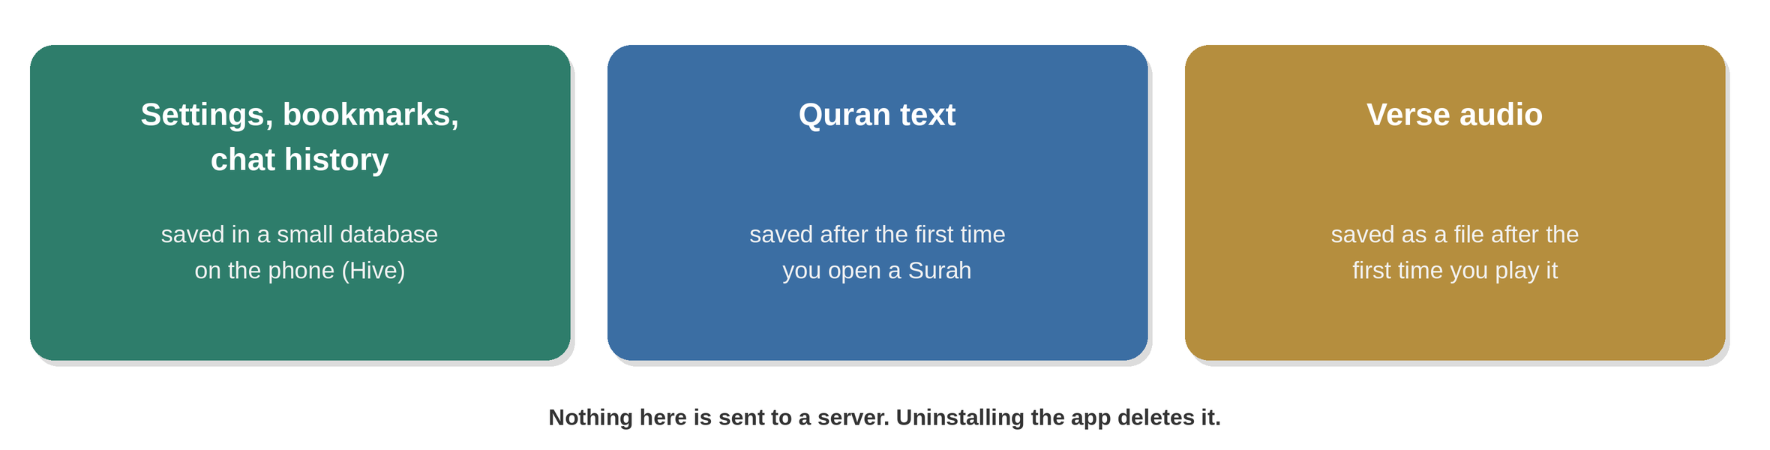
Because of this, verses you have already opened or played still work without internet.

5. The backend in short
The backend is one file. It has these jobs:
Address | Job
/surahs, /surahs/{id}/ayahs, /juz/{id} | Give Quran text with English and Urdu
/search | Search verses
/chat | AI answer (Groq first, Gemini if Groq fails)
/stt | Turn your voice into text
/recognize | Find which verse was recited
It needs two secret keys, GROQ_API_KEY and GEMINI_API_KEY, set in Vercel.

6. Where do I change…?
I want to change | Open this file
The backend address | lib/services.dart
Any text or language | lib/l10n/strings.dart
Colours or themes | lib/theme/theme_catalog.dart
How a verse card looks | lib/widgets/verse_widgets.dart
Auto Play | lib/screens/surah_screen.dart
Default settings | lib/state/settings_controller.dart
The AI models or the chat prompt | backend/api/index.py

7. Words used in this guide
Word | Meaning
Widget | A piece of the screen, like a button or a card
Controller | Holds data and tells the screen when it changes
Service | Code that does outside work: network, audio, saving
Backend | The small server on Vercel
Hive | The small database inside the app
Ayah | One verse of the Quran

