this account is for create the user and group, etc..

https://test.kmbkk.com/admin

user: aidan

password: 123

this account is for the group admin user for login

https://test.kmbkk.com/admin

user: tc

password: tc

this account is for the client login

https://test.kmbkk.com/admin

user: st

password: st

for test, you need to open the 2 browser separately and one for the client (remember to enalbe the sound permission), the web is based on webrtc.

in the tc acount page, if you press the button speak or play some sound, or the bell, in the client can get the sound. (https://test.kmbkk.com/admin user: tc password: tc)

in the tc acount page, if you press the speak button, or bell button, the client can get the sound also (https://test.kmbkk.com/ user: tc password: tc)

1. When add the master account, it can add the 3 youtube videos also, and in the web, all the button should show on the top of the video, and the video should show in full scale in the background and responsive for all devices, and the page should show like before, can not move left and right or move up and down for all devices. Means can not scroll.

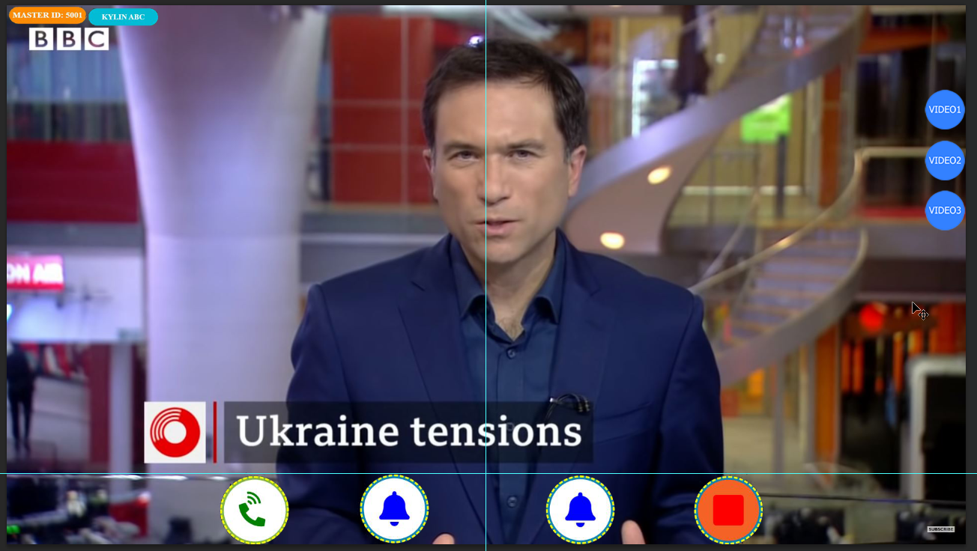

|  |  |
| --- | --- |
|  | When click the master button, it will show 3 more rows to input the youtube video urls and in the below page, all the button should show on the top of video and it will show 3 buttons for switch the video in the background. And also 2 rows for add the sound file for each account.  <https://test.kmbkk.com/> user: tc password: tc  and the text just made it smaller and show in the bottom left of the video |

|  |  |
| --- | --- |
| Video1 also like the video 2 and 3, when click it come, and click again, the video gone. | The first youtube video show as default in the background in full scale and responsive, and the second and third video default not show, and you can see, in the left just made 3 buttons for that, when click the button video2, the video will show on the up layer of the default video om the top left, and if press one more time of that button, the secpmd video will gone and not show, and for the video3 button on the left, it work the same way, just press it video come, press again, the video gone, the second and third video’s location in the top left. |

Different account the sound file should be different, so in the below area, when add data, it also should have 2 rows for upload the sound file.

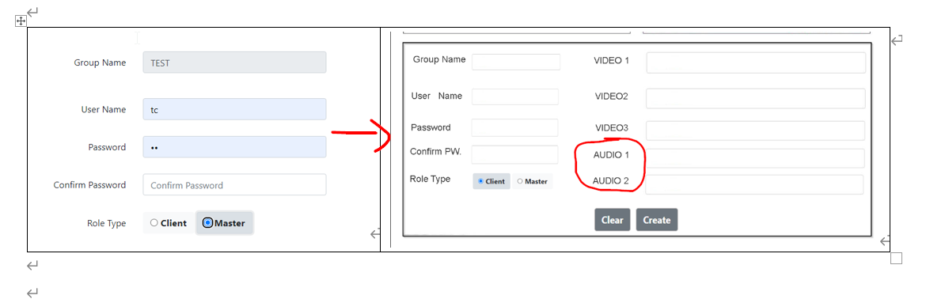

1. Made the below area look better, because the data is a little long, it goes to other rows

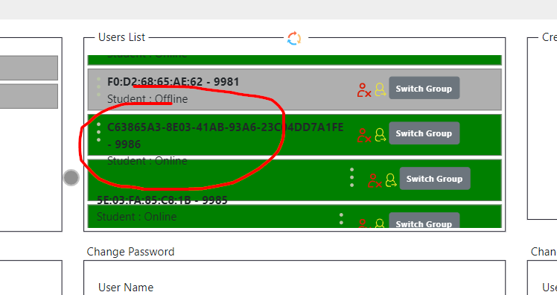

1. Show the name of the audio that is playing now which include the audio files in the below 2 areas.

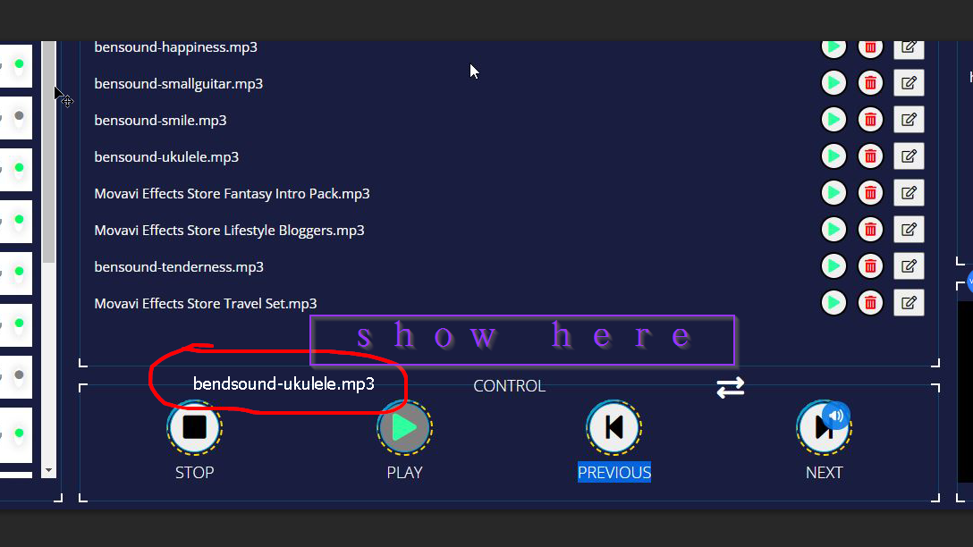

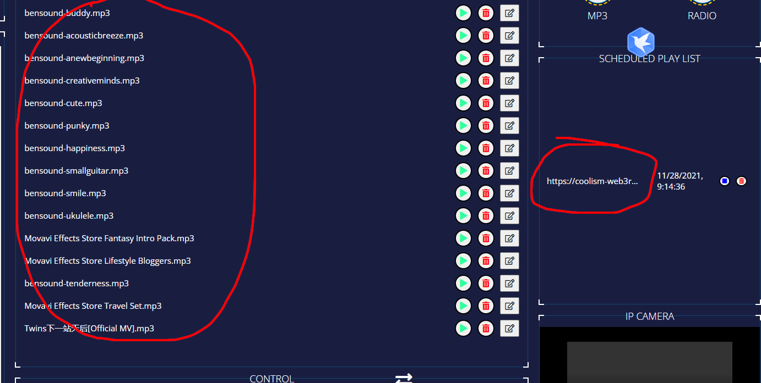

When click the playing button, the last playing button should show as the default green color.

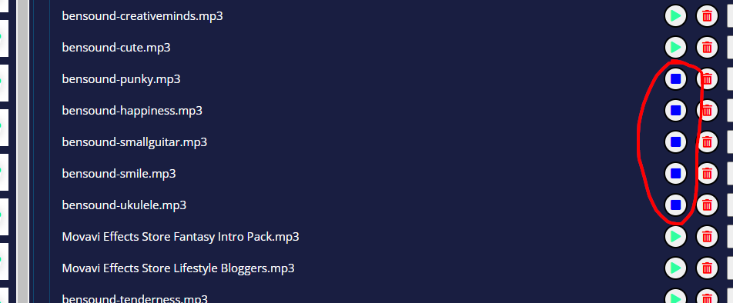

1. https://test.kmbkk.com/admin user: tc password: tc this page have video second, and also should show 3 video with the switch button..

