There are the following roles:

* Admin
  + Define Rate for each countries
  + Manage Companies
  + Paypal Account
* Company
* Company Admin
* Company Agent

Admin can create the companies for the following fields:

* Company Name
* Contact Name
* Email
* Phone
* Login
* Password

In the management page, we need a list of actions:

|  |  |  |  |  |  |  |
| --- | --- | --- | --- | --- | --- | --- |
| Company Name | Contact Name | Email | Phone | User | Balance | Action |
|  |  |  |  |  |  |  |

Action:

* Edit
* Enable/Disable
* View Payment History
  + Show : Pay On, Amount, Entered By, Note
  + Need to show in reverse time order
  + Need to support export
  + Need to enable
* View Usage
  + Show : Date, Country, Destination, Minutes, Total
  + Destination is either mobile / landline
  + Enable Filter and Search by Date , Country

|  |  |  |  |  |
| --- | --- | --- | --- | --- |
| Date | Country | Type | Minute | Cost |
| 2015/04/03 | France | Landline | 1009 | 10.83 |
| Mobile | 997 | 8.87 |
| UK |  |  |  |
|  |  |  |  |
| Total |  |  |  |

* View Detail - When click on it, it should expand to :
  + 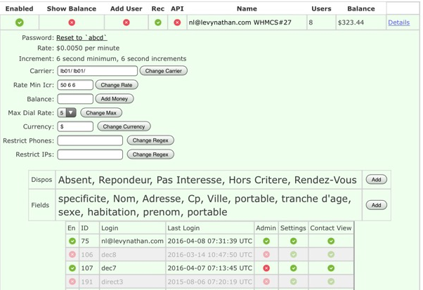
* Login is the list of Agents in that company
* Admin means whether that agent is also a company admin
* Setting means the agent can configure the setting of the campaign
* Contact View means the agent can see the list of contact

Company Admin can do the following:

* Manage Agents
  + Sipuser
  + Password
  + Is_admin
  + Contact view
  + Setting
* Manage Campaign
  + The following campaign fields are needed:
    - Campaign Name
    - Upload Contact List
      * First Name
      * Last Name
      * Phone Number
    - Connected message
    - Manual Recycle or Auto-Recycle
    - Agent ( admin can assign agents to a campaign, each agent can be in one campaign )
    - Contact Fields – each campign can have a set of customized fields for contacts. When upload contact, the PHP portal needs to match column with fields and check validation.
    - Require Recording
    - Require Q and A. If Yes, select one of the layout.
    - Require Appointment Setting
  + Each Campaign should have following action:
    - Statistic
* Manage Recording
* Manage Appointment
* Manage in-box
  + From user
  + To us
  + Sent on
  + Message
  + Read On
* Manage Layout ( this is what gets displayed at the call of answer ), Each campaign must select one layout. Layout has:
  + - Title
    - Background Image.
    - Background Color.
    - Questions:
      * Yes/No question.
      * Single Selection question.
        + Combo Box
        + Radio Button.
      * Multiple Selection question.
      * Calendar. Date + hour.
      * Notes question.
      * All question can be marked mandatory.
  + Each Layout can be defined with a number of questions.
  + When a call is connected, the UI should pop up the page, with the list of questions and agent can put the answer into it.
* Manage Appointment
* Manage Answer
  + Show Campaign Name, Time, From #, To #, Detail
  + When click on detail, user can see the answer of the question.
* Statistics
  + Agent Statistics
* See a list of user and live chat with them

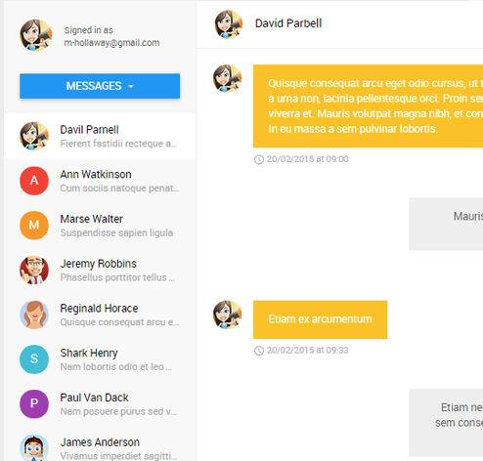

* Manage Office – Each company can have many offices and agent can be one of the office. Company admin can move agent from one office to another.
* Manage Salesman
  + The following fields are needed for sales man:
    - Name
    - Phone
    - Email
  + The following actions are needed for sales:
    - Edit
    - Enable/Disable
* Live Monitor
  + Company Admin can see the following fields for all live calls:
    - From Number
    - To Number
    - Status – Dialing, Ringing, Answering
    - Agent
* Agent Pop up
  + When an Agent login, they will see two buttons: Start and Stop
  + When the agent is started, we will record it as the beginning of an agent session. When the agent stop, it will be recorded as an end of that agent session.
  + In the main page, when the agent starts, the UI will use dubango javascript to register to the backend ( provided ). When a call arrive, the call will be answered. Also, the UI will display the “Layout” on the UI for the user to know how to response to the incoming calls.