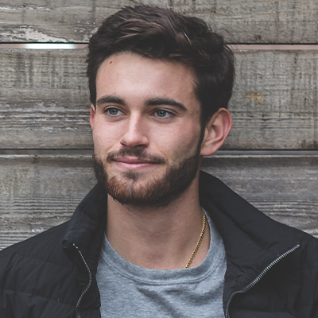

**THE VIRGINIAN PILOT | 20XX – 20XX**

Journalist, Norfolk

Tasks:

* + - * Pitch timely story ideas for investigative journalism.
      * Write 15 stories monthly covering the latest in breaking news.
      * In-depth analysis of relevant political events.
      * Fact-checking for accuracy and data visualization purposes.

**DAILY PRESS | 20XX – 20XX**

Staff Editor, Newport News

Tasks:

* + - * Published a weekly blog covering the latest in tech innovations.
      * Maintained a 3.5% engagement rate.
      * Interviewed digital entrepreneurs on a weekly basis.
      * Aided in-house writers in editing and fact-checking for accuracy.

**WASHINGTON POST | 20XX – 20XX**

Washington D.C, Washington

Tasks:

* + - * Created compelling pieces for online publications which included coordinating images and layout for best presentation standards.
      * Developed key story ideas by evaluating and following up on news leads and tips.
      * Aided contributors in editing and fact-checking for accuracy.

**THE GUARDIAN | 20XX – 20XX**

Contributor, Remote

Tasks:

* + - * Conducted interviews and covered key moments from the G20 Summit 2021 in Italy.
      * Produced in-depth and engaging online content in accordance with house style.

**WORK EXPERIENCE**

**DIPLOMAS Y HOBBIES**

**Formaciones :** Diplomados, Congresos, xxxxxxxxxx xxxxxx xxxxxxxxx xxxxxxxxxxxxxxxxx

**Hobbies:** xxxxxxxxxxxxxxxxxxxxxxxxxxxxxx

**KHALIL**

**RICHARDSON**

**ABOUT ME**

JOURNALIST

As a seasoned journalist with over 7 years of experience in delivering impactful and thought-provoking stories, I am passionate about investigating and uncovering the truth. I am committed to producing high-quality, accurate, and engaging content that informs, educates, and inspires readers. Seeking a challenging role in a reputable media organization where I can utilize my skills in research, writing, and storytelling to contribute to the organization's success while advancing my career as a journalist.



©AZURIUS - My-resume-templates.com

+1 686 0202 020

name.lastname@email.com

Virginia, US

20XX-20XX | Seattle - Washington

**Masters Digital Communication**

University of Washington

20XX | Blacksburg - Virginia

**B.A. Multimedia Journalism**

Virginia Tech

* Teamwork
* Communication
* Data visualization
* InDesign
* Google Suite

**SKILLS**

**CONTACT**

**LANGUAGES**

English: Native

Spanish: Proficient

French: Advanced

**EDUCATION**

**Dear Job Seeker,**

If you're having difficulty composing your resume, here are some free resources available that can assist you in creating a strong resume that highlights your suitability for the position to potential employers:

* [How to Make a Good Resume](https://www.my-resume-templates.com/how-to-make-a-resume/?utm_source=Word_Doc&utm_medium=Model_CV_Link&utm_campaign=MDC_Downloads)
* [Skills to Put on a Resume](https://www.my-resume-templates.com/skills-to-put-on-a-resume/?utm_source=Word_Doc&utm_medium=Model_CV_Link&utm_campaign=MDC_Downloads)
* [Resume Objective Examples](https://www.my-resume-templates.com/resume-objective-examples/?utm_source=Word_Doc&utm_medium=Model_CV_Link&utm_campaign=MDC_Downloads)

Also discover other free downloadable and ready-to-fill CV templates in Word format:

* [Basic Resume Templates](https://www.my-resume-templates.com/basic-resume-templates/?utm_source=Word_Doc&utm_medium=Model_CV_Link&utm_campaign=MDC_Downloads)
* [Modern Resume Templates](https://www.my-resume-templates.com/modern-resume-samples/?utm_source=Word_Doc&utm_medium=Model_CV_Link&utm_campaign=MDC_Downloads)
* [Creative Resume Templates](https://www.my-resume-templates.com/creative-cv-templates/?utm_source=Word_Doc&utm_medium=Model_CV_Link&utm_campaign=MDC_Downloads)
* [Professional Resume Templates](https://www.my-resume-templates.com/career-resume-templates/?utm_source=Word_Doc&utm_medium=Model_CV_Link&utm_campaign=MDC_Downloads)
* [Europass CV](https://www.my-resume-templates.com/europass-cv/?utm_source=Word_Doc&utm_medium=Model_CV_Link&utm_campaign=MDC_Downloads)

Best regards,

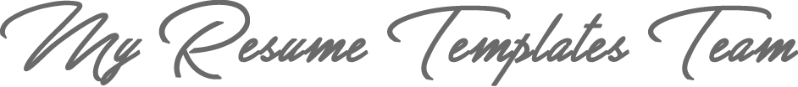

[www.my-resume-templates.com](https://www.modelos-de-curriculum.com/?utm_source=Word_Doc&utm_medium=Model_CV_Link&utm_campaign=MDC_Downloads)

**COPYRIGHT - PLEASE READ THIS MESSAGE**

©These examples of free resume templates are the property of Azurius S.L. You may download and modify them without any problem if they are for personal use.

Do not forget to remove this copyright notice before modifying and printing your CV.

You cannot resell these examples or their derivatives. You cannot make them available on other websites without our consent. For any related questions, please write to us at contact@my-resume-templates.com

Discover more resume templates at [www.my-resume-templates.com](https://www.my-resume-templates.com/)