SUPPORTING INFORMATION

Coral bleaching and mortality across a 24° latitudinal range in the
Southwestern Atlantic during the fourth global bleaching event

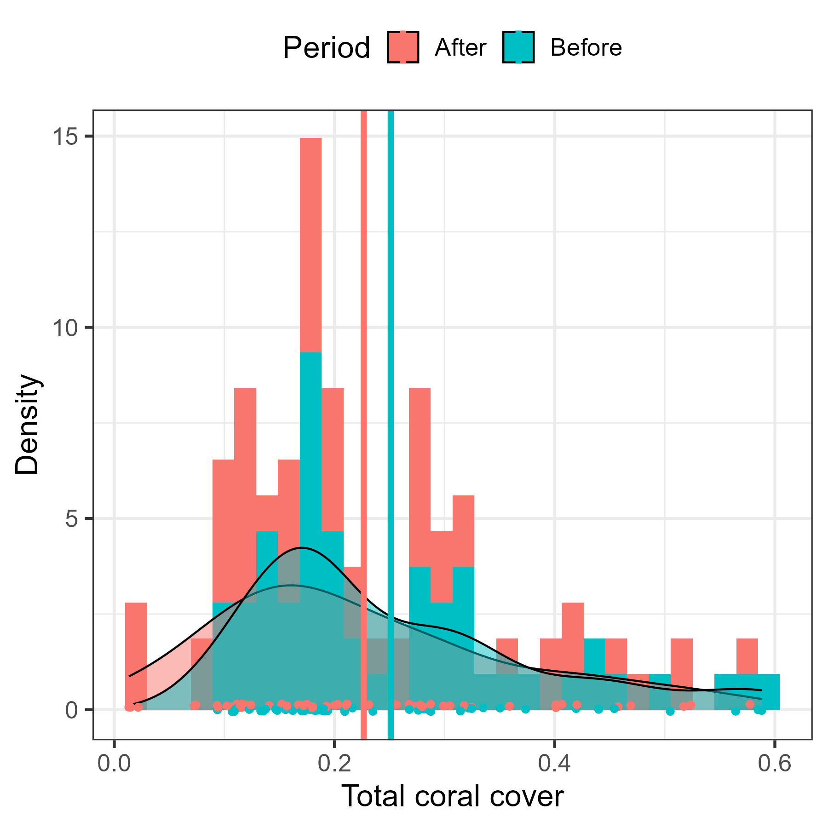

Fig. S1 Histogram with kernel density estimation showing the distribution of observed total coral cover between periods (before vs. after the bleaching event). The vertical lines depict the average total coral cover per period. The points show the individual observations. The observed difference in total cover between periods was -2.45%.

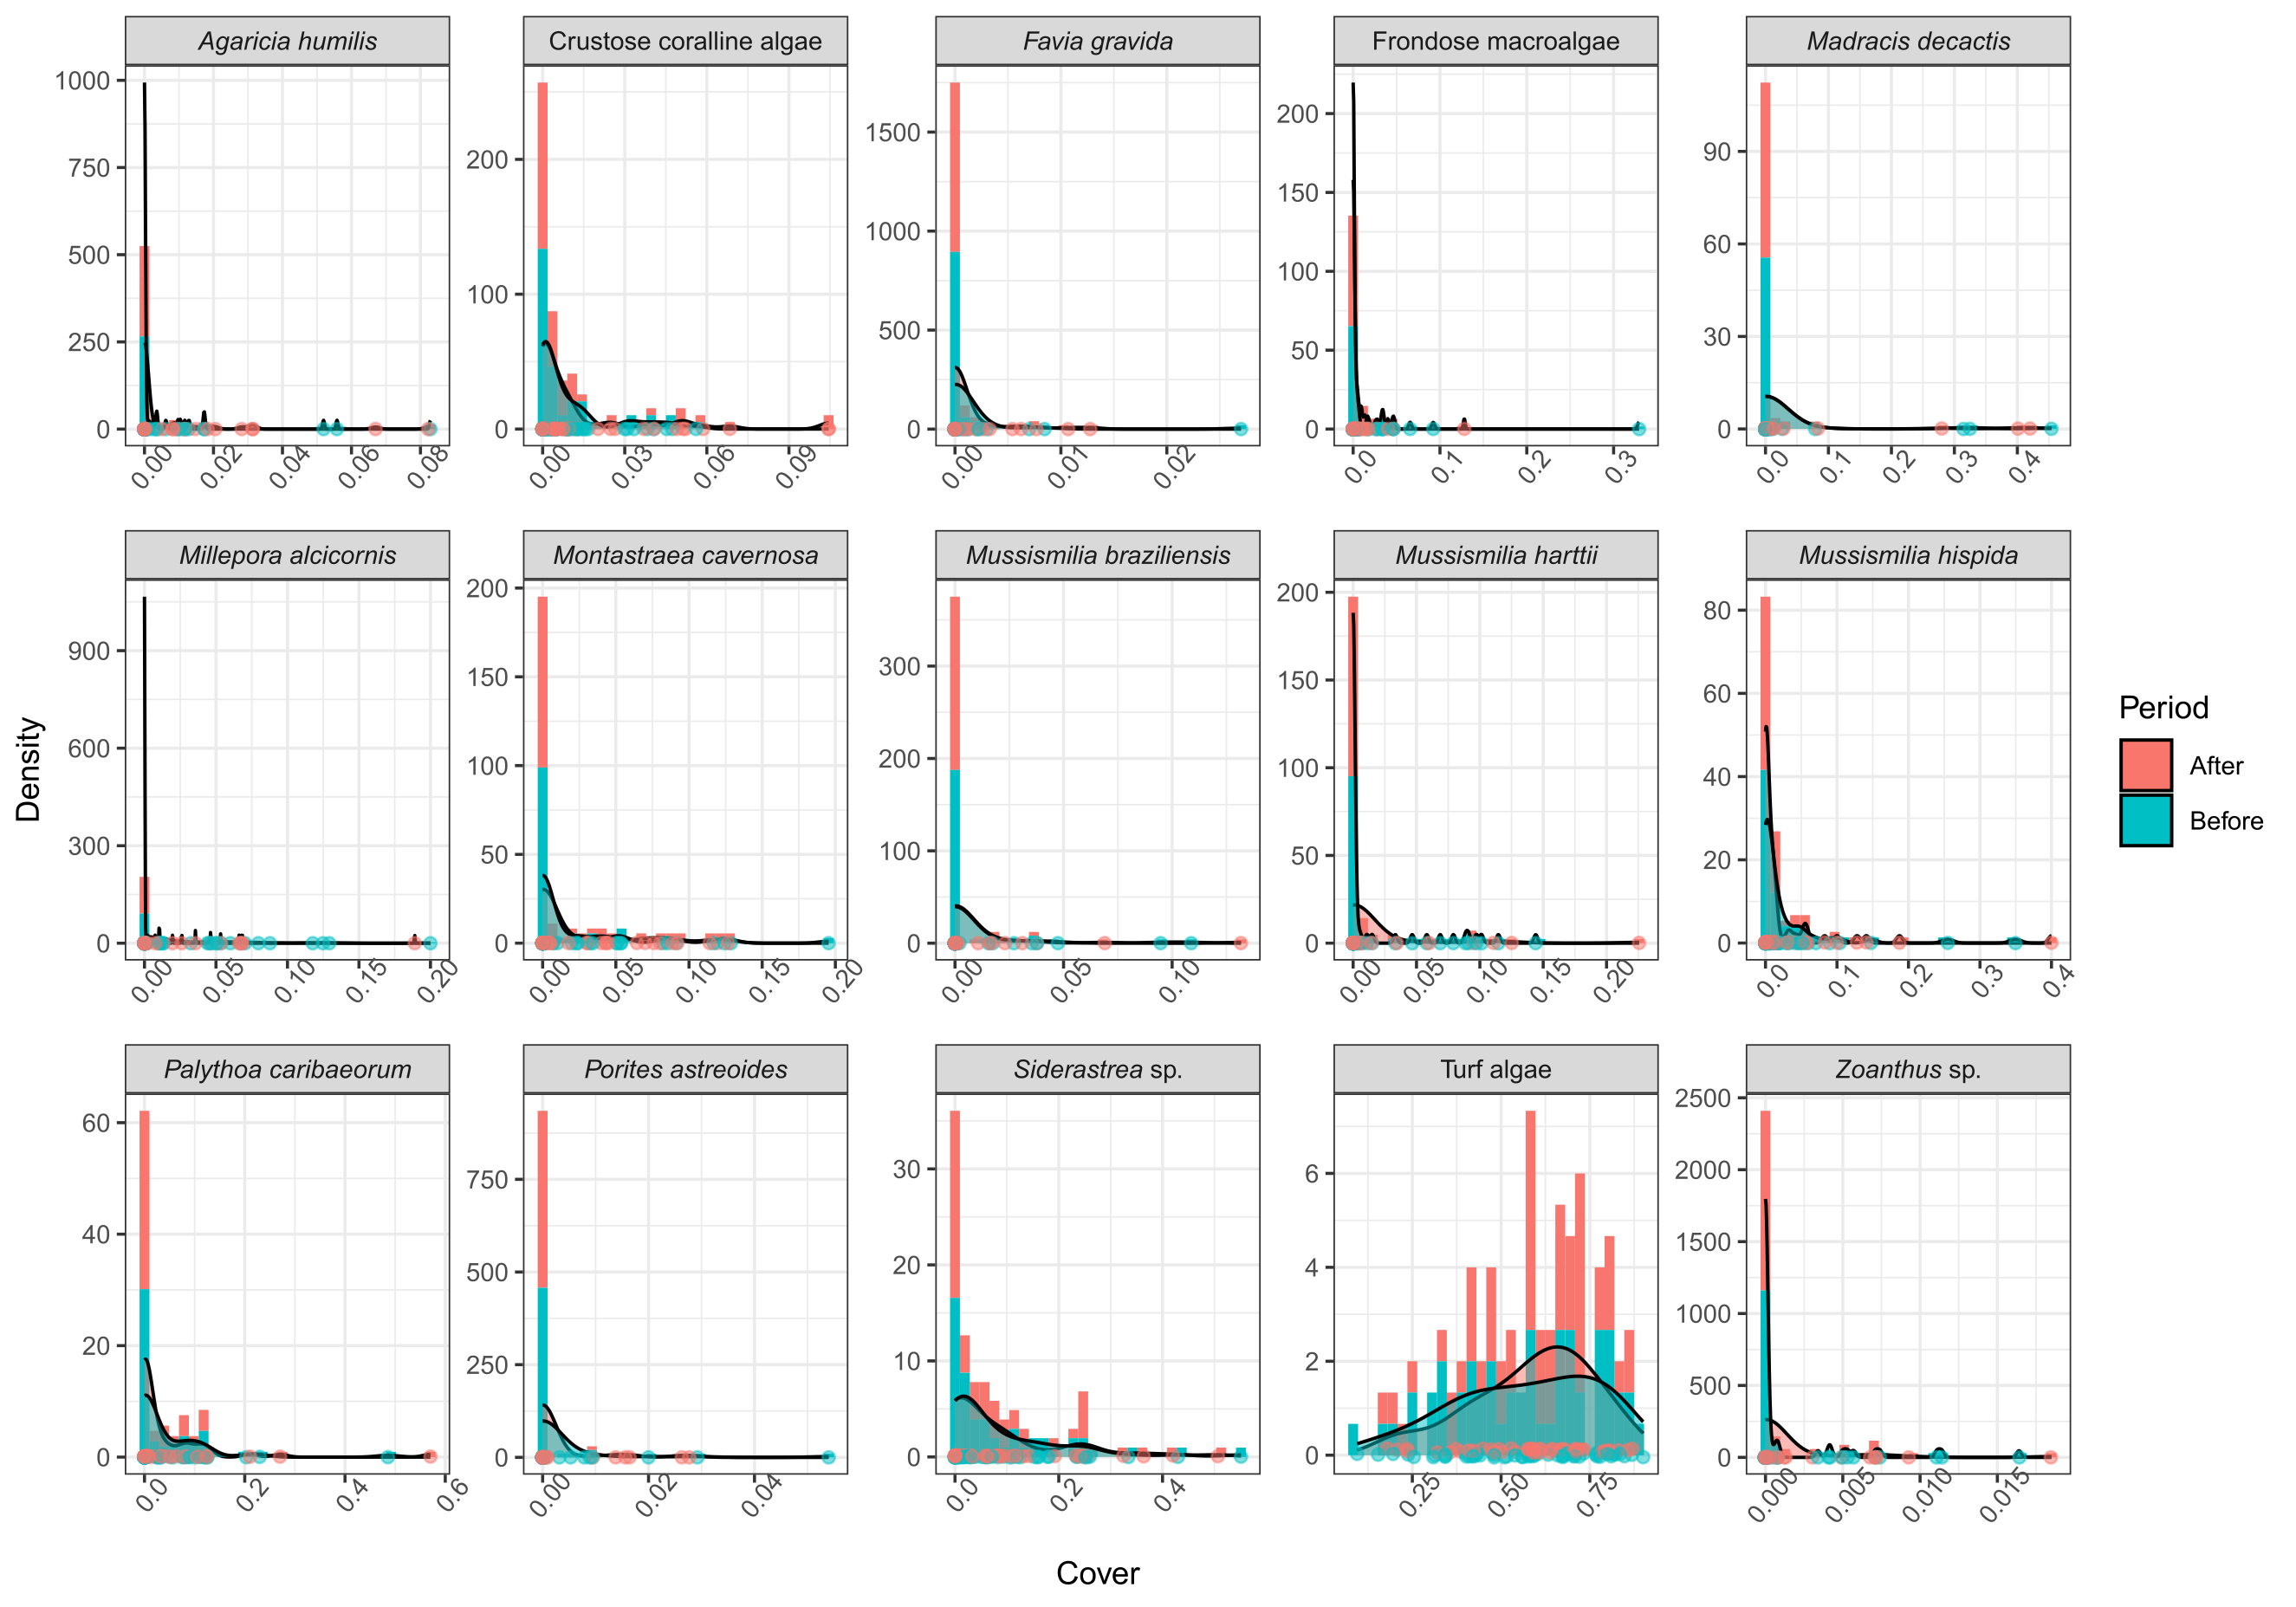
Fig. S2 Histogram with kernel density estimation showing the distribution of cover of individual species/taxa between periods (before vs. after the bleaching event). The points show the individual observations.

Table S3 Comparison of different Beta regression structures used to model total coral cover. ID refers to the transect identity used as random intercept. LOO-IC: Leave-One-Out Information Criterion, ELPD-LOO: expected log pointwise predictive density, P-LOO: Effective number of parameters, ELPD-Diff: ELPD difference between models relative to the best ranked model. The standard errors (SE) represent uncertainty around statistics (uncertainty about predictive performance and model selection) and are estimated using LOO cross-validation across the 2,000 posterior distribution samples of each statistics.
Model / Structure |  | LOO-IC (SE) | ELPD-LOO (SE) | P-LOO (SE) | ELPD-Diff (SE)
Total cover
1 | ϕ ~ 1 | -249.1 (18.5) | 124.5 (9.3) | 34.0 (4.2) | 0 (0)
1 | μ ~ period x site + (1|ID)
2 | ϕ ~ period | -246.8 (18.6) | 123.4 (9.3) | 34.6(4.3) | -1.2 (1)
2 | μ ~ period x site + (1|ID)
3 | ϕ ~ 1 | -242.7 (17.7) | 121.3 (8.8) | 30.8 (3.7) | -3.2 (3.3)
3 | μ ~ period x site
4 | ϕ ~ period | -239.9 (18.1) | 120.0 (9.1) | 31.9 (3.9) | -4.6 (3.4)
4 | μ ~ period x site
Species-level
1 | ϕ ~ 1 | 112.0 (48.9) | 21.5 (1.6) | -223.9 (97.9) | 0 (0.0)
1 | μ ~ period x species
1 | ψ ~ 1
2 | ϕ ~ 1 | 111.4 (49.0) | 22.9 (1.7) | -222.8 (98.0) | -0.6 (0.8)
2 | μ ~ period x species + (1|ID)
2 | ψ ~ 1
3 | ϕ ~ period | 109.8 (49.1) | 24.6 (1.8) | -219.6 (98.1) | -1.3 (0.4)
3 | μ ~ period x species + (1|ID)
3 | ψ ~ 1
4 | ϕ ~ 1 | 110.6 (49.0) | 22.9 (1.6) | -221.2 (97.9) | -1.4 (0.2)
4 | μ ~ period x species
4 | ψ ~ period
5 | ϕ ~ 1 | 110.5 (49.0) | 23.5 (1.6) | -221.0 (98.0) | -1.6 (0.8)
5 | μ ~ period x species + (1|ID)
5 | ψ ~ period
6 | ϕ ~ period | 110.7 (49.0) | 23.0 (1.7) | -221.3 (97.9) | -2.0 (1.0)
6 | μ ~ period x species + (1|ID)
6 | ψ ~ 1
7 | ϕ ~ period | 109.4 (49.0) | 24.3 (1.8) | -218.8 (98.0) | -2.6 (0.4)
7 | μ ~ period x species
7 | ψ ~ period
8 | ϕ ~ period | 109.1 (49.0) | 25.2 (1.8) | -218.2 (98.1) | -2.7 (1.0)
8 | μ ~ period x species + (1|ID)
8 | ψ ~ period

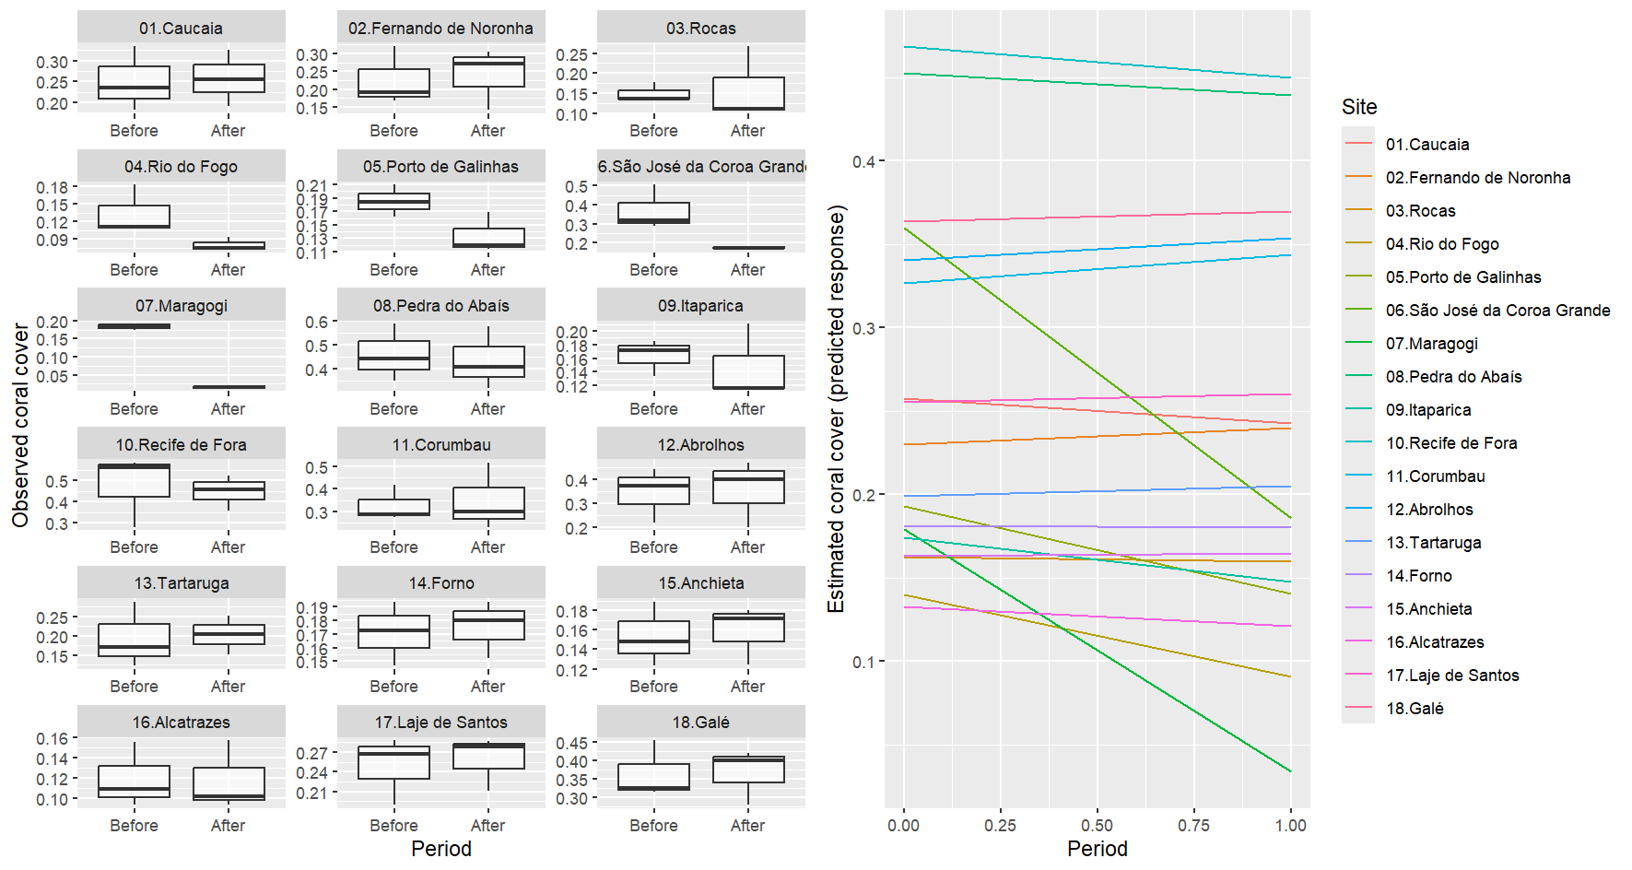
Fig. S4 Boxplots and line plots showing the observed (left) and estimated (right) variation in total cover before and after the 2023-24 bleaching event. Variability shown in the boxplots of the left plot is caused by benthic cover measurements made in replicated transects.

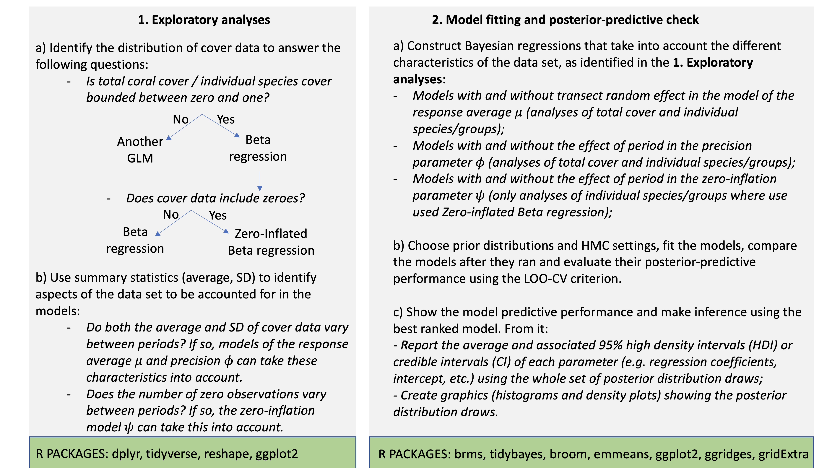
Fig. S5 Workflow of the decision making process for the exploratory and beta regression analyses used to assess changes in coral cover across species, sites, and time.

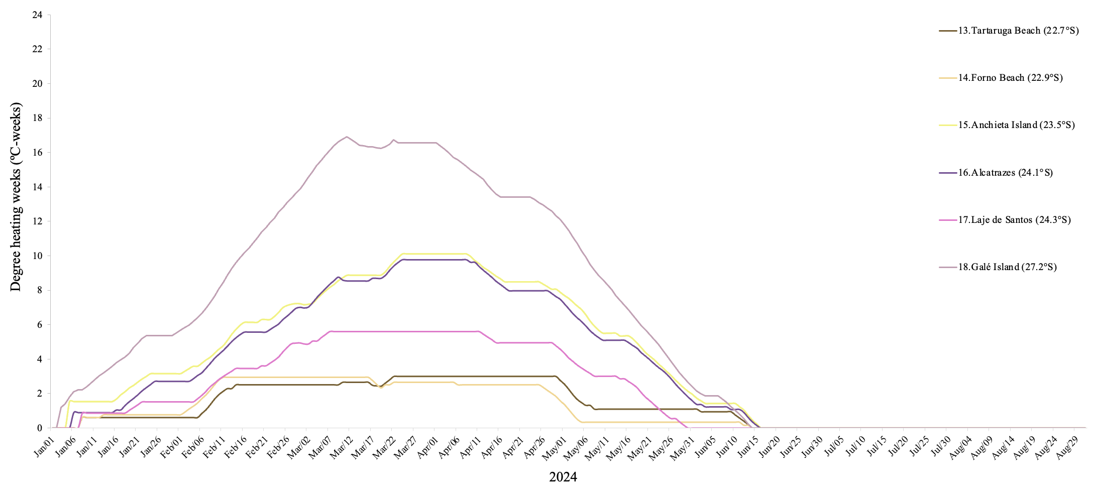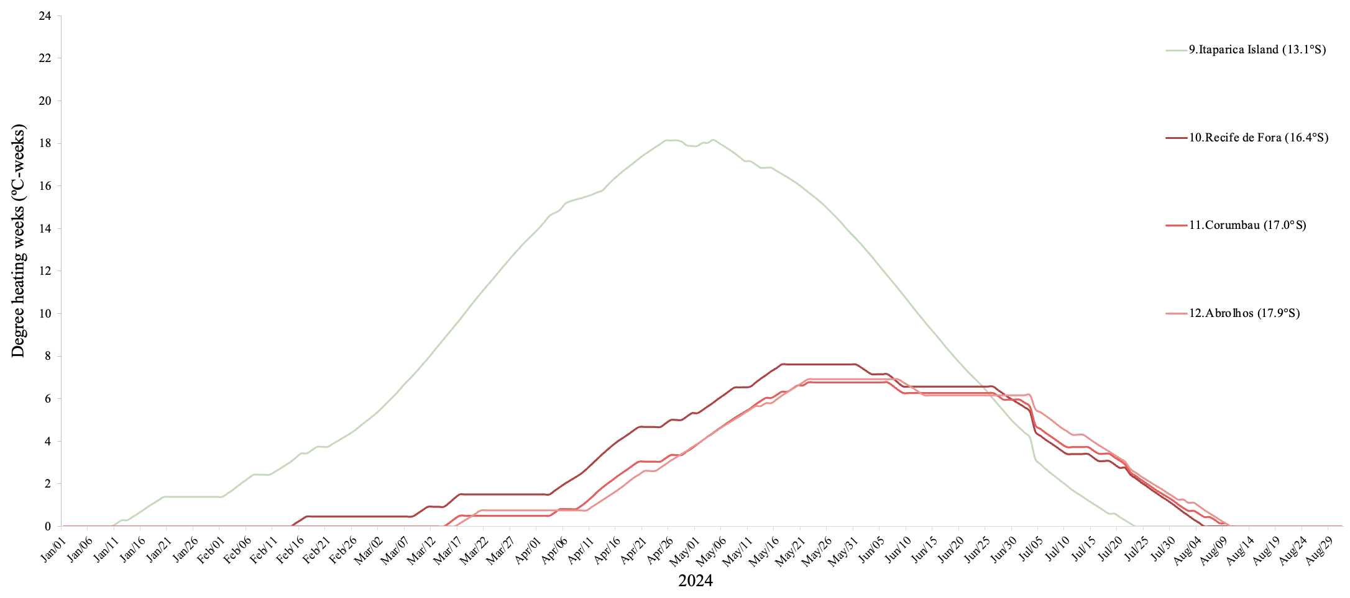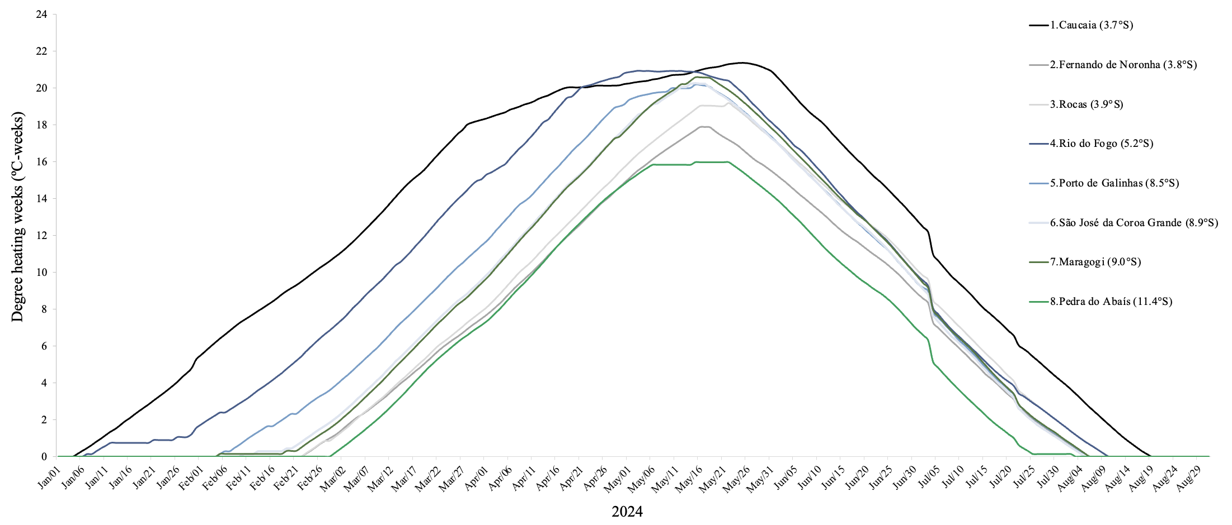
A
C
B
Fig. S6 The temporal progression of cumulative thermal stress (Degree Heating Weeks) in 18 Southwestern Atlantic reef sites during the fourth global bleaching event in 2024 in the northern (A), central (B) and southern (C) portions of the coast. Sites and corresponding latitudes are listed on the right panel.The sites are Caucaia, Fernando de Noronha Archipelago, Rocas Atoll, Rio do Fogo, Porto de Galinhas, São José da Coroa Grande (Costa dos Corais), Maragogi (Costa dos Corais), Pedra do Abaís, Itaparica Island (Todos os Santos Bay), Recife de Fora, Corumbau, Abrolhos Archipelago, Tartaruga Beach (Armação dos Búzios), Forno Beach (Arraial do Cabo), Anchieta Island, Alcatrazes Archipelago, Laje de Santos, Galé Island (Arvoredo).

Table S7 Detailed relative benthic cover for all photosymbiotic cnidarian species observed across all fixed transects for each of the 18 Southwestern Atlantic reef sites monitored before, during, and after the fourth global bleaching event in 2024. Data for other benthic functional groups are also included. Data are expressed as mean ± standard error. n/a = data not available.
Taxon or functional group | BENTHIC COVER
Taxon or functional group | Before thermal stress | During thermal stress | After thermal stress
CAUCAIA
Siderastrea sp. | 0.250 ± 0.045 | 0.249 ± 0.029 | 0.258 ± 0.038
Turf algae | 0.732 ± 0.041 | 0.609 ± 0.060 | 0.593 ± 0.037
Frondose algae | 0.000 ± 0.000 | 0.000 ± 0.000 | 0.000 ± 0.000
Crustose coralline algae | 0.001 ± 0.100 | 0.000 ± 0.000 | 0.000 ± 0.000
Other benthic invertebrates | 0.000 ± 0.000 | 0.002 ± 0.002 | 0.021 ± 0.013
Bare rock or sand | 0.000 ± 0.000 | 0.031 ± 0.029 | 0.069 ± 0.032
Unidentified | 0.016 ± 0.005 | 0.110 ± 0.054 | 0.049 ± 0.010
FERNANDO DE NORONHA ARCHIPELAGO
Favia gravida | 0.001 ± 0.000 | 0.001 ± 0.000 | 0.001 ± 0.000
Montastraea cavernosa | 0.034 ± 0.009 | 0.045 ± 0.008 | 0.038 ± 0.004
Mussismilia hispida | 0.014 ± 0.005 | 0.015 ± 0.008 | 0.016 ± 0.010
Siderastrea sp. | 0.176 ± 0.038 | 0.206 ± 0.013 | 0.184 ± 0.060
Turf algae | 0.724 ± 0.073 | 0.761 ± 0.012 | 0.686 ± 0.064
Frondose algae | 0.009 ± 0.009 | 0.000 ± 0.000 | 0.012 ± 0.008
Crustose coralline algae | 0.006 ± 0.002 | 0.006 ± 0.000 | 0.006 ± 0.003
Other benthic invertebrates | 0.021 ± 0.007 | 0.005 ± 0.003 | 0.022 ± 0.001
Bare rock or sand | 0.025 ± 0.011 | 0.006 ± 0.002 | 0.006 ± 0.003
Unidentified | 0.029 ± 0.020 | 0.026 ± 0.012 | 0.035 ± 0.019
ROCAS ATOLL
Mussismilia hispida | 0.006 ± 0.004 | 0.007 ± 0.004 | 0.004 ± 0.002
Porites astreoides | 0.015 ± 0.007 | 0.018 ± 0.009 | 0.017 ± 0.005
Siderastrea sp. | 0.125 ± 0.017 | 0.119 ± 0.007 | 0.142 ± 0.053
Zoanthus sp. | 0.004 ± 0.002 | 0.004 ± 0.004 | 0.000 ± 0.000
Turf algae | 0.782 ± 0.065 | 0.748 ± 0.052 | 0.675 ± 0.016
Frondose algae | 0.003 ± 0.000 | 0.001 ± 0.001 | 0.003 ± 0.002
Crustose coralline algae | 0.008 ± 0.004 | 0.002 ± 0.002 | 0.010 ± 0.002
Other benthic invertebrates | 0.001 ± 0.001 | 0.000 ± 0.000 | 0.000 ± 0.000
Bare rock or sand | 0.022 ± 0.020 | 0.089 ± 0.013 | 0.074 ± 0.030
Unidentified | 0.028 ± 0.017 | 0.042 ± 0.019 | 0.046 ± 0.008
RIO DO FOGO
Favia gravida | 0.006 ± 0.004 | 0.001 ± 0.001 | 0.003 ± 0.002
Palythoa caribaeorum | 0.073 ± 0.010 | 0.079 ± 0.002 | 0.032 ± 0.006
Porites astreoides | 0.003 ± 0.003 | 0.001 ± 0.000 | 0.000 ± 0.000
Siderastrea sp. | 0.042 ± 0.008 | 0.040 ± 0.002 | 0.023 ± 0.005
Zoanthus sp. | 0.009 ± 0.004 | 0.003 ± 0.003 | 0.012 ± 0.003
Turf algae | 0.783 ± 0.075 | 0.791 ± 0.033 | 0.756 ± 0.038
Frondose algae | 0.013 ± 0.004 | 0.004 ± 0.004 | 0.004 ± 0.004
Crustose coralline algae | 0.010 ± 0.005 | 0.004 ± 0.004 | 0.020 ± 0.016
Other benthic invertebrates | 0.003 ± 0.003 | 0.000 ± 0.000 | 0.000 ± 0.000
Bare rock or sand | 0.019 ± 0.012 | 0.020 ± 0.012 | 0.004 ± 0.004
Unidentified | 0.067 ± 0.005 | 0.042 ± 0.021 | 0.050 ± 0.018
PORTO DE GALINHAS
Millepora alcicornis | 0.044 ± 0.022 | 0.040 ± 0.015 | 0.000 ± 0.000
Montastraea cavernosa | 0.035 ± 0.017 | 0.034 ± 0.021 | 0.028 ± 0.011
Mussismilia harttii | 0.005 ± 0.005 | 0.006 ± 0.006 | 0.004 ± 0.002
Palythoa caribaeorum | 0.080 ± 0.027 | 0.088 ± 0.014 | 0.083 ± 0.001
Siderastrea sp. | 0.018 ± 0.003 | 0.038 ± 0.011 | 0.012 ± 0.009
Zoanthus sp. | 0.007 ± 0.004 | 0.000 ± 0.000 | 0.001 ± 0.001
Turf algae | 0.732 ± 0.042 | 0.741 ± 0.053 | 0.667 ± 0.031
Frondose algae | 0.002 ± 0.002 | 0.000 ± 0.000 | 0.000 ± 0.000
Crustose coralline algae | 0.015 ± 0.009 | 0.002 ± 0.002 | 0.037 ± 0.019
Other benthic invertebrates | 0.014 ± 0.008 | 0.001 ± 0.001 | 0.000 ± 0.000
Bare rock or sand | 0.026 ± 0.013 | 0.036 ± 0.022 | 0.058 ± 0.054
Unidentified | 0.034 ± 0.019 | 0.055 ± 0.011 | 0.059 ± 0.008
SÃO JOSÉ DA COROA GRANDE (COSTA DOS CORAIS)
Agaricia humilis | 0.011 ± 0.003 | 0.018 ± 0.006 | 0.008 ± 0.004
Millepora alcicornis | 0.124 ± 0.003 | 0.129 ± 0.029 | 0.000 ± 0.000
Millepora braziliensis | 0.002 ± 0.000 | 0.001 ± 0.000 | 0.001 ± 0.000
Montastraea cavernosa | 0.123 ± 0.036 | 0.142 ± 0.022 | 0.087 ± 0.017
Mussismilia harttii | 0.028 ± 0.012 | 0.019 ± 0.007 | 0.000 ± 0.000
Mussismilia hispida | 0.010 ± 0.004 | 0.012 ± 0.005 | 0.004 ± 0.004
Palythoa caribaeorum | 0.009 ± 0.008 | 0.000 ± 0.000 | 0.000 ± 0.000
Porites astreoides | 0.000 ± 0.000 | 0.001 ± 0.001 | 0.000 ± 0.000
Scolymia wellsii | 0.006 ± 0.002 | 0.006 ± 0.002 | 0.001 ± 0.001
Siderastrea sp. | 0.056 ± 0.020 | 0.068 ± 0.007 | 0.073 ± 0.022
Turf algae | 0.590 ± 0.060 | 0.525 ± 0.015 | 0.748 ± 0.028
Frondose algae | 0.000 ± 0.000 | 0.018 ± 0.017 | 0.001 ± 0.000
Crustose coralline algae | 0.006 ± 0.002 | 0.018 ± 0.002 | 0.013 ± 0.004
Other benthic invertebrates | 0.008 ± 0.005 | 0.009 ± 0.004 | 0.001 ± 0.001
Bare rock or sand | 0.006 ± 0.004 | 0.012 ± 0.001 | 0.022 ± 0.014
Unidentified | 0.020 ± 0.005 | 0.016 ± 0.006 | 0.019 ± 0.003
MARAGOGI (COSTA DOS CORAIS)
Agaricia fragilis | 0.001 ± 0.001 | 0.000 ± 0.000 | 0.000 ± 0.000
Agaricia humilis | 0.007 ± 0.003 | 0.014 ± 0.004 | 0.010 ± 0.003
Millepora alcicornis | 0.078 ± 0.006 | 0.084 ± 0.013 | 0.000 ± 0.000
Mussismilia harttii | 0.091 ± 0.013 | 0.074 ± 0.012 | 0.004 ± 0.002
Mussismilia hispida | 0.001 ± 0.001 | 0.002 ± 0.002 | 0.000 ± 0.000
Porites astreoides | 0.000 ± 0.000 | 0.004 ± 0.004 | 0.000 ± 0.000
Siderastrea sp. | 0.005 ± 0.002 | 0.006 ± 0.002 | 0.003 ± 0.003
Turf algae | 0.694 ± 0.052 | 0.688 ± 0.047 | 0.787 ± 0.040
Frondose algae | 0.000 ± 0.000 | 0.007 ± 0.002 | 0.006 ± 0.002
Crustose coralline algae | 0.013 ± 0.013 | 0.020 ± 0.011 | 0.016 ± 0.011
Other benthic invertebrates | 0.003 ± 0.002 | 0.010 ± 0.002 | 0.006 ± 0.002
Bare rock or sand | 0.057 ± 0.034 | 0.049 ± 0.037 | 0.065 ± 0.026
Unidentified | 0.073 ± 0.011 | 0.077 ± 0.006 | 0.079 ± 0.014
PEDRA DO ABAÍS
Montastraea cavernosa | n/a | 0.054 ± 0.032 | 0.064 ± 0.011
Mussismilia hispida | n/a | 0.001 ± 0.001 | 0.002 ± 0.001
Siderastrea sp. | n/a | 0.405 ± 0.092 | 0.368 ± 0.079
Turf algae | n/a | 0.459 ± 0.063 | 0.525 ± 0.096
Frondose algae | n/a | 0.000 ± 0.000 | 0.003 ± 0.001
Crustose coralline algae | n/a | 0.005 ± 0.002 | 0.010 ± 0.008
Other benthic invertebrates | n/a | 0.000 ± 0.000 | 0.019 ± 0.011
Bare rock or sand | n/a | 0.000 ± 0.000 | 0.017 ± 0.017
Unidentified | n/a | 0.041 ± 0.016 | 0.013 ± 0.007
ITAPARICA ISLAND (TODOS OS SANTOS BAY)
Millepora alcicornis | 0.015 ± 0.015 | 0.027 ± 0.013 | 0.008 ± 0.003
Montastraea cavernosa | 0.088 ± 0.020 | 0.081 ± 0.017 | 0.098 ± 0.008
Mussismilia braziliensis | 0.006 ± 0.006 | 0.007 ± 0.007 | 0.005 ± 0.005
Mussismilia harttii | 0.000 ± 0.000 | 0.000 ± 0.000 | 0.000 ± 0.000
Mussismilia hispida | 0.005 ± 0.003 | 0.004 ± 0.003 | 0.006 ± 0.004
Phyllogorgia dilatata | 0.011 ± 0.011 | 0.000 ± 0.000 | 0.000 ± 0.000
Porites astreoides | 0.001 ± 0.001 | 0.000 ± 0.000 | 0.001 ± 0.000
Siderastrea sp. | 0.016 ± 0.010 | 0.018 ± 0.006 | 0.008 ± 0.003
Turf algae | 0.676 ± 0.059 | 0.816 ± 0.010 | 0.745 ± 0.054
Frondose algae | 0.035 ± 0.006 | 0.000 ± 0.000 | 0.022 ± 0.013
Crustose coralline algae | 0.032 ± 0.015 | 0.000 ± 0.000 | 0.000 ± 0.000
Other benthic invertebrates | 0.022 ± 0.002 | 0.015 ± 0.004 | 0.029 ± 0.002
Bare rock or sand | 0.091 ± 0.057 | 0.006 ± 0.006 | 0.006 ± 0.005
Unidentified | 0.015 ± 0.006 | 0.017 ± 0.003 | 0.020 ± 0.002
RECIFE DE FORA
Agaricia fragilis | 0.000 ± 0.000 | 0.000 ± 0.000 | 0.002 ± 0.002
Agaricia humilis | 0.042 ± 0.012 | 0.024 ± 0.008 | 0.042 ± 0.012
Favia gravida | 0.006 ± 0.002 | 0.005 ± 0.003 | 0.006 ± 0.003
Meandrina brasiliensis | 0.001 ± 0.001 | 0.000 ± 0.000 | 0.000 ± 0.000
Millepora alcicornis | 0.027 ± 0.014 | 0.027 ± 0.019 | 0.022 ± 0.013
Millepora nitida | 0.010 ± 0.002 | 0.014 ± 0.006 | 0.012 ± 0.006
Montastraea cavernosa | 0.043 ± 0.043 | 0.033 ± 0.033 | 0.042 ± 0.042
Muriceopsis sulphurea | 0.029 ± 0.017 | 0.038 ± 0.025 | 0.017 ± 0.014
Mussismilia braziliensis | 0.026 ± 0.006 | 0.027 ± 0.019 | 0.023 ± 0.004
Mussismilia harttii | 0.080 ± 0.012 | 0.090 ± 0.021 | 0.085 ± 0.027
Mussismilia hispida | 0.035 ± 0.018 | 0.018 ± 0.010 | 0.006 ± 0.003
Palythoa caribaeorum | 0.010 ± 0.009 | 0.004 ± 0.001 | 0.007 ± 0.002
Plexaurella grandiflora | 0.010 ± 0.005 | 0.012 ± 0.011 | 0.005 ± 0.003
Porites astreoides | 0.020 ± 0.017 | 0.005 ± 0.003 | 0.010 ± 0.005
Porites branneri | 0.002 ± 0.000 | 0.004 ± 0.004 | 0.000 ± 0.000
Siderastrea sp. | 0.135 ± 0.063 | 0.144 ± 0.056 | 0.155 ± 0.047
Zoanthus sp. | 0.002 ± 0.002 | 0.000 ± 0.000 | 0.000 ± 0.000
Turf algae | 0.321 ± 0.050 | 0.471 ± 0.117 | 0.347 ± 0.061
Frondose algae | 0.112 ± 0.109 | 0.004 ± 0.002 | 0.048 ± 0.040
Crustose coralline algae | 0.015 ± 0.013 | 0.000 ± 0.000 | 0.010 ± 0.009
Other benthic invertebrates | 0.048 ± 0.044 | 0.006 ± 0.006 | 0.000 ± 0.000
Bare rock or sand | 0.003 ± 0.002 | 0.016 ± 0.008 | 0.043 ± 0.021
Unidentified | 0.045 ± 0.005 | 0.054 ± 0.019 | 0.056 ± 0.027
CORUMBAU
Agaricia humilis | 0.032 ± 0.025 | 0.046 ± 0.021 | 0.045 ± 0.019
Favia gravida | 0.009 ± 0.009 | 0.019 ± 0.007 | 0.005 ± 0.001
Meandrina brasiliensis | 0.002 ± 0.002 | 0.000 ± 0.000 | 0.000 ± 0.000
Millepora alcicornis | 0.018 ± 0.007 | 0.025 ± 0.013 | 0.025 ± 0.021
Millepora nitida | 0.001 ± 0.001 | 0.000 ± 0.000 | 0.000 ± 0.000
Montastraea cavernosa | 0.018 ± 0.006 | 0.024 ± 0.024 | 0.006 ± 0.005
Muriceopsis sulphurea | 0.011 ± 0.010 | 0.027 ± 0.011 | 0.025 ± 0.021
Mussismilia braziliensis | 0.017 ± 0.015 | 0.029 ± 0.017 | 0.016 ± 0.011
Mussismilia harttii | 0.110 ± 0.017 | 0.135 ± 0.047 | 0.132 ± 0.049
Mussismilia hispida | 0.050 ± 0.011 | 0.011 ± 0.005 | 0.041 ± 0.015
Palythoa caribaeorum | 0.000 ± 0.000 | 0.000 ± 0.000 | 0.003 ± 0.001
Plexaurella grandiflora | 0.018 ± 0.004 | 0.001 ± 0.001 | 0.001 ± 0.001
Porites astreoides | 0.000 ± 0.000 | 0.011 ± 0.006 | 0.000 ± 0.000
Siderastrea sp. | 0.038 ± 0.010 | 0.018 ± 0.008 | 0.048 ± 0.019
Zoanthus sp. | 0.002 ± 0.002 | 0.000 ± 0.000 | 0.002 ± 0.002
Turf algae | 0.540 ± 0.088 | 0.531 ± 0.019 | 0.627 ± 0.053
Frondose algae | 0.000 ± 0.000 | 0.011 ± 0.011 | 0.004 ± 0.002
Crustose coralline algae | 0.011 ± 0.011 | 0.010 ± 0.009 | 0.003 ± 0.002
Other benthic invertebrates | 0.040 ± 0.012 | 0.001 ± 0.001 | 0.000 ± 0.000
Bare rock or sand | 0.064 ± 0.046 | 0.012 ± 0.006 | 0.008 ± 0.002
Unidentified | 0.000 ± 0.000 | 0.000 ± 0.000 | 0.000 ± 0.000
ABROLHOSARCHIPELAGO
Agaricia humilis | 0.004 ± 0.003 | 0.001 ± 0.001 | 0.012 ± 0.003
Favia gravida | 0.001 ± 0.001 | 0.000 ± 0.000 | 0.006 ± 0.004
Meandrina brasiliensis | 0.005 ± 0.003 | 0.004 ± 0.004 | 0.000 ± 0.000
Millepora alcicornis | 0.000 ± 0.000 | 0.000 ± 0.000 | 0.009 ± 0.009
Millepora nitida | 0.000 ± 0.000 | 0.000 ± 0.000 | 0.002 ± 0.002
Montastraea cavernosa | 0.000 ± 0.000 | 0.000 ± 0.000 | 0.004 ± 0.001
Muriceopsis sulphurea | 0.000 ± 0.000 | 0.000 ± 0.000 | 0.007 ± 0.007
Mussismilia braziliensis | 0.080 ± 0.022 | 0.095 ± 0.026 | 0.067 ± 0.038
Mussismilia harttii | 0.000 ± 0.000 | 0.029 ± 0.029 | 0.000 ± 0.000
Mussismilia hispida | 0.005 ± 0.005 | 0.002 ± 0.001 | 0.021 ± 0.017
Mussismilia leptophylla | 0.002 ± 0.002 | 0.000 ± 0.000 | 0.000 ± 0.000
Palythoa caribaeorum | 0.067 ± 0.036 | 0.127 ± 0.030 | 0.052 ± 0.036
Phyllogorgia dilatata | 0.000 ± 0.000 | 0.000 ± 0.000 | 0.001 ± 0.001
Porites astreoides | 0.007 ± 0.007 | 0.004 ± 0.004 | 0.009 ± 0.009
Porites branneri | 0.000 ± 0.000 | 0.000 ± 0.000 | 0.003 ± 0.003
Siderastrea sp. | 0.197 ± 0.028 | 0.131 ± 0.033 | 0.213 ± 0.105
Zoanthus sp. | 0.000 ± 0.000 | 0.021 ± 0.021 | 0.001 ± 0.000
Turf algae | 0.528 ± 0.139 | 0.355 ± 0.053 | 0.351 ± 0.130
Frondose algae | 0.045 ± 0.010 | 0.011 ± 0.011 | 0.014 ± 0.013
Crustose coralline algae | 0.024 ± 0.016 | 0.087 ± 0.023 | 0.086 ± 0.018
Other benthic invertebrates | 0.009 ± 0.009 | 0.001 ± 0.000 | 0.000 ± 0.000
Bare rock or sand | 0.005 ± 0.004 | 0.002 ± 0.002 | 0.000 ± 0.000
Unidentified | 0.000 ± 0.000 | 0.000 ± 0.000 | 0.053 ± 0.028
TARTARUGA BEACH (ARMAÇÃO DOS BÚZIOS)
Millepora alcicornis | 0.098 ± 0.051 | 0.077 ± 0.021 | 0.093 ± 0.048
Mussismilia hispida | 0.012 ± 0.008 | 0.022 ± 0.017 | 0.005 ± 0.005
Palythoa caribaeorum | 0.037 ± 0.008 | 0.080 ± 0.010 | 0.075 ± 0.018
Phyllogorgia dilatata | 0.026 ± 0.014 | 0.027 ± 0.011 | 0.017 ± 0.017
Siderastrea sp. | 0.020 ± 0.004 | 0.030 ± 0.014 | 0.050 ± 0.026
Zoanthus sp. | 0.000 ± 0.000 | 0.000 ± 0.000 | 0.002 ± 0.002
Turf algae | 0.415 ± 0.160 | 0.365 ± 0.081 | 0.363 ± 0.120
Frondose algae | 0.000 ± 0.000 | 0.000 ± 0.000 | 0.000 ± 0.000
Crustose coralline algae | 0.002 ± 0.001 | 0.000 ± 0.000 | 0.003 ± 0.002
Other benthic invertebrates | 0.015 ± 0.010 | 0.015 ± 0.011 | 0.008 ± 0.007
Bare rock or sand | 0.338 ± 0.116 | 0.445 ± 0.052 | 0.343 ± 0.090
Unidentified | 0.020 ± 0.009 | 0.010 ± 0.003 | 0.004 ± 0.003
FORNO BEACH (ARRAIAL DO CABO)
Madracis decactis | 0.000 ± 0.000 | 0.004 ± 0.003 | 0.000 ± 0.000
Millepora alcicornis | 0.033 ± 0.016 | 0.052 ± 0.027 | 0.045 ± 0.023
Mussismilia hispida | 0.006 ± 0.003 | 0.004 ± 0.002 | 0.007 ± 0.004
Palythoa caribaeorum | 0.104 ± 0.012 | 0.165 ± 0.042 | 0.078 ± 0.026
Phyllogorgia dilatata | 0.036 ± 0.021 | 0.045 ± 0.023 | 0.015 ± 0.003
Siderastrea sp. | 0.073 ± 0.027 | 0.016 ± 0.005 | 0.070 ± 0.024
Turf algae | 0.253 ± 0.033 | 0.132 ± 0.062 | 0.456 ± 0.021
Frondose algae | 0.046 ± 0.026 | 0.057 ± 0.029 | 0.000 ± 0.000
Crustose coralline algae | 0.014 ± 0.009 | 0.000 ± 0.000 | 0.025 ± 0.022
Other benthic invertebrates | 0.053 ± 0.030 | 0.041 ± 0.014 | 0.020 ± 0.015
Bare rock or sand | 0.401 ± 0.060 | 0.489 ± 0.045 | 0.273 ± 0.077
Unidentified | 0.015 ± 0.007 | 0.019 ± 0.008 | 0.047 ± 0.038
ANCHIETA ISLAND
Mussismilia hispida | 0.162 ± 0.071 | 0.185 ± 0.065 | 0.143 ± 0.033
Palythoa caribaeorum | 0.186 ± 0.040 | 0.215 ± 0.072 | 0.200 ± 0.111
Zoanthus sp. | 0.003 ± 0.001 | 0.000 ± 0.000 | 0.000 ± 0.000
Turf algae | 0.446 ± 0.033 | 0.341 ± 0.096 | 0.425 ± 0.036
Frondose algae | 0.000 ± 0.000 | 0.000 ± 0.000 | 0.000 ± 0.000
Crustose coralline algae | 0.000 ± 0.000 | 0.000 ± 0.000 | 0.000 ± 0.000
Other benthic invertebrates | 0.002 ± 0.001 | 0.005 ± 0.003 | 0.003 ± 0.003
Bare rock or sand | 0.123 ± 0.067 | 0.116 ± 0.032 | 0.105 ± 0.014
Unidentified | 0.022 ± 0.018 | 0.000 ± 0.000 | 0.000 ± 0.000
ALCATRAZES ARCHIPELAGO
Madracis decactis | 0.006 ± 0.001 | 0.003 ± 0.001 | 0.004 ± 0.002
Mussismilia hispida | 0.114 ± 0.017 | 0.117 ± 0.021 | 0.108 ± 0.017
Palythoa caribaeorum | 0.000 ± 0.000 | 0.008 ± 0.002 | 0.006 ± 0.002
Turf algae | 0.785 ± 0.039 | 0.708 ± 0.037 | 0.725 ± 0.080
Frondose algae | 0.000 ± 0.000 | 0.000 ± 0.000 | 0.000 ± 0.000
Crustose coralline algae | 0.000 ± 0.000 | 0.000 ± 0.000 | 0.000 ± 0.000
Other benthic invertebrates | 0.000 ± 0.000 | 0.000 ± 0.000 | 0.000 ± 0.000
Bare rock or sand | 0.053 ± 0.015 | 0.100 ± 0.047 | 0.134 ± 0.051
Unidentified | 0.021 ± 0.015 | 0.002 ± 0.002 | 0.001 ± 0.001
LAJE DE SANTOS
Madracis decactis | 0.035 ± 0.023 | 0.039 ± 0.029 | 0.042 ± 0.020
Mussismilia hispida | 0.219 ± 0.088 | 0.230 ± 0.048 | 0.238 ± 0.083
Palythoa caribaeorum | 0.103 ± 0.008 | 0.109 ± 0.079 | 0.076 ± 0.037
Zoanthus sp. | 0.000 ± 0.000 | 0.003 ± 0.002 | 0.003 ± 0.002
Turf algae | 0.310 ± 0.082 | 0.522 ± 0.041 | 0.511 ± 0.023
Frondose algae | 0.000 ± 0.000 | 0.000 ± 0.000 | 0.000 ± 0.000
Crustose coralline algae | 0.005 ± 0.005 | 0.017 ± 0.012 | 0.018 ± 0.011
Other benthic invertebrates | 0.038 ± 0.034 | 0.026 ± 0.015 | 0.008 ± 0.005
Bare rock or sand | 0.281 ± 0.078 | 0.021 ± 0.011 | 0.041 ± 0.039
Unidentified | 0.041 ± 0.033 | 0.046 ± 0.010 | 0.082 ± 0.041
GALÉ ISLAND (ARVOREDO)
Madracis decactis | 0.364 ± 0.045 | 0.322 ± 0.072 | 0.367 ± 0.044
Turf algae | 0.480 ± 0.034 | 0.539 ± 0.020 | 0.582 ± 0.005
Frondose algae | 0.000 ± 0.000 | 0.000 ± 0.000 | 0.000 ± 0.000
Crustose coralline algae | 0.000 ± 0.000 | 0.000 ± 0.000 | 0.000 ± 0.000
Other benthic invertebrates | 0.022 ± 0.010 | 0.013 ± 0.008 | 0.012 ± 0.010
Bare rock or sand | 0.090 ± 0.047 | 0.093 ± 0.057 | 0.019 ± 0.017
Unidentified | 0.000 ± 0.000 | 0.000 ± 0.000 | 0.000 ± 0.000

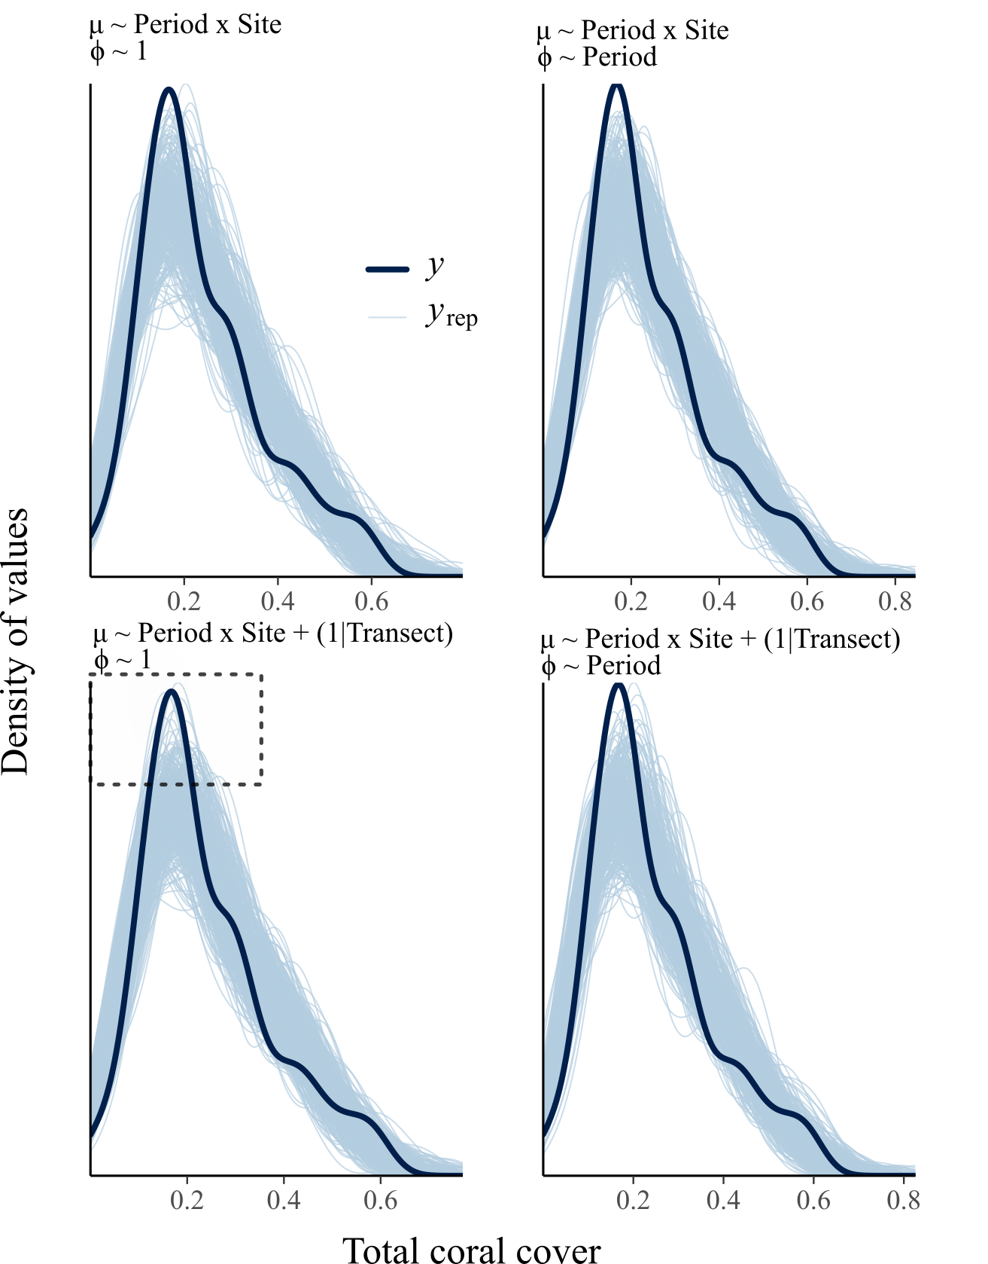
Fig. S8 Posterior-predictive check of the four models used to model total coral cover in function of covariates. $y$ represents the observed data, and $y_{rep}$ represents the same quantity for 400 new data sets generated from the model structure and using the Leaving-One-Out cross-validation procedure. The dashed rectangle in the bottom-left plot shows the region in which this model had better predictive performance than the others. This one is the best-ranked model used to make inference on total coral cover change between periods and sites (main text).

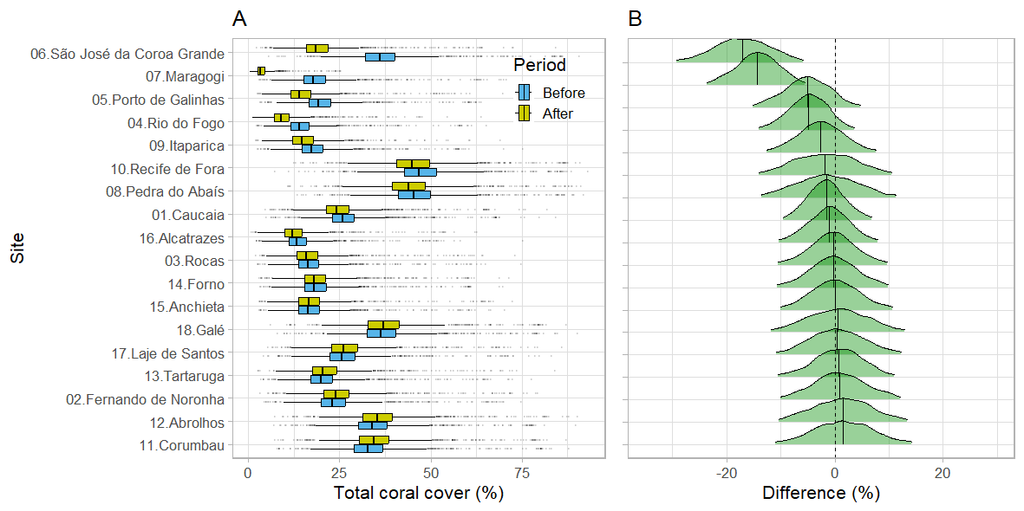
Fig. S9 Distribution of the estimated total coral cover per site and period (A), and distribution of the site-level difference in total coral cover before and after the 2023-24 bleaching event (B). Boxplots in A depict the median and 1st and 3rd quantiles of the distribution of the 2,000 posterior distribution draws. Densities in B depict the density of estimated differences considering all 2,000 posterior distribution draws. The dashed vertical line highlights the zone of zero difference in coral cover. Estimates were obtained through a Beta regression model estimated in a Bayesian framework.

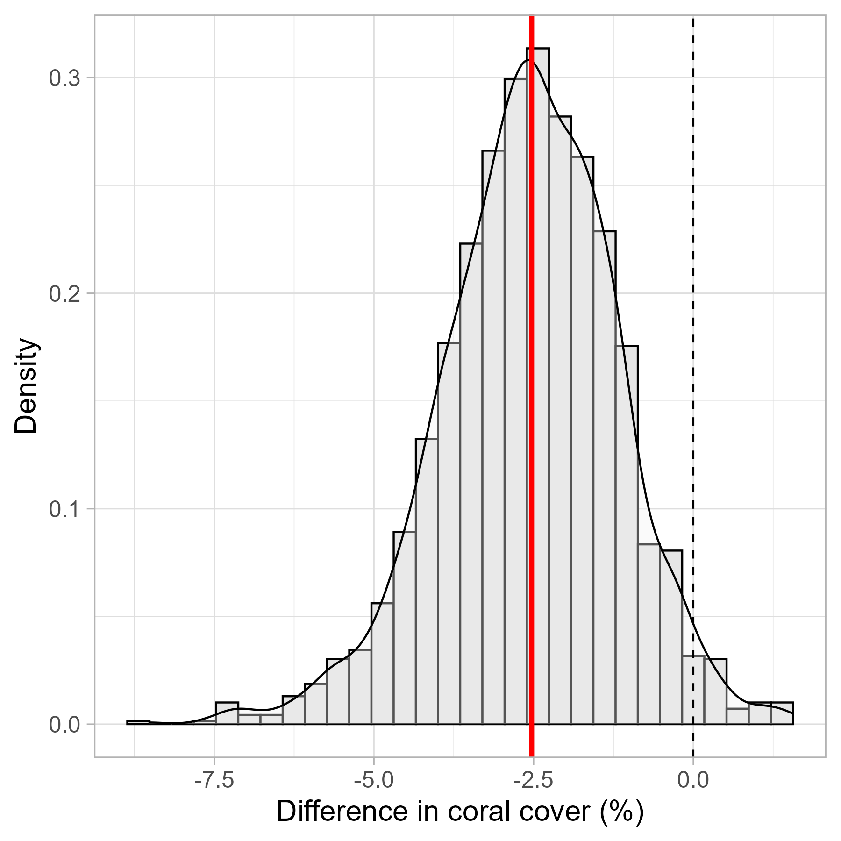
Fig. S10 Distribution of the estimated difference in total coral cover before and after the 2023-24 bleaching event. The dashed vertical line highlights the zone of zero difference in cover, and the red vertical line depicts the estimated median difference between periods, as obtained across the 2,000 posterior distribution draws from a Beta regression estimated in a Bayesian framework. The bars and the density line show the density of posterior distribution estimates considering the 2,000 posterior distribution draws.

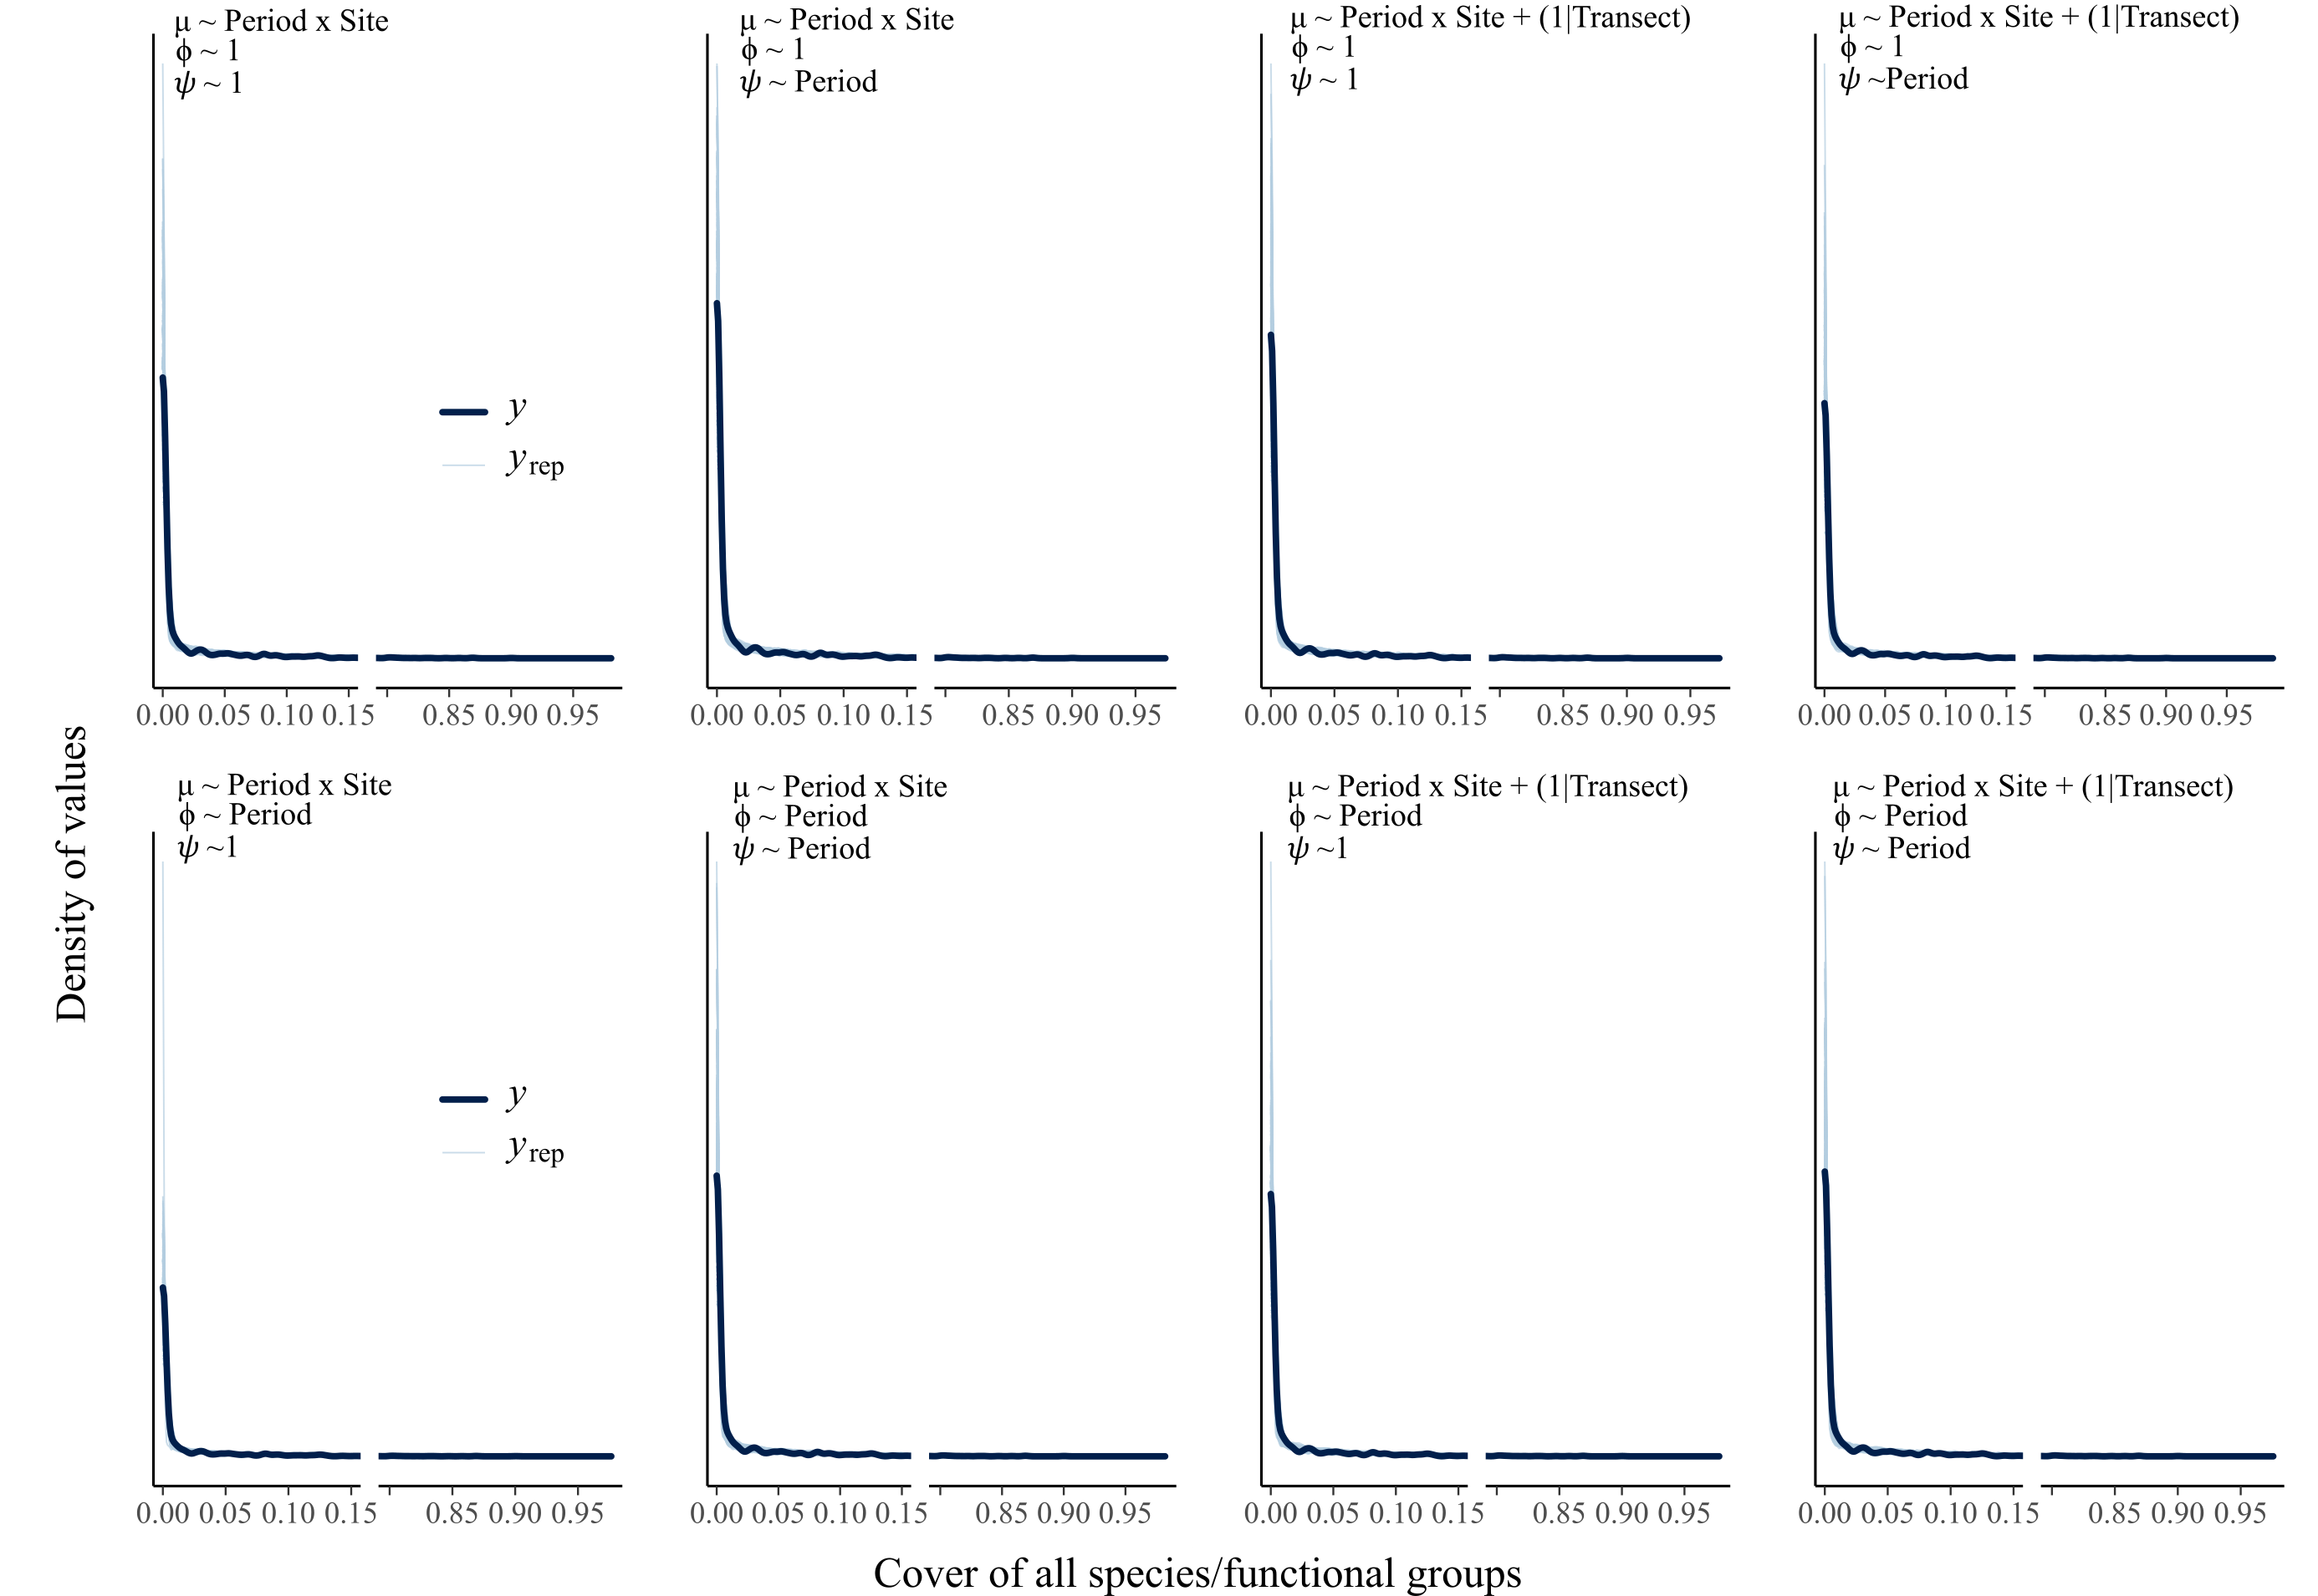
Fig. S11 Posterior-predictive check of the four models used to model total coral cover in function of covariates. $y$ represents the observed data, and $y_{rep}$ represents the same quantity for 400 new data sets generated from the model structure and using the Leaving-One-Out cross-validation procedure. The top-left model was used to make inference on species cover change (main text).

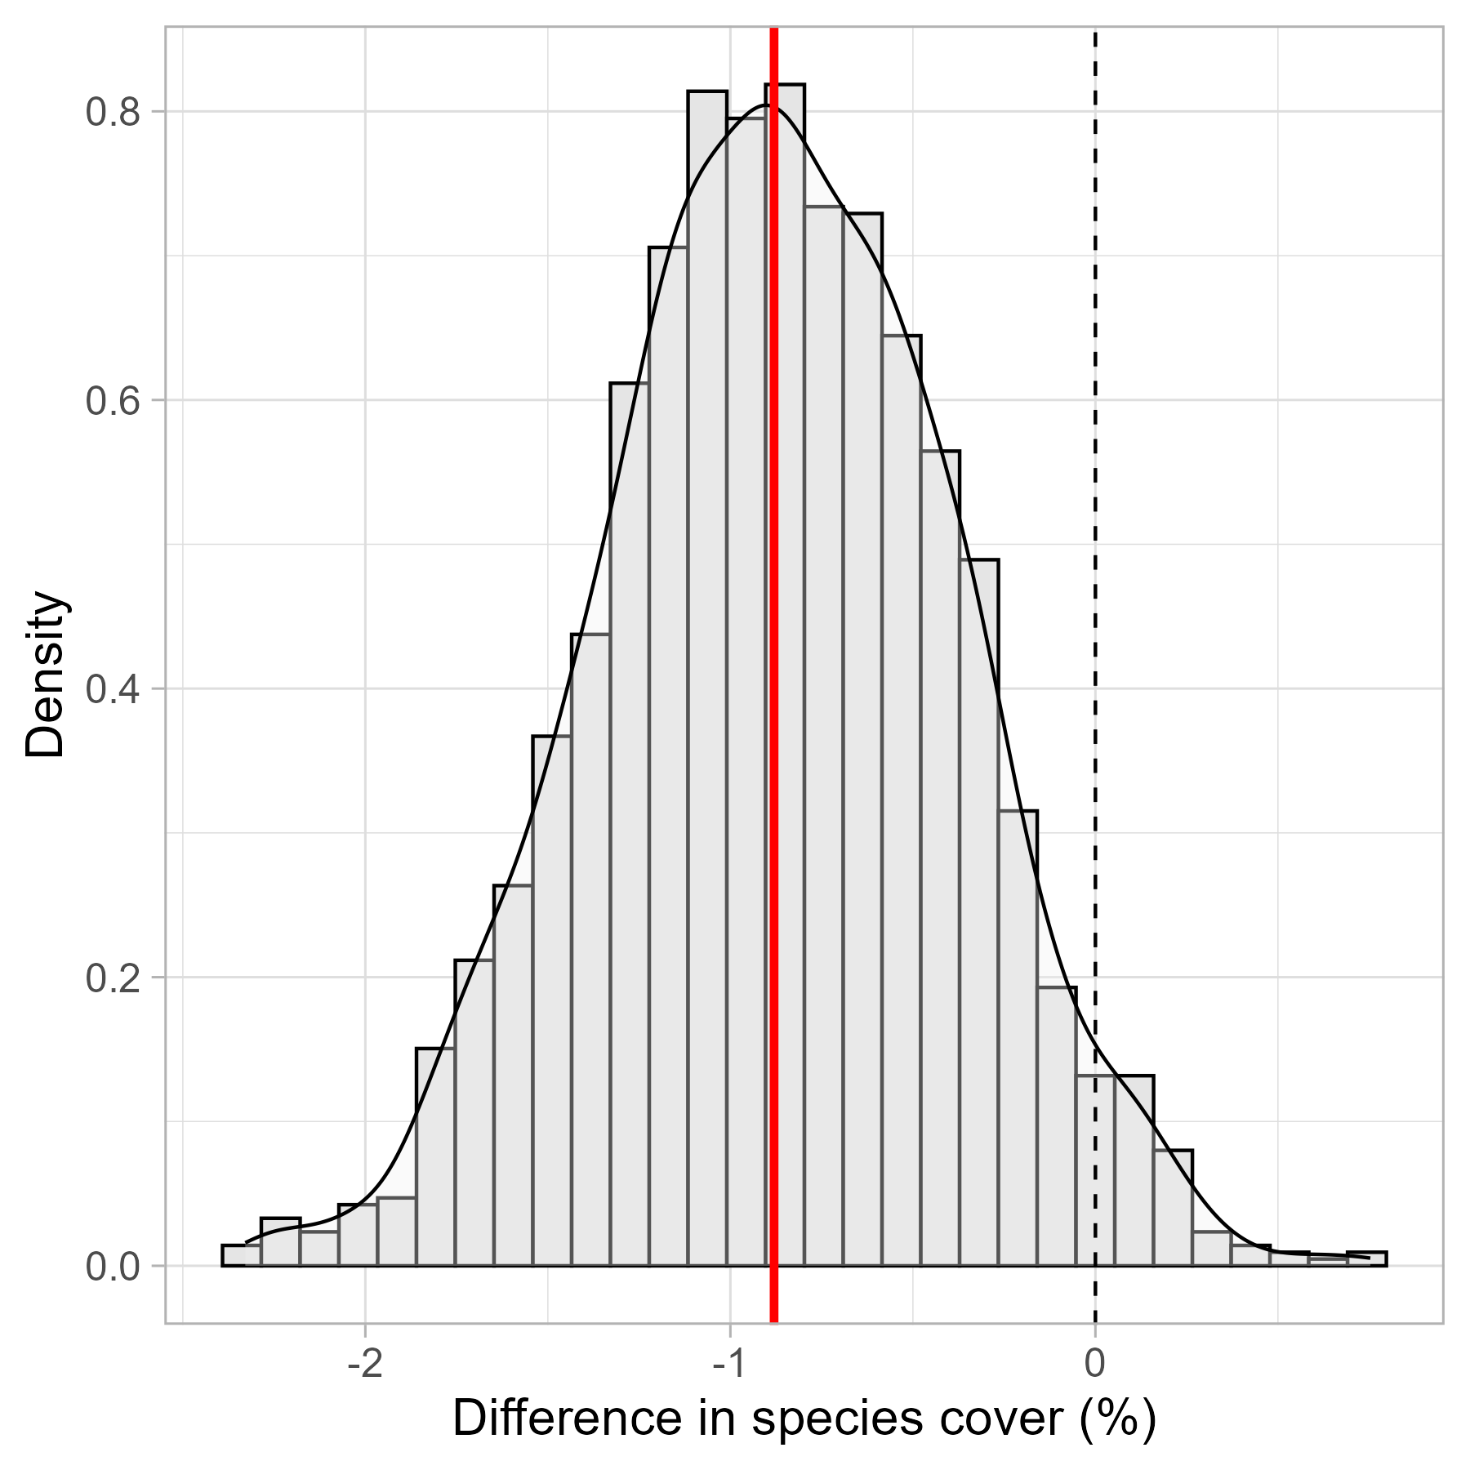
Fig. S12 Distribution of the estimated difference in species cover before and after the 2023-24 bleaching event. The dashed vertical line highlights the zone of zero difference in cover, and the red vertical line depicts the estimated median difference between periods, as obtained across the 2,000 posterior distribution draws from a Beta regression estimated in a Bayesian framework. The bars and the density line show the density of posterior distribution estimates considering the 2,000 posterior distribution draws.

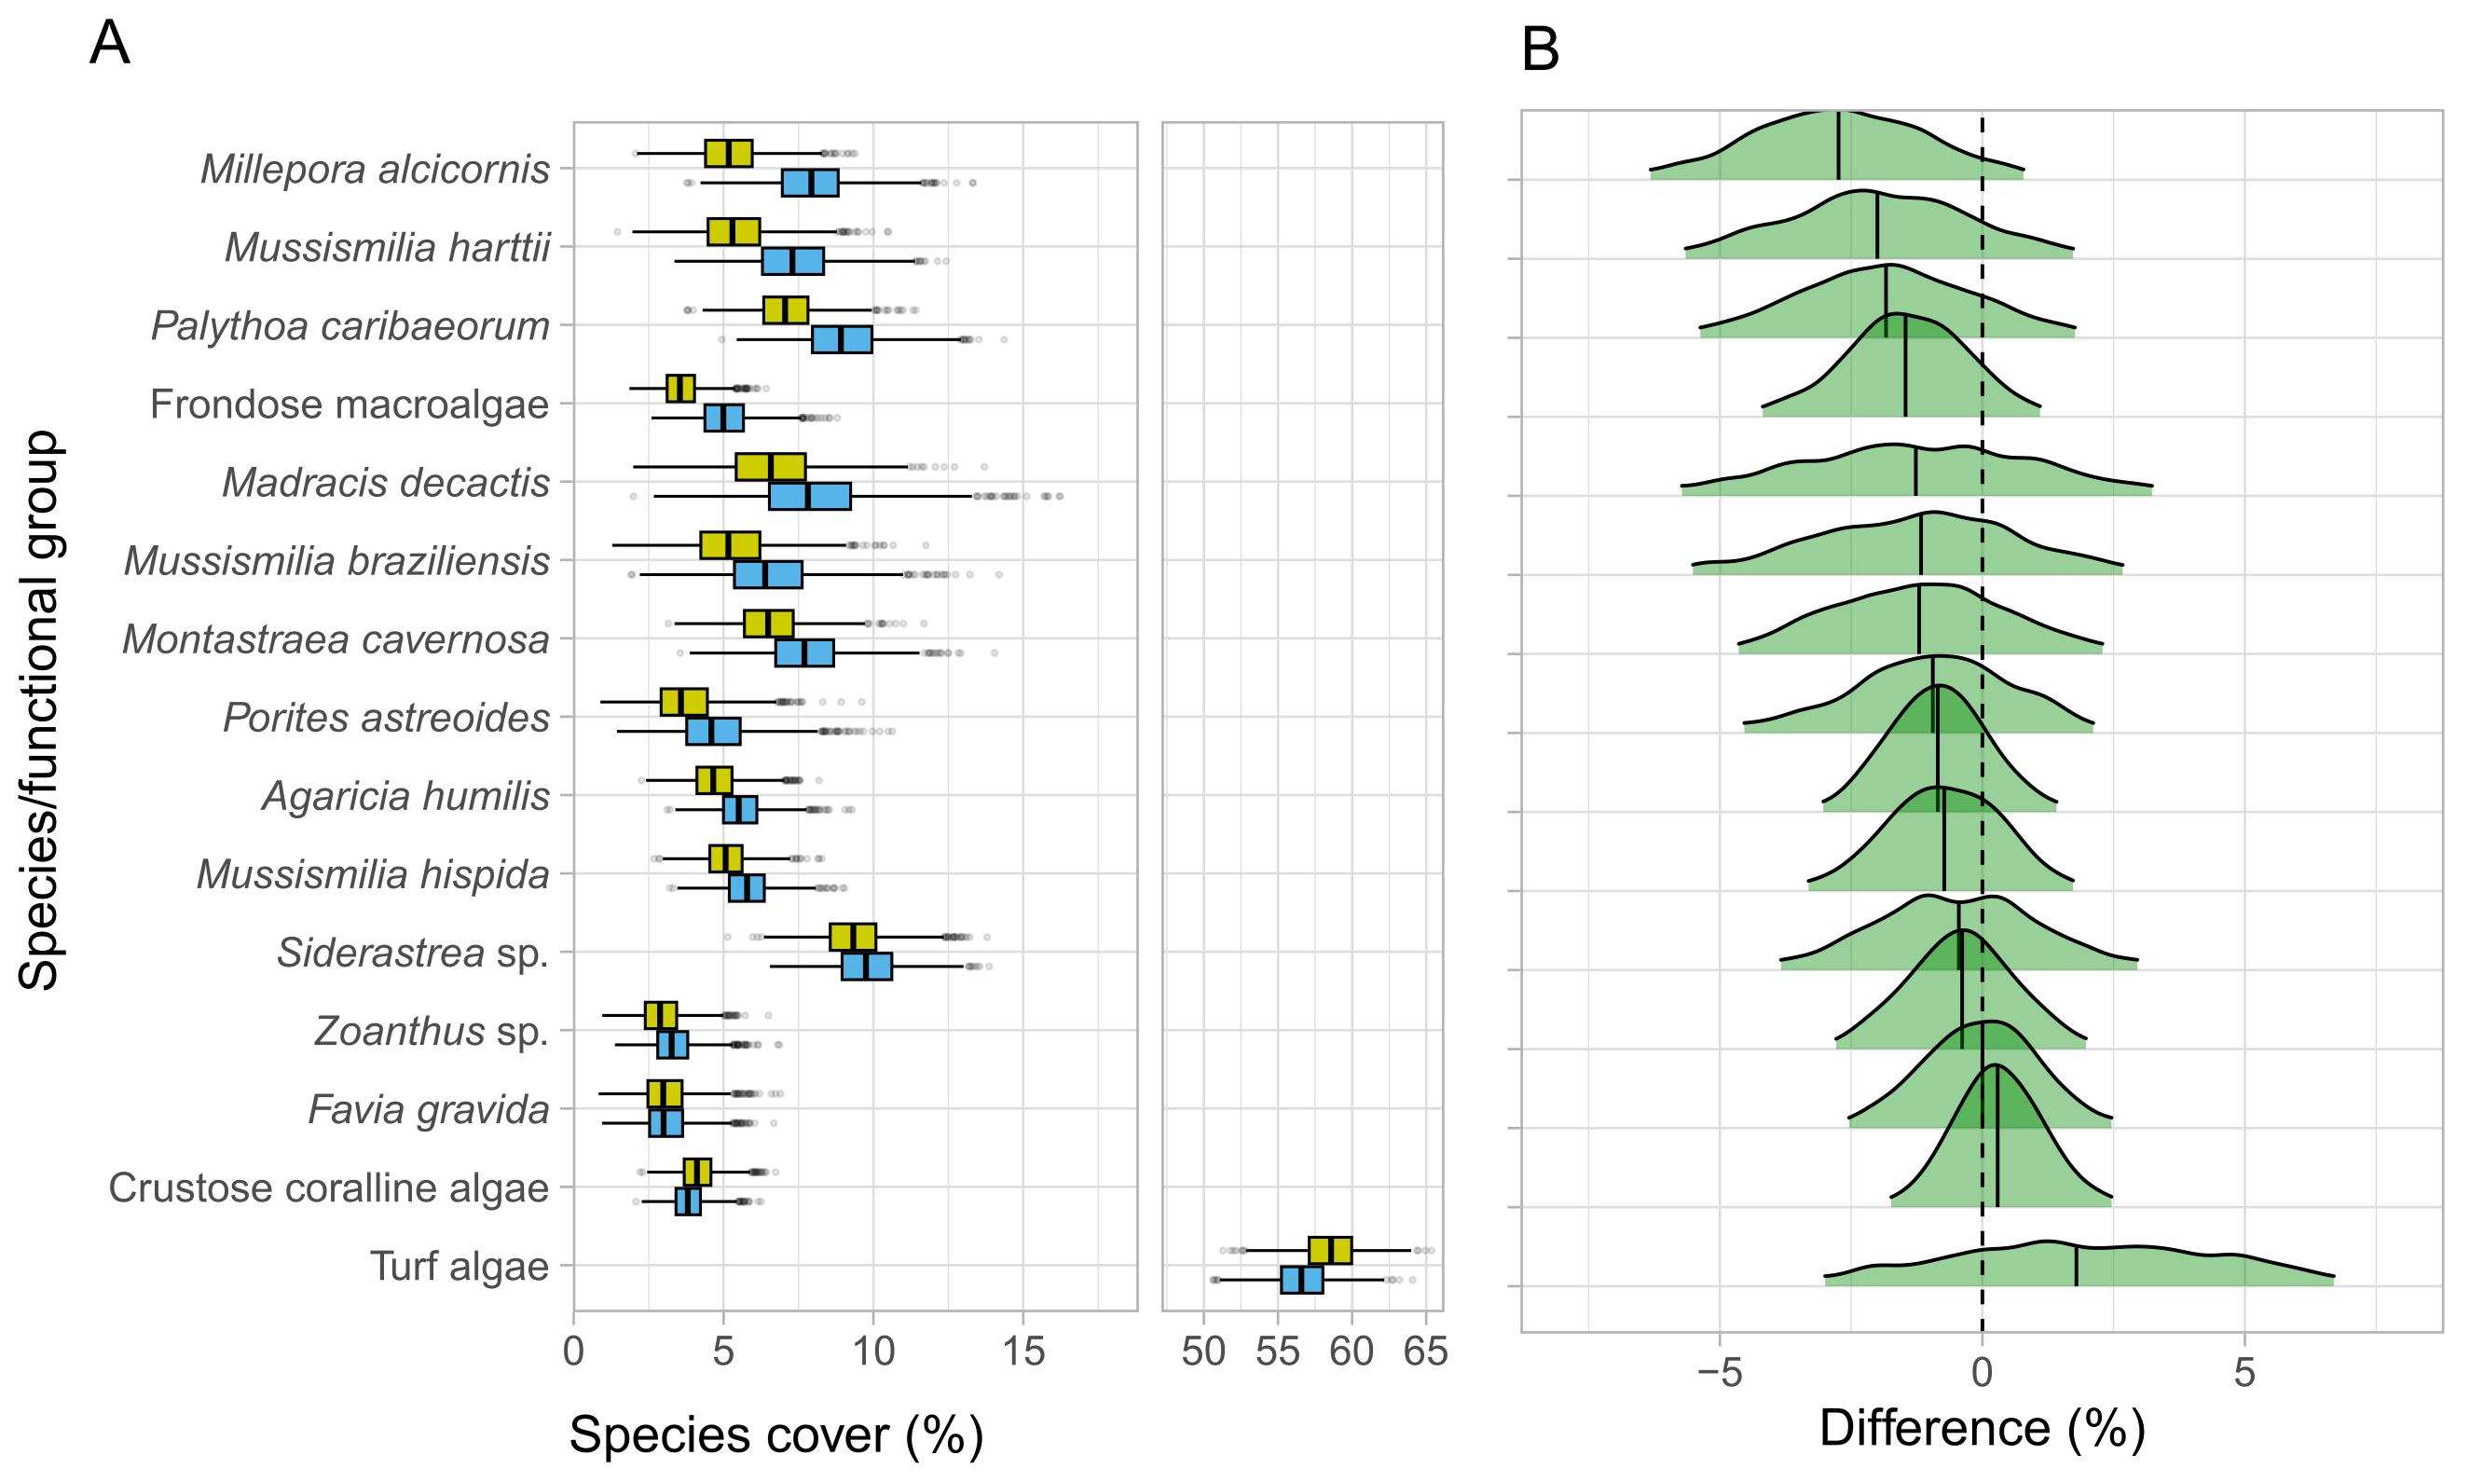
Fig. S13 Distribution of the estimated cover per species and period (A), and distribution of the species-level difference in cover before and after the 2023-24 bleaching event (B). Boxplots in A depict the median and 1st and 3rd quantiles of the distribution of the 2,000 posterior distribution draws. Densities in B depict the density of estimated differences considering all 2,000 posterior distribution draws. The dashed vertical line highlights the zone of zero difference in species cover. Estimates were obtained through a Zero-Inflated Beta regression model estimated in a Bayesian framework.

