CCIP Project Report
  - Integrative fine-scale habitat suitability and metapopulation modelling for targeted Crown-of-Thorns Starfish management (CCIP-BR-13)
  - [note : Please do not change the formatting of this document]

Report No. 1
Issued on: 28/01/2026

Table of Contents
Contents
1 Report Details 3
2 Project Delivery Partner Details 3
3 Summary Report 4
3.1 Project Deliverable Tracking 4
3.2 Key Highlights 4
4 Project Findings 4
4.1 Progress towards Objectives and Outcomes 5
4.2 Challenges, lessons learnt and unintended outcomes for the project 5
4.3 Traditional Owner engagement and participation 5
4.4 Communications and Engagement with Managers, Industry and Community 5
5 Future Actions 5
5.1 Summarise the key actions to be taken in the next phase of project 5
6 Supporting Material 6
7 Monitoring and Evaluation 6
7.1 Outputs 7
7.2 Metrics achieved within the reporting period 7
8 Risk & Budget Management 8
8.1 Actions taken during the reporting period to manage identified risks 8
8.2 Outline any substantial changes that have occurred from the original project risk assessment 8
8.3 Workplace health and safety 8
8.4 Workplace health and safety performance related to the immediate project 9
8.5 Budget Update 9
9 Declaration 9

Report Details
Project name & ID | CCIP-BR-13 Fine Scale Modelling – Integrative fine-scale habitat suitability and metapopulation modelling for targeted Crown-of-Thorns Starfish management
Contract identifier | Office use only
Report type | Progress report
Project start date | 15/10/2025
Project period | From 15/10/2025 To 31/01/2026
Date of submission | 13/02/2026
This report should focus on activities and outcomes from the funds specific to the contracted project. If there are linked activities funded through other leveraged investment that are relevant to the project, please ensure they are clearly identified.
The information provided in this report will be used to report against completion of agreed activities and milestones in your CCIP Project Work Plan and related contract, as well as collated and used to demonstrate outcomes across CCIP and the GBRF portfolio.

Project Delivery Partner Details
Organisation name | Australian Institute of Marine Science (AIMS) (Lead); Queensland University of Technology (QUT); James Cook University (JCU); Great Barrier Reef Marine Park Authority (GBRMPA)
Project lead | Name | Samuel Matthews
Project lead | Position | Project Lead; Senior Ecologist/ Conservation Scientist (AIMS)
Project lead | Email | s.matthews@aims.gov.au
Project lead | Phone | 0437967714
Project team members | Samuel Matthews (AIMS)  Dr Takuya Iwanaga (AIMS)  Prof Mike Bode (QUT)  Owen Stewart (QUT)  Dr Severine Choukroun (JCU)  Bridget Beesley (AIMS)  Isobel Ryan (GBRMPA)

Summary Report

Project Deliverable Tracking
List all the milestones and deliverables in your CCIP Project Work plan (Section 6.1) and report on status of those due in this reporting period. If a milestone or deliverable due in this reporting period is not fully complete, please explain why and indicate the action(s) taken to address this. If a milestone or deliverable due this reporting period has issues or has been delayed and this will impact future deliverables, please comment on likely impacts, including timing, for the future milestones.
Status key: GREEN: on track or completed on time, AMBER: minor delays or issues but under control, RED: major delays or blockers requiring immediate attention, BLUE: not started, no delays yet.
 |  |  | Overall Project Status |  | GREEN
ID | Deliverable | Due date | Status | Comments | Action to be taken & evidence where applicable
1 | TO comms & engagement plan | 15/11/25 | GREEN | Traditional Owner engagement initiated through the November workshop; engagement plan drafted and being implemented. | Confirm March on-country engagement schedule; prepare TO information package and map products for discussion.
2 | Prototype SDM workflow | 15/12/25 | GREEN | Computational workflow established; initial SDM layers produced and reviewed informally with GBRMPA colleagues. | Continue model refinement and validation; document workflow and assumptions; prepare interim maps for end-user testing.
3 | Interim connectivity networks | 15/01/26 | AMBER | Connectivity model grid established; simulations underway and being aggregated to a bespoke grid for the northern initiation box. | Finalize connectivity matrices and QA/QC checks; deliver interim connectivity summaries to support prototype metapopulation modelling. Develop “larval sinks” spatial layer as additional product
4 | GBRMPA workshop | 30/01/26 | GREEN | Informal presentations and feedback sessions completed; formal workshop scheduled for April to confirm use-cases and integration needs | Hold workshop and record agreed use-cases, integration requirements (Dashboards/Field Maps), and validation approach.
5 | Progress report | 06/02/26 | GREEN | Draft prepared in line with template and work plan; covers activities to 31 Jan 2026. | Submit final progress report with any supporting attachments (maps/workflow figures) as required.
6 | Prototype metacommunity model | 28/02/26 | AMBER | Prototype modelling approaches (hybrid GNN) developed; focus will accelerate once connectivity matrices are finalized. | Complete first end-to-end prototype for northern initiation box test grid; begin calibration plan and sensitivity analysis set-up.

Key Highlights
Provide two key highlights from within the reporting period. These highlights can be brief summaries about the deliverables achieved or underway.
Highlight #1 | A prototype fine-scale habitat suitability modelling workflow has been developed, producing initial suitability layers and informally reviewed with GBRMPA colleagues to confirm operational utility.  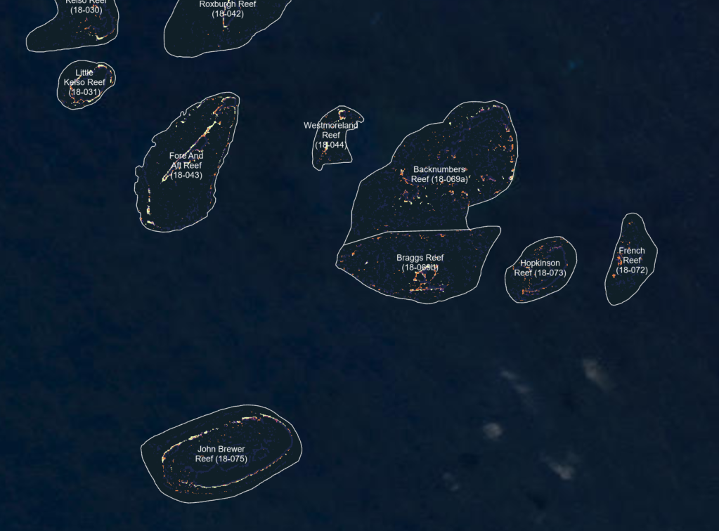
Highlight #2 | A prototype approach to generate standardized manta tow surveillance paths for each reef has been developed using the SDM layer, providing a pathway to compare targeted vs full perimeter-based surveillance.  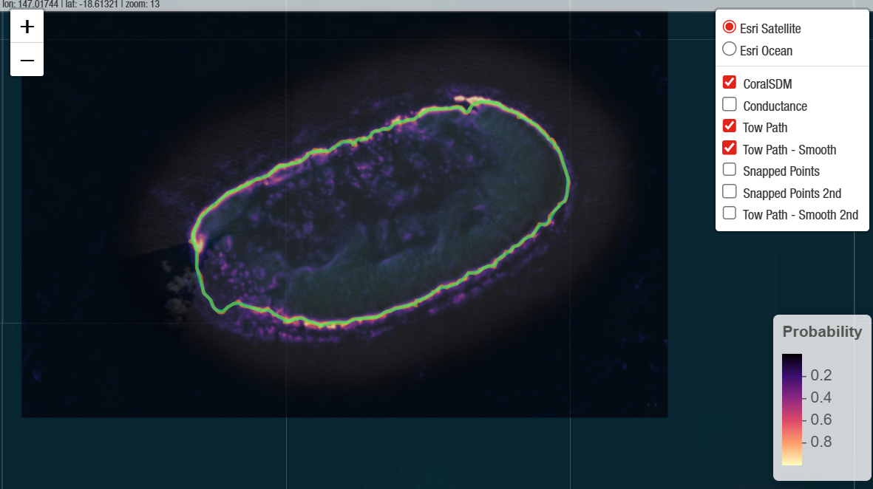

Project Findings

Progress towards Objectives and Outcomes
List the Objectives and Outcomes identified in your CCIP Project Work Plan (Sections 2.1 & 3.2) and provide a summary of progress towards achieving them in this reporting period.
Objectives | Objective 1: Develop predictive fine-scale habitat suitability models linking SALAD / ReefScan Deep / operational COTS observations to high-resolution benthic and coral habitat data.  - A repeatable SDM workflow has been established (data ingestion, predictor preparation, model fitting, validation and map generation) and is producing initial suitability layers.  - Initial SDM outputs have been generated and informally presented to GBRMPA colleagues to test practical utility for operations and program planning; feedback is being incorporated into subsequent model iterations (e.g., output formats, uncertainty communication and operational thresholds).  - Work is underway to extend SDM coverage to Torres Strait and the Far Northern GBR to support future program expansion and consistent decision support across regions.  Objective 2: Optimise and standardise manta tow surveillance paths to improve outbreak detection efficiency and consistency.  - A prototype workflow has been developed to generate/optimise tow paths for each reef using the SDM-derived suitability surface, providing a transparent basis for standardised survey design.  - Early outputs demonstrate how tow effort can be concentrated in predicted high-suitability habitats while maintaining reef coverage; the next step is operational piloting and quantifying performance (e.g., detection probability, effort, repeatability) against current practice.  Objective 3: Prototype a fine-scale metapopulation (metacommunity) model underpinned by new sub-scale connectivity networks to explore key operational and strategic decisions.  - The connectivity modelling framework is progressing: the model grid has been constructed and hydrodynamic/connectivity simulations are being aggregated to a bespoke grid for the Northern initiation box.  - Prototype metapopulation models, including a hybrid graph-neural-network approach, have been developed; these will become the primary focus once connectivity matrices are finalised and quality-checked.  - Scenario structure and intended decision questions (tactical control prioritisation, initiation suppression, and longer-term planning) are being refined to ensure model can answer useful questions.
Outcomes | Outcome 1: Improved operational surveillance efficiency through targeted survey effort in high-suitability habitats.  - The SDM outputs and tow-path prototype provide the required foundation to target surveillance toward higher-risk habitats, supporting more efficient use of limited tow effort.  - A clear pathway has been defined to quantify efficiency gains in the next period (e.g., comparing current vs SDM-informed tow designs using historic detections and/or operational trials).  Outcome 2: Stronger decision support for tactical operations and longer-term planning via integrated habitat, connectivity and metapopulation modelling.  - Early engagement with GBRMPA has started validating how outputs will be used in decision contexts (tactical planning vs strategic scenario testing).  - The project is now positioned to link spatial suitability (where outbreaks are likely/detectable) with connectivity-driven spread risk and metapopulation dynamics (how outbreaks may grow/spread under alternative control strategies).  Outcome 3: Improved engagement and applicability for Traditional Owner operators and managers through co-interpretation of outputs and operational integration.  - Discussions with Malu Ventures and Jabalbina were undertaken at the November workshop to co-develop expectations for how model outputs should be interpreted and used by Traditional Owner dive teams and managers.  - On-country trips are being organised for March to engage directly with dive leaders and teams, support co-interpretation of prototype outputs, and identify practical integration points with operational planning and reporting.

Challenges, lessons learnt and unintended outcomes for the project
Note any challenges and/or lessons learnt while progressing project activities to achieve identified objectives and outcomes. If this has prompted adaptations or changes in approach/methodology describe this here.
Challenges | Staffing shortfall / resourcing continuity: Progress this period was impacted by a temporary staffing shortfall. This has been partially mitigated through engaging a short-term contractor to maintain momentum on core workflow development and to avoid slippage against key dependencies (notably spatial data preparation and model prototyping).  Spatial data coverage gaps for Far Northern regions: Several key predictor layers currently used in the SDM workflow do not extend consistently into the Far Northern Great Barrier Reef and Torres Strait. This requires re-processing and harmonising base layers (projection, resolution, class schema, masking) for some regions before SDM layers can be extended reliably. This has added overhead and needs to be managed carefully to avoid parallel “one-off” regional variants of the workflow.  Computational constraints at GBR scale: Processing and aligning high-resolution spatial layers at whole-GBR extents remains computationally demanding and requires careful use of tiling, caching, and intermediate outputs to keep workflows tractable and reproducible.  Metapopulation dependency: Metapopulation model calibration and scenario testing remain dependent on finalised fine-scale connectivity products. While prototype models are advancing, the connectivity data needs to be finalised to properly test the model.  Product usability and interpretation: Ensuring end-users interpret SDM outputs appropriately (probabilistic predictions, thresholds, and uncertainty) and aligning outputs with operational tool requirements (e.g., Field Maps products and dashboard formats) requires iterative engagement and careful design to reduce misinterpretation risk.
Lessons learnt | Informal, early feedback from GBRMPA has materially improved product design (formats, map symbology, summary metrics, and how uncertainty is communicated). Building this engagement into the workflow early reduces downstream rework and supports smoother operational uptake.  Persisting intermediate aligned rasters and derived products is essential to avoid repeated heavy reprojections, support reproducibility, and enable efficient iteration (especially when extending the workflow to new regions).  Developing and validating a bespoke aggregation grid for connectivity/metapopulation work is time-consuming and can temporarily delay other tasks. However, the investment is justified: it produces a more operationally interpretable and computationally efficient product that better matches biological questions and management geographies (e.g., the initiation box).
Unintended outcomes | Larval pooling (sink) probability layer concept: In addition to traditional connectivity matrices, the project is now exploring producing a spatial probability layer of larval pooling / larval sinks. This “sink intensity” layer is intended to be directly usable by both the metapopulation model (as a spatial forcing/retention feature) and the SDM framework (as an explanatory predictor), improving cross-component integration and interpretability.  Shelf intrusion / upwelling diagnostics: The hydrodynamic modelling is also being leveraged to examine shelf intrusion / upwelling signals (linked with chlorophyll proxies) to help explain primary outbreak dynamics in the northern initiation box. This extends the utility of the hydro work beyond connectivity alone and may improve hypotheses and predictor sets for outbreak initiation modelling.  Tow-path standardisation opportunities: Early tow-path prototypes highlight opportunities to standardise operational planning across reef types and management zones, improving consistency and comparability of surveillance effort.

Traditional Owner engagement and participation
Provide a summary of how the project is progressing with implementation of the Traditional Owner Engagement Plan, and any other First Nations engagement or participation that has occurred.
Following initial discussions at the November workshop, further in-person engagement is now confirmed and scheduled. I will be meeting with Malu Ventures on Thursday Island (15–18 March), aligned with an AIMS field trip and a scheduled meeting with the Torres Strait Regional Authority (TSRA). This alignment provides an opportunity to:
- Present early SDM and tow-path prototype outputs in person
- Discuss how habitat suitability layers may support GBR and Torres Strait operations
- Explore how larval pooling / sink layers and hydro-dynamic insights may inform regional planning
- Ensure outputs are tailored to operational realities, including vessel logistics and reporting systems
In addition, I am planning to meet with Jabalbina Yalanji Aboriginal Corporation following the upcoming COTS workshop in April. This engagement will focus on:
- Co-interpreting SDM outputs in the context of Wet Tropics / Far Northern GBR reefs
- Discussing how tow-path optimisation products may integrate with existing surveillance practices
- Identifying preferred formats for map products and decision-support outputs
- Exploring how modelling outputs can be embedded within operational planning cycles
The intent is to ensure that modelling outputs are operationally realistic and genuinely useful for Traditional Owner dive teams and managers.

Communications and Engagement with Managers, Industry and Community
Provide a summary of how the project is engaging with managers, industry, end users and community.
Engagement with GBRMPA has been ongoing during the reporting period. Initial SDM results were presented informally to GBRMPA colleagues to gather early feedback on utility, interpretation, and integration pathways within existing decision-support systems and operational planning processes. This early engagement has helped refine the way outputs are framed (e.g., suitability as a probabilistic layer with uncertainty) and the types of summary products most useful for field planning (reef-level summaries, map symbology, and thresholds for operational decision points). A formal workshop is scheduled for late April 2026 to confirm priority use-cases, validation requirements, and delivery formats (including integration to GBRMPA ESRI Field Maps and the COTS Dashboards), and to agree a pathway for piloting tow-path optimisation outputs alongside current surveillance approaches.
To broaden end-user engagement beyond the immediate GBRMPA technical group, the project team is also planning to present the SDM workflow and emerging products to operational end users at a COTS Operations Group meeting in May. This will provide a structured forum to demonstrate the workflow end-to-end (inputs through to operational products), share preliminary suitability layers and tow-path outputs, and seek targeted feedback on usability, implementation constraints, and operational readiness. This engagement is intended to support consistent uptake across partners, identify any remaining barriers to implementation (e.g., preferred formats, update cadence, metadata requirements), and ensure the outputs align with the practical realities of on-water operations and reporting.
The project team has also maintained active coordination across AIMS, QUT and JCU through regular technical discussions to align modelling assumptions, data inputs (SALAD/ReefScan Deep/operational records), and implementation decisions for the connectivity and metapopulation components. These discussions have been important for keeping the habitat, connectivity and metapopulation workstreams convergent, and for ensuring that interim products (e.g., aligned spatial layers and prototype models) remain compatible as the workflow is scaled and operationalised.

Future Actions

Summarise the key actions to be taken in the next phase of project
Project action | Description
Finalize and document SDM workflow and interim products | Consolidate the end-to-end SDM pipeline into a documented, reproducible workflow (data ingestion, QA/QC, spatial alignment, feature engineering, model training, cross-validation, and prediction). Incorporate feedback already received from GBRMPA on output usability and decision thresholds. Define and document the validation approach (e.g., spatial/temporal cross-validation, and bias checks). Generate “interim” suitability map products and reef-level summary tables in formats suitable for end-user testing (Field Maps layers, dashboard-ready outputs, and printable map products).  Choose 5-10 “surveillance sink” reefs (with the highest proportion of surveillance that did not lead to culling) to compare if these new layers would have been able to avoid fruitless surveillance while ensuring no problematic aggregations where missed.
Operationalise reef-specific manta tow paths | Implement the tow-path generation across the target reef set, using the SDM suitability surface to target survey effort toward predicted high-suitability habitats while maintaining required coverage. Translate outputs into operational map layers that can be trialled by field teams. Define evaluation metrics to compare against current perimeter-based approaches (e.g., proportion of problematic COTS populations missed (false negatives), proportion of effort in high-suitability habitat, spatial coverage, repeatability, and operational simplicity). Where feasible, use historical detections / operational records to back-test the likely improvement in detection efficiency and standardisation.
Extend SDM layers to Torres Strait and far northern GBR | Extend the SDM workflow to Torres Strait and the Far Northern GBR as a scalable product, noting that several base predictor layers currently require re-processing and harmonisation (coverage gaps, CRS/resolution alignment, and class schema consistency). Identify and prioritise a “minimum viable predictor set” that is available consistently across regions, and document any region-specific covariate substitutions required. Produce interim suitability layers for end-user interpretation and discussion, with an emphasis on clear metadata and uncertainty communication to support decision-making in new operational contexts.
Finalize connectivity matrices and deliver interim summaries | Complete QA/QC of the connectivity simulations and finalise aggregation to the bespoke northern initiation box grid. Deliver interim connectivity products needed for the metapopulation model (matrices plus derived summaries such as inflow/outflow, source–sink indicators, retention proxies, and connectivity centrality metrics). Document assumptions (temporal averaging windows, larval duration/behaviour settings, and aggregation rules) so results are interpretable and reproducible. Provide a short interpretive brief linking connectivity patterns to candidate operational questions (e.g., which reefs/areas are likely to seed the initiation box).
Advance prototype metapopulation model (hybrid GNN) once connectivity finalized | Move from prototype development to first end-to-end runs for the northern initiation box, using the final connectivity products. Define the calibration and validation plan with partners (AIMS/QUT/JCU), including candidate observation targets (e.g., outbreak initiation timing/locations, spread patterns, and operational detection signals), sensitivity analysis, and scenario structure (e.g., targeted suppression strategies and alternative surveillance/control allocations). Prioritise producing a “decision-question-ready” minimal model first, then iterate complexity as validation and stakeholder use-cases mature.
Deliver March on-country engagement visits | Meet with Malu Ventures on Thursday Island (15–18 March) aligned with an AIMS trip and a meeting with TSRA, to co-interpret interim SDM outputs and discuss operational integration in Torres Strait. Following the April COTS workshop, meet with Jabalbina to undertake similar co-interpretation and practical planning discussions. Use a structured feedback approach (what is useful, what is confusing, preferred formats, thresholds, and integration points with planning/reporting) to directly inform product refinement and operationalisation.

Supporting Material
Supporting material including evidence of completed deliverables and activities are to be submitted as separate attachments.
Supporting material may include:
- Three to five good-quality photos in jpeg or png file format that demonstrate your work.
- Materials that have been produced as a result of your project such as: Media articles, Scientific reports, publications, and presentations etc.
- Please follow the following naming convention for all materials: Project Attachment [attachment #] [ attachment type] [attachment name].

Attachment no. | Name | Associated contract deliverable | Context | Consent to use exceptions only
Attachment 1 | Attachment 1 – Workflow schematic | Deliverable 2 | High-level schematic of the SDM workflow and data inputs (SALAD, ReefScan Deep, RHIS/culling).
Attachment 2 | Attachment 2 – Interim map products | Deliverable 2 | Examples of interim SDM suitability layers and reef-level summaries used for initial end-user feedback.
Attachment 3 | Attachment 3 –  Schematic of utility of connectivity modelling | Deliverable 3,6 | Summary figure of the connectivity approach and the multiple and complementary uses of the high resolution hydrodynamic model

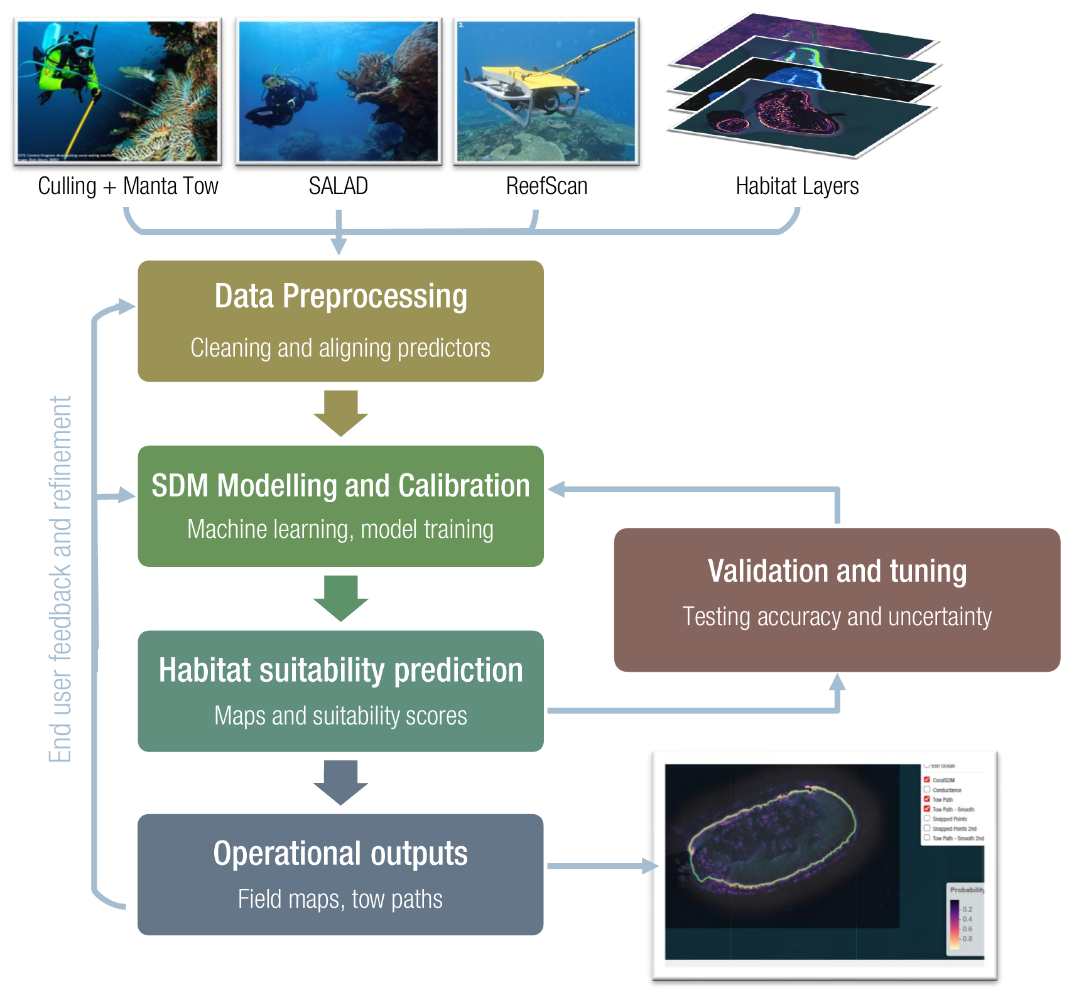
Figure 1 High-level SDM workflow for CCIP-BR-13 (habitat suitability and surveillance optimisation). Schematic showing how operational observations (Culling + manta tow records, SALAD imagery/annotations, and ReefScan Deep detections) are integrated with high-resolution habitat predictor layers. Inputs are cleaned and spatially aligned during data preprocessing, then used to train and calibrate a species distribution model (SDM). Model development is explicitly iterative, with validation and tuning (accuracy testing and uncertainty assessment) feeding back into SDM calibration. Final outputs include habitat suitability prediction layers (maps and suitability scores) packaged for operational use (e.g., field maps and reef-specific tow path products), with an end-user feedback and refinement loop to support uptake and ongoing improvement.

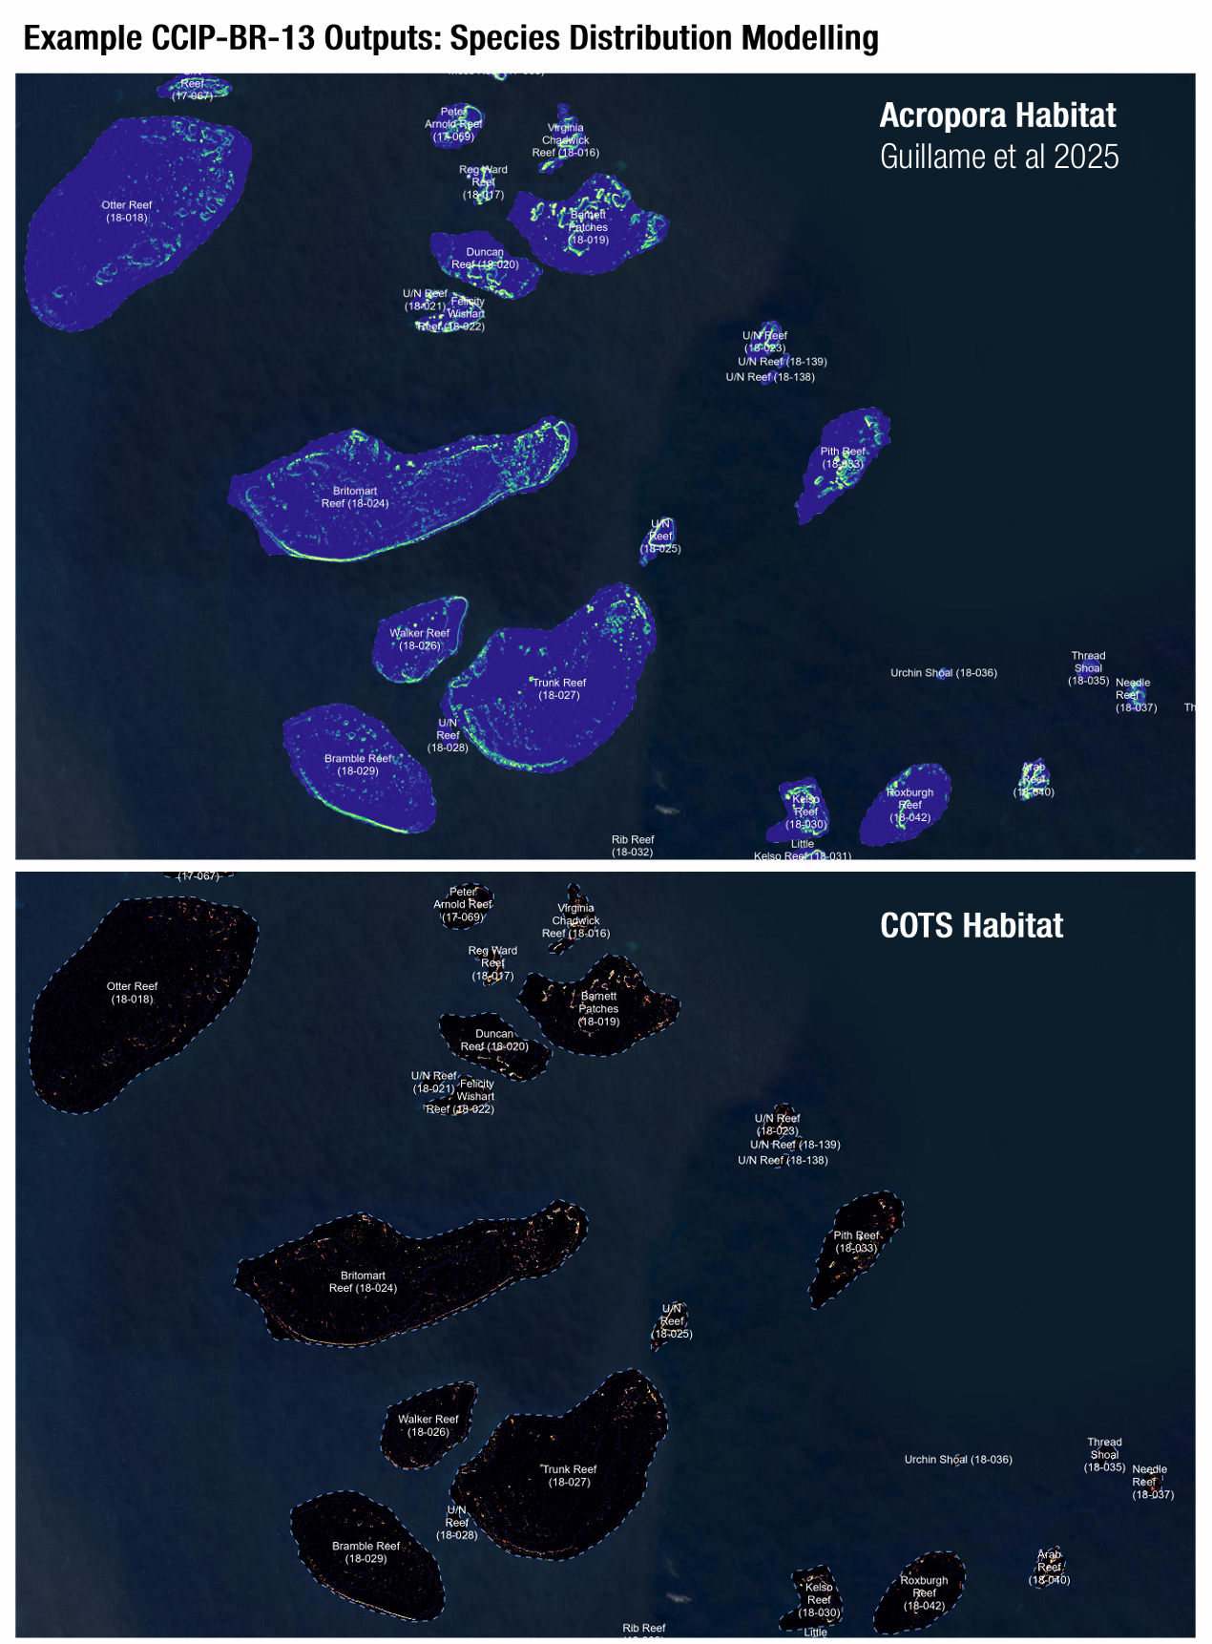
Figure 2 Example CCIP-BR-13 SDM outputs at reef scale (illustrative). Example fine-scale suitability outputs produced by SDM workflows for a representative reef cluster. The upper panel shows an Acropora habitat suitability surface (example from Guillaume et al. 2025), illustrating within-reef spatial heterogeneity captured at high resolution. The lower panel shows a corresponding COTS habitat suitability output (prototype), demonstrating how spatial predictions can be translated into operationally interpretable layers to support targeted surveillance and prioritisation. (Shown as an example output; formal validation/packaging is undertaken in subsequent project phases.)

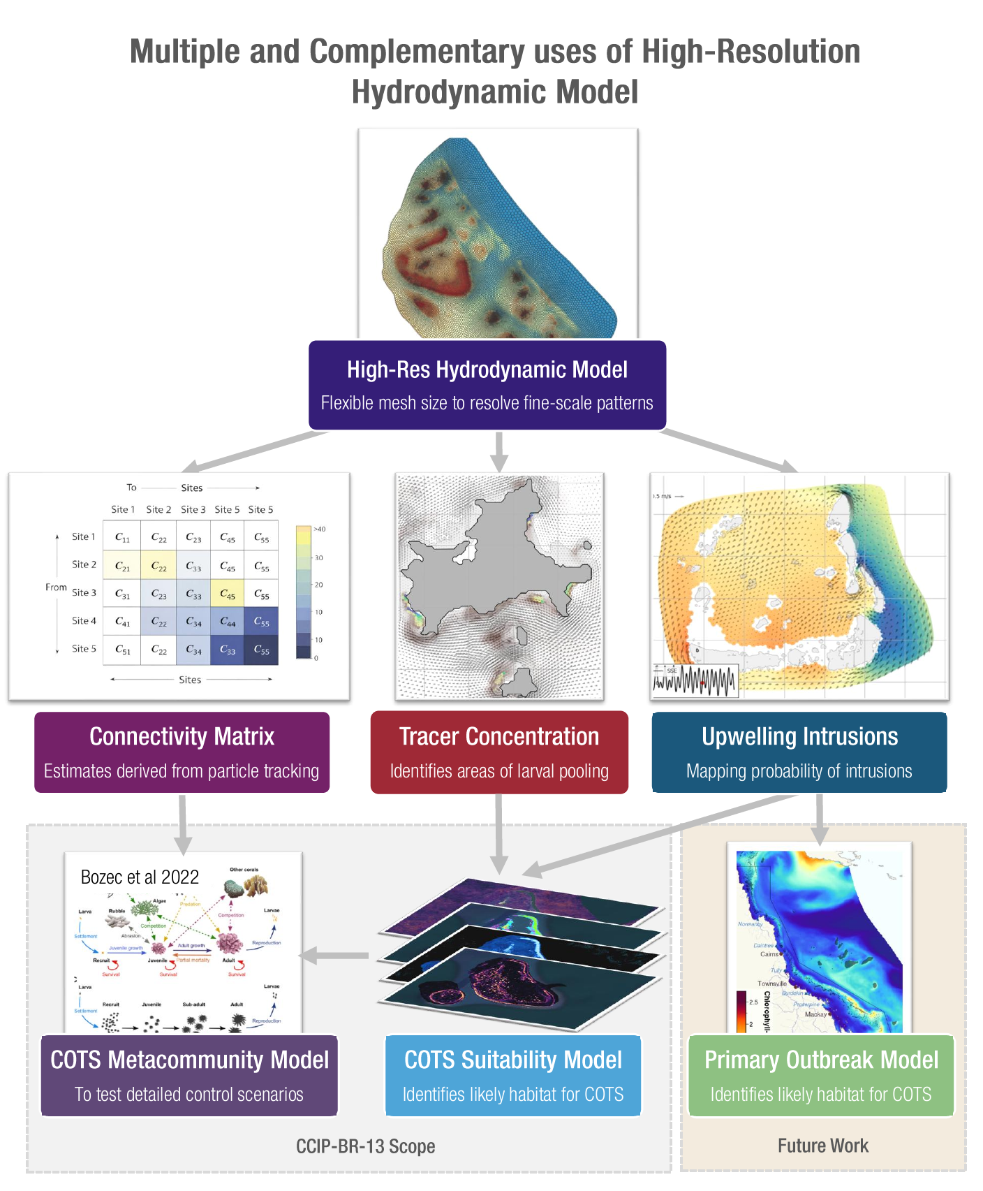
Figure 3 Multiple complementary products derived from the high-resolution hydrodynamic model and how they support CCIP-BR-13 modelling. Conceptual diagram illustrating how a high-resolution hydrodynamic model (flexible mesh resolving fine-scale connectivity patterns) can generate multiple outputs: (i) connectivity matrices from particle tracking, (ii) tracer concentration / larval pooling products to identify likely larval sink areas, and (iii) upwelling/shelf-intrusion probability layers to characterise physical drivers linked to outbreak initiation. These products feed into core CCIP-BR-13 components, including a fine-scale COTS metacommunity model for scenario testing, a COTS SDM modelling workflow, and (as future work) primary outbreak models integrating physical forcing to explain local upwelling and initiation zones.

Monitoring and Evaluation

Outputs
List the Outputs identified in your Work Plan (Section 3.1) and comment on progress in their development.
ID | Output | Progress update
A | Traditional Owner information package and documentation for TO operators | In development. Initial content needs and preferred formats were discussed at the November workshop (focus on interpretability, operational relevance, and integration with planning/reporting). Draft structure is being prepared and will be refined following March on-country visits (Malu Ventures, Thursday Island) and subsequent engagement with Jabalbina following the April COTS workshop, to ensure the package reflects how TO dive teams and managers will practically use the products.
E | Finalised habitat suitability model and surveillance paths | Strong progress. The SDM workflow has been established end-to-end and is producing initial suitability outputs. A tow-path optimisation prototype has also been developed to generate reef-specific surveillance paths informed by SDM outputs. The next phase will focus on formalising the validation approach, uncertainty summaries, and packaging outputs for operational testing (including formats suitable for Field Maps/dashboards and reef-level summary products).
F | Finalised and validated fine-scale connectivity network | In progress. The connectivity modelling grid is established and simulations are underway, with outputs being aggregated to a bespoke northern initiation grid to support operational interpretability and tractable modelling. Final deliverables (connectivity matrices and associated derived products) are pending completion of simulations and QA/QC. In parallel, the project is developing additional derived layers including larval pooling / sink probability surfaces and shelf intrusion / upwelling diagnostic maps to support both connectivity interpretation and outbreak initiation hypotheses.
G | Calibrated and validated fine-scale metacommunity model (single cluster) | In progress (prototype stage). Prototype metacommunity modelling approaches have been developed, including a hybrid GNN-based approach. Progress to calibrated, scenario-ready runs remains dependent on the finalised connectivity products (matrices/derived layers). A calibration, validation and sensitivity analysis plan is being prepared with partners to enable rapid progression once connectivity outputs are final.
H | Final project data sets and final report made publicly available (FAIR) | Scheduled for later phase, but foundations underway. Public release of final datasets and reporting outputs is planned for the later project phase once products stabilise and governance/metadata requirements are finalised. As an early step toward FAIR delivery, GitHub repositories have been created to manage and document project code and data identifiers, supporting version control, transparency, and reproducible workflows as outputs mature.

Metrics achieved within the reporting period
Refer to the metrics and targets identified in your project Work Plan (Section 6.2) and report on the actual number completed during this reporting period.
CCIP Metric | Unit of measurement | Target as per Work Plan | Actual in reporting period
Number of engagement events with key stakeholders:
- Workshops/ meetings with scientific community | Count | 2 | 1
- Workshops/ meetings with COTS managers | Count | 2 | 1
- In-field trials/ training with COTS managers | Count | 2 | 0
Number of new or updated tools developed:
- Decision support tools | Count | 1 | 0
- Models / code / software | Count | 2 | 1
- Operating procedures / plans | Count | 1 | 0
- Other: __(list here)_____________ | Count
Number of external communications:
- Scientific papers, reports and publications | Count | 2 | 0
- Educational tools/ fact sheets etc | Count | NA | NA
- Media/ social media outputs | Count | NA | NA
Number Traditional Owners/ First Nations People:
- Engaged with by phone, email, online presentation etc | Count | 2 | 0
- In person engagement (workshops, on Country meetings, field trials etc) | Count | 2 | 1
- Consultant / employed member of project team | Count | NA | NA
- Name groups engaged: __(list here)______________________ |  | Malu Ventures; Jabalbina

Risk & Budget Management
Refer to the risk management table in your CCIP Project Work Plan (Section 4.3) and comment on progress to monitor and mitigate identified risks

Actions taken during the reporting period to manage identified risks
Have new or emerging risks been identified and have contingency plans been put in place
Actions taken during the reporting period to manage identified risks included:
• Scheduling early engagement with GBRMPA to confirm use-cases and avoid integration risk.
• Prioritising workflow modularity and writing intermediate spatial products to manage computational risk.
• Maintaining regular coordination with JCU connectivity modellers to track timelines and align data processing requirements.
• Staging metapopulation model development so prototype components (hybrid GNN approach) can progress in parallel with connectivity finalisation.
No new material risks have been identified to date; contingency planning remains focused on potential delays to connectivity matrices, but these are well within the bounds of the project timeline

Outline any substantial changes that have occurred from the original project risk assessment
No substantial changes have occurred from the original project risk assessment during this reporting period.

Workplace health and safety
Please note: Reportable WHS incidents must be reported to GBRF when the incident occurs and after the incident has been contained and the necessary safety actions have been taken.
 | Y/N | If yes, please provide details
Have any material changes been made to WHS policy during the life of the project? | N | N/A
Have any material changes been made or implemented to WHS documents previously supplied to GBRF? | N | N/A
Has a notifiable incident occurred during the reporting period (whole of project)? (An incident is notifiable if it arises out of the conduct of a business or undertaking and results in the death, serious injury or serious illness of a person or involves a dangerous incident) | N | N/A
Have you and/or your organisation been issued with any prosecutions or notices over the life of the project? | N | N/A

Workplace health and safety performance related to the immediate project
 | Description | Number
Number of medical treatment injuries (MTI’s) | Any work-related injury or illness that requires treatment from a medical practitioner. | 0
Number of lost time injuries (LTI’s) | Any work-related injury or illness that results in the loss of one or more complete days any time after the day or shift on which the injury or illness occurred. | 0
Number of fatalities | Any work-related injury or illness that led to the death of a person/s. | 0

Budget Update
Review the budget in your Work Plan (Section 5) and provide an update on how the budget is progressing. Comment on whether it is on-track and any variations that have occurred, including forecasted over or underspends in expense types.
Budget expenditure is tracking broadly as expected for the reporting period. Costs have primarily been associated with personnel time to establish the SDM workflow, produce initial products, and coordinate with partners and GBRMPA. No fieldwork/engagement travel costs have been incurred to date; Traditional Owner engagement travel is planned for March 2026 and remains within the budget allocation. No material variances or forecast overspends have been identified at this stage.

Declaration
In submitting this report the Delivery Partner acknowledges that:
    - all information, material and data collected as part of this report has been collected in accordance with the terms of the GBRF Privacy Policy,
    - GBRF may use this information, material and data collected on the GBRF website and other external publications or sources except where consent is explicitly not provided

