COTS fine-scale habitat layers: Results

1. Results
Throughout, a problematic cull dive is one with a catch per unit effort (CPUE) of at least 0.02 COTS per minute of bottom time. A low-density dive found COTS below that threshold, and a ghost dive found none. Unless stated otherwise, performance is measured within reef-years: does a layer rank the places where COTS were found above the places where they were not, on the same reef in the same year? This removes differences between reefs and years, which the survey-year term in the habitat models already captures. An area under the curve (AUC) of 0.5 indicates no discrimination.
Key findings:
- The habitat layers rank locations within a reef only weakly. On independent manta tow data, the best layer (RG + year) reached a within reef-year AUC of 0.58.
- Recent cull history forecast the following season’s problematic sites better than habitat alone (AUC 0.68 vs 0.57), but partly reflects where crews have chosen to dive.
- Ranking manta tows by the habitat layer found fewer aggregations than thinning tows at random. Evenly spaced (systematic) thinning retained at least 95 % of aggregations with up to 40 % fewer tows.
- A habitat model trained on manta tows within reef-years ranked held-out tows best (AUC 0.61) and found more aggregations than the cull-trained layer. It did not improve the choice of cull sites.
- The habitat layer alone could not reduce the number of cull sites searched without losing problematic dives roughly in proportion. Combined with the previous season’s cull and manta records, it reduced the designated sites searched by 6–13 percentage points and avoided 6–12 points more low-density dives for the same share of problematic dives retained.

1.1 Spatial predictions
Three habitat layers were produced at the scale of individual reefs (Figure 1):
- Clean + year: an XGBoost model on 12 terrain and habitat layers plus survey year.
- RG + year: the same model with five ReefGuide layers added (wave height and period, turbidity, bathymetry and slope).
- HMSC joint: a joint model of Cull, SALAD and RHIS evidence at 120 m.
A fourth layer combined the HMSC habitat probability with a kernel of past cull outcomes (HMSC + history). A fifth, the manta model, was trained on strong-evidence and negative manta tows within reef-years (Section 1.4.5).
The two XGBoost layers placed their highest within-reef ranks along reef margins and outer slopes. Examples include the western and southern rim of Eyrie Reef, both long margins of Batt Reef and the ring reef of Lady Musgrave. The HMSC habitat layer was more diffuse at its coarser 120 m resolution and also ranked parts of the reef flat and back reef highly. The HMSC + history layer was dominated by locations of past high-density finds, for example the south-western margin of Batt Reef and the eastern side of Eyrie Reef. It therefore summarises where COTS have been culled rather than where suitable habitat lies. The 90 % posterior interval of the HMSC probability was typically 0.1–0.3 wide, so cell-level differences of a few percentage points are not meaningful.
The layers agreed only moderately on which cells rank highest. Median within-reef Spearman correlations were 0.41 between clean + year and RG + year, 0.33 between clean + year and HMSC, and 0.24 between RG + year and HMSC. RG + year was available for 61 % of 120 m cells within GBR reef polygons. The primary search-planning layer therefore used RG + year where available and a calibrated clean + year prediction elsewhere: - 54 reefs were covered entirely by RG + year; - 2,586 reefs used a mixture of both; - 920 reefs used clean + year only.
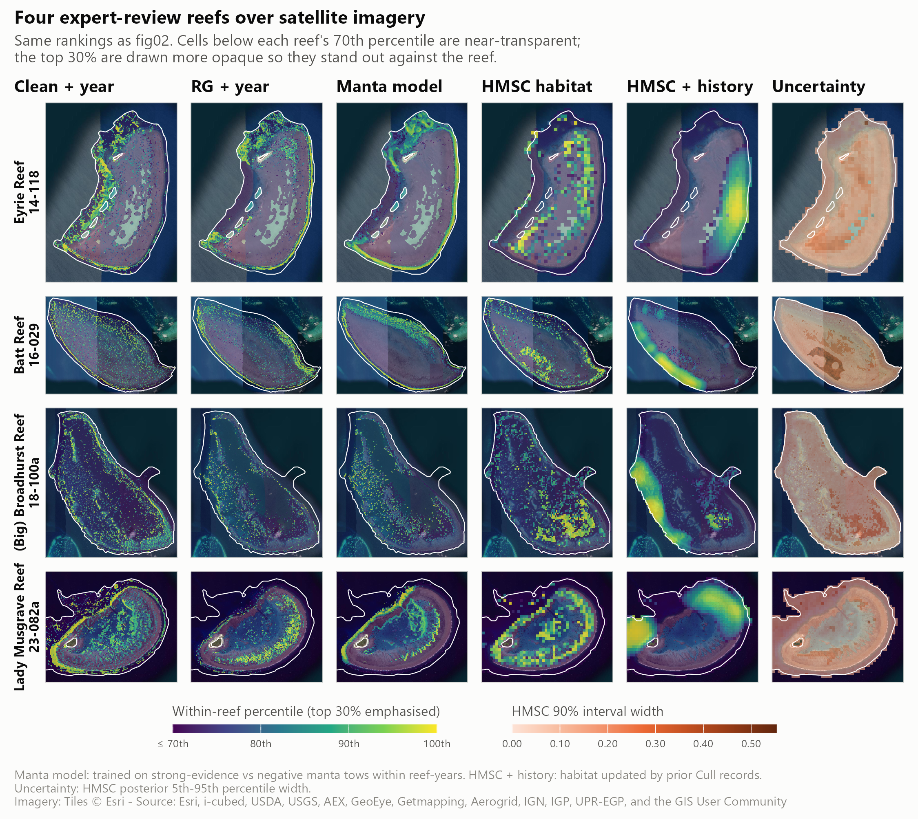
Figure 1: Within-reef percentile rank of each layer on four reefs reviewed by experts (Eyrie, Batt, Broadhurst and Lady Musgrave), shown over satellite imagery. Columns show clean + year, RG + year, the manta model (trained on manta tows within reef-years), HMSC habitat, HMSC habitat updated with cull history (forecast for 2027), and the width of the HMSC 90 % posterior interval. Cells below each reef’s 70th percentile are drawn near-transparent so that the top 30 % stand out.

1.2 Independent validation against manta tows
Manta tows were not used to fit any layer (HMSC used them only to flag active reef-years). They therefore provide an independent test. All three layers scored the same 117,318 tows in 1,003 active reef-years on 402 reefs. Within each reef-year, the 15,691 tows with strong COTS evidence were compared with tows that recorded neither COTS nor feeding scars (Figure 2, Table 1). Strong evidence meant a direct COTS sighting, at least two counted scars, or scars recorded as “common” in legacy surveys.
RG + year discriminated best (AUC 0.576, 95 % CI 0.548–0.602), followed by HMSC (0.567, 0.549–0.585). Clean + year was close to chance (0.516, 0.500–0.532). RG + year placed 23 % more strong-evidence tows in each reef’s top-ranked 20 % than expected by chance.
Table 1: Discrimination between strong-evidence and negative manta tows within reef-years. Lift is the share of strong-evidence tows in a reef-year’s top 20 % of tows, relative to the 20 % expected by chance. Intervals are 95 % bootstrap intervals over reef-years.
Layer | Within reef-year AUC (95 % CI) | Top-20 % lift (95 % CI)
Clean + year | 0.516 (0.500–0.532) | 1.11 (1.06–1.15)
RG + year | 0.576 (0.548–0.602) | 1.23 (1.18–1.29)
HMSC joint | 0.567 (0.549–0.585) | 1.15 (1.11–1.19)


Figure 2: Independent manta tow check. Left: within reef-year AUC; right: top-20 % lift. Points are estimates; bars are 95 % bootstrap intervals over reef-years. Dotted lines mark chance.

1.3 Forecasting with cull history
Cull records showed that high-density areas persisted between seasons at a scale of about 0.5–1 km. This was tested with a strictly forward validation (Figure 3, Table 2). For each test year from 2022 to 2026, every score was built only from data collected in earlier years. Scoring used first-visit cull site-years in active reef-years that contained both outcomes: 4,170 site-years in 315 reef-years.
The HMSC habitat model refitted on earlier years reached an AUC of 0.569. A kernel of prior cull outcomes reached 0.654. Combining the two (the deployed setting, specified before validation) reached 0.681 (95 % CI 0.640–0.718). Re-tuning the kernel each year on the previous season did not improve on the fixed setting (0.676).
The gain depended on history being available nearby. Where it was, the combined score reached 0.716. Where history was sparse, it fell to 0.540, and at sites never previously culled it was 0.553. A score based only on how often crews had dived a site reached 0.636. Much of the forecast skill therefore reflects where operators chose to work, rather than independent evidence of habitat.
Reef-context predictors at 0.5–1 km did not improve habitat forecasts robustly (0.582 vs 0.569, overlapping intervals). These were windward and seaward position, distance to reef edge, upwind open water, distance to channels, reef area, and eReefs current speed and steadiness. Their effect varied between years from −0.04 to +0.07.
Table 2: Forward validation of within reef-year AUC for problematic cull site-years, test years 2022–2026 pooled. Each score uses only data from before the test year.
Score | All site-years | With nearby history (n = 3,212) | Little or none (n = 958) | New sites (n = 1,664)
Habitat (HMSC refit before test year) | 0.569 | 0.584 | 0.554 | 0.524
Habitat + reef context | 0.582 | 0.600 | 0.520 | 0.514
Dive effort only | 0.636 | 0.656 | 0.491 | 0.513
History kernel | 0.654 | 0.705 | 0.465 | 0.476
Habitat + history (deployed) | 0.681 | 0.716 | 0.540 | 0.553


Figure 3: Forward validation of habitat, reef context and cull history scores. Left: all 4,170 test site-years, with 95 % bootstrap intervals over reef-years. Right: the same scores split by the amount of cull history within reach of the site.

1.4 Operational application

1.4.1 Planning a reef visit
Figure 4 illustrates how the primary search-planning layer would be used on two reefs. These reefs are in the layer’s training data, so the example shows the planning logic rather than independent performance. - Batt Reef manta survey (4 August 2025): keeping the 79 of 131 tows that crossed the highest-ranked cells would have retained 32 of the 42 strong-evidence tows. - Eyrie Reef manta survey (26 October 2023): keeping 56 of 92 tows would have retained 9 of 11. - Dive plans: fifteen dive sites were placed on top-ranked diveable cells (0.5–16 m deep, at least 400 m apart). On both reefs, every cull site that produced a problematic dive in the corresponding cull season (2025 for Batt, 2024 for Eyrie) lay within the layer’s top 30 %.

Figure 4: Example use of the primary search-planning layer on Batt Reef (top) and Eyrie Reef (bottom). Left: manta tows the layer would keep (solid) or skip (dashed) in an actual survey, with strong-evidence tows in red. Right: fifteen planned dive sites on the top-ranked diveable cells, ordered into a route, against the outcomes of that season’s cull dives. Colour shows each reef’s top 30 %. Illustrative only: these reefs were in the training data.

1.4.2 Thinning manta surveillance
The number of manta tows that could be cut without missing COTS aggregations was evaluated in two steps. Cull crews dive where manta tows detect COTS, and the layer is trained on cull data, so scoring tows with the deployed layer would partly test it against its own source. Each reef’s tows were therefore scored by a model refitted without that reef’s cull data (5-fold leave-reef-out). An aggregation was defined as strong-evidence tows within 500 m of each other in one survey. It counted as found if at least one of its tows was kept. Three thinning strategies kept the same number of tows per survey: - the layer’s top-ranked tows; - a random selection; - evenly spaced (systematic) tows around the reef.
Systematic thinning retained the most aggregations at every level of effort (Figure 5). At 60 % of tows kept, it found 96.6 % of the 1,900 aggregations of two or more strong-evidence tows, compared with 94.0 % for random selection and 88.1 % (86.6–89.5 %) for the layer. The largest cut that still found at least 95 % of aggregations was: - 40 % of tows for systematic thinning; - 30 % for random selection; - 20 % for the layer.
The layer concentrated the kept tows in a few high-scoring stretches and missed aggregations in low-scoring ones. It found slightly more isolated single strong-evidence tows than random selection (64 % vs 61 % at 60 % kept). Scoring with the deployed rather than the held-out layer overstated its performance by 1–3 percentage points.

Figure 5: Manta tows kept versus COTS aggregations found. Left: aggregations of two or more strong-evidence tows found as tows are cut, for the layer (held out and deployed), random selection and systematic thinning; the band is a 95 % bootstrap interval over surveys. Right: the share found at 60 % of tows kept, by aggregation size.

1.4.3 Selecting cull sites with the habitat layer
The cull question was whether crews could dive fewer sites without missing problematic densities. Candidate sites were all 15,884 designated cull sites on 576 reefs, including the 11,585 sites never dived. Each site was ranked among the designated sites on its reef by the RG + year model refitted without that reef’s cull data. The analysis then asked which of the 29,813 dives made in 918 reef-years from 2018 to 2026 would still have occurred if only the top-ranked sites had been dived (Figure 6).
The held-out layer retained problematic dives only slightly faster than low-density or ghost dives: - Top 70 % of sites: 77.2 % (72.9–80.8 %) of problematic dives retained, while 24.6 % of low-density and 29.5 % of ghost dives were avoided. These sites accounted for 75.6 % of all dives, so a ranking that could not tell outcomes apart would have retained 75.6 % of problematic dives and avoided 24.4 % of the others. - Top 50 % of sites: 59.8 % (55.5–64.5 %) of problematic dives retained, with 44.9 % of low-density and 48.2 % of ghost dives avoided.
Within reef-years, the AUC for problematic versus low-density dives was 0.57, and versus ghost dives 0.60. The deployed layer appeared stronger (0.61 and 0.66) only because it had been trained on these dives. Forty-three per cent of the site-years ranked in a reef’s top 30 % were at sites that had never been dived.

Figure 6: Share of cull dives that would still occur if only the highest-ranked designated cull sites on each reef were dived, by dive outcome. Left: held-out ranking (each reef scored without its own cull data); right: deployed layer (in-sample). The dashed diagonal is the share of sites dived. Bands are 95 % bootstrap intervals over reef-years.

1.4.4 Adding the previous season’s cull and manta records
The site ranking was then extended with evidence from the previous season only, never from the season being searched: - cull dives at the site (any problematic dive, or dived with none problematic); - the rate of problematic dives and dive effort within about 300 m; - strong-evidence and total manta tows within about 300 m.
These terms were combined with the held-out habitat rank in a logistic model fitted on other reefs (5-fold leave-reef-out). Because the evidence raises both problematic and low-density sites, rankings were compared at matched retention. Each was set to keep the same share of problematic dives, and the sites searched and dives avoided were then compared (Figure 7, Table 3).
At 90 % of problematic dives retained (2018–2026), the combined ranking: - reduced the share of designated sites searched from 88 % to 82 %; - increased low-density dives avoided from 10 % to 16 %; - increased ghost dives avoided from 13 % to 21 %.
Non-problematic dive time avoided rose from 11 % to 19 %. All four differences were supported by paired bootstrap intervals that excluded zero. Gains were larger in 2022–2026. At 80 % retention, the sites searched fell from 74 % to 61 % and low-density dives avoided rose from 20 % to 32 %.
Most of the improvement came from the evidence terms. A ranking built from last season’s evidence alone performed almost as well as the combined ranking. The habitat layer contributed mainly by ordering sites without recent evidence. It was the only information for the 30 % of reef-years whose reef had not been visited in the previous season. On those reefs (11 % of dives), no ranking discriminated well (AUC about 0.53).
The fitted model ranked sites higher when strong manta tows or problematic dives had been recorded nearby. It ranked them markedly lower when a site had been dived the previous season without a problematic result. A site that had itself been problematic ranked lower than its neighbourhood suggested, consistent with culling having reduced densities there. Among dives actually made, discrimination between problematic and low-density dives improved only slightly (AUC 0.57 to 0.59). The reduction in search area came mainly from ranking unproductive and never-dived sites lower. Results using a three-season evidence window were similar.
Table 3: Habitat-only ranking → habitat plus previous-season evidence, compared at matched retention of problematic dives (held out, 2018–2026; 30,037 dives in 926 reef-years). Brackets give the 95 % paired bootstrap interval of the difference in percentage points.
Problematic dives retained | Designated sites searched | Low-density dives avoided | Ghost dives avoided | Non-problematic dive time avoided
90 % | 88 % → 82 % (−11 to −1) | 10 % → 16 % (+2 to +10) | 13 % → 21 % (+4 to +13) | 11 % → 19 % (+4 to +12)
80 % | 73 % → 67 % (−11 to −3) | 22 % → 28 % (+2 to +10) | 27 % → 36 % (+5 to +14) | 23 % → 31 % (+4 to +13)


Figure 7: Habitat-only and evidence-informed rankings of designated cull sites compared at the same share of problematic dives retained (80–95 %). Panels show the share of designated sites searched (lower is better), and the shares of low-density and ghost dives avoided. Evidence is from the previous season only. Bars are 95 % bootstrap intervals over reef-years (2018–2026).
A caveat applies to the search-area results in Figure 6 and Figure 7. A ranking is credited when it agrees with where crews chose to dive, and crews already use the previous season’s knowledge. Part of the apparent reduction therefore formalises current practice. COTS densities at designated sites that were never dived cannot be verified from these data.

1.4.5 Training the habitat model on manta tows
Manta tows provide about 20 times more training rows than cull site-years. They also cover reef areas that were searched but never dived. A habitat model was therefore also trained on manta tows, with strong COTS evidence as the response and strict negatives as the alternative. It was fitted on the same leave-reef-out folds as the cull-trained model and evaluated on both goals (Figure 8). A second version fixed each reef-year’s strong-tow rate as an offset and omitted survey year, so that it could learn only where COTS occurred within a reef-year.
The within reef-year manta model ranked held-out tows best: - AUC 0.612 (0.578–0.636), compared with 0.575 for the manta model with year and 0.547 for the cull-trained model; - top-20 % lift 1.33, compared with 1.15 for the cull-trained model.
At 60 % of tows kept, it found 91.0 % of aggregations, 2.8 percentage points more than the cull-trained model (95 % CI +1.1 to +4.6). This was still below random (94.0 %) and systematic (96.5 %) thinning.
For cull-site selection, training on manta tows gave no benefit. The manta model with survey year ranked cull sites at chance (AUC 0.48 for problematic vs low-density dives), because survey year accounted for 70 % of its fitted gain. The within reef-year version matched the cull-trained model over 2018–2026 (AUC 0.566 vs 0.567). Once the previous season’s evidence was added, all three habitat models avoided the same share of low-density dives (about 15.5 % at 90 % of problematic dives retained).
The within reef-year manta model was refitted on all 198,852 labelled tows and mapped at 30 m wherever the ReefGuide layers exist (Figure 1, third column). It agreed with the cull-trained RG + year layer in favouring reef margins and outer slopes. It placed more weight on the exposed perimeter, for example the eastern rim of Eyrie Reef, and the northern and western rim of Lady Musgrave, where RG + year favours the southern rim. Manta tows follow reef perimeters, so its values in the back reef and lagoon are extrapolations.

Figure 8: Cull-trained and manta-trained habitat models compared on both goals. Left: within reef-year AUC for held-out manta tows (strong evidence vs negative). Centre: COTS aggregations found when 60 % of tows are kept, with random and systematic thinning for reference. Right: low-density cull dives avoided at 90 % of problematic dives retained, for the habitat model alone and with the previous season’s evidence. Bars are 95 % bootstrap intervals.

