Where and when to search for COTS on a reef

[TO CONFIRM: author list and order]
- [TO CONFIRM: author affiliations]
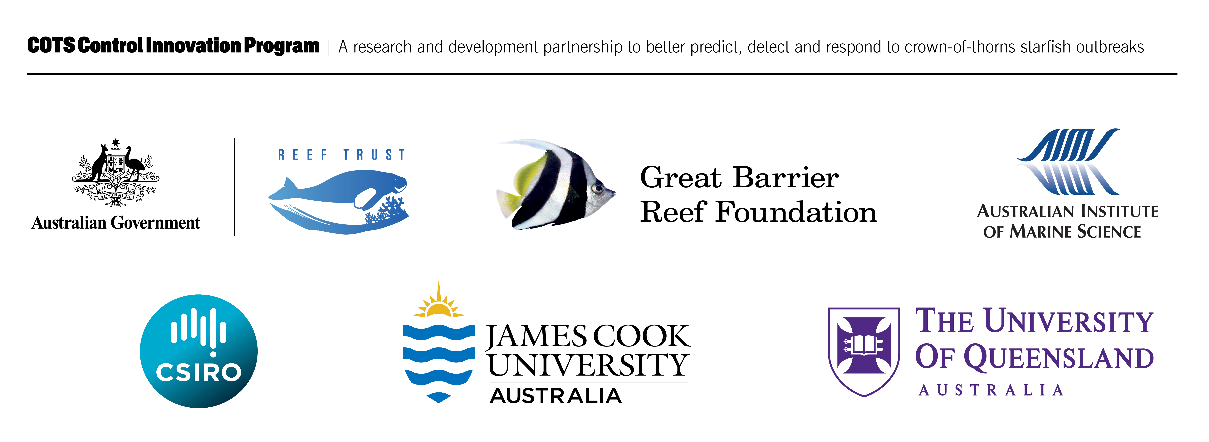

Inquiries should be addressed to:
[TO CONFIRM: contact name]
[TO CONFIRM: organisation]
[TO CONFIRM: contact email]
This report should be cited as
[TO CONFIRM: authors] (2026) Where and when to search for COTS on a reef. A report to the Australian Government by the COTS Control Innovation Program (108 pp).
Funding Acknowledgement
The COTS Control Innovation Program aims to accelerate the development of innovative surveillance and control methods to manage outbreaks of coral-eating starfish on the Great Barrier Reef. The Program is a collaboration between the Great Barrier Reef Foundation, Australian Institute of Marine Science, Commonwealth Scientific and Industrial Research Organisation, James Cook University and The University of Queensland. This project is part of CCIP’s Bridging Phase which is funded by Australian Government’s Reef Trust, the Australian Institute of Marine Science, and the Great Barrier Reef Foundation.
Traditional Owner Acknowledgement

The COTS Control Innovation Program extends its deepest respect and recognition to all Traditional Owners of the Great Barrier Reef and its Catchments, as First Nations Peoples holding the hopes, dreams, traditions and cultures of the Reef.
Disclaimer
While reasonable efforts have been made to ensure that the contents of this document are factually correct, CCIP does not make any representation or give any warranty regarding the accuracy, completeness, currency or suitability for any particular purpose of the information or statements contained in this document. The views and opinions expressed in this publication are those of the authors and do not necessarily reflect those of the Australian Government.
Copyright
© Copyright: [TO CONFIRM: copyright owner].

Contents
Project Summary 1
Context & Objectives 2
The management problem 2
Earlier models this project builds on 2
The decisions this work supports 3
Project priorities and objectives 4
Methods 5
Observations and habitat information 5
Testing habitat and recent-evidence rankings 7
Seasonal search products 8
Water movement and larval connections 8
Connected COTS and coral populations 9
Engagement with Rights-holders and Management Stakeholders 9
Results 10
GBR fine-scale habitat predictions 10
Habitat layers: a consistent first ordering on every reef 10
Predicted habitat and recent evidence increase cull-site search efficiency 11
Three alternative rankings 13
Seasonal products and exploration 13
Preliminary larval dispersal patterns vary across the reef cluster 13
Historical COTS and coral dynamics provide a basis for testing control strategies 15
Discussion & Outputs 17
Combining recent observations with habitat 17
Retention, surveillance and the cost of deferral 17
Using connected population models for strategic decisions 18
Final project outputs 19
Outcomes & Impact Pathway 20
More efficient control through operational testing 20
Co-interpretation with rights-holders and operators 20
Predictive knowledge for cluster-scale management 21
Conclusions & Next Steps 22
Acknowledgements 22
Data Accessibility 22
References 23
Appendix A: Delivered layers and products 26
Appendix B: Predictors 27
Appendix C: HMSC joint model 29
Appendix D: Supplementary validation 31
Appendix E: Alignment with the CCIP-BR-13 Work Plan 36
Appendix F: Reproducibility 36
Appendix G: Detailed model specification and evaluation 38
Model purposes and evaluation design 38
Data and response definitions 40
Habitat models and mapped layers 41
How habitat and recent observations determine a cull-site rank 42
Evaluation design and search-efficiency analyses 43
Seasonal products 46
Metacommunity model and historical culling 46
Design of the historical and future control assessments 48
Software and reproducibility 49
Appendix H: Detailed tactical model comparisons 50
Full cull-site and manta-effort trade-offs 50
Recent evidence combined with habitat reduces the cull-site search 53
The gain holds season by season 55
Retaining dives above 0.04 CPUE 56
Manta effort paired with the site-selection decisions 58
Each source covers the other’s gaps 59
Habitat layers: a consistent first ordering on every reef 59
Habitat alone as a cull-site ranking 61
Cull history: strong where it exists 62
Where recent evidence is missing 64
Manta surveillance: spread tows evenly, add where habitat ranks highest 64
The 2027 cull-site priority ranking and exploration areas 66
Appendix I: Updated metacommunity calibration and exploratory projections 69
Calibration updates and uncertainty 69
Recent densities and additional reefs 69
Initial control projections to 2050 71
Appendix J: Archived 15 October metacommunity comparisons 76
Metacommunity model: calibration and current limitations 76
Replicated candidates 76
Historical culling exposed missing populations 77
Extension to 2026 77
Appendix K: Preliminary larval-concentration comparisons 80
Variation among releases 80
Cross-shelf patterns and the domain boundary 81
Appendix L: Management assessment and field-trial design 84
Validation and interpretation limits 84
Combining recent observations with habitat for daily searches 84
Maintaining coverage during manta surveillance 85
Assessing the culling program from 2012 to the present and beyond 86
Projecting suppression of the fifth primary irruption wave 87
Monitoring operational performance 88
Developing an early-warning system 89
Complete follow-up checklist 89
Appendix M: Three alternatives to the cull-site ranking 91
What changed, and what remained comparable 91
Fixed site coverage and matched high-density retention 92
Comparing equal recorded dive effort 94
Did averaging hide a habitat contribution? 95
Experimental product and decision 96

List of Figures
Figure 1: Study areas and observations. A: reef locations with georeferenced cull records in the archived 2002–2026 data, available for habitat modelling; symbols summarise locations by reef. B: Lizard Island, Eyrie, MacGillivray and North Direction, whose monitoring series informed population-model calibration. C: reserved for the hydrodynamic mesh figure, to be supplied. D: the 2,895 sub-reef polygons on 113 reefs in the population model’s v0.4 GeoPackage. The panels describe data and model support, not independent validation or new fieldwork. Fine-scale hydrodynamic transport has not yet replaced the population model’s reef-level connections. 6
Figure 2: Batt Reef and Eyrie Reef: 2027 cull-site priority, manta tows of the last five seasons (blue) and exploration areas (purple, numbered by rank) over satellite imagery. A (red) is the top 20%, B the next 30%, C the next 30% and D (grey) the bottom approximately 20% of sites on each reef; integer site counts can shift these percentages. The proposed pathway defers D on a routine visit and retains A–C, with annual or pre-closure checks of deferred sites. Table 12 reports that cutoff’s retrospective cull-dive trade-off; Table 13 separately estimates manta effort. These maps illustrate the rule, rather than showing measured performance at Batt or Eyrie in 2027. 8
Figure 3: Within-reef habitat ranks on Eyrie, Batt, Broadhurst and Lady Musgrave reefs. Columns show the full-extent and limited-extent cull-trained models, the manta-trained model, the joint habitat model, habitat updated with cull history for 2027, and joint-model uncertainty (90% posterior interval width). The top 30% of each reef is emphasised. Satellite imagery: Esri World Imagery; full attribution is in Appendix H. 10
Figure 4: Persistence of simulated larval-concentration hotspots at day 10, across the model domain (A) and around Lizard Island (B). Colour shows the proportion of releases in which a sub-reef site ranked in the highest fifth of concentration within that release. The dashed box marks the enlarged area; grey shows land. This reformats concentration figure lc2 from the project analysis. High concentration does not by itself establish local retention, source strength or settlement. 14
Figure 5: Historical COTS and coral dynamics on the calibration reefs, combining source Figures 1 and 4 from the 21 October snapshot. Left: manta-tow equivalents (dotted line: 0.22 COTS per tow). Right: hard coral cover, modelled relative to habitable area. Blue solid lines omit recorded culling; purple dashed lines apply it. Lines are five-seed means; darker bands span those seeds and lighter bands span all 65 parameter-test runs per culling state. These ranges are not confidence intervals. Black points show LTMP manta observations (coral bars: reported 95% intervals); orange diamonds show 9 m photo-transects. Survey supports differ. These are calibration and diagnostic comparisons. 16
Figure 6: Relative importance (XGBoost gain) of each predictor in the clean + year and RG + year models. Survey year is the largest single driver of both, which is why absolute probabilities mostly reflect prevalence in the prediction year; wave period and height dominate the habitat terms where ReefGuide layers are available. 28
Figure 7: HMSC habitat effects on the mapped cull target, with posterior uncertainty. 30
Figure 8: HMSC coefficients across all 12 jointly fitted responses (cull, SALAD and RHIS evidence). 31
Figure 9: Within-reef agreement (Spearman correlation) between layers across reefs. The layers agree only moderately on which cells rank highest. 32
Figure 10: Which model fills each cell of the primary search-planning layer and of the HMSC layer. 32
Figure 11: Manta and cull effort cut by the primary layer versus at random (2022–2026). 33
Figure 12: Example use of the primary search-planning layer on Batt Reef (top) and Eyrie Reef (bottom). Left: manta tows the layer would keep (solid) or skip (dashed), with strong-evidence tows in red. Right: fifteen planned dive sites on top-ranked diveable cells (0.5–16 m, at least 400 m apart), ordered into a route, against that season’s cull outcomes. Illustrative only: these reefs were in the training data. 34
Figure 13: Habitat, cull history and the combined layer on the four reefs, with the history evidence weight. The combined layer is dominated by past finds wherever history exists. 35
Figure 14: Retention of observed dives above 0.04 CPUE against cull site-years selected for dives, using the existing forward evidence rankings. Random selection has the same site count on each reef. Shading shows 95% reef-year bootstrap intervals; dotted horizontal lines mark 80%, 90%, 95% and 99% retention. The diamond marks the exact A–C cutoff used for the priority classes in Figure 2 and the final rows of Table 12. Habitat fits were held out by reef, while the evidence regression used earlier seasons. Follow-up surveys were not evaluated. 52
Figure 15: Habitat-only and evidence-informed rankings of designated cull sites compared at the same share of problematic dives retained (80–95%). Panels: share of designated sites searched (lower is better), and shares of low-density and ghost dives avoided. Evidence is from the previous season only. Bars are 95% bootstrap intervals over reef-years (2018–2026). Adding last season’s evidence shifts every curve in the useful direction. 54
Figure 16: The three main habitat layers across the Great Barrier Reef, shown as cell means at about 2.9 km. The two cull-trained layers (left, centre) are annual probabilities of a problematic cull site-year in 2026; the HMSC layer (right) is conditional on an active reef-year. Gaps in RG + year are reefs without ReefGuide layers, filled by the clean + year fallback in the primary search-planning layer. 59
Figure 17: Independent manta tow check of the three habitat layers. Left: within reef-year AUC; right: top-20% lift. Bars are 95% bootstrap intervals over reef-years; dotted lines mark chance. 60
Figure 18: Original ≥0.02 evaluation: share of cull dives that would still occur if only the highest-ranked designated cull sites on each reef were dived, ranked by habitat alone, by dive outcome. Left: held-out ranking; right: deployed layer (in-sample). The dashed diagonal is the share of sites dived. Bands are 95% bootstrap intervals over reef-years. Without recent evidence, problematic, low-density and ghost dives fall away at almost the same rate. 62
Figure 19: Forward validation of habitat, reef context and cull-history scores. Left: all test site-years with 95% bootstrap intervals over reef-years. Right: the same scores split by how much cull history lies within reach of the site. History carries the forecast where it exists; habitat carries it where history is absent. 63
Figure 20: Manta tows kept versus COTS aggregations found. Left: aggregations of two or more strong-evidence tows found as tows are cut, for the cull-trained layer (held out and deployed), random selection and systematic thinning; bands are 95% bootstrap intervals over surveys. Right: share found at 60% of tows kept, by aggregation size. Evenly spaced thinning loses the fewest aggregations. 65
Figure 21: Cull-trained and manta-trained habitat models on both goals. Left: within reef-year AUC on held-out manta tows. Centre: aggregations found with 60% of tows kept, with random and systematic thinning for reference. Right: low-density cull dives avoided at 90% of problematic dives (CPUE ≥0.02) retained, for the habitat model alone and with last season’s evidence. Bars are 95% bootstrap intervals. The manta model ranks tows best; for cull sites, last season’s evidence brings every habitat model to the same result. 66
Figure 22: Recent adult COTS density with and without recorded culling, against SALAD diver estimates and catches converted to density (source Figure 2). The vertical axis is logarithmic. Lines are five-seed means; bands span seeds and parameter tests as in the main figure. Larval-input corrections and density targets share observations, so agreement is not independent validation. 70
Figure 23: COTS trajectories on additional reefs outside the four-reef calibration fit (source Figure 3). Points show LTMP manta observations; Ribbon No 10 has no LTMP series. Blue and purple indicate culling-off and culling-on trajectories with the main figure’s range definitions. 71
Figure 24: Exploratory COTS and coral projections under SSP2-4.5. Lines are medians across five climate models and five seed pairs. Bands show the 25th–75th percentiles for no further culling and three times recent effort, rather than confidence intervals. “Targeted ×1” reallocates the recent total effort. The dotted line separates history from projections. Recent population and outside-supply uncertainty carry forward. 73
Figure 25: The same exploratory effort comparisons under SSP3-7.0, with definitions matching the preceding figure. Lower COTS densities later in the period can accompany reduced coral food and should not be read as a control benefit. 74
Figure 26: Exploratory effort comparisons for 2027–2050. Points are medians; bars span the 10th–90th percentiles across climate models and seeds. The first three panels average Lizard Island, MacGillivray, North Direction, Eyrie and Martin; the last counts adult removals across the whole domain. “Recent” retains the recent allocation, “targeted” reallocates it, and multipliers scale total hours. These are model-conditional scenarios. 75
Figure 27: Historical COTS trajectories for W, C3a and C6. Lines are means across five seed pairs and ribbons are one standard deviation across seeds; points are AIMS LTMP manta observations. Adult density is shown through the fixed linear conversion of 0.015 COTS per tow per adult ha$​-1$, and the dotted line marks 0.22 COTS per tow. Peak-height and trough mismatches remain despite successful historical peak matching. 77
Figure 28: Single-seed extension to 2026 with original or corrected irruption-boundary inputs, under the earlier or revised coral thermal settings. Lines show adult density, with chlorophyll modifiers and culling off. Corrected boundary supply produces a larger late build-up; its response also depends on coral forcing. The same cull/SALAD evidence helped construct and assess the corrected boundary. These are diagnostic trajectories, without an uncertainty interval or an independent validation claim. 79
Figure 29: Mean reef concentration in each shelf zone relative to the domain mean, by release and larval age. A value of one means the zone matched the domain mean for that release and age. Colours are clipped at one-eighth and eight times the domain mean; labels retain the source values, with values below 0.1 grouped. This reformats source figure lc4. The ratios do not identify larval origins or measure local retention. 81
Figure 30: Cross-shelf concentration ranks within latitude bands, with the northern band at the top. Each point is a reef, showing its mean within-release rank over the simulated releases; the horizontal line marks rank 0.5. Columns show larval age and colours identify shelf zones. This reformats source figure lc6. Broad latitude bands aid comparison but do not eliminate domain-boundary effects or spatial dependence. 83
Figure 31: Three fixed alternatives, the incumbent, the all-cell mean control and random site selection, evaluated forward over 2019–2026. A shows candidate-site coverage at each share of observed >0.04 dives retained; lower is better. B shows recorded-dive avoidance at the same retention; higher is better. Curves are point estimates from common integer-site cutoffs. Paired uncertainty at 90% retention is reported in the accompanying table. Recorded visits are held fixed at selected sites; annual checks, exploration, manta-detection consequences and vessel-time savings are not included. 94
Figure 32: Habitat-only discrimination using the same reef-held-out 30 m predictions summarised differently within each designated site. Points and 95% paired reef-year intervals are shown for the full evaluation period and 2024–2026. AUC compares >0.04 dives with all other dives (top) or useful ≥0.02 dives with low-density and ghost dives (bottom). The dotted line is chance discrimination. The median result is diagnostic rather than a validated replacement for the combined model. 96

List of Tables
Table 1: Retaining classes A–C and deferring D, 2019–2026. Percentages [95% reef-year bootstrap intervals]. Both rankings select the same candidate-site count, not the same recorded dive count. Upper rows use all sites, all dives or all dives in the stated CPUE class as their denominator. Lower rows describe the composition of deferred dives and sum to 100% in each column. Tow reductions are conditional spatial estimates before annual checks and exploration, assuming retained cull visits still occur. Full matched-retention comparisons are in Appendix H. 12
Table 2: Delivered layers (outputs/layers/) and operational products (outputs/site_ranking/). 26
Table 3: Predictor codes. The terrain and coral-habitat surfaces follow Guillaume et al. (2025); additional layers were accessed through ReefGuide (open-AIMS). GBR10 mapping sources are Great Barrier Reef Marine Park Authority (2021a), Great Barrier Reef Marine Park Authority (2021b) and Roelfsema et al. (2021). [TO CONFIRM: exact predictor product versions and resampling methods.] 27
Table 4: HMSC production fits: training rows, convergence diagnostics and apparent (in-sample) AUC for the mapped cull target, and the share of mapped 120 m cells each component fills. All passed the gates (minimum effective sample size ≥ 400, maximum upper PSRF ≤ 1.1). 29
Table 5: Keeping about 60% of manta tows or cull sites within each survey or reef-year, 2022–2026: primary layer versus the same cut at random. Cull sites were scored by held-out predictions. 32
Table 6: Work Plan outputs and where they are reported. The Work Plan proposed validating tow paths at the 50th and 80th percentile thresholds; this report instead evaluates every level of tow retention from 90% to 30% against random and systematic baselines. 36
Table 7: Models and comparisons. Predictor counts for the two annual models include survey year. Original code labels and alternative combinations are mapped to these descriptions in Appendix G. 38
Table 8: Evaluation of the tactical decisions. The season-by-season evidence model used earlier outcomes, but its habitat models were withheld by reef and were not also restricted to earlier years. 39
Table 9: Model purposes and evaluation design. 39
Table 10: Coefficients used in the 2027 cull-site score, fitted to the archived ≥0.02 dive response. Inputs and transformations match the score equation in Methods. These coefficients describe the deployed fit, not the separately fitted forward-validation years. 43
Table 11: Observed dive counts and the dives deferred by the exact A–C rule, 2019–2026. Intermediate dives remain useful culling opportunities. Random selection uses the same candidate-site count, rather than the same observed dive count. 50
Table 12: Cull sites selected for dives and low-density or ghost dives avoided, 2019–2026. Upper rows fix retention of >0.04 CPUE dives; final rows fix the A–C site count and report retention. Percentages [95% reef-year bootstrap intervals]. Sites are candidate site-years, including never-dived sites, rather than confirmed culling visits. Low-density means positive CPUE <0.02; ghost means zero; intermediate dives (0.02–0.04 inclusive) are separate. Appendix G gives validation details; Table 13 gives manta effort. Annual follow-up is excluded. 50
Table 13: Potential manta-surveillance reductions paired with Table 12, before annual checks or exploration. Upper rows use the stated dive-retention targets; final rows fix the A–C site count. Percentages [95% reef-year bootstrap intervals] refer to whole recorded tows or total straight-line segment distance. Surveillance outside designated sites and in overlaps with retained sites remains. These spatial effort proxies assume retained cull visits still occur; detection after tow removal, route feasibility and time savings are untested. 52
Table 14: Habitat-only ranking → habitat plus previous-season evidence, compared at matched retention of problematic dives (CPUE ≥0.02; held out). Brackets: 95% paired bootstrap interval of the difference, in percentage points. 53
Table 15: Year-by-year forward test of the cull-site ranking with 90% of problematic dives (CPUE ≥0.02) retained. Each season uses an evidence model fitted only on earlier seasons, with habitat models withheld by reef. Values are habitat alone → cull-trained habitat + last season’s evidence (all earlier seasons). 55
Table 16: Unchanged rankings evaluated at >0.04 CPUE. Percentage of designated cull site-years selected for dives and low-density or ghost dives avoided at matched high-density retention; brackets are 95% paired reef-year bootstrap intervals. Low-density means positive CPUE <0.02. Spatial: 2018–2026; forward evidence test: 2019–2026. 56
Table 17: Spatial manta-effort proxies at matched >0.04 dive retention, all three rankings. Percentages [95% reef-year bootstrap intervals]. These conditional estimates retain surveillance outside designated sites and do not measure detection after tow removal. 58
Table 18: Discrimination between strong-evidence and strictly negative manta tows within reef-years. Manta tows were not used to fit any of these layers. Lift is the share of strong-evidence tows in a reef-year’s top 20% of tows, divided by 20%. Intervals are 95% bootstrap intervals over reef-years. 60
Table 19: Diving only the top-ranked designated cull sites on each reef, held-out habitat ranking alone, 2018–2026. ‘Dives kept’ is what a ranking with no information would retain of every outcome. Brackets: 95% bootstrap interval over reef-years. 61
Table 20: Forward validation: within reef-year AUC for problematic cull site-years, test years 2022–2026 pooled. Each score uses only data from before the test year. The deployed blend’s 95% bootstrap interval over reef-years is given for all site-years. 63
Table 21: Share of COTS aggregations (two or more strong-evidence tows within 500 m) still found when manta tows are cut within each survey, all years. The layer is the cull-trained RG + year model scored leave-reef-out; the deployed column is the same layer scored in-sample. Brackets: 95% bootstrap interval over surveys. 64
Table 22: Cull-trained and manta-trained habitat models on held-out manta tows (all three fitted on the same leave-reef-out folds). AUC: strong-evidence vs strictly negative tows within reef-years, with 95% bootstrap intervals. Aggregations: share found at 60% of tows kept. 66
Table 23: Original ≥0.02 evaluation: 2027 priority classes and what searching through each class retained in the forward test (dives 2019–2026). 67
Table 24: Archived percentile-rank cutoffs, forward test of 2019–2026. These are not the product’s integer priority-class cutoffs. Retained shares are percentages [95% reef-year bootstrap intervals]. Intermediate means 0.02–0.04 inclusive; high-density means >0.04. No annual effort saving is inferred. 67
Table 25: Replicated metacommunity calibration on the four Lizard Island reefs (run 20261014T_48). Means ± SD across five recorded seed pairs; these are measures of stochastic variation, not confidence intervals. Lower COTS loss (score v2) and coral J indicate better calibration fit. Gate columns count seeds passing G2′ under the indicated density-dependent manta detection assumption, with A½ in adults per hectare. All candidates matched seven historical peaks in every seed at the linear observation mapping. No entry represents held-out validation. 76
Table 26: Candidate rankings at the same A–C site count, 2019–2026. Percentages [95% paired reef-year bootstrap intervals]. All rows select the same candidate-site count. Recorded-dive avoidance and retention within each CPUE class have different denominators. The all-cell mean is a sampling control, not a fourth alternative. 92
Table 27: Candidate rankings at 90% retention of >0.04 dives, 2019–2026. Percentages [95% intervals]; differences are percentage points [paired 95% intervals] relative to the incumbent. This new comparison uses integer site counts at 1% cutoff steps and first-crossing interpolation. Earlier Appendix H tables used 5% percentile-cutoff steps, so interpolated incumbent values can differ slightly; its exact A–C point is unchanged. 93
Table 28: Retention at equal recorded effort, using the incumbent A–C rule as the reference budget. Percentages [95% paired reef-year intervals]. The first two columns match the number of recorded dives; the last matches recorded bottom time. The budget is derived from the incumbent’s A–C outcomes, not an instruction to retain 80% of dives. Curves are interpolated; feasible field stopping rules require testing. 95

Acronyms and Abbreviations
COTS | Crown-of-thorns starfish
CCIP | COTS Control Innovation Program
CPUE | Catch per unit effort
GBR | Great Barrier Reef
GBRF | Great Barrier Reef Foundation
GBRMPA / Reef Authority | Great Barrier Reef Marine Park Authority
AIMS | Australian Institute of Marine Science
SDM | Species distribution model
LTMP | Long-Term Monitoring Program
SALAD | Scooter-assisted large area diver-based survey
RHIS | Reef Health and Impact Surveys
RRAP | Reef Restoration and Adaptation Program
NESP | National Environmental Science Program
KMZ | Compressed Keyhole Markup Language spatial file
FAIR | Findable, accessible, interoperable and reusable

Project Summary
Crown-of-thorns starfish (COTS) control depends on finding aggregations before they consume substantial coral. Project CCIP-BR-13 combined fine-scale habitat maps, operational observations, hydrodynamic and connectivity modelling, and a prototype population model to guide searches within reefs and compare control across connected reefs. It addressed the program’s Detection & Monitoring and Decisions for Coral Resilience priorities.
The generated habitat maps cover the Great Barrier Reef at 30 m resolution, but provide only weak rankings for subsequent action on their own. Adding recent cull and manta observations improved cull-site selection and surveillance guidance. Retaining approximately the top 80% of sites selected 78.9% of candidate sites and retained 89.1% of observed dives above 0.04 COTS per minute of bottom time. It avoided 18.8% of low-density dives (positive CPUE <0.02) and 23.5% of ghost dives (zero COTS). Dives from 0.02 to 0.04 remained useful culling opportunities and were mostly retained. Candidate-site coverage and recorded dive effort differed; annual checks must address initially missed high-density dives.
A recency-weighted CPUE alternative showed modest gains and is supplied for experimental comparison.
The same rule could avoid 16.2% of recorded straight-line tow distance. This estimate retains nearby tows outside site polygons; further reductions may be possible but remain untested. The delivered layers also identify high-ranked habitat outside regular search areas for exploration. Habitat-only tow selection did not outperform evenly spaced thinning.
Products include a 2027 ranking of 15,884 cull sites and reproducible workflows. Lizard Island larval-concentration maps illustrate a basis for interpreting future fine-scale connectivity data. The COTS–coral model, integrated with AIMS’s ADRIA framework, reproduces historical irruption patterns, represents the emerging fifth wave and supports exploratory scenarios through 2050. Density mismatches, independent validation and the complete assessment of control since 2012 remain outstanding.
Regular GBRMPA meetings guided delivery and in-water testing plans. April and June 2026 Malu engagement supported a separate future Far Northern model. A delivery workshop is planned for 5 November 2026, followed by January–February 2027 vessel trials. Realised detection, effort and coral-protection benefits require measurement.

Context & Objectives

The management problem
Irruptions of crown-of-thorns starfish (Acanthaster cf. solaris; COTS) are a major cause of coral loss on the Great Barrier Reef (De’ath et al. 2012; Pratchett et al. 2017). The COTS Control Program suppresses irruptions by manual culling, which can protect coral when sustained at the right reefs (Matthews et al. 2024). A substantial portion of operational effort goes into searching for COTS, creating opportunities to improve where surveillance and culling are directed.
Manta tow surveillance records COTS and feeding scars and assesses reef irruption status. Crews then choose cull sites using manta results and previous culling records. The current EoTR register contains 15,884 designated sites on 576 reefs, of which approximately 1,300 sites across 200 actioned reefs are typically culled each year (Great Barrier Reef Marine Park Authority 2026). The dashboards bring together recent observations to support these decisions (Matthews et al. 2025). In the held-out cull records from 2018 to 2026, 18% of dives found no COTS (ghost dives), and a further 21% found COTS at CPUE below 0.02 COTS per minute of bottom time (low-density dives).
The operational strategy links decisions from individual sites to voyages and regional priorities (Fletcher et al. 2020). In practice, tow routes mostly follow established cull sites around reef perimeters. Many sites were initially delineated from satellite maps in 2018, leaving gaps in lagoon bommie fields, shallow crests and isolated patches. Search can therefore repeatedly trigger dives where few COTS are found while overlooking other potential habitat. Reducing repeated searches in low-priority areas could free effort to search these gaps, improving both efficiency and the chance of finding previously undetected populations.
Crews and GBRMPA analysts already hold useful information about recent culling, empty sites, and COTS or scars seen on manta tows. This knowledge is strongest on frequently visited reefs and within the established search footprint. Fine-scale habitat maps cover places with little recent evidence, including potential search areas outside that footprint, but say little about whether COTS are present this season. This project combines these sources to prioritise familiar sites and identify additional places to search.

Earlier models this project builds on
Most COTS modelling has treated whole reefs as its spatial units, either across the GBR for regional planning (Matthews et al. 2020a; Condie et al. 2021; Bozec et al. 2022) or on individual reefs to inform culling thresholds (Morello et al. 2014; Plagányi et al. 2020). Reef-level species distribution models (SDMs), which relate species observations to environmental conditions, showed that larval connectivity and water quality explain much of the spatial distribution of irruptions (Matthews et al. 2020b), and a hybrid machine-learning model estimates each reef’s annual irruption probability (Stewart et al. 2026). Population and ecosystem models help compare regional control strategies and ecological targets, but their whole-reef units do not identify where within a reef to search or cull.
Recent developments support finer spatial resolution. Coral species distribution models use satellite-derived multiscale terrain and benthic variables to map habitat for key coral taxa at tens of metres (Guillaume et al. 2025). Their predictions and environmental predictors are inputs to the habitat modelling here, which maps COTS suitability at 30 m and combines it with recent program observations.
In parallel, advances in hydrodynamic and COTS larval-connectivity modelling provide a route to representing connections among smaller areas of reef. This project adapts COTSMod, a spatially explicit model of COTS populations and coral recovery (Matthews et al. 2020a), to represent site-level dynamics in the northern GBR irruption initiation box. It uses AIMS’s high-throughput ADRIA ecosystem modelling framework and CoralBlox coral dynamics (open-AIMS 2026a; de Almeida et al. 2026). The prototype covers the Lizard Island cluster, with 2,895 sub-reef sites on 113 reefs. Its present transport inputs remain at reef scale; the fine-scale hydrodynamic network has not yet replaced them. This distinction matters when interpreting its capacity to represent within-reef differences (the population-model Methods).

The decisions this work supports
The tactical work addresses two operational uses: reducing manta tow effort while retaining detection of COTS aggregations, and searching fewer cull sites while avoiding empty or low-density dives. For management, the priority is to retain dives above 0.04 COTS per minute of bottom time. Missing some dives between 0.02 and 0.04 is acceptable under the proposed operational decision criterion; these should not carry the same penalty as missed dives above 0.04. The 0.04 value is the management target used here, while ecological sustainability also depends on coral cover (Plagányi et al. 2020; Great Barrier Reef Marine Park Authority 2026). The existing retrospective analyses used ≥0.02 to define a problematic dive and <0.02 for a low-density dive. Those results are retained under their original definitions, alongside a separate evaluation of the unchanged rankings against the >0.04 management criterion (the cull-site Results).
Reducing search effort can miss COTS even when sites are dropped without a model. The evaluation therefore asks whether a ranking finds more aggregations or retains more high-density dives than random selection at the same effort. For manta surveillance, it also compares model selection with evenly spaced tows. These comparisons distinguish the value of the ranking from the saving achieved simply by searching less. Additional searches outside the familiar footprint address a separate question: whether effort released from repeat searches can improve coverage and detection elsewhere.
A strategic decision sits above these: how to allocate control among connected reefs in a cluster or region. When should culling stop on a heavily affected reef if its remaining coral cannot be protected? When should control continue on a reef whose COTS population cannot be brought below a local target, because reducing its larval export could protect other reefs? A site-level model of population growth, collapse, dispersal and coral consumption is needed to compare those consequences. Evidence of renewed population growth at Lizard Island (Chandler et al. 2023; Uthicke et al. 2024) also motivates assessing whether the emerging fifth primary irruption wave can be suppressed, and what resources this would require.

Project priorities and objectives
The Work Plan identifies Decisions for Coral Resilience and Detection & Monitoring as the priority research areas. The bridging project adapts coral-habitat and hydrodynamic capabilities developed through linked NESP and RRAP work to COTS decisions, rather than duplicating those investments. The completed habitat and search evaluations address tactical planning; the Lizard Island prototype establishes the basis for strategic tests. Appendix E maps the Work Plan outputs to the evidence and remaining development needs.
The specific project objectives were to:
- Develop GBR-wide predictive fine-scale habitat suitability models by connecting fine-scale COTS data to new high-resolution benthic and coral habitat data.
- Optimise and standardise surveillance paths to improve irruption detection and operational efficiency, including a comparison against traditional perimeter-based surveillance.
- Refine site-level management strategies for individual reefs through predicted suitable habitat and metapopulation modelling.

Methods

Observations and habitat information
The analyses used existing Control Program and monitoring records across the GBR. Cull records covered 2002–2026; after excluding missing catches and invalid bottom time, matched records represented 4,299 designated sites on 339 reefs. Catch per unit effort (CPUE) was COTS culled per minute of bottom time. Habitat fitting used site-year summaries; operational assessment used individual dive outcomes.
The archived habitat response was CPUE ≥0.02. Ghost dives found no COTS; low-density dives had positive CPUE <0.02. The separate management assessment retained dives strictly above 0.04, the program’s ecological target where coral cover is below 40% (Plagányi et al. 2020; Great Barrier Reef Marine Park Authority 2026). Dives from 0.02 to 0.04 inclusive remained a separate intermediate group of useful culling opportunities. Existing rankings were reassessed, without refitting to the higher threshold.
Manta tows supplied COTS sightings and feeding-scar observations. Strong evidence meant a direct sighting, at least two counted scars, or scars recorded as common in legacy surveys. Records with neither COTS nor scars were negatives. Scooter-assisted large area diver-based surveys and Reef Health and Impact Surveys contributed to the explanatory habitat model (Beeden et al. 2014; Pratchett et al. 2022). ReefScan sightings supplied a separate presence-only check; missing effort tracks prevented a detection-rate estimate (Bainbridge and Coleman 2024).
Habitat predictors described depth, seabed shape, exposure, turbidity and predicted habitat for three Acropora taxa, assembled at 30 m resolution (open-AIMS; Great Barrier Reef Marine Park Authority 2021a, 2021b; Roelfsema et al. 2021; Guillaume et al. 2025). The search map used the model with extra environmental predictors where available and the full-extent model elsewhere. Appendix B lists predictors; Appendix G gives model definitions and data-access checks. No new sampling of COTS or coral was undertaken for these model fits. [TO CONFIRM: relevant approvals and permits governing reuse of the source observations.]
Figure 1 locates the available cull observations for habitat modelling, the northern population-model calibration reefs and the model’s sub-reef domain.
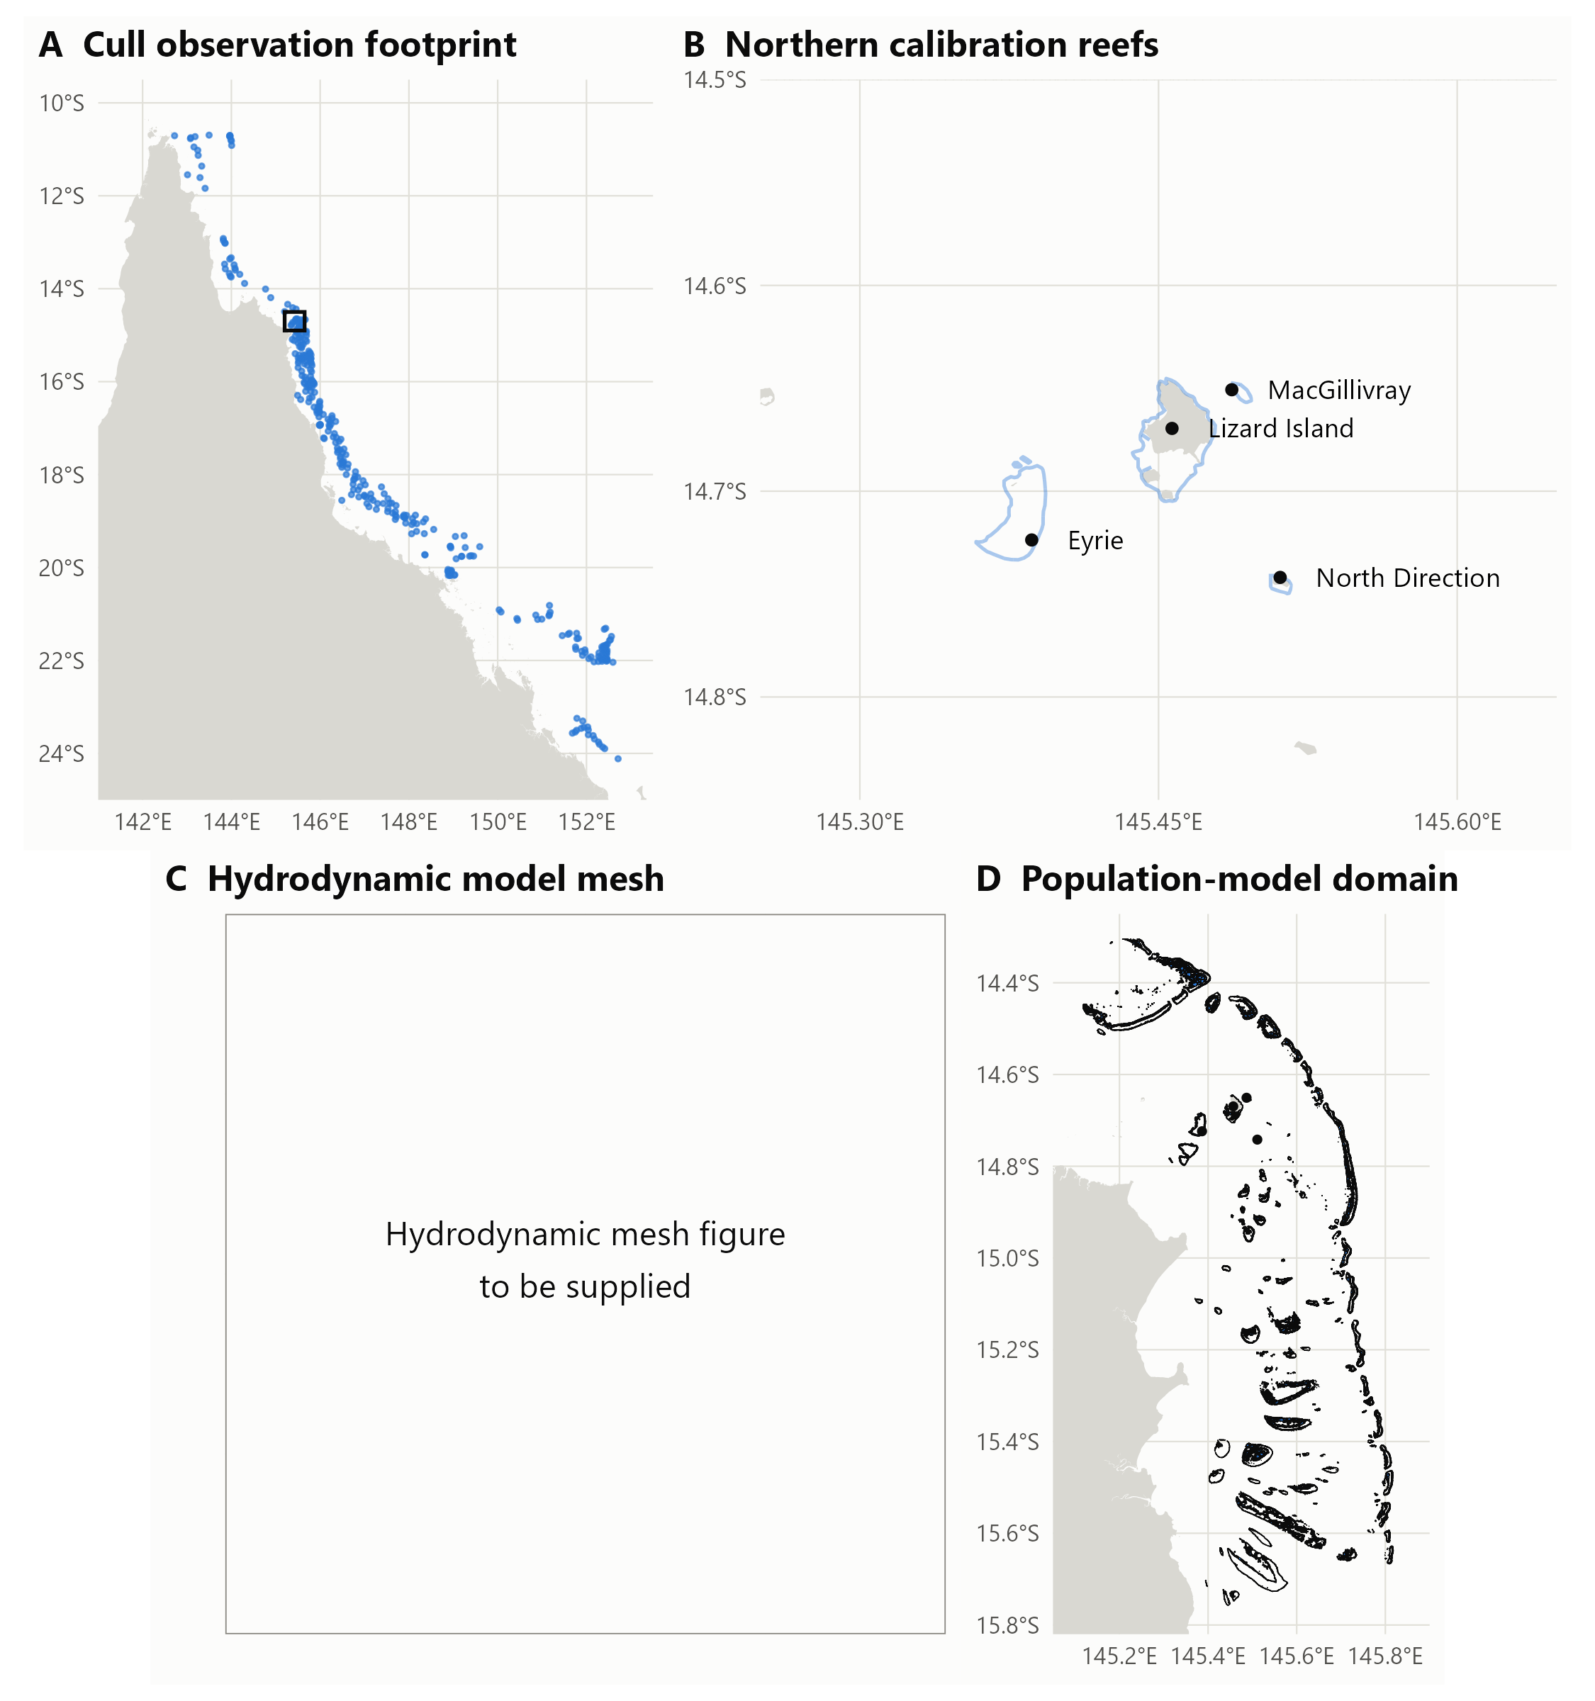
Figure 1: Study areas and observations. A: reef locations with georeferenced cull records in the archived 2002–2026 data, available for habitat modelling; symbols summarise locations by reef. B: Lizard Island, Eyrie, MacGillivray and North Direction, whose monitoring series informed population-model calibration. C: reserved for the hydrodynamic mesh figure, to be supplied. D: the 2,895 sub-reef polygons on 113 reefs in the population model’s v0.4 GeoPackage. The panels describe data and model support, not independent validation or new fieldwork. Fine-scale hydrodynamic transport has not yet replaced the population model’s reef-level connections.

Testing habitat and recent-evidence rankings
Habitat models ranked locations within reefs. The operational ranking combined a site’s habitat with the preceding season’s cull and nearby manta evidence through a logistic regression. Its score was:
$$\begin{matrix}s_{i} & =β_{0}+β_{H}H_{i}+β_{P}P_{i}+β_{Q}Q_{i}+β_{R}R_{i} \\ & +β_{E}log\left(1+E_{i}\right)+β_{M}log\left(1+M_{i}\right)+β_{T}log\left(1+T_{i}\right).\end{matrix}$$ | (1)
Here $H_{i}$ is the mean habitat score inside site $i$, ranked among designated sites on its reef. $P_{i}$ records whether any recent dive there reached CPUE ≥0.02; $Q_{i}$ records a searched site where none did. $R_{i}$ is the distance-weighted proportion of nearby dives reaching ≥0.02; $E_{i}$ is the weighted count of dives. $M_{i}$ and $T_{i}$ are weighted counts of strong-evidence and all nearby manta tows. Nearby records receive decreasing weights out to 900 m. Coefficients ($β$) were estimated jointly from dive outcomes at ≥0.02, rather than assigned as rules. All sites were ordered by decreasing score on each reef. Appendix G gives the distance equation, coefficients, missing-data treatment and priority classes.
The score incorporates crew behaviour as well as habitat. Evaluation used habitat fits that withheld the reef’s group. For 2019–2026, the evidence regression used only earlier seasons; the habitat component was spatially held out but was not also restricted to earlier years.
Comparisons kept candidate-site coverage or high-density-dive retention equal. All designated sites were candidates, including never-dived sites; outcomes at unvisited sites remained unknown. Random selection provided exact expectations at the same site count. Repeated visits meant equal site counts did not imply equal numbers of recorded dives or equal time. Class-specific retention or avoidance used all dives in that CPUE class as its denominator; deferred-dive composition instead used all deferred dives. Manta surveys were also compared with evenly spaced thinning of linked strong-evidence tows. Tow order was approximated from position, so thinning assessed existing surveys rather than new routes.
We evaluated 80%, 90%, 95% and 99% high-density retention and the product’s A–C rule, which selects sites with descending rank divided by reef site count ≤0.8. Separate spatial estimates counted whole tow segments and straight-line distance lying only within deferred sites. Surveillance outside designated polygons or overlapping retained sites remained. These estimates assumed retained cull visits still occurred. Uncertainty resampled whole reef-years; Appendix G documents interpolation, integer rounding, geometry exclusions and the 500 paired bootstrap draws.
Three pre-specified alternatives changed the prior high-density indicator, added recency-weighted CPUE, and replaced mean habitat with its within-site 90th percentile. Their evidence fits were tested forward on the same cohort; Appendix M gives definitions, controls and the distinction between candidate sites, recorded dives and bottom time.

Seasonal search products
The 2027 ranking used the latest available 12 months, June 2025–May 2026, and assigned sites to classes A–D. Exploration areas marked high-ranked habitat outside designated sites and recent tow paths (Figure 2). Annual or pre-closure checks of deferred sites, triggered revisits and exploration must be counted when testing annual effort and detection.

Figure 2: Batt Reef and Eyrie Reef: 2027 cull-site priority, manta tows of the last five seasons (blue) and exploration areas (purple, numbered by rank) over satellite imagery. A (red) is the top 20%, B the next 30%, C the next 30% and D (grey) the bottom approximately 20% of sites on each reef; integer site counts can shift these percentages. The proposed pathway defers D on a routine visit and retains A–C, with annual or pre-closure checks of deferred sites. Table 12 reports that cutoff’s retrospective cull-dive trade-off; Table 13 separately estimates manta effort. These maps illustrate the rule, rather than showing measured performance at Batt or Eyrie in 2027.

Water movement and larval connections
The dispersal assessment compared daily mean larval concentrations at ages 5, 9 and 10 days for 10 releases during December 2022–January 2023. Values were averaged by area to sub-reef sites and reefs, then ranked within releases. Hotspot persistence and cross-shelf patterns described relative exposure, without identifying origins, settlement or source-to-destination connectivity. Appendix K gives the comparisons.
[TO WRITE: Sev and Owen — provide hydrodynamic resolution, forcing, particle releases, larval biology, observational checks, boundary treatment and the completed connectivity-matrix methods. Distinguish delivered matrices and network tests from planned work.]

Connected COTS and coral populations
The Lizard Island prototype represents 2,895 sites on 113 reefs. COTSMod supplies population stages, predation and larval processes; ADRIA handles the spatial domain and disturbances, coupled to CoralBlox coral dynamics (Matthews et al. 2020a; open-AIMS 2026b, 2026a; de Almeida et al. 2026). Transport remains reef-to-reef; fine-scale hydrodynamic connections have not replaced it.
Calibration compared irruption timing, size, troughs and coral change on four monitoring reefs. Recorded culling was applied as removals limited by available animals. Paired scenarios used matching environmental forcing and random seeds. Initial projections linked diver-hours to removals through a density-dependent catch rate and compared control effort under two climate pathways through 2050. Appendix I describes the current calibration and projections; Appendix G retains equations, assumptions and the planned assessment of culling since 2012.

Engagement with Rights-holders and Management Stakeholders
GBRMPA meetings throughout the project guided delivery, including the decision to rank designated cull sites. Earlier informal feedback also informed map formats, uncertainty communication and integration with existing planning systems. The progress report records November discussions with Malu Ventures and Jabalbina about interpretation and operator use.
Engagement with Malu included an April 2026 visit and June follow-up. Fine-scale observations were collected for a standalone Far Northern species distribution model planned for future development; they were not used to fit the models assessed here. A final delivery workshop is planned for 5 November 2026. Trials of habitat plus recent-evidence rankings are planned aboard BPM in Cairns and with Malu in the Far Northern GBR and Torres Strait during January–February 2027. These trials will compare the recommendations with crew practice and record detection, effort and follow-up at deferred sites.

Results

GBR fine-scale habitat predictions

Habitat layers: a consistent first ordering on every reef
The habitat layers provide a first search order across the GBR, including reefs with little recent evidence. Their absolute values vary with survey year and region (Figure 16); within reefs, the cull-trained layers place their highest ranks along reef margins and outer slopes (Figure 3).
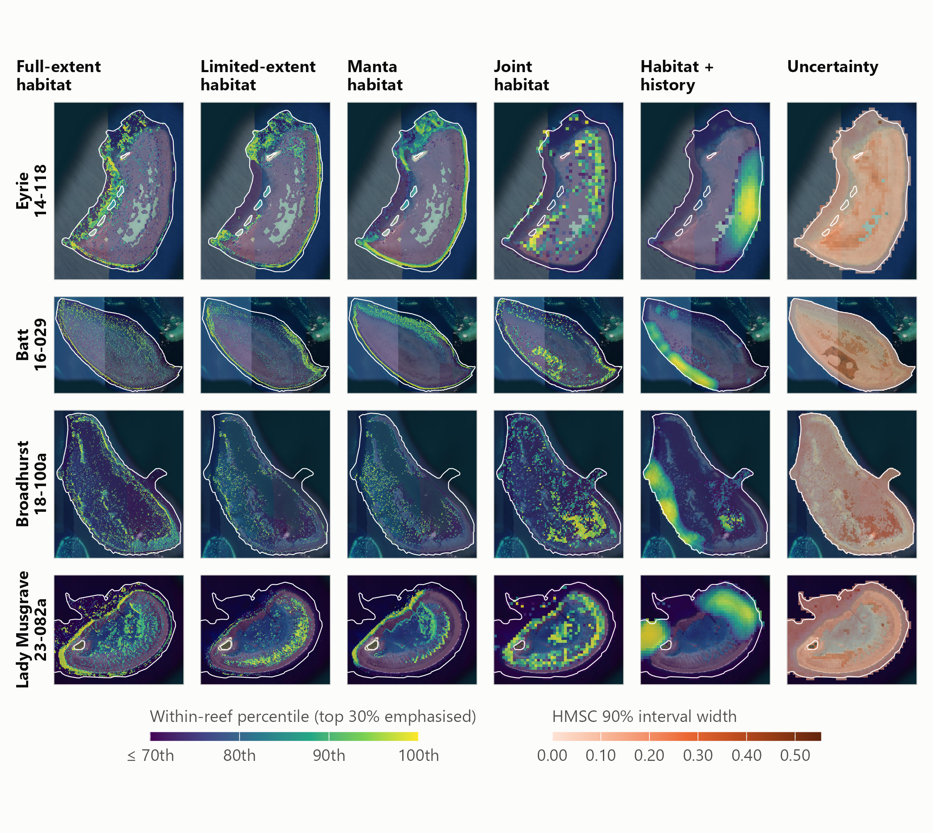
Figure 3: Within-reef habitat ranks on Eyrie, Batt, Broadhurst and Lady Musgrave reefs. Columns show the full-extent and limited-extent cull-trained models, the manta-trained model, the joint habitat model, habitat updated with cull history for 2027, and joint-model uncertainty (90% posterior interval width). The top 30% of each reef is emphasised. Satellite imagery: Esri World Imagery; full attribution is in Appendix H.
On their own, the layers discriminate modestly between places on the same reef. On independent manta tows, the limited-extent habitat model reached a within reef-year AUC of 0.576 (95% CI 0.548–0.602) (Table 18, Figure 17). It placed 23% more strong-evidence tows in each reef’s top-ranked 20% than chance. The manta model, trained on tows but scored leave-reef-out, reached 0.612 (95% CI 0.578–0.636) (Appendix H).

Predicted habitat and recent evidence increase cull-site search efficiency
Combining recent cull and manta observations with habitat improved cull-site selection compared with habitat alone. This pattern held across seasons (Appendix H). The assessment compared sites selected for cull dives and the share of observed high-density dives (>0.04 CPUE) they retained. In the test over 2019–2026 (28,431 dives in 861 reef-years), retaining 80% of those dives required selecting 66.6% (95% CI 62.0%–71.1%) of designated sites with habitat estimates plus recent observations; retaining 90% required 80.1% (95% CI 73.9%–85.2%). Both required fewer sites than habitat alone or random selection at the same retention (Appendix H, Table 12).
At the proposed A–C cutoff, avoiding the bottom approximately 20% of sites removed 18.8% (95% CI 17.4%–20.3%) of low-density cull dives (positive CPUE <0.02) and 23.5% (95% CI 21.8%–25.3%) of ghost cull dives (zero COTS). It retained 88.4% (95% CI 86.7%–90.1%) of dives from 0.02 to 0.04 inclusive. Retaining this intermediate group is useful: those dives remain suitable culling opportunities even though the assessment gives highest priority to retaining dives above 0.04.
Search reductions became smaller as retention increased. Retaining 95% required 90.2% (95% CI 85.4%–93.4%) of sites with the combined ranking, avoiding 8.9% of low-density dives and 11.2% of ghost dives. Retaining 99% required 98.2% (95% CI 97.2%–98.7%) of sites and avoided only 1.8% and 2.2% of those dive classes, respectively.
Deferring class D, the bottom-20% rule shown in Figure 2, selected 78.9% (95% CI 78.8%–79.0%) of cull sites and retained 89.1% (95% CI 85.4%–92.5%) of observed >0.04 dives. It initially omitted 10.9% of those dives. This is close to the 90% retention option. Random selection of the same number of sites retained 78.5% (95% CI 78.3%–78.8%) of high-density dives. Annual or pre-closure checks could recover missed populations, but their success and additional effort were not evaluated (the operational impact pathway).
Equal candidate-site counts did not represent equal dive effort. The ranking deferred 14.9% (95% CI 12.9%–16.9%) of recorded dives, compared with 21.6% (95% CI 21.4%–21.8%) under random site selection, because it retained more repeatedly visited sites. Of its 4,248 deferred dives, 55.2% were ghost or low-density, compared with 39.7% under random selection. Table 1 gives all four classes. These composition percentages use deferred dives as their denominator, unlike the class-specific retention and avoidance percentages above. The comparison shows better protection of useful culling opportunities at equal candidate-site coverage; it does not compare equal dive counts or measured search time.
Table 1: Retaining classes A–C and deferring D, 2019–2026. Percentages [95% reef-year bootstrap intervals]. Both rankings select the same candidate-site count, not the same recorded dive count. Upper rows use all sites, all dives or all dives in the stated CPUE class as their denominator. Lower rows describe the composition of deferred dives and sum to 100% in each column. Tow reductions are conditional spatial estimates before annual checks and exploration, assuming retained cull visits still occur. Full matched-retention comparisons are in Appendix H.
Outcome | Habitat + recent observations | Random selection
Candidate cull sites selected | 78.9 [78.8–79.0] | 78.9 [78.8–79.0]
All recorded dives avoided | 14.9 [12.9–16.9] | 21.6 [21.4–21.8]
Dives above 0.04 CPUE retained | 89.1 [85.4–92.5] | 78.5 [78.3–78.8]
Dives at 0.02–0.04 CPUE retained | 88.4 [86.7–90.1] | 78.5 [78.3–78.6]
Low-density dives avoided (0 < CPUE <0.02) | 18.8 [17.4–20.3] | 21.6 [21.5–21.8]
Ghost dives avoided (CPUE = 0) | 23.5 [21.8–25.3] | 21.9 [21.7–22.2]
Whole manta tows potentially avoided | 11.6 [11.1–12.1] | 10.0 [9.6–10.3]
Manta distance potentially avoided | 16.2 [15.6–16.9] | 15.9 [15.4–16.4]
Composition of deferred dives
Ghost: CPUE = 0 | 28.5 [24.4–33.0] | 18.4 [16.0–20.9]
Low: 0 < CPUE <0.02 | 26.7 [23.0–30.8] | 21.3 [18.9–23.7]
Intermediate: 0.02 ≤ CPUE ≤0.04 | 11.9 [10.3–13.8] | 15.4 [14.1–16.6]
High: CPUE >0.04 | 32.9 [25.0–40.7] | 44.9 [39.7–49.3]

Habitat alone separated locations with and without COTS only weakly. Its practical contribution was to cover places where recent observations were absent: 67% of designated sites in the 2027 product were on reefs without dives or tows in the preceding 12 months. Those sites relied on habitat and should be treated as initial search priorities. Past observations carried most of the information on recently visited reefs, but also reflected where crews chose to work. Maps, habitat comparisons and tests beyond the familiar footprint are in Appendix H.
Manta surveillance required a separate effort estimate (Table 1; Appendix H). At the A–C cutoff, 11.6% (95% CI 11.1%–12.1%) of recorded tows lay entirely within deferred-only sites, and 16.2% (95% CI 15.6%–16.9%) of recorded straight-line tow distance lay within those sites. The distance estimate allows shortening a tow; the tow-count estimate omits only whole segments. Both keep surveillance outside designated sites and in any overlap with retained sites. The >0.04 retention values describe cull dives at selected sites, conditional on those dives still occurring. They do not establish detection after removing the corresponding manta surveillance, or annual savings after follow-up and exploration.
In the retrospective manta comparison, habitat-only selection did not outperform evenly spaced thinning. That comparison is an analytical benchmark; practical searches require crew judgement and recent observations alongside habitat. Appendix H retains the surveillance comparisons.

Three alternative rankings
Adding recency-weighted site CPUE was the most promising alternative to the current ranking. At the same A–C site coverage, it retained 90.5% (95% CI 87.2%–93.2%) of >0.04 dives, compared with 89.1% (95% CI 85.6%–92.1%). At matched 90% high-density retention, it avoided 14.7% (95% CI 11.9%–16.8%) of recorded dives versus 13.8% (95% CI 11.5%–15.8%). The paired gain was +0.89 [-0.08 to +1.97] percentage points, so a clear improvement in dive efficiency remains uncertain. The 90th-percentile habitat alternative did not improve on recent CPUE with mean habitat and performed worse in 2024–2026. A separate recent-CPUE layer is supplied for experimental comparison; the current ranking remains the default. Appendix M reports all three options and habitat-summary tests.

Seasonal products and exploration
The delivered ranking covers 15,884 designated sites on 576 reefs. Its map shows search priority and the recent evidence behind each site.
The product also identifies 3,807 exploration areas on 488 reefs, outside designated sites and recent tow paths (Figure 2). These allow operators to direct some effort toward overlooked habitat. Historical observations on new ground supported investigating such gaps, but the proposed exploration areas themselves have not been trialled. Their detection yield and the annual effort required for added searches and deferred-site checks remain to be estimated or measured.

Preliminary larval dispersal patterns vary across the reef cluster
The larval-concentration maps showed uneven exposure to simulated larvae across 2,895 sub-reef sites on 113 reefs during the 2022–23 spawning season. Persistent day-10 hotspots were concentrated on mid-shelf reefs south of the Lizard Island group, including Williamson, Mackay and Osterlund (Figure 4). Reefs toward the northern end of the domain generally ranked lower.
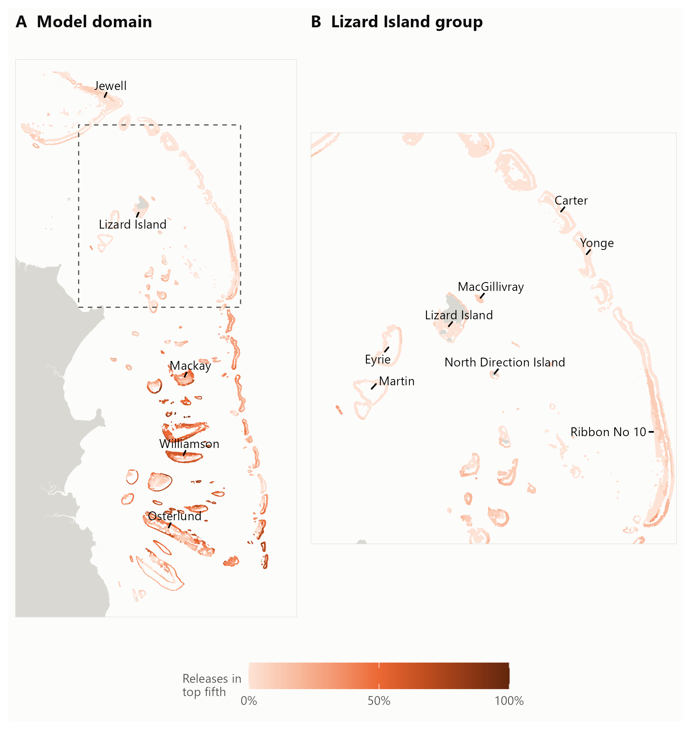
Figure 4: Persistence of simulated larval-concentration hotspots at day 10, across the model domain (A) and around Lizard Island (B). Colour shows the proportion of releases in which a sub-reef site ranked in the highest fifth of concentration within that release. The dashed box marks the enlarged area; grey shows land. This reformats concentration figure lc2 from the project analysis. High concentration does not by itself establish local retention, source strength or settlement.
The Lizard Island group was not a persistent concentration hotspot at the later larval ages examined. Some releases produced higher concentrations around Lizard earlier in development, but these peaks generally did not persist (Appendix K). This may partly reflect the domain boundary, which excludes larval sources on reefs outside the model.
Cross-shelf patterns differed along the domain. In its central part, later-age concentrations were generally higher on mid-shelf reefs than on Ribbon Reefs at similar latitudes; the southern Ribbon Reefs did not show the same deficit. The mid-shelf–Ribbon contrast qualitatively matches the irruption contrasts in the regional monitoring checks (Appendix I), while the one-season concentration result remains sensitive to the domain boundary.
Following this project, network analysis will examine when reefs in the initiation box exchange larvae within tightly connected groups, and when groups become relatively isolated. Combining these results with larval-concentration patterns could identify periods and locations favourable to irruption initiation or escalation and feed into an early-warning system. The planned work will compare these signals with long-term monitoring and reef-level irruption estimates (Stewart et al. 2026). Appendix K describes the network tests needed to assess this use.

Historical COTS and coral dynamics provide a basis for testing control strategies
The updated metacommunity model reproduced the broad sequence of historical irruption waves and coral decline and recovery on the four calibration reefs (Figure 5). The comparison used 5 random-seed pairs, with additional parameter tests giving 65 runs each with and without recorded culling. Lizard Island’s first (1990s) COTS peak remains too small, and coral trajectories differed from the surveys in some periods. Manta and photo-transect coral estimates also differed because they sampled different parts of the reef. Initial effort scenarios through 2050 reduced simulated near-term COTS peaks, but coral gains varied among reefs and climate pathways; these exploratory comparisons demonstrate capability rather than likely outcomes (Appendix I).
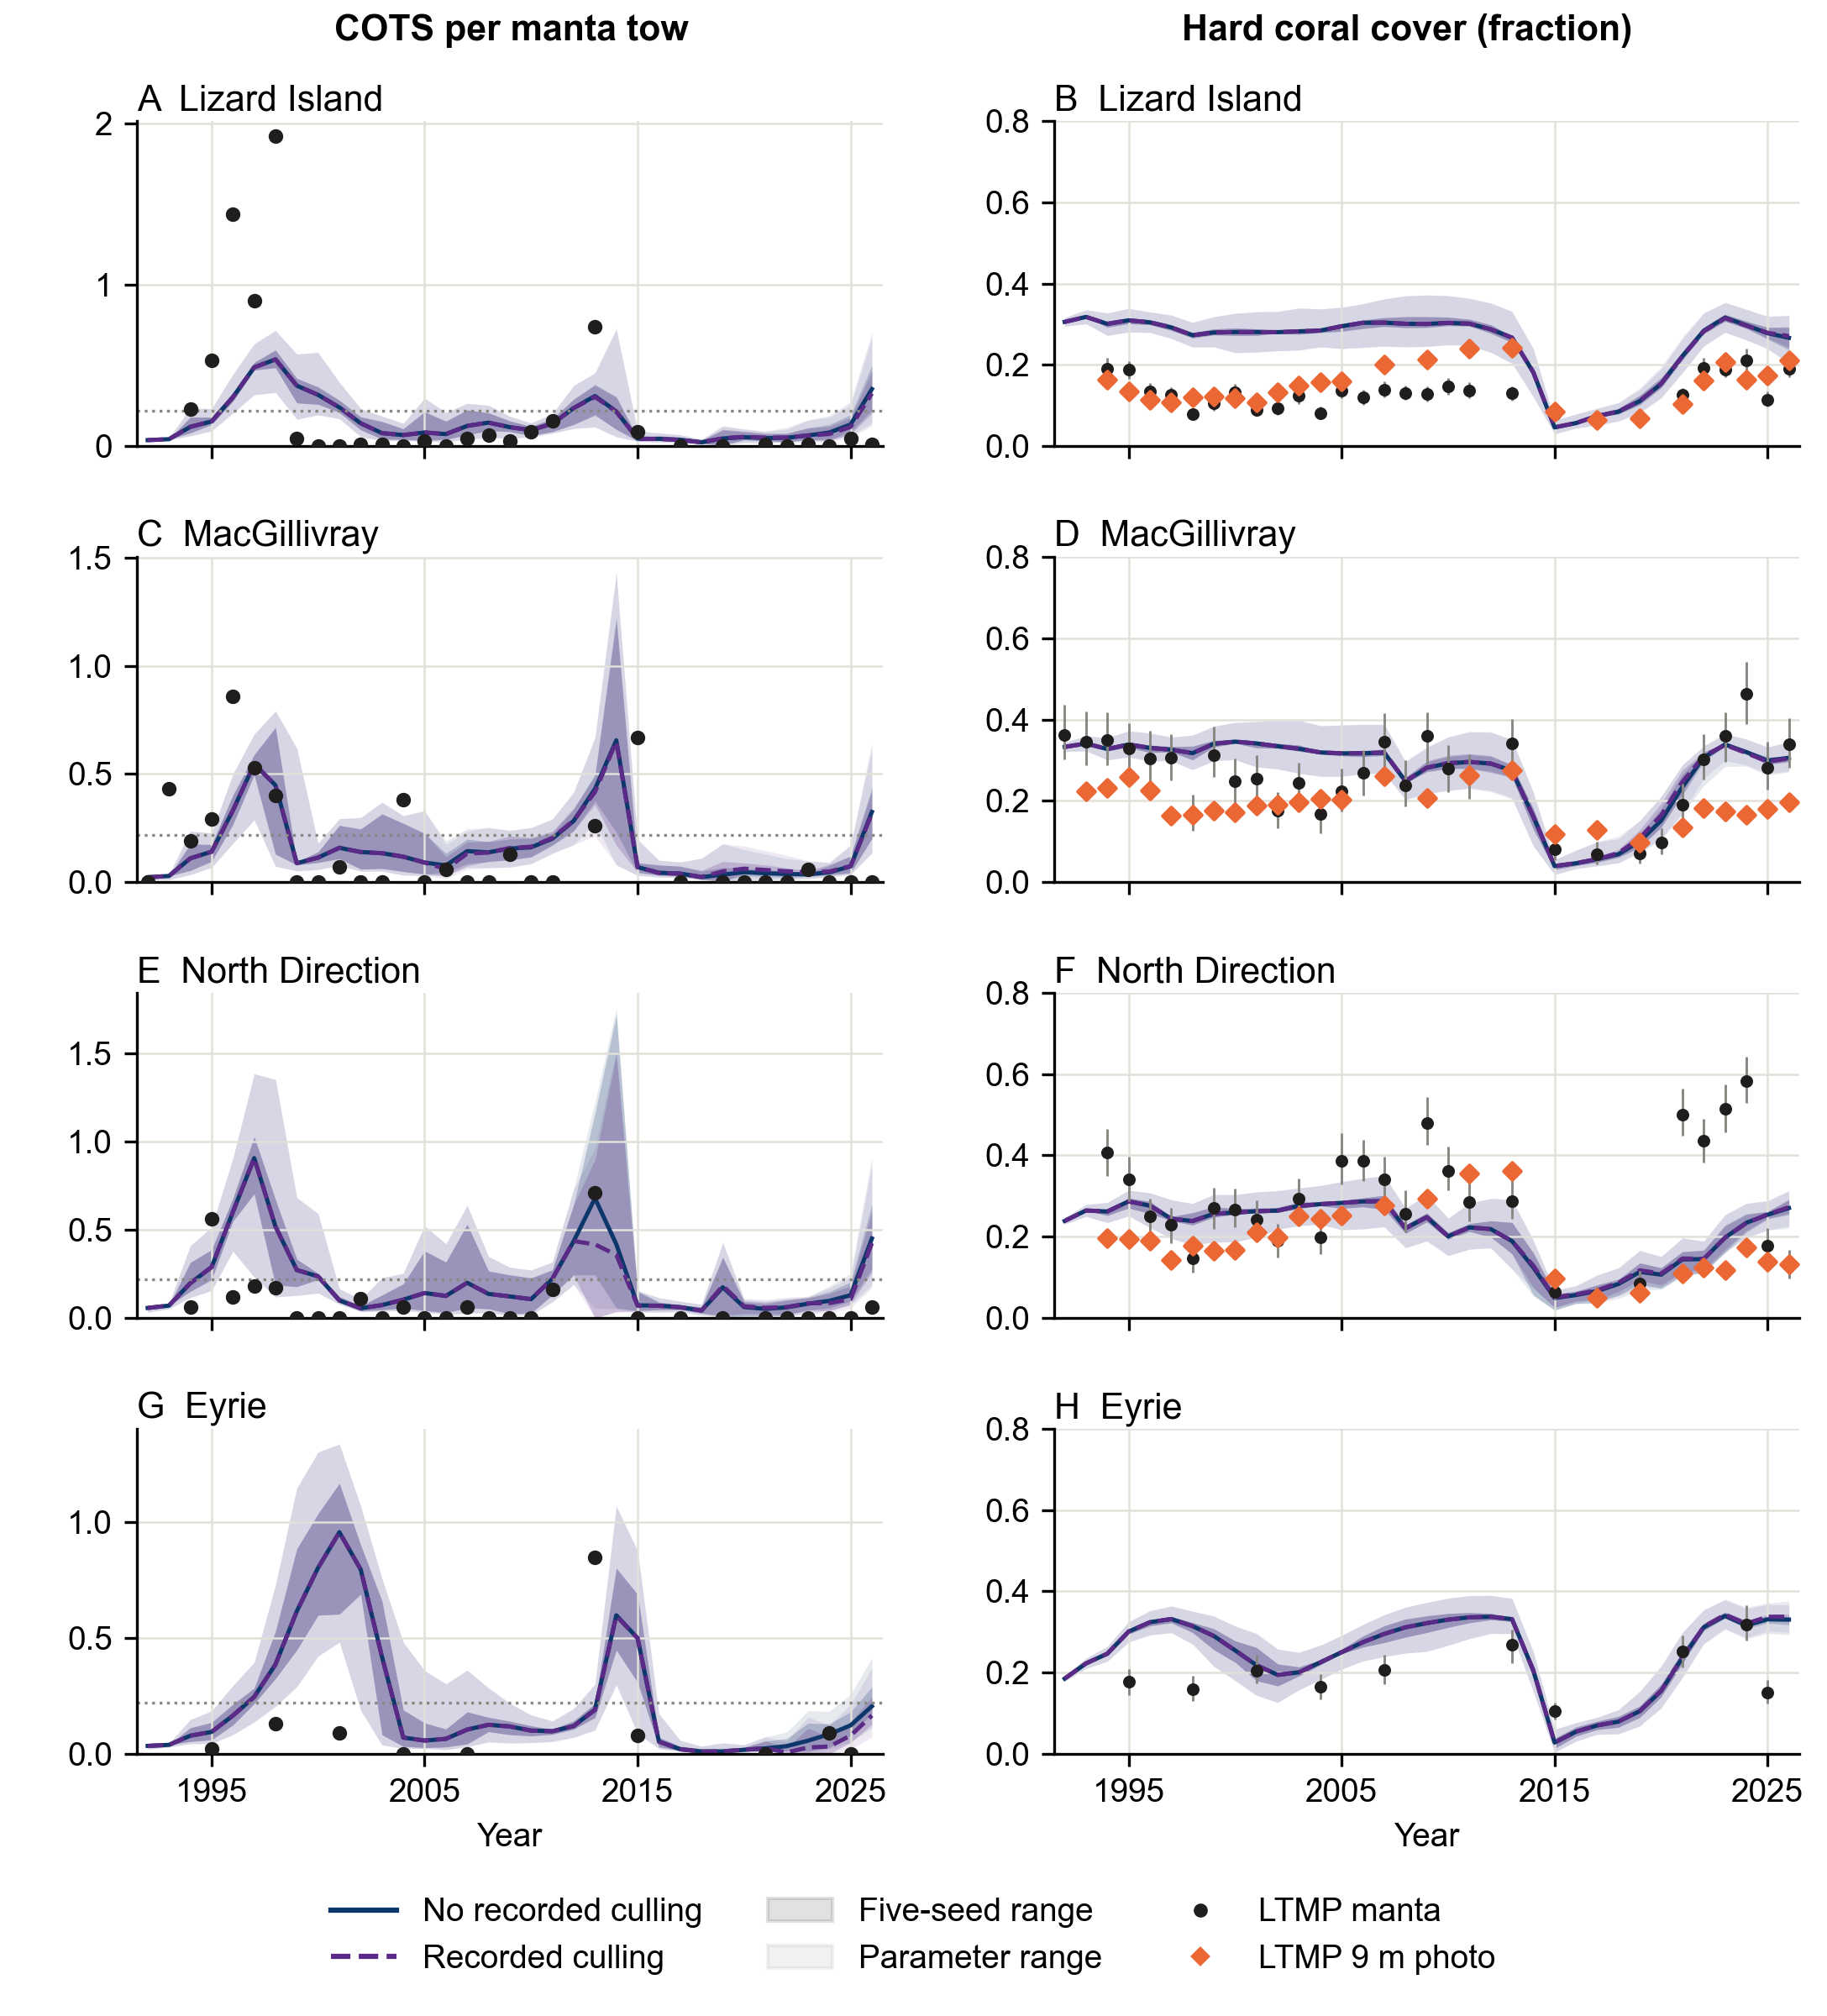
Figure 5: Historical COTS and coral dynamics on the calibration reefs, combining source Figures 1 and 4 from the 21 October snapshot. Left: manta-tow equivalents (dotted line: 0.22 COTS per tow). Right: hard coral cover, modelled relative to habitable area. Blue solid lines omit recorded culling; purple dashed lines apply it. Lines are five-seed means; darker bands span those seeds and lighter bands span all 65 parameter-test runs per culling state. These ranges are not confidence intervals. Black points show LTMP manta observations (coral bars: reported 95% intervals); orange diamonds show 9 m photo-transects. Survey supports differ. These are calibration and diagnostic comparisons.
The model represents the build-up of the fifth primary irruption wave, but exceeds observed densities on several reefs. This overshoot could understate the relative effect of contemporary culling, a sensitivity that requires testing. The paired culling trajectories demonstrate the model’s response to recorded removals; they do not yet provide an independently validated estimate of the program’s impact since 2012.

Discussion & Outputs

Combining recent observations with habitat
The main tactical finding is that recent observations improve the order in which designated cull sites are searched, while habitat supplies an initial ordering where observations are absent. This extends the program’s existing use of surveillance and crew knowledge (Fletcher et al. 2020; Matthews et al. 2025). The maps make that information more consistent and available across vessels. Their value lies in the comparison with random or simpler selection at the same effort, rather than in the reduction obtained simply by omitting sites.
Habitat alone ranked locations on the same reef weakly. This is compatible with reef-level distribution studies showing the importance of connectivity and conditions associated with irruption development (Matthews et al. 2020b; Stewart et al. 2026). Static terrain and coral habitat cannot describe the current stage of an irruption, recent removals or movement of aggregations. The recent-evidence ranking captures some of those changes, but also captures where crews chose to work. It should be interpreted as operational knowledge combined with habitat, rather than independent confirmation that a preferred location holds COTS.
The distinction matters most on rarely visited reefs and beyond designated sites. Prioritising repeated finds can continually direct effort towards the same footprint. Exploration areas provide a way to examine suitable habitat outside it, including lagoon patches and other places poorly covered by perimeter surveillance. Those areas remain hypotheses about useful search locations. Records from new ground support investigating such gaps, but do not establish the detection yield of the proposed areas. Recording nil observations and effort will be as important as recording finds.

Retention, surveillance and the cost of deferral
The A–C rule offers a concrete entry point for operational testing. It retains approximately nine in ten observed high-density dives while selecting approximately four in five candidate cull sites. Most dives from 0.02 to 0.04 are also retained, preserving useful culling opportunities below the ecological target. Ghost and low-density dives form a larger share of the deferred set than under random site selection. Low-density avoidance is lower than random selection, however, and ghost-dive avoidance improves only slightly. The ranking also keeps more recorded dives overall at the same site count. The comparison supports protection of useful dives at equal candidate-site coverage; Appendix M makes the additional comparison at equal recorded dive effort. Remaining high-density omissions require agreed tolerances and follow-up. The relevant target also depends on coral cover and the purpose of control (Plagányi et al. 2020; Matthews et al. 2024).
The separate manta estimate improves the interpretation of effort. Fewer cull sites selected does not translate directly into the same percentage fewer tows, because recorded segments cross site boundaries and include surveillance elsewhere. The geometry calculation preserves portions needed by retained sites and all portions outside designated sites, including nearby tows that do not intersect them. This conservatively limits the spatial accounting; further reductions outside polygons may be possible, but their feasibility and detection consequences are untested. The estimate does not show that crews would make the same dive decisions after associated manta evidence was removed, nor whether a shortened route saves vessel time.
Recent CPUE may improve prioritisation, but its extra gains were modest and varied among seasons. At matched retention it also kept slightly fewer intermediate dives than the current ranking. The experimental layer supports a direct field comparison rather than a replacement recommendation. Upper habitat percentiles did not strengthen the ranking in this test; this does not establish that real within-site hotspots are absent. Their value may depend on how the mapped habitat aligns with the areas crews actually search.
The retrospective tow comparison reinforces the need for coverage. Habitat-only selection did not outperform evenly spaced thinning, although the latter is an analytical benchmark based on recorded surveys. Practical route planning must account for workability, travel, crew judgement and recent observations. A poor result for habitat-only thinning does not remove habitat’s role in identifying additional places to search; it does rule out claiming that the habitat score alone supplies an improved exclusion rule.
Annual full surveys, pre-closure checks and revisits triggered by new evidence could detect populations initially deferred. They cannot guarantee that a missed aggregation will be found before coral is consumed. Later detections may also represent new population growth rather than an original false negative. An initial audit of deferred sites, together with dated follow-up and a maximum acceptable delay, is needed to distinguish these outcomes. Full-season effort must include those checks, repeat dives and exploration. January–February 2027 trials should test the ranking against normal crew planning before an annual saving is claimed.

Using connected population models for strategic decisions
The metacommunity strand addresses a different management scale: how culling on one reef affects COTS and coral there and on connected reefs. Reef-scale ecosystem models have already established the importance of comparing control strategies under interacting disturbances (Morello et al. 2014; Condie et al. 2021; Bozec et al. 2022). This prototype builds on COTSMod within a framework that can connect site-level habitat, population processes and intervention scenarios (Matthews et al. 2020a; open-AIMS 2026a). Keeping the COTS equations in a reusable package also allows their use in other modelling frameworks.
The historical comparisons provide evidence that the framework can reproduce broad irruption cycles and respond to recorded removals. They remain calibration and diagnostics. Peak sizes, densities between waves and the recent build-up depend on coral assumptions and the relationship between manta observations and true abundance. Recent cull and diver observations also informed the corrected larval inputs, so agreement with those observations is not independent validation. The excess simulated COTS carried into the near-term projections could affect the apparent benefit of culling. That sensitivity needs testing before estimates of coral protected are used in decisions.
The intended assessment of control since 2012 must compare paired histories beginning from the same population and coral state. Holding outside larval supply constant estimates the effect of control inside the model domain under unchanged outside conditions. A regional no-control history instead needs outside supply consistent with no control on those reefs. Those are different questions, and the existing reef-level irruption predictions do not supply the second counterfactual by themselves. Requested catches that exceed simulated availability must also remain visible, rather than being treated as successful removals.
For the fifth primary irruption wave, the useful comparison is among feasible allocations of present capacity, additional effort and rules for beginning or stopping control. A reef with little coral left to protect may still supply larvae to neighbours. Conversely, fewer COTS need not yield lasting local coral gains if heat stress or cyclones remove the spared coral. Scenarios must therefore follow larval export, downstream populations and coral recovery as well as local catches. The initial projections demonstrate this capability; they do not yet identify a preferred management strategy.
Larval-concentration hotspots provide a complementary regional signal, but concentration is not equivalent to settlement, local retention or source strength. Release-specific networks, distance-based comparisons and explicit tests of the northern boundary are needed before a hydrodynamic early-warning interpretation is supported. The metacommunity model still uses reef-level transport. Coupling the new habitat layers or fine-scale connections to intervention decisions is a subsequent test, rather than a completed integration. Appendix L retains the scenario and field-assessment design.

Final project outputs
The outputs and their current evidence status are:
- GBR-wide 30 m habitat-suitability and search-priority layers, with a separate layer showing known aggregation locations and accompanying uncertainty products.
- The 2027 designated cull-site ranking and exploration-area products in CSV and KMZ formats, supported by spatial and season-by-season evaluation; a separate recent-CPUE candidate is available in CSV, GeoPackage and KMZ for experimental comparison.
- Retrospective surveillance and cull-site comparisons, including the >0.04 retention assessment and separate conditional tow-effort estimates; operational deployment remains to be trialled.
- Lizard Island larval-concentration products and a reproducible COTS–coral metacommunity prototype with calibration diagnostics and initial control scenarios; fine-scale network delivery and independent validation remain open.
- This technical report and documented analysis workflows. Public repository registration, release identifiers and the final rights-holder information package require completion (Appendices E and F).

Outcomes & Impact Pathway

More efficient control through operational testing
The Work Plan selects CCIP Outcome 2, a more effective, efficient and scalable response to COTS irruptions, and Outcome 4, decisions informed by biophysical and predictive knowledge. The project contributes through explicit search priorities, measurable trade-offs and a platform for strategic comparisons. The outputs establish capability; reduced annual costs, improved detection and additional coral protection are intended outcomes that have not yet been demonstrated.
For Outcome 2, the immediate users are Control Program managers, vessel planners and dive teams. The ranking converts habitat and recent observations into a common site order that can be refreshed each season. This supports testing whether repeat searches at lower-priority sites can be deferred and whether some effort can be redirected to overlooked habitat. The 10–15% proposed reductions in surveillance searches and low-density or empty dives remain adoption targets. They require an agreed allowance for missed >0.04 dives, reliable follow-up coverage and a complete account of effort.
Repeated GBRMPA meetings shaped delivery, including the choice to rank designated cull sites. This aligns the product with locations crews already recognise and record, while the exploration component addresses the limits of that register. The planned 5 November 2026 workshop will support final interpretation and agreement on delivery and integration. Product files can support Field Maps and COTS Dashboard workflows, but the report does not claim that either integration or routine uptake is complete.

Co-interpretation with rights-holders and operators
The engagement described in Methods provides a direct pathway to testing usefulness with Traditional Owner operators. Malu’s April visit and June follow-up also collected fine-scale observations for a future standalone Far Northern model. Those observations are an additional resource for subsequent work, rather than evidence validating the current GBR-wide ranking. Clear separation of the two avoids overstating where the delivered models have been tested.
January–February 2027 trials are planned aboard BPM in Cairns and with Malu in the Far Northern GBR and Torres Strait. They will compare habitat plus recent evidence with normal planning, record departures from the recommended order and assess how crews interpret low ranks. Independent checks of deferred sites will help estimate initial false negatives; annual and pre-closure checks will assess later detection and delay. All follow-up and exploration effort must enter the seasonal comparison. Agreement on monitoring ownership, reporting and the acceptable omission rate is needed before trial findings can support adoption.

Predictive knowledge for cluster-scale management
For Outcome 4, the population model and dispersal analyses provide a framework for comparing control across connected reefs, including cases where local and downstream benefits differ. The intended users include GBRMPA planners and researchers developing control scenarios. The next steps are to resolve the recent population mismatch, complete independent checks and agree feasible effort and external-supply assumptions before estimating program impact since 2012 or recommending fifth-wave suppression strategies.
The delivery pathway therefore links documented consultation to field testing, repeatable evaluation and only then wider use. Suitable metadata, accessible product versions and clear limits are necessary for other researchers and managers to reproduce the comparisons. Data access and outstanding release requirements are stated below. No benefit is attributed to a model merely because it produces a map or a scenario trajectory.

Conclusions & Next Steps
This bridging project established a repeatable way to combine fine-scale habitat with recent operational evidence, rank every designated cull site and identify habitat beyond the usual search footprint. Recent observations supplied most of the tactical gain. Habitat alone discriminated weakly within reefs but provided coverage where current evidence was absent.
The proposed A–C cutoff makes the management choice explicit: it selected 78.9% of candidate sites and retained 89.1% of observed >0.04 dives. Conditional spatial estimates suggest reductions in whole manta tows and distance, but the initially missed high-density dives and the effort of annual checks prevent treating these as established annual savings. The next operational step is the planned January–February 2027 vessel trial, with an agreed omission allowance, checks of deferred sites and comparison against normal crew practice.
At cluster scale, the COTS–coral prototype and larval-concentration products extend the capacity to ask where control could protect local and downstream coral. Independent validation, the recent population-state mismatch, boundary supply and feasible effort must be resolved before historical program-impact estimates or fifth-wave strategies can guide management. Fine-scale hydrodynamic connections and habitat-informed control remain candidate extensions.
The most significant change is the availability of explicit, reproducible decisions and comparisons at the scale where crews search, together with a developing framework for their regional consequences. The final delivery workshop, rights-holder and operator co-interpretation, and transparent data releases will determine how those capabilities become useful routine practice.

Acknowledgements
The standard funding and Traditional Owner acknowledgements supplied by CCIP appear in the front matter. We acknowledge the Control Program crews and data custodians, Malu Ventures and Jabalbina participants, and GBRMPA colleagues whose observations and feedback informed the work. [TO CONFIRM: individual acknowledgements, permissions to name contributors and any additional funding or in-kind contributions beyond the standard statement.]

Data Accessibility
Operational cull and manta records are held by GBRMPA and remain subject to custodian access conditions. They are not redistributed here. AIMS Long-Term Monitoring Program observations and the habitat inputs retain their source access arrangements (Appendix B).
Derived layers, rankings, tables and code are organised in the documented pipeline with frozen input checksums (Appendix F). [TO CONFIRM: public or institutional repository URL, DOI, licence, metadata record, release identifier and restricted-data access procedure.] Registration in the COTS Information System or another agreed data-information system also needs confirmation. These requirements must be completed for a FAIR public release.

References
Bainbridge S, Coleman G (2024) ReefScan transom. Standard operating procedure number 15 (v1.08). https://doi.org/10.25845/HD2Z-KM55
Beeden RJ, Turner MA, Dryden J, Merida F, Goudkamp K, Malone C, Marshall PA, Birtles A, Maynard JA (2014) Rapid survey protocol that provides dynamic information on reef condition to managers of the great barrier reef. Environmental Monitoring and Assessment 186:8527–8540 https://doi.org/10.1007/s10661-014-4022-0
Bozec Y-M, Hock K, Mason RAB, Baird ME, Castro-Sanguino C, Condie SA, Puotinen M, Thompson A, Mumby PJ (2022) Cumulative impacts across Australia’s Great Barrier Reef: A mechanistic evaluation. Ecological Monographs 92: https://doi.org/10.1002/ecm.1494
Chandler JF, Burn D, Caballes CF, Doll PC, Kwong SLT, Lang BJ, Pacey KI, Pratchett MS (2023) Increasing densities of pacific crown-of-thorns starfish (acanthaster cf. Solaris) at lizard island, northern great barrier reef, resolved using a novel survey method. Scientific Reports 13:19306 https://doi.org/10.1038/s41598-023-46749-x
Chen T, Guestrin C (2016) XGBoost: A scalable tree boosting system. 785–794 https://doi.org/10.1145/2939672.2939785
Condie SA, Anthony KRN, Babcock RC, Baird ME, Beeden R, Fletcher CS, Gorton R, Harrison D, Hobday AJ, Plagányi ÉE, Westcott DA (2021) Large-scale interventions may delay decline of the Great Barrier Reef. Royal Society Open Science 8: https://doi.org/10.1098/rsos.201296
de Almeida PR, Crocker R, Tan D, Bairos-Novak KR, Ani CJ, Benthuysen JA, Robson BJ, Matthews S, Iwanaga T (2026) CoralBlox: A computationally efficient coral model for decision support. bioRxiv [Preprint] https://doi.org/10.64898/2026.04.13.718315
De’ath G, Fabricius KE, Sweatman H, Puotinen M (2012) The 27-year decline of coral cover on the Great Barrier Reef and its causes. Proceedings of the National Academy of Sciences 109:17995–17999 https://doi.org/10.1073/pnas.1208909109
Fletcher CS, Bonin MC, Westcott DA (2020) An ecologically-based operational strategy for COTS control: Integrated decision making from the site to the regional scale. https://nesptropical.edu.au/wp-content/uploads/2020/04/NESP-TWQ-Project-3.1.1-Technical-Report-2.pdf
Great Barrier Reef Marine Park Authority (2021a) GBR10 GBRMP Bathymetry. https://tiles-ap1.arcgis.com/8gXWSCxaJlFIfiTr/arcgis/rest/services/GBR10_GBRMP_Bathymetry/MapServer
Great Barrier Reef Marine Park Authority (2021b) GBR10 GBRMP Geomorphic. https://reef-geohub-ext-geohubgbrmpa.hub.arcgis.com/maps/2621ac24d749409395d7bb1dfdec5d5c/explore
Great Barrier Reef Marine Park Authority (2026) Crown-of-thorns starfish control program dashboard. https://www.gbrmpa.gov.au/our-work/programs-and-projects/crown-thorns-starfish-management/crown-thorns-starfish-control-program-dashboard
Guillaume AS, Ferrari R, Selmoni O, Mocellin VJL, Denis H, Naugle M, Howells E, Bay LK, Joost S (2025) Harnessing multiscale topographic environmental variables for regional coral species distribution models. Ecology and Evolution 15: https://doi.org/10.1002/ece3.71292
Matthews SA, Mellin C, Pratchett MS (2020b) Larval connectivity and water quality explain spatial distribution of crown-of-thorns starfish outbreaks across the Great Barrier Reef. Advances in Marine Biology 87:223–258 https://doi.org/10.1016/bs.amb.2020.08.007
Matthews SA, Shoemaker K, Pratchett MS, Mellin C (2020a) COTSMod: A spatially explicit metacommunity model of outbreaks of crown-of-thorns starfish and coral recovery. Advances in Marine Biology 87:259–290 https://doi.org/10.1016/bs.amb.2020.09.001
Matthews SA, Williamson DH, Beeden R, Emslie MJ, Abom RTM, Beard D, Bonin M, Bray P, Campili AR, Ceccarelli DM, Fernandes L, Fletcher CS, Godoy D, Hemingson CR, Jonker MJ, Lang BJ, Morris S, Mosquera E, Phillips GL, Sinclair-Taylor TH, Taylor S, Tracey D, Wilmes JC, Quincey R (2024) Protecting Great Barrier Reef resilience through effective management of crown-of-thorns starfish outbreaks. PLOS ONE 19:e0298073 https://doi.org/10.1371/journal.pone.0298073
Matthews SA, Beeden R, Bonin MC, Mellin C, Pratchett MS, Ryan I, Wilmes J, Williamson DH (2025) From business intelligence to conservation intelligence: Operationalising adaptive pest control to protect the resilience of the great barrier reef. https://doi.org/10.32942/X2HD3J
Morello EB, Plagányi ÉE, Babcock RC, Sweatman H, Hillary R, Punt AE (2014) Model to manage and reduce crown-of-thorns starfish outbreaks. Marine Ecology Progress Series 512:167–183 https://doi.org/10.3354/meps10858
open-AIMS ReefGuide.jl: Regional and suitability assessment functions. https://github.com/open-AIMS/ReefGuide.jl
open-AIMS (2026c) ADRIA.jl: COTS calibration and exploratory effort-based projections. https://github.com/open-AIMS/ADRIA.jl
open-AIMS (2026b) COTSMod.jl: Population dynamics and observed cull removals. https://github.com/open-AIMS/COTSMod.jl
open-AIMS (2026a) ADRIA.jl: COTS calibration and historical culling workflow. https://github.com/open-AIMS/ADRIA.jl
Ovaskainen O, Tikhonov G, Norberg A, Guillaume Blanchet F, Duan L, Dunson D, Roslin T, Abrego N (2017) How to make more out of community data? A conceptual framework and its implementation as models and software. Ecology Letters 20:561–576 https://doi.org/10.1111/ele.12757
Plagányi ÉE, Babcock RC, Rogers J, Bonin M, Morello EB (2020) Ecological analyses to inform management targets for the culling of crown-of-thorns starfish to prevent coral decline. Coral Reefs 39:1483–1499 https://doi.org/10.1007/s00338-020-01981-z
Pratchett M, Caballes C, Wilmes J, Matthews S, Mellin C, Sweatman H, Nadler L, Brodie J, Thompson C, Hoey J, Bos A, Byrne M, Messmer V, Fortunato S, Chen C, Buck A, Babcock R, Uthicke S (2017) Thirty years of research on Crown-of-Thorns Starfish (1986–2016): Scientific advances and emerging opportunities. Diversity 9:41 https://doi.org/10.3390/d9040041
Pratchett MS, Caballes CF, Burn D, Doll PC, Chandler JF, Doyle JR, Uthicke S (2022) Scooter-assisted large area diver-based (SALAD) visual surveys to test for renewed outbreaks of crown-of-thorns starfish (acanthaster cf. Solaris) in the northern great barrier reef. https://www.barrierreef.org/uploads/CCIP-EIP-02-Early-Investment-Project-COTS-Surveys-Final-Report.pdf
Roberts DR, Bahn V, Ciuti S, Boyce MS, Elith J, Guillera-Arroita G, Hauenstein S, Lahoz-Monfort JJ, Schröder B, Thuiller W, Warton DI, Wintle BA, Hartig F, Dormann CF (2017) Cross-validation strategies for data with temporal, spatial, hierarchical, or phylogenetic structure. Ecography 40:913–929 https://doi.org/10.1111/ecog.02881
Roelfsema CM, Lyons MB, Castro-Sanguino C, Kovacs EM, Callaghan D, Wettle M, Markey K, Borrego-Acevedo R, Tudman P, Roe M, Kennedy EV, Gonzalez-Rivero M, Murray N, Phinn SR (2021) How much shallow coral habitat is there on the great barrier reef? Remote Sensing 13:4343 https://doi.org/10.3390/rs13214343
Stewart O, Matthews S, Warne D, Bode M (2026) Modelling irruptive species with hybrid machine learning: A case study of crown-of-thorns starfish outbreaks on the Great Barrier Reef. EcoEvoRxiv [Preprint] https://doi.org/10.32942/X2J391
Tikhonov G, Opedal ØH, Abrego N, Lehikoinen A, Jonge MMJ de, Oksanen J, Ovaskainen O (2020) Joint species distribution modelling with the R-package Hmsc. Methods in Ecology and Evolution 11:442–447 https://doi.org/10.1111/2041-210X.13345
Uthicke S, Doyle JR, Gomez Cabrera M, Patel F, McLatchie MJ, Doll PC, Chandler JF, Pratchett MS (2024) eDNA monitoring detects new outbreak wave of corallivorous seastar (acanthaster cf. Solaris) at lizard island, great barrier reef. Coral Reefs 43:857–866 https://doi.org/10.1007/s00338-024-02506-8
Zurell D, Franklin J, König C, Bouchet PJ, Dormann CF, Elith J, Fandos G, Feng X, Guillera-Arroita G, Guisan A, Lahoz-Monfort JJ, Leitão PJ, Park DS, Peterson AT, Rapacciuolo G, Schmatz DR, Schröder B, Serra-Diaz JM, Thuiller W, Yates KL, Zimmermann NE, Merow C (2020) A standard protocol for reporting species distribution models. Ecography 43:1261–1277 https://doi.org/10.1111/ecog.04960

Appendix A: Delivered layers and products
All layers are in GDA2020 / MGA zone 55, with checksums in outputs/layers/layer_manifest.csv.
Table 2: Delivered layers (outputs/layers/) and operational products (outputs/site_ranking/).
Role | File | Resolution | Contents
Primary search-planning layer | cots_search_planning_2026_30m.tif (+ _priority_) | 30 m | P(problematic site-year, 2026), RG + year with calibrated clean + year fallback; percentile within reef polygon; priority classes (top 10%, 10–20%, 20–30%)
Clean + year | cots_legacy_clean_year2026_30m.tif | 30 m | P(problematic site-year, 2026) from the 12-layer clean stack + year
RG + year | cots_legacy_rg_year2026_30m.tif | 30 m | As above with five ReefGuide layers; missing where ReefGuide layers are missing
Manta model | cots_manta_within_30m.tif | 30 m | Relative log-odds of strong manta evidence against the reef-year average; percentile within reef
Exploration 2027 | cots_exploration_2027_30m.tif | 30 m | Habitat percentile on eligible cells; distances to recent tows and cull sites
HMSC joint (explanatory) | cots_hmsc_joint_120m.tif (+ uncertainty, source) | 120 m | Posterior mean P(problematic density given an active reef-year); posterior SD and 5th/95th percentiles
Known aggregation sites | cots_cull_history_kernel_120m.tif, cots_hmsc_history_combined_120m.tif | 120 m | Kernel-weighted prior problematic rate and evidence weight; habitat updated by history (forecast for 2027)
2027 cull-site priority | cots_cull_site_priority_2027.csv, .kmz, _reefs.csv, _classes_2027.csv | site | Priority class, rank on reef, P(problematic if dived), evidence behind the score
Experimental recent-CPUE priority | CSV, GeoPackage and KMZ in outputs/site_ranking_candidates/ | site | A separate field-comparison option; the current ranking remains the default
Exploration areas 2027 | cots_exploration_areas_2027.csv, .gpkg (also in the KMZ) | area | Rank, area, habitat percentile, depth, distances to cull sites and recent tows

Appendix B: Predictors
Table 3: Predictor codes. The terrain and coral-habitat surfaces follow Guillaume et al. (2025); additional layers were accessed through ReefGuide (open-AIMS). GBR10 mapping sources are Great Barrier Reef Marine Park Authority (2021a), Great Barrier Reef Marine Park Authority (2021b) and Roelfsema et al. (2021). [TO CONFIRM: exact predictor product versions and resampling methods.]
Code | Layer | Stack
DEM | Depth | Clean
SLO | Slope | Clean
EAST, NORTH | Eastness, northness (aspect) | Clean
BPI | Bathymetric position index | Clean
VRM | Vector ruggedness measure | Clean
SVF | Sky-view factor | Clean
HCU, VCU | Horizontal and vertical curvature | Clean
AhyaD, Aspat, Aten | Coral habitat suitability for three Acropora taxa | Clean
RG_bathy, RG_slope | ReefGuide bathymetry and slope | ReefGuide
RG_turbid | ReefGuide turbidity | ReefGuide
RG_waves_Hs, RG_waves_Tp | ReefGuide significant wave height and wave period | ReefGuide

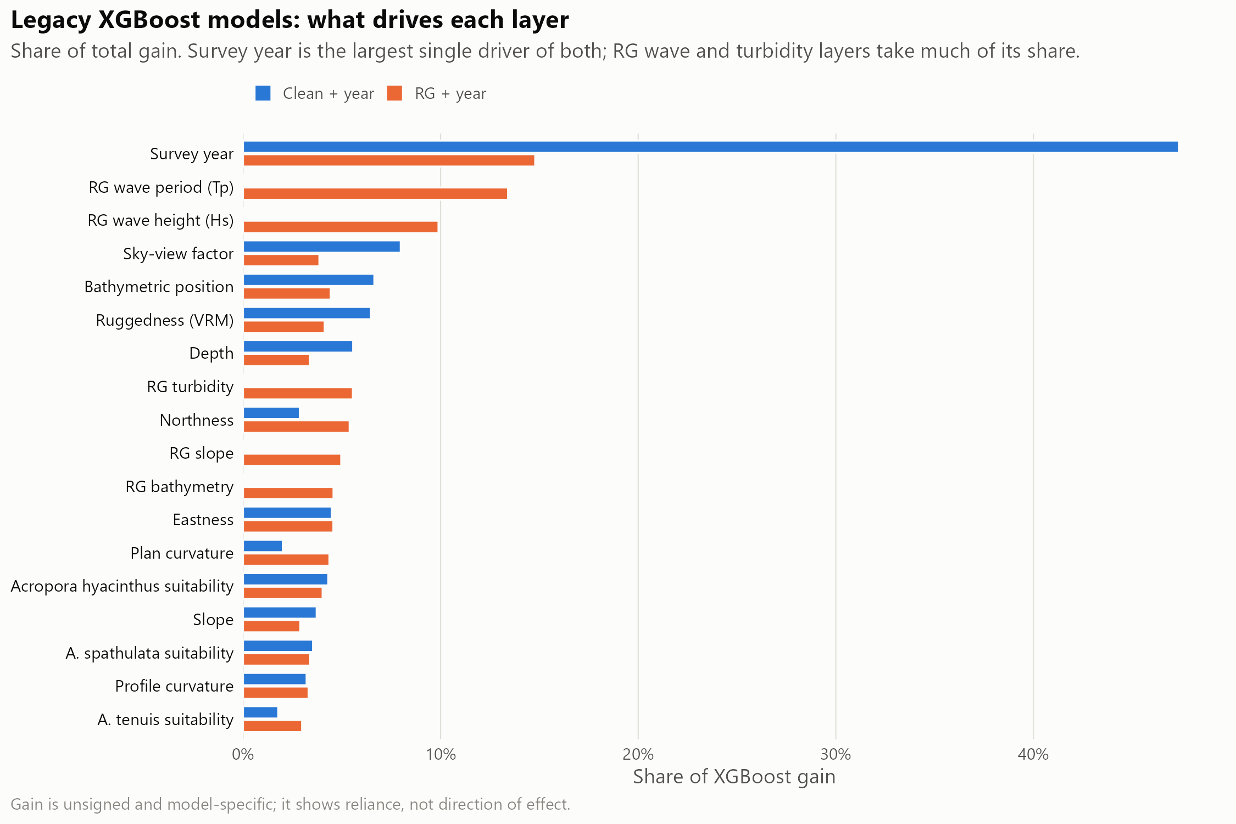
Figure 6: Relative importance (XGBoost gain) of each predictor in the clean + year and RG + year models. Survey year is the largest single driver of both, which is why absolute probabilities mostly reflect prevalence in the prediction year; wave period and height dominate the habitat terms where ReefGuide layers are available.

Appendix C: HMSC joint model
Table 4: HMSC production fits: training rows, convergence diagnostics and apparent (in-sample) AUC for the mapped cull target, and the share of mapped 120 m cells each component fills. All passed the gates (minimum effective sample size ≥ 400, maximum upper PSRF ≤ 1.1).
Component | Training rows | Min ESS | Max upper PSRF | Apparent AUC | Share of mapped cells
enhanced_joint | 14,120 | 705 | 1.012 | 0.600 | 24.6%
clean_joint | 15,512 | 1,645 | 1.020 | 0.576 | 71.8%
clean_native_joint | 15,571 | 409 | 1.018 | 0.565 | 3.6%

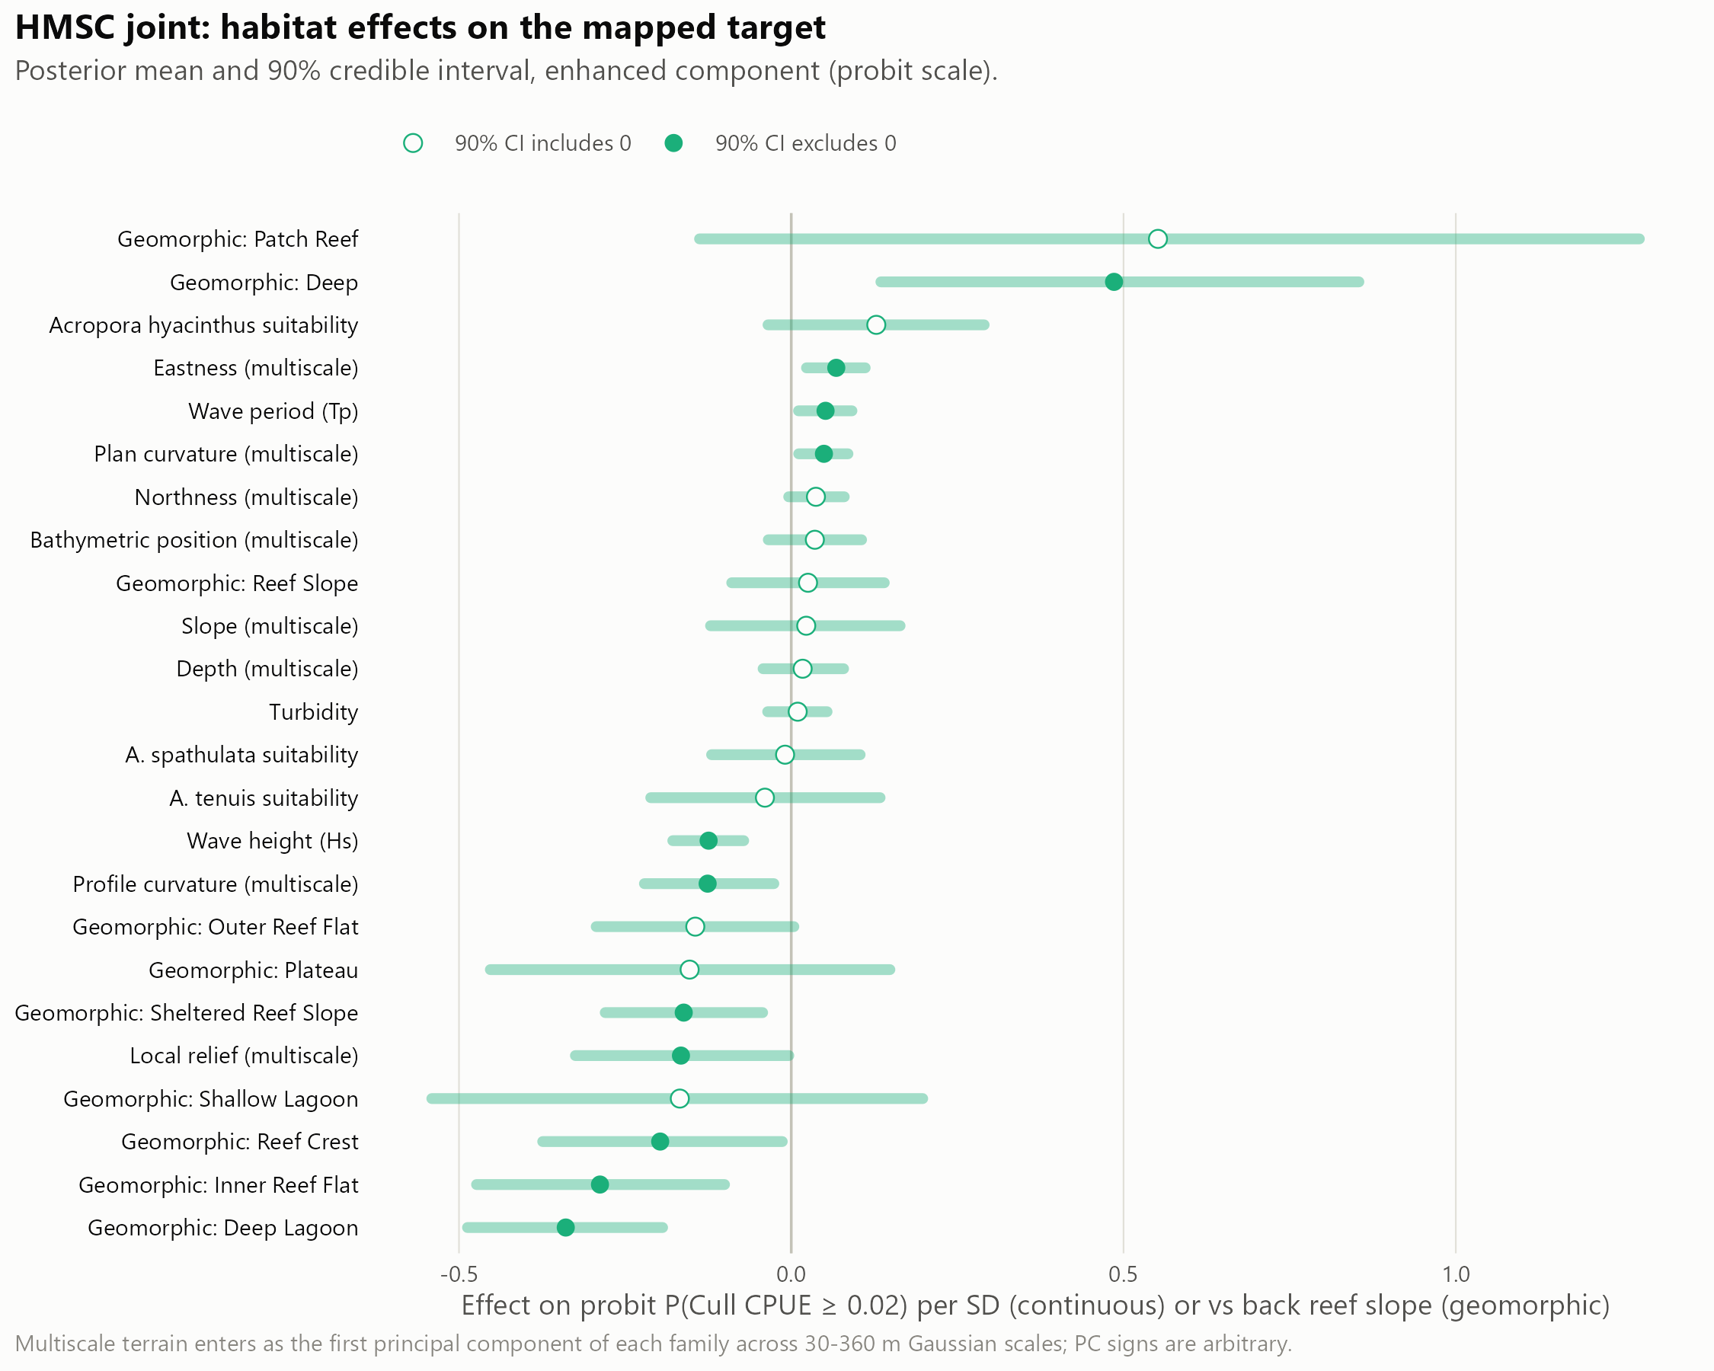
Figure 7: HMSC habitat effects on the mapped cull target, with posterior uncertainty.

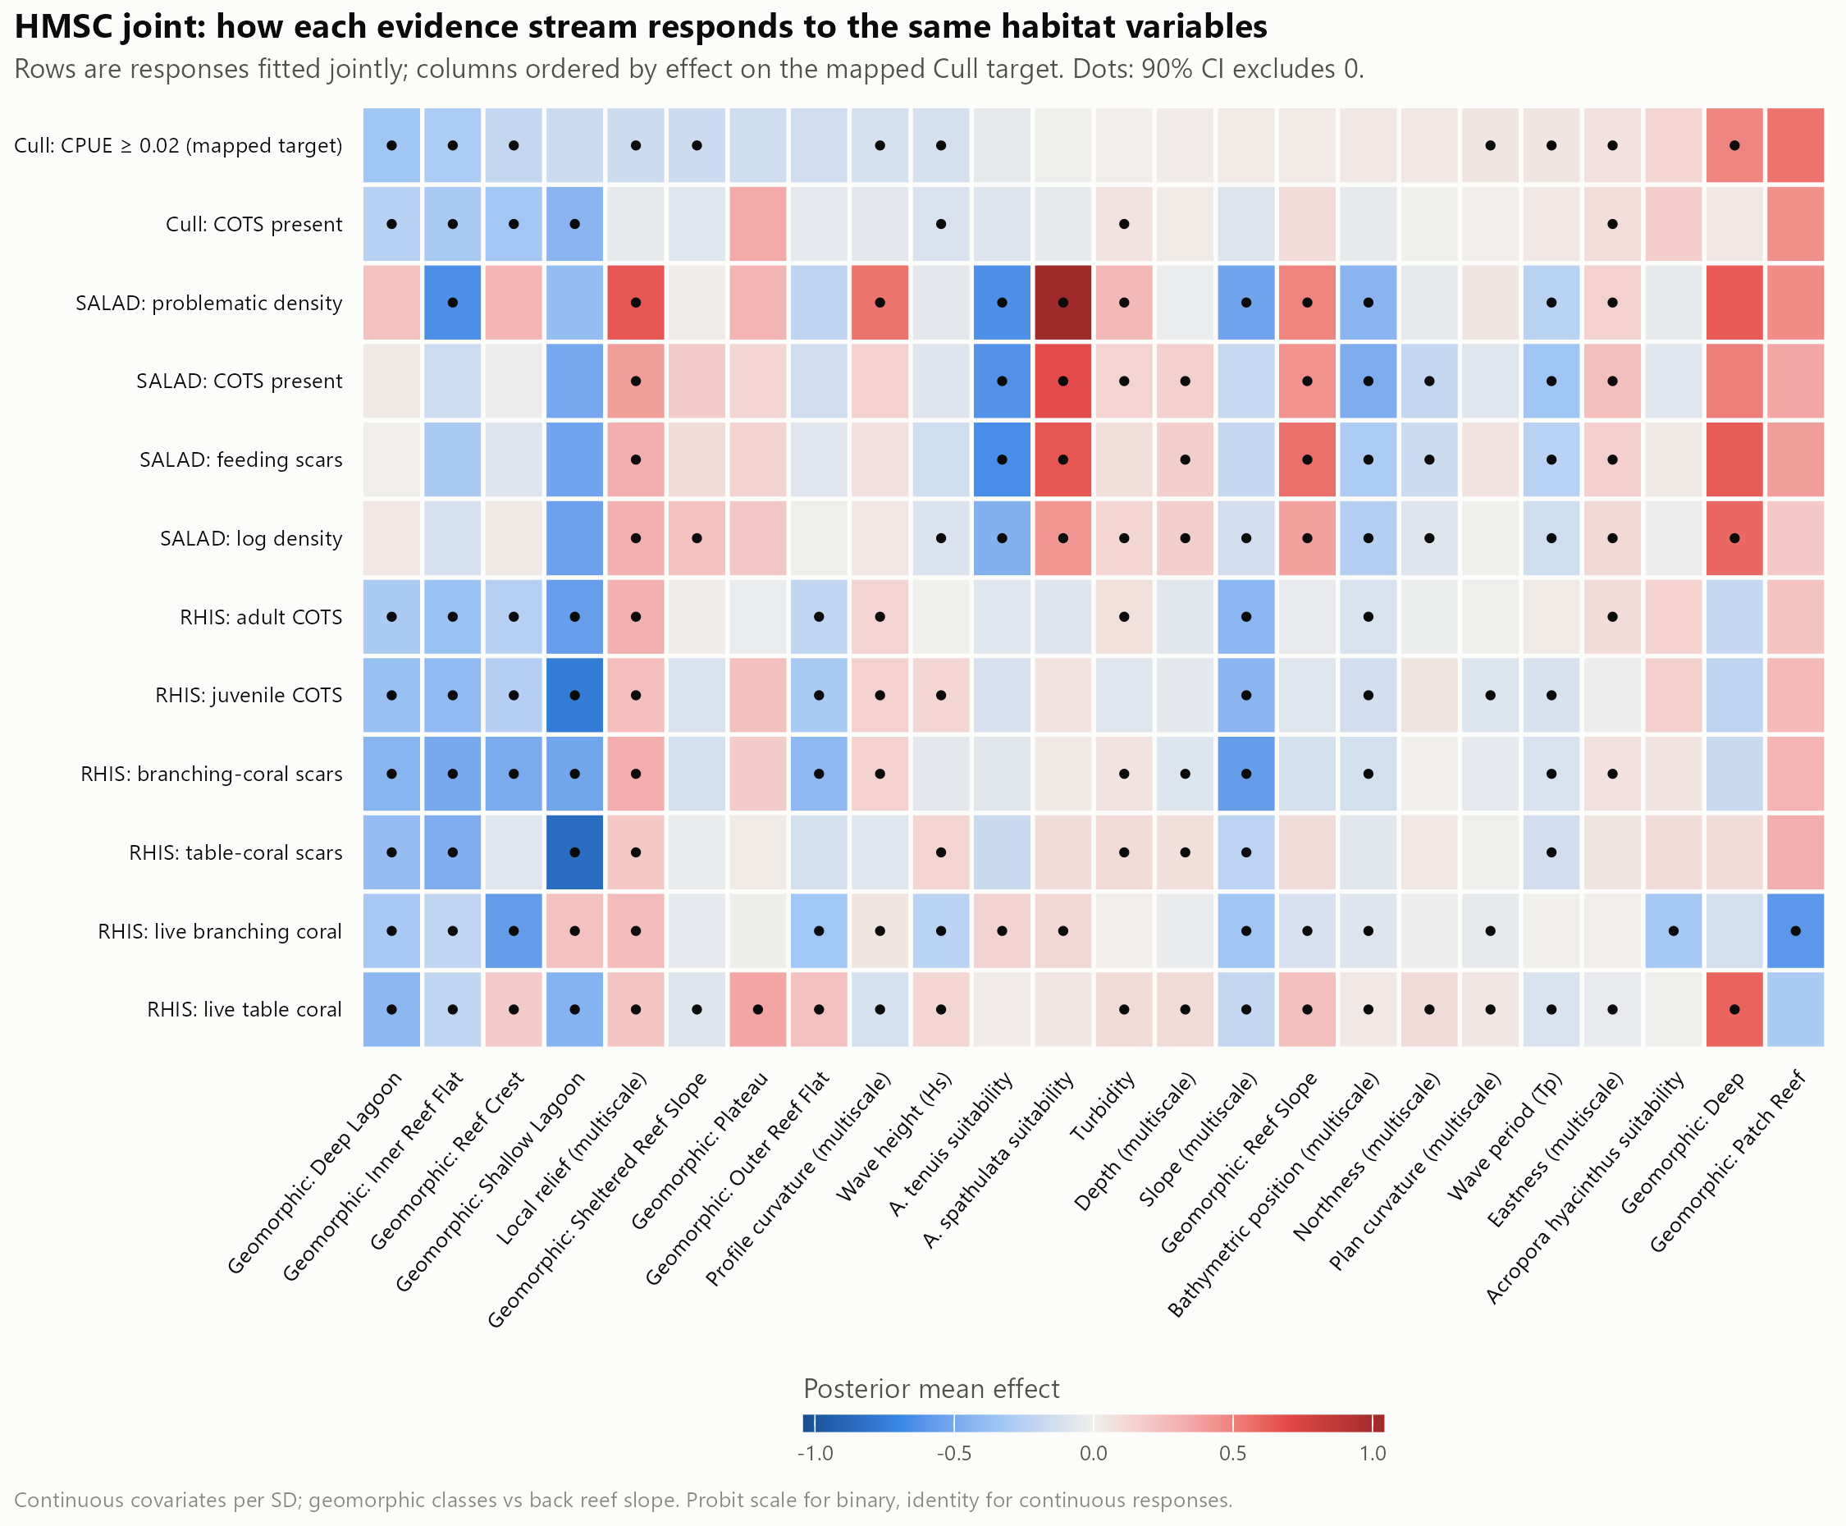
Figure 8: HMSC coefficients across all 12 jointly fitted responses (cull, SALAD and RHIS evidence).

Appendix D: Supplementary validation
Layer agreement and coverage.
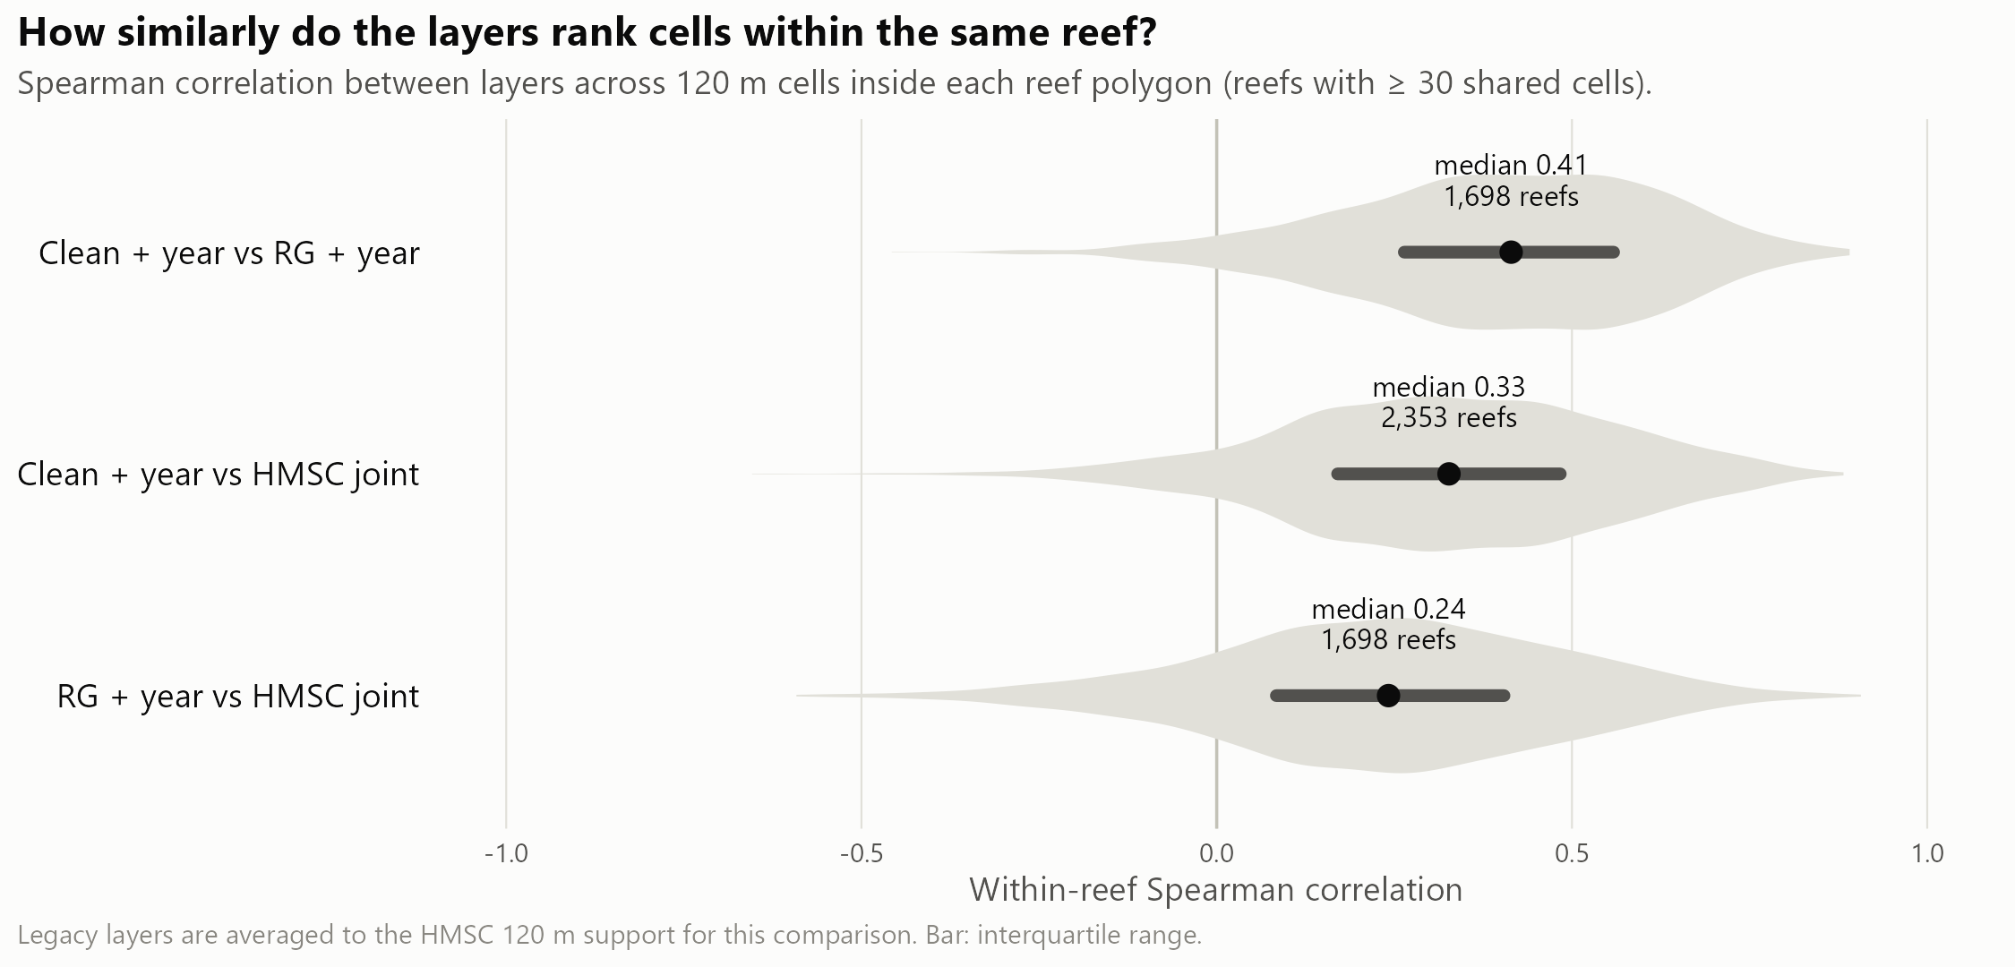
Figure 9: Within-reef agreement (Spearman correlation) between layers across reefs. The layers agree only moderately on which cells rank highest.

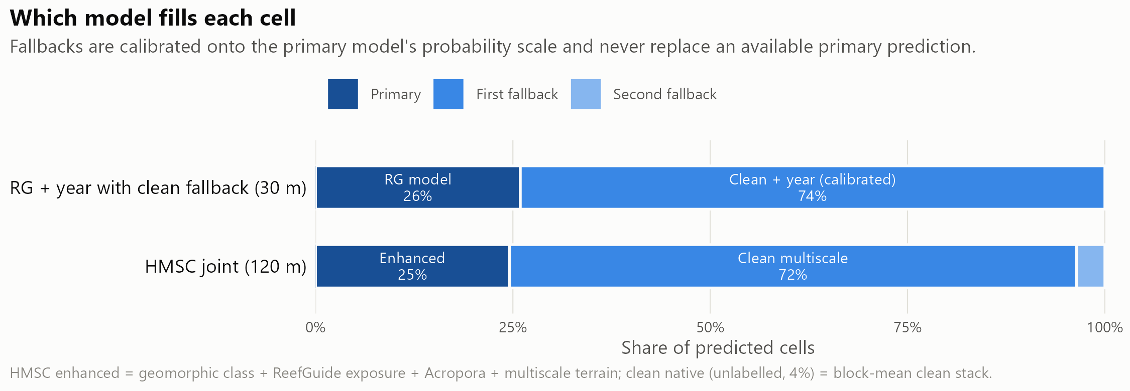
Figure 10: Which model fills each cell of the primary search-planning layer and of the HMSC layer.
Effort cut by the primary layer versus at random. An earlier analysis cut manta and cull effort within each survey or reef-year by the primary layer and compared it with the same cut at random (Table 5, Figure 11). Most of the effort saved is the effect of the cut itself, not of the layer. Systematic thinning and the matched cull-site analysis in the main text supersede this comparison for manta tows and cull sites, respectively.
Table 5: Keeping about 60% of manta tows or cull sites within each survey or reef-year, 2022–2026: primary layer versus the same cut at random. Cull sites were scored by held-out predictions.
Metric | Primary layer | Random
Manta: strong-evidence tows kept | 67.6% | 60.9%
Manta: outbreak reef-years still detected | 88.6% | 87.0%
Cull: share of COTS at kept sites | 69.9% | 62.5%
Cull: share of ghost dives avoided | 40.9% | 36.5%

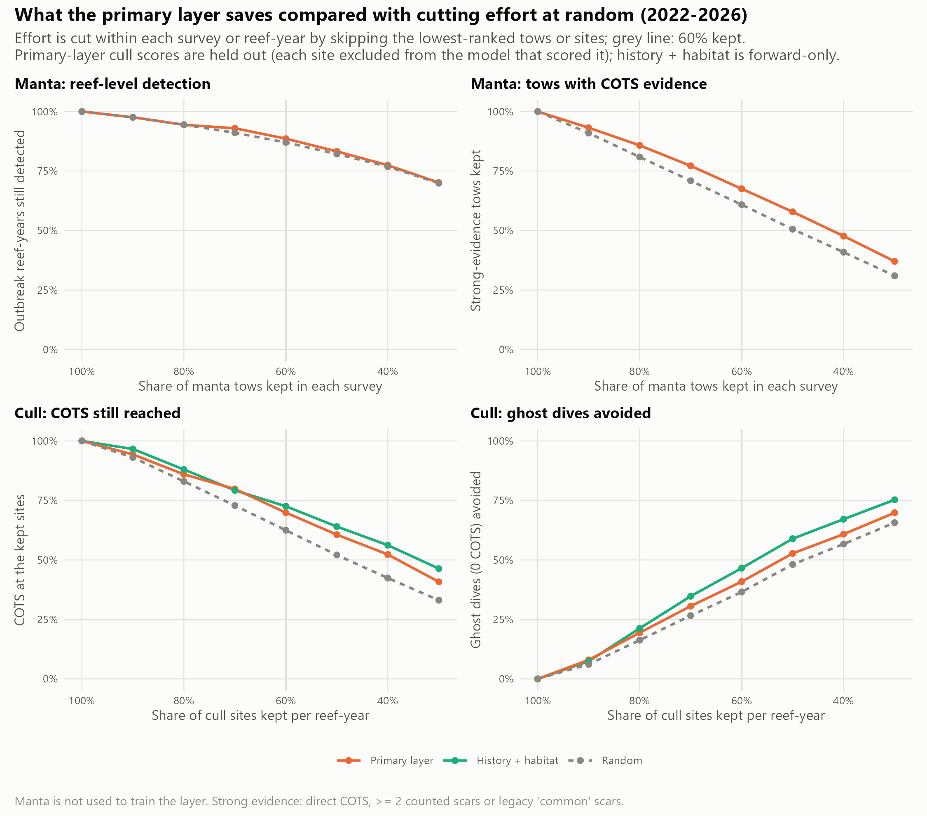
Figure 11: Manta and cull effort cut by the primary layer versus at random (2022–2026).
Example search plans. On Batt Reef (manta survey 2025-08-04), keeping the 79 of 131 tows that crossed the highest-ranked cells would have retained 32 of 42 strong-evidence tows; on Eyrie Reef (2023-10-26), 56 of 92 tows would have retained 9 of 11 (Figure 12). Both reefs are in the layer’s training data, so this illustrates the planning logic only; the held-out results in the main text are the evidence.

Figure 12: Example use of the primary search-planning layer on Batt Reef (top) and Eyrie Reef (bottom). Left: manta tows the layer would keep (solid) or skip (dashed), with strong-evidence tows in red. Right: fifteen planned dive sites on top-ranked diveable cells (0.5–16 m, at least 400 m apart), ordered into a route, against that season’s cull outcomes. Illustrative only: these reefs were in the training data.
Cull history on four reefs.
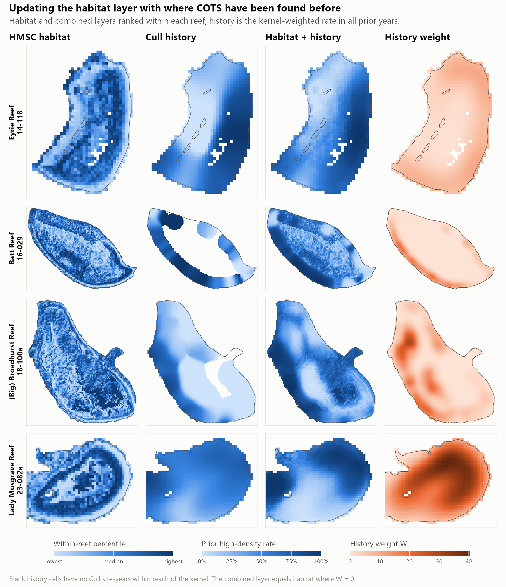
Figure 13: Habitat, cull history and the combined layer on the four reefs, with the history evidence weight. The combined layer is dominated by past finds wherever history exists.
ReefScan check. 237 presence-only ReefScan detections on 29 reefs were compared with each layer’s within-reef percentile. Detections sat near or below the median for every layer (mean percentile 0.41–0.53). Without survey tracks that recorded no detections, this mostly reflects where ReefScan was towed, so the check is inconclusive.

Appendix E: Alignment with the CCIP-BR-13 Work Plan
Table 6: Work Plan outputs and where they are reported. The Work Plan proposed validating tow paths at the 50th and 80th percentile thresholds; this report instead evaluates every level of tow retention from 90% to 30% against random and systematic baselines.
Work Plan output | Delivered in this report | Status
E. Finalised GBR-wide habitat suitability model and surveillance paths | 30 m habitat layers (Appendix A); held-out evaluation of model-ranked versus systematic manta thinning (Appendix H); example search plans (Appendix D) | [TO CONFIRM]
E (extension). Cull-site selection | 2027 cull-site priority ranking and exploration areas (the habitat Results) | [TO CONFIRM]
F. Fine-scale connectivity network at four reef clusters | Hydrodynamic and connectivity Methods (the larval-modelling Methods); preliminary larval dispersal Results (the dispersal Results) | Concentration patterns described for the Lizard region; expert methods and matrix results pending. [TO CONFIRM: delivery and coverage of all four clusters.]
G. Prototype fine-scale metacommunity model | Main Methods/Results and Appendices G and I | Prototype and exploratory effort projections implemented; independent validation and full program-impact assessment incomplete
H. Final data sets and public report (FAIR) | This report; layers, tables, threshold reassessment and code | [TO CONFIRM: repository, DOI and licence]
I. Peer-reviewed publication | Manuscript in preparation for Frontiers in Marine Science | [TO CONFIRM]

Appendix F: Reproducibility
The technical-report export assembles Quarto content inside a working copy of the supplied CCIP Bridging Project template. The source template is checksum-protected; native Word refreshes the contents, captions and page fields before exporting the matching PDF. The export scripts and report metadata are stored with the Quarto source; CCIP_TEMPLATE_GUIDE.md records the content and formatting requirements.
The pipeline is in DataProcessing/cots_sdm_v2/final/ [TO CONFIRM: public repository URL and release DOI]. Inputs are pinned by SHA-256 checksum in config.R; the dated calibration snapshot additionally checks member files against its pinned metadata. Run scripts in the order given in README.md, with 07 (figures) last. Script 25 imports the 21 October calibration and projection summaries. Every reported analysis result is read from outputs/tables/ or outputs/site_ranking/ when the report is rendered. COTS Control Program cull and manta records are held by GBRMPA and are not public [TO CONFIRM: access statement].

Appendix G: Detailed model specification and evaluation

Model purposes and evaluation design
Table 7: Models and comparisons. Predictor counts for the two annual models include survey year. Original code labels and alternative combinations are mapped to these descriptions in Appendix G.
Model or comparison | Purpose | Information used
Annual full-extent habitat model, 13 predictors | Predict cull outcomes across the full habitat-map extent | Twelve terrain and coral-habitat predictors plus survey year; fitted to cull site-years
Annual limited-extent habitat model, 18 predictors | Test whether added environmental information improves the annual prediction | The same predictors and year, plus five ReefGuide layers; fitted to cull site-years
Manta habitat models | Rank tow locations with strong COTS evidence | The environmental predictors above, fitted to tow observations; versions with year and with differences among reef-years accounted for were compared
Recent-evidence site ranking | Set a search order for designated cull sites | Habitat rank plus the preceding season’s cull dives and nearby manta tows
Multi-observation habitat model | Explain habitat associations while allowing for different observations | Cull, SALAD and RHIS evidence, terrain, geomorphic classes and coral habitat; implemented with a hierarchical model of species communities
Habitat updated by longer cull history | Test how much past finds add to a habitat forecast | Multi-observation habitat estimates and spatially weighted earlier cull records
COTS–coral metacommunity model | Simulate connected populations, coral consumption and responses to removals | Population and coral processes, larval supply, disturbance and historical culling in the Lizard Island cluster

Table 8: Evaluation of the tactical decisions. The season-by-season evidence model used earlier outcomes, but its habitat models were withheld by reef and were not also restricted to earlier years.
Decision | How the prediction was tested | Comparison and outcome
Where habitat predicts COTS | Each reef was scored by models fitted without its group of reefs | Ability to rank observations on the same reef and in the same year
Which cull sites to search | All designated sites were ranked, including never-dived sites; recent evidence came only from earlier seasons | Habitat alone, recent evidence and their combination; sites searched and dive outcomes retained
Whether the ranking works in later seasons | The evidence model was fitted on seasons before each test season, 2019–2026 | The same search outcomes, evaluated season by season
Whether >0.04 dives are retained | Saved rankings were assessed at the higher threshold without refitting | Missed high-density dives, low-density and ghost dives avoided, and intermediate dives retained
Which manta tows to omit | Recorded surveys were thinned while keeping the same number of tows for each strategy | Habitat-ranked, random and evenly spaced tows; observed aggregations still detected

The main Methods define each model by its purpose. This appendix retains the implementation detail needed to reproduce it. Original software labels are used in archived tables and figure legends; their meanings are mapped below.
Table 9: Model purposes and evaluation design.
Original label | Description used in the main report
clean + year | Annual full-extent model (13 predictors)
RG + year | Annual limited-extent model (18 predictors)
manta / manta with year | Annual habitat model fitted to manta observations
manta within reef-year | Manta habitat model accounting for differences among reef-years
combined site ranking | Recent-evidence site ranking
HMSC joint | Multi-observation habitat model
HMSC + history | Habitat updated by longer cull history; distinct from the operational site ranking

The habitat-model reporting follows the Overview, Data, Model, Assessment and Prediction (ODMAP) protocol for species distribution models (Zurell et al. 2020). This structure specifies the management question and prediction target, the observations and predictors used, the model fitting, how predictions are evaluated, and how the resulting maps should be used. The sections below describe these elements for the habitat and search-ranking analyses; the metacommunity methods describe the population model, calibration and prescribed culling separately.

Data and response definitions
The COTS Control Program’s full cull dataset covered 2002–2026 and supplied the site, date, number of COTS culled and bottom time for each dive. Records with missing counts or non-positive bottom time were excluded. Records matched to designated cull sites covered 4,299 sites on 339 reefs; the wider cleaned dataset contained records from 361 reefs. The archived habitat fits used the full-period source dataset, while each validation applied its stated spatial and temporal subsets. [TO CONFIRM: data-access agreement.]
Two CPUE thresholds serve different purposes. The archived habitat fits and original validation defined a problematic dive as CPUE ≥0.02 COTS per minute of bottom time. A ghost dive found no COTS; a low-density dive found COTS at positive CPUE <0.02. This lower threshold identifies dives that might be avoided while retaining some control below the ecological management target. The revised management evaluation instead penalises missed dives above 0.04. Dives from 0.02 to 0.04 inclusive form an intermediate group of useful culling opportunities. Their retention is reported separately, while missed >0.04 dives remain the primary omission measure. Thus exactly 0.02 remains positive under the original response and belongs to the intermediate group in the new evaluation; exactly 0.04 also belongs to the intermediate group. Ecologically sustainable densities vary with coral cover, so 0.04 is the operational criterion for this assessment, rather than a universal coral-growth threshold (Plagányi et al. 2020). Habitat fits used a site-year response, while search selection was assessed against individual dive outcomes. The two thresholds do not change the definition of a manta aggregation.
The habitat model fitted to manta observations used 198,852 labelled tows in 1,015 reef-years, including 16,199 with strong COTS evidence. Strong evidence meant a direct COTS sighting, at least two counted feeding scars, or scars recorded as “common” in legacy surveys. Strict negatives recorded neither COTS nor scars; weak single-scar records were excluded from model fitting. The observation archives included Control Program crews (2016 onward), the Reef Joint Field Management Program (2012 onward) and AIMS LTMP (1992 onward), as specified by the author. SALAD (Pratchett et al. 2022) and RHIS (Beeden et al. 2014) observations contributed to the joint habitat model. ReefScan imagery (Bainbridge and Coleman 2024) supplied a separate presence-only check in script 10 and was not a fitted response in the delivered joint model.
Predictors were assembled on a 30 m grid in GDA2020 / MGA zone 55. The clean stack contained depth, slope, eastness, northness, bathymetric position index, vector ruggedness, sky-view factor, horizontal and vertical curvature, and three coral habitat-suitability surfaces for Acropora taxa (Guillaume et al. 2025). Five ReefGuide layers added significant wave height, wave period, turbidity, bathymetry and slope. The joint model also used geomorphic classes and reef features. Appendix B lists predictor codes. Sources: Great Barrier Reef Marine Park Authority (2021a), Great Barrier Reef Marine Park Authority (2021b), Roelfsema et al. (2021) and open-AIMS. ReefGuide coverage was reduced in some deeper areas, particularly beyond about 15–20 m. [TO CONFIRM: predictor product versions and resampling methods.]

Habitat models and mapped layers
The clean + year model used gradient-boosted trees [XGBoost; Chen and Guestrin (2016)] to predict the problematic-density indicator from the clean stack and survey year. The RG + year model added the five ReefGuide predictors. These cull-trained models learned from locations selected by crews, often following manta evidence, so their scores reflect the program’s sampling footprint as well as habitat. The operational refits used 1,500 boosting rounds, a learning rate of 0.00137382379588326, maximum tree depth 5, minimum child weight 20 and gamma ${10}^{-10}$, retaining the archived hyperparameters. These settings were not retuned on the evaluation reefs.
The primary search-planning layer used RG + year where available and clean + year elsewhere, calibrated onto the RG probability scale before combining them. Each 30 m cell was then ranked within its reef polygon, with map priority classes for the top 10%, 10–20% and 20–30%. RG + year covered 61% of the reef-polygon support cells used in the coverage analysis. Of the mapped reefs, 54 used RG alone, 2,586 mixed the two sources and 920 used the clean fallback alone.
Manta-trained XGBoost models used the RG stack and the same boosting settings. Predictor values were averaged along each tow. A model with survey year was compared with a model designed specifically to rank locations within reef-years. For the latter, the logit of the reef-year’s strong-tow proportion, with a half-count correction, entered training as a fixed offset and survey year was omitted. The offset was omitted when predicting relative habitat scores because it was constant within a reef-year. The resulting map represents relative log-odds, not an annual occurrence probability. The cull-trained and manta-trained ranks were also compared as an average rank and as separate terms in the evidence model.
The hierarchical model of species communities [HMSC; Ovaskainen et al. (2017); Tikhonov et al. (2020)] related cull, SALAD and RHIS responses jointly to habitat at 120 m, conditional on an active reef-year. Three predictor components supplied fallbacks where enhanced predictors were unavailable. Production fits used four chains, each retaining 1,000 samples at thinning 30 after 5,000 transient iterations. Convergence was assessed against a minimum effective sample size of 400 and maximum upper potential scale reduction factor of 1.1 (Appendix C). This model supplied explanatory habitat effects and uncertainty.
An additional layer represented known aggregation sites using a Gaussian kernel of the problematic rate in earlier active cull site-years (σ = 500 m). Its rate H and evidence weight W updated the HMSC habitat probability p as (κp + WH)/(κ + W), with κ = 2 for the fixed-setting comparison. History and dive effort were interpreted as records of past finds and crew targeting, rather than independent habitat evidence.

How habitat and recent observations determine a cull-site rank
The main Methods gives the score equation. The fitted response was whether a dive reached CPUE ≥0.02; reassessment at >0.04 changed the evaluation target, not this model. The habitat term $H_{i}$ was the mean deployed habitat score over a site’s polygon, converted to a percentile among designated sites on the reef. A missing habitat rank was replaced by 0.5. The operational product used the cull-trained habitat layer with its full-extent fallback, without a second manta-habitat term.
Recent dive and tow records were represented at dive coordinates and tow midpoints. Missing dive coordinates used a representative point inside the matched site. For site $i$ and nearby record $j$, the spatial weight was:
$$w_{ij}=\left\{\begin{matrix}exp\left[-d_{ij}^{2}/\{2{\left(300 m\right)}^{2}\}\right], & d_{ij}≤900 m, \\ 0, & d_{ij}>900 m.\end{matrix}\right.$$ | (2)
Distances were measured from the site’s representative interior point in GDA2020 / MGA zone 55. The calculation considered at most the 400 nearest records in each data stream. Ei=j​wij was the weighted number of dive records, not minutes of bottom time. Ri=j​wijyj/Ei, where $y_{j}=1$ for CPUE ≥0.02, was their weighted positive proportion. The analogous tow sums supplied $T_{i}$ for all records and $M_{i}$ for strong evidence (a direct COTS sighting, multiple counted scars or legacy common scars). Searches with no strong evidence contributed to effort but not to the positive sum. There was no additional age weighting within the evidence window.
The direct-site indicators were $P_{i}=1$ if any recent dive assigned to that site reached ≥0.02, and $Q_{i}=1$ if the site was dived but none reached that threshold. Both were zero for an undived site. Where no nearby dives were available, $R_{i}$ and $E_{i}$ were zero; absent tows gave $M_{i}=T_{i}=0$. With no recent evidence, the score therefore reduced to the intercept plus habitat term. No evidence was treated differently from a searched site with a quiet result.
The coefficients were estimated jointly by logistic regression. They are conditional associations, not independent bonuses or penalties. Table 10 records the final 2027 coefficients; the forward evaluation estimated a different coefficient set using only years preceding each test year.
Table 10: Coefficients used in the 2027 cull-site score, fitted to the archived ≥0.02 dive response. Inputs and transformations match the score equation in Methods. These coefficients describe the deployed fit, not the separately fitted forward-validation years.
Input | Symbol | Coefficient
Intercept | β₀ | -0.148
Within-reef habitat rank | βH | 0.264
Any ≥0.02 dive at this site | βP | -0.077
Dived here, none ≥0.02 | βQ | -1.142
Nearby ≥0.02 dive proportion | βR | 1.285
log(1 + weighted dive count) | βE | 0.068
log(1 + weighted strong tow count) | βM | 0.647
log(1 + weighted total tow count) | βT | -0.233

The logistic transform $p_{i}=1/\left(1+exp\left[-s_{i}\right]\right)$ expresses the fitted probability of a ≥0.02 outcome conditional on diving there. Rankings use $s_{i}$, so the transform does not change their order. This is not a probability of an irruption or of presence at an unvisited site. In the deployed product, sites are sorted from highest to lowest score on each reef, using higher cull-habitat rank to break score ties. Descending rank divided by the reef’s site count defines A (≤0.2), B (>0.2 to 0.5), C (>0.5 to 0.8) and D (>0.8); retaining A–C selects floor(0.8 × site count). Pop-up evidence labels describe the records; they do not override the fitted score. Historical evaluation retains the archived random tie order.
For validation, prior evidence came from the preceding calendar season. The 2027 product instead used the latest complete 365-day window, 1 June 2025–31 May 2026, and coefficients fitted on 28,431 dives from 2019-2026. The search tool is therefore a habitat ranking updated with both positive and negative operational evidence, and its effort terms also encode where crews chose to work.

Evaluation design and search-efficiency analyses
Operational discrimination was measured among locations on the same reef in the same year. Within reef-year AUC compared positive and negative locations only within those groups; an AUC of 0.5 indicated no discrimination. Top-20% lift was the share of positives in the highest-ranked fifth divided by 0.2. These metrics were supplemented by the outcomes retained when effort was reduced.
For operational habitat comparisons, reefs were assigned to five folds and every reef was scored by a model refitted without any reefs in its fold (Roberts et al. 2017). The pipeline calls this leave-reef-out validation; it is grouped five-fold validation, rather than one refit per reef. This prevented a reef’s cull or manta observations from contributing to its habitat fit. A separate matched manta check scored the same 117,318 tows in 1,003 active reef-years on 402 reefs where all deployed layers were available. That check used the fitted layers and was not a substitute for the refitted operational evaluation.
Manta aggregations were connected groups of strong-evidence tow midpoints linked within 500 m in a survey (reef and date); successive links could join a group wider than 500 m. The principal aggregation analysis required at least two strong tows, with isolated records examined separately. Surveys required at least five scored tows and some strong evidence. An aggregation was retained if at least one of its tows was kept. This measured retention of observed aggregation evidence under retrospective thinning.
Each thinning strategy kept the same number of tows per survey, over retained shares from 90% to 30%. Model thinning kept the highest-scoring tows. Random thinning used the exact hypergeometric expectation of retaining at least one tow in each aggregation. Systematic thinning kept evenly spaced positions in the tow sequence, averaged over 20 starting offsets. Recorded tow order was unavailable, so sequence was approximated by bearing from the survey centre. The comparison therefore concerned thinning existing surveillance, not the performance of newly designed tow routes.
Cull-site analyses ranked every designated site on a reef, including never-dived sites, by its mean habitat score over the polygon. For each retained share of designated sites, the analysis recorded the share of observed problematic, low-density and ghost dives at retained sites. Random selection supplied a no-information expectation: retaining a fraction of sites gives that fraction’s expected retention of each observed outcome. Outcomes at never-dived sites were unknown, so this exercise could not measure COTS missed at those sites or changes in crew behaviour under deployment.
To add recent evidence, each site received indicators for any problematic dive there in the previous season and for having been dived with none problematic. Neighbourhood terms were the problematic rate and dive effort among nearby cull dives, and strong-evidence and total manta tows, using a Gaussian kernel with σ = 300 m. Effort and tow counts entered logistic regressions after log(1 + x) transformation; missing habitat ranks were assigned the midpoint. Habitat alone, evidence alone, habitat + evidence and a simple flagged-sites-first rule were compared. The regressions were fitted on other reef folds, and evidence for a test year came only from preceding seasons. This spatial test did not also restrict regression training outcomes to years before the test year.
Rankings were compared at matched retention of problematic dives because evidence could move both problematic and low-density dives upwards. Retention curves were evaluated over 5% steps in designated sites searched and interpolated at 80%, 85%, 90% and 95% problematic-dive retention. The separate season-by-season test used 80% and 90%. For each test year from 2019 to 2026, its evidence regression was fitted only on earlier dive outcomes, comparing all earlier seasons with the last five or three, and cull-only, averaged cull–manta or separate habitat terms. Habitat covariates in this test were the reef-held-out ranks from the spatial analysis; the habitat fits themselves were not restricted to preceding years. Thus the evidence regression was tested forward in time, while the habitat component was held out spatially.
The >0.04 reassessment kept the saved rankings from the habitat-only, recent-evidence and manta-habitat comparisons and the season-by-season evidence test; none was refitted to the higher threshold. Dive counts and CPUE were rejoined to the saved scores using reef, year and designated site. For the forward test, the recovered dive counts and original outcome classes were checked against the saved evaluation sample, preventing repeated dives at one site from generating duplicated records. The candidate set remained every designated site on each evaluated reef, including never-dived sites. At each rank cutoff, effort was the actual number of designated site-years selected, summed across evaluated reef-years, divided by all candidate site-years. Consequently the proportion searched could differ slightly from the nominal cutoff on reefs with few sites or tied habitat ranks.
The reassessment reported retention and omission of >0.04 dives, low-density and ghost dives avoided, and intermediate dives retained. Random selection used the exact expected outcomes for the same number of sites on each reef; it matched the combined ranking’s effort in the spatial comparison and all rankings’ effort in the forward comparison. Curves were also interpolated at 80%, 90%, 95% and 99% retention of >0.04 dives, using the first crossing of each target over 5% rank-cutoff steps. This interpolation describes a trade-off between adjacent effort levels, rather than a validated stopping rule for an individual reef. Confidence intervals used 500 paired reef-year bootstrap draws for this reassessment, including the forward scores. Earlier ≥0.02 results retain their original calculations and bootstrap counts. The high-density reassessment retains the original spatial and temporal holdout limits of each ranking.
Site-selection counts describe candidate locations for cull dives; tow effort, dive effort and annual coverage are separate quantities. For the exact operational cutoff we retained sites with descending rank divided by the number of sites on the reef ≤0.8, matching classes A–C in the delivered product. This selects floor(0.8 × site count) sites per reef and can differ from the percentile interpolation used for the matched-retention rows. The saved forward coefficients and original random tie sequence reproduced every archived dive rank exactly; no model was refitted. Historical ties retain the forward test’s random order; the deployed product uses habitat as a tie-breaker. The retrospective habitat component retained its spatial holdout, while the evidence regression used earlier years. The 2027 map itself uses the deployed habitat layer and latest evidence, rather than those validation fits.
The manta-effort estimate used recorded tows on the same evaluated reef-years. Valid start and end coordinates defined straight segments, projected to GDA2020 / MGA zone 55; source geometry fallbacks and zero-length segments were excluded. Each segment was split at designated-site boundaries. A portion could be deferred only if it lay within designated sites and all sites sharing that portion were deferred. Parts outside designated sites remained surveyed. The whole-tow metric counted only segments entirely deferred; the distance metric summed deferred portions and divided by total valid segment length. Repeated surveys contributed their recorded effort. No buffer was added around site polygons, and endpoints did not reconstruct the actual curved vessel track.
For random selection, exact probabilities that none of a portion’s overlapping sites was selected supplied the expected deferred distance; whole-tow omission used the union of sites along a segment. The random comparison selected the same integer count of sites on each reef. The matched-retention tow estimates used the same percentile cutoffs and first-crossing interpolation as the existing dive curves. A separate set of 500 paired reef-year bootstrap draws propagated cull outcomes, site counts and tow effort together. These estimates describe spatial scope for reducing recorded surveillance conditional on still diving selected sites. No causal tow-to-dive detection model, route feasibility or vessel-time saving was inferred. All site-years contributed to the dive and site metrics; only reef-years with valid tow segments contributed to the tow denominators.
A field trial will record tows and their duration, dives and bottom time, COTS outcomes, added exploration searches, departures from the proposed search order, and later checks of deferred sites. It will compare the ranking with crews’ normal planning. Sites deferred on a visit will still be checked annually or before the reef closes to further control visits. Analyses of the full season must count those later checks and added exploration, so that shifting effort between sites or visits is distinguished from reducing total vessel and diver time. Existing records cannot estimate outcomes at unvisited sites or the yield of the proposed new routes.
The HMSC–history forecast used a separate temporal design: for each test year from 2022 to 2026, habitat models were refitted on earlier years and history used earlier active site-years only. First-visit cull site-years were compared within reef-years containing both outcomes, using habitat, prior dive effort, history and their blend. This distinguished habitat transfer from the persistence of previous finds.
Uncertainty intervals used paired bootstrap resamples of reef-years for tow and cull metrics, or surveys for aggregation retention. Operational spatial comparisons used 500 resamples; the season-by-season site-ranking test used 200. The same resampled units were used across scores to preserve paired comparisons.

Seasonal products
For 2027, the selected cull-habitat + evidence model was fitted on 28,431 dives from 2019-2026. Recent evidence covered 1 June 2025 to 31 May 2026, the latest 12 months available, because calendar 2026 contained only January–May. Sites were ranked within reefs and assigned classes A (top 20%), B (20–50%), C (50–80%) and D (bottom 20%). The deployed habitat layer supplied scores for this product; the operational validation used refitted habitat scores.
Exploration areas were drawn from 30 m cells 0.5–16 m deep in the reef’s top 30% of habitat, more than 100 m from designated cull sites and more than 150 m from manta tows in the preceding five seasons. Habitat was the mean of the primary-layer and manta-model percentiles, re-ranked within the reef, with the primary layer alone where manta scores were missing. Nearby pockets were joined, large patches split into compact areas of about 9 ha, and outlines smoothed and clipped to the reef outside cull sites. Areas smaller than 0.5 ha were removed; up to ten areas per reef polygon, at least 350 m apart, were retained. These areas identified places to explore beyond the recent search footprint.

Metacommunity model and historical culling
The detailed calibration and spatial-kernel removal specification below records the 15 October setup. Appendix I describes the subsequent changes to settlement, coral settings, reef-wide removal allocation and effort-based projections used in the current Results.
The strategic modelling strand extended COTSMod (Matthews et al. 2020a) through the Julia package COTSMod.jl, coupled to ADRIA and the CoralBlox coral model (open-AIMS 2026b, 2026a; de Almeida et al. 2026). COTSMod.jl supplied population transitions, coral predation and larval processes; ADRIA supplied the spatial domain, disturbance forcing and scenario execution. The prototype used the Lizard Island cluster, with 2,895 sub-reef sites on 113 reefs. Historical simulations beginning in 1991 were assessed against AIMS Long-Term Monitoring Program (LTMP) manta COTS and coral records on Lizard Island, Eyrie, MacGillivray and North Direction reefs. The model state was expressed as recruit, juvenile and adult densities per hectare of site area, with coral cover represented relative to habitable area.
Site-level habitable fractions came from benthic maps in domain v0.3 and its v0.4 extension. Historical heat stress was supplied through ADRIA, with cyclone exposure examined as an option. Reef-to-reef larval flows were divided evenly among sites within a receiving reef. Habitable fractions and prescribed removals varied among sites, but transport did not yet resolve within-reef flows. The 30 m habitat layers and evidence-based search rankings were candidate inputs for future coupling, rather than validated components of the metacommunity model. [TO CONFIRM: source and attribution of the annual 2018–2022 connectivity matrices, status and delivery date of Work Plan output F, and the planned coupling to the habitat layers.]
The working COTS formulation combined preferred-first per-capita grazing, survival linked to remembered preferred coral cover, adult senescence and preferred-food effects on reproductive condition. Larval production included a low-density Allee effect, juvenile survival included a saturating predator-pit term, and larvae were transported using reef-level connectivity and supplied from outside the domain. External supply was derived from the reef-level irruption-probability hindcast (Stewart et al. 2026); its production multiplier was a calibration assumption, not measured recruitment. Mechanisms suggested by MICE, CoCoNet and ReefMod-GBR were examined as optional alternatives (Morello et al. 2014; Plagányi et al. 2020; Condie et al. 2021; Bozec et al. 2022). Testing a mechanism did not make it part of the working configuration. [TO CONFIRM: attribution and final choice of the annual connectivity matrices; the sub-reef hydrodynamic network had not replaced these reef-level inputs.]
Calibration used bounded comparisons of candidate mechanisms and parameter settings. Each screen was preregistered, included an exact-replay reference and recorded settings, seeds, input checksums and repository revisions. Candidate mechanisms had to pass a qualitative peak-and-trough gate before wider optimisation. Irruption peak presence, timing and height, inter-irruption troughs and coral trajectories were assessed together. Coral dynamics were also assessed with COTS grazing forced from observed records to separate coral-model errors from population-dynamics errors. Simulated adult density was converted to manta CPUE through an explicit observation model. The working linear conversion used CPUE = qA, with A in adults ha$​^{-1}$ and q = 0.015 COTS tow$​^{-1}$ per adult ha$​^{-1}$; alternative scales and density-dependent detection, CPUE = qA²/(A + A½), were sensitivity analyses. These alternatives were kept distinct because they change both initial-density estimates and the comparison with observations. In-sample calibration and diagnostic screens were not treated as held-out validation or evidence of management benefit.
The replicated historical comparison used score v2, which scored North Direction against its raw series and omitted Eyrie’s unobserved first wave from the peak count. Its three retained candidates were compared over five recorded seed pairs. The later v0.4 diagnostic extended forcing to 2026 and used score v3: the manta-based score on 1992–2021 plus 1.5 times a diver-anchored recent-density log error. Original and cull/SALAD-corrected irruption boundaries were crossed with earlier and revised coral thermal settings; exploratory chlorophyll-derived larval-survival modifiers were also screened. These later runs used one seed pair and prescribed culling was off. Their corrected boundary and recent-density score shared evidence, so the comparison was a diagnostic fit rather than a validation. The two score versions were reported separately.
Observed historical culling was included as prescribed removals. Cull records from the licensed CSIRO compilation were retained for reefs in the domain, grouped by site and year, and mapped to model sites on the same reef. Counts were distributed with weights proportional to site area × exp(−d²/(2σ²)) within 3σ of the cull-site centroid, normalised to preserve total counts. The primary width was σ = 210 m, with nearest-site allocation (σ = 0) and σ = 420 m as sensitivities; the nearest site was used if no centroid lay within the kernel. Allocated counts were divided by model-site area to obtain removals in COTS ha$​^{-1}$. COTS below 15 cm were assigned to the juvenile stage and those at least 15 cm to adults, an explicit size-to-stage approximation.
September–December removals were assigned to the following LTMP reporting year and applied before spawning; January–August removals were applied after spawning in their reporting year. The annual implementation placed these removals immediately before or after the COTS predation and population-transition call. Requested removals were capped at the simulated juvenile or adult population present, recruits were left unchanged, and adult age and size substates were scaled by the surviving adult fraction. The model logged actual removals separately from requested removals, allowing a shortage of simulated COTS to be diagnosed rather than removing animals that were absent.
This culling implementation prescribed observed catches. It did not yet predict diver search, catchability, effort costs or adaptive starting and stopping decisions. The intended scenarios—primary irruption suppression, starting and stopping rules, and downstream consequences—require further calibration and independent validation before their management performance can be assessed.

Design of the historical and future control assessments
The intended historical assessment pairs simulations with recorded removals from 2012 onward and simulations without program removals, starting from the same pre-control population and coral state and using matching environmental sequences and random seeds. Outcomes will include actual removals, infeasible requested removals, COTS abundance, larval export, cumulative coral consumption and coral cover. Holding external larval supply identical estimates the effect of control within the model domain conditional on unchanged outside reefs. A regional no-culling assessment instead requires an external supply history consistent with no control outside the domain. This experiment is a planned extension of the prescribed-removal diagnostics reported here; no completed paired program-impact estimate is asserted.
Future comparisons will examine stopping when local coral protection is no longer achievable versus continuing to reduce larval export, and when to begin or intensify control on reefs whose COTS populations cannot be reduced below a local target. Reallocation within existing vessel capacity and additional capacity will be compared separately, using current control and no control as references. Feasible removals must follow population availability and an effort–catchability relationship, rather than prescribed catches alone. Each paired comparison will share climate, disturbance and random-seed sequences, and repeat across plausible population, coral, connectivity and observation assumptions. Local and downstream coral outcomes and the resources required for fifth-wave suppression will be reported together. [TO CONFIRM: final effort–catchability model, projection horizon, vessel budgets, intervention rules and climate scenarios agreed with partners.]

Software and reproducibility
The SDM analyses used R 4.5.0 with xgboost, Hmsc and terra. Inputs were pinned by SHA-256 checksum in the final pipeline configuration, and reported results were read from output tables when the documents were rendered. [TO CONFIRM: package versions for the archived fits and a release identifier for the final analysis.] Metacommunity methods were checked against local COTSMod.jl and ADRIA code on 15 October 2026. The citations record both repository revisions and declare the uncommitted ADRIA changes inspected for this pass. [TO CONFIRM: Julia and package versions and the frozen code release to accompany submission.]

Appendix H: Detailed tactical model comparisons

Full cull-site and manta-effort trade-offs
The four mutually exclusive dive classes complete the accounting for the exact A–C cutoff (Table 11). Counts describe observed dives at selected or deferred sites, including repeated visits. Random values are exact expected counts under the same number of candidate sites selected on each reef; they need not be integers. Table 1 in the main Results reports retention, avoidance and deferred-dive composition with paired reef-year intervals. Those percentages have different denominators and must not be added across those three groups.
Table 11: Observed dive counts and the dives deferred by the exact A–C rule, 2019–2026. Intermediate dives remain useful culling opportunities. Random selection uses the same candidate-site count, rather than the same observed dive count.
Dive class | All observed dives | Ranking: deferred dives | Random: expected deferred dives
Ghost: CPUE = 0 | 5,154 | 1,212 | 1,129.7
Low: 0 < CPUE <0.02 | 6,034 | 1,133 | 1,306.0
Intermediate: 0.02 ≤ CPUE ≤0.04 | 4,384 | 507 | 944.3
High: CPUE >0.04 | 12,859 | 1,396 | 2,759.6

Table 12: Cull sites selected for dives and low-density or ghost dives avoided, 2019–2026. Upper rows fix retention of >0.04 CPUE dives; final rows fix the A–C site count and report retention. Percentages [95% reef-year bootstrap intervals]. Sites are candidate site-years, including never-dived sites, rather than confirmed culling visits. Low-density means positive CPUE <0.02; ghost means zero; intermediate dives (0.02–0.04 inclusive) are separate. Appendix G gives validation details; Table 13 gives manta effort. Annual follow-up is excluded.
High-density retained (%) | Ranking | Sites selected for cull dives (%) | Low-density avoided (%) | Ghost dives avoided (%)
80 | Habitat + recent observations | 66.6 [62.0–71.1] | 28.7 [24.5–32.8] | 34.5 [30.3–39.2]
80 | Habitat alone | 72.6 [67.1–77.2] | 21.6 [17.7–26.5] | 25.3 [20.9–30.6]
80 | Random selection | 80.4 [80.1–80.8] | 20.0 [19.7–20.3] | 20.0 [19.6–20.3]
90 | Habitat + recent observations | 80.1 [73.9–85.2] | 17.5 [13.5–22.3] | 21.8 [17.0–27.9]
90 | Habitat alone | 85.8 [81.4–88.7] | 11.1 [9.0–14.4] | 13.4 [10.9–17.2]
90 | Random selection | 90.5 [90.1–91.0] | 10.0 [9.6–10.4] | 10.5 [10.0–10.9]
95 | Habitat + recent observations | 90.2 [85.4–93.4] | 8.9 [6.2–12.9] | 11.2 [8.0–16.8]
95 | Habitat alone | 94.0 [89.7–95.5] | 4.9 [3.7–8.2] | 6.8 [4.9–10.5]
95 | Random selection | 95.6 [95.3–95.9] | 4.9 [4.6–5.2] | 5.3 [4.9–5.8]
99 | Habitat + recent observations | 98.2 [97.2–98.7] | 1.8 [1.2–2.7] | 2.2 [1.6–3.6]
99 | Habitat alone | 98.8 [98.3–99.1] | 1.0 [0.7–1.4] | 1.4 [1.0–2.0]
99 | Random selection | 99.1 [99.1–99.2] | 1.0 [0.9–1.0] | 1.1 [1.0–1.2]
89.1 [85.4–92.5] | A–C: habitat + recent observations | 78.9 [78.8–79.0] | 18.8 [17.4–20.3] | 23.5 [21.8–25.3]
85.1 [80.8–89.0] | A–C count: habitat alone | 78.9 [78.8–79.0] | 16.5 [15.0–18.0] | 20.0 [18.2–21.8]
78.5 [78.3–78.8] | A–C count: random selection | 78.9 [78.8–79.0] | 21.6 [21.5–21.8] | 21.9 [21.7–22.2]

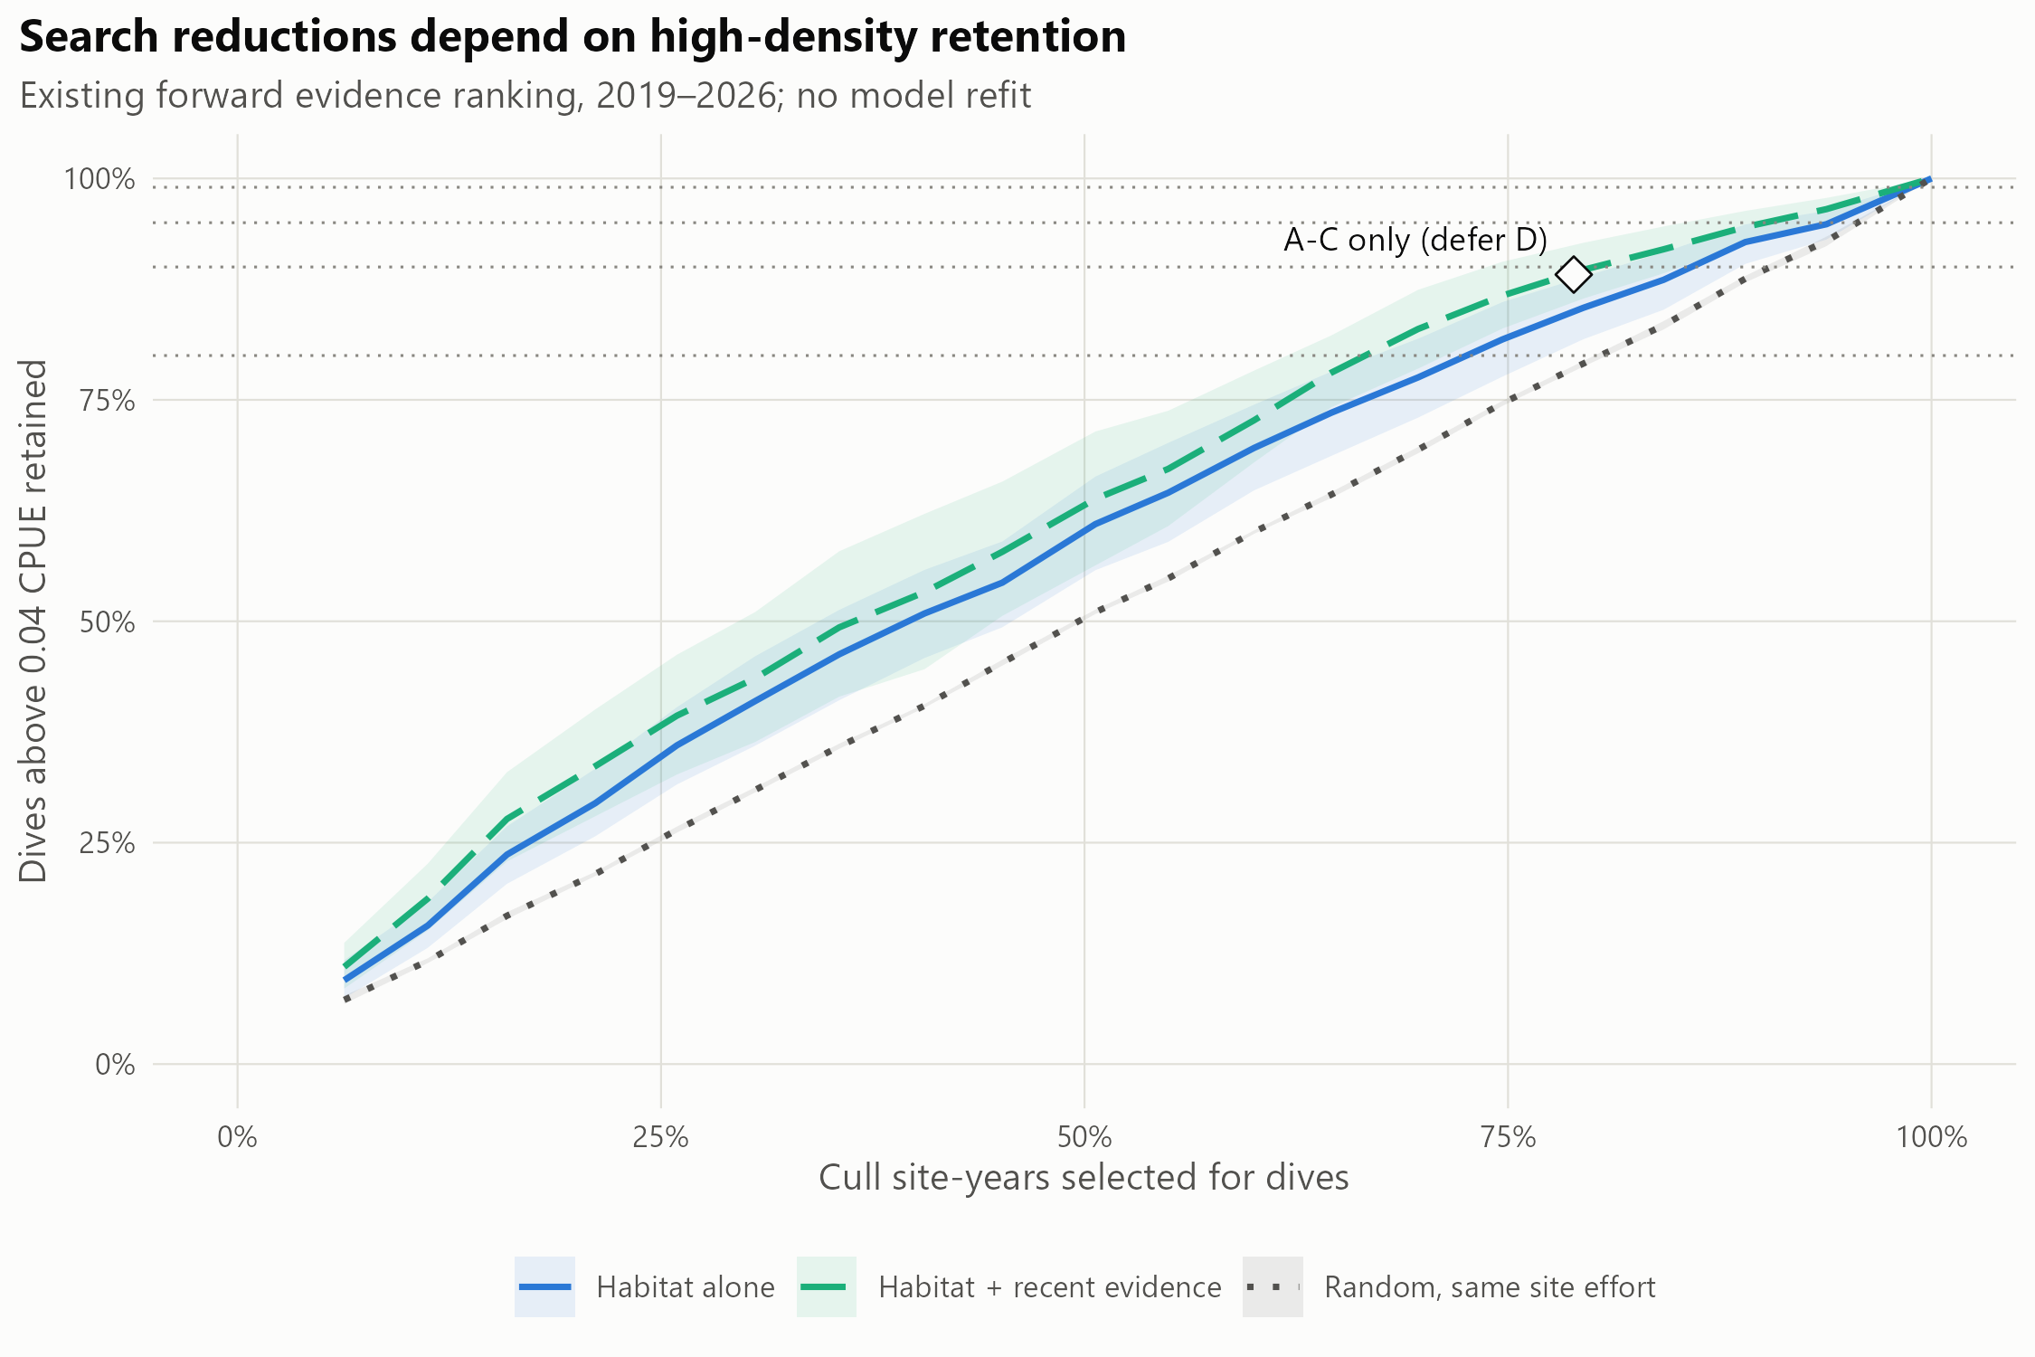
Figure 14: Retention of observed dives above 0.04 CPUE against cull site-years selected for dives, using the existing forward evidence rankings. Random selection has the same site count on each reef. Shading shows 95% reef-year bootstrap intervals; dotted horizontal lines mark 80%, 90%, 95% and 99% retention. The diamond marks the exact A–C cutoff used for the priority classes in Figure 2 and the final rows of Table 12. Habitat fits were held out by reef, while the evidence regression used earlier seasons. Follow-up surveys were not evaluated.

Table 13: Potential manta-surveillance reductions paired with Table 12, before annual checks or exploration. Upper rows use the stated dive-retention targets; final rows fix the A–C site count. Percentages [95% reef-year bootstrap intervals] refer to whole recorded tows or total straight-line segment distance. Surveillance outside designated sites and in overlaps with retained sites remains. These spatial effort proxies assume retained cull visits still occur; detection after tow removal, route feasibility and time savings are untested.
Rule | Ranking | Whole manta tows avoided (%) | Manta tow distance avoided (%)
80% dive retention | Habitat + recent observations | 19.2 [16.1–22.0] | 25.5 [21.8–28.8]
90% dive retention | Habitat + recent observations | 10.9 [7.7–14.5] | 15.3 [11.2–19.8]
95% dive retention | Habitat + recent observations | 5.1 [3.3–7.9] | 7.6 [5.0–11.3]
99% dive retention | Habitat + recent observations | 0.9 [0.6–1.4] | 1.4 [1.0–2.2]
A–C site count | Habitat + recent observations | 11.6 [11.1–12.1] | 16.2 [15.6–16.9]
A–C site count | Habitat alone | 11.5 [11.0–12.0] | 15.6 [15.0–16.1]
A–C site count | Random selection | 10.0 [9.6–10.3] | 15.9 [15.4–16.4]

These comparisons retain the original ≥0.02 response and the separate >0.04 management assessment. They support the highlights in the main Results and should be read with the model definitions in Appendix G. Original labels in figure legends and source tables refer to the same frozen models.

Recent evidence combined with habitat reduces the cull-site search
In the original ≥0.02 evaluation, ranking designated cull sites by last season’s cull dives and manta tows, with the habitat layer ordering sites that lack recent evidence, reduced the search needed for the same problematic dives (Table 14, Figure 15). The ranking is a logistic model fitted on other reefs (leave-reef-out) that uses evidence from the previous season only, never from the season being searched. Held out over 2018–2026 (30,037 dives in 926 reef-years), with 90% of problematic dives retained, the combined ranking:
- reduced the designated sites searched from 88% to 82%;
- raised low-density dives avoided from 10% to 16%;
- raised ghost dives avoided from 13% to 21%.
All paired bootstrap intervals excluded zero. Gains were larger in recent seasons. In 2022–2026, keeping 80% of problematic dives needed 61% of designated sites instead of 74%. Low-density dives avoided rose from 20% to 32%.
Table 14: Habitat-only ranking → habitat plus previous-season evidence, compared at matched retention of problematic dives (CPUE ≥0.02; held out). Brackets: 95% paired bootstrap interval of the difference, in percentage points.
Period | Problematic dives kept | Designated sites searched | Low-density dives avoided | Ghost dives avoided
2018–2026 | 90% | 88% → 82% (-11 to -1) | 10% → 16% (+2 to +10) | 13% → 21% (+4 to +13)
2018–2026 | 80% | 73% → 67% (-11 to -3) | 22% → 27% (+2 to +10) | 26% → 36% (+5 to +14)
2022–2026 | 90% | 88% → 78% (-14 to -4) | 10% → 19% (+6 to +13) | 12% → 25% (+8 to +17)
2022–2026 | 80% | 74% → 61% (-22 to -4) | 20% → 32% (+6 to +20) | 25% → 41% (+8 to +24)


Figure 15: Habitat-only and evidence-informed rankings of designated cull sites compared at the same share of problematic dives retained (80–95%). Panels: share of designated sites searched (lower is better), and shares of low-density and ghost dives avoided. Evidence is from the previous season only. Bars are 95% bootstrap intervals over reef-years (2018–2026). Adding last season’s evidence shifts every curve in the useful direction.
The fitted model weighs the evidence in ways that match field experience:
- strong manta tows or problematic dives nearby raised a site’s rank;
- a site dived the previous season with nothing problematic dropped sharply;
- a site that had itself been problematic ranked slightly lower than its neighbourhood suggested, consistent with culling having reduced it.
Most of the reduction came from ranking quiet and never-dived sites lower. Among dives actually made, discrimination between problematic and low-density dives rose only from 0.57 to 0.59.
A simple rule (“last season’s flagged sites first, then habitat”) searched the fewest sites but avoided fewer low-density dives than the fitted model. A three-season evidence window gave the same picture.

The gain holds season by season
The evidence model was also tested using earlier seasons to predict later ones. Its habitat models were withheld by reef but were not restricted to earlier years. It avoided more low-density dives than habitat alone in every season from 2022, and searched fewer sites in every season from 2023 (Table 15). It did not help in 2019–2021, when fewer earlier seasons were available to learn from.
Pooled over 2019–2026 (28,431 dives in 861 reef-years), with 90% of problematic dives retained, sites searched fell from 86% to 81%. Low-density dives avoided rose from 11% to 17%. Training on all earlier seasons matched the last five (81% of sites) and outperformed the last three (86%). Adding the manta model to the habitat term made no difference (80%), so the simpler cull-trained habitat term was kept.
Table 15: Year-by-year forward test of the cull-site ranking with 90% of problematic dives (CPUE ≥0.02) retained. Each season uses an evidence model fitted only on earlier seasons, with habitat models withheld by reef. Values are habitat alone → cull-trained habitat + last season’s evidence (all earlier seasons).
Test season | Dives | Cull sites selected | Low-density dives avoided | AUC, problematic vs low-density
2019 | 4,380 | 88% → 85% | 11% → 14% | 0.59 → 0.50
2020 | 3,311 | 75% → 73% | 23% → 21% | 0.61 → 0.59
2021 | 3,769 | 78% → 80% | 19% → 17% | 0.54 → 0.56
2022 | 4,109 | 80% → 81% | 13% → 15% | 0.55 → 0.61
2023 | 4,119 | 89% → 74% | 10% → 21% | 0.59 → 0.61
2024 | 3,910 | 88% → 84% | 7% → 15% | 0.54 → 0.61
2025 | 3,676 | 88% → 84% | 11% → 18% | 0.52 → 0.60
2026 (Jan–May) | 1,157 | 96% → 76% | 5% → 25% | 0.53 → 0.71
2019–2026 | 28,431 | 86% → 81% | 11% → 17% | 0.57 → 0.58

A caveat applies to all cull-site results. A ranking is credited when it agrees with where crews chose to dive. Crews already use the previous season’s knowledge, so part of the gain formalises current practice. COTS densities at designated sites that were never dived cannot be verified from these data.

Retaining dives above 0.04 CPUE
Re-evaluating the unchanged rankings against dives above 0.04 CPUE showed how the acceptable omission rate constrains search reductions (Table 16, Figure 14). In the forward evidence test over 2019–2026, retaining 95% of these dives required searching 90.2% (95% CI 85.4%–93.4%) of designated site-years with the combined ranking, compared with 94.0% (95% CI 89.7%–95.5%) using habitat alone and 95.6% (95% CI 95.3%–95.9%) under random selection. The combined ranking avoided 8.9% (95% CI 6.2%–12.9%) of low-density dives and 11.2% (95% CI 8.0%–16.8%) of ghost dives at this retention. These are retained outcomes from observed dives; they do not establish the number of aggregations missed or the consequences of deferring unvisited sites.
The acceptable loss makes a large difference. Retaining 99% of >0.04 dives required 98.2% (95% CI 97.2%–98.7%) of site-years with the combined ranking, leaving much less scope to avoid low-density and ghost dives. At the nominal top-85% rank cutoff, the forward ranking searched 84.2% of candidate site-years and missed 8.0% (95% CI 5.4%–10.7%) of >0.04 dives. The proposed 10–15% search reduction therefore cannot be assumed compatible with negligible omissions; the allowed omission rate must be agreed and tested in the field.
Table 16: Unchanged rankings evaluated at >0.04 CPUE. Percentage of designated cull site-years selected for dives and low-density or ghost dives avoided at matched high-density retention; brackets are 95% paired reef-year bootstrap intervals. Low-density means positive CPUE <0.02. Spatial: 2018–2026; forward evidence test: 2019–2026.
Test | Retention (%) | Ranking | Cull sites selected (%) | Low avoided (%) | Ghost avoided (%)
forward | 80 | Habitat + evidence | 66.6 [62.0–71.1] | 28.7 [24.5–32.8] | 34.5 [30.3–39.2]
forward | 80 | Habitat | 72.6 [67.1–77.2] | 21.6 [17.7–26.5] | 25.3 [20.9–30.6]
forward | 90 | Habitat + evidence | 80.1 [73.9–85.2] | 17.5 [13.5–22.3] | 21.8 [17.0–27.9]
forward | 90 | Habitat | 85.8 [81.4–88.7] | 11.1 [9.0–14.4] | 13.4 [10.9–17.2]
forward | 95 | Habitat + evidence | 90.2 [85.4–93.4] | 8.9 [6.2–12.9] | 11.2 [8.0–16.8]
forward | 95 | Habitat | 94.0 [89.7–95.5] | 4.9 [3.7–8.2] | 6.8 [4.9–10.5]
forward | 99 | Habitat + evidence | 98.2 [97.2–98.7] | 1.8 [1.2–2.7] | 2.2 [1.6–3.6]
forward | 99 | Habitat | 98.8 [98.3–99.1] | 1.0 [0.7–1.4] | 1.4 [1.0–2.0]
spatial | 80 | Habitat + evidence | 66.8 [62.1–71.6] | 27.0 [23.2–30.6] | 35.1 [30.2–39.4]
spatial | 80 | Habitat | 72.6 [68.1–78.0] | 21.6 [17.3–26.4] | 26.4 [21.1–31.4]
spatial | 90 | Habitat + evidence | 81.6 [75.0–86.9] | 15.8 [11.6–20.4] | 20.6 [15.3–27.1]
spatial | 90 | Habitat | 87.1 [83.1–90.2] | 10.1 [7.9–12.9] | 12.5 [9.2–16.8]
spatial | 95 | Habitat + evidence | 92.5 [87.9–94.9] | 7.2 [5.1–10.5] | 9.6 [6.5–14.4]
spatial | 95 | Habitat | 94.6 [92.1–95.9] | 4.6 [3.4–6.3] | 5.7 [4.2–8.1]
spatial | 99 | Habitat + evidence | 98.6 [97.9–99.0] | 1.4 [1.0–2.1] | 1.9 [1.3–2.8]
spatial | 99 | Habitat | 98.9 [98.6–99.2] | 0.9 [0.7–1.2] | 1.1 [0.8–1.6]

The full retention curve is shown above (Figure 14); the compact A–C comparison is in the main Results (Table 1).
Intermediate dives were tracked separately rather than treated as failed high-density detections. At 95% >0.04 retention, the forward combined ranking retained 95.2% (95% CI 93.2%–96.7%) of dives from 0.02 to 0.04 inclusive. Allowing their omission in the management criterion did not itself change the search order: the saved model still learned the original ≥0.02 response and recent crew observations. The spatial comparison and manta-habitat alternatives were likewise rescored without refitting. Full fixed-effort, matched-retention, paired-difference and per-season results are provided in cull_high_density_*.csv.

Manta effort paired with the site-selection decisions
The spatial effort estimate used 125,375 valid tow segments from 774 of the 861 evaluated reef-years, totalling 21,934 km of straight-line distance. Of 125,387 tow records on these reef-years, 12 lacked usable segment geometry or had zero length and were excluded from both tow denominators. Designated sites contained 75.1% of the valid distance; 63.8% of whole segments lay entirely inside designated sites. Surveillance outside that footprint remains in the calculation at every cutoff.
Table 17: Spatial manta-effort proxies at matched >0.04 dive retention, all three rankings. Percentages [95% reef-year bootstrap intervals]. These conditional estimates retain surveillance outside designated sites and do not measure detection after tow removal.
Dive retention (%) | Ranking | Whole tows avoided (%) | Tow distance avoided (%)
80 | Habitat + recent observations | 19.2 [16.1–22.0] | 25.5 [21.8–28.8]
80 | Habitat alone | 15.1 [12.0–18.8] | 20.0 [16.1–24.6]
80 | Random selection | 9.2 [8.8–9.6] | 14.8 [14.3–15.3]
90 | Habitat + recent observations | 10.9 [7.7–14.5] | 15.3 [11.2–19.8]
90 | Habitat alone | 7.6 [5.9–10.5] | 10.6 [8.4–14.3]
90 | Random selection | 4.3 [4.1–4.5] | 7.2 [6.9–7.6]
95 | Habitat + recent observations | 5.1 [3.3–7.9] | 7.6 [5.0–11.3]
95 | Habitat alone | 3.0 [2.2–5.7] | 4.5 [3.4–8.2]
95 | Random selection | 2.0 [1.8–2.1] | 3.4 [3.1–3.6]
99 | Habitat + recent observations | 0.9 [0.6–1.4] | 1.4 [1.0–2.2]
99 | Habitat alone | 0.6 [0.4–0.9] | 0.9 [0.7–1.4]
99 | Random selection | 0.4 [0.4–0.4] | 0.7 [0.6–0.7]

The class A–C cutoff in the main Results uses the product’s descending-rank/site-count rule. The older cull_high_density_priority_classes.csv instead uses a percentile threshold and is retained as an archived analytical comparison. It should not be substituted for the exact product cutoff, particularly on reefs with few sites. The matching values for the current operational rule are in operational_priority_cutoff.csv; operational_tow_effort_matched.csv and operational_tow_effort_fixed.csv retain the full spatial effort comparisons.

Each source covers the other’s gaps

Habitat layers: a consistent first ordering on every reef
The habitat layers cover every reef. They give a consistent ordering within each reef, which is useful wherever crews have little recent evidence. Across the GBR, each layer’s absolute values mostly reflect survey year and region (Figure 16). Within reefs, the cull-trained layers placed their highest ranks along reef margins and outer slopes (Figure 3).

Figure 16: The three main habitat layers across the Great Barrier Reef, shown as cell means at about 2.9 km. The two cull-trained layers (left, centre) are annual probabilities of a problematic cull site-year in 2026; the HMSC layer (right) is conditional on an active reef-year. Gaps in RG + year are reefs without ReefGuide layers, filled by the clean + year fallback in the primary search-planning layer.
See Figure 3 in the main habitat Results. Imagery attribution: Tiles © Esri — Source: Esri, i-cubed, USDA, USGS, AEX, GeoEye, Getmapping, Aerogrid, IGN, IGP, UPR-EGP, and the GIS User Community.
On their own, the layers discriminate modestly between places on the same reef. On independent manta tows, RG + year reached a within reef-year AUC of 0.576 (95% CI 0.548–0.602) (Table 18, Figure 17). It placed 23% more strong-evidence tows in each reef’s top-ranked 20% than chance. The manta model, trained on tows but scored leave-reef-out, reached 0.612 (95% CI 0.578–0.636) (Appendix H).
Table 18: Discrimination between strong-evidence and strictly negative manta tows within reef-years. Manta tows were not used to fit any of these layers. Lift is the share of strong-evidence tows in a reef-year’s top 20% of tows, divided by 20%. Intervals are 95% bootstrap intervals over reef-years.
Layer | Within reef-year AUC (95% CI) | Top-20% lift (95% CI)
Clean + year | 0.516 (0.500–0.532) | 1.11 (1.06–1.15)
RG + year | 0.576 (0.548–0.602) | 1.23 (1.18–1.29)
HMSC joint | 0.567 (0.549–0.585) | 1.15 (1.11–1.19)


Figure 17: Independent manta tow check of the three habitat layers. Left: within reef-year AUC; right: top-20% lift. Bars are 95% bootstrap intervals over reef-years; dotted lines mark chance.
The layers agree only in part on which cells rank highest. Median within-reef Spearman correlations were 0.41 between clean + year and RG + year, 0.33 between clean + year and HMSC, and 0.24 between RG + year and HMSC (Appendix D). Where both cull-trained layers exist, the fallback and RG rankings correlate at 0.34, so ranks near the RG coverage boundary within a reef are less reliable.

Habitat alone as a cull-site ranking
Used alone to rank all designated sites on a reef, the held-out habitat layer retained problematic dives only slightly faster than low-density or ghost dives (Table 19, Figure 18). Searching the top 70% of sites retained 77.2% (95% CI 72.9%–80.8%) of problematic dives. A ranking with no information would have retained 75.6%, the share of all dives at those sites. Within reef-years, the AUC was 0.57 for problematic versus low-density dives and 0.60 versus ghost dives. The in-sample layer looked stronger (0.61 and 0.66) only because it had been trained on those dives.
Whether a site holding COTS is above or below the action threshold on a given visit depends mainly on irruption stage, earlier culling and the movement of aggregations. Recent evidence captures these; static habitat cannot. The habitat ranking does reach places crews have not tested: 43% of site-years ranked in a reef’s top 30% were at sites that had never been dived.
Table 19: Diving only the top-ranked designated cull sites on each reef, held-out habitat ranking alone, 2018–2026. ‘Dives kept’ is what a ranking with no information would retain of every outcome. Brackets: 95% bootstrap interval over reef-years.
Cull sites selected for dives | Dives kept (no-information baseline) | Problematic dives kept | Low-density dives avoided | Ghost dives avoided
top 80% | 83.8% | 84.9% (81.9%–87.7%) | 16.1% | 19.8%
top 70% | 75.6% | 77.2% (72.9%–80.8%) | 24.6% | 29.5%
top 60% | 66.5% | 68.7% (64.1%–72.8%) | 35.2% | 38.9%
top 50% | 57.4% | 59.8% (55.5%–64.5%) | 44.9% | 48.2%


Figure 18: Original ≥0.02 evaluation: share of cull dives that would still occur if only the highest-ranked designated cull sites on each reef were dived, ranked by habitat alone, by dive outcome. Left: held-out ranking; right: deployed layer (in-sample). The dashed diagonal is the share of sites dived. Bands are 95% bootstrap intervals over reef-years. Without recent evidence, problematic, low-density and ghost dives fall away at almost the same rate.

Cull history: strong where it exists
Problematic sites persist between seasons at a scale of about 0.5–1 km. In the strictly forward test, the blend of habitat and cull history reached a within reef-year AUC of 0.681 (95% CI 0.640–0.718), against 0.569 for habitat alone (Table 20, Figure 19).
The forecast is strongest where history exists. It reached 0.716 with history nearby, 0.540 where history was sparse and 0.553 at sites never culled before. History lies within reach of only 8.6% of 120 m reef cells, so across most of the reef the blend falls back to habitat.
Part of the skill reflects operator behaviour: a score based only on how often crews had dived a site reached 0.636. This layer is therefore delivered as a map of known aggregation sites for briefing crews, not as habitat. Reef-context predictors at 0.5–1 km (windward position, distance to reef edge, channels, eReefs currents) did not improve habitat forecasts robustly (0.582 vs 0.569, overlapping intervals).
Table 20: Forward validation: within reef-year AUC for problematic cull site-years, test years 2022–2026 pooled. Each score uses only data from before the test year. The deployed blend’s 95% bootstrap interval over reef-years is given for all site-years.
Score | All site-years (n = 4,170) | With nearby history (n = 3,212) | Little or none (n = 958) | New sites (n = 1,664)
Habitat (HMSC refitted before test year) | 0.569 | 0.584 | 0.554 | 0.524
Habitat + reef context | 0.582 | 0.600 | 0.520 | 0.514
Dive effort only | 0.636 | 0.656 | 0.491 | 0.513
History kernel | 0.654 | 0.705 | 0.465 | 0.476
Habitat + history (deployed) | 0.681 (95% CI 0.640–0.718) | 0.716 | 0.540 | 0.553


Figure 19: Forward validation of habitat, reef context and cull-history scores. Left: all test site-years with 95% bootstrap intervals over reef-years. Right: the same scores split by how much cull history lies within reach of the site. History carries the forecast where it exists; habitat carries it where history is absent.

Where recent evidence is missing
Recent evidence is unevenly spread. 30% of reef-years were on reefs not visited the season before. On those reefs (3,221 dives) every ranking was close to chance (AUC about 0.53), and habitat was the only information available.
Habitat also reaches ground that recent search has not covered. A tow was counted as new ground if no tow lay within 300 m in the previous five seasons. On new ground, the manta model ranked tows with a within reef-year AUC of 0.619 (95% CI 0.587–0.651), and the cull-trained layer at 0.56. Strong evidence was more common on new ground than on repeat ground (13.6% vs 5.8% of tows), partly because new ground is often surveyed early in an irruption. This is the basis for the exploration areas in the 2027 product.

Manta surveillance: spread tows evenly, add where habitat ranks highest
Systematic thinning found the most aggregations at every level of effort (Table 21, Figure 20). With 60% of tows kept, it found 96.6% of the 1,900 aggregations of two or more strong-evidence tows in 1,082 surveys. Random thinning found 94.0%, and thinning by the held-out cull-trained layer found 88.1% (95% CI 86.6%–89.5%).
The largest cut that still found at least 95% of aggregations was:
- 40% of tows for systematic thinning (40% with bootstrap assurance);
- 30% for random thinning;
- 20% for thinning by habitat rank.
Results for 2022–2026 alone were the same: 40%, 30% and 20%.
Ranking concentrates the kept tows in a few high-scoring stretches of reef, so aggregations in low-scoring stretches are missed entirely. Habitat rank is therefore not a good basis for dropping tows. It did find slightly more isolated single strong tows than random (64% vs 61% at 60% kept). Scoring with the deployed (in-sample) layer instead of the held-out one overstated aggregations found by 2 percentage points at 60% kept.
Reef-level detection is robust to thinning whichever tows are kept. Irruption reef-years have many positive tows, so keeping about 60% of tows in 2022–2026 still flagged 89% of irruption reef-years with the layer and 87% at random (Appendix D).
Table 21: Share of COTS aggregations (two or more strong-evidence tows within 500 m) still found when manta tows are cut within each survey, all years. The layer is the cull-trained RG + year model scored leave-reef-out; the deployed column is the same layer scored in-sample. Brackets: 95% bootstrap interval over surveys.
Tows kept | Layer, held out | Layer, deployed | Random | Systematic
80% | 96.2% (95.3%–97.2%) | 96.9% | 98.8% | 99.7%
70% | 93.0% (91.8%–94.2%) | 93.7% | 97.0% | 98.7%
60% | 88.1% (86.6%–89.5%) | 90.4% | 94.0% | 96.6%
50% | 81.8% (80.0%–83.4%) | 85.2% | 89.7% | 93.0%


Figure 20: Manta tows kept versus COTS aggregations found. Left: aggregations of two or more strong-evidence tows found as tows are cut, for the cull-trained layer (held out and deployed), random selection and systematic thinning; bands are 95% bootstrap intervals over surveys. Right: share found at 60% of tows kept, by aggregation size. Evenly spaced thinning loses the fewest aggregations.
A habitat model trained on manta tows is the best guide to where to add tows. Manta tows provide about 20 times more training rows than cull site-years. The within reef-year manta model ranked held-out tows best (Table 22, Figure 21). It found 3 percentage points more aggregations than the cull-trained model at 60% kept (95% CI +1 to +5). That is still below random (94.0%) and systematic thinning (96.5%), so its role is to direct extra tows rather than to remove them. Its top predictors were wave period and height, bathymetry and slope.
Training on manta did not improve cull-site selection. With survey year as a predictor, the manta model ranked cull dives at chance (AUC 0.48), because survey year took 70% of its fitted gain. The within reef-year version matched the cull-trained model over 2018–2026 (0.566 vs 0.567). Once last season’s evidence was added, every habitat model gave the same result. Manta tows see COTS and scars from the surface along the reef perimeter, whereas a problematic dive measures how many COTS a diver finds in a site; the two are related but not the same.
Table 22: Cull-trained and manta-trained habitat models on held-out manta tows (all three fitted on the same leave-reef-out folds). AUC: strong-evidence vs strictly negative tows within reef-years, with 95% bootstrap intervals. Aggregations: share found at 60% of tows kept.
Model | Tow AUC (95% CI) | Top-20% lift | Aggregations found, 60% kept
Cull-trained | 0.547 (0.516–0.574) | 1.15 | 88.2%
Manta-trained (with year) | 0.575 (0.547–0.599) | 1.27 | 88.4%
Manta-trained, within reef-year | 0.612 (0.578–0.636) | 1.33 | 91.0%


Figure 21: Cull-trained and manta-trained habitat models on both goals. Left: within reef-year AUC on held-out manta tows. Centre: aggregations found with 60% of tows kept, with random and systematic thinning for reference. Right: low-density cull dives avoided at 90% of problematic dives (CPUE ≥0.02) retained, for the habitat model alone and with last season’s evidence. Bars are 95% bootstrap intervals. The manta model ranks tows best; for cull sites, last season’s evidence brings every habitat model to the same result.

The 2027 cull-site priority ranking and exploration areas
Every designated cull site (15,884 sites on 576 reefs) was ranked within its reef for the 2027 season, using the combined model with the most recent 12 months of evidence. The ranking is delivered as a CSV and as the EoTR cull-site KMZ, with each polygon coloured by priority class. Each polygon also carries its rank, its modelled chance of a problematic dive if dived, and last season’s evidence. Table 23 shows what each class kept in the forward test.
Table 23: Original ≥0.02 evaluation: 2027 priority classes and what searching through each class retained in the forward test (dives 2019–2026).
Searching through | Sites on the reef | Problematic dives kept | Low-density dives avoided | Ghost dives avoided
A | top 20% | 33% | 75% | 79%
A + B | top 50% | 64% | 42% | 49%
A + B + C | top 80% | 89% | 18% | 22%
All (incl. D) | 100% | 100% | 0% | 0%

The archived percentile-cutoff summary (Table 24) retains the earlier analytical definition. Its nominal top-80% cutoff retained 89.7% of observed >0.04 dives. It differs slightly from the product’s exact A–C rule, which retained 89.1%, because the two definitions round site counts differently on small reefs. Use Table 12 for the operational A–C trade-off. Neither cutoff is an established safe stopping point.
Table 24: Archived percentile-rank cutoffs, forward test of 2019–2026. These are not the product’s integer priority-class cutoffs. Retained shares are percentages [95% reef-year bootstrap intervals]. Intermediate means 0.02–0.04 inclusive; high-density means >0.04. No annual effort saving is inferred.
Percentile selection | Rank cutoff (%) | High-density retained (%) | Intermediate retained (%)
Top 20% | 20 | 33.6 [28.0–40.0] | 33.1 [29.3–36.5]
Top 50% | 50 | 63.8 [56.3–71.4] | 65.8 [62.0–69.3]
Top 80% | 80 | 89.7 [86.4–92.7] | 88.7 [87.0–90.3]
All | 100 | 100.0 [100.0–100.0] | 100.0 [100.0–100.0]

The two sources share the ranking:
- Evidence ranks the top. 678 sites had a problematic dive last season and 809 have strong manta evidence nearby.
- Evidence also lowers sites. 293 sites were dived last season with nothing problematic, which strongly lowers their rank.
- Habitat ranks the rest. 10,654 sites (67%) are on reefs with no dives or tows in the last 12 months. Habitat alone orders them, as a first search order to update once manta tows come in.
The exploration layer adds high-ranked habitat outside the current search footprint (Figure 2), so that the ranking does not keep consolidating search on the same places. It contains 3,807 areas on 488 reefs, with a median size of 8 ha, a median habitat percentile of 0.84, and a median distance from a cull site of 170 m. On well-surveyed reefs such as Batt and Eyrie, cull sites and five seasons of tows already cover most high-ranked habitat. The larger opportunities are on reefs with little recent towing.
See the seasonal-product example in Methods (Figure 2).

Appendix I: Updated metacommunity calibration and exploratory projections
This appendix reports the completed 21 October 2026 figure set for the current working model, identified in the source files as W-wave-lf04. The COTS and coral comparison combines source Figures 1 and 4 in Figure 5. The remaining figures appear below, with panels rearranged for portrait pages and the source summaries and uncertainty bands retained. Appendix J preserves the 15 October snapshot as a development record.

Calibration updates and uncertainty
Since the earlier snapshot, the working model has incorporated revised coral thermal responses, a chlorophyll-based larval-survival modifier, wave-exposure effects on settlement, and revised initial population and coral settings. Initial fast-growing coral at Lizard Island was increased by 0.04 in absolute cover. Larger increases were rejected because they left too many COTS between irruptions. The linear observation conversion remains 0.015 COTS per tow per adult per hectare; nonlinear alternatives failed regional checks. These decisions improved the working calibration without identifying a unique population mechanism (open-AIMS 2026c).
The comparison comprises 5 base seed pairs plus twelve one-at-a-time parameter perturbations of ±25%, giving 65 runs in each culling state. Perturbations cover outside larval supply, background coral mortality, bleaching under low heat stress, the chlorophyll response, juvenile survival and initial fast-growing coral shares. Inner bands span the base seeds; outer bands span all runs. Neither is a probability interval, and joint parameter and structural uncertainty are not fully represented.
Recorded cull totals are now distributed among sites on the same reef in proportion to simulated population counts, retaining juvenile/adult stages and pre-/post-spawning timing. Removals remain limited by the animals available. This replaces the spatial-kernel allocation in the earlier diagnostic. Calibration scoring keeps culling off; paired culling-on runs provide the overlay. Earlier unmet-removal percentages therefore do not describe the current model.

Recent densities and additional reefs
The recent-density comparison (Figure 22) shows partial agreement with diver estimates and differences among reefs. Corrected external irruption probabilities and density targets share cull and SALAD evidence, so this is a diagnostic comparison. The additional reefs (Figure 23) show the contrast between historical irruption reefs and low-density ribbon reefs, while individual peak timing and size remain imperfect. These checks do not complete regional validation; Ribbon No 10 has no LTMP series here.
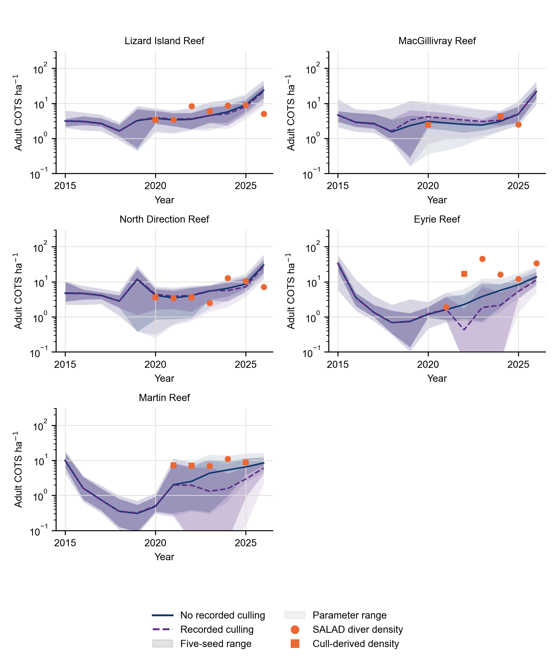
Figure 22: Recent adult COTS density with and without recorded culling, against SALAD diver estimates and catches converted to density (source Figure 2). The vertical axis is logarithmic. Lines are five-seed means; bands span seeds and parameter tests as in the main figure. Larval-input corrections and density targets share observations, so agreement is not independent validation.

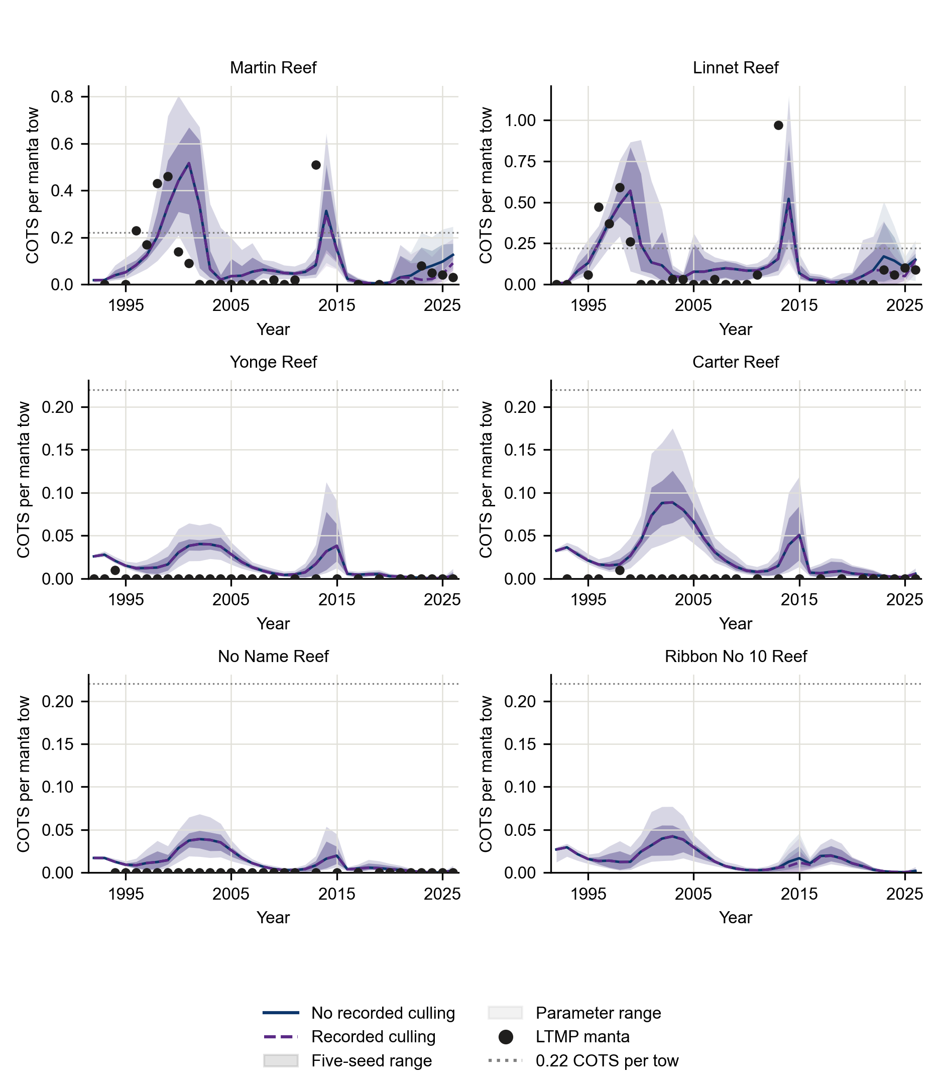
Figure 23: COTS trajectories on additional reefs outside the four-reef calibration fit (source Figure 3). Points show LTMP manta observations; Ribbon No 10 has no LTMP series. Blue and purple indicate culling-off and culling-on trajectories with the main figure’s range definitions.

Initial control projections to 2050
The completed ensemble spans 5 climate models, five seed pairs, two climate pathways, nine culling levels and two treatments of the 2026 population state. The figures use the 450 continuous-history runs without a population reset. Historical catches apply through 2026; effort-based culling begins in 2027. “Recent effort” uses 2023–25 diver-hours on each reef. Increased effort multiplies those hours; targeted effort reallocates the same total each half-year among reefs with at least 3 adults per hectare. Density-dependent catch rates determine adult removals, capped by the available population. Vessel travel and search costs are not represented explicitly.
Outside larval supply resamples historical irruption patterns and scales them by projected coral in the domain. These conditional scenarios include neither thermal acclimation nor external coral-larval supplementation. Excess simulated COTS in 2026 carry into the near-term projections. Proposed changes to the population reset, thermal acclimation scenarios and source-reef culling corrections had not yet entered the reported ensemble.
Increased effort lowered near-term COTS peaks, with climate-dependent coral outcomes (Figure 24, Figure 25). Reallocation could increase domain-wide removals without providing the largest benefit at the five displayed reefs (Figure 26). Population and coral summaries cover those reefs, whereas removals cover the whole domain. These summaries cannot establish domain-wide coral protection or an optimal allocation; local and downstream outcomes and operational constraints need further assessment.
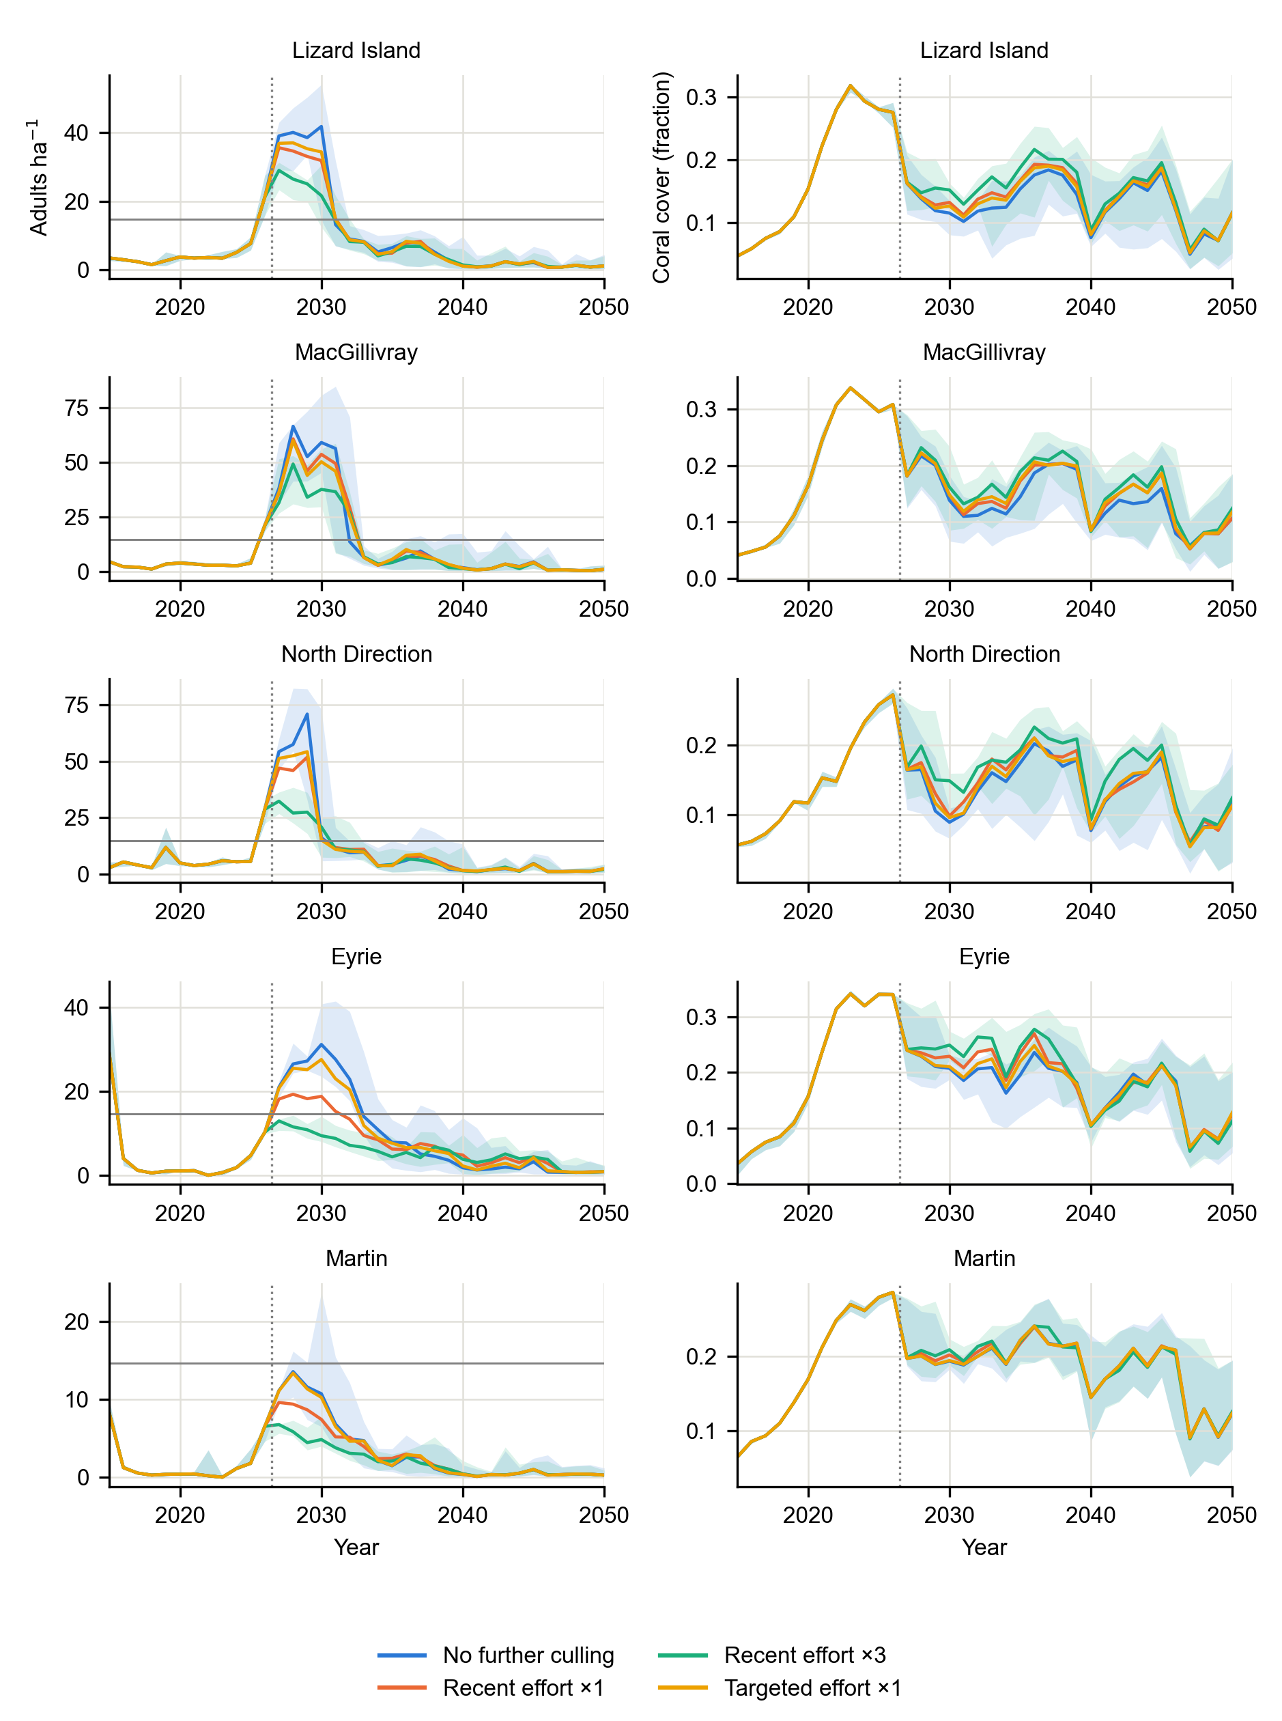
Figure 24: Exploratory COTS and coral projections under SSP2-4.5. Lines are medians across five climate models and five seed pairs. Bands show the 25th–75th percentiles for no further culling and three times recent effort, rather than confidence intervals. “Targeted ×1” reallocates the recent total effort. The dotted line separates history from projections. Recent population and outside-supply uncertainty carry forward.

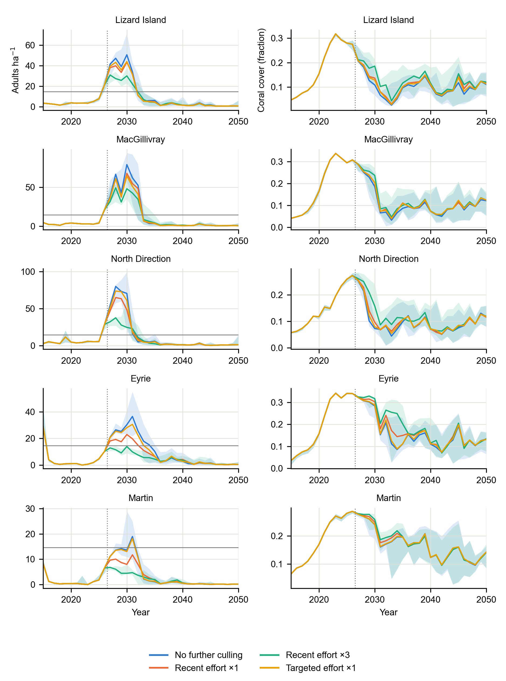
Figure 25: The same exploratory effort comparisons under SSP3-7.0, with definitions matching the preceding figure. Lower COTS densities later in the period can accompany reduced coral food and should not be read as a control benefit.

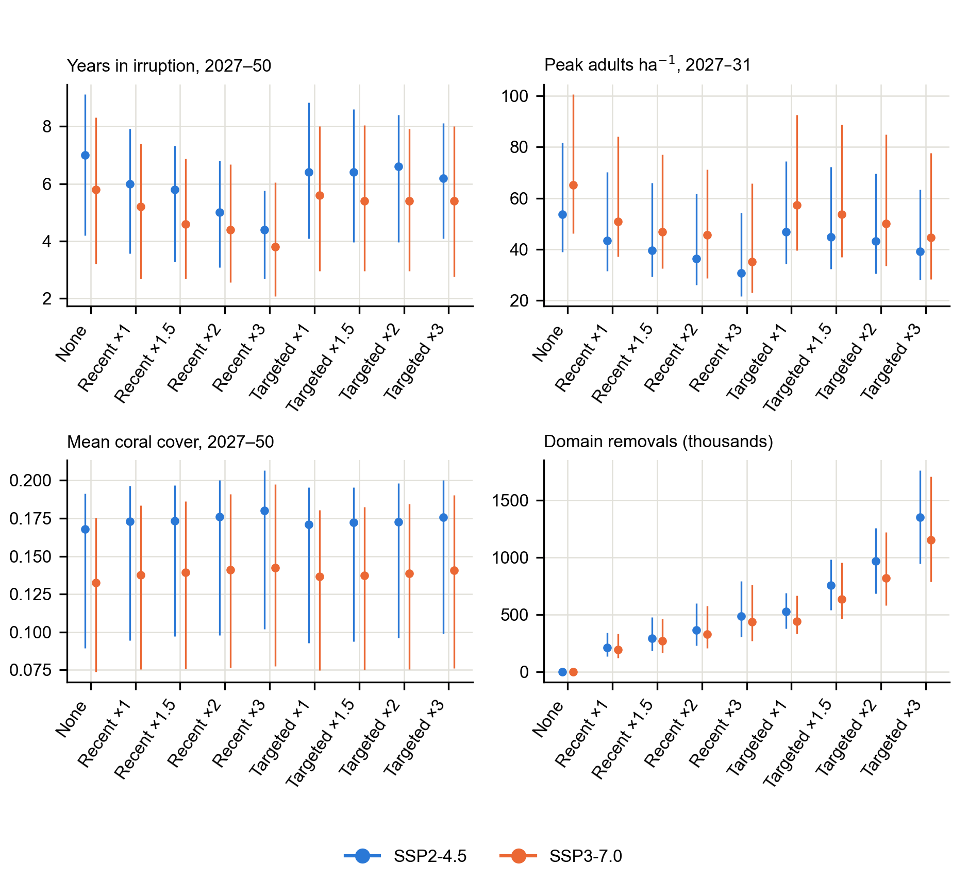
Figure 26: Exploratory effort comparisons for 2027–2050. Points are medians; bars span the 10th–90th percentiles across climate models and seeds. The first three panels average Lizard Island, MacGillivray, North Direction, Eyrie and Martin; the last counts adult removals across the whole domain. “Recent” retains the recent allocation, “targeted” reallocates it, and multipliers scale total hours. These are model-conditional scenarios.

Appendix J: Archived 15 October metacommunity comparisons
The candidate codes below are technical identifiers. W denotes the working configuration; the version with more initial preferred coral at Lizard Island is C3a; the version with lower background coral mortality is C6. They remain calibration alternatives, not validated control policies. Methods and scenario design are documented in Appendix G; the following results retain the frozen 15 October 2026 reporting snapshot.

Metacommunity model: calibration and current limitations

Replicated candidates
The metacommunity model now reproduced both historical irruption waves on the reefs with two observed waves, although irruption heights and intervening densities remained imperfect (Figure 27). Three configurations were retained for further testing: the working configuration W, C3a with a higher initial preferred-coral share at Lizard Island, and C6 with lower chronic background coral mortality. Each was run with 5 recorded pairs of ecological and connectivity seeds. Under the revised score v2, each candidate matched 7 of 7 observed historical peaks in every seed. Matching allowed a timing window; it did not establish accurate peak heights or performance on independent data.
The candidates retained different compromises (Table 25). Mean COTS losses overlapped in their variation across seeds. C3a produced a larger first Lizard irruption, 56.1 ± 6.5 adults ha$​^{-1}$, compared with 29.0 ± 2.3 for W, and had a lower coral error. However, it left more COTS between irruptions. C6 reduced the troughs at the cost of a higher coral error, 0.279 against 0.250 for W.
The qualitative gate was sensitive to the observation model. At A½ = 30 adults ha$​^{-1}$, W passed in 5 of 5 seeds, C6 in 3 and C3a in 0. At A½ = 10, W passed in 0 and C6 in 3. These are conditional calibration checks: the detection curve remains uncertain, and a passing qualitative gate does not replace held-out or regional validation.
Table 25: Replicated metacommunity calibration on the four Lizard Island reefs (run 20261014T_48). Means ± SD across five recorded seed pairs; these are measures of stochastic variation, not confidence intervals. Lower COTS loss (score v2) and coral J indicate better calibration fit. Gate columns count seeds passing G2′ under the indicated density-dependent manta detection assumption, with A½ in adults per hectare. All candidates matched seven historical peaks in every seed at the linear observation mapping. No entry represents held-out validation.
Candidate | COTS loss v2 | Coral J | Gate A½ = 10 | Gate A½ = 30
W | 6.79 ± 0.79 | 0.250 ± 0.002 | 0/5 | 5/5
C3a | 6.72 ± 0.70 | 0.228 ± 0.002 | 0/5 | 0/5
C6 | 7.13 ± 0.85 | 0.279 ± 0.002 | 3/5 | 3/5

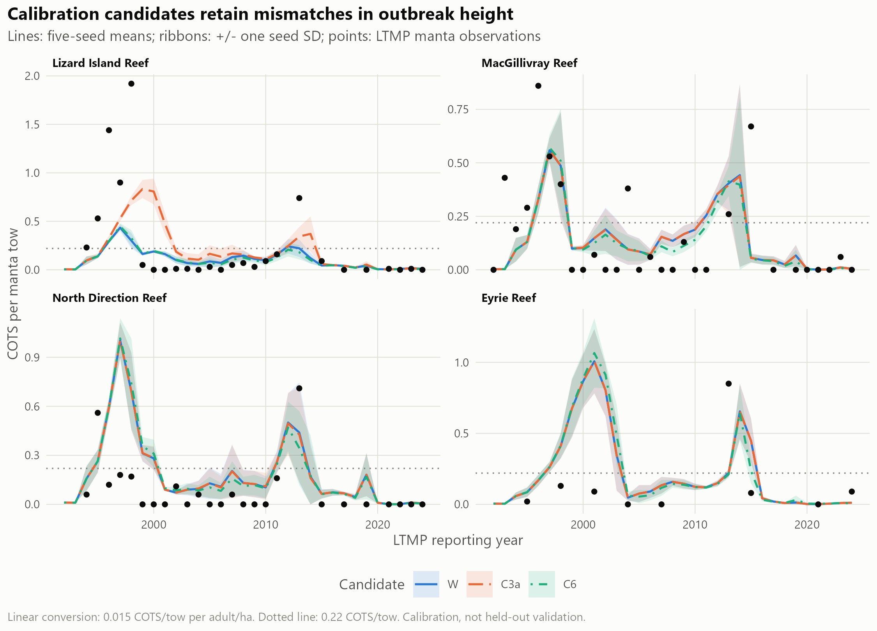
Figure 27: Historical COTS trajectories for W, C3a and C6. Lines are means across five seed pairs and ribbons are one standard deviation across seeds; points are AIMS LTMP manta observations. Adult density is shown through the fixed linear conversion of 0.015 COTS per tow per adult ha$​^{-1}$, and the dotted line marks 0.22 COTS per tow. Peak-height and trough mismatches remain despite successful historical peak matching.

Historical culling exposed missing populations
Prescribing the recorded historical removals exposed populations that were too small to support the observed catches. In the working configuration with the primary 210 m allocation kernel, 88% of requested removals at Eyrie in 2021–24 could not be applied because the simulated juvenile or adult population was absent. Across the model domain, the corresponding share was 70%. This discrepancy identified a failure to represent the recent build-up, rather than evidence that actual culling was ineffective.
Where simulated COTS were available, removals changed the historical trajectory. North Direction’s simulated second-wave maximum fell from 0.82 to 0.55 COTS per tow. The summed calibration loss v2 increased from 6.44 to 6.57. These single-seed comparisons tested the removal implementation and consistency with recorded catches. They did not estimate the benefit of a control policy, and culling was left off in the subsequent build-up diagnostics.

Extension to 2026
The latest completed diagnostic runs extended the domain to 2026 and examined the recent build-up separately from the historical candidate comparison (Figure 28). They crossed original and cull/SALAD-corrected irruption-boundary inputs with changes to coral thermal settings. With the earlier thermal settings and no chlorophyll modifier, correcting the boundary reduced score v3 from 15.61 to 12.63. With revised thermal settings, losses were 11.34 and 11.34, respectively. The revised settings removed the extra bleaching multiplier and raised the threshold below which bleaching mortality was reduced. The trajectories showed that both the food trajectory and boundary supply affected the timing and magnitude of the new irruption.
Exploratory chlorophyll-based larval-survival modifiers gave smaller additional changes: the lowest score v3 in the corrected-boundary screen was 10.99, against 11.34 with those modifiers off. Score v3 includes a diver-anchored recent-density error and is not numerically comparable with the earlier score v2. All of these extended runs used one seed pair. Cull and SALAD evidence contributed to both the corrected boundary and its assessment, so their apparent improvement was not independent validation.
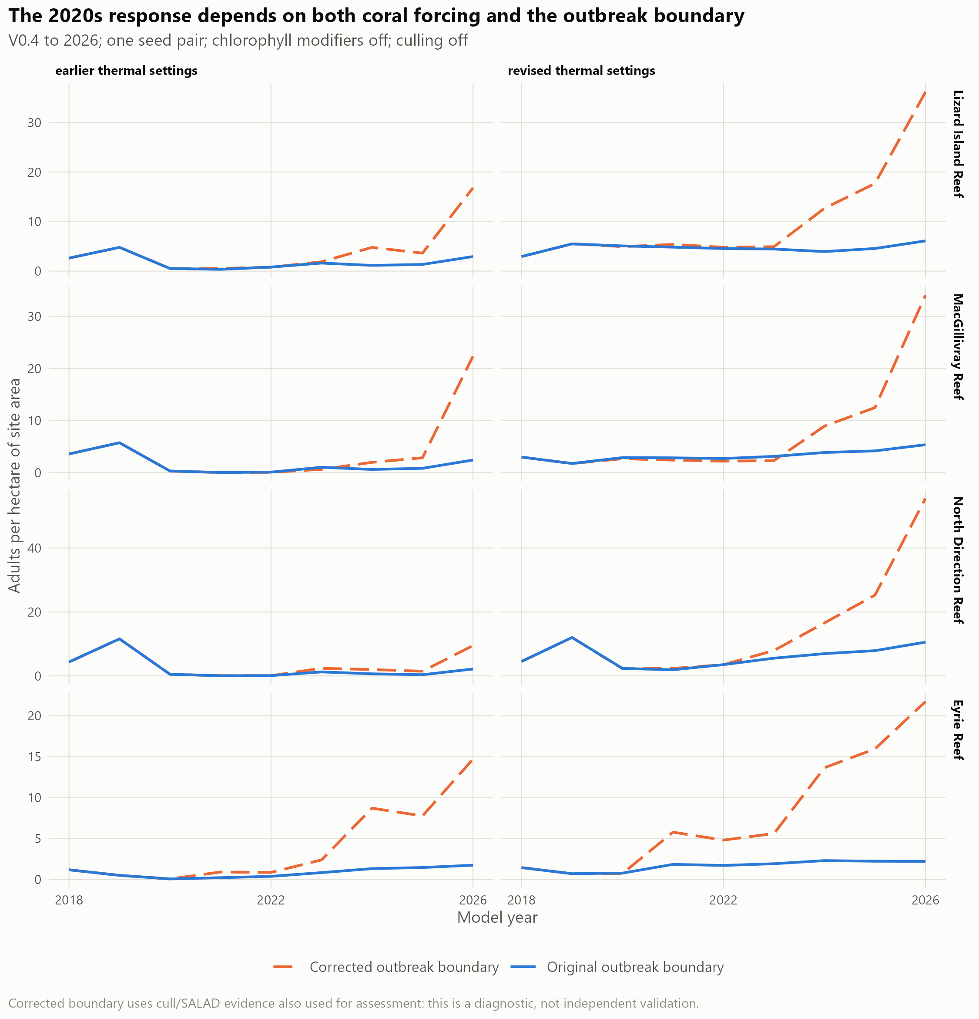
Figure 28: Single-seed extension to 2026 with original or corrected irruption-boundary inputs, under the earlier or revised coral thermal settings. Lines show adult density, with chlorophyll modifiers and culling off. Corrected boundary supply produces a larger late build-up; its response also depends on coral forcing. The same cull/SALAD evidence helped construct and assess the corrected boundary. These are diagnostic trajectories, without an uncertainty interval or an independent validation claim.
No configuration has completed the full validation sequence. The model remains a platform for testing irruption mechanisms and developing control scenarios. Held-out reefs and years, regional transfer and sensitivity tests are still required before reporting benefits of primary-irruption suppression or rules for starting and stopping control. The fine-scale habitat rankings have not been validated as inputs to the metacommunity model.

Appendix K: Preliminary larval-concentration comparisons
These comparisons support the dispersal Results and reformat project figures lc4 and lc6. They describe concentrations, rather than source-to-destination exchange, at larval ages 5, 9 and 10 days across 10 releases. The full source set, including concentration ranks, hotspot persistence, zone comparisons and the north–south profile, remains in DataProcessing/connectivity_lizard/outputs/figures/.

Variation among releases
Concentrations around Lizard varied among release dates. Elevated early-age concentrations in some releases did not consistently persist to the later ages (Figure 29). Values compare the unweighted mean reef concentration within a zone with the mean across all reefs in the domain. They are relative to that release and larval age, rather than a fraction of larvae produced locally. The Lizard group comprised reefs within 20 km of Lizard Island after the outer-barrier and Ribbon classifications were applied. Full zone rules and the component tables are retained with the source analysis.
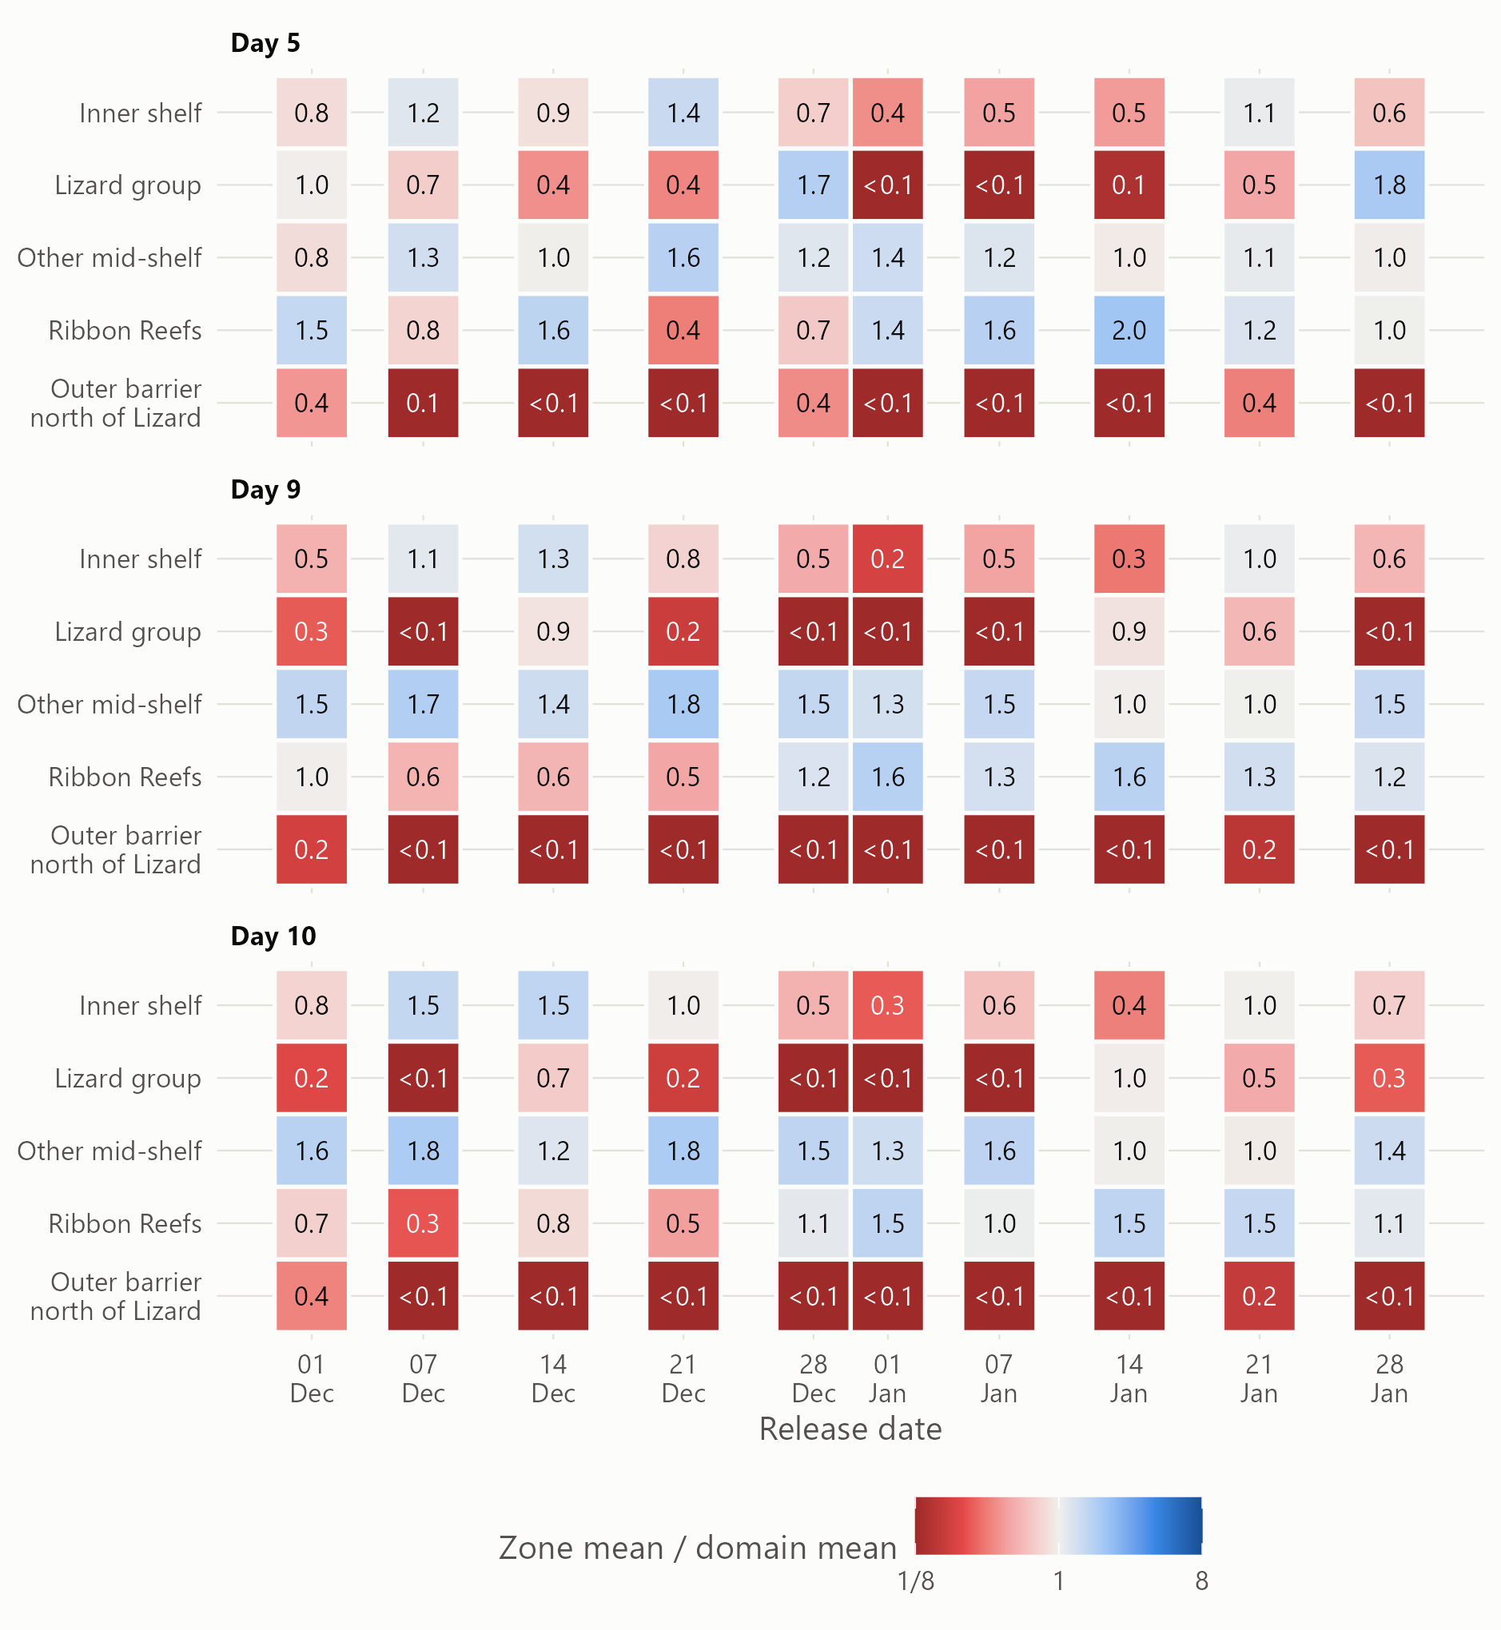
Figure 29: Mean reef concentration in each shelf zone relative to the domain mean, by release and larval age. A value of one means the zone matched the domain mean for that release and age. Colours are clipped at one-eighth and eight times the domain mean; labels retain the source values, with values below 0.1 grouped. This reformats source figure lc4. The ratios do not identify larval origins or measure local retention.

Cross-shelf patterns and the domain boundary
The broad north–south gradient makes an overall Lizard-versus-other-reefs contrast difficult to interpret. Comparing cross-shelf positions within latitude bands gives a more useful view (Figure 30). The central Ribbon Reefs generally ranked below nearby mid-shelf reefs at the later ages, whereas the southern Ribbon Reefs did not show the same pattern. Latitude bands reduce the influence of the broad gradient but do not remove all spatial dependence or possible boundary effects.
These results describe one spawning season. The local analysis plan calls for source-to-destination matrices for individual releases, explicit checks of sources and losses at the model boundary, and comparisons against connections based on distance alone. Those tests are needed before attributing concentration patterns to retention within reef groups, interpreting Ribbon Reef isolation, or using the patterns to identify reefs for source control. Exploratory reef-label permutations in the source analysis did not account for spatial autocorrelation; their p-values are not used here as confirmatory evidence. [TO CONFIRM: concentration units, larval biology and source-buffer coverage with Sev and Owen, alongside the Methods placeholders.]
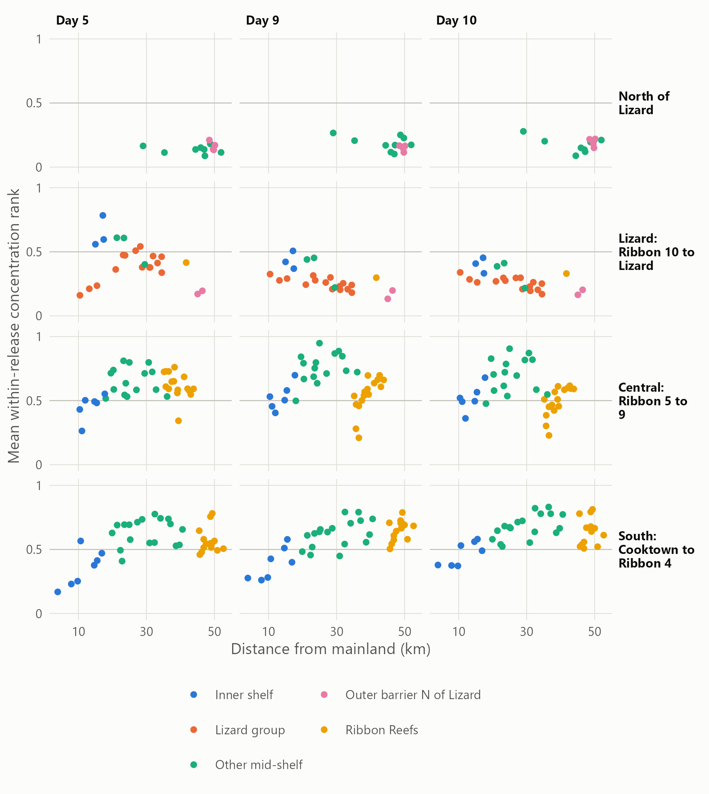
Figure 30: Cross-shelf concentration ranks within latitude bands, with the northern band at the top. Each point is a reef, showing its mean within-release rank over the simulated releases; the horizontal line marks rank 0.5. Columns show larval age and colours identify shelf zones. This reformats source figure lc6. Broad latitude bands aid comparison but do not eliminate domain-boundary effects or spatial dependence.

Appendix L: Management assessment and field-trial design

Validation and interpretation limits
The search evaluation used outcomes from dives crews chose to make. It cannot establish densities at never-dived sites or the consequences of changing crew behaviour. Reefs without recent observations depend mainly on habitat, where discrimination is weak. Spatially held-out habitat scores reduce bias from scoring a reef with its own training data, but the season-by-season evidence test did not also restrict the habitat fits to preceding years. The evidence regression was tested forward in time; the entire combined modelling process was not a fully prospective forecast.
Spatial coverage also limits interpretation. The primary habitat layer joins models with different predictor coverage, and their rankings differ near that boundary. The explanatory joint habitat model relies heavily on fallback predictors in some regions. Values from the manta-trained model away from tow paths are extrapolations, including at some proposed exploration areas. The retrospective thinning result also depends on an inferred order around the reef, which may be less suitable for surveys that do not follow the perimeter. None of the proposed 2027 products has yet demonstrated its performance in a field trial.
The metacommunity results are calibration, diagnostic comparisons and exploratory projections within one northern reef cluster. Replicated runs and additional-reef checks improve the assessment but do not complete independent regional validation. Historical peak heights and between-irruption densities depend on the assumed relationship between manta observations and true abundance. Recent cull and SALAD observations helped construct corrected irruption inputs and also assess their fit. The current calibration uses five seed pairs and parameter sensitivity tests; projections additionally span five climate models. Those ranges do not capture all structural uncertainty. In particular, excess simulated COTS in 2026 carry into the near-term projections, outside larval supply is only approximately coupled to future coral, and thermal acclimation scenarios have not yet entered the reported ensemble. No estimate of historical program impact or future coral protection should be presented as validated until these assumptions and held-out performance have been assessed.
Larval connectivity has different roles in the two strands. It was not a predictor in the within-reef habitat ranking, whereas it carries population effects among reefs in the metacommunity model. The latter still uses reef-level transport and does not establish fine-scale transport among sites. Uncertainty in that transport, external larval pressure and coral disturbance must accompany any assessment of downstream control benefits.
The main management implications summarise the five uses below. This appendix retains the detailed interpretation, scenario design and field-assessment requirements that support them.

Combining recent observations with habitat for daily searches
The practical contribution of the search models is a consistent way to combine what crews have recently observed with habitat information covering places they have not visited. Recent cull dives and manta tows carry most of the information about the current irruption, while habitat provides a first search order where that evidence is absent. The resulting ranking reduced the designated sites searched for a matched share of problematic dives in the retrospective comparisons. Its value is therefore in helping crews decide where to look first and releasing effort to search habitat outside the established footprint. Whether this improves overall detection depends on what is found in the added searches, as well as which familiar sites can be deferred.
This use follows from the different information each source contains. Habitat describes the setting in which COTS occur, but it cannot identify the current population after recruitment, movement and earlier control. Conversely, recent observations are informative about the places crews have searched but leave large gaps. Combining them is useful even when habitat alone separates high- and low-priority locations only weakly. The combined score should be read as a relative search priority within a reef, with the evidence behind it available to planners.
The >0.04 evaluation shows a benefit from ranking sites, with its size depending on the retention required. At 80% and 90% retention, the combined ranking searched 66.6% and 80.1% of sites, respectively, compared with 80.4% and 90.5% at random (Table 12). Requiring 95% retention still reduced searches, whereas 99% required almost all sites. The smaller reductions at high retention should not be attributed to the change in CPUE threshold alone: earlier ≥0.02 examples used lower retention targets. Any operational choice must weigh the sites deferred against the high-density dives potentially missed.
One option for field assessment is to use the ranking for repeated targeted visits while retaining an annual full-coverage survey that includes all deferred designated sites. Positive manta observations, feeding scars or nearby high-density detections could trigger earlier checks, and a full coverage check before reef closure could provide another opportunity to find missed populations. These measures could reduce the time that false negatives remain undetected, but their recovery rate has not been measured. Their effort, detection limits and the ecological consequences of delayed control must be included when judging the overall benefit (the operational impact pathway).
The retrospective gains also include knowledge already held by experienced crews. Sites were selected for dives using previous observations and local experience, so the ranking partly formalises existing practice. A field trial is needed to establish how much it adds to crew planning, particularly at never-dived sites. Exploration areas provide a way to extend the evidence base: visiting a small number of them and recording nil results as well as detections would allow future rankings to learn from a broader sample of reef habitat. Historical tows on previously unsurveyed ground found strong evidence more often than repeat tows, but this does not establish the yield of the proposed exploration areas; irruption stage may contribute to that difference.

Maintaining coverage during manta surveillance
The retrospective manta comparison provides a spatial-coverage benchmark for assessing search strategies; evenly spaced omissions are not a proposed field route. Model-based selection concentrated tows in a few highly ranked areas and could miss whole aggregations elsewhere. Even spacing retained better coverage of the observed aggregations. This finding concerns retrospective thinning of existing surveys: tow order was inferred from position around the reef, and new routes have not been trialled. Habitat remains useful for proposing where to add or repeat observations, subject to field assessment, especially beyond the current footprint. The surveillance objective therefore has two parts: preserve coverage when thinning familiar routes, and test additional searches in lagoon bommie fields, shallow crests and isolated patches that perimeter routes can overlook. The trial should account for effort used on both, so that shifting effort to new habitat is distinguished from reducing total surveillance.

Assessing the culling program from 2012 to the present and beyond
The fine-scale metacommunity model was developed to reconstruct the third and fourth irruption waves and the emerging fifth wave in the initiation zone, assess how culling has changed COTS populations and coral trajectories since 2012, and guide future prioritisation. The historical assessment compares the observed program with a counterfactual in which the same reefs receive no control. Counts of COTS culled document the program’s removals, but do not show how many animals would otherwise have survived, reproduced and dispersed larvae, or how much coral those animals and their descendants would have consumed. Linking these processes allows the model to assess effects extending beyond the treated sites.
We compared paired simulations beginning from the same population and coral state before control. One applied recorded removals from 2012 onward, focusing on the periods of control in 2014–15 and 2020–2026; the other omitted program removals. Both received the same heat stress, cyclone and other environmental forcing and used matched random seeds. Reproduction, larval dispersal and coral consumption evolved within each simulation. Differences in COTS abundance, larval export, cumulative coral consumption and coral cover provided the comparison of program effects within the model’s assumptions. Requested removals exceeding the simulated population were recorded explicitly. [TO CONFIRM BEFORE FINALISATION: completion of the full paired historical assessment and removal-record coverage through 2026; this paragraph is drafted in past tense as requested.]
Matching historical peak timing alone is insufficient: the model must also represent irruption sizes, populations between irruptions and the recent build-up documented by divers. Initial population estimates, the relationship between manta observations and actual density, and coral recovery all contribute to uncertainty in the estimated effects of culling.
Larvae arriving from reefs outside the Lizard Island model domain also affect this comparison. Their supply is currently informed by the GBR-wide irruption predictions of Stewart et al. (2026). For a regional history without culling, we would ideally need corresponding predictions of what happened on those outside reefs without culling, so that their larval supply reflects the same counterfactual. The existing prediction layer does not by itself provide that causal comparison. Using the same outside supply in both simulations instead estimates the effect of culling inside the Lizard Island domain while holding conditions on outside reefs unchanged. Any estimate of coral protected must state which of these questions it answers.

Projecting suppression of the fifth primary irruption wave
The forward-looking extension will assess how attempts to suppress the fifth primary irruption wave in the initiation box during 2020–2026, including increased resources during 2026–2028, could change subsequent irruptions and coral protection outcomes. Within the current domain, the first test is whether suppression reduces COTS densities and larval supply at its southern extent, including Irene Reef and Startle Reefs. Those results would help assess potential consequences farther south toward the Cairns region; a direct estimate of coral protection there would require a model domain or linked model that includes those reefs. This extension is partly developed and builds on the strategic questions addressed by earlier COTS population and reef ecosystem models (Morello et al. 2014; Matthews et al. 2020a; Condie et al. 2021; Bozec et al. 2022).
The scenario comparisons will focus on what increased effort from now can achieve in suppressing the primary irruption. This question differs from protecting coral at individual reefs after secondary irruptions are established, as discussed by Matthews et al. (2024). One set of comparisons will reallocate existing capacity among reefs, for example by targeting dense populations on reefs that supply larvae to others. A second set will assess the additional benefit of one or two vessels. Comparisons within each capacity level will show the value of changing allocation, while comparisons across capacity levels will show what extra resources could achieve. Continuation of current control and no control will provide reference trajectories. Starting and stopping rules will be examined within this primary-suppression objective. A stopping rule based only on the inability to save local coral could abandon a reef that remains an important larval source. Scenarios should therefore compare stopping when local protection is no longer achievable with continued control to reduce downstream recruitment. They should also test when to begin or intensify control on source reefs whose populations cannot feasibly be reduced below the local ecological target. These comparisons will show whether downstream benefits justify effort that produces little immediate local coral protection.
Each paired comparison will use the same climate and disturbance sequences. Repeating it across plausible population states, biological processes, larval transport and future environmental conditions will help identify strategies that are robust to deep uncertainty in the system. The aim is to find strategies that continue to meet management objectives across a wide range of plausible futures, rather than selecting a strategy that performs best under one assumed future.
The outcomes will connect suppression to the duration and extent of high COTS densities, larvae exported to connected reefs, coral loss through feeding, and subsequent coral recovery. Fewer COTS at a treated reef need not produce a proportional local coral benefit, particularly if coral spared from feeding is later affected by heat stress or cyclones. Conversely, culling a large aggregation might not prevent substantial coral loss at that reef but could still reduce COTS recruitment and protect coral on connected reefs. The assessment therefore needs to follow both local and downstream consequences.
Future scenarios must also represent what crews can achieve. The initial projections now link diver effort and COTS density to achievable removals, alongside prescribed historical catches. That relationship still requires assessment against operational records, including search and travel costs, before starting and stopping rules can describe operational choices credibly. Site rankings from the species distribution models could help allocate searches, although that coupling has not been validated. Scenario design will depend on future funding and direct consultation with GBRMPA, program partners and contractors to reflect operational realities. The exploratory horizon is 2050 under SSP2-4.5 and SSP3-7.0. [TO CONFIRM: vessel budgets, intervention rules and climate scenarios agreed with program partners.]

Monitoring operational performance
A field trial of the 2027 site rankings from the species distribution models is planned for January–February 2027, while the strategic metacommunity model continues to be developed. Before each visit, the trial will record the recommended priority of each site. It will then record which sites crews searched by manta tow or dive, the effort used, the COTS found and any reasons for departing from the suggested order. Outcomes will be compared with the search order crews would normally use and with the modelled expectations in Table 23. The original class expectations use ≥0.02 COTS per minute of bottom time. The separate >0.04 reassessment (the cull-site Results) supplies the more relevant high-density trade-offs, but neither retrospective test establishes what will be found in the trial or at unvisited sites.
The trial will aim for a 10–15% reduction in the number of designated sites requiring manta-tow searches on individual visits, with a negligible share of dives above 0.04 COTS per minute of bottom time missed. It will also aim for a 10–15% reduction in low-density or empty dives under the same allowance for missed dives above 0.04. Here, empty dives find no COTS, and low-density dives retain the report’s definition of positive CPUE below 0.02. Dives from 0.02 to 0.04 will be reported separately: some may be deferred without the penalty assigned to missed dives above 0.04. These remain proposed adoption criteria: the retrospective reassessment does not establish both reductions at an agreed negligible omission rate. [TO CONFIRM: the numerical tolerance for missed dives above 0.04 and whether reductions are measured per visit or over the full season.]
A fallback option is an annual full-coverage surveillance round that includes every designated site, including those deferred by the ranking, using manta tows and follow-up dives as appropriate. A further coverage check before reef closure could catch populations that develop or remain undetected between visits. New COTS sightings, feeding scars or nearby high-density dives could prompt earlier checks of low-ranked sites. Crews should record coverage and reasons for revisiting, rather than treating a low rank as evidence that COTS are absent.
The trial should record >0.04 dives found during follow-up at deferred sites, the time since the initial visit, and the extra tow and dive effort required. Independent checks of a sample of deferred sites during the initial visit would help estimate the false-negative rate; annual detections alone could also include newly developed populations. A negative manta observation alone cannot establish that a site has no high-density population. Annual surveys and pre-closure checks offer opportunities to detect false negatives, without guaranteeing complete detection or coral protection during the delay. The 80% and 90% options therefore need assessment with an agreed maximum delay and omission allowance, rather than assuming later coverage makes their initial 20% or 10% omissions negligible.
Full-season effort must include annual full surveys, pre-closure and triggered checks, repeat dives and exploration visits. Sites deferred on one visit may be searched later, so the initial site reductions in Table 12 cannot be read directly as annual time savings. Visits to exploration areas should be reported separately, with dates and irruption conditions recorded. If the trial meets the 10–15% improvement targets while remaining within the agreed missed-dive allowance and completing the coverage checks, the approach can be considered for adoption; otherwise, the ranking or search rules should be refined. [TO CONFIRM: trial design, monitoring owner and reporting route agreed with GBRMPA and vessel operators.]
Savings should be attributed to the ranking only to the extent that it improves retention of high-density dives at the same effort, or reduces effort at the same retention. Translating those gains into vessel time or money requires an agreed account of travel, search, diving and culling time. [TO CONFIRM: whether to estimate financial savings and which operational cost data to use.]

Developing an early-warning system
The proposed application combines concentration patterns with release-specific network analysis to identify periods when reefs in the initiation box exchange larvae within tightly connected groups. Comparisons with distance-based connections and explicit checks of sources beyond the domain boundary are needed to distinguish hydrodynamic clustering from reef layout and boundary truncation. Repeating the analysis across seasons and comparing its signals with subsequent COTS observations and reef-level irruption estimates would assess warning lead time and false alarms. Appendix K describes the planned connectivity tests; no early-warning performance has yet been evaluated.

Complete follow-up checklist
- Agree the tolerance for missed dives above 0.04 CPUE, then trial the 2027 ranking with crews. Record site searches, tows, dive effort, intermediate and high-density outcomes, exploration visits and later coverage checks. The revised retrospective trade-off does not establish the proposed adoption targets.
- Maintain representative surveillance coverage and trial habitat-guided searches beyond familiar routes. The retrospective thinning benchmark is not an operational route; Appendix H documents the comparison.
- Trial a small number of exploration areas per reef visit and record outcomes, including nil results, so that the evidence base can expand beyond familiar sites.
- Refresh the ranking each season and repeat its temporal evaluation as new observations arrive. Compare the product with current crew practice as well as a no-information baseline.
- Complete expert review with GBRMPA, vessel crews and Traditional Owner operators, and agree ownership of monitoring and integration into Field Maps and the COTS Dashboards. [TO CONFIRM: participants, timing and operational owner.]
- Obtain survey-effort information for additional observation sources, including ReefScan, to support independent assessment beyond places selected for cull dives.
- Resolve the recent COTS population mismatch and complete independent validation of the metacommunity model before estimating the program’s impact from 2012 to the present.
- Extend the paired historical culling diagnostics to a complete program-impact assessment, reporting effects on COTS populations, larval export and coral trajectories, with the limits imposed by the external boundary stated explicitly.
- Refine the exploratory fifth-wave projections under agreed effort budgets, climate conditions and starting and stopping rules. Test the recent population state and outside supply assumptions, and report domain-wide as well as local coral consequences.
- Test finer-scale hydrodynamic connectivity against a distance-based control, and assess any coupling of search rankings to intervention scenarios before using it for management comparisons. [TO CONFIRM: link to Work Plan output F and the agreed pilot region.]

Appendix M: Three alternatives to the cull-site ranking

What changed, and what remained comparable
Recent CPUE was the most promising addition; selecting unusually high habitat values within a site did not improve on it. Three alternatives were specified before fitting. The first replaced the direct-site indicator of any preceding-season dive at ≥0.02 with any dive strictly above 0.04. The quiet-site indicator still meant a searched site with no ≥0.02 dive, so intermediate finds were not treated as quiet searches. The second added a continuous, recency-weighted site CPUE and its effective number of recent dive records. The third used the same recent evidence but replaced mean habitat with the 90th percentile of predictions within the site.
All three logistic models still learned the ≥0.02 response, preserving intermediate dives as useful culling opportunities. Each coefficient set was refitted only on years preceding its test year. The 90-day half-life and 90th-percentile choice were fixed before candidate assessment. For recent records assigned to site $i$, catch $n_{j}$, bottom time $t_{j}$ and age $a_{j}$ in days defined:
uj=2-aj/90, Wi=j∈i​uj,Ci=j∈i​ujnjj∈i​ujtj. | (3)
The second and third models added $log\left(1+C_{i}/0.02\right)$ and $log\left(1+W_{i}\right)$ to the score in Methods, with all coefficients estimated again. The weight sum distinguishes an old or weakly supported estimate from a recent one. An undived site had $C_{i}=W_{i}=0$. Nearby dive and manta terms retained the original spatial weighting. Historical evidence used the preceding calendar season; the 2027 comparison product used the same 365-day window as the incumbent, June 2025–May 2026.
Habitat summaries used 2,201,095 polygon-cell or fallback records, with a median of 139 per site, compared with 16 sample points in the original validation. The mean, median, 75th, 90th and 95th percentiles were calculated from the same 30 m support and ranked among sites on each reef. The same five reef folds and fixed XGBoost settings reproduced every archived sample-point mean exactly before new summaries were used. Habitat fits remained spatially held out; they were not also restricted to earlier years. Coverage flagged 21 sites without usable predictor values, where a habitat interpretation remains unsupported.
The archived current ranking was retained as the incumbent. A separate control refitted its original evidence model using the all-cell mean. This distinguished denser habitat sampling from changing the indicator, recent CPUE or habitat summary. The comparison used the same 28,431 dives, 861 reef-years and 32,444 candidate site-years. Never-dived sites remained candidates; their unobserved densities were not assigned zero outcomes.

Fixed site coverage and matched high-density retention
At the exact A–C cutoff, recent CPUE retained more >0.04 dives and almost the same proportion of intermediate dives as the incumbent (Table 26). It also retained more recorded dives overall, so this site-count comparison alone overstates the gain attributable to selecting more productive dives.
Table 26: Candidate rankings at the same A–C site count, 2019–2026. Percentages [95% paired reef-year bootstrap intervals]. All rows select the same candidate-site count. Recorded-dive avoidance and retention within each CPUE class have different denominators. The all-cell mean is a sampling control, not a fourth alternative.
Ranking | >0.04 retained (%) | 0.02–0.04 retained (%) | Recorded dives avoided (%)
Current ranking | 89.1 [85.6–92.1] | 88.4 [86.7–90.1] | 14.9 [13.2–16.9]
Current model: all-cell mean | 89.4 [86.0–92.3] | 88.6 [86.9–90.3] | 14.8 [13.0–16.7]
Prior >0.04 indicator | 89.5 [86.0–92.4] | 89.2 [87.4–91.0] | 14.4 [12.6–16.4]
Indicator + recent CPUE | 90.5 [87.2–93.2] | 88.4 [86.7–89.8] | 14.3 [12.4–16.2]
Recent CPUE + 90th-percentile habitat | 90.0 [86.6–92.7] | 89.0 [87.4–90.4] | 14.3 [12.5–16.2]
Random sites | 78.5 [78.3–78.8] | 78.5 [78.2–78.6] | 21.6 [21.4–21.8]

At matched 90% high-density retention, recent CPUE avoided 14.7% (95% CI 11.9%–16.8%) of recorded dives, versus 13.8% (95% CI 11.5%–15.8%) with the incumbent (Table 27). Its gain was +0.89 [-0.08 to +1.97] percentage points against the incumbent and +0.77 [-0.11 to +1.83] against the all-cell mean control. Neither paired interval excluded zero. Recorded bottom-time avoidance was 14.8% (95% CI 11.5%–17.6%) versus 13.7% (95% CI 10.9%–16.2%); bottom time includes searching and culling and is not a measure of vessel-time savings.
Table 27: Candidate rankings at 90% retention of >0.04 dives, 2019–2026. Percentages [95% intervals]; differences are percentage points [paired 95% intervals] relative to the incumbent. This new comparison uses integer site counts at 1% cutoff steps and first-crossing interpolation. Earlier Appendix H tables used 5% percentile-cutoff steps, so interpolated incumbent values can differ slightly; its exact A–C point is unchanged.
Ranking | Candidate sites selected (%) | Recorded dives avoided (%) | Change in dive avoidance (points)
Current ranking | 80.7 [76.1–85.5] | 13.8 [11.5–15.8] | —
Current model: all-cell mean | 80.4 [75.4–85.1] | 13.9 [11.5–15.8] | +0.12 [-0.20 to +0.61]
Prior >0.04 indicator | 79.6 [75.1–85.3] | 13.9 [11.3–15.9] | +0.09 [-0.76 to +0.49]
Indicator + recent CPUE | 78.5 [72.9–84.6] | 14.7 [11.9–16.8] | +0.89 [-0.08 to +1.97]
Recent CPUE + 90th-percentile habitat | 78.9 [73.4–84.7] | 14.3 [11.6–16.8] | +0.52 [-1.10 to +1.69]
Random sites | 90.6 [90.3–90.9] | 10.1 [9.9–10.2] | —

At this matched retention, recent CPUE retained 88.1% (95% CI 85.4%–91.6%) of intermediate dives versus 89.6% (95% CI 86.9%–92.7%) for the incumbent. This small loss must be weighed against the potential effort reduction; intermediate dives remain useful. Benefits also varied among seasons. The recent-CPUE point estimate improved recorded-dive avoidance in 5 of eight test years. Across 2024–2026, the gain was +1.86 [-0.23 to +5.50] percentage points; 2026 records covered January–May only. Figure 31 shows the wider trade-offs across retention targets.
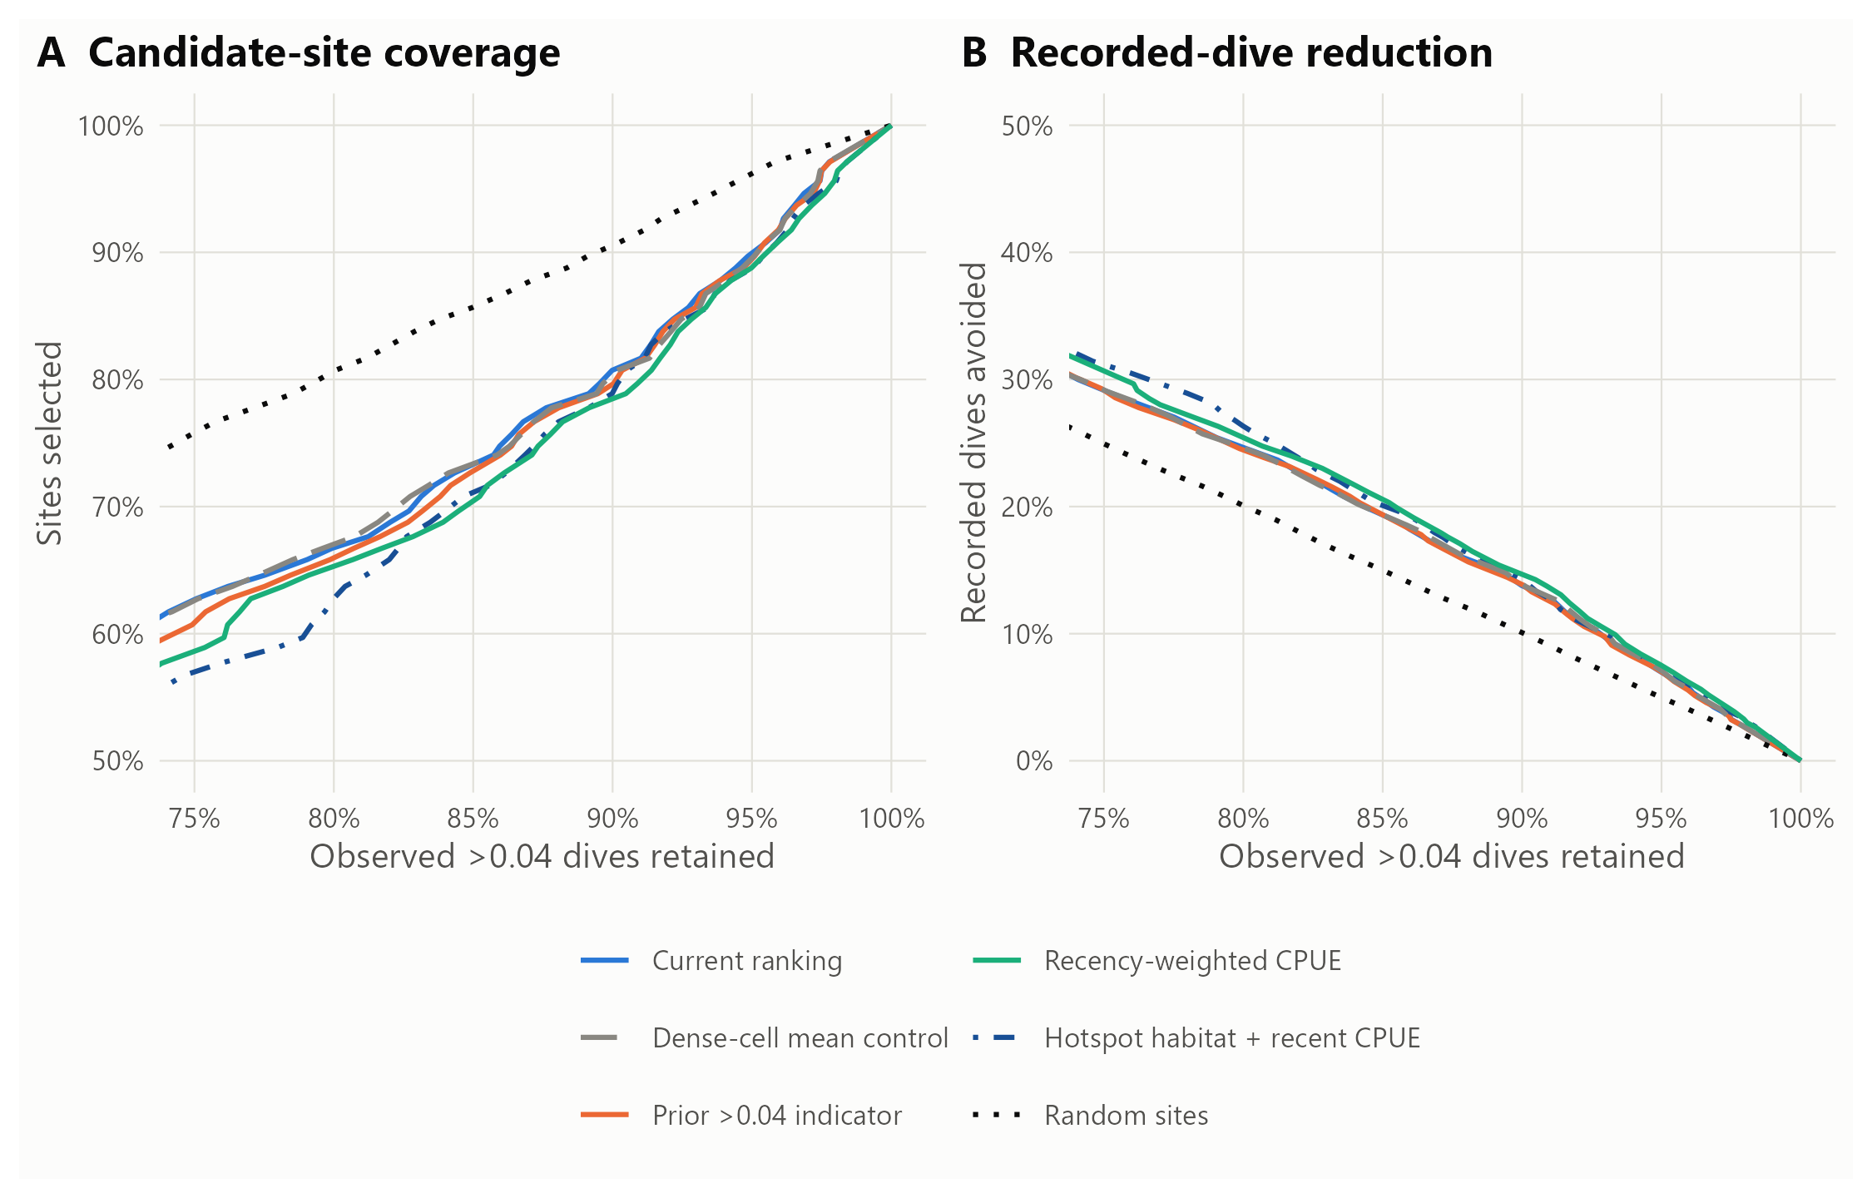
Figure 31: Three fixed alternatives, the incumbent, the all-cell mean control and random site selection, evaluated forward over 2019–2026. A shows candidate-site coverage at each share of observed >0.04 dives retained; lower is better. B shows recorded-dive avoidance at the same retention; higher is better. Curves are point estimates from common integer-site cutoffs. Paired uncertainty at 90% retention is reported in the accompanying table. Recorded visits are held fixed at selected sites; annual checks, exploration, manta-detection consequences and vessel-time savings are not included.

Comparing equal recorded dive effort
When recorded-dive coverage was matched to the incumbent’s A–C budget, recent CPUE retained 89.7% (95% CI 86.2%–92.6%) of high-density dives versus 89.1% (95% CI 85.6%–92.1%). The paired gain was +0.54 [-0.05 to +1.31] percentage points. It was smaller than the fixed-site gain and remained uncertain. Table 28 also matches recorded bottom time. These retrospective budgets differ from measured operational search time and do not account for later coverage of deferred sites.
Table 28: Retention at equal recorded effort, using the incumbent A–C rule as the reference budget. Percentages [95% paired reef-year intervals]. The first two columns match the number of recorded dives; the last matches recorded bottom time. The budget is derived from the incumbent’s A–C outcomes, not an instruction to retain 80% of dives. Curves are interpolated; feasible field stopping rules require testing.
Ranking | >0.04 retained: same dive count (%) | ≥0.02 retained: same dive count (%) | >0.04 retained: same bottom time (%)
Current ranking | 89.1 [85.6–92.1] | 89.0 [86.1–91.5] | 89.1 [85.6–92.1]
Current model: all-cell mean | 89.2 [85.8–92.2] | 89.1 [86.1–91.7] | 89.3 [85.9–92.2]
Prior >0.04 indicator | 88.9 [85.3–92.0] | 88.9 [86.0–91.4] | 88.9 [85.4–92.0]
Indicator + recent CPUE | 89.7 [86.2–92.6] | 89.2 [86.4–91.6] | 90.0 [86.6–92.8]
Recent CPUE + 90th-percentile habitat | 89.4 [85.9–92.3] | 89.2 [86.3–91.5] | 89.5 [86.1–92.3]
Random sites | 85.1 [83.0–86.8] | 85.1 [83.0–86.8] | 85.1 [83.4–86.7]

Did averaging hide a habitat contribution?
Upper habitat percentiles did not improve the habitat-only ranking in this test. Within reef-year AUC for useful dives was 0.576 for the mean, 0.589 for the median and 0.568 for the 90th percentile (Figure 32). The median was more promising in this diagnostic, but was not substituted into the combined model after inspecting these outcomes. The upper-tail combined model also performed worse than recent CPUE with mean habitat in 2024–2026. These results do not rule out real habitat hotspots; they show that favouring the best-valued part of a designated site did not improve this operational assessment.
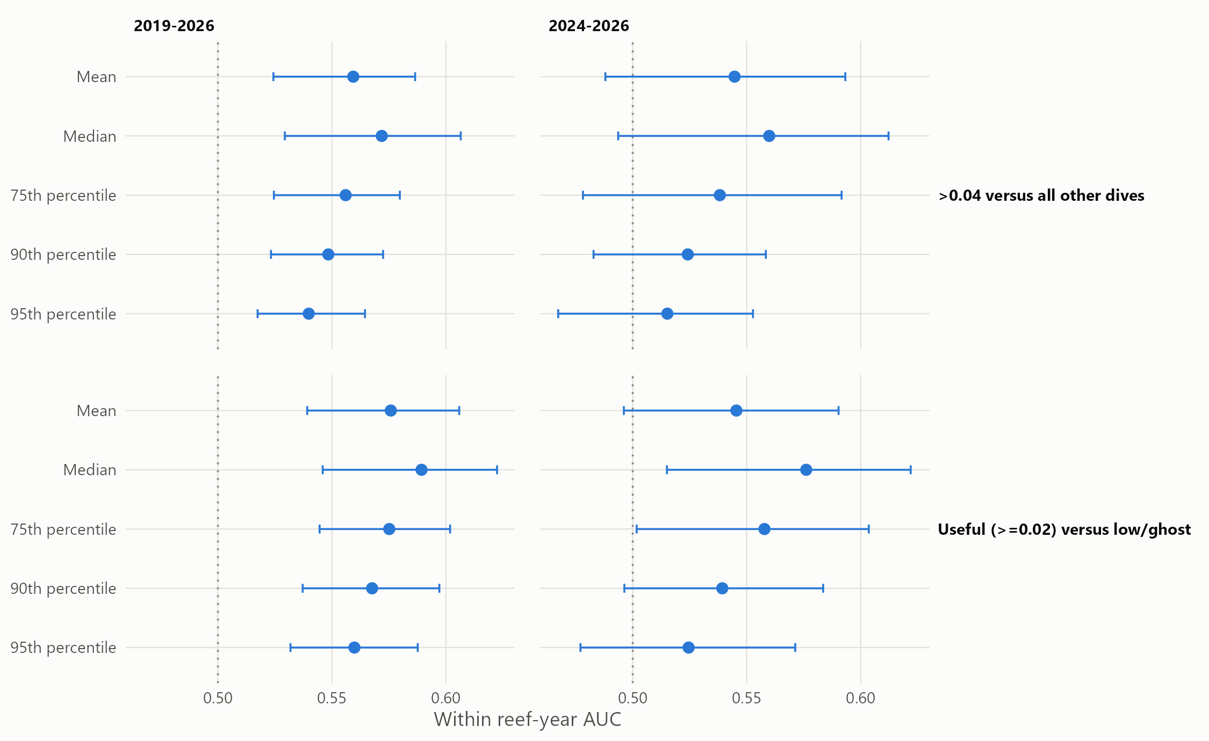
Figure 32: Habitat-only discrimination using the same reef-held-out 30 m predictions summarised differently within each designated site. Points and 95% paired reef-year intervals are shown for the full evaluation period and 2024–2026. AUC compares >0.04 dives with all other dives (top) or useful ≥0.02 dives with low-density and ghost dives (bottom). The dotted line is chance discrimination. The median result is diagnostic rather than a validated replacement for the combined model.

Experimental product and decision
No candidate met the pre-specified strong replacement gate: at least a one-point improvement in the primary recorded-dive trade-off, paired support against both controls, and gains sustained recently without loss of useful-dive retention. Recent CPUE had the best positive overall and recent point estimates, so a separate experimental layer was fitted on the same 2019–2026 deployment years and June 2025–May 2026 evidence as the incumbent. CSV, GeoPackage and KMZ files in outputs/site_ranking_candidates/ cover every designated site; the incumbent files and default selection remain unchanged. This is an exploratory choice from three alternatives, and its intervals are not adjusted for that selection.
The experimental product should be compared with the incumbent during field trials, recording intermediate and high-density catches, dive and tow effort, exploration, and later checks of deferred sites. The half-life was not optimised and the median diagnostic remains a candidate for a separately specified test. Additional calibration or a better in-sample fit would not by itself establish an operational improvement. Scripts 29–32, their input checksums, full per-year metrics and paired contrasts record the analysis separately from the original ranking results.

[TO CONFIRM: key contact name, title and email]

