Where to look for crown-of-thorns starfish on a reef
  - Fine-scale habitat layers and evidence-based search priorities for COTS surveillance and culling · Technical report to the Great Barrier Reef Foundation, COTS Control Innovation Program, project CCIP-BR-13 · [TO CONFIRM: organisations as they should appear, e.g. AIMS, QUT, JCU, GBRMPA]
[TO CONFIRM: author list and order]
October 2026
Table of contents

Suggested citation: [TO CONFIRM: Authors (2026). Where to look for crown-of-thorns starfish on a reef: fine-scale habitat layers and evidence-based search priorities for COTS surveillance and culling. Report to the Great Barrier Reef Foundation, COTS Control Innovation Program (CCIP-BR-13). Australian Institute of Marine Science, Townsville. DOI/URL.]

Executive summary
The COTS Control Program spends much of its vessel time searching for crown-of-thorns starfish (COTS). Crews tow manta observers around reefs and dive designated cull sites, many holding few or no COTS. Project CCIP-BR-13 set out to make that search more efficient at the scale where crews decide, within a reef. It had two strands:
- fine-scale layers and rankings showing where on a reef to tow and dive first;
- a prototype metacommunity model for control strategies across reef clusters.
Every search-efficiency result below was tested on held-out data against a no-information baseline at the same effort.
Key findings
- Recent evidence combined with predicted habitat makes cull-site searches more efficient. Sites were ranked by last season’s cull dives and manta tows, with the 30 m habitat layer ordering sites without recent evidence. For the same 90% of problematic dives (at least 0.02 COTS per minute of bottom time), the share of sites searched fell from 88% to 82%. Low-density dives avoided rose from 10% to 16%, and ghost dives (no COTS) avoided from 13% to 21%. In 2022–2026, keeping 80% of problematic dives needed only 61% of sites, against 74%.
- It held up season after season. Trained only on earlier seasons, the combined ranking avoided more low-density dives than habitat alone in every season from 2022, and searched fewer sites in every season from 2023.
- Each source covers the other’s gaps.
  - Past cull records plus habitat forecast next season’s problematic sites with an AUC of 0.68, against 0.57 for habitat alone.
  - History lies within reach of only 9% of reef cells, and 67% of designated sites are on reefs with no recent visits. There, habitat supplies the first search order.
  - Habitat also points to ground outside the current search footprint, where strong manta evidence was more common than on repeat ground (13.6% vs 5.8% of tows).
- For manta surveillance, keep tows evenly spaced and use habitat to decide where to add effort. Skipping tows evenly found at least 95% of aggregations with 40% fewer tows. Ranking by habitat alone allowed only a 20% cut.
- The metacommunity model reproduces historical outbreak waves, but recent build-up and validation remain unresolved. Three candidates matched all 7 historical peaks across 5 seed pairs. Recorded culling exposed too few simulated COTS in the 2020s. New runs extend to 2026, but control-policy benefits await independent validation.
What was delivered
- A 2027 priority ranking of all 15,884 designated cull sites on 576 reefs (classes A–D; CSV and KMZ).
- 3,807 exploration areas on 488 reefs: high-ranked habitat outside the cull sites and away from recent tows.
- 30 m habitat layers for the Great Barrier Reef, a known-aggregation-sites layer, and a pipeline re-run each season.
- The COTSMod.jl model, integrated with ADRIA, with a reproducible calibration workflow for the Lizard Island cluster.
What managers can do now
- Order cull-site searches by the 2027 ranking and work down the classes. The lowest class (D) is the realistic candidate to defer.
- Thin manta surveillance evenly if effort must be cut, and add tows where habitat ranks highest.
- Add one or two exploration areas per reef visit and log the outcome.
Main limitations. On reefs with no recent visits the ranking relies on habitat and is close to chance. Rankings learned from past effort partly encode crew behaviour, and densities at never-dived sites cannot be verified. The products have not yet been trialled in the field, and the metacommunity model has not passed its validation gates.

1. Background

1.1 The management problem
Outbreaks of crown-of-thorns starfish (Acanthaster cf. solaris; COTS) are a major cause of coral loss on the Great Barrier Reef (De’ath et al., 2012; Pratchett et al., 2017). The COTS Control Program suppresses outbreaks by manual culling, which can protect coral when it is sustained at the right reefs (Westcott et al., 2020). Most of the program’s vessel and diver time goes into finding COTS, not killing them:
- Manta tow surveillance. Observers are towed around a reef, usually along its perimeter, to record COTS and feeding scars and to assess the reef’s outbreak status.
- Cull dives. Crews dive designated cull sites (15,884 sites on 576 reefs in the current EoTR cull-site register). They choose sites from manta results and their knowledge of where COTS were found before. 18% of held-out cull dives from 2018 to 2026 found no COTS (ghost dives), and a further 21% found COTS below the action threshold (low-density dives).
Decisions about where to tow and dive are made reef by reef, at a scale of tens to hundreds of metres. [TO CONFIRM: wording on how sites and tow paths are chosen in current practice, e.g. the Integrated Pest Management framework and contractor guidance.]
Crews already carry a great deal of useful information: where they culled last season, which sites came up empty, and where manta tows saw COTS. That knowledge is strongest on reefs they visit often and weakest on reefs and parts of reefs they rarely search. Fine-scale habitat maps have the opposite profile. They cover every reef but say little about whether COTS are present this season. This project therefore asked how the two can be combined in a practical tool.

1.2 Earlier models this project builds on
Most COTS modelling so far has worked at the scale of whole reefs. Reef-level distribution models showed that larval connectivity and water quality explain much of where outbreaks occur across the GBR (Matthews et al., 2020a), and a hybrid machine-learning model now estimates the probability that each reef is in outbreak in a given year (Stewart et al., 2026). Models of intermediate complexity and reef-scale ecosystem models, including MICE, CoCoNet and ReefMod-GBR, represent the dynamics of COTS and coral and have been used to compare control strategies across many reefs (Morello et al., 2014; Plagányi et al., 2014; Condie et al., 2021; Bozec et al., 2022). These models help decide which reefs to prioritise, but each treats a reef as a single unit, so none can say where on a reef to search or cull.
Two developments made a finer scale possible. Coral species distribution models built from multiscale terrain variables now map habitat for key coral taxa at tens of metres (Guillaume et al., 2025), and coral habitat layers of this kind are among the predictors of the COTS habitat models in this report. COTSMod, a spatially explicit metacommunity model of COTS outbreaks and coral recovery (Matthews et al., 2020b), showed how outbreaks can be simulated across connected sites. This project extends both lines of work. The habitat strand moves COTS distribution modelling from whole reefs to 30 m cells and combines it with the program’s own recent evidence. The metacommunity strand builds on COTSMod within the ADRIA modelling framework (Section 1.5).

1.3 The decisions this work supports
The tactical work in this report is judged against two uses, set with the program:
- Manta tow less without missing COTS aggregations.
- Search fewer cull sites without missing problematic densities, defined as catch per unit effort (CPUE) ≥ 0.02 COTS per minute of bottom time. In practice this means avoiding ghost dives and low-density dives.
A tool is useful only if it beats a no-information baseline on held-out data, for the same effort. Any cut in effort saves time; only the difference from the baseline is the tool’s contribution.
A third, strategic decision sits above these: how to allocate control among the reefs of a cluster. One example is when to stop culling a heavily affected reef; another is when to begin on reefs that supply larvae to their neighbours. These questions need a model of how COTS populations grow, crash, disperse and respond to culling across connected reefs. The metacommunity strand of the project (Section 1.5) is building that model.

1.4 Project objectives
The CCIP-BR-13 Work Plan set three objectives:
- Develop GBR-wide predictive fine-scale habitat suitability models by connecting fine-scale COTS data to new high-resolution benthic and coral habitat data.
- Optimise and standardise surveillance paths to improve outbreak detection and operational efficiency, including a comparison against traditional perimeter-based surveillance.
- Refine management strategies for distinct reef habitat types through predicted suitable habitat and metapopulation modelling.
Most of this report addresses Objectives 1 and 2: the habitat layers, the evaluation of manta thinning, and the cull-site ranking that combines recent evidence with habitat (Section 3.1), which together produced the 2027 operational product. Objective 3 is summarised below (Section 1.5), with full detail in the model’s calibration record (open-AIMS, 2026b). Appendix E maps the Work Plan outputs to the sections of this report.

1.5 The metacommunity model: approach and status
Purpose. The Work Plan proposed a prototype fine-scale metacommunity model for one data-rich reef cluster. The model was to test whether sub-reef population dynamics and connectivity can be simulated credibly, and to provide a platform for scenario analysis of control strategies such as “stopping rules” for heavily affected reefs.
Model. The model builds on COTSMod (Matthews et al., 2020b). Its COTS dynamics are implemented in the Julia package COTSMod.jl (open-AIMS, 2026c), which represents transitions between recruit, juvenile and adult stages, predation on fast- and slow-growing coral, and larval production with an Allee effect at low density, followed by dispersal among sites and supply from outside the domain. COTSMod.jl is coupled to the ADRIA reef ecosystem model, which supplies the spatial domain, disturbance forcing and scenario handling (open-AIMS, 2026b), and coral dynamics come from the CoralBlox coral model (de Almeida et al., 2026). Several candidate mechanisms tested during calibration were adapted from other COTS models: prey switching and diet-linked starvation from MICE (Morello et al., 2014; Plagányi et al., 2014), juvenile predation and the form of the Allee effect from CoCoNet (Condie et al., 2021), and post-outbreak collapse from ReefMod (Bozec et al., 2022). Keeping the COTS equations in their own tested package lets them be reused in other model frameworks.
Domain and data. The prototype covers the Lizard Island cluster in the Far Northern GBR: 2,895 sub-reef sites on 113 reefs.
- Calibration data. AIMS Long-Term Monitoring Program manta tow COTS densities and coral cover on four reefs: Lizard Island, Eyrie, MacGillivray and North Direction.
- Larval connectivity. Reef-to-reef COTS connectivity matrices. [TO CONFIRM: source and attribution of the annual 2018–2022 matrices used in the working model.]
- External larval supply. Derived from a GBR-wide reef-level hindcast of outbreak probability (Stewart et al., 2026).
- Habitat and disturbance. A site-level habitable fraction (benthic-map values in domain v0.3 and its v0.4 extension), historical heat stress, and cyclone exposure as a tested option.
The fine-scale hydrodynamic connectivity network (Work Plan output F) has not yet replaced the reef-level matrices. [TO CONFIRM: status of output F and the expected date of the sub-reef hydrodynamic matrix.]
Calibration approach. The calibration targets outbreak cycles, not point-by-point agreement:
- the presence, timing and height of outbreak peaks;
- the troughs between outbreaks;
- the response of coral cover.
Candidate mechanisms are preregistered and tested against an exact-replay reference run. A mechanism is not adopted unless it passes a qualitative peak-and-trough gate before any wider optimisation. Every run records its settings, seeds and input checksums (open-AIMS, 2026b).
Status (15 October 2026). Three configurations have now been tested across replicated seeds. Historical peak matching has improved, but outbreak heights, between-outbreak densities and the recent build-up remain sensitive to coral and observation assumptions. Historical culling is implemented as prescribed removals. Single-seed diagnostics extend the domain to 2026; no configuration has completed the full validation sequence (Section 3.6).
Link to the fine-scale habitat work. The model’s sites are spatially resolved. In practice, though, it behaves at reef level, because larval supply arrives as reef-to-reef flows divided evenly among a reef’s sites. Habitable fractions and prescribed cull removals vary among sites, but the connectivity remains at reef scale. The 30 m habitat layers and the evidence-based rankings in this report are candidate inputs for giving the model genuine within-reef structure. [TO CONFIRM: whether this link is planned work.]

2. Methods
Model reporting follows the ODMAP structure for species distribution models where it applies (Zurell et al., 2020).

2.1 Data and response definitions
Cull dives from the COTS Control Program provided the site, date, number of COTS culled and bottom time for each dive. Records with missing counts or non-positive bottom time were excluded. Dives were matched to the November 2025 EoTR designated cull-site register by reef and standardised site name, with a spatial fallback to the nearest polygon within 100 m on the same reef. This matched 93.8% of dives. The register contained 15,884 site polygons on 576 reefs; 4,299 sites had been dived. [TO CONFIRM: years of cull records used for the archived habitat fits and the data-access agreement.]
A problematic dive had catch per unit effort (CPUE) ≥ 0.02 COTS per minute of bottom time. Dives that found COTS below this threshold were low-density dives; those that found none were ghost dives. Habitat models used the archived problematic-density indicator at the cull site-year scale, while operational selection was evaluated against individual dive outcomes.
The manta-trained model used 198,852 labelled tows in 1,015 reef-years, including 16,199 with strong COTS evidence. Strong evidence meant a direct COTS sighting, at least two counted feeding scars, or scars recorded as “common” in legacy surveys. Strict negatives recorded neither COTS nor scars; weak single-scar records were excluded from model fitting. Cull and manta records were collected by program crews and held by GBRMPA. [TO CONFIRM: years covered by the manta records.] SALAD imagery surveys and Reef Health and Impact Surveys (RHIS) contributed to the explanatory joint model only. [TO CONFIRM: SALAD and RHIS custodians, sampling methods and years.]
Predictors were assembled on a 30 m grid in GDA2020 / MGA zone 55. The clean stack contained depth, slope, eastness, northness, bathymetric position index, vector ruggedness, sky-view factor, horizontal and vertical curvature, and three coral habitat-suitability surfaces for Acropora taxa (Guillaume et al., 2025). Five ReefGuide layers added significant wave height, wave period, turbidity, bathymetry and slope. The joint model also used geomorphic classes and reef features. Appendix B lists predictor codes. [CITATION NEEDED: bathymetry, ReefGuide and GBR10 geomorphic-map sources.] [TO CONFIRM: that AhyaD, Aspat and Aten are the Guillaume et al. (2025) models, and predictor dates and resampling methods.]

2.2 Habitat models and mapped layers
The clean + year model used gradient-boosted trees [XGBoost; Chen and Guestrin (2016)] to predict the problematic-density indicator from the clean stack and survey year. The RG + year model added the five ReefGuide predictors. These cull-trained models learned from locations selected by crews, often following manta evidence, so their scores reflect the program’s sampling footprint as well as habitat. The operational refits used 1,500 boosting rounds, a learning rate of 0.00137382379588326, maximum tree depth 5, minimum child weight 20 and gamma 10⁻¹⁰, retaining the archived hyperparameters. These settings were not retuned on the evaluation reefs.
The primary search-planning layer used RG + year where available and clean + year elsewhere, calibrated onto the RG probability scale before combining them. Each 30 m cell was then ranked within its reef polygon, with map priority classes for the top 10%, 10–20% and 20–30%. RG + year covered 61% of the reef-polygon support cells used in the coverage analysis. Of the mapped reefs, 54 used RG alone, 2,586 mixed the two sources and 920 used the clean fallback alone.
Manta-trained XGBoost models used the RG stack and the same boosting settings. Predictor values were averaged along each tow. A model with survey year was compared with a model designed specifically to rank locations within reef-years. For the latter, the logit of the reef-year’s strong-tow proportion, with a half-count correction, entered training as a fixed offset and survey year was omitted. The offset was omitted when predicting relative habitat scores because it was constant within a reef-year. The resulting map represents relative log-odds, not an annual occurrence probability. The cull-trained and manta-trained ranks were also compared as an average rank and as separate terms in the evidence model.
The hierarchical model of species communities [HMSC; Ovaskainen et al. (2017); Tikhonov et al. (2020)] related cull, SALAD and RHIS responses jointly to habitat at 120 m, conditional on an active reef-year. Three predictor components supplied fallbacks where enhanced predictors were unavailable. Production fits used four chains, each retaining 1,000 samples at thinning 30 after 5,000 transient iterations. Convergence was assessed against a minimum effective sample size of 400 and maximum upper potential scale reduction factor of 1.1 (Appendix C). This model supplied explanatory habitat effects and uncertainty.
An additional layer represented known aggregation sites using a Gaussian kernel of the problematic rate in earlier active cull site-years (σ = 500 m). Its rate H and evidence weight W updated the HMSC habitat probability p as (κp + WH)/(κ + W), with κ = 2 for the fixed-setting comparison. History and dive effort were interpreted as records of past finds and crew targeting, rather than independent habitat evidence.

2.3 Evaluation design and search-efficiency analyses
Operational discrimination was measured among locations on the same reef in the same year. Within reef-year AUC compared positive and negative locations only within those groups; an AUC of 0.5 indicated no discrimination. Top-20% lift was the share of positives in the highest-ranked fifth divided by 0.2. These metrics were supplemented by the outcomes retained when effort was reduced.
For operational habitat comparisons, reefs were assigned to five folds and every reef was scored by a model refitted without any reefs in its fold (Roberts et al., 2017). The pipeline calls this leave-reef-out validation; it is grouped five-fold validation, rather than one refit per reef. This prevented a reef’s cull or manta observations from contributing to its habitat fit. A separate matched manta check scored the same 117,318 tows in 1,003 active reef-years on 402 reefs where all deployed layers were available. That check used the fitted layers and was not a substitute for the refitted operational evaluation.
Manta aggregations were connected groups of strong-evidence tow midpoints linked within 500 m in a survey (reef and date); successive links could join a group wider than 500 m. The principal aggregation analysis required at least two strong tows, with isolated records examined separately. Surveys required at least five scored tows and some strong evidence. An aggregation was retained if at least one of its tows was kept. This measured retention of observed aggregation evidence under retrospective thinning.
Each thinning strategy kept the same number of tows per survey, over retained shares from 90% to 30%. Model thinning kept the highest-scoring tows. Random thinning used the exact hypergeometric expectation of retaining at least one tow in each aggregation. Systematic thinning kept evenly spaced positions in the tow sequence, averaged over 20 starting offsets. Recorded tow order was unavailable, so sequence was approximated by bearing from the survey centre. The comparison therefore concerned thinning existing surveillance, not the performance of newly designed tow routes.
Cull-site analyses ranked every designated site on a reef, including never-dived sites, by its mean habitat score over the polygon. For each retained share of designated sites, the analysis recorded the share of observed problematic, low-density and ghost dives at retained sites. Random selection supplied a no-information expectation: retaining a fraction of sites gives that fraction’s expected retention of each observed outcome. Outcomes at never-dived sites were unknown, so this exercise could not measure COTS missed at those sites or changes in crew behaviour under deployment.
To add recent evidence, each site received indicators for any problematic dive there in the previous season and for having been dived with none problematic. Neighbourhood terms were the problematic rate and dive effort among nearby cull dives, and strong-evidence and total manta tows, using a Gaussian kernel with σ = 300 m. Effort and tow counts entered logistic regressions after log(1 + x) transformation; missing habitat ranks were assigned the midpoint. Habitat alone, evidence alone, habitat + evidence and a simple flagged-sites-first rule were compared. The regressions were fitted on other reef folds, and evidence for a test year came only from preceding seasons. This spatial test did not also restrict regression training outcomes to years before the test year.
Rankings were compared at matched retention of problematic dives because evidence could move both problematic and low-density dives upwards. Retention curves were evaluated over 5% steps in designated sites searched and interpolated at 80%, 85%, 90% and 95% problematic-dive retention. The separate season-by-season test used 80% and 90%. For each test year from 2019 to 2026, its evidence regression was fitted only on earlier dive outcomes, comparing all earlier seasons with the last five or three, and cull-only, averaged cull–manta or separate habitat terms. Habitat covariates in this test were the reef-held-out ranks from the spatial analysis; the habitat fits themselves were not restricted to preceding years. Thus the evidence regression was tested forward in time, while the habitat component was held out spatially.
The HMSC–history forecast used a separate temporal design: for each test year from 2022 to 2026, habitat models were refitted on earlier years and history used earlier active site-years only. First-visit cull site-years were compared within reef-years containing both outcomes, using habitat, prior dive effort, history and their blend. This distinguished habitat transfer from the persistence of previous finds.
Uncertainty intervals used paired bootstrap resamples of reef-years for tow and cull metrics, or surveys for aggregation retention. Operational spatial comparisons used 500 resamples; the season-by-season site-ranking test used 200. The same resampled units were used across scores to preserve paired comparisons.

2.4 Seasonal products
For 2027, the selected cull-habitat + evidence model was fitted on 28,431 dives from 2019-2026. Recent evidence covered 1 June 2025 to 31 May 2026, the latest 12 months available, because calendar 2026 contained only January–May. Sites were ranked within reefs and assigned classes A (top 20%), B (20–50%), C (50–80%) and D (bottom 20%). The deployed habitat layer supplied scores for this product; the operational validation used refitted habitat scores.
Exploration areas were drawn from 30 m cells 0.5–16 m deep in the reef’s top 30% of habitat, more than 100 m from designated cull sites and more than 150 m from manta tows in the preceding five seasons. Habitat was the mean of the primary-layer and manta-model percentiles, re-ranked within the reef, with the primary layer alone where manta scores were missing. Nearby pockets were joined, large patches split into compact areas of about 9 ha, and outlines smoothed and clipped to the reef outside cull sites. Areas smaller than 0.5 ha were removed; up to ten areas per reef polygon, at least 350 m apart, were retained. These areas identified places to explore beyond the recent search footprint.

2.5 Metacommunity model and historical culling
The strategic modelling strand extended COTSMod (Matthews et al., 2020b) through the Julia package COTSMod.jl, coupled to ADRIA and the CoralBlox coral model (de Almeida et al., 2026; open-AIMS, 2026d, 2026a). COTSMod.jl supplied population transitions, coral predation and larval processes; ADRIA supplied the spatial domain, disturbance forcing and scenario execution. The prototype used the Lizard Island cluster, with 2,895 sub-reef sites on 113 reefs. Historical simulations beginning in 1991 were assessed against AIMS Long-Term Monitoring Program (LTMP) manta COTS and coral records on Lizard Island, Eyrie, MacGillivray and North Direction reefs. The model state was expressed as recruit, juvenile and adult densities per hectare of site area, with coral cover represented relative to habitable area.
The working COTS formulation combined preferred-first per-capita grazing, survival linked to remembered preferred coral cover, adult senescence and preferred-food effects on reproductive condition. Larval production included a low-density Allee effect, juvenile survival included a saturating predator-pit term, and larvae were transported using reef-level connectivity and supplied from outside the domain. External supply was derived from the reef-level outbreak-probability hindcast (Stewart et al., 2026); its production multiplier was a calibration assumption, not measured recruitment. Mechanisms suggested by MICE, CoCoNet and ReefMod-GBR were examined as optional alternatives (Morello et al., 2014; Plagányi et al., 2014; Condie et al., 2021; Bozec et al., 2022). Testing a mechanism did not make it part of the working configuration. [TO CONFIRM: attribution and final choice of the annual connectivity matrices; the sub-reef hydrodynamic network had not replaced these reef-level inputs.]
Calibration used bounded comparisons of candidate mechanisms and parameter settings. Each screen was preregistered, included an exact-replay reference and recorded settings, seeds, input checksums and repository revisions. Outbreak peak presence, timing and height, inter-outbreak troughs and coral trajectories were assessed together. Coral dynamics were also assessed with COTS grazing forced from observed records to separate coral-model errors from population-dynamics errors. Simulated adult density was converted to manta CPUE through an explicit observation model. The working linear conversion used CPUE = qA, with A in adults ha$​^{−1}$ and q = 0.015 COTS tow$​^{−1}$ per adult ha$​^{−1}$; alternative scales and density-dependent detection, CPUE = qA²/(A + A½), were sensitivity analyses. These alternatives were kept distinct because they change both initial-density estimates and the comparison with observations. In-sample calibration and diagnostic screens were not treated as held-out validation or evidence of management benefit.
The replicated historical comparison used score v2, which scored North Direction against its raw series and omitted Eyrie’s unobserved first wave from the peak count. Its three retained candidates were compared over five recorded seed pairs. The later v0.4 diagnostic extended forcing to 2026 and used score v3: the manta-based score on 1992–2021 plus 1.5 times a diver-anchored recent-density log error. Original and cull/SALAD-corrected outbreak boundaries were crossed with earlier and revised coral thermal settings; exploratory chlorophyll-derived larval-survival modifiers were also screened. These later runs used one seed pair and prescribed culling was off. Their corrected boundary and recent-density score shared evidence, so the comparison was a diagnostic fit rather than a validation. The two score versions were reported separately.
Observed historical culling was included as prescribed removals. Cull records from the licensed CSIRO compilation were retained for reefs in the domain, grouped by site and year, and mapped to model sites on the same reef. Counts were distributed with weights proportional to site area × exp(−d²/(2σ²)) within 3σ of the cull-site centroid, normalised to preserve total counts. The primary width was σ = 210 m, with nearest-site allocation (σ = 0) and σ = 420 m as sensitivities; the nearest site was used if no centroid lay within the kernel. Allocated counts were divided by model-site area to obtain removals in COTS ha$​^{−1}$. COTS below 15 cm were assigned to the juvenile stage and those at least 15 cm to adults, an explicit size-to-stage approximation.
September–December removals were assigned to the following LTMP reporting year and applied before spawning; January–August removals were applied after spawning in their reporting year. The annual implementation placed these removals immediately before or after the COTS predation and population-transition call. Requested removals were capped at the simulated juvenile or adult population present, recruits were left unchanged, and adult age and size substates were scaled by the surviving adult fraction. The model logged actual removals separately from requested removals, allowing a shortage of simulated COTS to be diagnosed rather than removing animals that were absent.
This culling implementation prescribed observed catches. It did not yet predict diver search, catchability, effort costs or adaptive starting and stopping decisions. The intended scenarios—primary outbreak suppression, starting and stopping rules, and downstream consequences—require further calibration and independent validation before their management performance can be assessed.

2.6 Software and reproducibility
The SDM analyses used R 4.5.0 with xgboost, Hmsc and terra. Inputs were pinned by SHA-256 checksum in the final pipeline configuration, and reported results were read from output tables when the documents were rendered. [TO CONFIRM: package versions for the archived fits and a release identifier for the final analysis.] Metacommunity methods were checked against local COTSMod.jl and ADRIA code on 15 October 2026. The citations record both repository revisions and declare the uncommitted ADRIA changes inspected for this pass. [TO CONFIRM: Julia and package versions and the frozen code release to accompany submission.]

3. Results

3.1 Recent evidence combined with habitat reduces the cull-site search
Ranking designated cull sites by last season’s cull dives and manta tows, with the habitat layer ordering sites that lack recent evidence, reduced the search needed for the same problematic dives (Table 1, Figure 1). The ranking is a logistic model fitted on other reefs (leave-reef-out) that uses evidence from the previous season only, never from the season being searched. Held out over 2018–2026 (30,037 dives in 926 reef-years), with 90% of problematic dives retained, the combined ranking:
- reduced the designated sites searched from 88% to 82%;
- raised low-density dives avoided from 10% to 16%;
- raised ghost dives avoided from 13% to 21%.
All paired bootstrap intervals excluded zero. Gains were larger in recent seasons. In 2022–2026, keeping 80% of problematic dives needed 61% of designated sites instead of 74%. Low-density dives avoided rose from 20% to 32%.
Table 1: Habitat-only ranking → habitat plus previous-season evidence, compared at matched retention of problematic dives (held out). Brackets: 95% paired bootstrap interval of the difference, in percentage points.
Period | Problematic dives kept | Designated sites searched | Low-density dives avoided | Ghost dives avoided
2018–2026 | 90% | 88% → 82% (-11 to -1) | 10% → 16% (+2 to +10) | 13% → 21% (+4 to +13)
2018–2026 | 80% | 73% → 67% (-11 to -3) | 22% → 27% (+2 to +10) | 26% → 36% (+5 to +14)
2022–2026 | 90% | 88% → 78% (-14 to -4) | 10% → 19% (+6 to +13) | 12% → 25% (+8 to +17)
2022–2026 | 80% | 74% → 61% (-22 to -4) | 20% → 32% (+6 to +20) | 25% → 41% (+8 to +24)


Figure 1: Habitat-only and evidence-informed rankings of designated cull sites compared at the same share of problematic dives retained (80–95%). Panels: share of designated sites searched (lower is better), and shares of low-density and ghost dives avoided. Evidence is from the previous season only. Bars are 95% bootstrap intervals over reef-years (2018–2026). Adding last season’s evidence shifts every curve in the useful direction.
The fitted model weighs the evidence in ways that match field experience:
- strong manta tows or problematic dives nearby raised a site’s rank;
- a site dived the previous season with nothing problematic dropped sharply;
- a site that had itself been problematic ranked slightly lower than its neighbourhood suggested, consistent with culling having reduced it.
Most of the reduction came from ranking quiet and never-dived sites lower. Among dives actually made, discrimination between problematic and low-density dives rose only from 0.57 to 0.59.
A simple rule (“last season’s flagged sites first, then habitat”) searched the fewest sites but avoided fewer low-density dives than the fitted model. A three-season evidence window gave the same picture.

3.2 The gain holds season by season
The combined ranking was also tested strictly forward. For each season it was fitted only on earlier seasons. It avoided more low-density dives than habitat alone in every season from 2022, and searched fewer sites in every season from 2023 (Table 2). It did not help in 2019–2021, when fewer earlier seasons were available to learn from.
Pooled over 2019–2026 (28,431 dives in 861 reef-years), with 90% of problematic dives retained, sites searched fell from 86% to 81%. Low-density dives avoided rose from 11% to 17%. Training on all earlier seasons matched the last five (81% of sites) and outperformed the last three (86%). Adding the manta model to the habitat term made no difference (80%), so the simpler cull-trained habitat term was kept.
Table 2: Year-by-year forward test of the cull-site ranking with 90% of problematic dives retained. Each season is ranked by a model fitted only on earlier seasons. Values are habitat alone → cull-trained habitat + last season’s evidence (all earlier seasons).
Test season | Dives | Sites searched | Low-density dives avoided | AUC, problematic vs low-density
2019 | 4,380 | 88% → 85% | 11% → 14% | 0.59 → 0.50
2020 | 3,311 | 75% → 73% | 23% → 21% | 0.61 → 0.59
2021 | 3,769 | 78% → 80% | 19% → 17% | 0.54 → 0.56
2022 | 4,109 | 80% → 81% | 13% → 15% | 0.55 → 0.61
2023 | 4,119 | 89% → 74% | 10% → 21% | 0.59 → 0.61
2024 | 3,910 | 88% → 84% | 7% → 15% | 0.54 → 0.61
2025 | 3,676 | 88% → 84% | 11% → 18% | 0.52 → 0.60
2026 (Jan–May) | 1,157 | 96% → 76% | 5% → 25% | 0.53 → 0.71
2019–2026 | 28,431 | 86% → 81% | 11% → 17% | 0.57 → 0.58

A caveat applies to all cull-site results. A ranking is credited when it agrees with where crews chose to dive. Crews already use the previous season’s knowledge, so part of the gain formalises current practice. COTS densities at designated sites that were never dived cannot be verified from these data.

3.3 Each source covers the other’s gaps

3.3.1 Habitat layers: a consistent first ordering on every reef
The habitat layers cover every reef. They give a consistent ordering within each reef, which is useful wherever crews have little recent evidence. Across the GBR, each layer’s absolute values mostly reflect survey year and region (Figure 2). Within reefs, the cull-trained layers placed their highest ranks along reef margins and outer slopes (Figure 3).

Figure 2: The three main habitat layers across the Great Barrier Reef, shown as cell means at about 2.9 km. The two cull-trained layers (left, centre) are annual probabilities of a problematic cull site-year in 2026; the HMSC layer (right) is conditional on an active reef-year. Gaps in RG + year are reefs without ReefGuide layers, filled by the clean + year fallback in the primary search-planning layer.

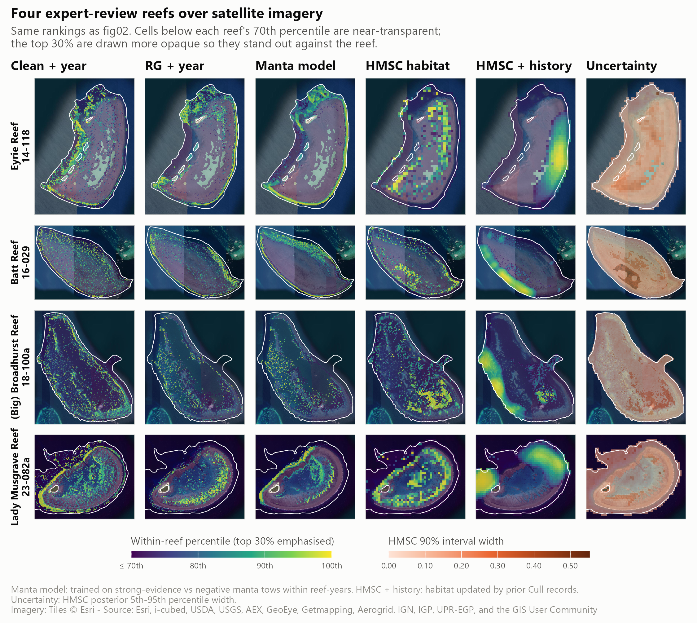
Figure 3: Within-reef percentile rank of each layer on four reefs (Eyrie, Batt, Broadhurst and Lady Musgrave) over satellite imagery. Columns: clean + year, RG + year, the manta model, HMSC habitat, HMSC updated with cull history (forecast for 2027), and the width of the HMSC 90% posterior interval. Cells below each reef’s 70th percentile are drawn near-transparent so the top 30% stands out. The layers agree on margins and outer slopes but differ in detail.
On their own, the layers discriminate modestly between places on the same reef. On independent manta tows, RG + year reached a within reef-year AUC of 0.576 (95% CI 0.548–0.602) (Table 3, Figure 4). It placed 23% more strong-evidence tows in each reef’s top-ranked 20% than chance. The manta model, trained on tows but scored leave-reef-out, reached 0.612 (95% CI 0.578–0.636) (Section 3.4).
Table 3: Discrimination between strong-evidence and strictly negative manta tows within reef-years. Manta tows were not used to fit any of these layers. Lift is the share of strong-evidence tows in a reef-year’s top 20% of tows, divided by 20%. Intervals are 95% bootstrap intervals over reef-years.
Layer | Within reef-year AUC (95% CI) | Top-20% lift (95% CI)
Clean + year | 0.516 (0.500–0.532) | 1.11 (1.06–1.15)
RG + year | 0.576 (0.548–0.602) | 1.23 (1.18–1.29)
HMSC joint | 0.567 (0.549–0.585) | 1.15 (1.11–1.19)


Figure 4: Independent manta tow check of the three habitat layers. Left: within reef-year AUC; right: top-20% lift. Bars are 95% bootstrap intervals over reef-years; dotted lines mark chance.
The layers agree only in part on which cells rank highest. Median within-reef Spearman correlations were 0.41 between clean + year and RG + year, 0.33 between clean + year and HMSC, and 0.24 between RG + year and HMSC (Appendix D). Where both cull-trained layers exist, the fallback and RG rankings correlate at 0.34, so ranks near the RG coverage boundary within a reef are less reliable.

3.3.2 Habitat alone as a cull-site ranking
Used alone to rank all designated sites on a reef, the held-out habitat layer retained problematic dives only slightly faster than low-density or ghost dives (Table 4, Figure 5). Searching the top 70% of sites retained 77.2% (95% CI 72.9%–80.8%) of problematic dives. A ranking with no information would have retained 75.6%, the share of all dives at those sites. Within reef-years, the AUC was 0.57 for problematic versus low-density dives and 0.60 versus ghost dives. The in-sample layer looked stronger (0.61 and 0.66) only because it had been trained on those dives.
Whether a site holding COTS is above or below the action threshold on a given visit depends mainly on outbreak stage, earlier culling and the movement of aggregations. Recent evidence captures these; static habitat cannot. The habitat ranking does reach places crews have not tested: 43% of site-years ranked in a reef’s top 30% were at sites that had never been dived.
Table 4: Diving only the top-ranked designated cull sites on each reef, held-out habitat ranking alone, 2018–2026. ‘Dives kept’ is what a ranking with no information would retain of every outcome. Brackets: 95% bootstrap interval over reef-years.
Designated sites searched | Dives kept (no-information baseline) | Problematic dives kept | Low-density dives avoided | Ghost dives avoided
top 80% | 83.8% | 84.9% (81.9%–87.7%) | 16.1% | 19.8%
top 70% | 75.6% | 77.2% (72.9%–80.8%) | 24.6% | 29.5%
top 60% | 66.5% | 68.7% (64.1%–72.8%) | 35.2% | 38.9%
top 50% | 57.4% | 59.8% (55.5%–64.5%) | 44.9% | 48.2%


Figure 5: Share of cull dives that would still occur if only the highest-ranked designated cull sites on each reef were dived, ranked by habitat alone, by dive outcome. Left: held-out ranking; right: deployed layer (in-sample). The dashed diagonal is the share of sites dived. Bands are 95% bootstrap intervals over reef-years. Without recent evidence, problematic, low-density and ghost dives fall away at almost the same rate.

3.3.3 Cull history: strong where it exists
Problematic sites persist between seasons at a scale of about 0.5–1 km. In the strictly forward test, the blend of habitat and cull history reached a within reef-year AUC of 0.681 (95% CI 0.640–0.718), against 0.569 for habitat alone (Table 5, Figure 6).
The forecast is strongest where history exists. It reached 0.716 with history nearby, 0.540 where history was sparse and 0.553 at sites never culled before. History lies within reach of only 8.6% of 120 m reef cells, so across most of the reef the blend falls back to habitat.
Part of the skill reflects operator behaviour: a score based only on how often crews had dived a site reached 0.636. This layer is therefore delivered as a map of known aggregation sites for briefing crews, not as habitat. Reef-context predictors at 0.5–1 km (windward position, distance to reef edge, channels, eReefs currents) did not improve habitat forecasts robustly (0.582 vs 0.569, overlapping intervals).
Table 5: Forward validation: within reef-year AUC for problematic cull site-years, test years 2022–2026 pooled. Each score uses only data from before the test year. The deployed blend’s 95% bootstrap interval over reef-years is given for all site-years.
Score | All site-years (n = 4,170) | With nearby history (n = 3,212) | Little or none (n = 958) | New sites (n = 1,664)
Habitat (HMSC refitted before test year) | 0.569 | 0.584 | 0.554 | 0.524
Habitat + reef context | 0.582 | 0.600 | 0.520 | 0.514
Dive effort only | 0.636 | 0.656 | 0.491 | 0.513
History kernel | 0.654 | 0.705 | 0.465 | 0.476
Habitat + history (deployed) | 0.681 (95% CI 0.640–0.718) | 0.716 | 0.540 | 0.553


Figure 6: Forward validation of habitat, reef context and cull-history scores. Left: all test site-years with 95% bootstrap intervals over reef-years. Right: the same scores split by how much cull history lies within reach of the site. History carries the forecast where it exists; habitat carries it where history is absent.

3.3.4 Where recent evidence is missing
Recent evidence is unevenly spread. 30% of reef-years were on reefs not visited the season before. On those reefs (3,221 dives) every ranking was close to chance (AUC about 0.53), and habitat was the only information available.
Habitat also reaches ground that recent search has not covered. A tow was counted as new ground if no tow lay within 300 m in the previous five seasons. On new ground, the manta model ranked tows with a within reef-year AUC of 0.619 (95% CI 0.587–0.651), and the cull-trained layer at 0.56. Strong evidence was more common on new ground than on repeat ground (13.6% vs 5.8% of tows), partly because new ground is often surveyed early in an outbreak. This is the basis for the exploration areas in the 2027 product.

3.4 Manta surveillance: spread tows evenly, add where habitat ranks highest
Systematic thinning found the most aggregations at every level of effort (Table 6, Figure 7). With 60% of tows kept, it found 96.6% of the 1,900 aggregations of two or more strong-evidence tows in 1,082 surveys. Random thinning found 94.0%, and thinning by the held-out cull-trained layer found 88.1% (95% CI 86.6%–89.5%).
The largest cut that still found at least 95% of aggregations was:
- 40% of tows for systematic thinning (40% with bootstrap assurance);
- 30% for random thinning;
- 20% for thinning by habitat rank.
Results for 2022–2026 alone were the same: 40%, 30% and 20%.
Ranking concentrates the kept tows in a few high-scoring stretches of reef, so aggregations in low-scoring stretches are missed entirely. Habitat rank is therefore not a good basis for dropping tows. It did find slightly more isolated single strong tows than random (64% vs 61% at 60% kept). Scoring with the deployed (in-sample) layer instead of the held-out one overstated aggregations found by 2 percentage points at 60% kept.
Reef-level detection is robust to thinning whichever tows are kept. Outbreak reef-years have many positive tows, so keeping about 60% of tows in 2022–2026 still flagged 89% of outbreak reef-years with the layer and 87% at random (Appendix D).
Table 6: Share of COTS aggregations (two or more strong-evidence tows within 500 m) still found when manta tows are cut within each survey, all years. The layer is the cull-trained RG + year model scored leave-reef-out; the deployed column is the same layer scored in-sample. Brackets: 95% bootstrap interval over surveys.
Tows kept | Layer, held out | Layer, deployed | Random | Systematic
80% | 96.2% (95.3%–97.2%) | 96.9% | 98.8% | 99.7%
70% | 93.0% (91.8%–94.2%) | 93.7% | 97.0% | 98.7%
60% | 88.1% (86.6%–89.5%) | 90.4% | 94.0% | 96.6%
50% | 81.8% (80.0%–83.4%) | 85.2% | 89.7% | 93.0%


Figure 7: Manta tows kept versus COTS aggregations found. Left: aggregations of two or more strong-evidence tows found as tows are cut, for the cull-trained layer (held out and deployed), random selection and systematic thinning; bands are 95% bootstrap intervals over surveys. Right: share found at 60% of tows kept, by aggregation size. Evenly spaced thinning loses the fewest aggregations.
A habitat model trained on manta tows is the best guide to where to add tows. Manta tows provide about 20 times more training rows than cull site-years. The within reef-year manta model ranked held-out tows best (Table 7, Figure 8). It found 3 percentage points more aggregations than the cull-trained model at 60% kept (95% CI +1 to +5). That is still below random (94.0%) and systematic thinning (96.5%), so its role is to direct extra tows rather than to remove them. Its top predictors were wave period and height, bathymetry and slope.
Training on manta did not improve cull-site selection. With survey year as a predictor, the manta model ranked cull dives at chance (AUC 0.48), because survey year took 70% of its fitted gain. The within reef-year version matched the cull-trained model over 2018–2026 (0.566 vs 0.567). Once last season’s evidence was added, every habitat model gave the same result. Manta tows see COTS and scars from the surface along the reef perimeter, whereas a problematic dive measures how many COTS a diver finds in a site; the two are related but not the same.
Table 7: Cull-trained and manta-trained habitat models on held-out manta tows (all three fitted on the same leave-reef-out folds). AUC: strong-evidence vs strictly negative tows within reef-years, with 95% bootstrap intervals. Aggregations: share found at 60% of tows kept.
Model | Tow AUC (95% CI) | Top-20% lift | Aggregations found, 60% kept
Cull-trained | 0.547 (0.516–0.574) | 1.15 | 88.2%
Manta-trained (with year) | 0.575 (0.547–0.599) | 1.27 | 88.4%
Manta-trained, within reef-year | 0.612 (0.578–0.636) | 1.33 | 91.0%


Figure 8: Cull-trained and manta-trained habitat models on both goals. Left: within reef-year AUC on held-out manta tows. Centre: aggregations found with 60% of tows kept, with random and systematic thinning for reference. Right: low-density cull dives avoided at 90% of problematic dives retained, for the habitat model alone and with last season’s evidence. Bars are 95% bootstrap intervals. The manta model ranks tows best; for cull sites, last season’s evidence brings every habitat model to the same result.

3.5 The 2027 cull-site priority ranking and exploration areas
Every designated cull site (15,884 sites on 576 reefs) was ranked within its reef for the 2027 season, using the combined model with the most recent 12 months of evidence. The ranking is delivered as a CSV and as the EoTR cull-site KMZ, with each polygon coloured by priority class. Each polygon also carries its rank, its modelled chance of a problematic dive if dived, and last season’s evidence. Table 8 shows what each class kept in the forward test.
Table 8: 2027 priority classes and what searching through each class retained in the forward test (dives 2019–2026).
Searching through | Sites on the reef | Problematic dives kept | Low-density dives avoided | Ghost dives avoided
A | top 20% | 33% | 75% | 79%
A + B | top 50% | 64% | 42% | 49%
A + B + C | top 80% | 89% | 18% | 22%
All (incl. D) | 100% | 100% | 0% | 0%

The two sources share the ranking:
- Evidence ranks the top. 678 sites had a problematic dive last season and 809 have strong manta evidence nearby.
- Evidence also lowers sites. 293 sites were dived last season with nothing problematic, which strongly lowers their rank.
- Habitat ranks the rest. 10,654 sites (67%) are on reefs with no dives or tows in the last 12 months. Habitat alone orders them, as a first search order to update once manta tows come in.
The exploration layer adds high-ranked habitat outside the current search footprint (Figure 9), so that the ranking does not keep consolidating search on the same places. It contains 3,807 areas on 488 reefs, with a median size of 8 ha, a median habitat percentile of 0.84, and a median distance from a cull site of 170 m. On well-surveyed reefs such as Batt and Eyrie, cull sites and five seasons of tows already cover most high-ranked habitat. The larger opportunities are on reefs with little recent towing.

Figure 9: Batt Reef and Eyrie Reef: 2027 cull-site priority (A red to D grey), manta tows of the last five seasons (blue) and exploration areas (purple, numbered by rank) over satellite imagery. On these well-surveyed reefs the exploration areas are outer-edge pockets, reef ends and, at Eyrie, part of the northern back reef that no tow has crossed in five seasons.

3.6 Metacommunity model: calibration and current limitations

3.6.1 Replicated candidates
The metacommunity model now reproduced both historical outbreak waves on the reefs with two observed waves, although outbreak heights and intervening densities remained imperfect (Figure 10). Three configurations were retained for further testing: the working configuration W, C3a with a higher initial preferred-coral share at Lizard Island, and C6 with lower chronic background coral mortality. Each was run with 5 recorded pairs of ecological and connectivity seeds. Under the revised score v2, each candidate matched 7 of 7 observed historical peaks in every seed. Matching allowed a timing window; it did not establish accurate peak heights or performance on independent data.
The candidates retained different compromises (Table 9). Mean COTS losses overlapped in their variation across seeds. C3a produced a larger first Lizard outbreak, 56.1 ± 6.5 adults ha$​^{−1}$, compared with 29.0 ± 2.3 for W, and had a lower coral error. However, it left more COTS between outbreaks. C6 reduced the troughs at the cost of a higher coral error, 0.279 against 0.250 for W.
The qualitative gate was sensitive to the observation model. At A½ = 30 adults ha$​^{−1}$, W passed in 5 of 5 seeds, C6 in 3 and C3a in 0. At A½ = 10, W passed in 0 and C6 in 3. These are conditional calibration checks: the detection curve remains uncertain, and a passing qualitative gate does not replace held-out or regional validation.
Table 9: Replicated metacommunity calibration on the four Lizard Island reefs (run 20261014T_48). Means ± SD across five recorded seed pairs; these are measures of stochastic variation, not confidence intervals. Lower COTS loss (score v2) and coral J indicate better calibration fit. Gate columns count seeds passing G2′ under the indicated density-dependent manta detection assumption, with A½ in adults per hectare. All candidates matched seven historical peaks in every seed at the linear observation mapping. No entry represents held-out validation.
Candidate | COTS loss v2 | Coral J | Gate A½ = 10 | Gate A½ = 30
W | 6.79 ± 0.79 | 0.250 ± 0.002 | 0/5 | 5/5
C3a | 6.72 ± 0.70 | 0.228 ± 0.002 | 0/5 | 0/5
C6 | 7.13 ± 0.85 | 0.279 ± 0.002 | 3/5 | 3/5

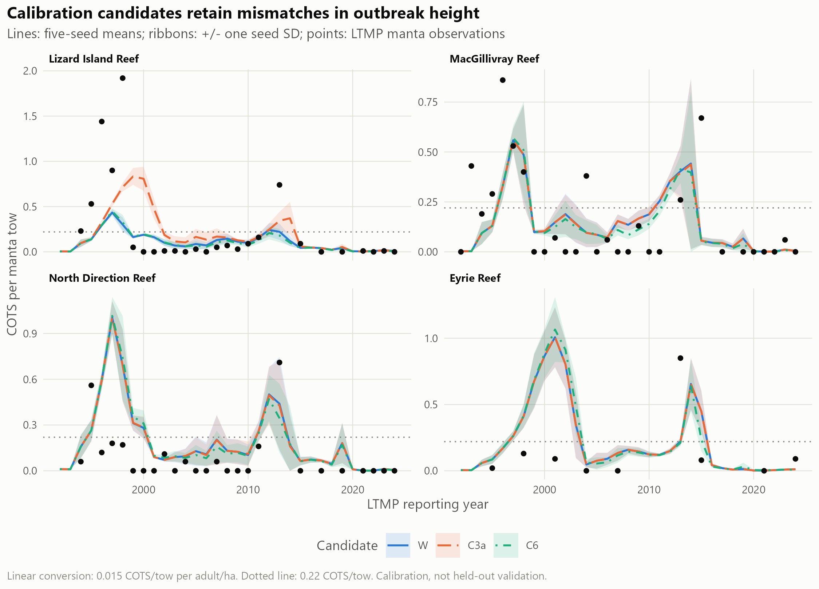
Figure 10: Historical COTS trajectories for W, C3a and C6. Lines are means across five seed pairs and ribbons are one standard deviation across seeds; points are AIMS LTMP manta observations. Adult density is shown through the fixed linear conversion of 0.015 COTS per tow per adult ha$​^{−1}$, and the dotted line marks 0.22 COTS per tow. Peak-height and trough mismatches remain despite successful historical peak matching.

3.6.2 Historical culling exposed missing populations
Prescribing the recorded historical removals exposed populations that were too small to support the observed catches. In the working configuration with the primary 210 m allocation kernel, 88% of requested removals at Eyrie in 2021–24 could not be applied because the simulated juvenile or adult population was absent. Across the model domain, the corresponding share was 70%. This discrepancy identified a failure to represent the recent build-up, rather than evidence that actual culling was ineffective.
Where simulated COTS were available, removals changed the historical trajectory. North Direction’s simulated second-wave maximum fell from 0.82 to 0.55 COTS per tow. The summed calibration loss v2 increased from 6.44 to 6.57. These single-seed comparisons tested the removal implementation and consistency with recorded catches. They did not estimate the benefit of a control policy, and culling was left off in the subsequent build-up diagnostics.

3.6.3 Extension to 2026
The latest completed diagnostic runs extended the domain to 2026 and examined the recent build-up separately from the historical candidate comparison (Figure 11). They crossed original and cull/SALAD-corrected outbreak-boundary inputs with changes to coral thermal settings. With the earlier thermal settings and no chlorophyll modifier, correcting the boundary reduced score v3 from 15.61 to 12.63. With revised thermal settings, losses were 11.34 and 11.34, respectively. The revised settings removed the extra bleaching multiplier and raised the threshold below which bleaching mortality was reduced. The trajectories showed that both the food trajectory and boundary supply affected the timing and magnitude of the new outbreak.
Exploratory chlorophyll-based larval-survival modifiers gave smaller additional changes: the lowest score v3 in the corrected-boundary screen was 10.99, against 11.34 with those modifiers off. Score v3 includes a diver-anchored recent-density error and is not numerically comparable with the earlier score v2. All of these extended runs used one seed pair. Cull and SALAD evidence contributed to both the corrected boundary and its assessment, so their apparent improvement was not independent validation.
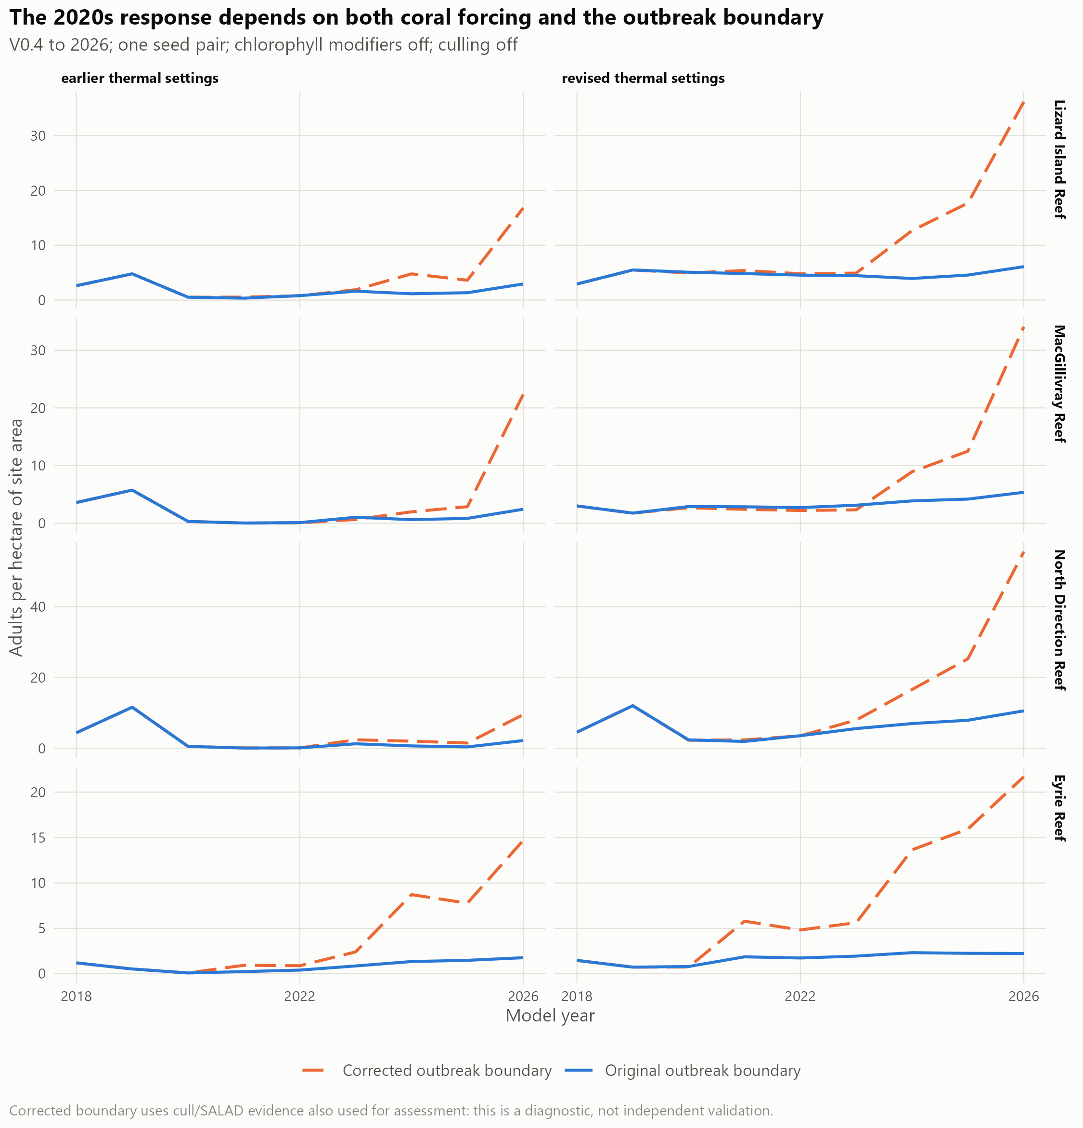
Figure 11: Single-seed extension to 2026 with original or corrected outbreak-boundary inputs, under the earlier or revised coral thermal settings. Lines show adult density, with chlorophyll modifiers and culling off. Corrected boundary supply produces a larger late build-up; its response also depends on coral forcing. The same cull/SALAD evidence helped construct and assess the corrected boundary. These are diagnostic trajectories, without an uncertainty interval or an independent validation claim.
No configuration has completed the full validation sequence. The model remains a platform for testing outbreak mechanisms and developing control scenarios. Held-out reefs and years, regional transfer and sensitivity tests are still required before reporting benefits of primary-outbreak suppression or rules for starting and stopping control. The fine-scale habitat rankings have not been validated as inputs to the metacommunity model.

4. Implications for management

4.1 Combining recent observations with habitat for daily searches
The practical contribution of the search models is a consistent way to combine what crews have recently observed with habitat information covering places they have not visited. Recent cull dives and manta tows carry most of the information about the current outbreak, while habitat provides a first search order where that evidence is absent. The resulting ranking reduced the designated sites searched for a matched share of problematic dives in the retrospective comparisons. Its value is therefore in helping crews decide where to look first, while retaining opportunities to discover populations outside the established search footprint.
This use follows from the different information each source contains. Habitat describes the setting in which COTS occur, but it cannot identify the current population after recruitment, movement and earlier control. Conversely, recent observations are informative about the places crews have searched but leave large gaps. Combining them is useful even when habitat alone separates high- and low-priority locations only weakly. The combined score should be read as a relative search priority within a reef, with the evidence behind it available to planners.
The retrospective gains also include knowledge already held by experienced crews. Sites were selected for dives using previous observations and local experience, so the ranking partly formalises existing practice. A field trial is needed to establish how much it adds to crew planning, particularly at never-dived sites. Exploration areas provide a way to extend the evidence base: visiting a small number of them and recording nil results as well as detections would allow future rankings to learn from a broader sample of reef habitat. Historical tows on previously unsurveyed ground found strong evidence more often than repeat tows, but this does not establish the yield of the proposed exploration areas; outbreak stage may contribute to that difference.

4.2 Maintaining coverage during manta surveillance
The manta results support retaining evenly distributed surveillance when tow effort must be reduced. Model-based selection concentrated tows in a few highly ranked areas and could miss whole aggregations elsewhere. Even spacing retained better coverage of the observed aggregations. This finding concerns retrospective thinning of existing surveys: tow order was inferred from position around the reef, and new routes have not been trialled. Habitat remains useful for proposing where to add or repeat observations, subject to field assessment, especially beyond the current footprint.

4.3 Assessing the culling program from 2012 to the present and beyond
The fine-scale metacommunity model was developed to reconstruct the third and fourth outbreak waves and the emerging fifth wave in the initiation zone, assess how culling has changed COTS populations and coral trajectories since 2012, and guide future prioritisation. The historical assessment compares the observed program with a counterfactual in which the same reefs receive no control. Counts of COTS culled document the program’s removals, but do not show how many animals would otherwise have survived, reproduced and dispersed larvae, or how much coral those animals and their descendants would have consumed. Linking these processes allows the model to assess effects extending beyond the treated sites.
We compared paired simulations beginning from the same population and coral state before control. One applied recorded removals from 2012 onward, focusing on the periods of control in 2014–15 and 2020–2026; the other omitted program removals. Both received the same heat stress, cyclone and other environmental forcing and used matched random seeds. Reproduction, larval dispersal and coral consumption evolved within each simulation. Differences in COTS abundance, larval export, cumulative coral consumption and coral cover provided the comparison of program effects within the model’s assumptions. Requested removals exceeding the simulated population were recorded explicitly. [TO CONFIRM BEFORE FINALISATION: completion of the full paired historical assessment and removal-record coverage through 2026; this paragraph is drafted in past tense as requested.]
Matching historical peak timing alone is insufficient: the model must also represent outbreak sizes, populations between outbreaks and the recent build-up documented by divers. Initial population estimates, the relationship between manta observations and actual density, and coral recovery all contribute to uncertainty in the estimated effects of culling.
Larvae arriving from reefs outside the Lizard Island model domain also affect this comparison. Their supply is currently informed by the GBR-wide outbreak predictions of Stewart et al. (2026). For a regional history without culling, we would ideally need corresponding predictions of what happened on those outside reefs without culling, so that their larval supply reflects the same counterfactual. The existing prediction layer does not by itself provide that causal comparison. Using the same outside supply in both simulations instead estimates the effect of culling inside the Lizard Island domain while holding conditions on outside reefs unchanged. Any estimate of coral protected must state which of these questions it answers.

4.4 Projecting suppression of the fifth primary outbreak wave
The forward-looking extension will assess how attempts to suppress the fifth primary outbreak wave in the initiation box during 2020–2026, including increased resources during 2026–2028, could change subsequent outbreaks and coral protection outcomes. Within the current domain, the first test is whether suppression reduces COTS densities and larval supply at its southern extent, including Irene Reef and Startle Reefs. Those results would help assess potential consequences farther south toward the Cairns region; a direct estimate of coral protection there would require a model domain or linked model that includes those reefs. This extension is partly developed and builds on the strategic questions addressed by earlier COTS population and reef ecosystem models (Morello et al., 2014; Matthews et al., 2020b; Condie et al., 2021; Bozec et al., 2022).
The scenario comparisons will focus on what increased effort from now can achieve in suppressing the primary outbreak. This question differs from protecting coral at individual reefs after secondary outbreaks are established, as discussed by Matthews et al. (2024). One set of comparisons will reallocate existing capacity among reefs, for example by targeting dense populations on reefs that supply larvae to others. A second set will assess the additional benefit of one or two vessels. Comparisons within each capacity level will show the value of changing allocation, while comparisons across capacity levels will show what extra resources could achieve. Continuation of current control and no control will provide reference trajectories. Starting and stopping rules will be examined within this primary-suppression objective.
Each paired comparison will use the same climate and disturbance sequences. Repeating it across plausible population states, biological processes, larval transport and future environmental conditions will help identify strategies that are robust to deep uncertainty in the system. The aim is to find strategies that continue to meet management objectives across a wide range of plausible futures, rather than selecting a strategy that performs best under one assumed future.
The outcomes will connect suppression to the duration and extent of high COTS densities, larvae exported to connected reefs, coral loss through feeding, and subsequent coral recovery. Fewer COTS at a treated reef need not produce a proportional local coral benefit, particularly if coral spared from feeding is later affected by heat stress or cyclones. Conversely, culling a large aggregation might not prevent substantial coral loss at that reef but could still reduce COTS recruitment and protect coral on connected reefs. The assessment therefore needs to follow both local and downstream consequences.
Future scenarios must also represent what crews can achieve. The current implementation applies prescribed historical catches and does not predict how search effort and COTS density determine removals. Starting and stopping rules require that relationship to be represented before the scenarios can describe operational choices credibly. Site rankings from the species distribution models could help allocate searches, although that coupling has not been validated. Scenario design will depend on future funding and direct consultation with GBRMPA, program partners and contractors to reflect operational realities. [TO CONFIRM: projection horizon, vessel budgets, intervention rules and climate scenarios agreed with program partners.]

4.5 Monitoring operational performance
A field trial of the 2027 site rankings from the species distribution models is planned for January 2027, while the strategic metacommunity model continues to be developed. Before each visit, the trial will record the recommended priority of each site. It will then record which sites crews searched by manta tow or dive, the effort used, the COTS found and any reasons for departing from the suggested order. Outcomes will be compared with the search order crews would normally use and with the modelled expectations in Table 8. The existing expectations use a threshold of at least 0.02 COTS per minute of bottom time; the trial’s decision criteria below require a separate evaluation using dives above 0.04.
The trial will aim for a 10–15% reduction in the number of designated sites requiring manta-tow searches on individual visits, with a negligible share of dives above 0.04 COTS per minute of bottom time missed. It will also aim for a 10–15% reduction in low-density or empty dives under the same allowance for missed dives above 0.04. Here, an empty dive finds no COTS, while a low-density dive finds COTS but does not exceed the trial threshold. These are proposed adoption criteria, not gains already demonstrated by the current validation. [TO CONFIRM: the numerical tolerance for missed dives above 0.04 and whether reductions are measured per visit or over the full season.]
Lower-ranked sites deferred on a visit will still receive at least one manta tow or dive each year, as appropriate, or be checked before the reef is closed to further control visits. This coverage is intended to catch populations missed by the initial ranking. The trial should record these later checks and any COTS found, and distinguish effort deferred to a later visit from a reduction in total annual effort. Visits to proposed exploration areas should be reported separately from visits to familiar sites, with dates and outbreak conditions recorded so that differences in detections can be interpreted. If the trial meets the 10–15% improvement targets while remaining within the agreed tolerance for missed high-density dives and completing these coverage checks, the approach can be considered for adoption; otherwise, the ranking or search rules should be refined. [TO CONFIRM: trial design, monitoring owner and reporting route agreed with GBRMPA and vessel operators.]
Savings should be attributed to the ranking only to the extent that it improves retention of high-density dives at the same effort, or reduces effort at the same retention. Translating those gains into vessel time or money requires an agreed account of travel, search, diving and culling time. [TO CONFIRM: whether to estimate financial savings and which operational cost data to use.]

5. Limitations
The search evaluation used outcomes from dives crews chose to make. It cannot establish densities at never-dived sites or the consequences of changing crew behaviour. Reefs without recent observations depend mainly on habitat, where discrimination is weak. Spatially held-out habitat scores reduce bias from scoring a reef with its own training data, but the season-by-season evidence test did not also restrict the habitat fits to preceding years. The evidence regression was tested forward in time; the entire combined modelling process was not a fully prospective forecast.
Spatial coverage also limits interpretation. The primary habitat layer joins models with different predictor coverage, and their rankings differ near that boundary. The explanatory joint habitat model relies heavily on fallback predictors in some regions. Values from the manta-trained model away from tow paths are extrapolations, including at some proposed exploration areas. The retrospective thinning result also depends on an inferred order around the reef, which may be less suitable for surveys that do not follow the perimeter. None of the proposed 2027 products has yet demonstrated its performance in a field trial.
The metacommunity results are calibration and diagnostic comparisons within one northern reef cluster. Replicated runs improve the assessment of stochastic variation but do not establish transfer to new reefs or years. Historical peak matching and checks of between-outbreak densities depend on assumptions about detection. Recent cull and SALAD observations helped construct corrected outbreak inputs and also assess their fit, so that comparison is not independent validation. The latest extended runs used one pair of random seeds. No estimate of historical program impact or future coral protection should be presented as validated until the recent population mismatch is resolved and held-out, regional and sensitivity tests have been completed.
Larval connectivity has different roles in the two strands. It was not a predictor in the within-reef habitat ranking, whereas it carries population effects among reefs in the metacommunity model. The latter still uses reef-level transport and does not establish fine-scale transport among sites. Uncertainty in that transport, external larval pressure and coral disturbance must accompany any assessment of downstream control benefits.

6. Recommendations and next steps
- Trial the 2027 cull-site ranking with crews, recording the proposed priority, actual search effort, departures from the ranking and dive outcomes.
- If manta effort must be reduced, preserve coverage through evenly distributed tows and assess the approach in the field. Use habitat to propose additional searches, with extrapolated areas identified.
- Trial a small number of exploration areas per reef visit and record outcomes, including nil results, so that the evidence base can expand beyond familiar sites.
- Refresh the ranking each season and repeat its temporal evaluation as new observations arrive. Compare the product with current crew practice as well as a no-information baseline.
- Complete expert review with GBRMPA, vessel crews and Traditional Owner operators, and agree ownership of monitoring and integration into Field Maps and the COTS Dashboards. [TO CONFIRM: participants, timing and operational owner.]
- Obtain survey-effort information for additional observation sources, including ReefScan, to support independent assessment beyond places selected for cull dives.
- Resolve the recent COTS population mismatch and complete independent validation of the metacommunity model before estimating the program’s impact from 2012 to the present.
- Develop paired historical simulations with and without program removals, reporting effects on COTS populations, larval export and coral trajectories, with the limits imposed by the external boundary stated explicitly.
- Develop projections of fifth-wave suppression under agreed effort budgets, climate conditions and starting and stopping rules. Report local and downstream coral consequences across the plausible model configurations.
- Test finer-scale hydrodynamic connectivity against a distance-based control, and assess any coupling of search rankings to intervention scenarios before using it for management comparisons. [TO CONFIRM: link to Work Plan output F and the agreed pilot region.]

Acknowledgements
This project was funded by the COTS Control Innovation Program (Reef Trust, AIMS, GBRF), project CCIP-BR-13. [TO CONFIRM: exact funding wording; partner organisations (AIMS, QUT, JCU, GBRMPA); data providers (COTS Control Program vessel crews and contractors, GBRMPA, SALAD, RHIS, ReefGuide); Traditional Owner acknowledgement of Sea Country in the authors’ own words.]

References
Bozec, Y.-M., Hock, K., Mason, R. A. B., Baird, M. E., Castro-Sanguino, C., Condie, S. A., et al. (2022). Cumulative impacts across Australia’s Great Barrier Reef: A mechanistic evaluation. Ecological Monographs 92. doi: 10.1002/ecm.1494
Chen, T., and Guestrin, C. (2016). XGBoost: A scalable tree boosting system., in Proceedings of the 22nd ACM SIGKDD international conference on knowledge discovery and data mining, (ACM), 785–794. doi: 10.1145/2939672.2939785
Condie, S. A., Anthony, K. R. N., Babcock, R. C., Baird, M. E., Beeden, R., Fletcher, C. S., et al. (2021). Large-scale interventions may delay decline of the Great Barrier Reef. Royal Society Open Science 8. doi: 10.1098/rsos.201296
de Almeida, P. R., Crocker, R., Tan, D., Bairos-Novak, K. R., Ani, C. J., Benthuysen, J. A., et al. (2026). CoralBlox: A computationally efficient coral model for decision support. bioRxiv [Preprint]. doi: 10.64898/2026.04.13.718315
De’ath, G., Fabricius, K. E., Sweatman, H., and Puotinen, M. (2012). The 27-year decline of coral cover on the Great Barrier Reef and its causes. Proceedings of the National Academy of Sciences 109, 17995–17999. doi: 10.1073/pnas.1208909109
Guillaume, A. S., Ferrari, R., Selmoni, O., Mocellin, V. J. L., Denis, H., Naugle, M., et al. (2025). Harnessing multiscale topographic environmental variables for regional coral species distribution models. Ecology and Evolution 15. doi: 10.1002/ece3.71292
Matthews, S. A., Mellin, C., and Pratchett, M. S. (2020a). Larval connectivity and water quality explain spatial distribution of crown-of-thorns starfish outbreaks across the Great Barrier Reef. Advances in Marine Biology 87, 223–258. doi: 10.1016/bs.amb.2020.08.007
Matthews, S. A., Shoemaker, K., Pratchett, M. S., and Mellin, C. (2020b). COTSMod: A spatially explicit metacommunity model of outbreaks of crown-of-thorns starfish and coral recovery. Advances in Marine Biology 87, 259–290. doi: 10.1016/bs.amb.2020.09.001
Matthews, S. A., Williamson, D. H., Beeden, R., Emslie, M. J., Abom, R. T. M., Beard, D., et al. (2024). Protecting Great Barrier Reef resilience through effective management of crown-of-thorns starfish outbreaks. PLOS ONE 19, e0298073. doi: 10.1371/journal.pone.0298073
Morello, E. B., Plagányi, É. E., Babcock, R. C., Sweatman, H., Hillary, R., and Punt, A. E. (2014). Model to manage and reduce crown-of-thorns starfish outbreaks. Marine Ecology Progress Series 512, 167–183. doi: 10.3354/meps10858
open-AIMS (2026a). ADRIA.jl: COTS calibration and historical culling workflow. Available at: https://github.com/open-AIMS/ADRIA.jl
open-AIMS (2026b). ADRIA.jl: COTS calibration workflow (sandbox/calibration). Available at: https://github.com/open-AIMS/ADRIA.jl
open-AIMS (2026c). COTSMod.jl: Crown-of-thorns starfish population and dispersal model. Available at: https://github.com/open-AIMS/COTSMod.jl
open-AIMS (2026d). COTSMod.jl: Population dynamics and observed cull removals. Available at: https://github.com/open-AIMS/COTSMod.jl
Ovaskainen, O., Tikhonov, G., Norberg, A., Guillaume Blanchet, F., Duan, L., Dunson, D., et al. (2017). How to make more out of community data? A conceptual framework and its implementation as models and software. Ecology Letters 20, 561–576. doi: 10.1111/ele.12757
Plagányi, É. E., Ellis, N., Blamey, L. K., Morello, E. B., Norman-Lopez, A., Robinson, W., et al. (2014). Ecosystem modelling provides clues to understanding ecological tipping points. Marine Ecology Progress Series 512, 99–113. doi: 10.3354/meps10909
Pratchett, M., Caballes, C., Wilmes, J., Matthews, S., Mellin, C., Sweatman, H., et al. (2017). Thirty years of research on Crown-of-Thorns Starfish (1986–2016): Scientific advances and emerging opportunities. Diversity 9, 41. doi: 10.3390/d9040041
Roberts, D. R., Bahn, V., Ciuti, S., Boyce, M. S., Elith, J., Guillera-Arroita, G., et al. (2017). Cross-validation strategies for data with temporal, spatial, hierarchical, or phylogenetic structure. Ecography 40, 913–929. doi: 10.1111/ecog.02881
Stewart, O., Matthews, S., Warne, D., and Bode, M. (2026). Modelling irruptive species with hybrid machine learning: A case study of crown-of-thorns starfish outbreaks on the Great Barrier Reef. EcoEvoRxiv [Preprint]. doi: 10.32942/X2J391
Tikhonov, G., Opedal, Ø. H., Abrego, N., Lehikoinen, A., Jonge, M. M. J. de, Oksanen, J., et al. (2020). Joint species distribution modelling with the R-package Hmsc. Methods in Ecology and Evolution 11, 442–447. doi: 10.1111/2041-210X.13345
Westcott, D. A., Fletcher, C. S., Kroon, F. J., Babcock, R. C., Plagányi, E. E., Pratchett, M. S., et al. (2020). Relative efficacy of three approaches to mitigate Crown-of-Thorns Starfish outbreaks on Australia’s Great Barrier Reef. Scientific Reports 10. doi: 10.1038/s41598-020-69466-1
Zurell, D., Franklin, J., König, C., Bouchet, P. J., Dormann, C. F., Elith, J., et al. (2020). A standard protocol for reporting species distribution models. Ecography 43, 1261–1277. doi: 10.1111/ecog.04960

Appendices

Appendix A: Delivered layers and products
All layers are in GDA2020 / MGA zone 55, with checksums in outputs/layers/layer_manifest.csv.
Table 10: Delivered layers (outputs/layers/) and operational products (outputs/site_ranking/).
Role | File | Resolution | Contents
Primary search-planning layer | cots_search_planning_2026_30m.tif (+ _priority_) | 30 m | P(problematic site-year, 2026), RG + year with calibrated clean + year fallback; percentile within reef polygon; priority classes (top 10%, 10–20%, 20–30%)
Clean + year | cots_legacy_clean_year2026_30m.tif | 30 m | P(problematic site-year, 2026) from the 12-layer clean stack + year
RG + year | cots_legacy_rg_year2026_30m.tif | 30 m | As above with five ReefGuide layers; missing where ReefGuide layers are missing
Manta model | cots_manta_within_30m.tif | 30 m | Relative log-odds of strong manta evidence against the reef-year average; percentile within reef
Exploration 2027 | cots_exploration_2027_30m.tif | 30 m | Habitat percentile on eligible cells; distances to recent tows and cull sites
HMSC joint (explanatory) | cots_hmsc_joint_120m.tif (+ uncertainty, source) | 120 m | Posterior mean P(problematic density given an active reef-year); posterior SD and 5th/95th percentiles
Known aggregation sites | cots_cull_history_kernel_120m.tif, cots_hmsc_history_combined_120m.tif | 120 m | Kernel-weighted prior problematic rate and evidence weight; habitat updated by history (forecast for 2027)
2027 cull-site priority | cots_cull_site_priority_2027.csv, .kmz, _reefs.csv, _classes_2027.csv | site | Priority class, rank on reef, P(problematic if dived), evidence behind the score
Exploration areas 2027 | cots_exploration_areas_2027.csv, .gpkg (also in the KMZ) | area | Rank, area, habitat percentile, depth, distances to cull sites and recent tows

Appendix B: Predictors
Table 11: Predictor codes. [TO CONFIRM: full names of the terrain codes, the coral taxa behind AhyaD, Aspat and Aten, and sources for each layer.]
Code | Layer | Stack
DEM | Depth | Clean
SLO | Slope | Clean
EAST, NORTH | Eastness, northness (aspect) | Clean
BPI | Bathymetric position index | Clean
VRM | Vector ruggedness measure | Clean
SVF | Sky-view factor | Clean
HCU, VCU | Horizontal and vertical curvature | Clean
AhyaD, Aspat, Aten | Coral habitat suitability for three Acropora taxa | Clean
RG_bathy, RG_slope | ReefGuide bathymetry and slope | ReefGuide
RG_turbid | ReefGuide turbidity | ReefGuide
RG_waves_Hs, RG_waves_Tp | ReefGuide significant wave height and wave period | ReefGuide

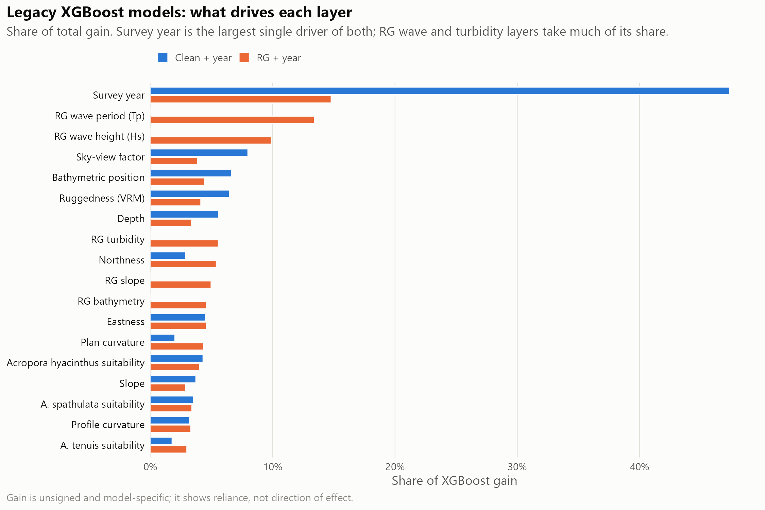
Figure 12: Relative importance (XGBoost gain) of each predictor in the clean + year and RG + year models. Survey year is the largest single driver of both, which is why absolute probabilities mostly reflect prevalence in the prediction year; wave period and height dominate the habitat terms where ReefGuide layers are available.

Appendix C: HMSC joint model
Table 12: HMSC production fits: training rows, convergence diagnostics and apparent (in-sample) AUC for the mapped cull target, and the share of mapped 120 m cells each component fills. All passed the gates (minimum effective sample size ≥ 400, maximum upper PSRF ≤ 1.1).
Component | Training rows | Min ESS | Max upper PSRF | Apparent AUC | Share of mapped cells
enhanced_joint | 14,120 | 705 | 1.012 | 0.600 | 24.6%
clean_joint | 15,512 | 1,645 | 1.020 | 0.576 | 71.8%
clean_native_joint | 15,571 | 409 | 1.018 | 0.565 | 3.6%

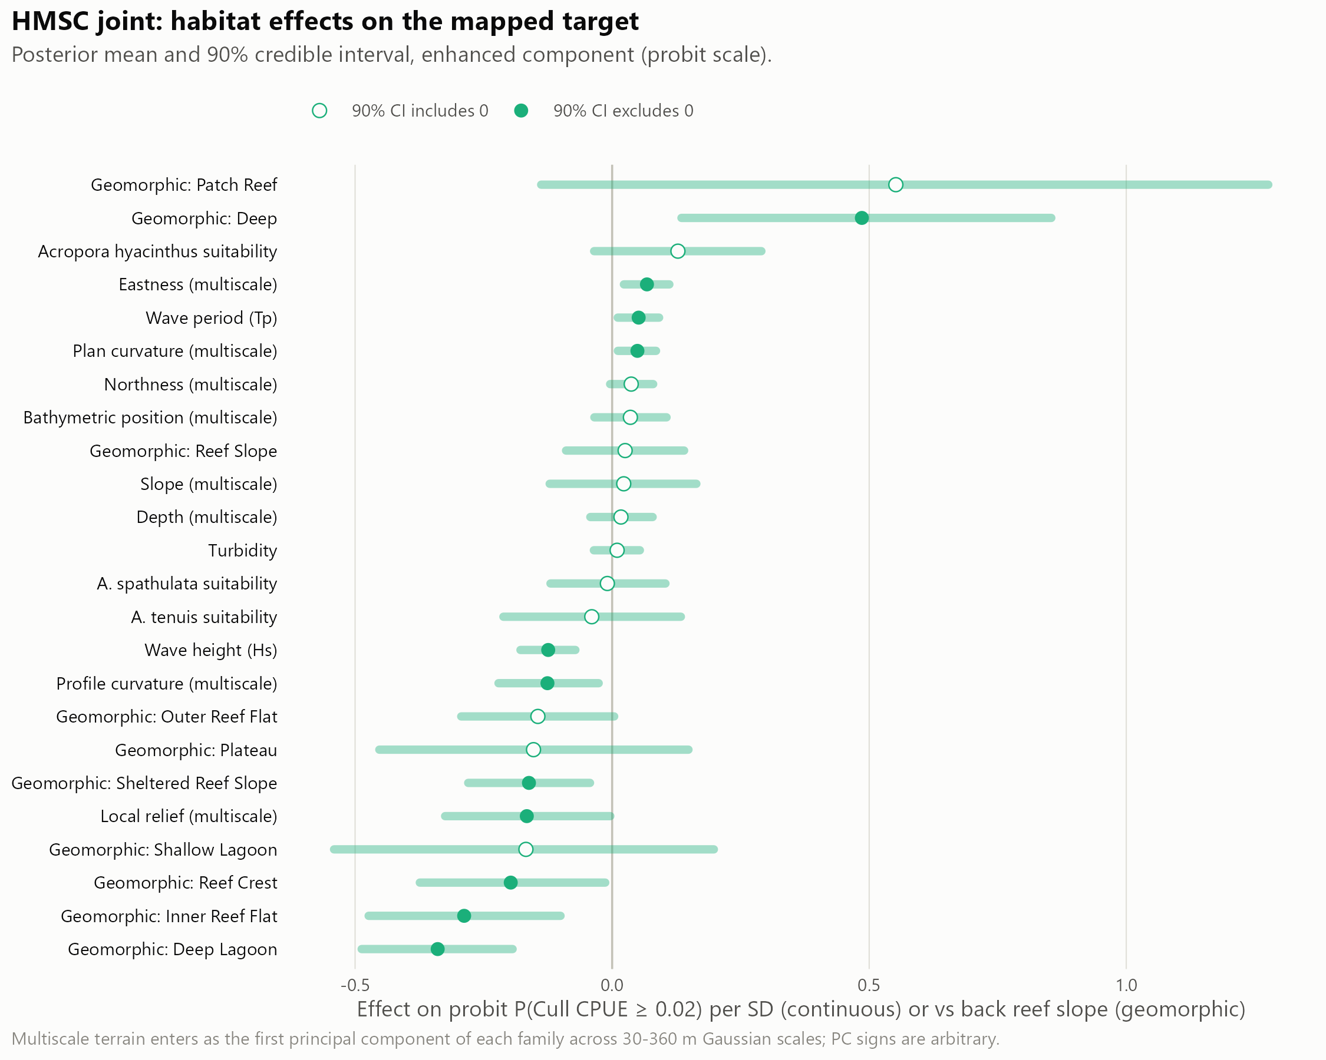
Figure 13: HMSC habitat effects on the mapped cull target, with posterior uncertainty.

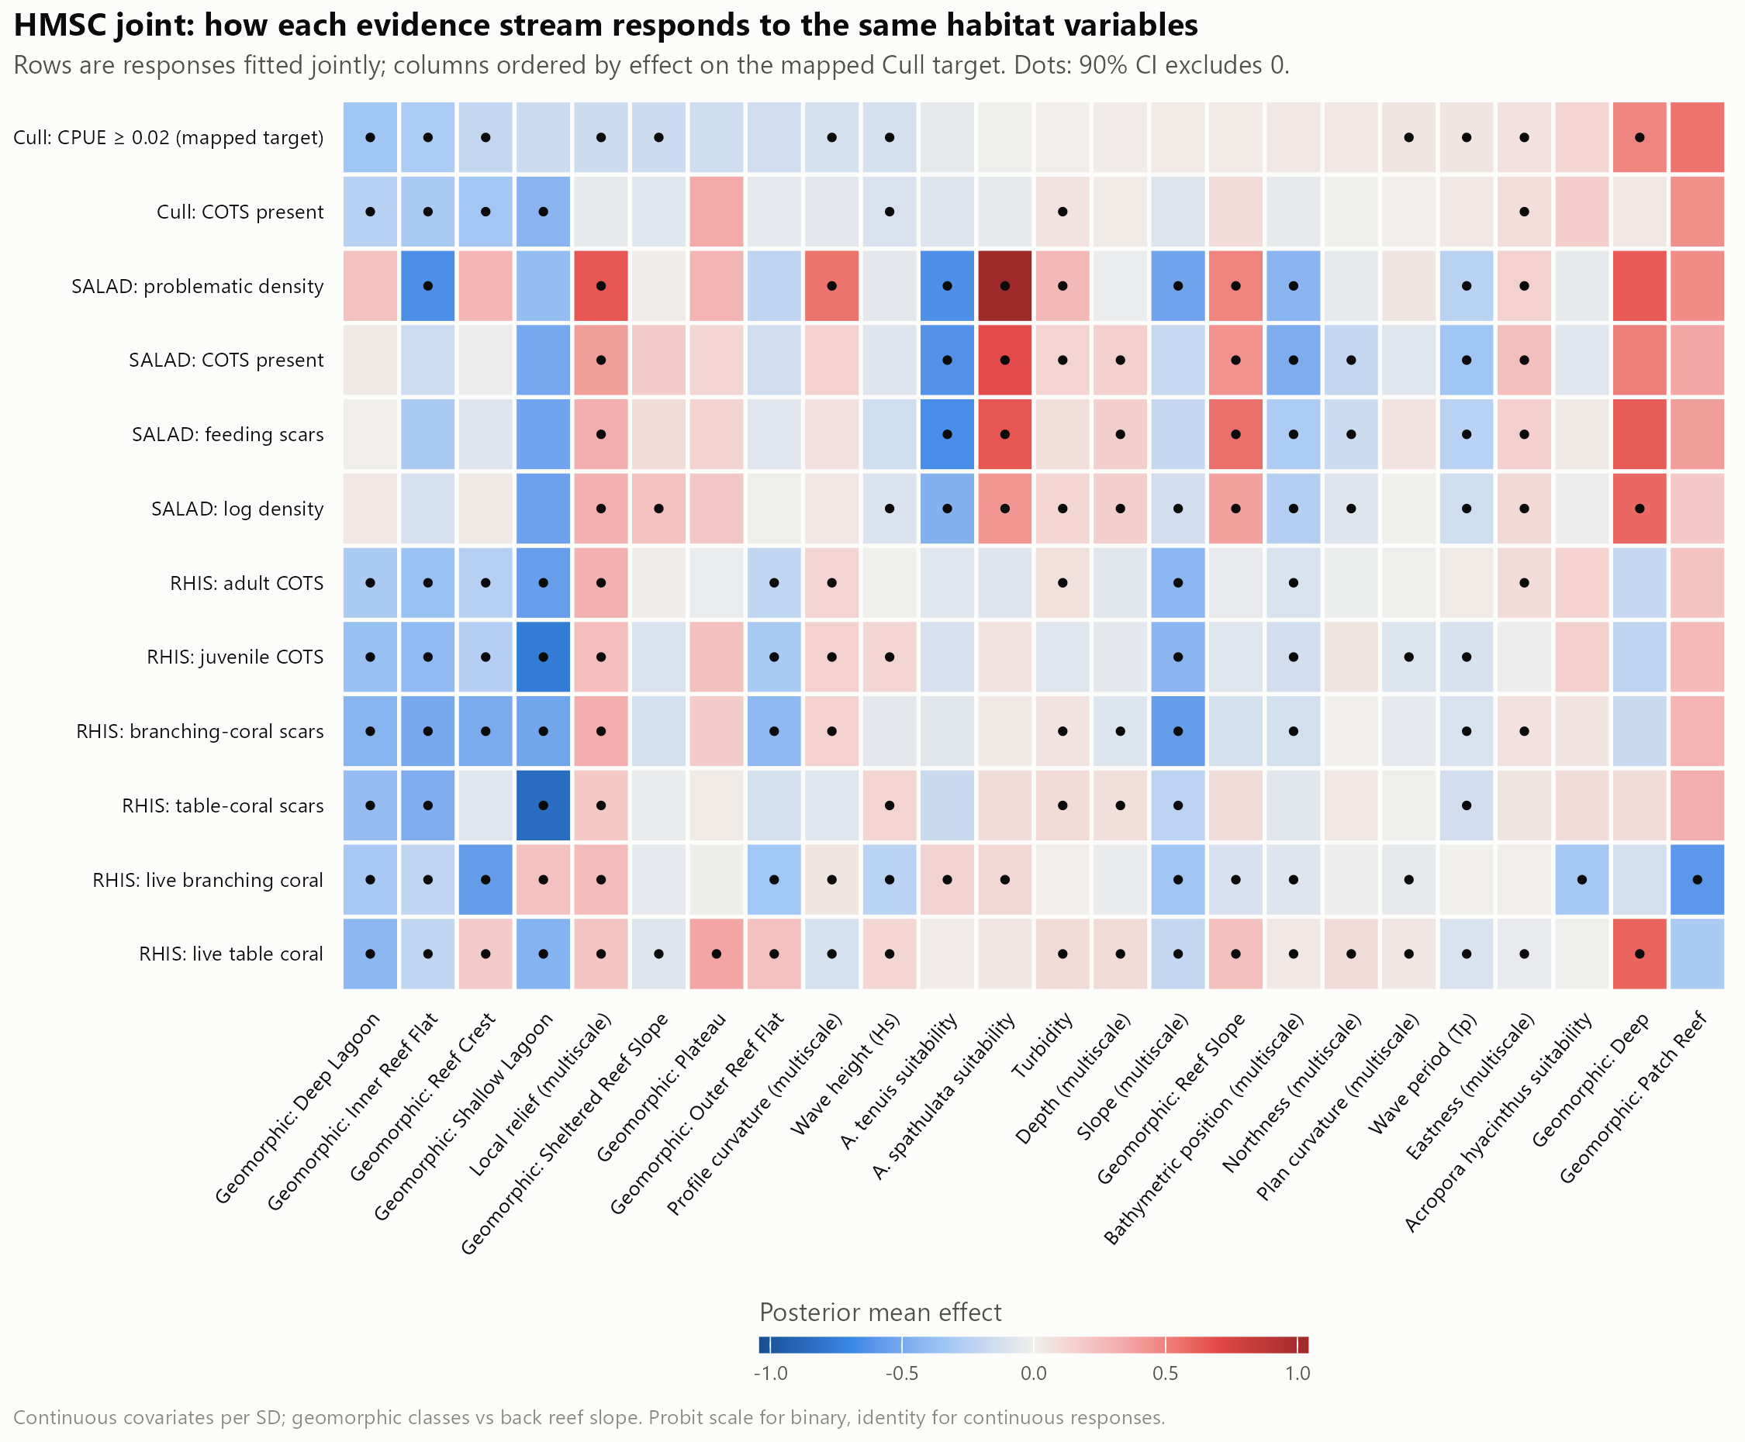
Figure 14: HMSC coefficients across all 12 jointly fitted responses (cull, SALAD and RHIS evidence).

Appendix D: Supplementary validation
Layer agreement and coverage.
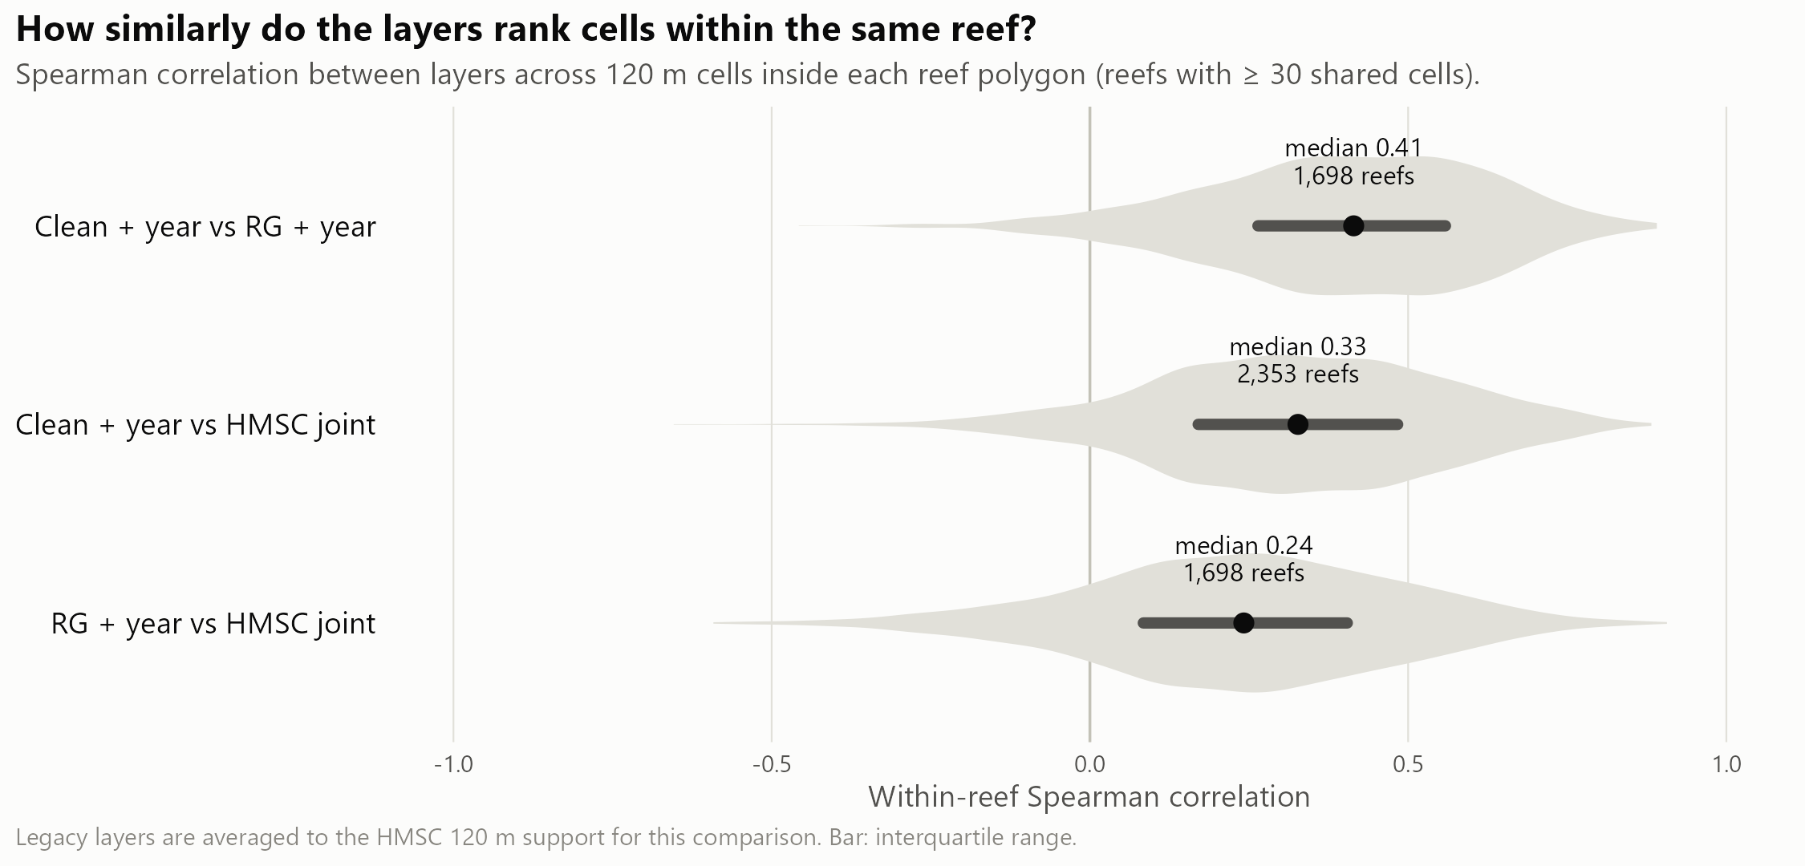
Figure 15: Within-reef agreement (Spearman correlation) between layers across reefs. The layers agree only moderately on which cells rank highest.

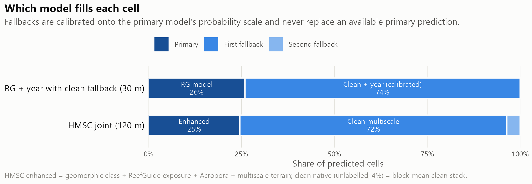
Figure 16: Which model fills each cell of the primary search-planning layer and of the HMSC layer.
Effort cut by the primary layer versus at random. An earlier analysis cut manta and cull effort within each survey or reef-year by the primary layer and compared it with the same cut at random (Table 13, Figure 17). Most of the effort saved is the effect of the cut itself, not of the layer. Systematic thinning and the matched cull-site analysis in the main text supersede this comparison for manta tows and cull sites, respectively.
Table 13: Keeping about 60% of manta tows or cull sites within each survey or reef-year, 2022–2026: primary layer versus the same cut at random. Cull sites were scored by held-out predictions.
Metric | Primary layer | Random
Manta: strong-evidence tows kept | 67.6% | 60.9%
Manta: outbreak reef-years still detected | 88.6% | 87.0%
Cull: share of COTS at kept sites | 69.9% | 62.5%
Cull: share of ghost dives avoided | 40.9% | 36.5%

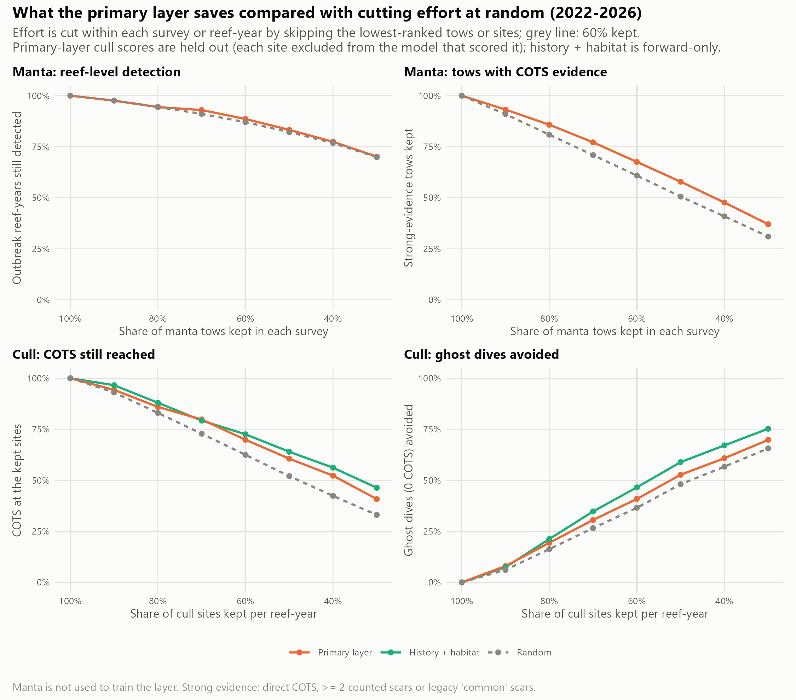
Figure 17: Manta and cull effort cut by the primary layer versus at random (2022–2026).
Example search plans. On Batt Reef (manta survey 2025-08-04), keeping the 79 of 131 tows that crossed the highest-ranked cells would have retained 32 of 42 strong-evidence tows; on Eyrie Reef (2023-10-26), 56 of 92 tows would have retained 9 of 11 (Figure 18). Both reefs are in the layer’s training data, so this illustrates the planning logic only; the held-out results in the main text are the evidence.

Figure 18: Example use of the primary search-planning layer on Batt Reef (top) and Eyrie Reef (bottom). Left: manta tows the layer would keep (solid) or skip (dashed), with strong-evidence tows in red. Right: fifteen planned dive sites on top-ranked diveable cells (0.5–16 m, at least 400 m apart), ordered into a route, against that season’s cull outcomes. Illustrative only: these reefs were in the training data.
Cull history on four reefs.
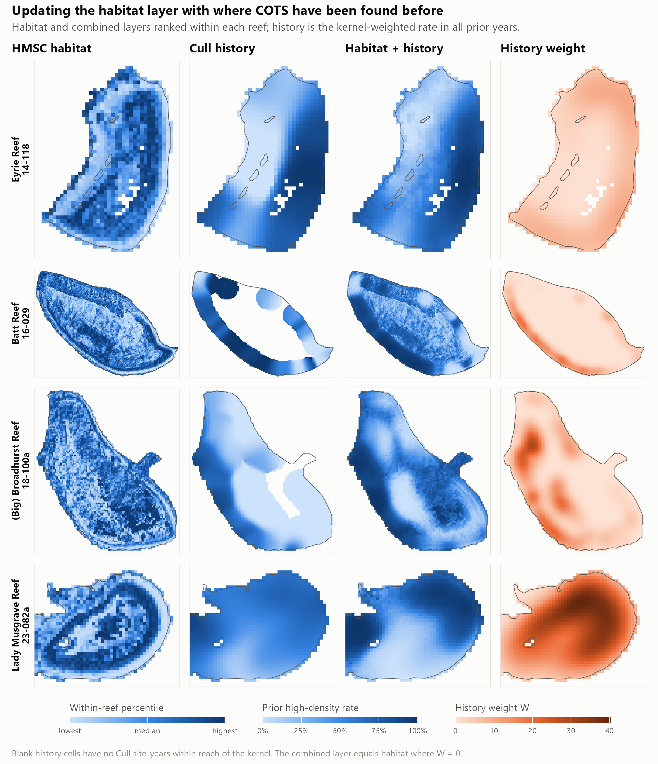
Figure 19: Habitat, cull history and the combined layer on the four reefs, with the history evidence weight. The combined layer is dominated by past finds wherever history exists.
ReefScan check. 237 presence-only ReefScan detections on 29 reefs were compared with each layer’s within-reef percentile. Detections sat near or below the median for every layer (mean percentile 0.41–0.53). Without survey tracks that recorded no detections, this mostly reflects where ReefScan was towed, so the check is inconclusive.

Appendix E: Alignment with the CCIP-BR-13 Work Plan
Table 14: Work Plan outputs and where they are reported. The Work Plan proposed validating tow paths at the 50th and 80th percentile thresholds; this report instead evaluates every level of tow retention from 90% to 30% against random and systematic baselines.
Work Plan output | Delivered in this report | Status
E. Finalised GBR-wide habitat suitability model and surveillance paths | 30 m habitat layers (Appendix A); held-out evaluation of model-ranked versus systematic manta thinning (Section 3.4); example search plans (Appendix D) | [TO CONFIRM]
E (extension). Cull-site selection | 2027 cull-site priority ranking and exploration areas (Section 3.1) | [TO CONFIRM]
F. Fine-scale connectivity network at four reef clusters | Not in this report | [TO CONFIRM]
G. Prototype fine-scale metacommunity model | Methods and metacommunity calibration Results | Prototype implemented; validation and control-policy comparisons incomplete
H. Final data sets and public report (FAIR) | This report; layers, tables and code | [TO CONFIRM: repository, DOI and licence]
I. Peer-reviewed publication | Manuscript in preparation for Frontiers in Marine Science | [TO CONFIRM]

Appendix F: Reproducibility
The pipeline is in DataProcessing/cots_sdm_v2/final/ [TO CONFIRM: public repository URL and release DOI]. Every input is pinned by SHA-256 checksum in config.R; scripts 00–21 run in the order given in README.md, with 07 (figures) last. Every number in this report is read from outputs/tables/ or outputs/site_ranking/ when the report is rendered. COTS Control Program cull and manta records are held by GBRMPA and are not public [TO CONFIRM: access statement].

