Sam McDowell

6/24/2020

Lab 1.1

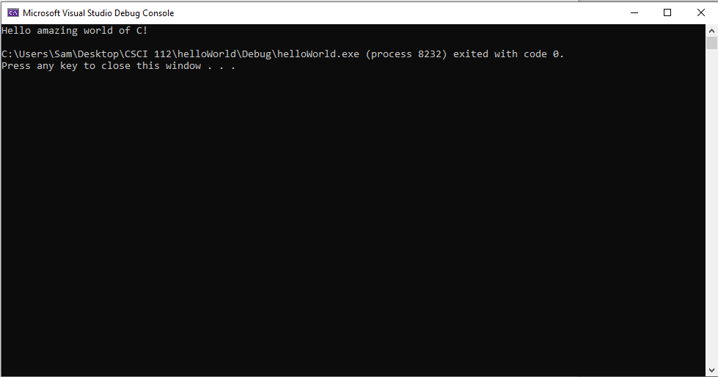

# Transcription:

Hello amazing world of C!