Lab 7: Course Registration

*Sam McDowell*

*11/17/2023*

Algorithm

In this lab we are making a course registration tool. This will allow the user to create a course. Then they can add a faculty member, add students and list the information about the course. To make this happen, there will be 5 classes.

The first class will be a Person. This class should store a name, ID, and birthdate. It will also have getters and setter for each of those data members.

The second class will be a Faculty member. This class should inherit from Person such that all the getters and setters of a Person are available to use for a Faculty member. Additionally, a Faculty member will have a date hired, a title, a rank, and a salary. These data members will all have getters and setters. Finally the “<<” operator will be overloaded so that a faculty member can be printed to cout.

The third class will be a Student. This class will also inherit from a Person with all the getters and setters available. It will also have a date enrolled, major, level, and GPA. These will also have getters and setters. Like a faculty member, the “<<” operator will be overloaded to print it to cout. Additionally, the “<” operator will be overloaded to allow sorting by ID.

The fourth class is a Course. This class will have a name, a Faculty member, a list of students and a maximum capacity. It will have getters and setters for each of those data members. For the list of students there should also be a check if full method to make sure a new student can be added. It will also have “<<” overloaded so that the course information can be printed out correctly and easily.

The fifth class will be a Date. It simply represents a day, month and year. It should also have the “<<” operator overloaded for printing.

The main program will start by printing a title. It will then get the basic info about the course like the name and maximum number of students. It will then enter a menu loop. During this loop it will ask whether the user would like to add a Faculty member, add a Student, list the course info, or end the program. If they would like to add a Faculty member of Student, it will prompt them for the necessary information and add it to the course. Course information will be printed if the list info option is selected. The program will end when the user selects exit. It will wait to close until the user hits a key.

Screen-Shots of Running Program

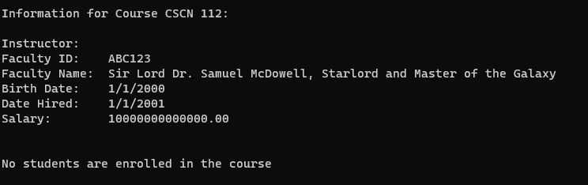

Integrity Statements

* I have not shared the source code in my program with anyone other than the pre-approved human sources.
* I have not used source code obtained from another student, or any other unauthorized source, either modified or unmodified.
* If any source code or documentation used in my program was obtained from another source, such as the course textbook or course notes, that has been clearly noted with a proper citation in the comments of my program.
* I have not knowingly designed this program in such a way as to defeat or interfere with the normal operation of any machine it is graded on or to produce apparently correct results when in fact it does not.