Fynd AMM ETH/USDG: LP return vs Binance, Oct 6 – Nov 5, 2026
Pool: Ekubo v3 on Robinhood Chain, ETH/USDG, Fynd extension 0x550CFe12…1D09. Window 2026-10-06 19:39 to 2026-11-05 23:57 UTC (30.2 days). This replaces the v1 chart: v1 under-counted fees (section 5).

1. Summary
- All flow: 20,326 swaps, $4.13M. LPs earned $1,466 in fees (3.55 bp) and lost $4,694 at 12 s against Binance (−11.37 bp). LP return −$3,228 (−7.82 bp).
- Likely Fynd bot (one wallet, not confirmed by Fynd): 17,146 swaps, $3.32M, LP return −$2,612 (−7.87 bp). It pays 1.62 bp in fees against 11.46 bp for everyone else.
- External flow: 3,180 swaps, $0.81M, LP return −$617 (−7.62 bp). Swaps that moved the pool toward Binance by more than their fee lost LPs $1,186; the other external swaps made LPs $569.
- The loss is there at the moment of the trade. 92% of the 12 s loss (98% for external flow) is already present at 0 s: the pool's price was behind Binance before the swap. Measured loss is 0.58× theoretical LVR ($4,694 vs $8,041).
- Fee sweep (external toward-Binance swaps only): at the actual 3.54 bp, LP return −$1,186. A flat 10 bp gives −$818 and keeps 77% of that volume; 30 bp gives −$210 and keeps 29%. Under a strong assumption (section 3).
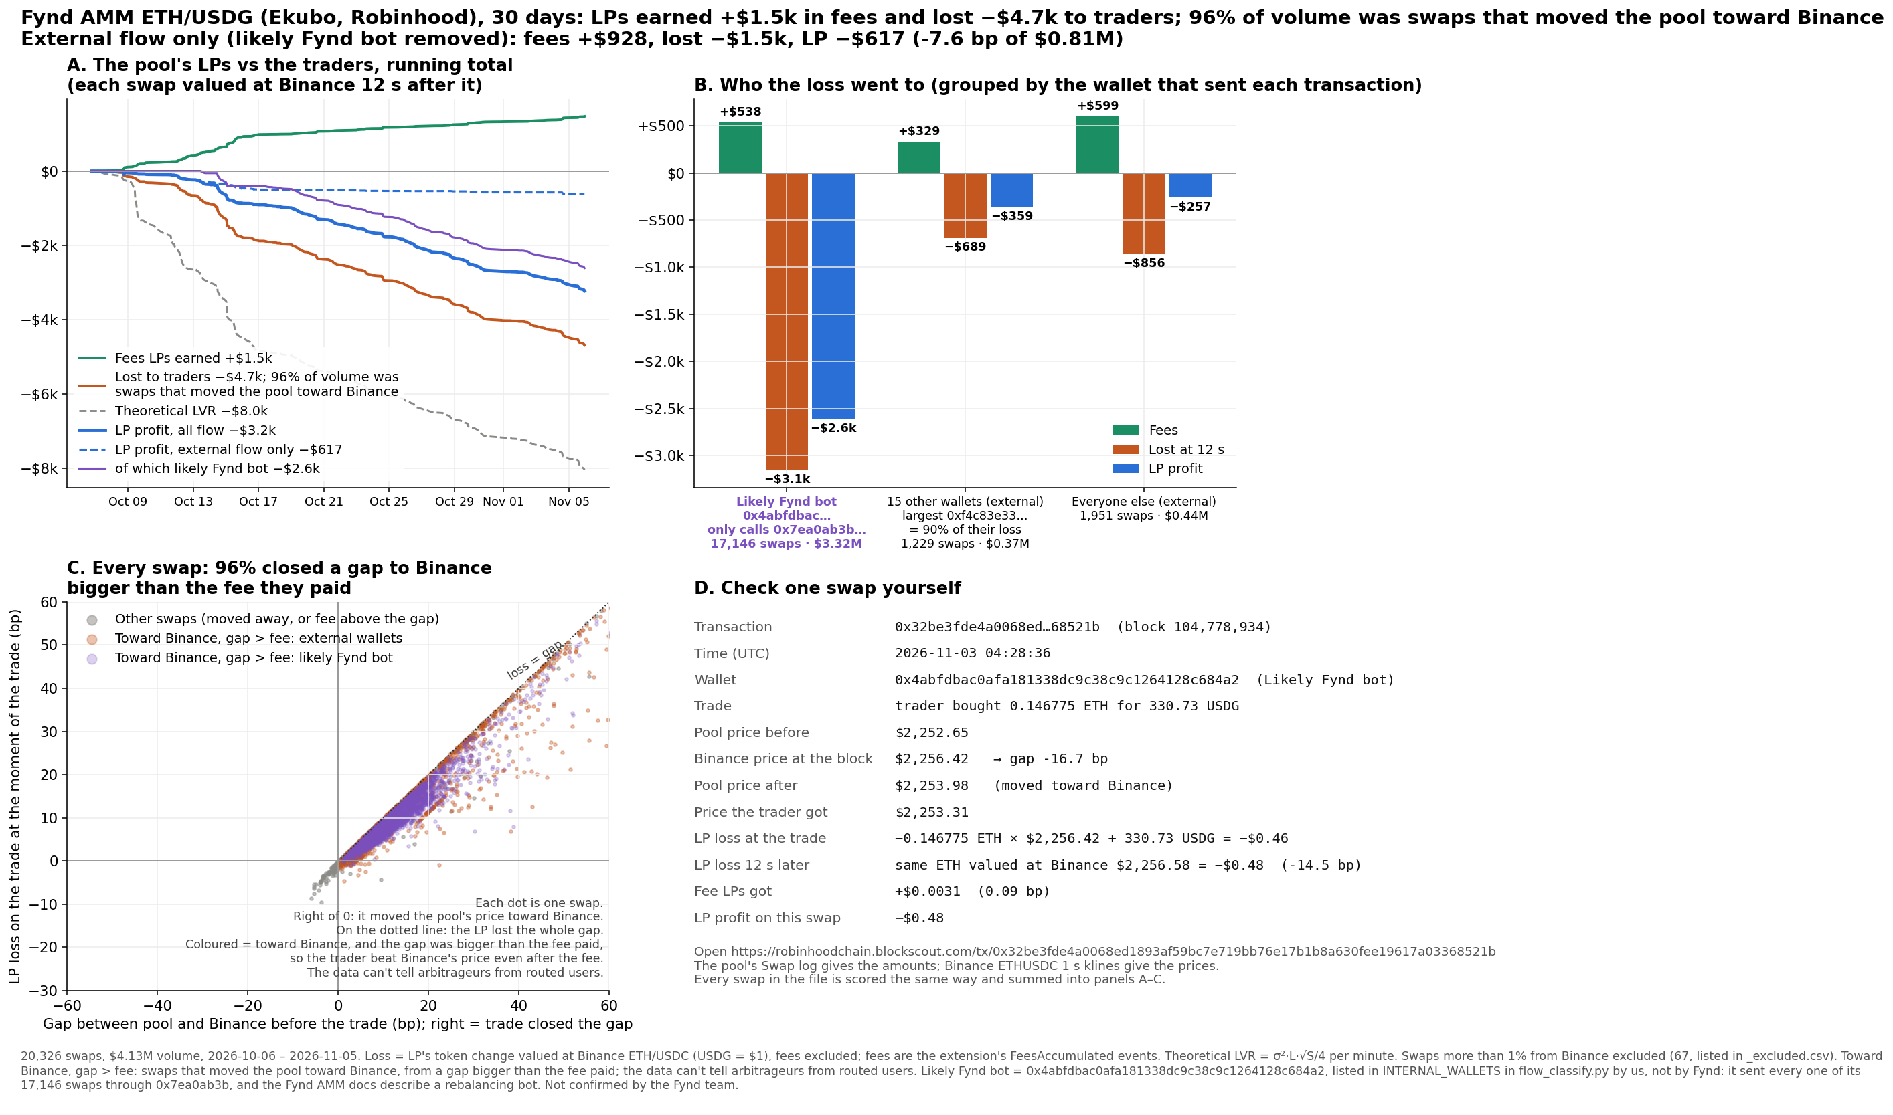
Figure 1. Where the LP loss comes from: running totals (A), by wallet group (B), gap vs loss for every swap (C), and one swap worked through by hand (D).

2. Definitions
- LP return = fees − LP loss at 12 s. LP loss at h s = what the pool gave minus what it received, both valued at the Binance ETHUSDC close h seconds after the swap (USDG = $1), fees excluded. This is not position P&L: it leaves out price moves on the LPs' inventory after 12 s, deposits and withdrawals, gas, and anything Fynd pays or hedges outside the pool.
- bp = per dollar of swap volume.
- Toward Binance, gap > fee: before the swap, the pool's price differed from Binance by more than the fee the swap paid, and the swap moved the pool toward Binance. The code calls these arbitrage; the pool is exclusive, so the data can't tell arbitrageurs from routed users.
- Likely Fynd bot: 0x4abfdbac0afa181338dc9c38c9c1264128c684a2. Listed by us, not by Fynd: every one of its swaps goes through 0x7ea0ab3b, and the Fynd AMM docs describe a rebalancing bot. Not confirmed by the Fynd team.
- External: every other wallet (transaction sender).

3. Method
- Swaps: Ekubo Core swap logs matched on poolId, with block times from the RPC. Daily volume is within 0.2% of GeckoTerminal, with 0 duplicates.
- Fees: the extension's FeesAccumulated events, split across each transaction's swaps by USDG size.
- Prices: Binance ETHUSDC 1 s klines.
- TVL: rebuilt daily from position, fee and swap events, valued at Binance.
- LVR: theoretical LVR per minute = σ²·L·√S/4, from 60 s Binance returns and the pool's in-range liquidity.
- Fee sweep: for a flat fee f, a swap is kept only if its gap was bigger than f, at the same size and markout. It ignores smaller trades, retail demand, and routing to other venues.
- Exclusions: 68 swaps, all listed in results_flow_fynd_excluded.csv. 67 executed more than 1% from Binance, and 1 has no earlier swap to give a pre-swap price.
- Checks: 13 tests pass. Every group split adds back to its total, the sign conventions and the toward-Binance rule are unit-tested, and the chart's example swap is recomputed by hand from raw data to the cent.

4. Results
Flow | Swaps | Volume | Fees | Loss at 12 s | LP return
All | 20,326 | $4.13M | $1,466 (3.55 bp) | −$4,694 (−11.37 bp) | −$3,228 (−7.82 bp)
Likely Fynd bot | 17,146 | $3.32M | $538 (1.62 bp) | −$3,149 (−9.49 bp) | −$2,612 (−7.87 bp)
External | 3,180 | $0.81M | $928 (11.46 bp) | −$1,545 (−19.08 bp) | −$617 (−7.62 bp)
External, toward Binance, gap > fee | 2,079 | $726k | $257 (3.54 bp) | −$1,443 (−19.88 bp) | −$1,186 (−16.34 bp)
External, other | 1,101 | $84k | $671 (80.07 bp) | −$102 (−12.19 bp) | +$569 (+67.89 bp)

- Horizons, all flow: loss is −10.47 bp at 0 s, −11.37 bp at 12 s and −11.39 bp at 60 s.
- TVL: the average daily TVL in the window was $22,499 (range about $2k to $38k). LP return as a share of average TVL, scaled to a year: −174% for all flow and −33% for external flow. This is an extrapolation, not a forecast.
- LVR: measured loss divided by theoretical LVR, by week. The first and last weeks are partial.
 | Oct 5 | Oct 12 | Oct 19 | Oct 26 | Nov 2
All flow | 0.18× | 0.56× | 0.89× | 0.94× | 0.79×
External only | 0.18× | 0.34× | 0.05× | 0.06× | 0.09×

- Fee sweep on external toward-Binance swaps:
Flat fee | Swaps kept | Volume kept | LP return
0 bp | 2,079 | 100% | −$1,443
10 bp | 1,116 | 77% | −$818
20 bp | 729 | 53% | −$397
30 bp | 454 | 29% | −$210

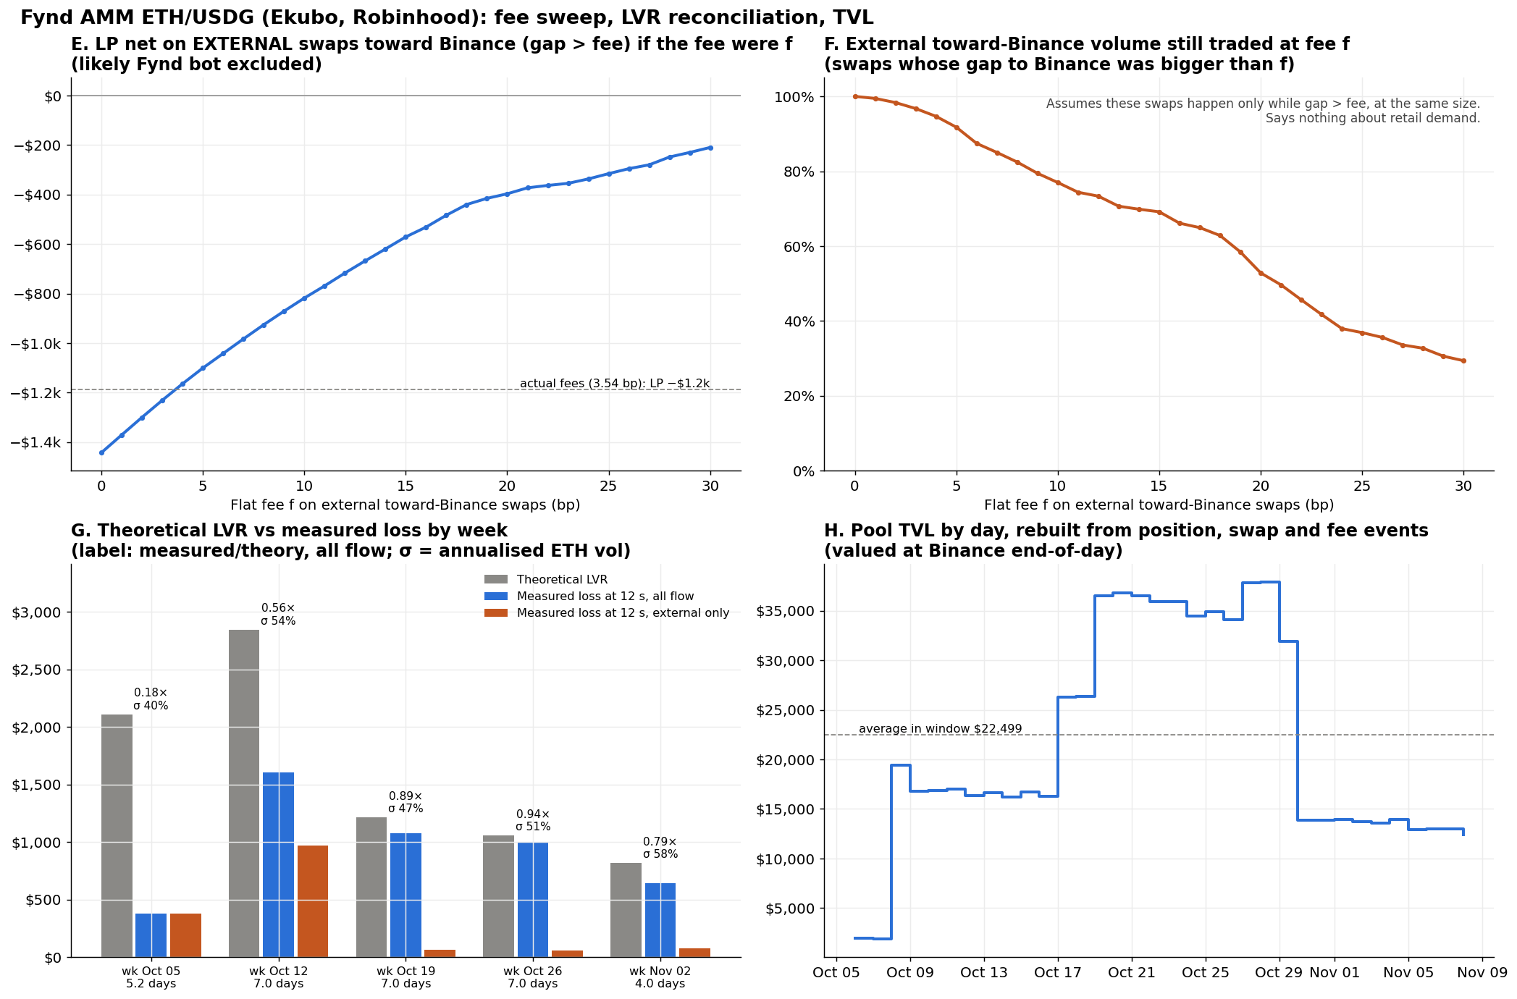
Figure 2. Fee sweep on external toward-Binance swaps (E, F), theoretical LVR vs measured loss by week (G), and daily TVL rebuilt from events (H).

5. Fee correction
The v1 results (commit 1ed3fd8) gave fees of $516 (1.25 bp) and an LP return of −$4,179 over this same window. The fetch script dropped any fee paid in the token the pool paid out. Corrected, fees are $1,466 (3.55 bp) and the LP return is −$3,228. The loss at 12 s (−$4,694) is unchanged. It was caught when the TVL rebuild from raw events didn't balance. Discard any v1 numbers or charts.

6. What the data can't show
- Who controls any wallet. The likely Fynd bot is our label, inferred from on-chain behaviour.
- Whether a toward-Binance swap was an arbitrageur or a routed user.
- Why the pool's price lags Binance, or why measured loss sits below theoretical LVR. Only that it does, and by how much.
- What volume or LP return a different fee would produce once traders and routers respond.
- Position P&L for any LP (see LP return above).

7. Open items
- The Fynd team to confirm or correct the bot wallet, and say how its LP loss should be counted (it may stay inside Fynd).
- TVL not reconciled: the rebuild gives $12,370 on Nov 8, and GeckoTerminal showed $10,490 on Nov 9.
- Compare against an LP in Uniswap's public USDG/WETH 0.01% pool on Robinhood.
- Fee effectiveness against the best on-chain quote in the same block, not only Binance.
- Data is fetched through Nov 8; the analysis stops at Nov 5.

8. How to rerun
From the unzipped folder, with Python 3 and pip install pandas numpy matplotlib requests pycryptodome pytest. The swap and position inputs are in data_swaps/. No API key is needed; the RPC is public.
# Binance 1 s klines, Oct 5 – Nov 8, into klines_eth_1s/
mkdir -p klines_eth_1s && for d in $(python3 -c "import pandas as p;print(*p.date_range('2026-10-05','2026-11-08').strftime('%Y-%m-%d'))"); do
curl -sf -o klines_eth_1s/ETHUSDC-1s-$d.zip https://data.binance.vision/data/spot/daily/klines/ETHUSDC/1s/ETHUSDC-1s-$d.zip; done

python3 flow_classify.py --swaps data_swaps/eth_usdg_ekubo_robinhood_to1108.csv --fee-mode columns \
--name "Fynd AMM ETH/USDG (Ekubo, Robinhood)" --tvl 10490 --end 2026-11-06 --persistence \
--positions data_swaps/eth_usdg_ekubo_robinhood_positions.csv --out-prefix results_flow_fynd
python3 flow_chart.py --prefix results_flow_fynd --name "Fynd AMM ETH/USDG (Ekubo, Robinhood)" \
--explorer https://robinhoodchain.blockscout.com/tx/ --raw data_swaps/eth_usdg_ekubo_robinhood_to1108.csv \
--png charts_flow/F5_fynd_toxic_flow.png --png2 charts_flow/F7_fynd_fee_sweep_lvr_tvl.png
python3 -m pytest -q test_flow.py

To refetch the inputs from chain, see the commands at the top of fetch_ekubo_swaps.py and fetch_ekubo_positions.py (pool initialised at block 72,277,109). README_flow_fynd.md has every assumption in full.

