Design a website by using bootstrap and html5.

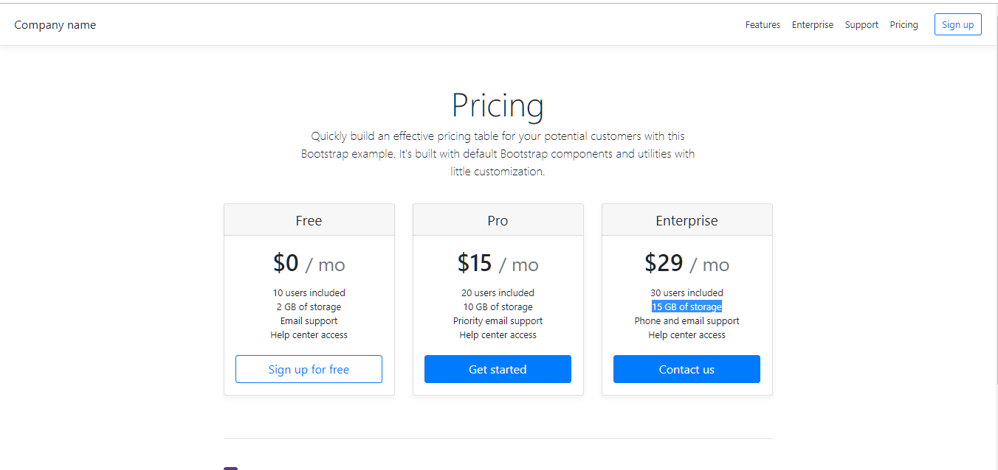 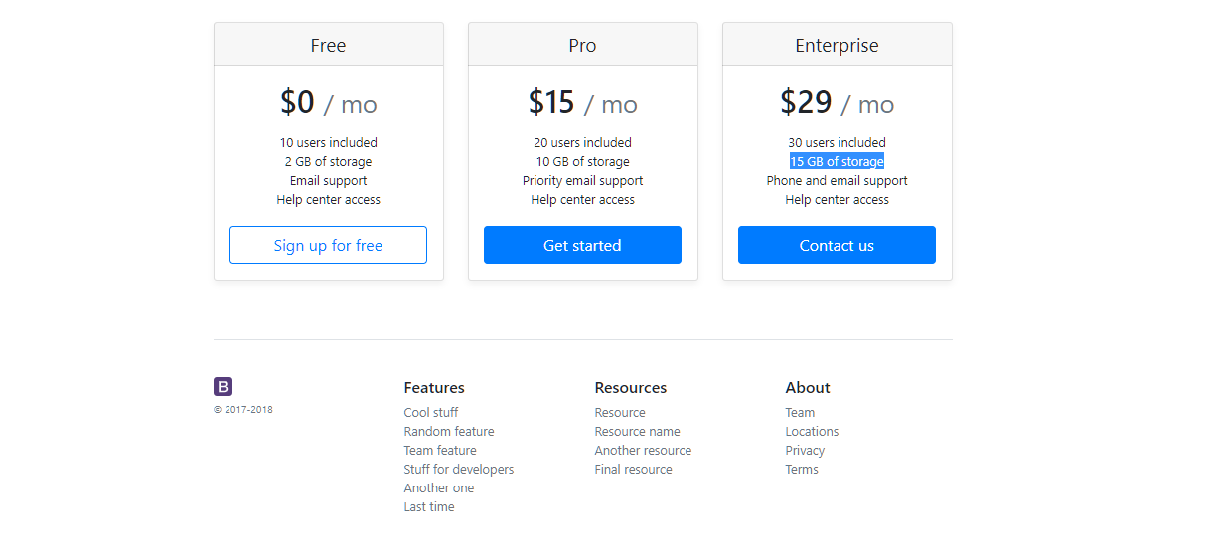

Also Include the location at the bottom of the of the page with the google map integration.