Project Description:

This project implements RRT(Rapidly exploring random trees) algorithm for motion planning in a 2D configuration space with 2D obstacles and robot.

Programming Language: Python, python 2.7
Modules Used: Pygame (Ref: http://www.pygame.org/hifi.html)

Program Design:

- The program uses pygame module to show a GUI for the user. The program generates rectangular obstacles randomly in the space once started and waits for the user to interact.
- A left mouse click by the user selects the initial position of the bot, and a right mouse click selects the goal position.
- Both, initial and final positions are added as a vertex to the graph.
- The left mouse click also starts the RRT generation. After the completing RRT for an already calculated number of vertices, the algorithm exits.
- After the selection of goal position and completion of RRT, the program runs a DFS (Depth first search) algorithm starting from the initial position until it finds the goal vertex.
- Once DFS finds the path between the two nodes, it exits returning the path to the main program.
- The main program then draws the path from the initial to the final position.

RRT algorithm:
The algorithm uses a slightly different algorithm than normally used. It is similar to rrt connect in the manner in which it uses a greedy approach while adding edge to a graph, but it does'nt create trees from both the initial and goal positions. Please refer https://personalrobotics.ri.cmu.edu/files/courses/papers/Kuffner00-rrtconnect.pdf for more details. The basic algorithm used in the program looks something like this:
- Start with an empty search tree
- Add your initial location (configuration) to the search tree
- while your search tree has not reached the maximum number of nodes
3.1. Pick a location randomly in free space q_rand
3.2. Find the vertex in the search tree closest to that random point q_near
3.3. Try to add an edge (path) in the tree between q_near and q_rand, if you can link them without a collision occurring.
3.4. If collision occurs at q_collision, draw an edge from q_near to q_collision

Collision Detection:
Pygame.sprite(ref: http://www.pygame.org/docs/ref/sprite.html ) class in pygame is used for collision detection in the program. The basic algorithm used is as follows:
- Add all the obstacles in a Group class.
- Make a line joining the random configuration and the node nearest to it.
- Place a small bot (2D dimensions of the bot can be used here) along the path at some intervals until it reaches the end of line or collides.
- Use groupcollide function in sprite class to find if the bot collided with the obstacles.

DFS algorithm:

procedure DFS-iterative(G,v,):
let S be a stack
S.push(v)
while S is not empty or goal_not_reached:
v = S.pop()
if v is not labeled as discovered:
label v as discovered
for all edges from v to w in G.adjacentEdges(v) do
S.push(w)

Data Structure design:
This program uses a graph data structure to keep a track of all the vertices and edges in the RRT.

Graph Data Structure: Graph data structure is used to store the graph elements. It is composed of a list which contains a list of all the vertices in the graph and another variable ‘no_of_vertices’ to store the number of vertices in the graph

Vertex: Vertex class is used to store the vertex objects in the graph. It is composed of the position of vertex and has a list named ‘connectedTo’ which contains the pointers to all its neighbors.

The data structure can be better explained by the figure below:

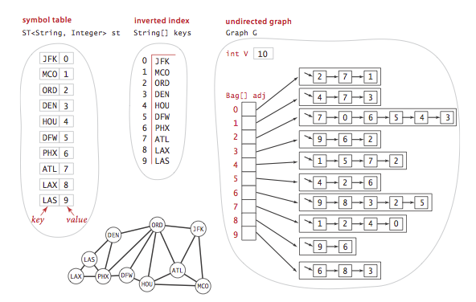
Graph Data structure Ref:http://algs4.cs.princeton.edu/41graph/

Run the project:

1. Install all the required software (python,pygame)

2. Open the folder containing all the files

3. Run rrt.py

4. A single left click anywhere on the opened window selects the current position of the bot and also triggers the program to create a RRT.

5. A single right click selects the goal position for the robot.

5. After the goal position has been selected, the dfs algorithm is used to find the path from the initial to the final position which is shown by red colored line.

Files:
1. Graph.py: This file has a class named my_Graph that is used to implement graph data structure.

2. Vertex.py: This file has a class named my_Vertex that is used to implement Vertex objects in the graph data structure and helps in implementation of Graph data structure.

3. dfs.py: This class has the implementation of DFS (Depth First Search) algorithm which is used in the program to find the path from initial location to final location once the rrt is constructed.

4. rrt.py: This is the main file to be executed to run the program.

Results:
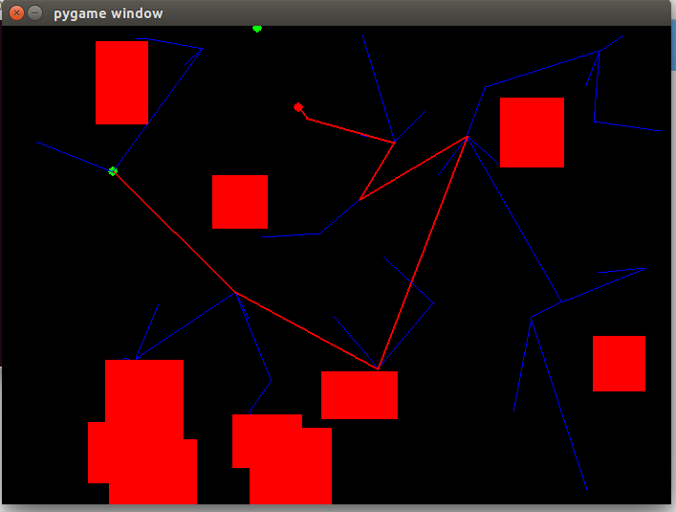
50 vertices

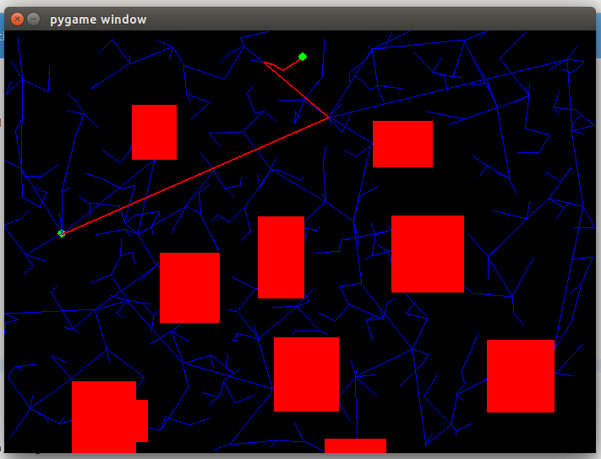

500 vertices

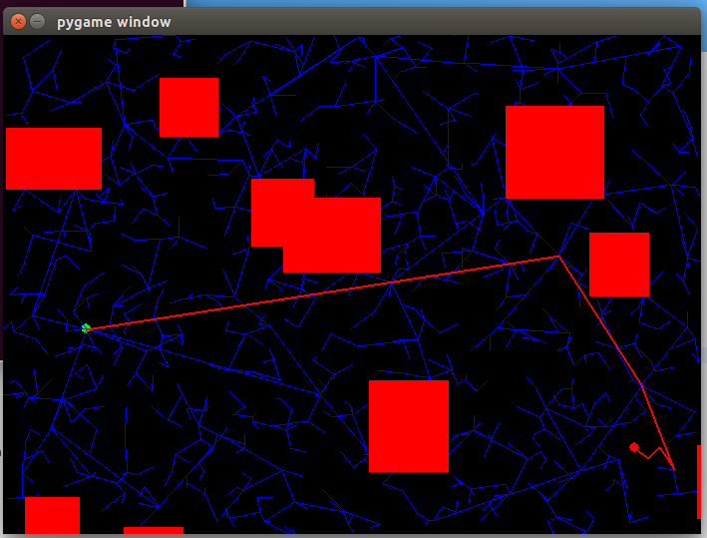
1000 vertices

