Job Execution State Machines

Software Functional Specification

State Machines' description

PURPOSE:

This document will present the different job’s execution state machines.

SCOPE:

**Author**

Date :

Company : Agileo Automation

Revision History

|  |  |  |  |  |
| --- | --- | --- | --- | --- |
| **Release** | **Modified parts** | **Comments** | **Date** | **Author** |
| 1.0 | All | Documents creation | 06/13/2022 | Agileo |
|  |  |  |  |  |
|  |  |  |  |  |
|  |  |  |  |  |
|  |  |  |  |  |

Table of Contents

1 Definitions and References 5

1.1 Definitions, Acronyms and Abbreviations 5

1.2 References 5

2 Job execution on one process module 6

2.1 Job execution on one process module state description 7

2.2 Job execution on one process module transitions description 8

3 Job execution on two chained process modules 10

3.1 Job execution on two chained process modules state description 11

3.2 Job execution on two chained process modules transitions description 12

4 Generic job execution 16

4.1 General state machine 16

4.1.1 General state machine state description 17

4.1.2 General state machine transition description 18

4.2 Prepare destination state machine 19

4.2.1 Prepare destination state machine state description 20

4.2.2 Prepare destination state machine transition description 21

Disclosure and Confidentiality

This document is Agileo Automation Company private. It contains the intellectual property of Agileo Automation and may not be copied, modified, or otherwise duplicated, reproduced, or changed without the expressed written permission of Agileo Automation.

This document may only be distributed on a need-to-know basis and may not be disclosed to any other party without the written permission of Agileo Automation.

Agileo Automation requires that a non-disclosure agreement shall be signed before the dissemination and distribution of this document.

# Definitions and References

## Definitions, Acronyms and Abbreviations

|  |  |
| --- | --- |
| **Term or Abbreviation** | Description |
|  |  |
|  |  |
|  |  |
|  |  |
|  |  |
|  |  |
|  |  |
|  |  |
|  |  |
|  |  |
|  |  |

## References

|  |  |  |  |
| --- | --- | --- | --- |
| Mnémonic | Reference | Rev | Title |
|  |  |  |  |
|  |  |  |  |
|  |  |  |  |
|  |  |  |  |

# Job execution on one process module

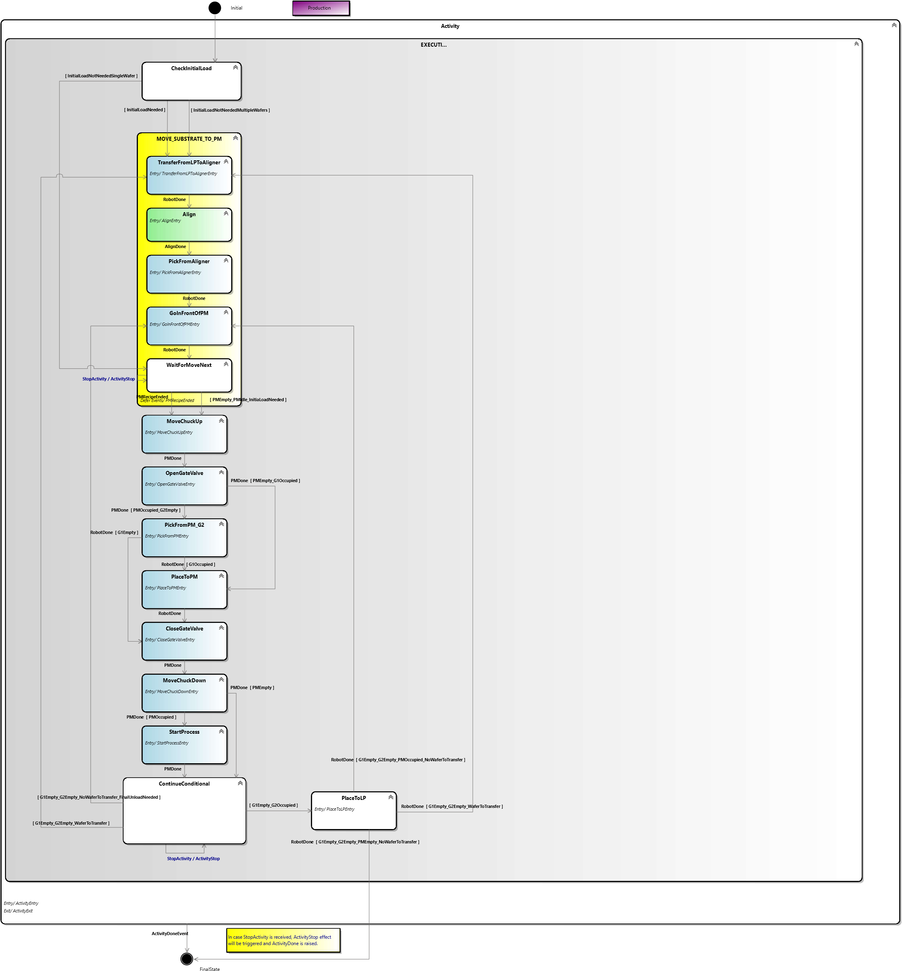

## Job execution on one process module state description

|  |  |
| --- | --- |
| State | Description |
| *Initial* | Initial state of the state machine |
| *Activity* | Macro state for the activity |
| *Executing* | Executing macro state |
| *CheckInitialLoad* | Check if an initial load is needed |
| *MoveSubstrateToPM* | Move substrate to PM macro state |
| *TransferFromLPToAligner* | Transfer the next wafer from load port to aligner |
| *Align* | Align the wafer with desired angle |
| *PickFromAligner* | Pick the wafer on the aligner |
| *GoInFrontOfPM* | Robot moves in front of the process module |
| *WaitForMoveNext* | Waiting that the PM is ready to be loaded/unloaded |
| *MoveChuckUp* | Move the process module’s chuck up |
| *OpenGateValve* | Open the process module’s gate valve |
| *PickFromPM_G2* | Robot picks the wafer on the process module with lower arm |
| *PlaceToPM* | Robot places the wafer on its upper arm on the process module |
| *CloseGateValve* | Close the process module’s gate valve |
| *MoveChuckDown* | Move the process module’s chuck down |
| *StartProcess* | Start the selected recipe on the process module |
| *ContinueConditional* | Check what is the next move to do |
| *PlaceToLP* | Place the wafer in the load port on its original slot |
| *FinalState* | Final state of the state machine |

## Job execution on one process module transitions description

|  |  |  |  |  |
| --- | --- | --- | --- | --- |
| # | Current State | Event | Conditions | New State |
| 1 | Initial |  |  | CheckInitialLoad |
| 2 | CheckInitialLoad |  | A first load is needed | TransferFromLPToAligner |
| 3 | CheckInitialLoad |  | A first load is not needed and there is still wafers to be transfered | TransferFromLPToAligner |
| 4 | TransferFromPLToAligner | Robot command is done |  | Align |
| 5 | Align | Aligner command is done |  | PickFromAligner |
| 6 | PickFromAligner | Robot command is done |  | GoInFrontOfPM |
| 7 | GoInFrontOfPM | Robot command is done |  | WaitForMoveNext |
| 8 | WaitForMoveNext | Process module’s recipe exécution ended |  | MoveChuckUp |
| 9 | WaitForMoveNext |  | Process module is empty and process module is idle and a first load is needed | MoveChuckUp |
| 10 | WaitForMoveNext | Activity has been stopped |  | WaitForMoveNext |
| 11 | MoveChuckUp | Process module command is done |  | OpenGateValve |
| 12 | OpenGateValve | Process module command is done | Process module is occupied and robot’s lower arm is empty | PickFromPM_G2 |
| 13 | OpenGateValve | Process module command is done | Process module is empty and robot’s upper arm is occupied | PlaceToPM |
| 14 | PickFromPM_G2 | Robot command is done | Robot’s upper arm is occupied | PlaceToPM |
| 15 | PickFromPM_G2 | Robot command is done | Robot’s upper arm is empty | CloseGateValve |
| 16 | PlaceToPM | Robot command is done |  | CloseGateValve |
| 17 | CloseGateValve | Process module command is done |  | MoveChuckDown |
| 18 | MoveChuckDown | Process module command is done | Process module is occupied | StartProcess |
| 19 | MoveChuckDown | Process module command is done | Process module is empty | ContinueConditional |
| 20 | StartProcess | Process module command is done |  | ContinueConditional |
| 21 | ContinueConditional |  | Robot’s upper arm is empty and robot’s lower arm is occupied | PlaceToLP |
| 22 | ContinueConditional |  | Robot’s arms are empty and there are still wafers to transfer | TransferFromLPToAligner |
| 23 | ContinueConditional |  | Robot’s arm are empty and there is no wafer left to transfer and final unload is needed | GoInFrontOfPM |
| 24 | ContinueConditional | Activity has been stopped |  | ContinueConditional |
| 25 | PlaceToLP | Robot command is done | Robot’s arms are empty and there are still wafers to transfer | TransferFromLPToAligner |
| 26 | PlaceToLP | Robot command is done | Robot’s arms are empty and process module is occupied and there is no wafer left to transfer | GoInFrontOfPM |
| 27 | PlaceToLP | Robot command is done | Robot’s arms are empty and process module is empty and there is no wafer left to transfer | FinalState |
| 28 | Activity | Activity is done |  | FinalState |

# Job execution on two chained process modules

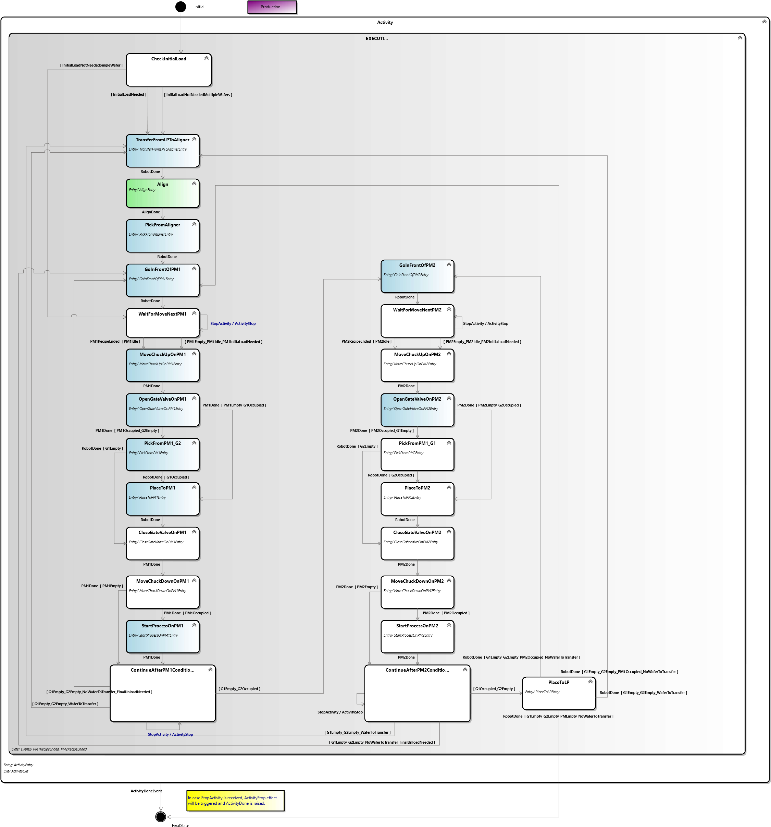

## Job execution on two chained process modules state description

|  |  |
| --- | --- |
| State | Description |
| *Initial* | Initial state of the state machine |
| *Activity* | Macro state for the activity |
| *Executing* | Executing macro state |
| *CheckInitialLoad* | Check if an initial load is needed |
| *TransferFromLPToAligner* | Transfer the next wafer from load port to aligner |
| *Align* | Align the wafer with desired angle |
| *PickFromAligner* | Pick the wafer on the aligner |
| *GoInFrontOfPM1* | Robot moves in front of the first process module |
| *WaitForMoveNextPM1* | Waiting that the first process module is ready to be loaded/unloaded |
| *MoveChuckUpOnPM1* | Move the first process module’s chuck up |
| *OpenGateValveOnPM1* | Open the first process module’s gate valve |
| *PickFromPM1_G2* | Robot picks the wafer on the first process module with lower arm |
| *PlaceToPM1* | Robot places the wafer on its upper arm on the first process module |
| *CloseGateValveOnPM1* | Close the first process module’s gate valve |
| *MoveChuckDownOnPM1* | Move the first process module’s chuck down |
| *StartProcessOnPM1* | Start the selected recipe on the first process module |
| *ContinueAfterPM1Conditional* | Check what is the next move to do after first process module |
| *GoInFrontOfPM2* | Robot moves in front of the second process module |
| *WaitForMoveNextPM2* | Waiting that the second process module is ready to be loaded/unloaded |
| *MoveChuckUpOnPM2* | Move the second process module’s chuck up |
| *OpenGateValveOnPM2* | Open the second process module’s gate valve |
| *PickFromPM2_G1* | Robot picks the wafer on the second process module with upper arm |
| *PlaceToPM2* | Robot places the wafer on its lower arm on the second process module |
| *CloseGateValveOnPM2* | Close the second process module’s gate valve |
| *MoveChuckDownOnPM2* | Move the second process module’s chuck down |
| *StartProcessOnPM2* | Start the selected recipe on the second process module |
| *ContinuerAfterPM2Conditional* | Check what is the next move to do after second process module |
| *PlaceToLP* | Place the wafer in the load port on its original slot |
| *FinalState* | Final state of the state machine |

## Job execution on two chained process modules transitions description

|  |  |  |  |  |
| --- | --- | --- | --- | --- |
| # | Current State | Event | Conditions | New State |
| 1 | Initial |  |  | CheckInitialLoad |
| 2 | CheckInitialLoad |  | A first load is needed | TransferFromLPToAligner |
| 3 | CheckInitialLoad |  | A first load is not needed and there is still wafers to be transfered | TransferFromLPToAligner |
| 4 | TransferFromPLToAligner | Robot command is done |  | Align |
| 5 | Align | Aligner command is done |  | PickFromAligner |
| 6 | PickFromAligner | Robot command is done |  | GoInFrontOfPM1 |
| 7 | GoInFrontOfPM1 | Robot command is done |  | WaitForMoveNextPM1 |
| 8 | WaitForMoveNextPM1 | First process module’s recipe exécution ended |  | MoveChuckUpOnPM1 |
| 9 | WaitForMoveNextPM1 |  | First process module is empty and first process module is idle and a first load is needed | MoveChuckUpOnPM1 |
| 10 | WaitForMoveNextOnPM1 | Activity has been stopped |  | WaitForMoveNextOnPM1 |
| 11 | MoveChuckUpOnPM1 | First process module command is done |  | OpenGateValveOnPM1 |
| 12 | OpenGateValveOnPM1 | First process module command is done | First process module is occupied and robot’s lower arm is empty | PickFromPM1_G2 |
| 13 | OpenGateValveOnPM1 | First process module command is done | First process module is empty and robot’s upper arm is occupied | PlaceToPM1 |
| 14 | PickFromPM1_G2 | Robot command is done | Robot’s upper arm is occupied | PlaceToPM1 |
| 15 | PickFromPM1_G2 | Robot command is done | Robot’s upper arm is empty | CloseGateValveOnPM1 |
| 16 | PlaceToPM1 | Robot command is done |  | CloseGateValveOnPM1 |
| 17 | CloseGateValveOnPM1 | First process module command is done |  | MoveChuckDownOnPM1 |
| 18 | MoveChuckDownOnPM1 | First process module command is done | First process module is occupied | StartProcessOnPM1 |
| 19 | MoveChuckDownOnPM1 | First process module command is done | First process module is empty | ContinueAfterPM1Conditional |
| 20 | StartProcessOnPM1 | First process module command is done |  | ContinueAfterPM1Conditional |
| 21 | ContinueAfterPM1Conditional |  | Robot’s upper arm empty and robot’s lower arm occupied | GoInFrontOfPM2 |
| 22 | ContinueAfterPM1Conditional |  | Robot’s arms are empty and there are still wafers to transfer | TransferFromLPToAligner |
| 23 | ContinueAfterPM1Conditional |  | Robot’s arm are empty and there is no wafer left to transfer and final unload is needed | GoInFrontOfPM1 |
| 24 | ContinueAfterPM1Conditional | Activity has been stopped |  | ContinueAfterPM1Conditional |
| 25 | GoInFrontOfPM2 | Robot command is done |  | WaitForMoveNextPM2 |
| 26 | WaitForMoveNextPM2 | Second process module’s recipe exécution ended |  | MoveChuckUpOnPM2 |
| 27 | WaitForMoveNextOnPM2 |  | Second process module is empty and second process module is idle and a first load is needed | MoveChuckUpOnPM2 |
| 28 | WaitForMoveNextOnPM2 | Activity has been stopped |  | WaitForMoveNextOnPM2 |
| 29 | MoveChuckUpOnPM2 | Second process module command is done |  | OpenGateValveOnPM2 |
| 30 | OpenGateValveOnPM2 | Second process module command is done | Second process module is occupied and robot’s upper arm is empty | PickFromPM2_G1 |
| 31 | OpenGateValveOnPM2 | Second process module command is done | Second process module is empty and robot’s lower arm is occupied | PlaceToPM2 |
| 32 | PickFromPM2_G1 | Robot command is done | Robot’s lower arm is occupied | PlaceToPM2 |
| 33 | PickFromPM2_G1 | Robot command is done | Robot’s lower arm is empty | CloseGateValveOnPM2 |
| 34 | PlaceToPM2 | Robot command is done |  | CloseGateValveOnPM2 |
| 35 | CloseGateValveOnPM2 | Second process module command is done |  | MoveChuckDownOnPM2 |
| 36 | MoveChuckDownOnPM2 | Second process module command is done | Second process module is occupied | StartProcessOnPM2 |
| 37 | MoveChuckDownOnPM2 | Second process module command is done | Second process module is empty | ContinueAfterPM2Conditional |
| 38 | StartProcessOnPM2 | Second process module command is done |  | ContinueAfterPM2Conditional |
| 39 | ContinueAfterPM2Conditional |  | Robot’s upper arm occupied and robot’s lower arm empty | PlaceToLP |
| 40 | ContinueAfterPM2Conditional |  | Robot’s arms are empty and there are still wafers to transfer | TransferFromLPToAligner |
| 41 | ContinueAfterPM2Conditional |  | Robot’s arm are empty and there is no wafer left to transfer and final unload is needed | GoInFrontOfPM1 |
| 42 | ContinueAfterPM2Conditional | Activity has been stopped |  | ContinueAfterPM2Conditional |
| 43 | PlaceToLP | Robot command is done | Robot’s arms are empty and there are still wafers to transfer | TransferFromLPToAligner |
| 44 | PlaceToLP | Robot command is done | Robot’s arms are empty and first process module is occupied and there is no wafer left to transfer | GoInFrontOfPM1 |
| 45 | PlaceToLP | Robot command is done | Robot’s arms are empty and second process module is occupied and there is no wafer left to transfer | GoInFrontOfPM2 |
| 46 | PlaceToLP | Robot command is done | Robot’s arms are empty and there is no wafer left to transfer | FinalState |
| 47 | Activity | Activity is done |  | FinalState |

# Generic job execution

## General state machine

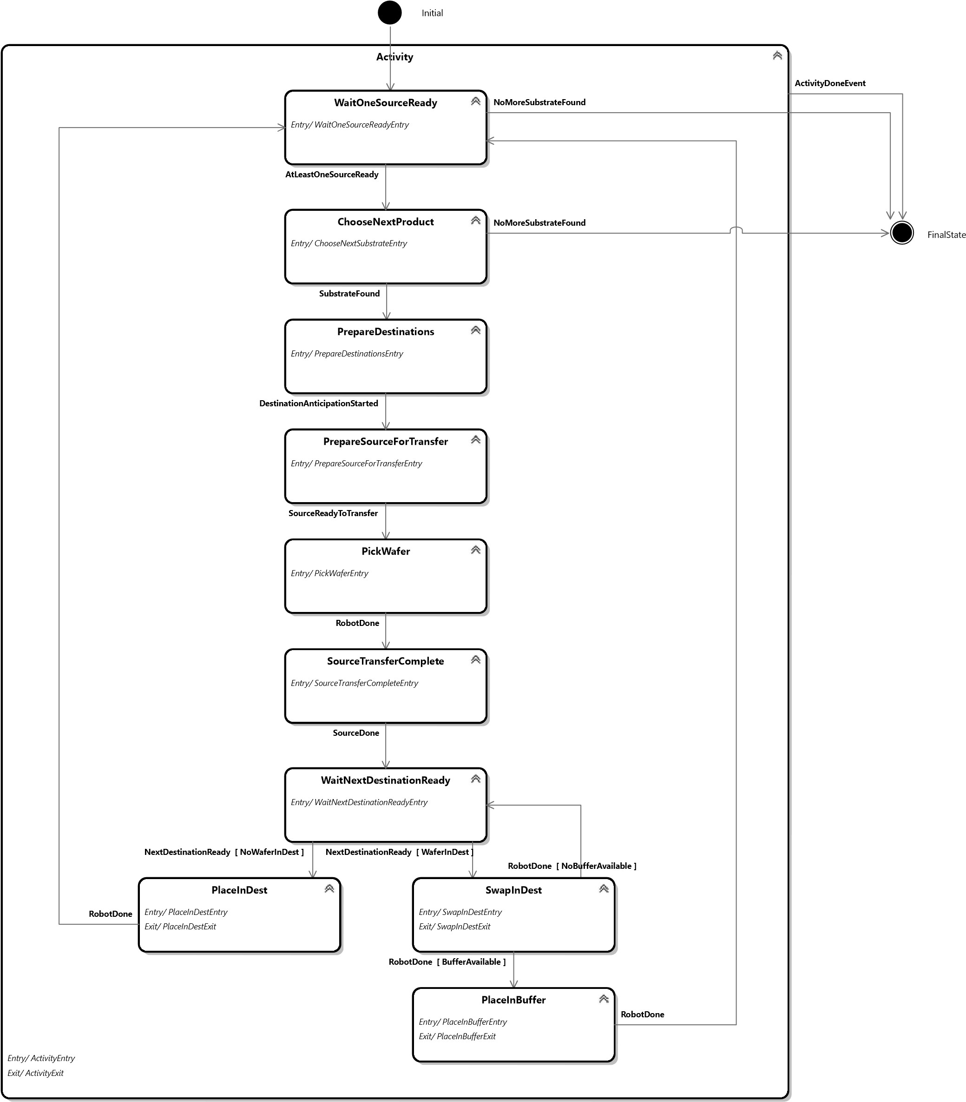

### General state machine state description

|  |  |
| --- | --- |
| State | Description |
| *Initial* | Initial state of the state machine |
| *Activity* | Macro state for the activity |
| *WaitOneSourceReady* | Wait that at least one source is ready to accept transfer |
| *ChooseNextProduct* | Choose the next product to transfer with the desired algorithm |
| *PrepareDestinations* | Generates prepare destination state machines for each potential destinations |
| *PrepareSourceForTransfer* | Prepare the source for the transfer |
| *PickWafer* | Pick the wafer in the source |
| *SourceTransferComplete* | Signal to the source that the transfer is complete |
| *WaitNextDestinationReady* | Wait that the next potential destination is ready for transfer |
| *PlaceInDest* | Place the wafer in the destination |
| *SwapInDest* | Swap wafers in the destination |
| *PlaceInBuffer* | Place the wafer in the buffer |
| *FinalState* | Final state of the state machine |

### General state machine transition description

|  |  |  |  |  |
| --- | --- | --- | --- | --- |
| # | Current State | Event | Conditions | New State |
| 1 | Initial |  |  | WaitOneSourceReady |
| 2 | WaitOneSourceReady | At least one source is ready to accept transfer |  | ChooseNextProduct |
| 3 | WaitOneSourceReady | No more substrate to be transferred |  | FinalState |
| 4 | ChooseNextProduct | Substrate has been found in the algorithm |  | PrepareDestinations |
| 5 | ChooseNextProduct | No more substrate to be transferred |  | FinalState |
| 6 | PrepareDestinations | Prepare destination state machines have been started |  | PrepareSourceForTransfer |
| 7 | PrepareSourceForTransfer | Source is ready to transfer |  | PickWafer |
| 8 | PickWafer | Robot command is done |  | SourceTransferComplete |
| 9 | SourceTransferComplete | Source command is done |  | WaitNextDestinationReady |
| 10 | WaitNextDestinationReady | Next destination is ready for transfer | There is no wafer in the destination | PlaceInDest |
| 11 | WaitNextDestinationReady | Next destination is ready for transfer | There is a wafer in the destination | SwapInDest |
| 12 | PlaceInDest | Robot command is done |  | WaitOneSourceReady |
| 13 | SwapInDest | Robot command is done | No buffer available | WaitNextDestinationReady |
| 14 | SwapInDest | Robot command is done | Buffer is available | PlaceInBuffer |
| 15 | PlaceInBuffer | Robot command is done |  | WaitOneSourceReady |
| 16 | Activity | Activity is done |  | FinalState |

## Prepare destination state machine

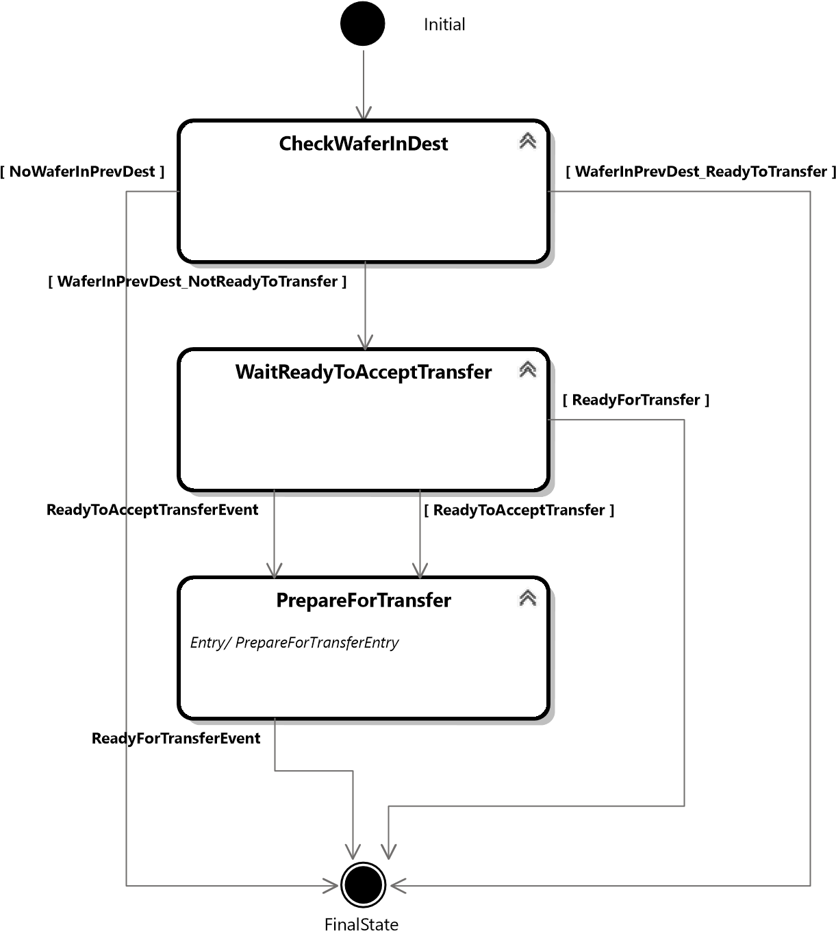

### Prepare destination state machine state description

|  |  |
| --- | --- |
| State | Description |
| *Initial* | Initial state of the state machine |
| *CheckWaferInDest* | Check if there is a wafer in the previous destination |
| *WaitReadyToAcceptTransfer* | Wait that the destination is ready to accept transfer |
| *PrepareForTransfer* | Prepare the destination for transfer |
| *FinalState* | Final state of the state machine |

### Prepare destination state machine transition description

|  |  |  |  |  |
| --- | --- | --- | --- | --- |
| # | Current State | Event | Conditions | New State |
| 1 | Initial |  |  | CheckWaferInDest |
| 2 | CheckWaferInDest |  | There is a wafer in the previous destination and the destination is not ready to transfer | WaitReadyToAcceptTransfer |
| 3 | CheckWaferInDest |  | There is no wafer in the previous destination | FinalState |
| 4 | CheckWaferInDest |  | There is a wafer in the previous destination and the destination is already ready to transfer | FinalState |
| 5 | WaitReadyToAcceptTransfer | Destination is ready to accept transfer |  | PrepareForTransfer |
| 6 | WaitReadyToAcceptTransfer |  | Destination is ready to accept transfer | PrepareForTransfer |
| 7 | WaitReadyToAcceptTransfer |  | Destination is ready for transfer | FinalState |
| 8 | PrepareForTransfer | Destination is ready for transfer |  | FinalState |