Job Execution State Machines
Software Functional Specification
State Machines' description
PURPOSE:
This document will present the different job’s execution state machines.

SCOPE:

Author

Date :
Company : Agileo Automation

Revision History

Release | Modified parts | Comments | Date | Author
1.0 | All | Documents creation | 06/13/2022 | Agileo

Table of Contents
1 Definitions and References 5
1.1 Definitions, Acronyms and Abbreviations 5
1.2 References 5
2 Job execution on one process module 6
2.1 Job execution on one process module state description 7
2.2 Job execution on one process module transitions description 8
3 Job execution on two chained process modules 10
3.1 Job execution on two chained process modules state description 11
3.2 Job execution on two chained process modules transitions description 12
4 Generic job execution 16
4.1 General state machine 16
4.1.1 General state machine state description 17
4.1.2 General state machine transition description 18
4.2 Prepare destination state machine 19
4.2.1 Prepare destination state machine state description 20
4.2.2 Prepare destination state machine transition description 21

Disclosure and Confidentiality

This document is Agileo Automation Company private. It contains the intellectual property of Agileo Automation and may not be copied, modified, or otherwise duplicated, reproduced, or changed without the expressed written permission of Agileo Automation.

This document may only be distributed on a need-to-know basis and may not be disclosed to any other party without the written permission of Agileo Automation.

Agileo Automation requires that a non-disclosure agreement shall be signed before the dissemination and distribution of this document.

Definitions and References

Definitions, Acronyms and Abbreviations
Term or Abbreviation | Description

References
Mnémonic | Reference | Rev | Title

Job execution on one process module
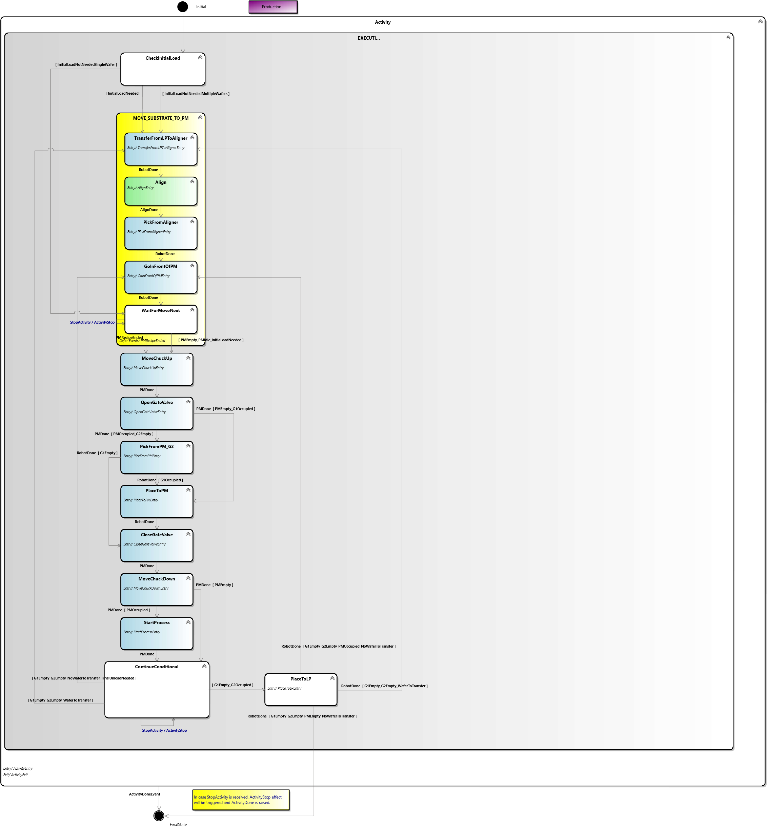

Job execution on one process module state description
State | Description
Initial | Initial state of the state machine
Activity | Macro state for the activity
Executing | Executing macro state
CheckInitialLoad | Check if an initial load is needed
MoveSubstrateToPM | Move substrate to PM macro state
TransferFromLPToAligner | Transfer the next wafer from load port to aligner
Align | Align the wafer with desired angle
PickFromAligner | Pick the wafer on the aligner
GoInFrontOfPM | Robot moves in front of the process module
WaitForMoveNext | Waiting that the PM is ready to be loaded/unloaded
MoveChuckUp | Move the process module’s chuck up
OpenGateValve | Open the process module’s gate valve
PickFromPM_G2 | Robot picks the wafer on the process module with lower arm
PlaceToPM | Robot places the wafer on its upper arm on the process module
CloseGateValve | Close the process module’s gate valve
MoveChuckDown | Move the process module’s chuck down
StartProcess | Start the selected recipe on the process module
ContinueConditional | Check what is the next move to do
PlaceToLP | Place the wafer in the load port on its original slot
FinalState | Final state of the state machine

Job execution on one process module transitions description
# | Current State | Event | Conditions | New State
1 | Initial |  |  | CheckInitialLoad
2 | CheckInitialLoad |  | A first load is needed | TransferFromLPToAligner
3 | CheckInitialLoad |  | A first load is not needed and there is still wafers to be transfered | TransferFromLPToAligner
4 | TransferFromPLToAligner | Robot command is done |  | Align
5 | Align | Aligner command is done |  | PickFromAligner
6 | PickFromAligner | Robot command is done |  | GoInFrontOfPM
7 | GoInFrontOfPM | Robot command is done |  | WaitForMoveNext
8 | WaitForMoveNext | Process module’s recipe exécution ended |  | MoveChuckUp
9 | WaitForMoveNext |  | Process module is empty and process module is idle and a first load is needed | MoveChuckUp
10 | WaitForMoveNext | Activity has been stopped |  | WaitForMoveNext
11 | MoveChuckUp | Process module command is done |  | OpenGateValve
12 | OpenGateValve | Process module command is done | Process module is occupied and robot’s lower arm is empty | PickFromPM_G2
13 | OpenGateValve | Process module command is done | Process module is empty and robot’s upper arm is occupied | PlaceToPM
14 | PickFromPM_G2 | Robot command is done | Robot’s upper arm is occupied | PlaceToPM
15 | PickFromPM_G2 | Robot command is done | Robot’s upper arm is empty | CloseGateValve
16 | PlaceToPM | Robot command is done |  | CloseGateValve
17 | CloseGateValve | Process module command is done |  | MoveChuckDown
18 | MoveChuckDown | Process module command is done | Process module is occupied | StartProcess
19 | MoveChuckDown | Process module command is done | Process module is empty | ContinueConditional
20 | StartProcess | Process module command is done |  | ContinueConditional
21 | ContinueConditional |  | Robot’s upper arm is empty and robot’s lower arm is occupied | PlaceToLP
22 | ContinueConditional |  | Robot’s arms are empty and there are still wafers to transfer | TransferFromLPToAligner
23 | ContinueConditional |  | Robot’s arm are empty and there is no wafer left to transfer and final unload is needed | GoInFrontOfPM
24 | ContinueConditional | Activity has been stopped |  | ContinueConditional
25 | PlaceToLP | Robot command is done | Robot’s arms are empty and there are still wafers to transfer | TransferFromLPToAligner
26 | PlaceToLP | Robot command is done | Robot’s arms are empty and process module is occupied and there is no wafer left to transfer | GoInFrontOfPM
27 | PlaceToLP | Robot command is done | Robot’s arms are empty and process module is empty and there is no wafer left to transfer | FinalState
28 | Activity | Activity is done |  | FinalState

Job execution on two chained process modules
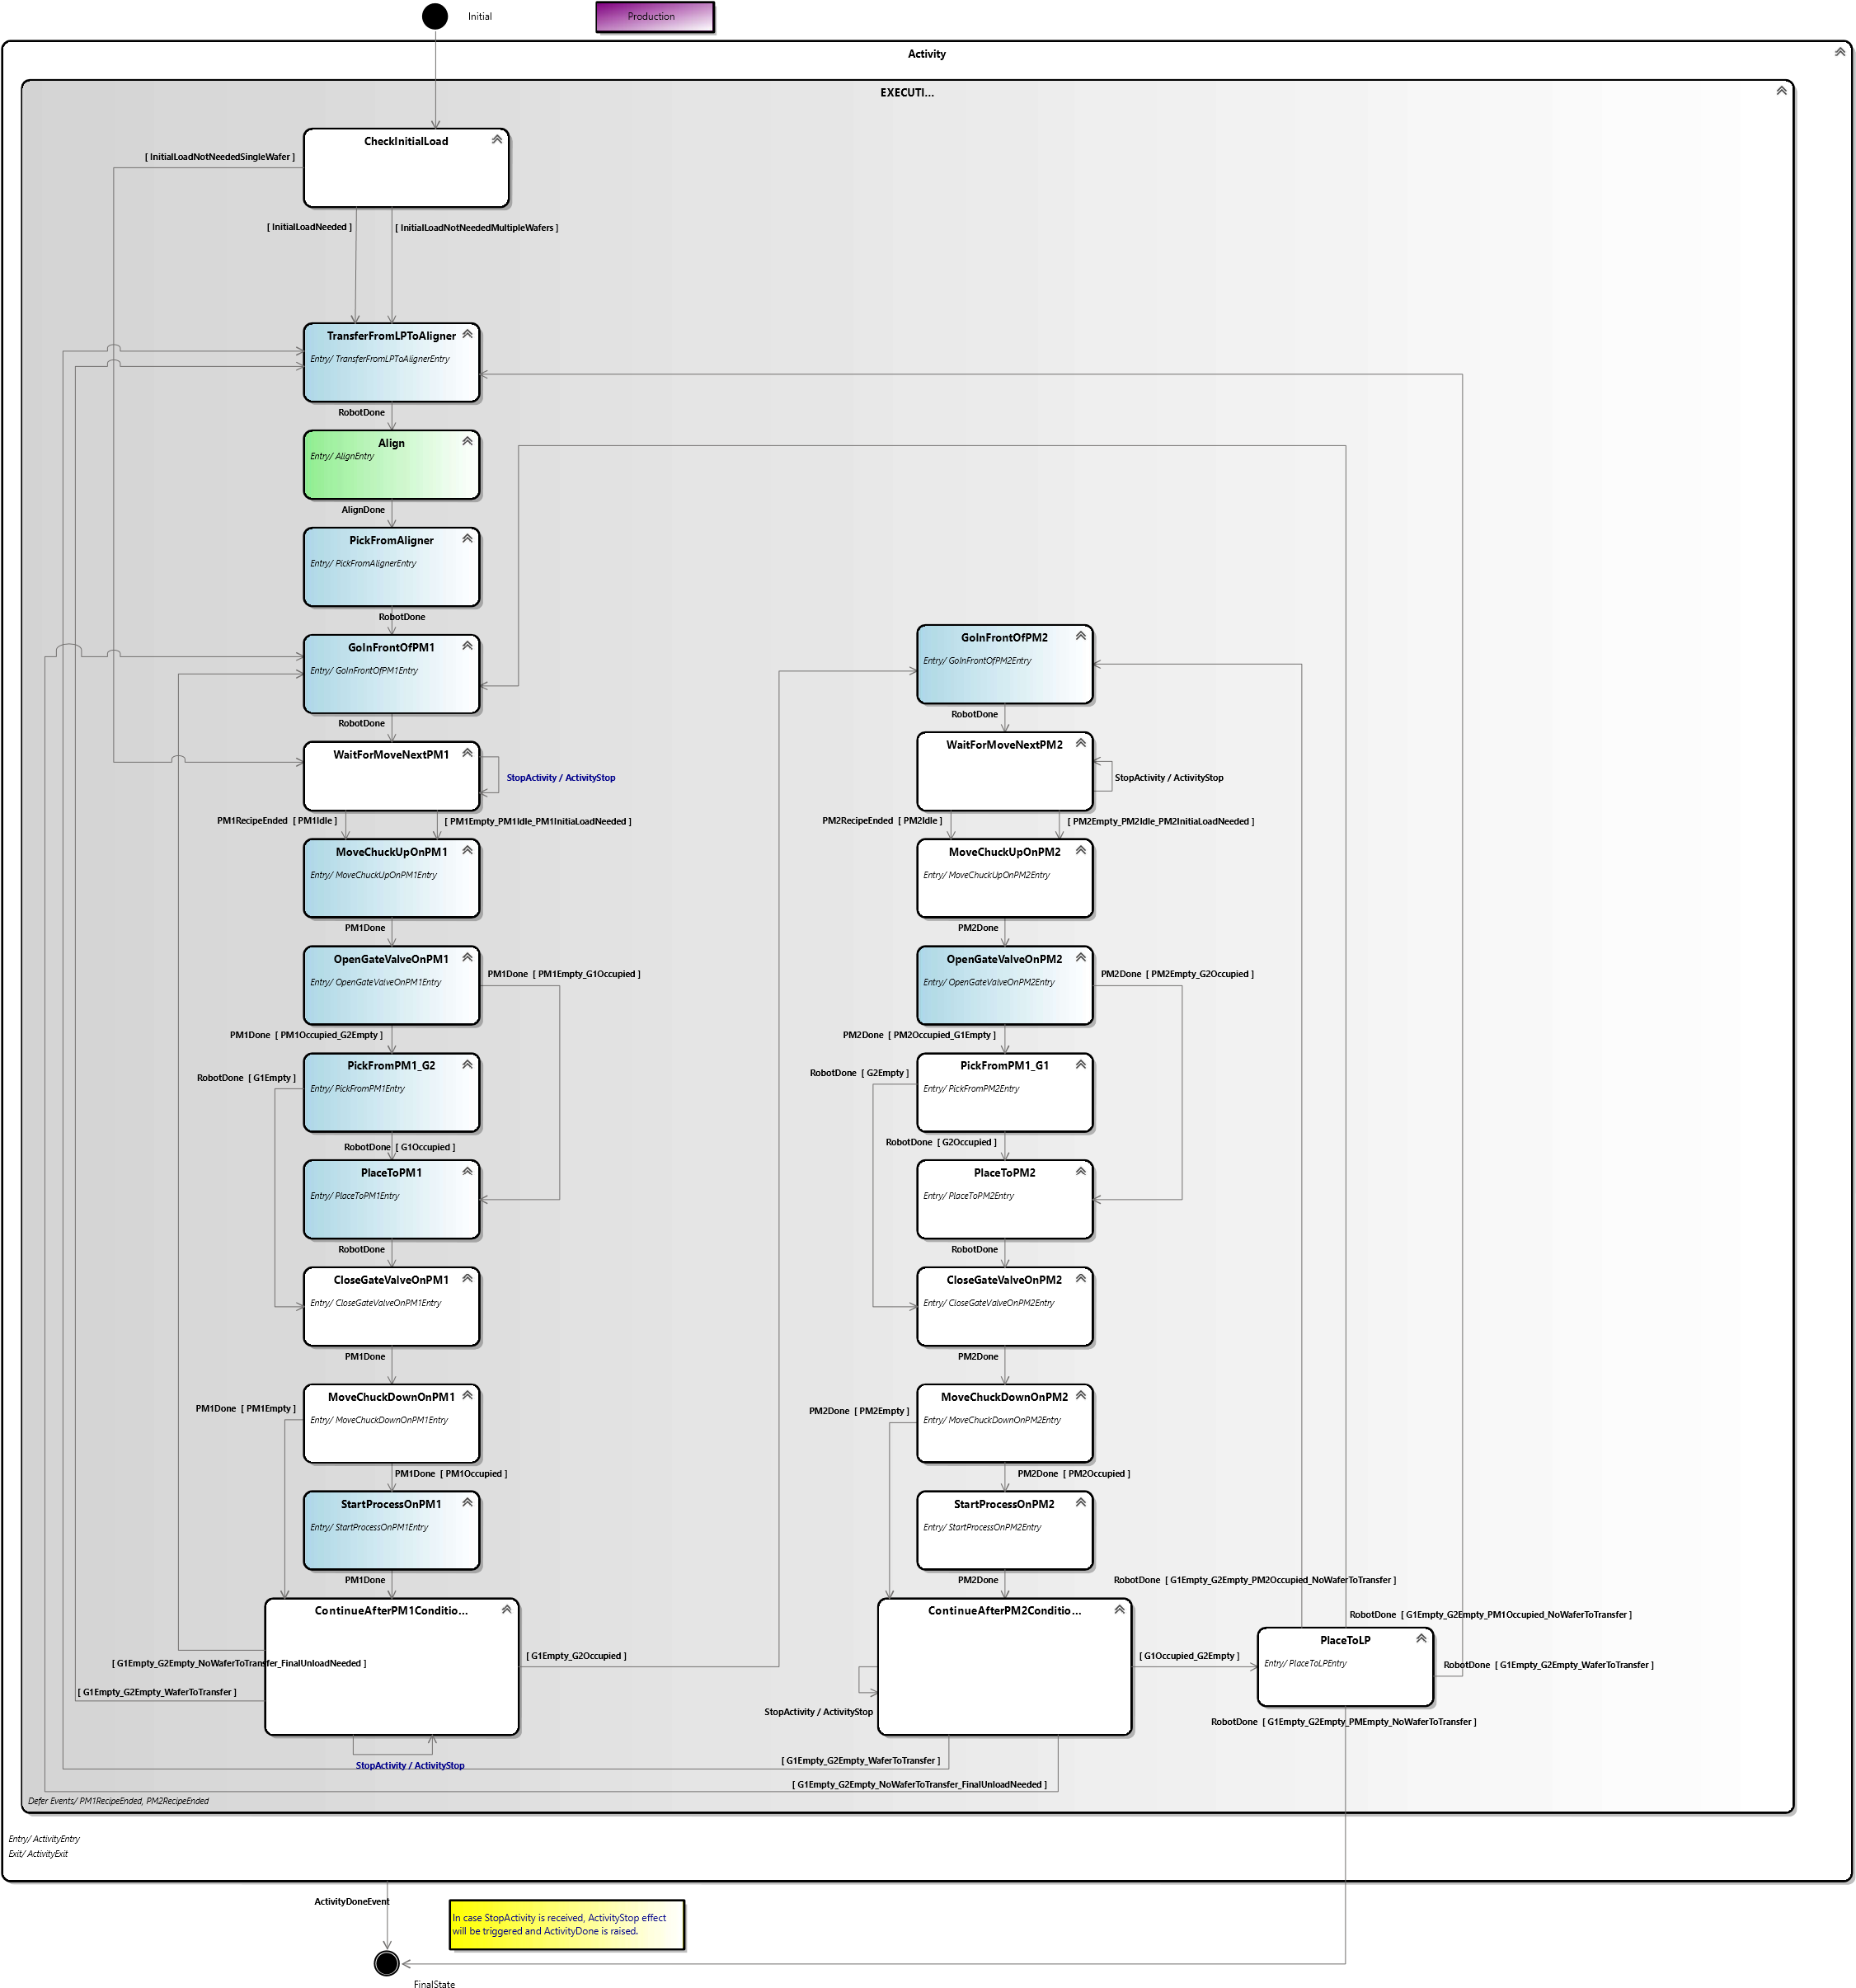

Job execution on two chained process modules state description
State | Description
Initial | Initial state of the state machine
Activity | Macro state for the activity
Executing | Executing macro state
CheckInitialLoad | Check if an initial load is needed
TransferFromLPToAligner | Transfer the next wafer from load port to aligner
Align | Align the wafer with desired angle
PickFromAligner | Pick the wafer on the aligner
GoInFrontOfPM1 | Robot moves in front of the first process module
WaitForMoveNextPM1 | Waiting that the first process module is ready to be loaded/unloaded
MoveChuckUpOnPM1 | Move the first process module’s chuck up
OpenGateValveOnPM1 | Open the first process module’s gate valve
PickFromPM1_G2 | Robot picks the wafer on the first process module with lower arm
PlaceToPM1 | Robot places the wafer on its upper arm on the first process module
CloseGateValveOnPM1 | Close the first process module’s gate valve
MoveChuckDownOnPM1 | Move the first process module’s chuck down
StartProcessOnPM1 | Start the selected recipe on the first process module
ContinueAfterPM1Conditional | Check what is the next move to do after first process module
GoInFrontOfPM2 | Robot moves in front of the second process module
WaitForMoveNextPM2 | Waiting that the second process module is ready to be loaded/unloaded
MoveChuckUpOnPM2 | Move the second process module’s chuck up
OpenGateValveOnPM2 | Open the second process module’s gate valve
PickFromPM2_G1 | Robot picks the wafer on the second process module with upper arm
PlaceToPM2 | Robot places the wafer on its lower arm on the second process module
CloseGateValveOnPM2 | Close the second process module’s gate valve
MoveChuckDownOnPM2 | Move the second process module’s chuck down
StartProcessOnPM2 | Start the selected recipe on the second process module
ContinuerAfterPM2Conditional | Check what is the next move to do after second process module
PlaceToLP | Place the wafer in the load port on its original slot
FinalState | Final state of the state machine

Job execution on two chained process modules transitions description
# | Current State | Event | Conditions | New State
1 | Initial |  |  | CheckInitialLoad
2 | CheckInitialLoad |  | A first load is needed | TransferFromLPToAligner
3 | CheckInitialLoad |  | A first load is not needed and there is still wafers to be transfered | TransferFromLPToAligner
4 | TransferFromPLToAligner | Robot command is done |  | Align
5 | Align | Aligner command is done |  | PickFromAligner
6 | PickFromAligner | Robot command is done |  | GoInFrontOfPM1
7 | GoInFrontOfPM1 | Robot command is done |  | WaitForMoveNextPM1
8 | WaitForMoveNextPM1 | First process module’s recipe exécution ended |  | MoveChuckUpOnPM1
9 | WaitForMoveNextPM1 |  | First process module is empty and first process module is idle and a first load is needed | MoveChuckUpOnPM1
10 | WaitForMoveNextOnPM1 | Activity has been stopped |  | WaitForMoveNextOnPM1
11 | MoveChuckUpOnPM1 | First process module command is done |  | OpenGateValveOnPM1
12 | OpenGateValveOnPM1 | First process module command is done | First process module is occupied and robot’s lower arm is empty | PickFromPM1_G2
13 | OpenGateValveOnPM1 | First process module command is done | First process module is empty and robot’s upper arm is occupied | PlaceToPM1
14 | PickFromPM1_G2 | Robot command is done | Robot’s upper arm is occupied | PlaceToPM1
15 | PickFromPM1_G2 | Robot command is done | Robot’s upper arm is empty | CloseGateValveOnPM1
16 | PlaceToPM1 | Robot command is done |  | CloseGateValveOnPM1
17 | CloseGateValveOnPM1 | First process module command is done |  | MoveChuckDownOnPM1
18 | MoveChuckDownOnPM1 | First process module command is done | First process module is occupied | StartProcessOnPM1
19 | MoveChuckDownOnPM1 | First process module command is done | First process module is empty | ContinueAfterPM1Conditional
20 | StartProcessOnPM1 | First process module command is done |  | ContinueAfterPM1Conditional
21 | ContinueAfterPM1Conditional |  | Robot’s upper arm empty and robot’s lower arm occupied | GoInFrontOfPM2
22 | ContinueAfterPM1Conditional |  | Robot’s arms are empty and there are still wafers to transfer | TransferFromLPToAligner
23 | ContinueAfterPM1Conditional |  | Robot’s arm are empty and there is no wafer left to transfer and final unload is needed | GoInFrontOfPM1
24 | ContinueAfterPM1Conditional | Activity has been stopped |  | ContinueAfterPM1Conditional
25 | GoInFrontOfPM2 | Robot command is done |  | WaitForMoveNextPM2
26 | WaitForMoveNextPM2 | Second process module’s recipe exécution ended |  | MoveChuckUpOnPM2
27 | WaitForMoveNextOnPM2 |  | Second process module is empty and second process module is idle and a first load is needed | MoveChuckUpOnPM2
28 | WaitForMoveNextOnPM2 | Activity has been stopped |  | WaitForMoveNextOnPM2
29 | MoveChuckUpOnPM2 | Second process module command is done |  | OpenGateValveOnPM2
30 | OpenGateValveOnPM2 | Second process module command is done | Second process module is occupied and robot’s upper arm is empty | PickFromPM2_G1
31 | OpenGateValveOnPM2 | Second process module command is done | Second process module is empty and robot’s lower arm is occupied | PlaceToPM2
32 | PickFromPM2_G1 | Robot command is done | Robot’s lower arm is occupied | PlaceToPM2
33 | PickFromPM2_G1 | Robot command is done | Robot’s lower arm is empty | CloseGateValveOnPM2
34 | PlaceToPM2 | Robot command is done |  | CloseGateValveOnPM2
35 | CloseGateValveOnPM2 | Second process module command is done |  | MoveChuckDownOnPM2
36 | MoveChuckDownOnPM2 | Second process module command is done | Second process module is occupied | StartProcessOnPM2
37 | MoveChuckDownOnPM2 | Second process module command is done | Second process module is empty | ContinueAfterPM2Conditional
38 | StartProcessOnPM2 | Second process module command is done |  | ContinueAfterPM2Conditional
39 | ContinueAfterPM2Conditional |  | Robot’s upper arm occupied and robot’s lower arm empty | PlaceToLP
40 | ContinueAfterPM2Conditional |  | Robot’s arms are empty and there are still wafers to transfer | TransferFromLPToAligner
41 | ContinueAfterPM2Conditional |  | Robot’s arm are empty and there is no wafer left to transfer and final unload is needed | GoInFrontOfPM1
42 | ContinueAfterPM2Conditional | Activity has been stopped |  | ContinueAfterPM2Conditional
43 | PlaceToLP | Robot command is done | Robot’s arms are empty and there are still wafers to transfer | TransferFromLPToAligner
44 | PlaceToLP | Robot command is done | Robot’s arms are empty and first process module is occupied and there is no wafer left to transfer | GoInFrontOfPM1
45 | PlaceToLP | Robot command is done | Robot’s arms are empty and second process module is occupied and there is no wafer left to transfer | GoInFrontOfPM2
46 | PlaceToLP | Robot command is done | Robot’s arms are empty and there is no wafer left to transfer | FinalState
47 | Activity | Activity is done |  | FinalState

Generic job execution

General state machine
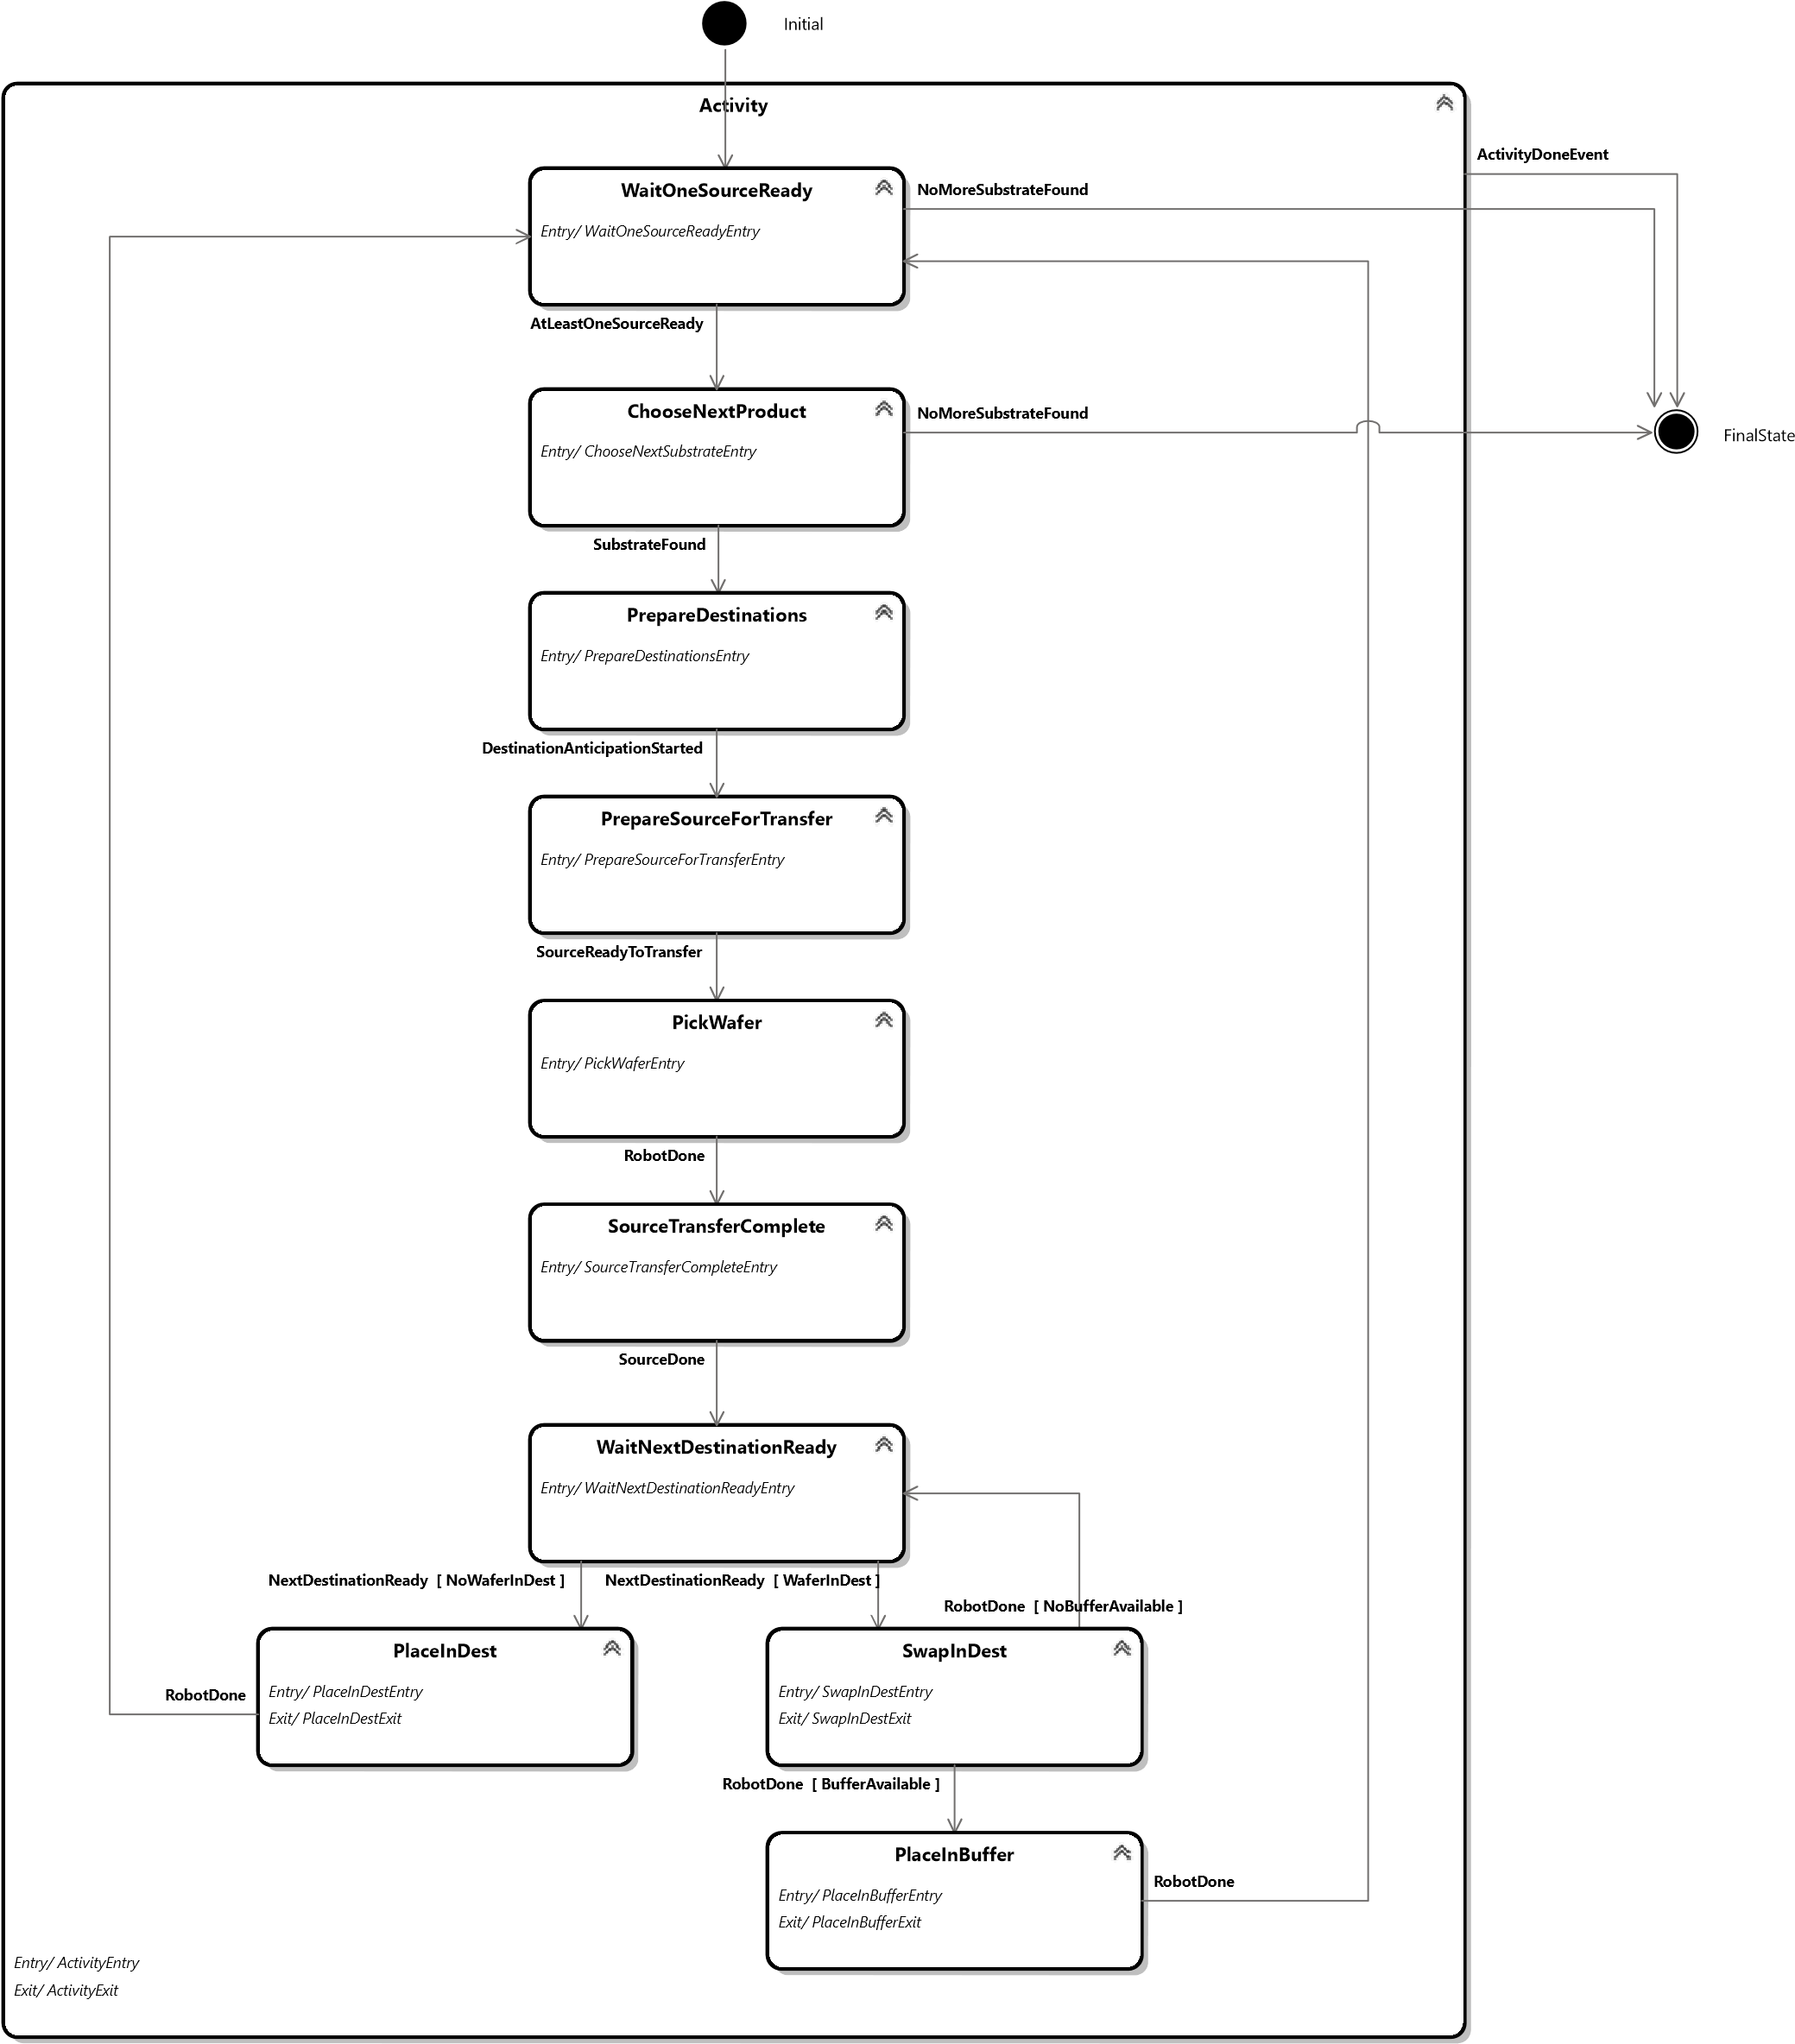

General state machine state description
State | Description
Initial | Initial state of the state machine
Activity | Macro state for the activity
WaitOneSourceReady | Wait that at least one source is ready to accept transfer
ChooseNextProduct | Choose the next product to transfer with the desired algorithm
PrepareDestinations | Generates prepare destination state machines for each potential destinations
PrepareSourceForTransfer | Prepare the source for the transfer
PickWafer | Pick the wafer in the source
SourceTransferComplete | Signal to the source that the transfer is complete
WaitNextDestinationReady | Wait that the next potential destination is ready for transfer
PlaceInDest | Place the wafer in the destination
SwapInDest | Swap wafers in the destination
PlaceInBuffer | Place the wafer in the buffer
FinalState | Final state of the state machine

General state machine transition description
# | Current State | Event | Conditions | New State
1 | Initial |  |  | WaitOneSourceReady
2 | WaitOneSourceReady | At least one source is ready to accept transfer |  | ChooseNextProduct
3 | WaitOneSourceReady | No more substrate to be transferred |  | FinalState
4 | ChooseNextProduct | Substrate has been found in the algorithm |  | PrepareDestinations
5 | ChooseNextProduct | No more substrate to be transferred |  | FinalState
6 | PrepareDestinations | Prepare destination state machines have been started |  | PrepareSourceForTransfer
7 | PrepareSourceForTransfer | Source is ready to transfer |  | PickWafer
8 | PickWafer | Robot command is done |  | SourceTransferComplete
9 | SourceTransferComplete | Source command is done |  | WaitNextDestinationReady
10 | WaitNextDestinationReady | Next destination is ready for transfer | There is no wafer in the destination | PlaceInDest
11 | WaitNextDestinationReady | Next destination is ready for transfer | There is a wafer in the destination | SwapInDest
12 | PlaceInDest | Robot command is done |  | WaitOneSourceReady
13 | SwapInDest | Robot command is done | No buffer available | WaitNextDestinationReady
14 | SwapInDest | Robot command is done | Buffer is available | PlaceInBuffer
15 | PlaceInBuffer | Robot command is done |  | WaitOneSourceReady
16 | Activity | Activity is done |  | FinalState

Prepare destination state machine
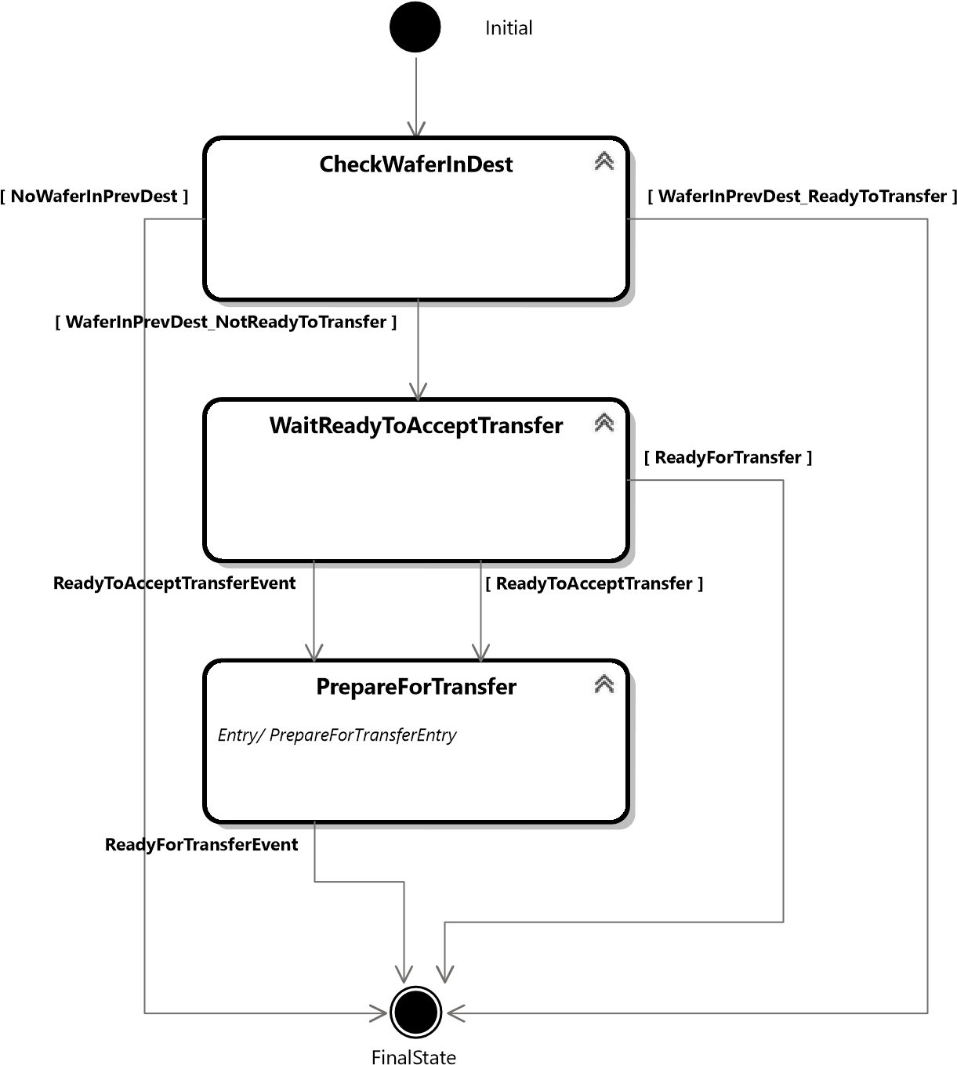

Prepare destination state machine state description
State | Description
Initial | Initial state of the state machine
CheckWaferInDest | Check if there is a wafer in the previous destination
WaitReadyToAcceptTransfer | Wait that the destination is ready to accept transfer
PrepareForTransfer | Prepare the destination for transfer
FinalState | Final state of the state machine

Prepare destination state machine transition description
# | Current State | Event | Conditions | New State
1 | Initial |  |  | CheckWaferInDest
2 | CheckWaferInDest |  | There is a wafer in the previous destination and the destination is not ready to transfer | WaitReadyToAcceptTransfer
3 | CheckWaferInDest |  | There is no wafer in the previous destination | FinalState
4 | CheckWaferInDest |  | There is a wafer in the previous destination and the destination is already ready to transfer | FinalState
5 | WaitReadyToAcceptTransfer | Destination is ready to accept transfer |  | PrepareForTransfer
6 | WaitReadyToAcceptTransfer |  | Destination is ready to accept transfer | PrepareForTransfer
7 | WaitReadyToAcceptTransfer |  | Destination is ready for transfer | FinalState
8 | PrepareForTransfer | Destination is ready for transfer |  | FinalState

