display – look at the 6px solid black border
.container{
display: flex;
border: 6px solid black;
}

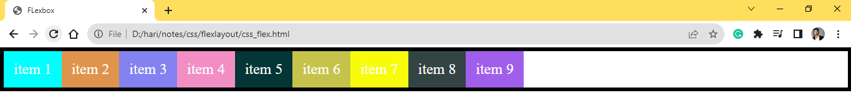
.container{
display: inline-flex;
border: 6px solid black;
}
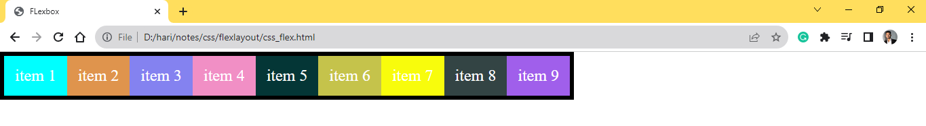

flex-direction
.container{
display: flex;
border: 6px solid black;
flex-direction: row;
}

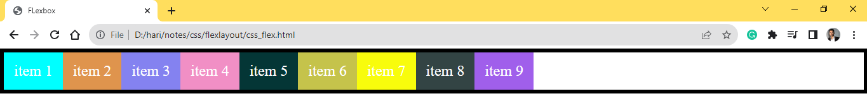
.container{
display: flex;
border: 6px solid black;
flex-direction: row-reverse;
}
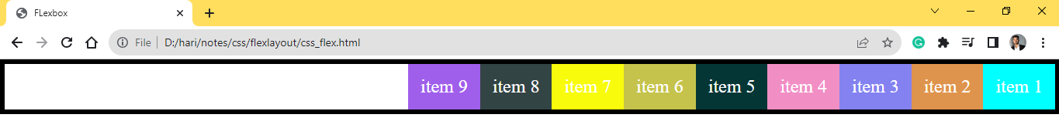
.container{
display: flex;
border: 6px solid black;
flex-direction: column;
}
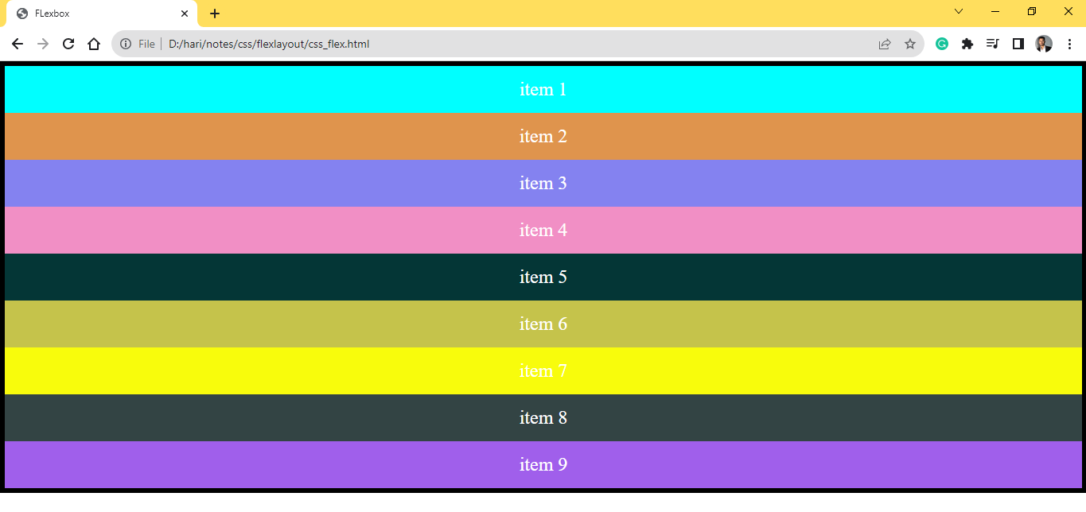
.container{
display: flex;
border: 6px solid black;
flex-direction: column-reverse;
}
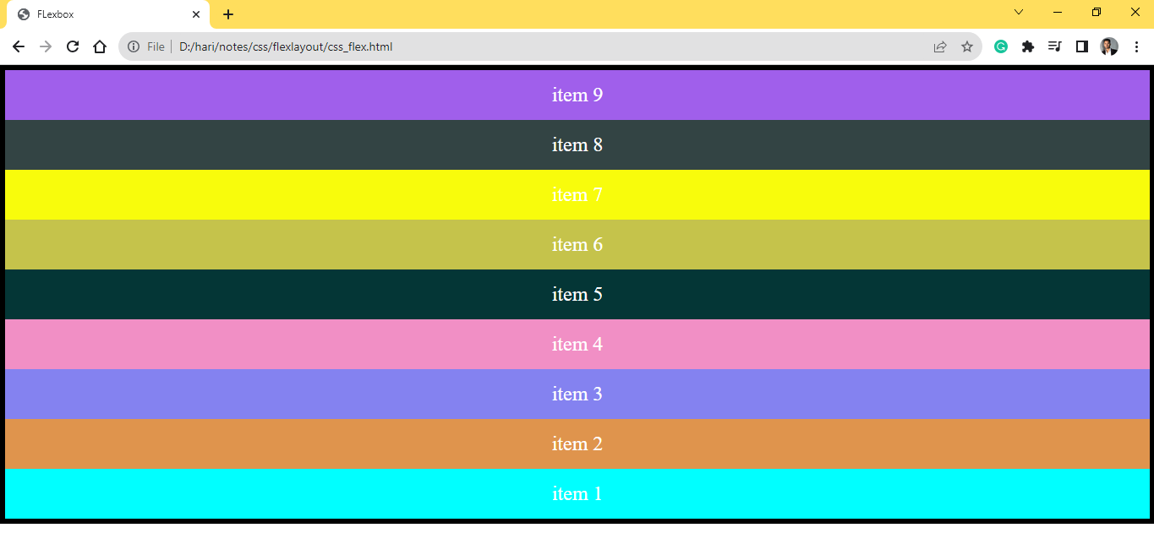

when display property is set to row -
flex-wrap
.container{
flex-wrap: nowrap;
}
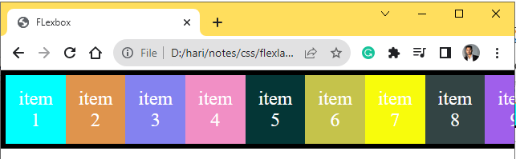
.container{
flex-wrap: wrap;
}
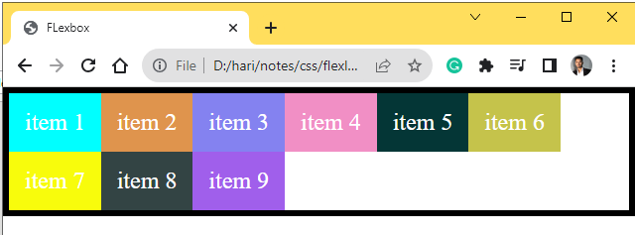
.container{
flex-wrap: wrap-reverse;
}
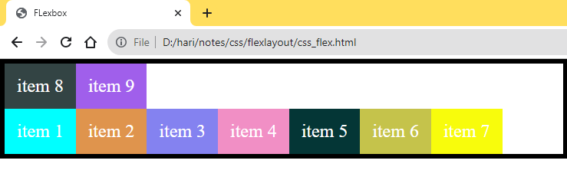

when display property is set to column -

flex-wrap
.container{
display: flex;
flex-direction: column;
flex-wrap: nowrap;
border: 30px solid black;
height: 400px;
}
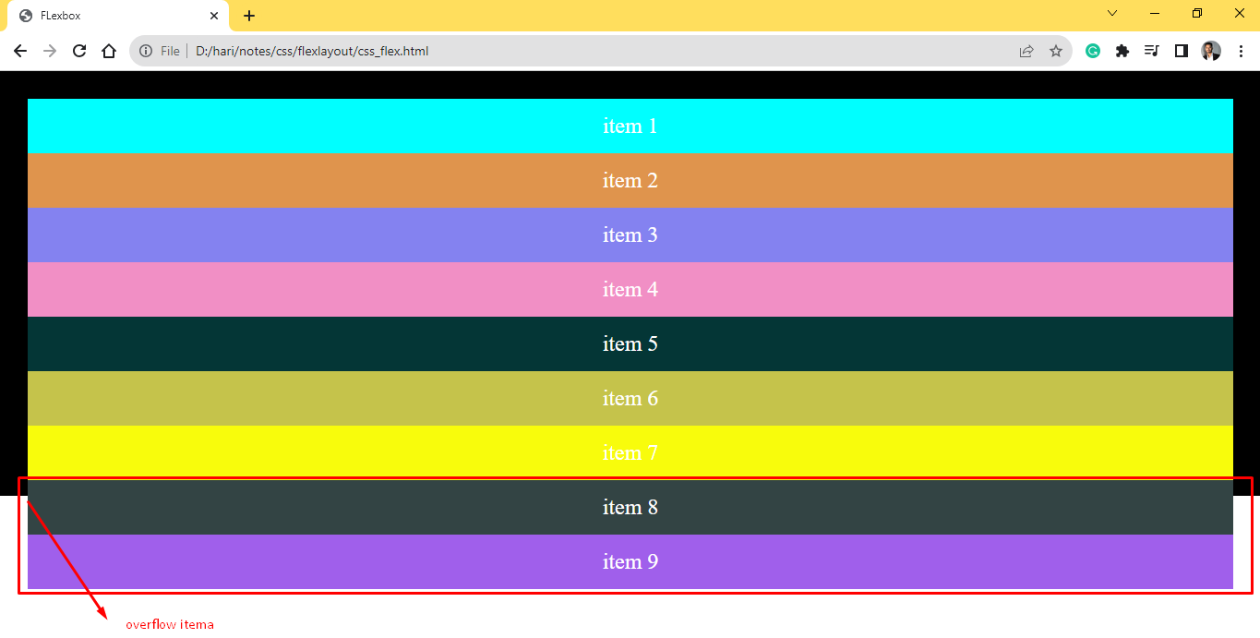
.container{
display: flex;
flex-direction: column;
border: 30px solid black;
flex-wrap: wrap;
height: 400px;
}
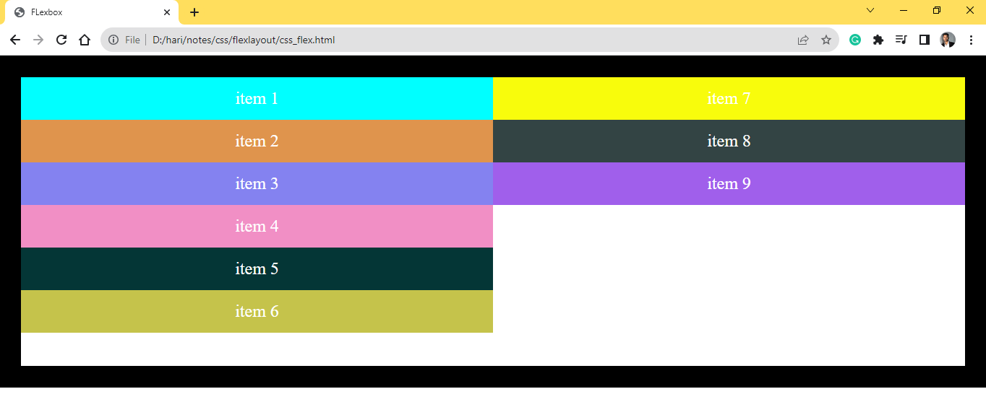
.container{
display: flex;
flex-direction: column;
border: 30px solid black;
flex-wrap: wrap-reverse;
height: 400px;
}
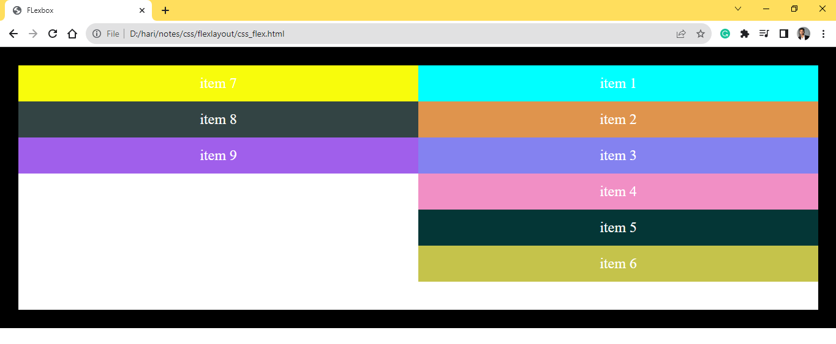

justify-content
.container{
display: flex;
border: 10px solid black;
justify-content: flex-start;
}
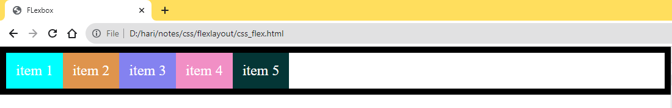
.container{
display: flex;
border: 10px solid black;
justify-content: flex-end;
}
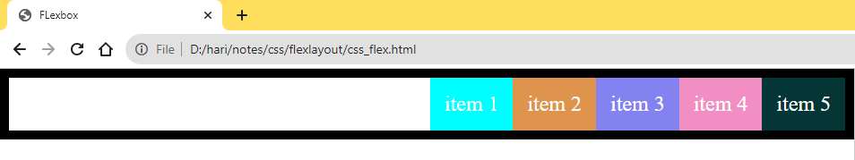
.container{
display: flex;
border: 10px solid black;
justify-content: center;
}
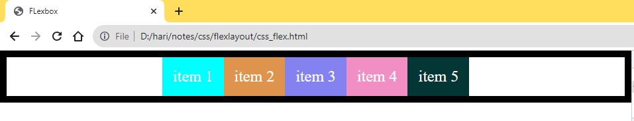
.container{
display: flex;
border: 10px solid black;
justify-content: space-between;
}
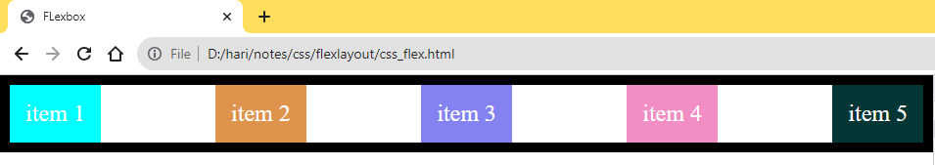
.container{
display: flex;
border: 10px solid black;
justify-content: space-around;
}
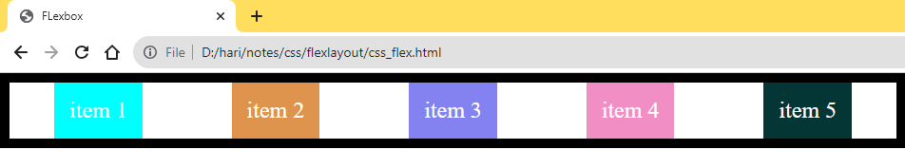
.container{
display: flex;
border: 10px solid black;
justify-content: space-evenly;
}
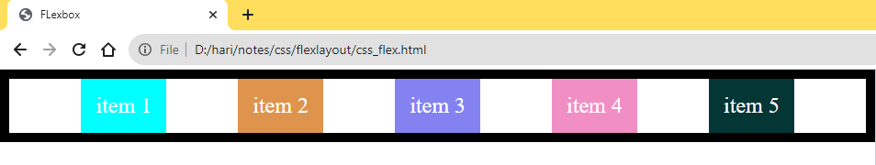

align-items
.container{
display: flex;
border: 10px solid black;
height: 600px;
align-items:stretch;
}
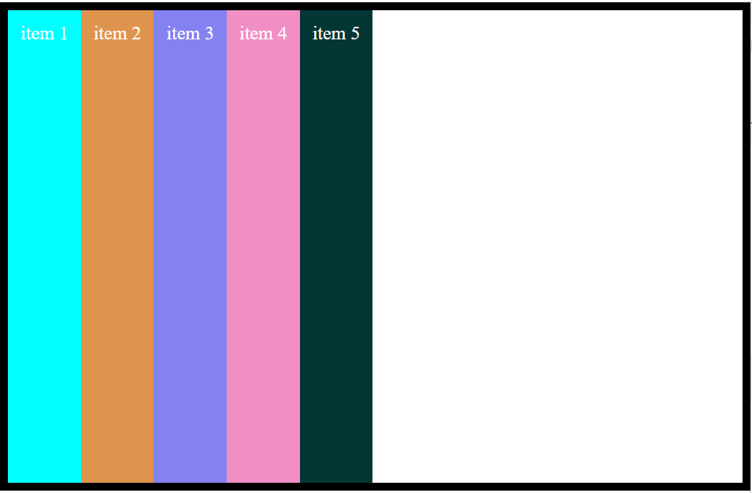
.container{
display: flex;
border: 10px solid black;
height: 600px;
align-items:flex-start;
}
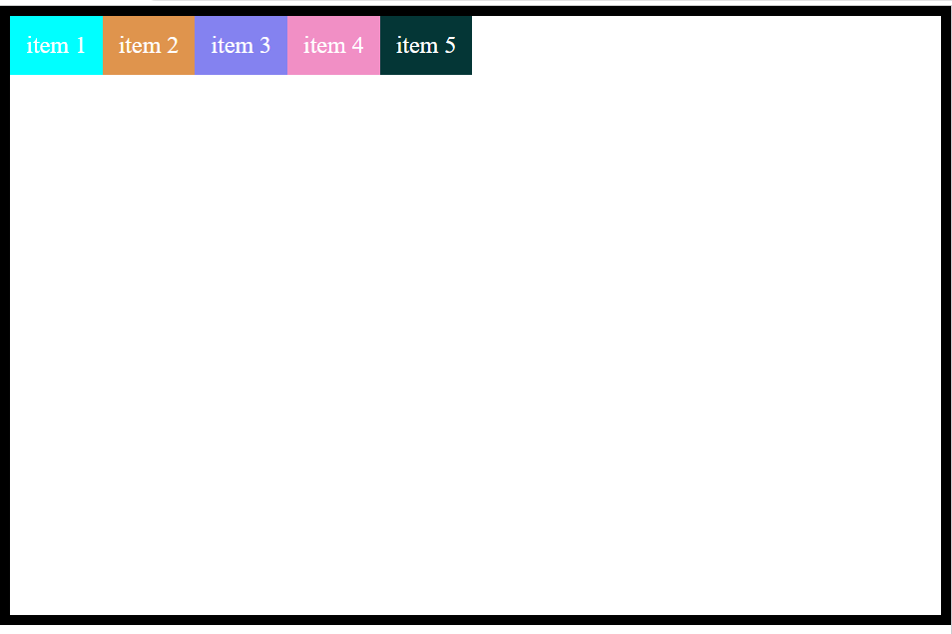
.container{
display: flex;
border: 10px solid black;
height: 600px;
align-items:flex-end;
}
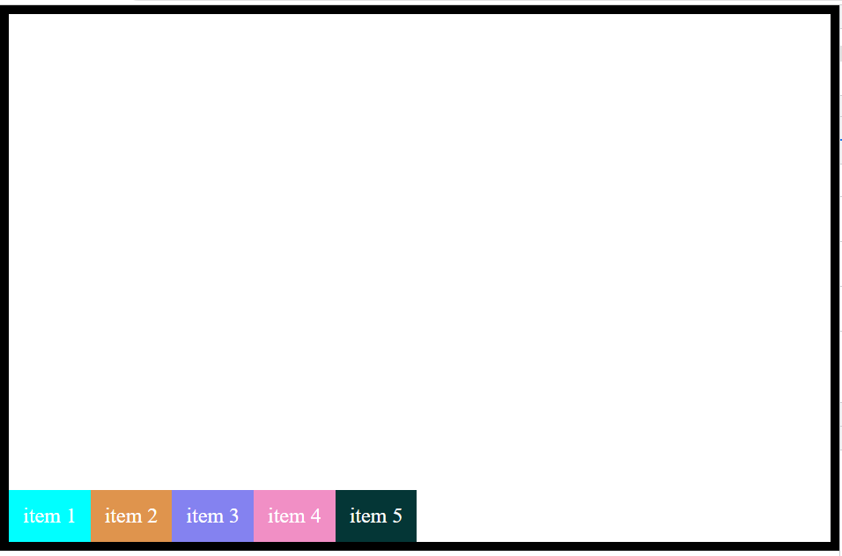
.container{
display: flex;
border: 10px solid black;
height: 600px;
align-items:center;
}

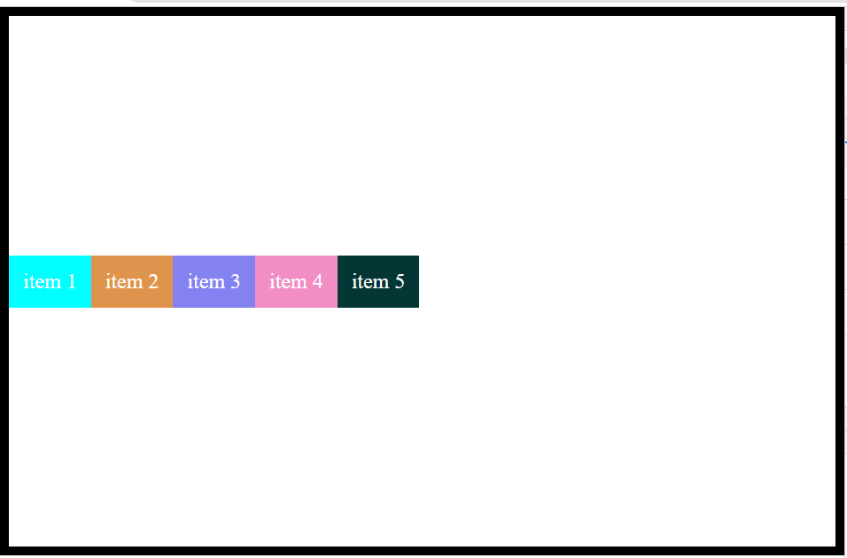
.container{
display: flex;
border: 10px solid black;
height: 600px;
align-items:baseline;
}
