**Account microservice:**

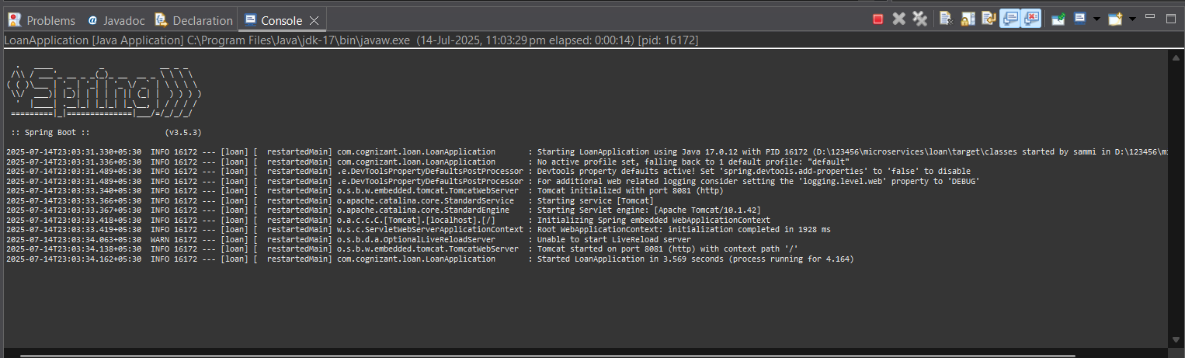

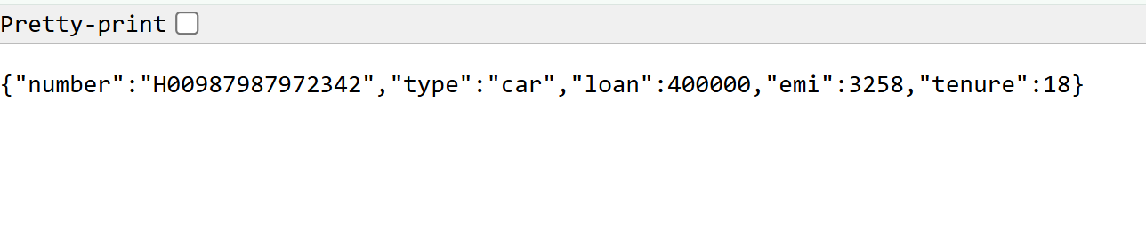

**Loan microservice:**

