TIME-AR-001: Temporal Admissible Region Study
Supplementary Data Tables — Generated from Processed Data

Table 1: F15 Classification Summary
Classification | Count | Fraction
T2ok | 26 | 0.283
T3req | 10 | 0.109
T3req_bio | 3 | 0.033
Tmarg | 21 | 0.228
Tmarg_cultural | 9 | 0.098
Tna | 23 | 0.250

Table 2: Organism-Level F15 Scorecard
Organism | Domain | D_org | D_fam | Family | T_mid | gc_org | gc_fam | F15a | F15b
H. sapiens | Mammalia | 5.5 | 8.0 | Kinases | 9290000.0 | 18.5 | 7.4 | Tmarg | T3req
D. rerio | Actinopterygii | 5.5 | 3.5 | Hox (WGD-adj D=3.5) | 1020000000.0 | 43.4 | 370.0 | Tmarg | Tmarg
O. sativa | Plantae | 5.5 | 5.5 | NBS-LRR | 160000000.0 | 31.0 | 23.3 | Tmarg | T3req
A. thaliana | Plantae | 5.0 | 5.0 | RLKs | 3580000000.0 | 81.4 | 81.4 | Tmarg | Tmarg
C. elegans | Nematoda | 4.5 | 5.0 | NHR | 62600000000.0 | 250.7 | 144.3 | Tmarg | Tmarg
D. melanogaster | Insecta | 4.0 | 4.0 | ORs | 6520000000.0 | 284.2 | 284.2 | Tmarg | Tmarg
E. coli | Bacteria | 3.0 | 3.0 | ABC transporters | 20400000000000.0 | 27323.9 | 27323.9 | T2ok | T2ok
S. cerevisiae | Fungi | 3.5 | 4.0 | Kinases | 3290000000000.0 | 3770.0 | 1346.8 | Tmarg | Tmarg
P. aeruginosa | Bacteria | 3.5 | 4.0 | Two-component | 10200000000000.0 | 5208.9 | 1787.1 | Tmarg | Tmarg
S. pombe | Fungi | 3.0 | 3.0 | Kinases | 2190000000000.0 | 12986.2 | 12986.2 | T2ok | T2ok
F. albicollis | Aves | 3.5 | 4.0 | Kinases | 75000000.0 | 177.8 | 93.1 | Tmarg | Tmarg
D. discoideum | Amoebozoa | 3.5 | 4.0 | PKS | 2190000000000.0 | 3356.1 | 1216.5 | Tmarg | Tmarg
S. solfataricus | Crenarchaeota | 2.5 | 3.0 | GH | 6570000000000.0 | 133975.7 | 18729.3 | T2ok | T2ok
M. jannaschii | Euryarchaeota | 2.0 | 2.0 | MCR | 17500000000000.0 | 4183300.1 | 4183300.1 | T2ok | T2ok
H. salinarum | Euryarchaeota | 2.5 | 3.0 | Htr | 1750000000000.0 | 78925.1 | 12050.7 | T2ok | T2ok
B. floridae | Cephalochordata | 5.0 | 9.0 | TLR | 400000000.0 | 52.5 | 9.0 | Tmarg | T3req

Table 3: Gamma_crit Ranked Table
system | D | T_midpoint | gamma_crit | F15_verdict
Programming language families | 6.5 | 10000.0 | 4.1 | Tmarg_cultural
Compiler IR hierarchies | 8.5 | 1000000.0 | 5.1 | Tmarg_cultural
Legal precedent chains | 12.5 | 1400000000.0 | 5.4 | Tmarg_cultural
Linux kernel (module nesting) | 8.0 | 2500000.0 | 6.3 | Tmarg_cultural
Protein kinases | 8.0 | 9300000.0 | 7.4 | T3req
Amphioxus TLR | 9.0 | 400000000.0 | 9.0 | T3req
Chess opening trees (branching) | 10.0 | 10000000000.0 | 10.0 | Tmarg_cultural
GPCR superfamily | 7.5 | 9300000.0 | 11.0 | T3req
Zinc finger TFs (KRAB-ZF) | 7.5 | 9300000.0 | 11.0 | T3req
Homeodomain TFs | 6.5 | 9300000.0 | 11.8 | Tmarg
Cytochrome P450 | 6.5 | 9300000.0 | 11.8 | Tmarg
Immunoglobulin SF | 6.5 | 9300000.0 | 11.8 | Tmarg
NR superfamily | 6.0 | 9300000.0 | 14.5 | Tmarg
Olfactory receptors | 6.5 | 9300000.0 | 18.0 | T3req
H. sapiens | 5.5 | 9290000.0 | 18.5 | T3req
Hox clusters | 5.5 | 9300000.0 | 18.5 | Tmarg
bHLH TFs | 5.5 | 9300000.0 | 18.5 | Tmarg
Patent citation genealogy | 5.5 | 10000000.0 | 18.7 | Tmarg_cultural
Mathematical notation | 7.0 | 1000000000.0 | 19.3 | Tmarg_cultural
Rice NBS-LRR | 5.5 | 160000000.0 | 23.0 | T3req
FGF family | 5.0 | 9300000.0 | 24.8 | Tmarg
Wnt family | 5.0 | 9300000.0 | 24.8 | Tmarg
Eph/ephrin family | 5.0 | 9300000.0 | 24.8 | Tmarg
Musical composition forms | 5.5 | 100000000.0 | 28.5 | Tmarg_cultural
O. sativa | 5.5 | 160000000.0 | 31.0 | T3req
Brain cortical hierarchy (GENE-FAMILY BASIS) | 6.0 | 1000000000.0 | 31.6 | T3req_bio
D. rerio | 5.5 | 1020000000.0 | 43.4 | Tmarg
B. floridae | 5.0 | 400000000.0 | 52.5 | T3req
WWW site nesting | 4.0 | 10000000.0 | 56.2 | Tna
A. thaliana | 5.0 | 3580000000.0 | 81.4 | Tmarg
F. albicollis | 3.5 | 75000000.0 | 177.8 | Tmarg
Neural cell type diversity | 4.0 | 1000000000.0 | 177.8 | T3req_bio
C. elegans | 4.5 | 62600000000.0 | 250.7 | Tmarg
PPI module hierarchy | 5.0 | 1000000000000.0 | 251.2 | T3req_bio
D. melanogaster | 4.0 | 6520000000.0 | 284.2 | Tmarg
ABC transporters | 5.0 | 20400000000000.0 | 459.1 | T2ok
Natural language morpheme families | 4.5 | 7000000000000.0 | 715.3 | Tmarg_cultural
D. discoideum | 3.5 | 2190000000000.0 | 3356.1 | Tmarg
S. cerevisiae | 3.5 | 3290000000000.0 | 3770.0 | Tmarg
P. aeruginosa | 3.5 | 10200000000000.0 | 5208.9 | Tmarg
Regular expressions | 2.5 | 10000000000.0 | 10000.0 | T2ok
S. pombe | 3.0 | 2190000000000.0 | 12986.2 | T2ok
E. coli | 3.0 | 20400000000000.0 | 27323.9 | T2ok
H. salinarum | 2.5 | 1750000000000.0 | 78925.1 | T2ok
S. solfataricus | 2.5 | 6570000000000.0 | 133975.7 | T2ok
M. jannaschii | 2.0 | 17500000000000.0 | 4183300.1 | T2ok
Proverb families | 1.5 | 1000000000000.0 | 100000000.0 | T2ok

Table 4: Fisher Exact Test Result
test | n_t3req | n_t2ok | d_threshold | t3req_above | t3req_below | t2ok_above | t2ok_below | odds_ratio | p_value | conclusion
Fisher exact (two-sided) | 6 | 24 | 5.0 | 6 | 0 | 0 | 24 | inf | 1.68e-06 | p = 1.68e-06; NOT < 1e-6

Figures
Figure 1: Temporal Exclusion Zone (D vs log T)
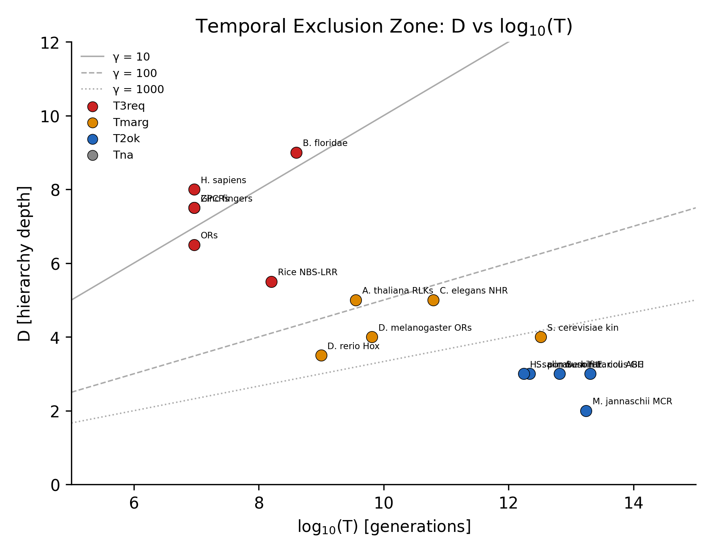

Figure 2: Gamma_crit for T3req Families
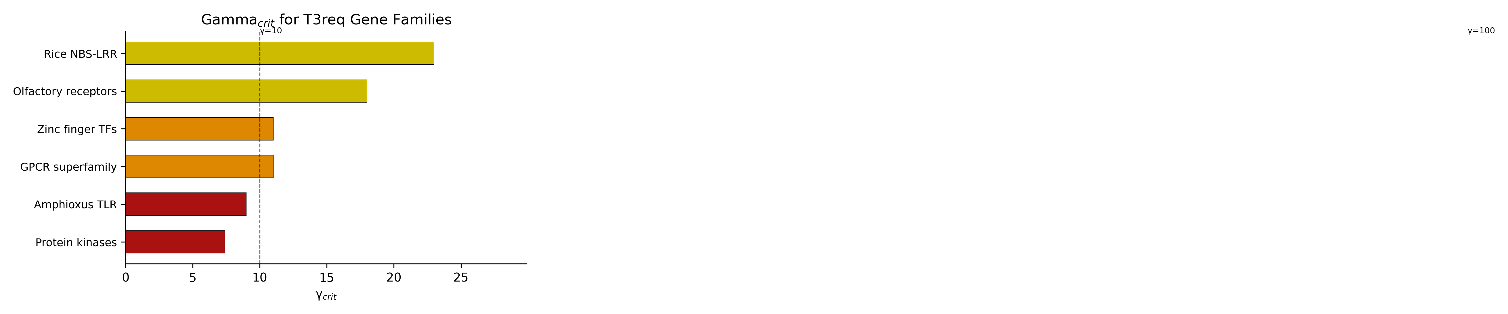

Figure 3: Deepest Gene Family Hierarchies
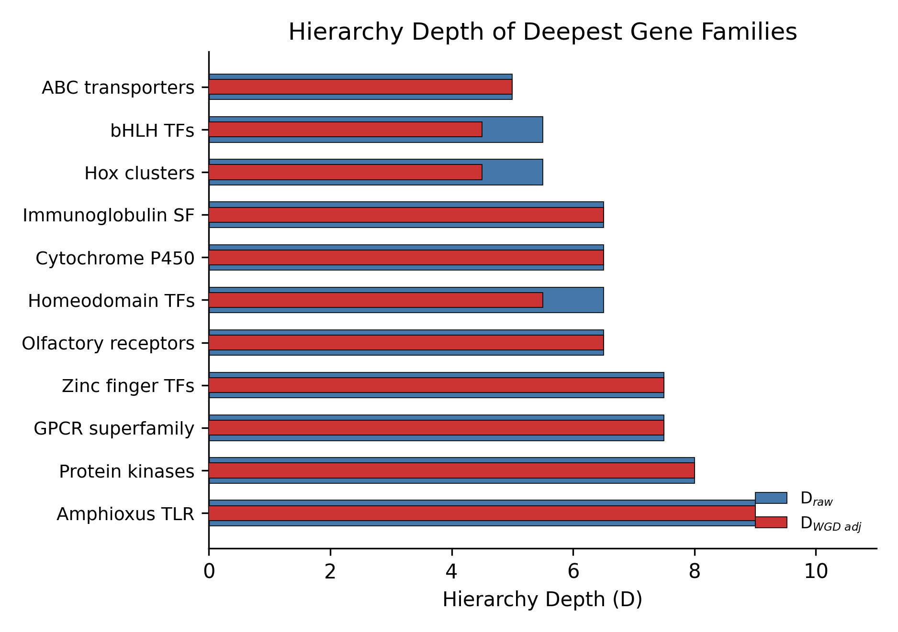

Figure 4: Physical Fractals vs Biological Hierarchies
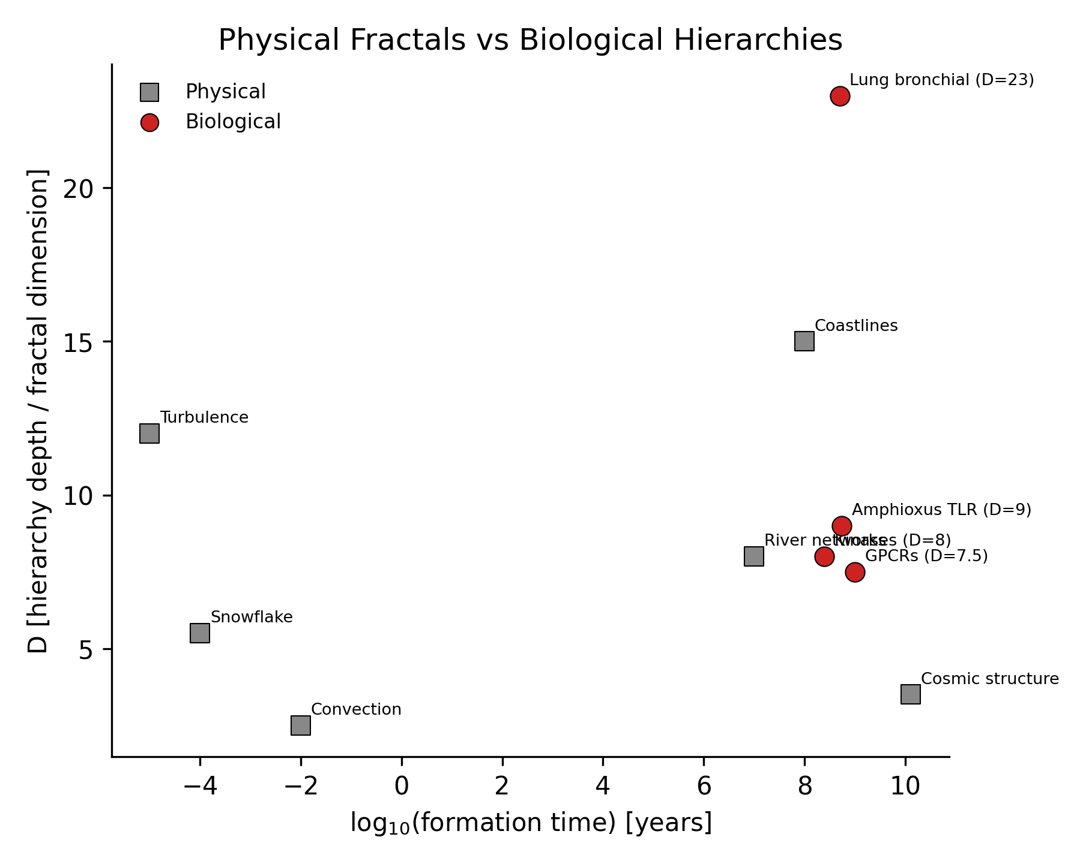

Figure 5: Two-Regime Empirical Gamma Structure
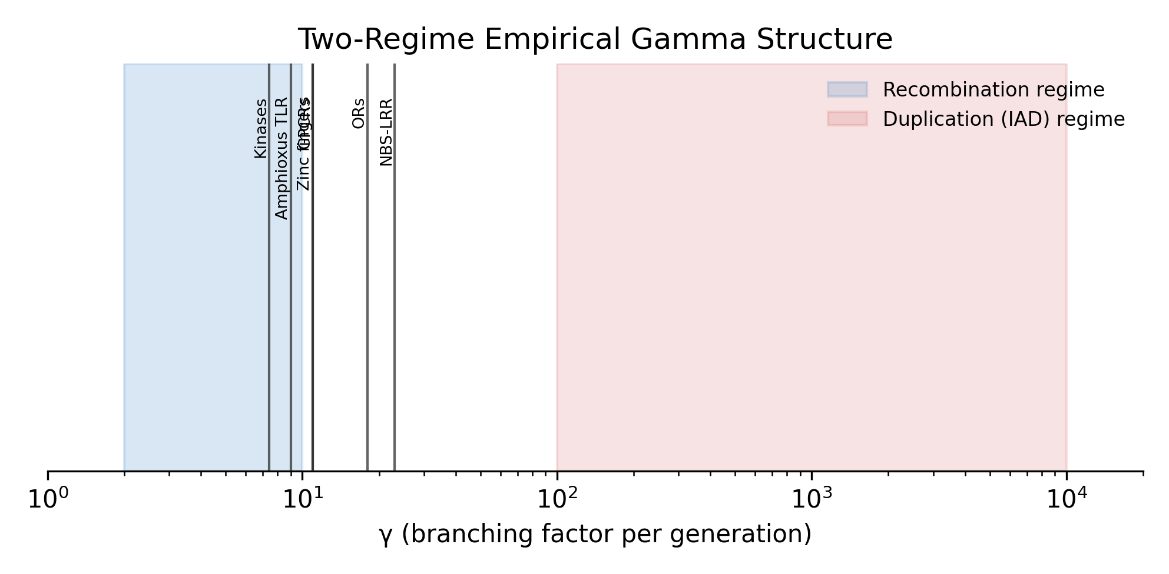

Figure 6: Gene Family Depth Distribution
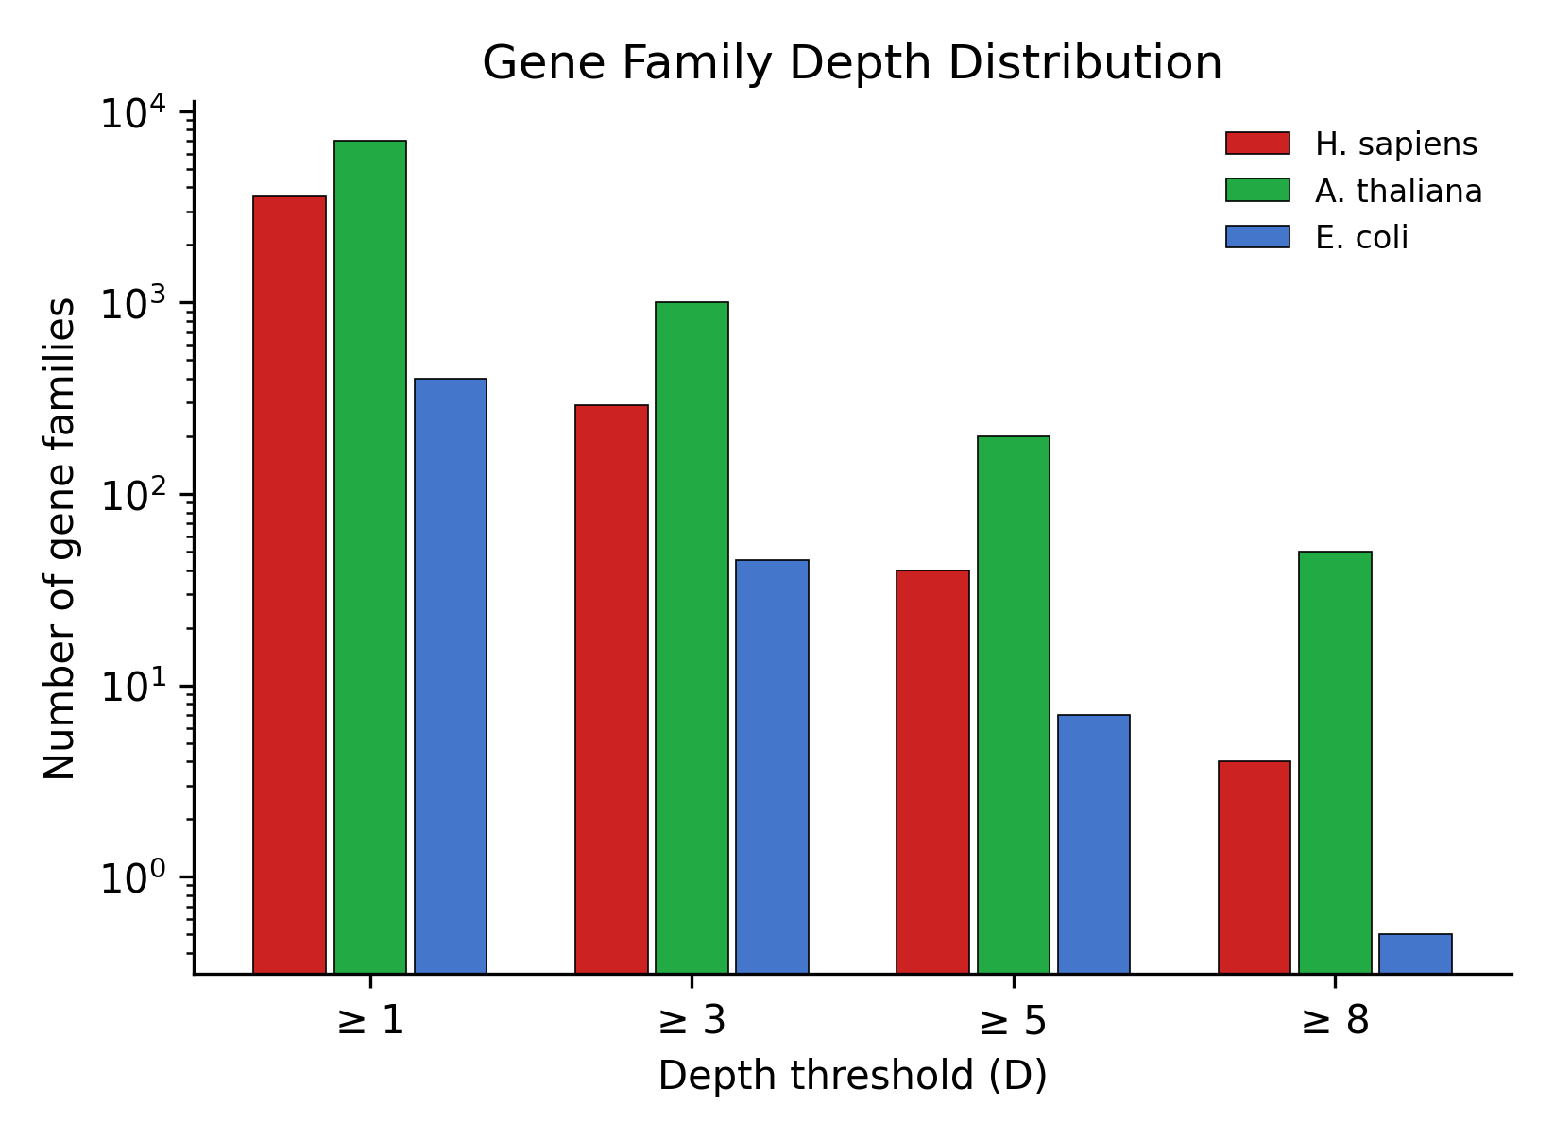

Figure 7: Gamma_crit Sensitivity Analysis
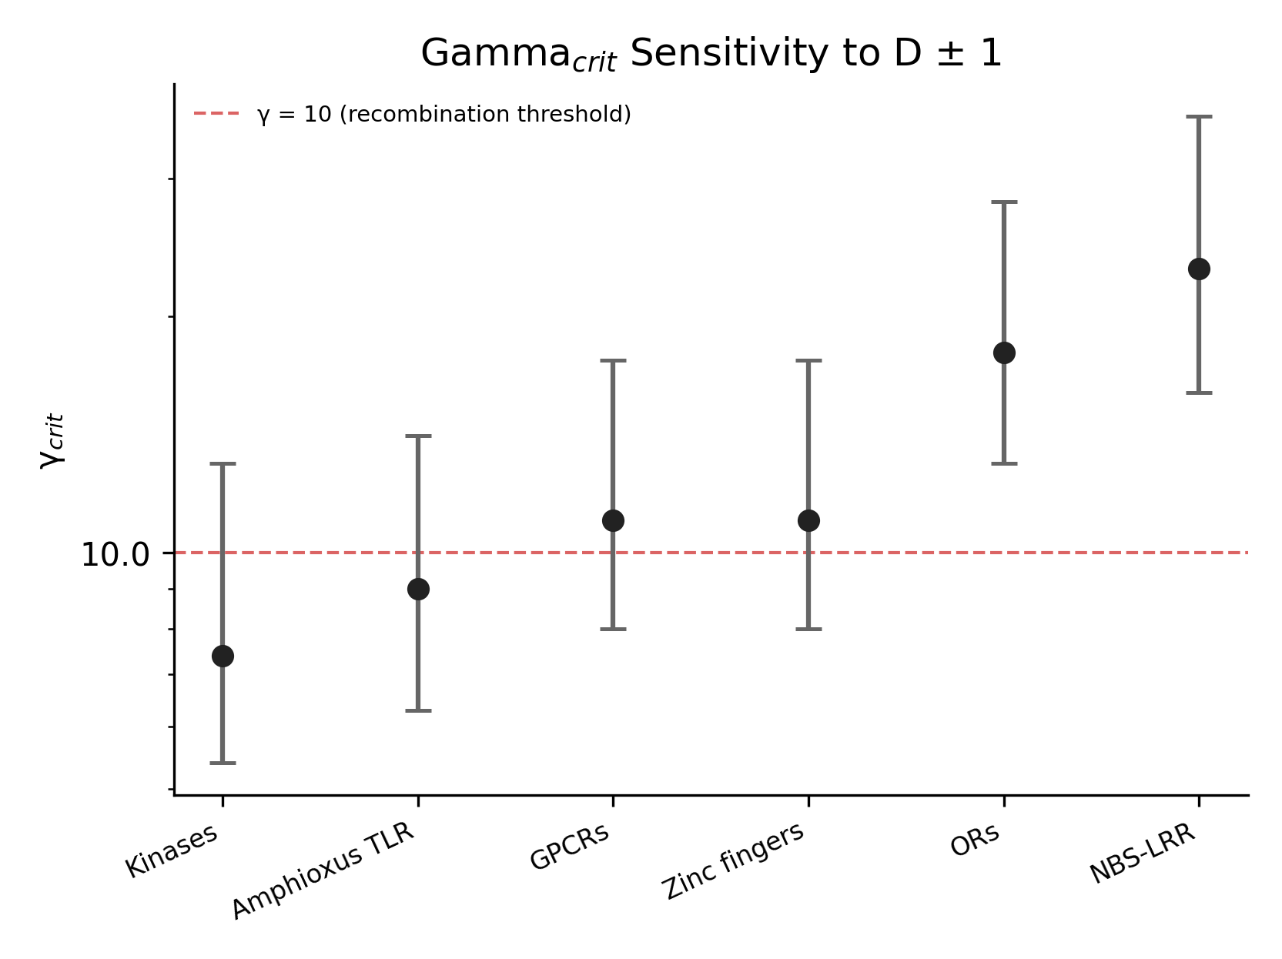

Figure 8: F15 Classification Distribution
