Restaurant Finder

Restaurant Finder is a project that helps you to find a restaurant near to you.

It gets the current position of the mobile device and searches for restaurants near to your location. It also displays restaurants information like type, name, full-address that can be opened with map application on the mobile, photo and shows also the reviews and the rating.

The distance of the searching range and the sorting type (nearest, top rated) can also be changed.

It is also possible to add a restaurant to the favourite list to easily access it later.

Why is the application suitable for mobile?

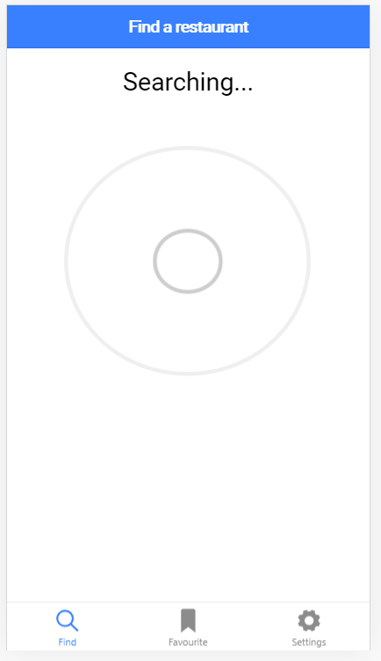It happened very often that we are walking on the street and hungry, but we don't know where to go. We can still go to google maps and search manually by giving the searching term and scroll throw the map and search for them. But we still get lots of features that we don't really need, and the design is not optimal for this purpose.

People normally would like more concrete applications that they can use for a certain purpose. And these apps expected to be perfectly designed and well fit to the purpose.

Our laptop is not always available with us, especially if you are walking on the street with friends and just wanting to search for restaurants with ease and less traffic.

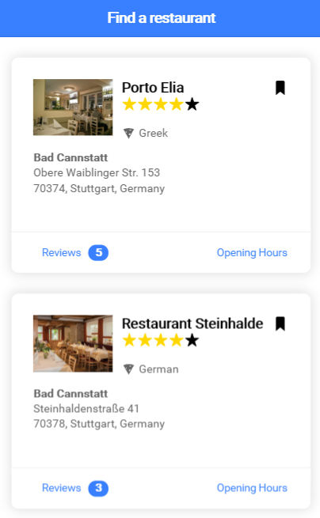The application offers an easy and efficient way to search for restaurants near your location with as fewer clicks as possible. At the start of the application, your current position will be read, and the search will start automatically.

As soon as the restaurant is found, the list page will be shown as in the figure to the right.

All the necessary information is displayed aside with opening hours and reviews.

The designing for mobile use

This application is developed under ionic 4 and angular 7 which they both are JavaScript base frameworks with help from bootstrap 4 for a better UX.

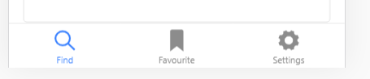Ionic provides many features like loading components, alerts, tabs and plugins to give a more mobile-feel design as shown below.

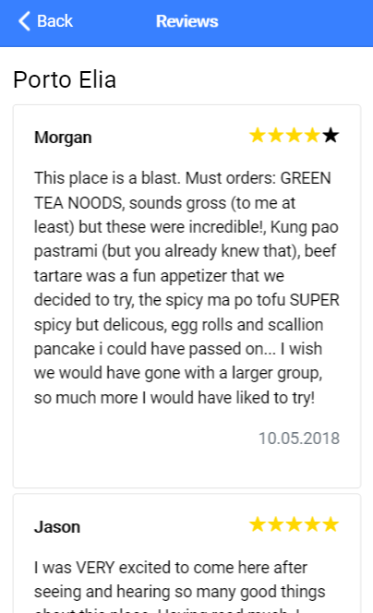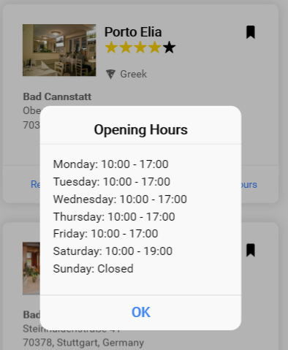This application called Hybrid applications based on JavaScript and for that, there is a need for a backend that has been separately developed under .NET Web API.

Ionic can be deployed on both iOS and Android devices after setting the platforms and can also display the output using emulators. The application can be packed later on to an executable file (.apk for Android and .ipa for iOS) to be installed and used in on devices.

How it works

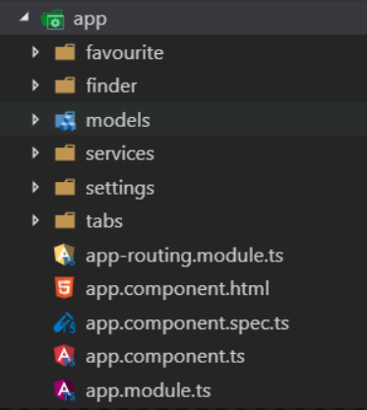The application uses Angular 7 and lazy load the modules. (Each tab is a module)

The tabs module is the module that will be started at the beginning and lazy load the three other modules (finder, favourite, settings)

The “models” folder contains the model classes and the services are caring for calling the backend and requesting the data.

A mixed between ionic components and bootstrap classes has been used to design the UX.

The services are using HttpClient from Angular to connect with the server.

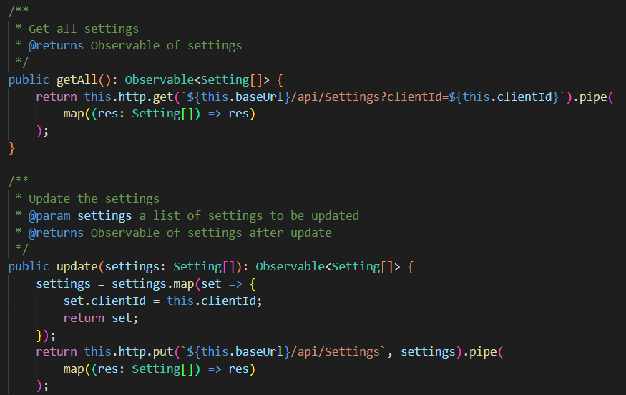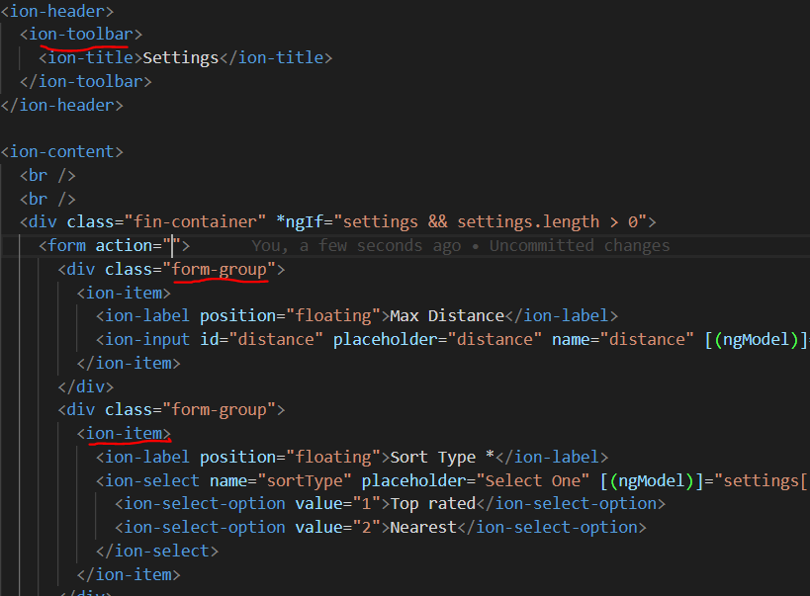

I have tried to use a variety of methods to achieve the goals. I used Alert controllers to display opening hours for example and navigation with a back button for the reviews.

The tabs component contains the three main tabs at the button of the application that can be navigated throw.

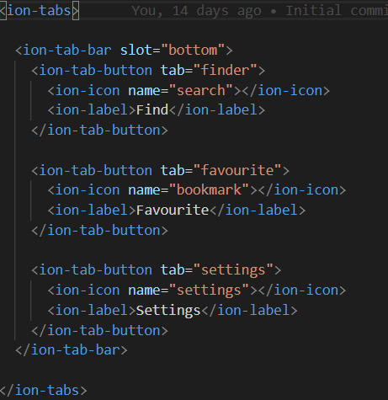

To make the application run faster, the modules have been lazy loaded to when they are called.

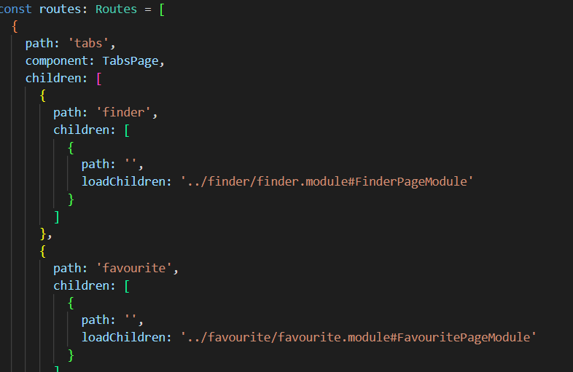

Startup

To install the necessary packages, the following command should be used:

* npm install

The following command is enough to start up the ionic application after installing all the packages:

* ionic serve

This will start a browser instance (default browser) when ready and will start the app.

To start the emulator, there is a need to install the correct SDK for both Android and iOS and then start the wanted emulator using one of these commands:

* ionic cordova emulate android
* ionic cordova emulate ios

The backend should be started separately.