RENTAL AGREEMENT

This agreement of tenancy is made and executed at Bangalore on this 1st day of Apr’2021.

Between:

Owner

SRI. Imran Shariff


Door No: 182,
1st Cross, Karumariamman temple Street,
Whilefield,
City and State: Bangalore, Karnataka PIN: 560066

Herein after referred to as the “LESSOR” (Owner) of the ONE PART:

Tenant

Miss. Samra Afreen
Door No: 364, Kannamangala via MIMS villas, near govt school
Street: Adrenale Street,
Area: Kannamangala,
City and State: Bangalore, Karnataka PIN: 560067

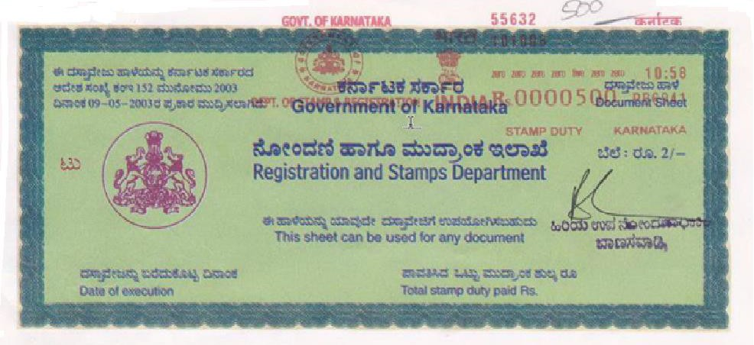

Herein after referred to as the “LESSEE” (Tenant) of the OTHER PART.

Whereas the first party is the absolute owner of the House, consisting of one hall, one kitchen, two bedrooms and two bathroom & with electricity and water facility situated at House # 196, Block 2, Lake view Apartment, Phase 3, Nallurhalli, bangalore – 560066 and the owner has decided to let out the same to the said tenant under the following terms and conditions.

Contd…..2

:: 2 ::

TERMS AND CONDITIONS:

- This rental agreement is for a period of 11 months with effect from 1st Apr 2021
- The LESSEE has paid a sum of Rs.75,000/- (Rupees One Lakh only) towards security deposit to the LESSOR. The security deposit shall not carry any interest and shall be refunded back to the LESSEE at the time of vacating the scheduled premises after deducting any arrears in rent, electricity bills, breakages, cleaning and painting charges.
- The LESSEE further agrees to pay a monthly rent of Rs. 8,300/- (Rupees Eight Thousand three hundred only). The rent for each month shall be paid on or before 1st of every month (after completion of the month)
- In case the LESSEE wants to vacate the premises before the period available to them, they should give one-month notice, in writing, or one month rent in lieu of the notice period. The LESSOR also shall give one-month notice to the LESSEE for terminating the Lease period.
- The LESSOR and LESSEE on mutual agreement can renew this LEASE for a further period of 11 month. In such event the LESSEE shall pay and enhance the rent by 10% upon renewal of this agreement.
- The LESSEE shall not have any right to claim deduction of rent from the security deposit amount. On the other hand the LESSEE shall keep paying the rent as agreed.
- If the LESSEE commits any default to pay the rent regularly on due dates or commit any default to observe or perform any of the terms here to agreed, the LESSOR hereby reserves the right to terminate the LEASE hereto granted and take over possession of the schedule premises.
- The LESSEE shall bear and pay the electricity consumed to the Karnataka Power Transmission Corporation Limited as per their monthly bill and pass on the copy of the bill along with the payment receipt to the LESSOR. Water charges will be in shared basis.

- The LESSEE agrees not to sub-let or under-let the schedule premises in whole or part to any third person/party.
- The LESSEE shall keep and maintain the schedule premises clean and in good condition if any damage shall be borne by the LESSEE
- At the time of vacating the schedule premises, half month rent will be deducted towards painting charges of the scheduled premises.
- The LESSOR shall have the right to terminate the tenancy if the LESSEE fails to pay the rents regularly for a consecutive period of two months or commits breach of any of the terms herein and take possession of the scheduled premises.
10. List of Fittings and Fixtures available in the premises

Ceiling Fans : 2 Nos.
Tube Light : 1 No.
CFL Bulb : 2 Nos.
Lights : 2 Nos.

In witness where of the LESSOR and the LESSEE have signed the deed of rental agreement on the day month and year above written

Mr. Mr.

LESSOR (OWNER) LESSEE (TENANT)

Witness:


1)

2)

