PHONEBOOK

1. Insert Contact

class Contact:

def __init__(self, name, phone_number):

self.name = name

self.phone_number =

contacts = []

current_size = 0

insert_contact(name, phone_number):

global current_size

if current_size >= MAX_SIZE:

print("Contact list is full.")

return

new_contact = Contact(name, phone_number)

contacts.append(new_contact)

current_size += 1

print("Contact added successfully.")

START

"Insert contact(name, phone number)"

"Initialize contacts = []/ncurrent_size=0"

YES



"Is current_size>= MAX_SIZE?"



NO

END

"Print 'Contacts added successfully' "

"Increment current_size by 1"

"Append new_contact to contacts"

"Create new_contact with Contact(name, phone_number)"

"print 'Contact list is full' "



2. search contact

SearchContact(phoneBook[], size, searchName) {

foundIndex = -1

FOR (i = 0; i < size; i++) {

IF phoneBook[i].name == searchName THEN

foundIndex = i

PRINT "Contact Found:"

PRINT "Name: " + phoneBook[i].name

PRINT "Phone Number: " + phoneBook[i].phoneNumber

IF phoneBook[i].email != NULL THEN

PRINT "Email: " + phoneBook[i].email

ENDIF

IF phoneBook[i].address != NULL THEN

PRINT "Address: " + phoneBook[i].address

ENDIF

BREAK

ENDIF

}

IF foundIndex != -1 THEN

RETURN phoneBook[foundIndex]

ELSE

PRINT "Contact not found"

RETURN "Contact not found"

ENDIF

}

START

Initialize foundIndex = -1

FOR (i = 0; i < size;

i++)

NO

Continue to next i

Set foundIndex = i

Print Contact Info

BREAK

YES

Is phoneBook[i].name ==

searchName?

Is foundIndex != -1?

Return

phoneBook[foundIndex]

Print "Contact Not Found"

Return "Contact Not Found"

YES

NO

END

4.Delete contact

Delete(Phonebook, Name)

FOR (i = 0; i < size; i++)

IF (Phonebook[i].Name == Name) THEN

FOR (j = i; j < size - 1; j++)

Phonebook[j] = Phonebook[j + 1]

ENDFOR

size = size – 1

RETURN "Contact deleted"

ENDIF

ENDFOR

RETURN "Contact not found"

END

5.Update contact

UpdateContactArray(contacts: array, size: int, phoneNumber: string, newName: string, newPhoneNumber: string, newEmail: string)

for i = 0 size - 1

if contacts[i].phoneNumber == phoneNumber then

contacts[i].name = newName

contacts[i].phoneNumber = newPhoneNumber

contacts[i].email = newEmail

Display "Contact updated."

return

end if

end for

Display "Contact not found."

End

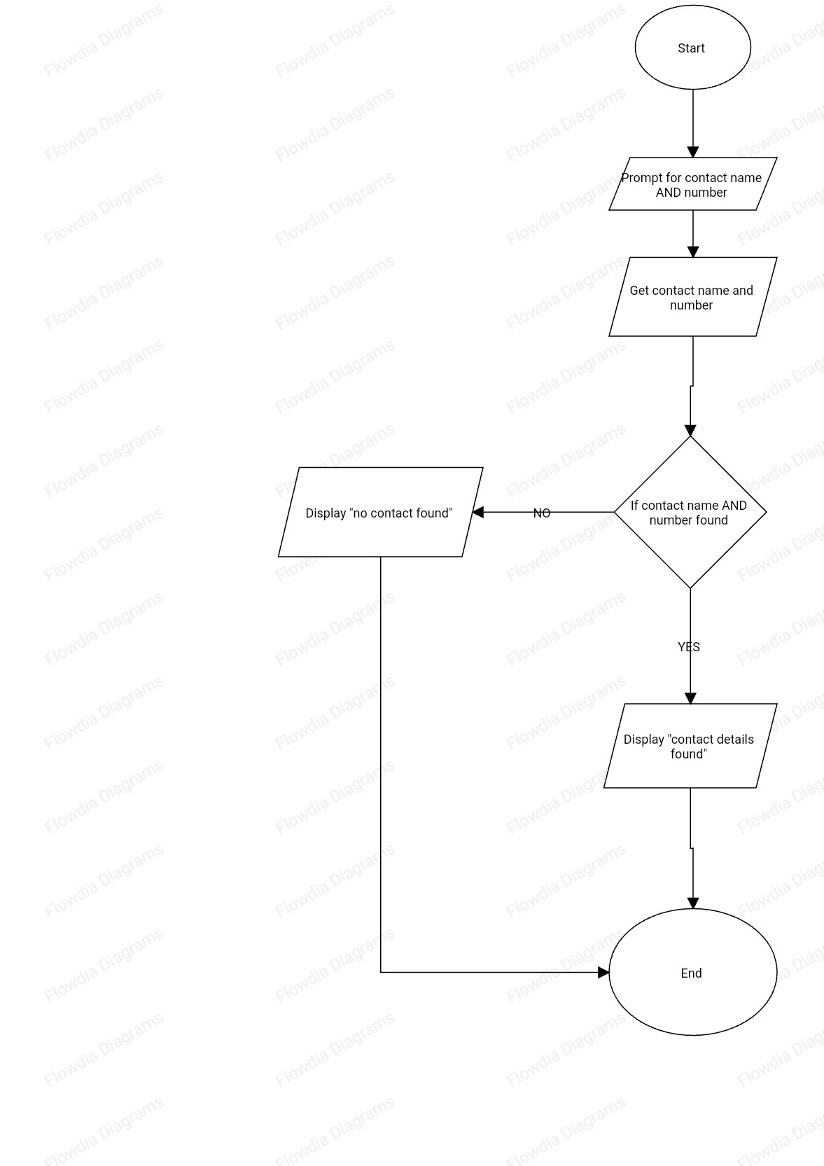

6. Sort contact

for i = 0 to n-1 do

min = i

for j = i+1 to n do

if array[j] < array[min] then

min = j

endif

endfor

temp = array[i]

array[i] = array[min]

array[min] = temp

endfor

-1

< n

1

min = 1

Start

i=0

j = i + 1

j < n

End

No

array [min]

min=j

i by 1

j < n

End

No

Yes

No

Yes

Yes

Yes

No

Yes

7. Analysis of time efficiency of Search algorithm

Best-case time complexity: O(1) (if the contact is at the start of the list).

Worst-case time complexity: O(n) (if the contact is at the end of the list or not present).