Student Number: 2408842
Student Name: Samrajya Neupane

6CS005 High Performance Computing Week 5 Questions

- Code:
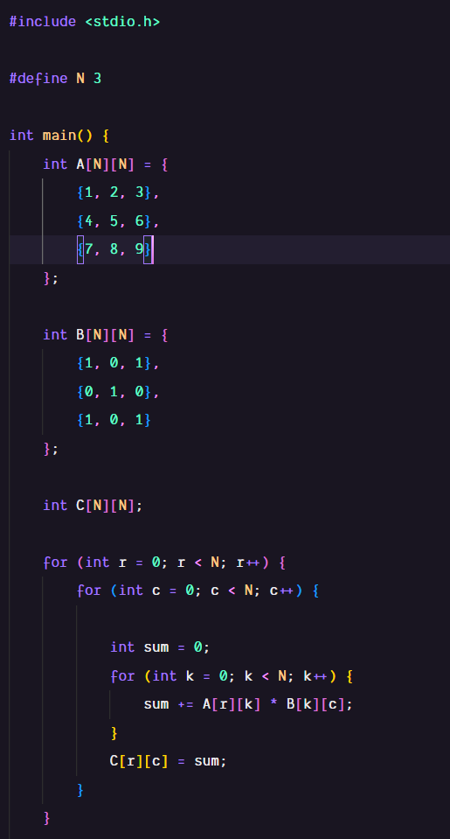
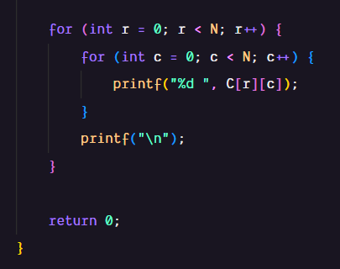
Output:
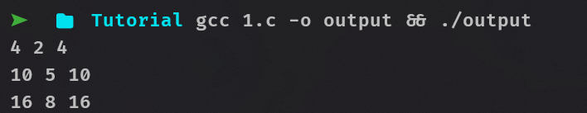
Explanation:
This program multiplies two statically defined N size square matrices. Since it is a 2D array, two loops are used for effective iteration. The first for loop is used to iterate through its rows and the second loop is used for columns. Then an additional third loop is used to multiply elements of the current row of matric A with the elements of current column of matric B. It is then set as an element for the resulting matric C. Then finally another nested loop is used to print out the final matric.
2. Code:
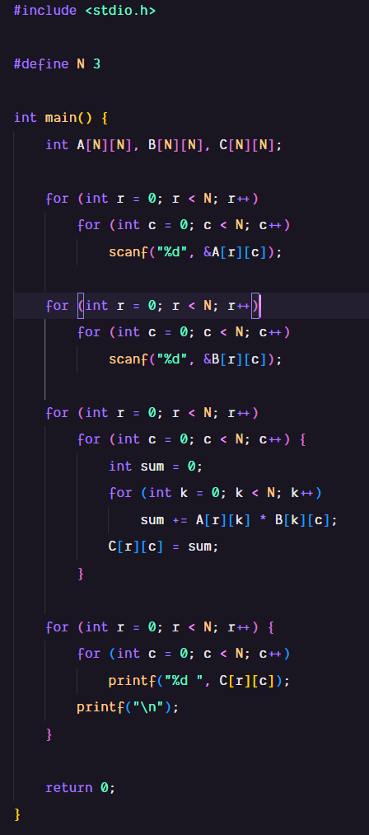
Output:
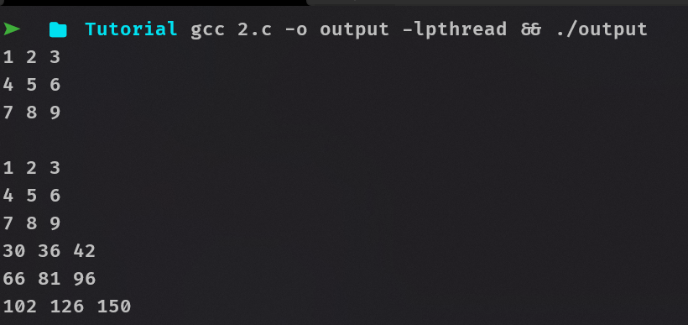
Explanation:
This program multiplies two user defined N size square matrices that utilizes for loops with scanf() and whitespaces to populate the two matrices. Since it is a 2D array, two loops are used for effective iteration. The first for loop is used to iterate through its rows and the second loop is used for columns. Then an additional third loop is used to multiply elements of the current row of matric A with the elements of current column of matric B. It is then set as an element for the resulting matric C. Then finally another nested loop is used to print out the final matric.
3. Code:
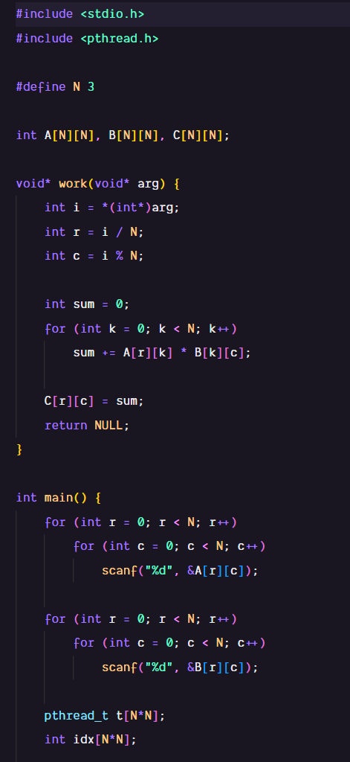
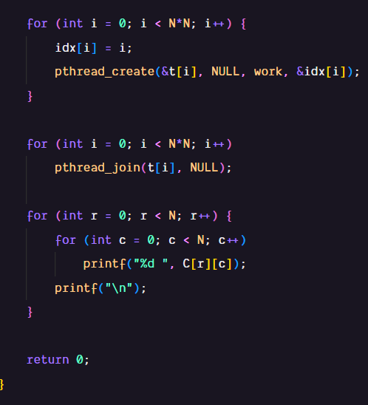
Output:
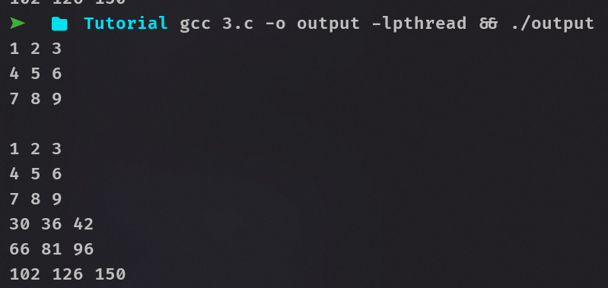
Explanation:
This code uses multi-threading to multiply two N size square matrices that utilizes for loop with scanf() and whitespaces to populate the two matrices. An array of 9 threads is created to account for all the 9 elements in the resulting matric. Another array is also created and filled with numbers from 0 to 8 to track the index of the thread. pthread_create() is used inside the loop to create a thread and assign it the work function. Along with that, the index is also passed as an address because the signature of thread function. The work function type casts the index as int and dereferences it. Row are calculated by dividing and the index of the thread by the size of the matrix which ensures that the row’s value remains the same for every 3 elements and increases from 0-2. Columns are calculated by applying modulus operator to the index with the size of the matrix which allows it to oscillate from 0-2 each iteration. Finally a loop is used to join all the threads and print out the final matric.
4. Code:
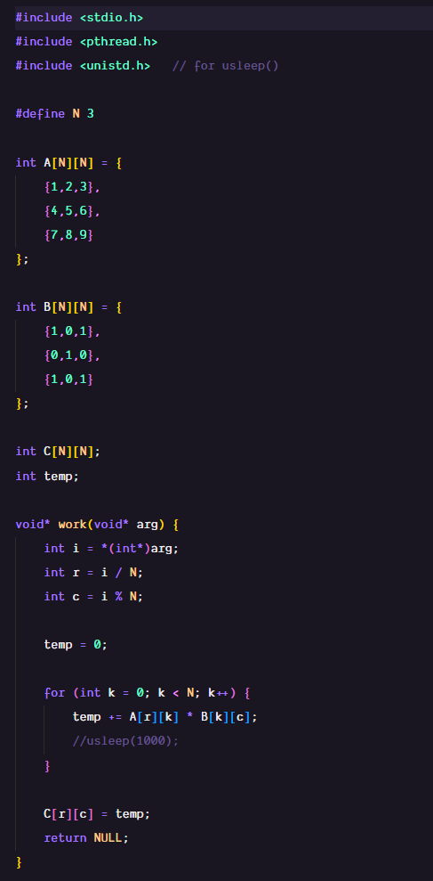
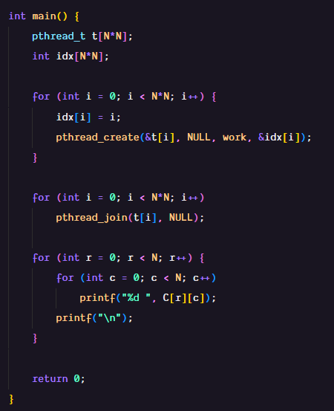
Output:
With usleep():
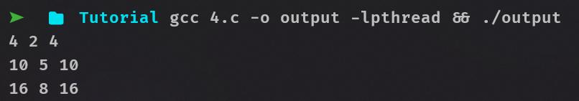
With usleep():
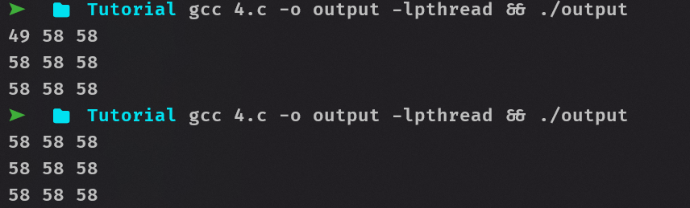
This program uses muti-threading to multiply two statically defined N size square matrices. The code is identical to the previous program with the difference being that the work function uses a global variable to store the resulting element in the resulting matric. This causes a race condition as multiple threads are using the same variable at once without any kind of condition or barrier. To try and tackle this, the program tries and utilizes usleep() which pauses the thread but this further escalates the situation as the other threads do not pause when one of the threads is paused. The program without the usleep() gives consistent correct answers even though it is incorrect because the scale of the program is small and all the threads execute relatively fast without overlapping each other.
5. Code:
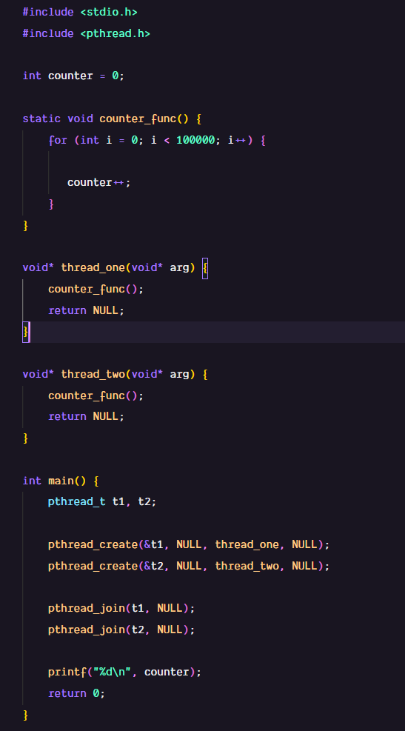
Output:
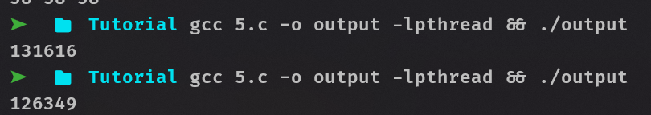
Explanation:
This program uses two threads to increase a global variable counter 100,000 times. The expected output is 200,000 but due to race condition the output is not as expected. When both of the threads try to add on the same variable, they both LOAD the same value from the memory and increment on it. Then, both the threads try and STORE at the same time which results in one of the increment being lost.
6. Code:
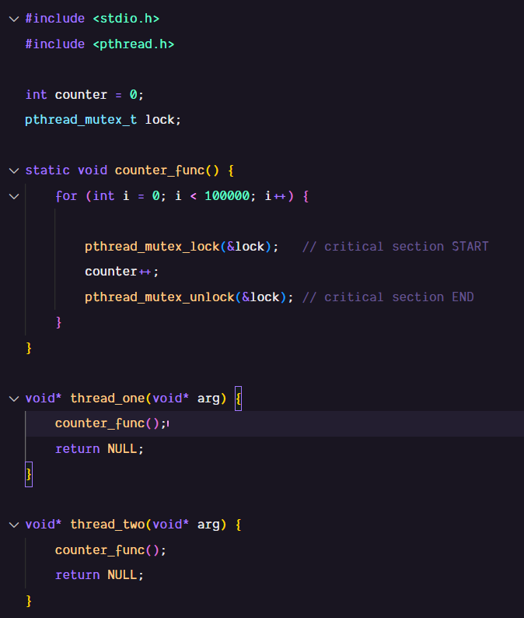
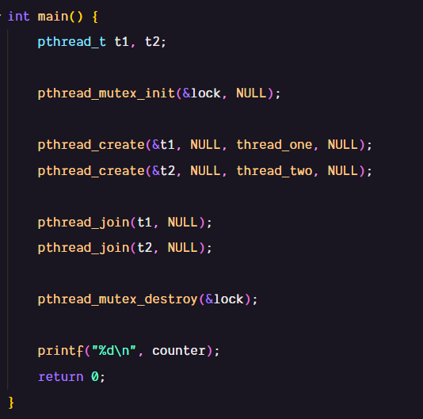
Output:

Explanation:
This program addresses the flaw of the previous program by using mutex at the critical section. A mutex is initialized and used to lock and unlock the increment of the counter which allows it atomicity among the threads and allows the counter to be consistently increment. When the pthreuad_mutex_lock() is used, the OS schedules other threads at the critical section to wait until it is unlocked again saving valuable CPU resources.
7. Code:
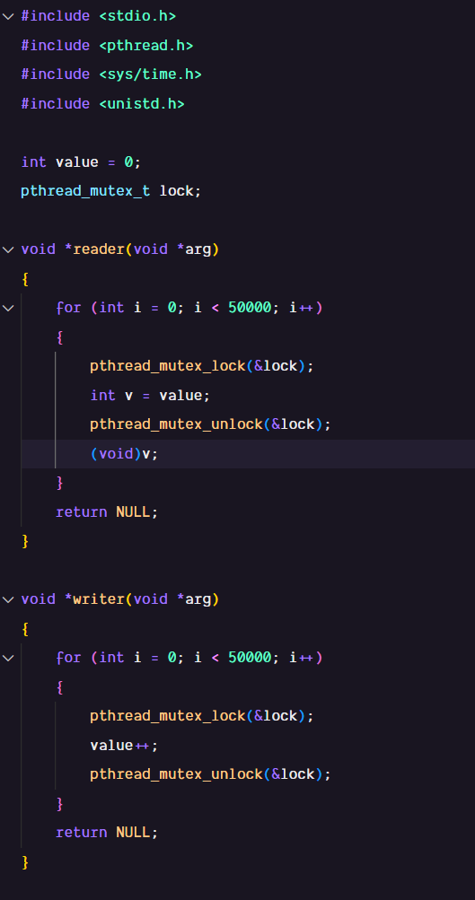
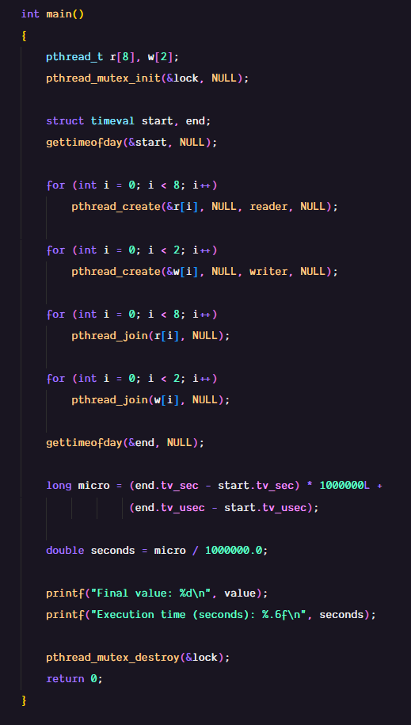
Output:
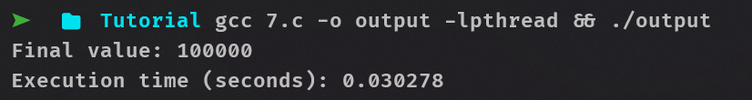
The program contains 8 reader threads and 2 writer threads. They both use the same global variable and use mutex to avoid race condition. Each writer thread loop to 50,000 and increments the value by one each iteration while the reader thread just assigns the value into another variable simulating a reading operation. The void(v) line is used to avoid warnings in some compilers for unused variable. The execution time of the program is also calculated using <sys/time.h> header file that provides time in microseconds and seconds. The seconds are converted into microseconds, added onto the microseconds and the final sum is converted back to seconds.

8. Code:
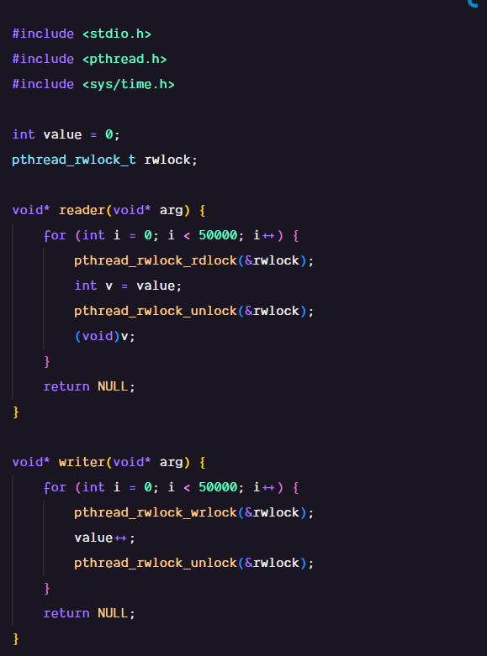
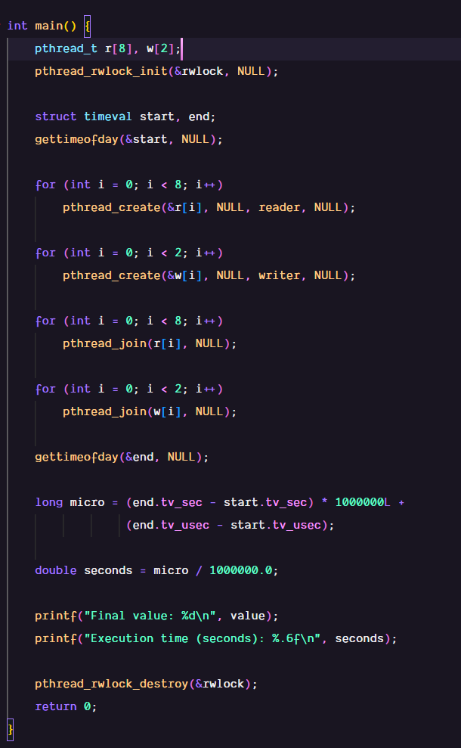
Output:
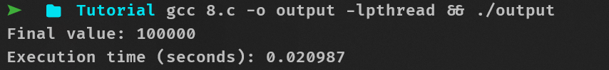
This program is the same as the previous with the only difference being the usage of pthread_rwlock_t instead of mutex. The read-write lock behaves similar to mutex in avoiding race conditions but it allows multiple readers to simultaneously access the value allow for a overall faster execution. But when a writer is using the value, all the other readers and writers are blocked behaving identical to a mutex.
9. Code:
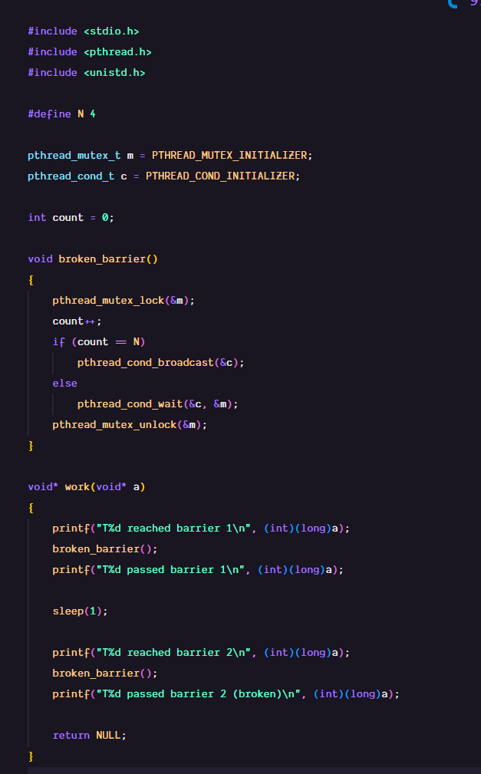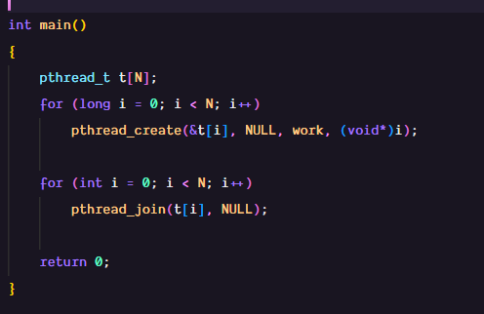

Without resetting the counter:
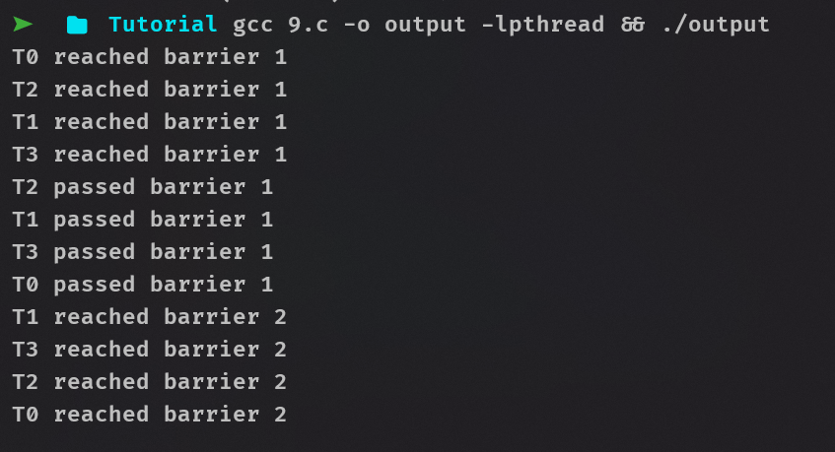
With resetting the counter:
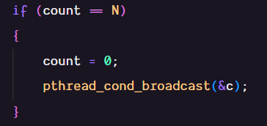
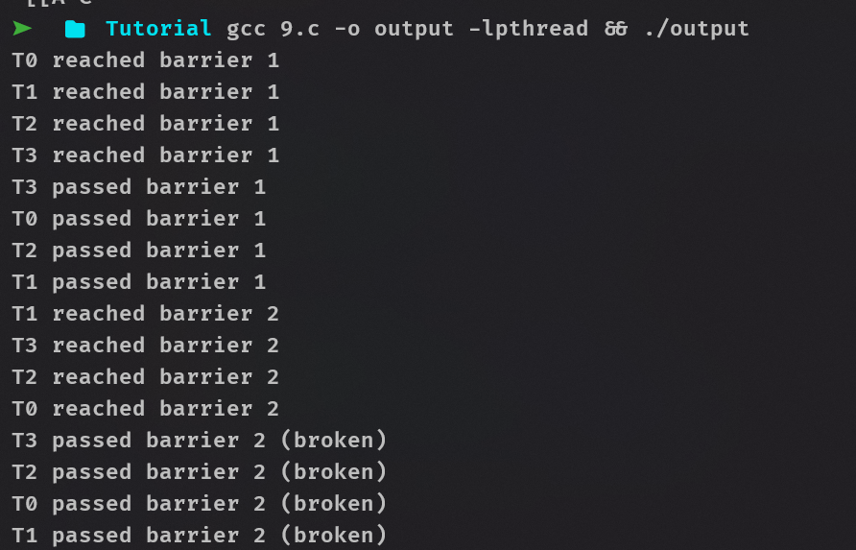

This program utilizes the concepts of barrier and synchronization in multi-threading. 4 threads are created and they all follow a pattern of logging the entry point, executing broken_barrier() and logging exit point. This is done twice for the first and second barrier. A count variable is used to keep track of the number of threads that have broken the barrier. After all the threads have finished executing broken_barrier(), pthread_cond_broadcast() is used to wake up all the other threads that were locked using pthread_cond_wait due to the condition count == N not being satisfied. The same function is used for the second barrier but due to count not being reset, none of the threads are able to pass the barrier. So upon resetting the count just before broadcasting, the threads are able to pass the second barrier.
10. Code:
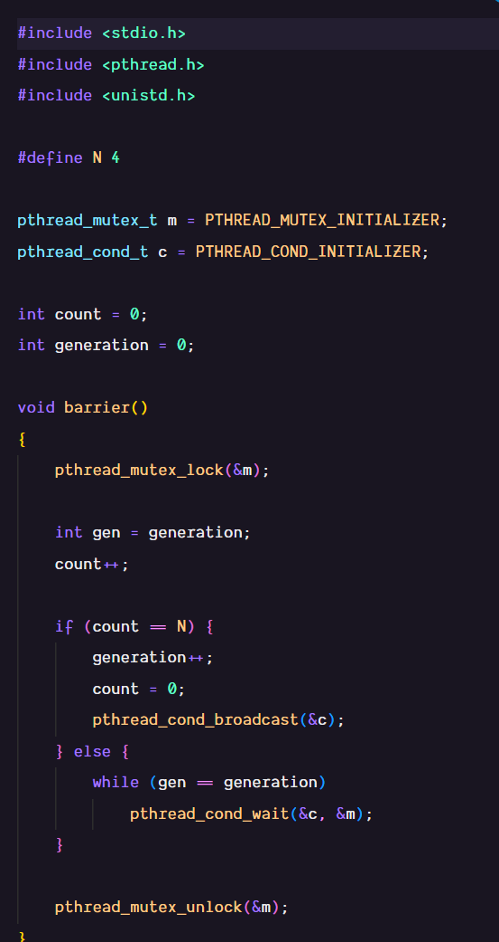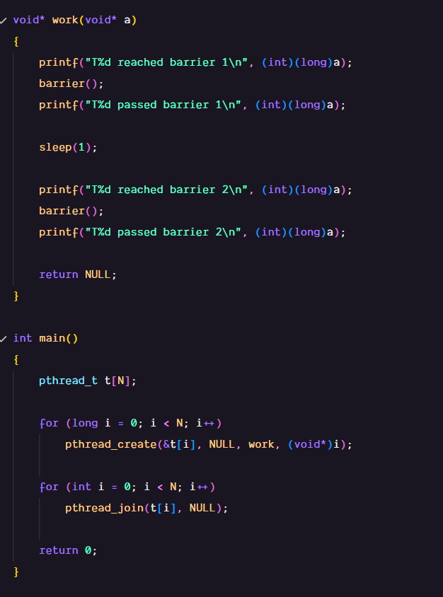
Output:
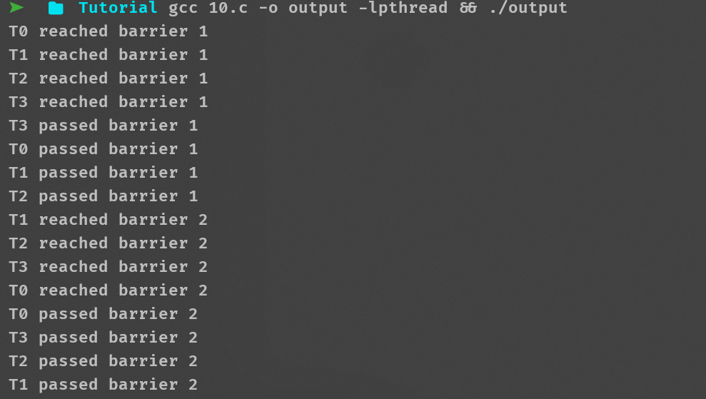

This program fixes the issue of the previous program by adding a new variable to the mix which keeps track of the round of barrier we are in. It checks to see if the current threads are of the same batch and handles the broadcasting accordingly.
11. Code:
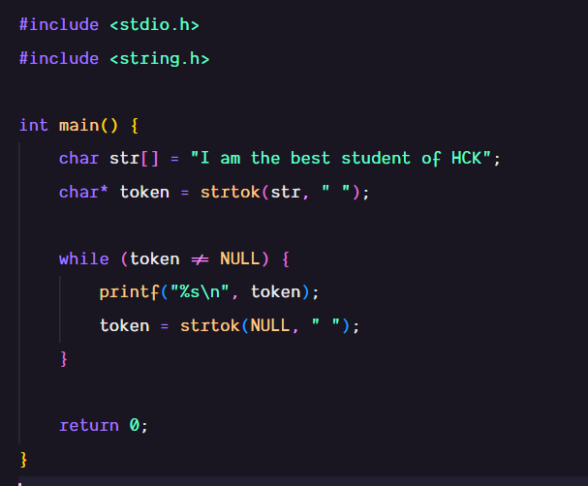
Output:
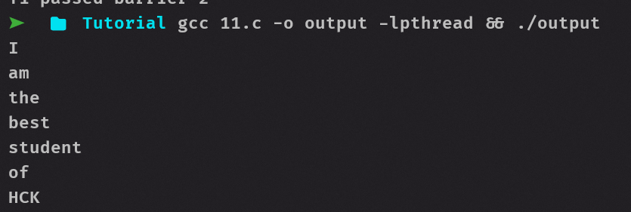

This program uses the strtok() function which splits the string into different tokens, each containing a null character at the end and returns the address of the first token. So token is lopped through and each token is printed to print out the full message. strtok(NULL, “ “ ) is used to tell strtok to continue where it left off with the string which it stores in an internal static pointer. The original string (str) is also modified because of strtok() and now only contains the first token, that is I.

12. Code:
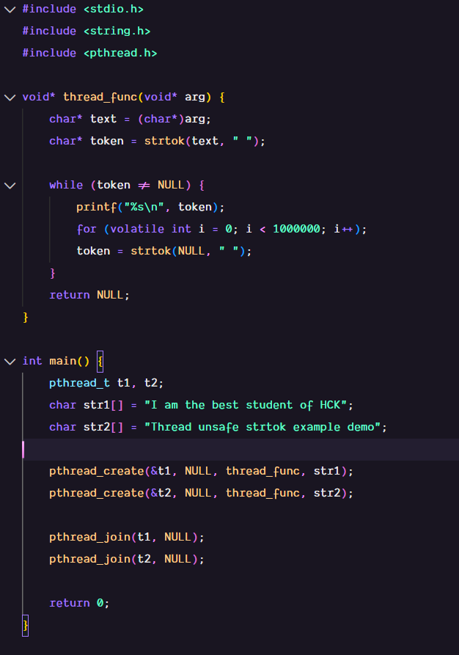

Output:
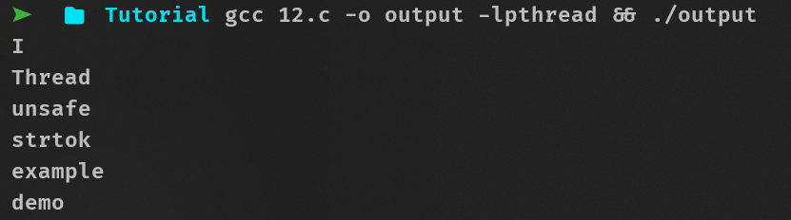

This program demonstrates that strtok() are not thread safe and are prone to race conditions. Two threads are created, both working on their own string. A single thread function is used with strtok() to print the string but since strtok() uses the same static pointer to reference the string its working on, the first string gets overridden by the string that comes later on. The for loop is used to increase the likelihood of race condition and the volatile integer is used to prevent compiler from optimizing or removing the for loop as it does nothing.
13. Code:
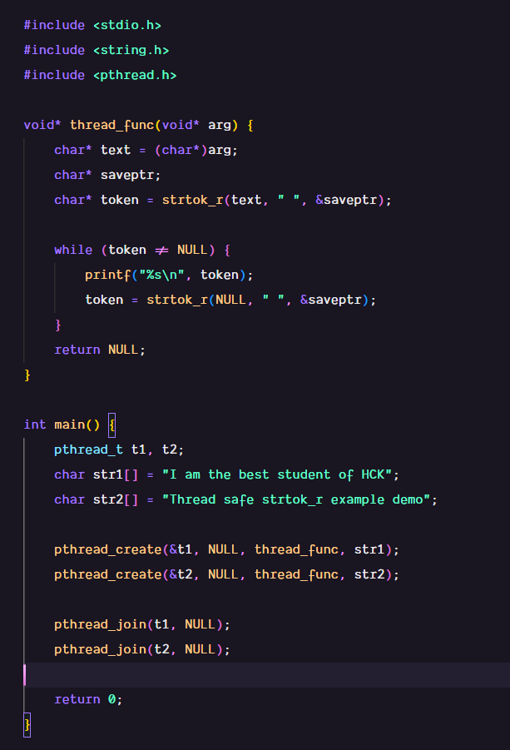
Output:
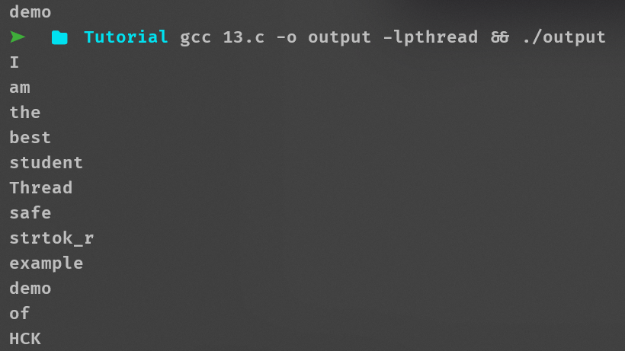
This program fixes the issue of the previous multithreaded strtok example by introducing a thread-specific pointer saveptr. This pointer keeps track of the position within each string for each thread individually. By using strtok_r, each thread maintains its own state while tokenizing its string, preventing interference between threads. The function first retrieves the first token from the string, then continues to fetch subsequent tokens using the same saveptr, ensuring that each word is correctly printed in order without affecting other threads.
14. Code:
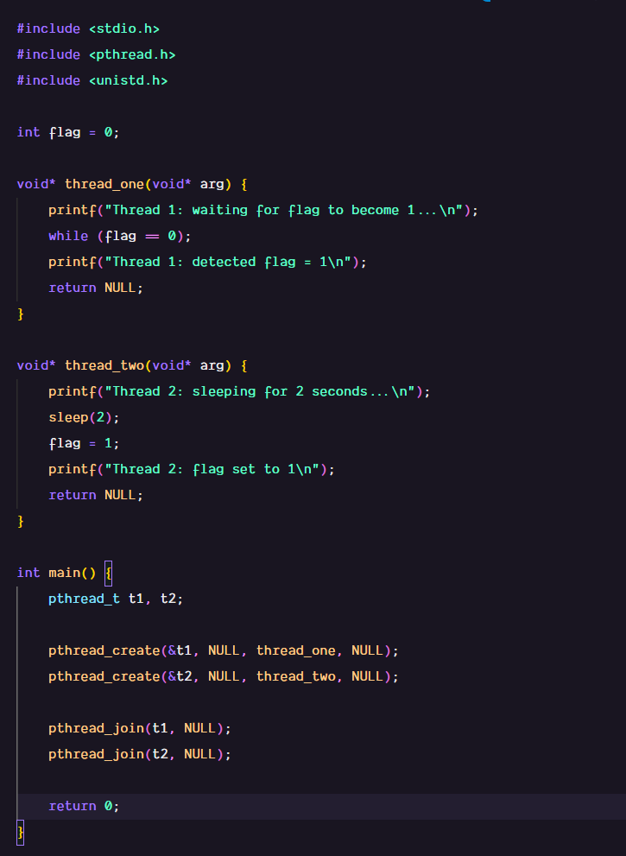
Output:
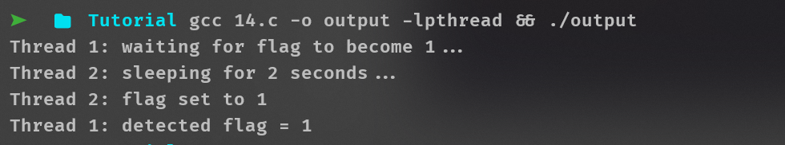
This program demonstrates simple communication between two threads using a shared flag. Thread 1 keeps checking the flag in a loop until it sees the flag set, while Thread 2 sleeps for 2 seconds and then sets the flag to 1. This change allows Thread 1 to detect the update and proceed. Essentially, the program shows how one thread can signal another using a shared variable, though the busy-waiting approach is inefficient and can be improved with proper synchronization.
15. Code:
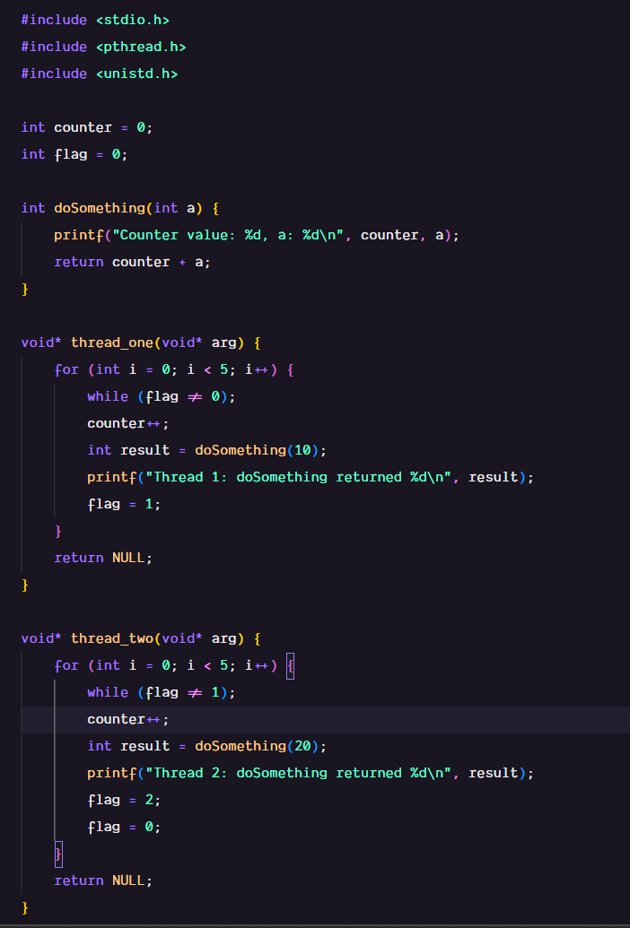
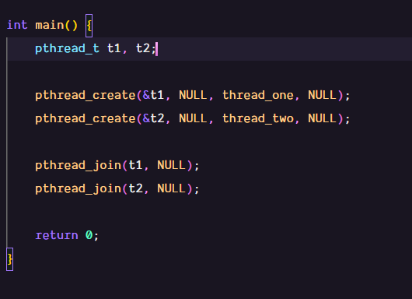
Output:
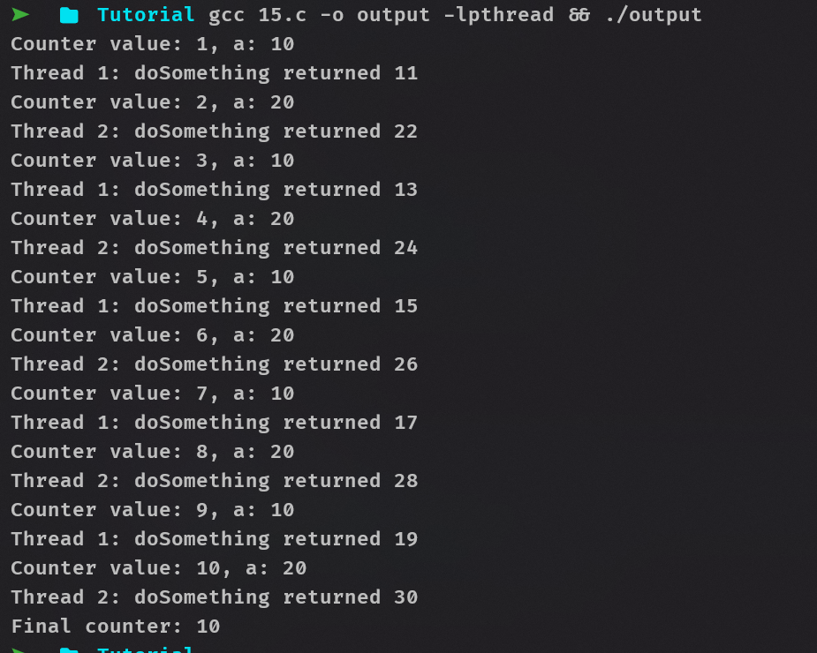

This program makes two threads run alternately using a shared flag. Thread 1 runs when flag = 0, does its work, and sets flag = 1 for Thread 2. Thread 2 runs when flag = 1, does its work, and resets flag = 0 for Thread 1. The while (flag != …) loops ensure each thread waits its turn, so the threads execute in order and the counter increments correctly.

