- Code
#include <stdio.h>
#include <omp.h>

int main()
{
#pragma omp parallel
printf("Hello from thread %d\n", omp_get_thread_num());
}

Output:
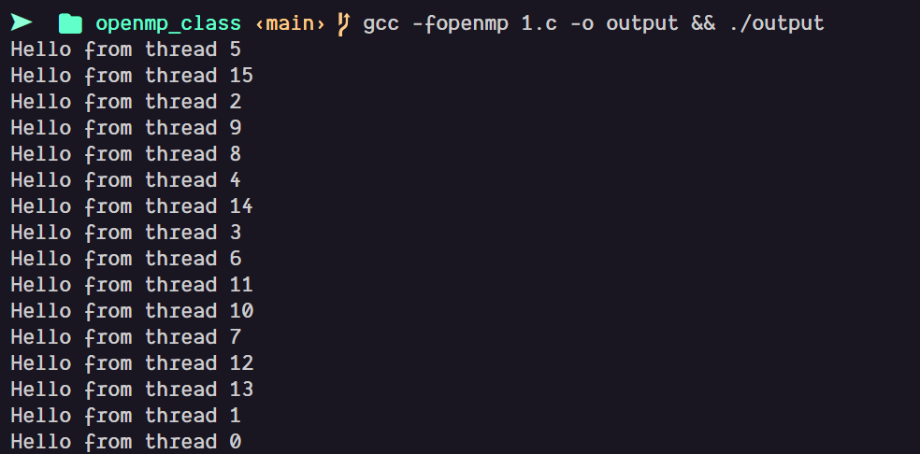
2. Code:

#include <stdio.h>
#include <omp.h>

int main() {
omp_set_num_threads(4);
#pragma omp parallel
printf("%d\n", omp_get_thread_num());
}

Output:
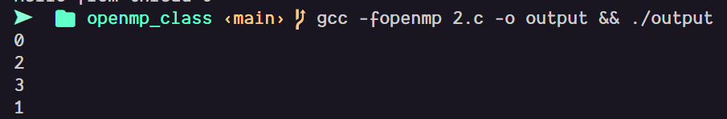
3. Code:

#include <stdio.h>
#include <omp.h>

int main() {
#pragma omp parallel for
for(int i=0;i<10;i++)
printf("%d\n", i);
}

Output:
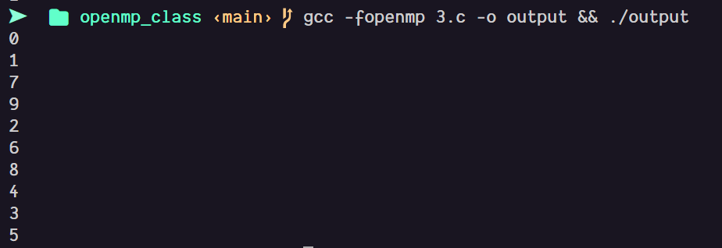
4. Code:

#include <stdio.h>
#include <omp.h>

int main() {
int s=0;
#pragma omp parallel for reduction(+:s)
for(int i=1;i<=100;i++) s+=i;
printf("%d\n", s);
}

Output:
5. Code:
#include <stdio.h>
#include <omp.h>

int main() {
int x=0;
#pragma omp parallel
{
#pragma omp critical
x++;
}
printf("%d\n", x);
}

Output:
6. Code:

#include <stdio.h>
#include <omp.h>

int main() {
int x=0;
#pragma omp parallel
{
#pragma omp atomic
x++;
}
printf("%d\n", x);
}

Output:
7. Code:
#include <stdio.h>
#include <omp.h>

int main() {
int a=5;
#pragma omp parallel private(a)
printf("%d\n", a);
}

Output:
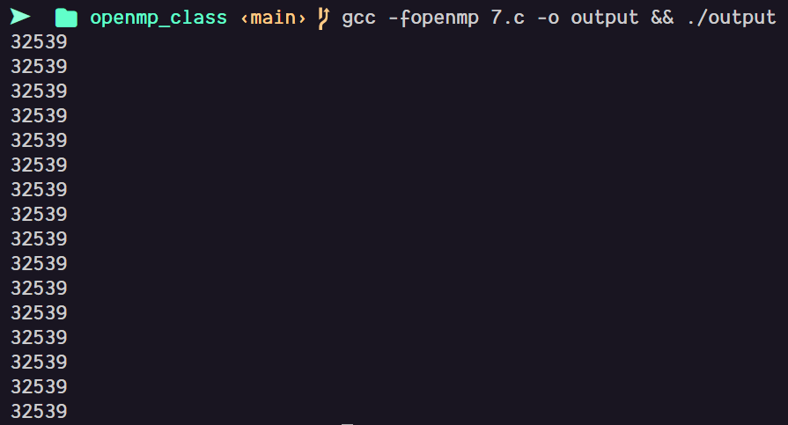
8. Code:
#include <stdio.h>
#include <omp.h>

int main() {
int a=5;
#pragma omp parallel firstprivate(a)
printf("%d\n", a+1);
}

Output:
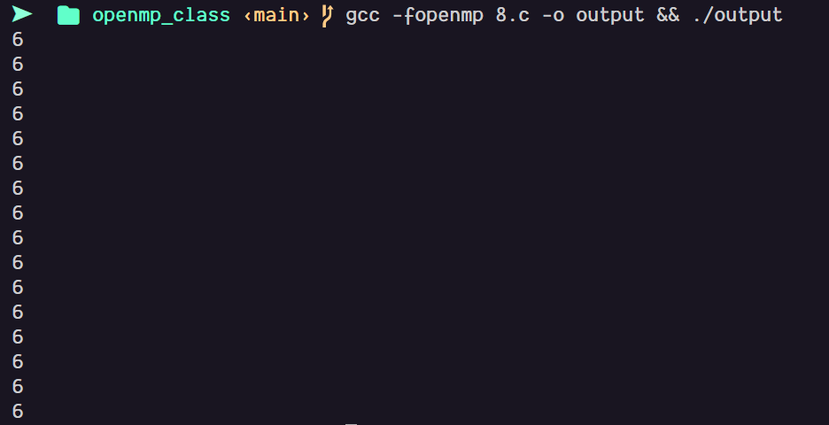
9. Code:
#include <stdio.h>
#include <omp.h>

int main() {
int x=0;
#pragma omp parallel shared(x)
printf("%d\n", x);
}

Output:
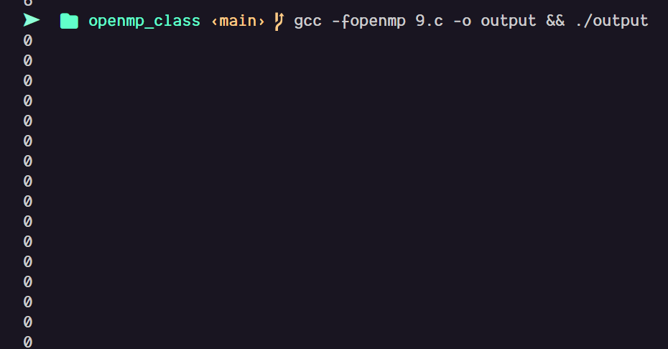
10. Code:
#include <stdio.h>
#include <omp.h>

int main() {
#pragma omp parallel
{
#pragma omp barrier
printf("After barrier %d\n", omp_get_thread_num());
}
}

Output:
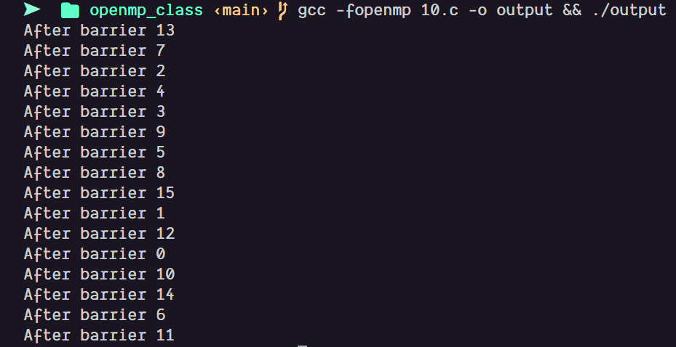

11. Code:
#include <stdio.h>
#include <omp.h>

int main() {
#pragma omp parallel
{
#pragma omp master
printf("Master: %d\n", omp_get_thread_num());
}
}

Output:

12. Code:
#include <stdio.h>
#include <omp.h>

int main() {
#pragma omp parallel
{
#pragma omp single
printf("Only once\n");
}
}

Output:
13. Code:
#include <stdio.h>
#include <omp.h>

int main() {
#pragma omp parallel sections
{
#pragma omp section
printf("A\n");
#pragma omp section
printf("B\n");
}
}

Output:
14. Code:
#include <stdio.h>
#include <omp.h>

int main() {
#pragma omp parallel for schedule(dynamic,2)
for(int i=0;i<10;i++)
printf("%d\n", i);
}

Output:
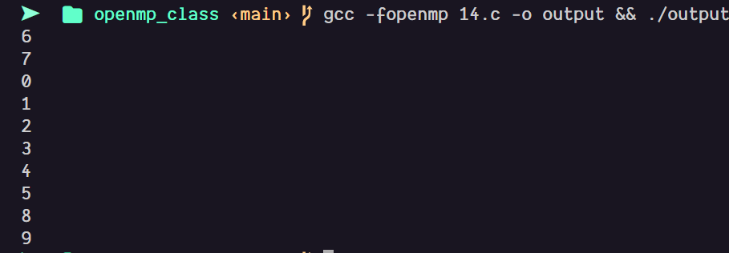

15. Code:
#include <stdio.h>
#include <omp.h>

int main() {
omp_set_nested(1);
#pragma omp parallel num_threads(2)
{
#pragma omp parallel num_threads(2)
printf("%d\n", omp_get_thread_num());
}
}

Output:
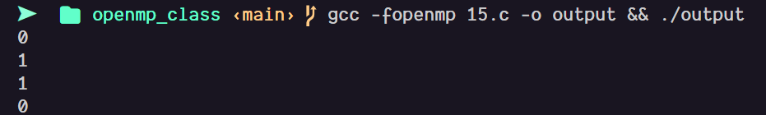

16. Code:
#include <stdio.h>
#include <omp.h>

int isprime(int n) {
if(n<2) return 0;
for(int i=2;i*i<=n;i++)
if(n%i==0) return 0;
return 1;
}

int main() {
#pragma omp parallel for schedule(dynamic)
for(int i=1;i<=100000;i++)
if(isprime(i))
printf("%d\n", i);
}

Output:
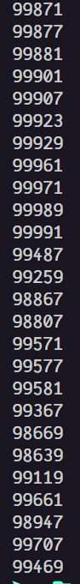

17. Code:

#include <stdio.h>
#include <omp.h>

int isprime(int n) {
if(n<2) return 0;
for(int i=2;i*i<=n;i++)
if(n%i==0) return 0;
return 1;
}

void p1() {
for(int i=1;i<=50000;i++)
if(isprime(i))
printf("%d\n", i);
}

void p2() {
for(int i=50001;i<=100000;i++)
if(isprime(i))
printf("%d\n", i);
}

int main() {
#pragma omp parallel sections
{
#pragma omp section
p1();
#pragma omp section
p2();
}
}

Output:
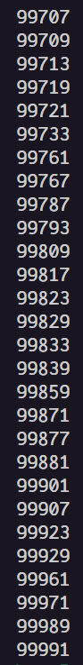

18. Code:

#include <stdio.h>
#include <omp.h>

int isprime(int n) {
if(n<2) return 0;
for(int i=2;i*i<=n;i++)
if(n%i==0) return 0;
return 1;
}

int main() {
int n;
int count=0;
scanf("%d",&n);

#pragma omp parallel for reduction(+:count)
for(int i=1;i<=n;i++)
if(isprime(i)) count++;

if(count>500) {
omp_set_num_threads(2);
#pragma omp parallel for schedule(dynamic)
for(int i=1;i<=n;i++)
if(isprime(i))
printf("%d\n", i);
} else {
#pragma omp parallel for
for(int i=1;i<=n;i++)
if(isprime(i))
printf("%d\n", i);
}
}

Output:

