University of Wolverhampton
School of Mathematics and Computer Science

6CS005 High Performance Computing Week 6 Workshop

Tasks - OpenMP Multithreading
You may need to refer to the Week 6 lecture slides in order to complete these tasks.

- The following program prints out "Hello World!" with the default number of threads which is usually the number of CPU processor cores that are on your computer system:
#include <stdio.h>
void main()
{
#pragma omp parallel
printf("Hello world from OpenMP!\n");
}
  - Enter and run the program to see how many processor cores are on the system you are using.
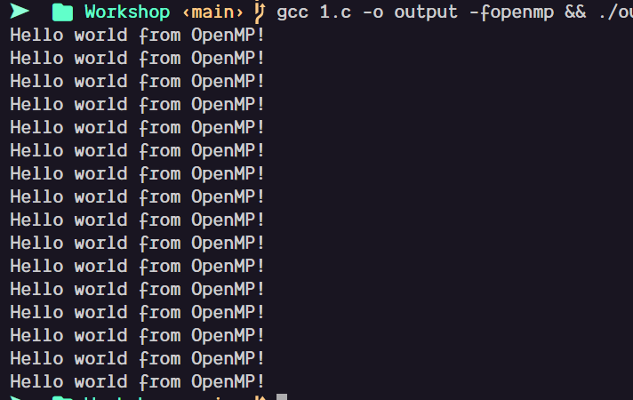
16 cores
  - Modify the program so that it run with exactly 10 threads.
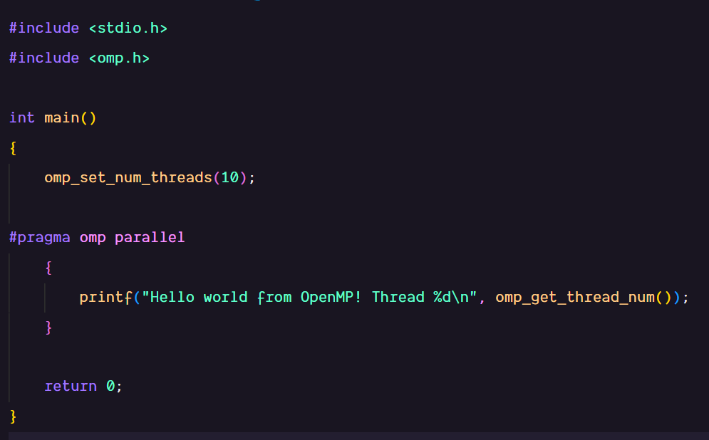
Output:
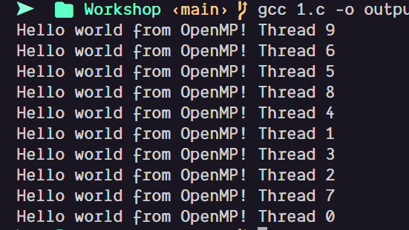
- The following program prints out all the prime numbers from 1 to 1000:
#include <stdio.h>
void main()
{
int i, c;
printf("Prime numbers between 1 and 1000 are :\n");
for(i = 1; i <= 1000; i++){
for(c = 2; c <= i - 1; c++){
if ( i % c == 0 )
break;
}
if ( c == i )
printf("%d\n", i);
}
}
Convert this to a multithread OpenMP program using the default number of threads to calculate the prime numbers.
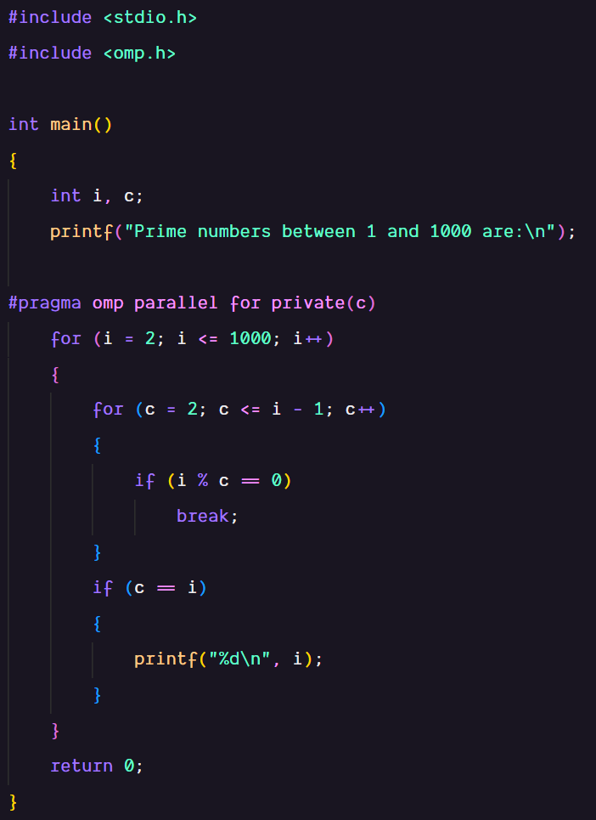
Output:
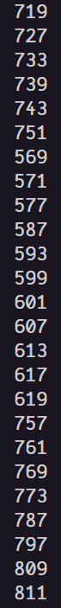
- Convert the above program so that it uses exactly 5 threads and each thread prints out their thread ID when they print out their prime number.
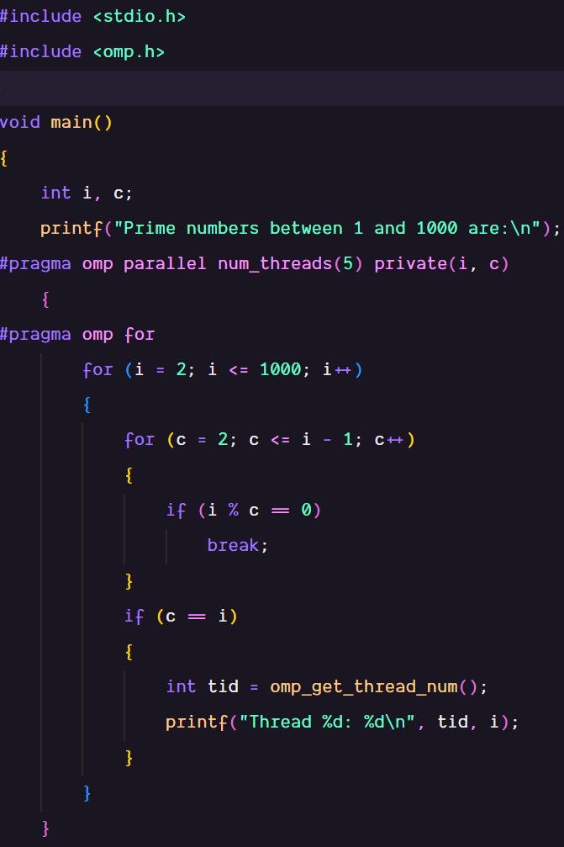
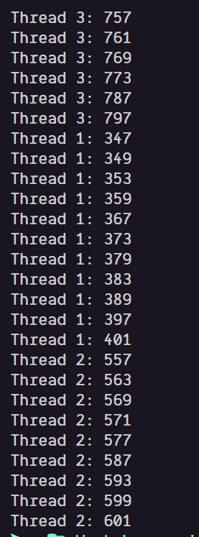
- Modify the program in (3) so that the program prints out the total number of prime numbers found. Check this whether this is correct by running it with exactly 1 thread.
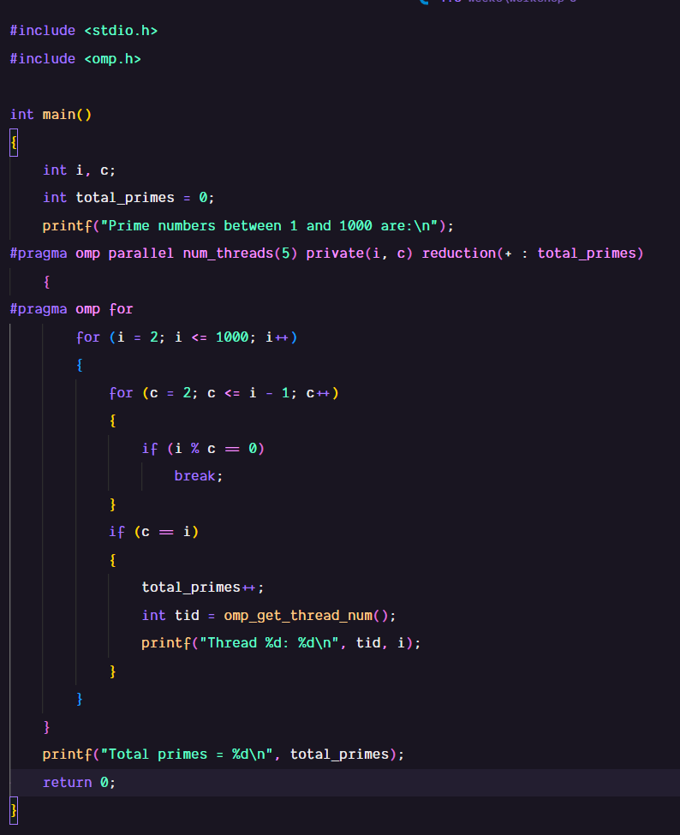
Output:
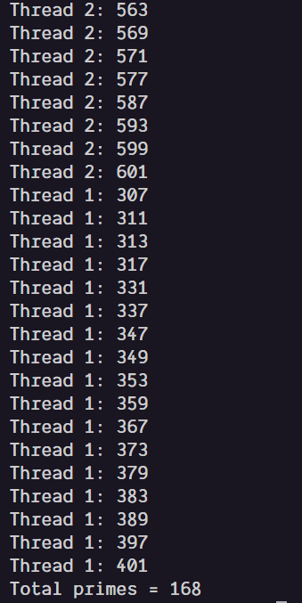
- The following PThreads program demonstrates 3 thread sending string messages to each other, using a global array. The messages are meant to be sent in the following order:
  - Thread 0 sends Thread 1 a message
  - Thread 1 receives the message
  - Thread 1 sends Thread 2 a message
  - Thread 2 receives the message
  - Thread 2 sends Thread 0 a message
  - Thread 0 receives the message
  - This then repeats from (a) 10 times

#include <stdio.h>
#include <stdlib.h>
#include <string.h>
#include <pthread.h>
#include <unistd.h>

char *messages[3] = {NULL, NULL, NULL};

void *messenger(void *p)
{
long tid = (long)p;
char tmpbuf[100];

for(int i=0; i<10; i++)
{
/* Sending a message */
long int dest = (tid + 1) % 3;
sprintf(tmpbuf,"Hello from Thread %ld!", tid);
char *msg = strdup(tmpbuf);
messages[dest] = msg;
printf("Thread %ld sent the message to Thread %ld\n",tid, dest);

/* Receiving a message */
printf("Thread %ld received the message '%s'\n",tid, messages[tid]);
free(messages[tid]);
messages[tid] = NULL;
}
return NULL;
}

void main()
{
pthread_t thrID1, thrID2, thrID3;

pthread_create(&thrID1, NULL, messenger, (void *)0);
pthread_create(&thrID2, NULL, messenger, (void *)1);
pthread_create(&thrID3, NULL, messenger, (void *)2);
pthread_join(thrID1, NULL);
pthread_join(thrID2, NULL);
pthread_join(thrID3, NULL);
}

Convert the program to using OpenMP instead of Pthreads.
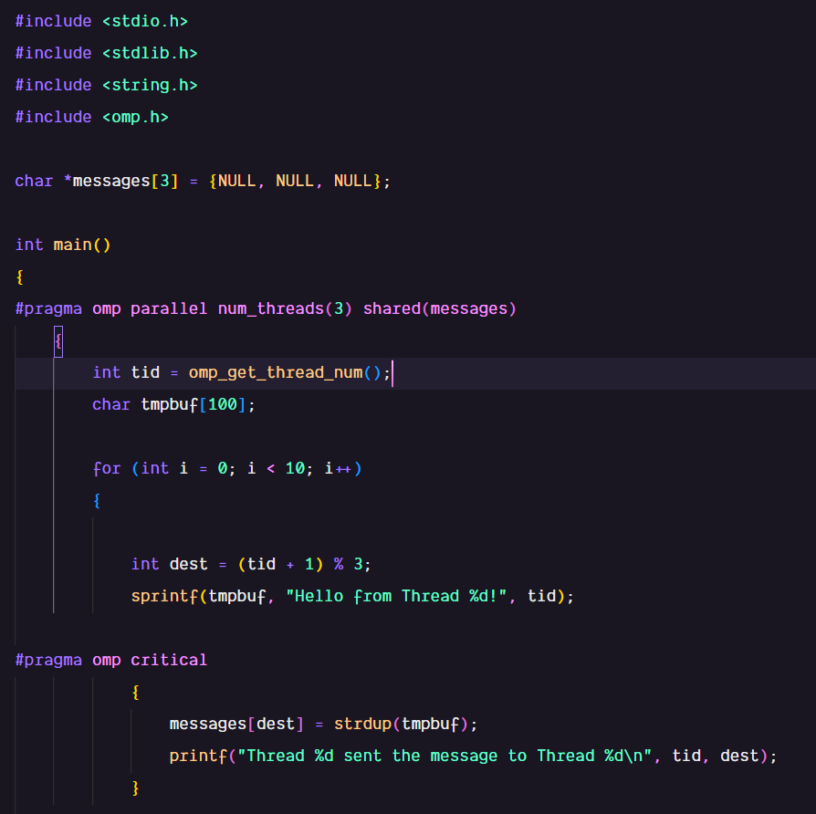
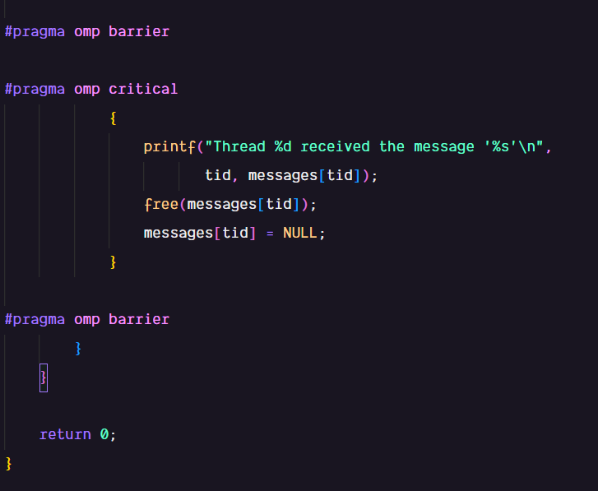
Output:
