University of Wolverhampton
School of Mathematics and Computer Science
Student Number: 2408842
Name: Samrajya Neupane
6CS005 High Performance Computing Week 3 Workshop
Revision on Multithreading
Tasks – Multithreading

You will need to refer to the Week 3 lecture sides in order to complete these tasks.
1. Write a multithreaded C program to print out all the prime numbers between 1 to 10000. Use exactly 3 threads.
Code:
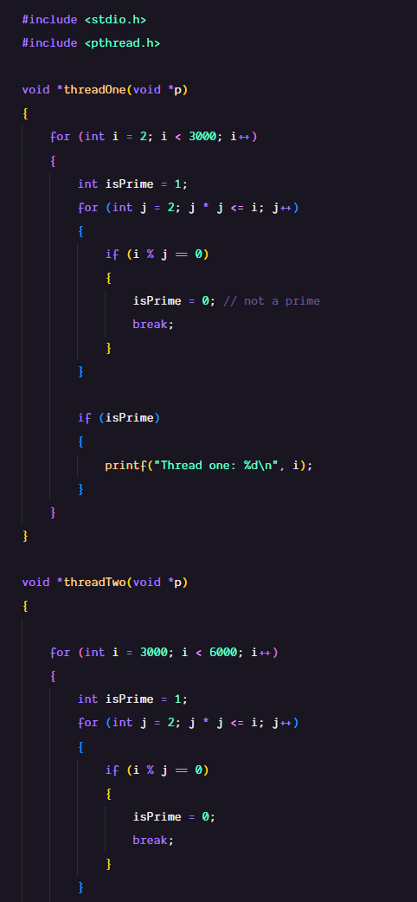
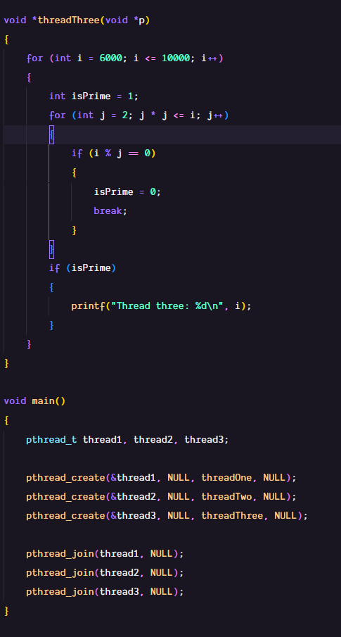
Output:
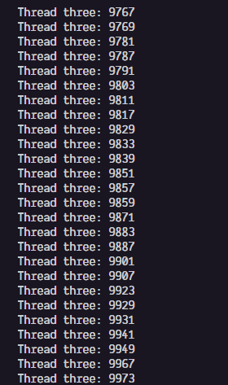
2. Convert this program to prompt the user for a number and then to create the number of threads the user has specified to find the prime numbers.
Code:
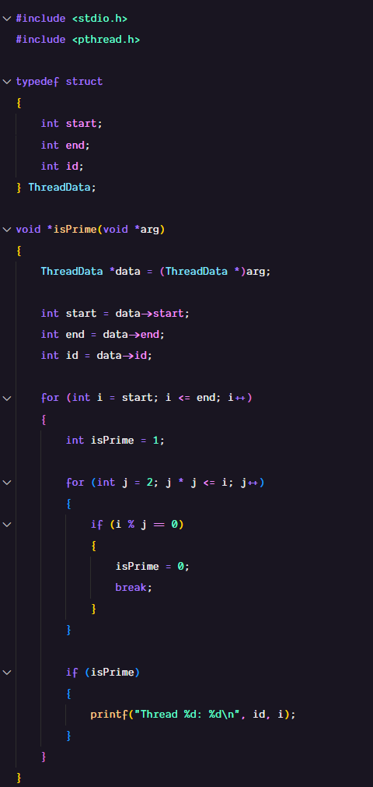
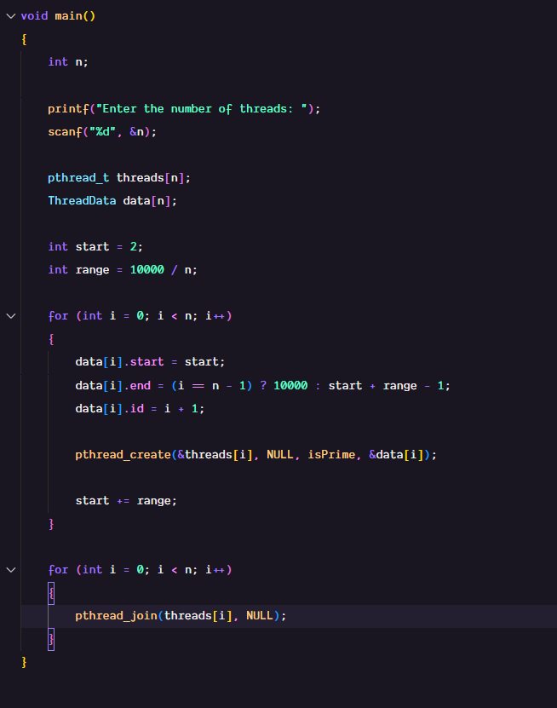

Output:
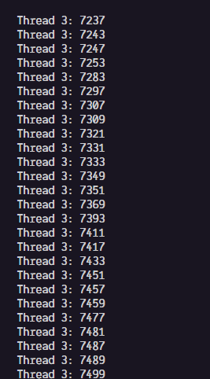
3. Convert the program in (2) so that each thread returns the number of prime numbers that it has found using pthread_exit() and for main program to print out the number of prime number that each thread has found.
Code:
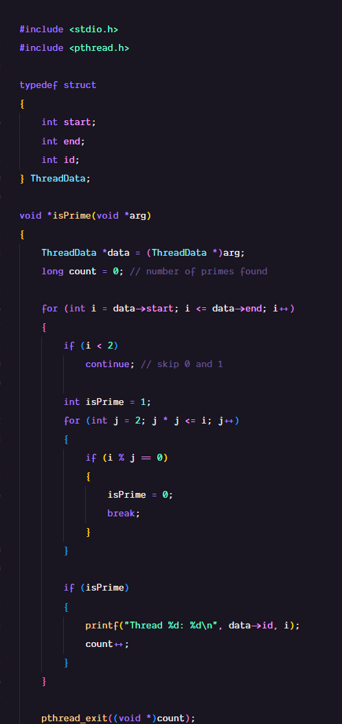
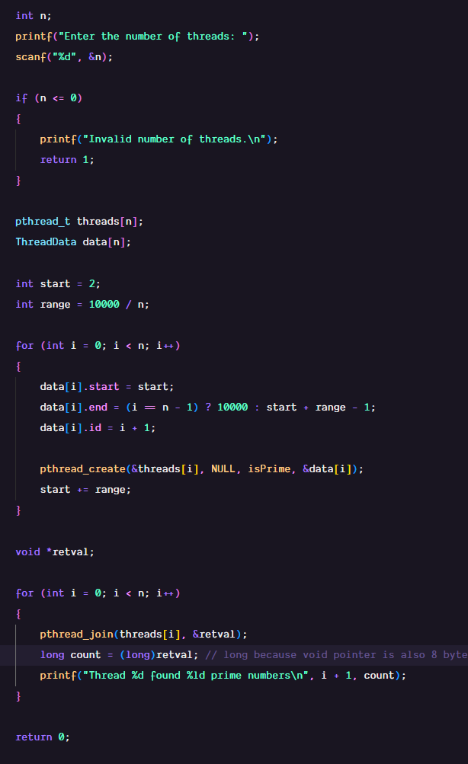
Output:
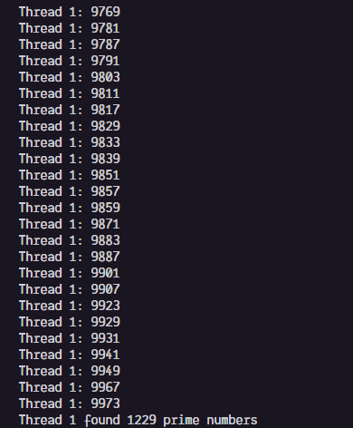
4. Convert the program in (3) to use pthread_cancel() to cancel all threads as soon as the 5th prime number has been found.
Code:
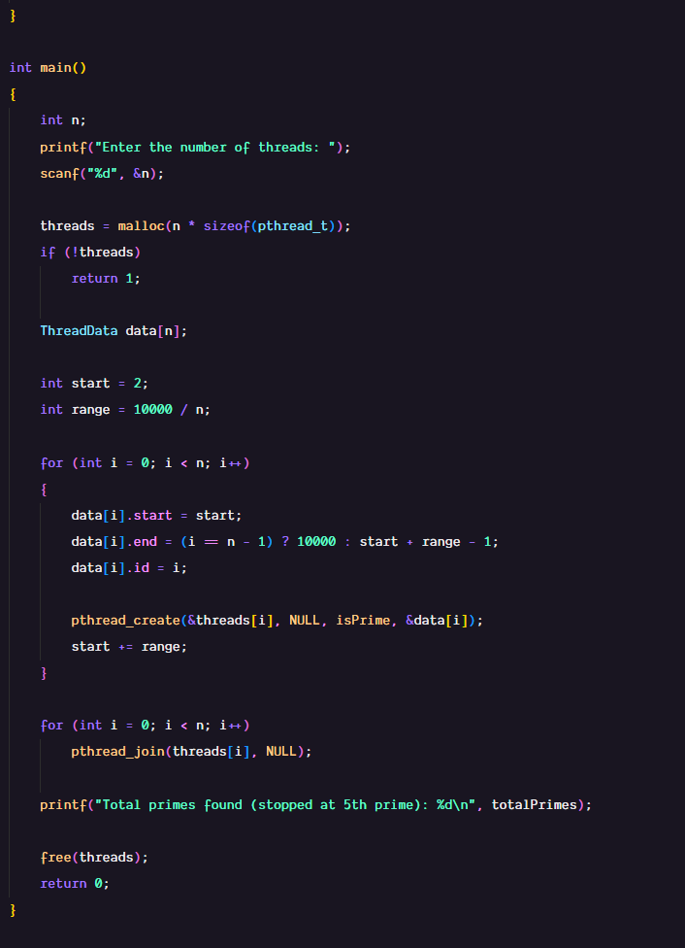
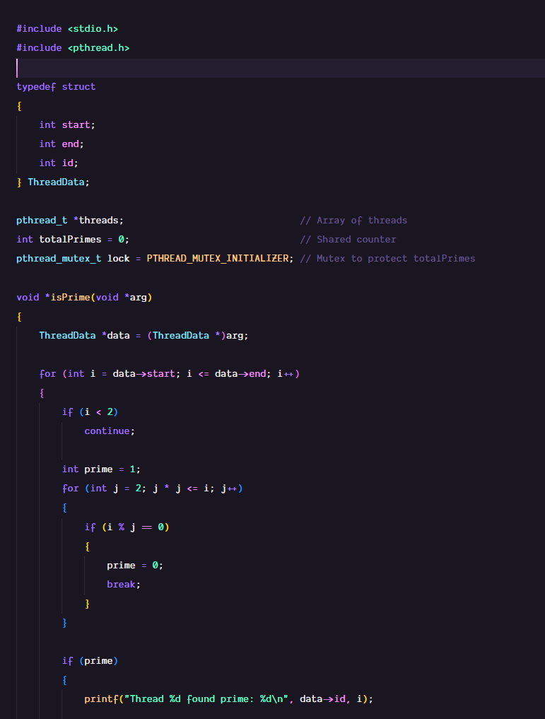
Output:
