University of Wolverhampton
School of Mathematics and Computer Science
Student Number: 2408842
Name: Samrajya Neupane
6CS005 High Performance Computing Week 3 Workshop
Revision on Multithreading
Tasks – Multithreading

You will need to refer to the Week 3 lecture sides in order to complete these tasks.
1. Write a multithreaded C program to print out all the prime numbers between 1 to 10000. Use exactly 3 threads.
Code:
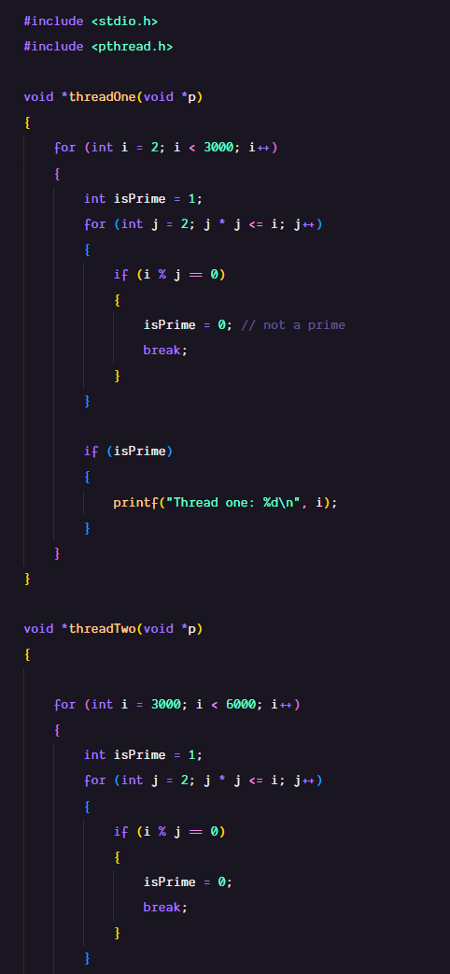
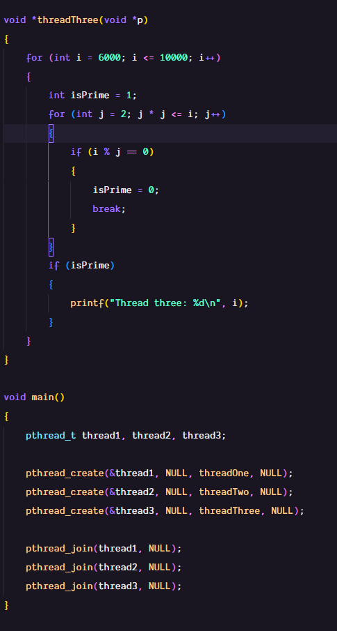
Output:
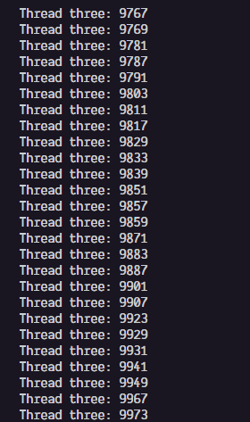
2. Convert this program to prompt the user for a number and then to create the number of threads the user has specified to find the prime numbers.
Code:
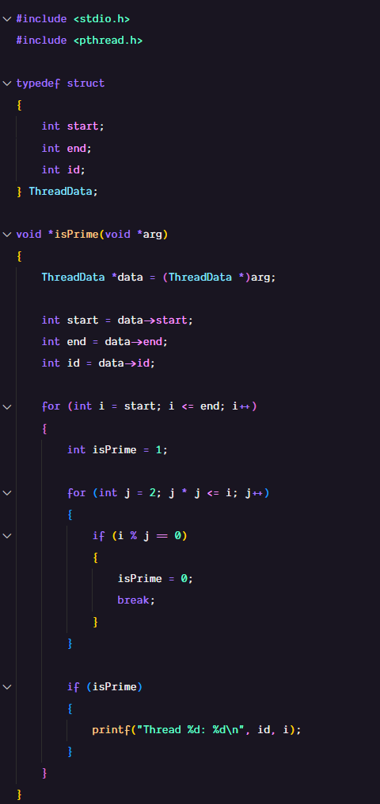
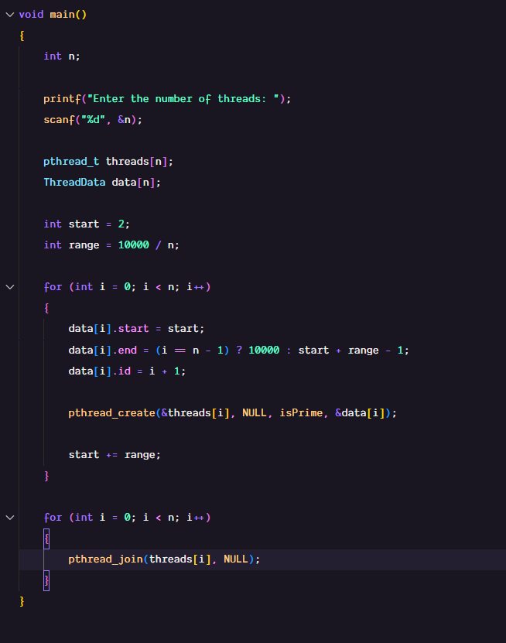

Output:
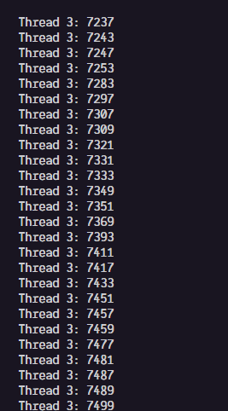
3. Convert the program in (2) so that each thread returns the number of prime numbers that it has found using pthread_exit() and for main program to print out the number of prime number that each thread has found.
Code:
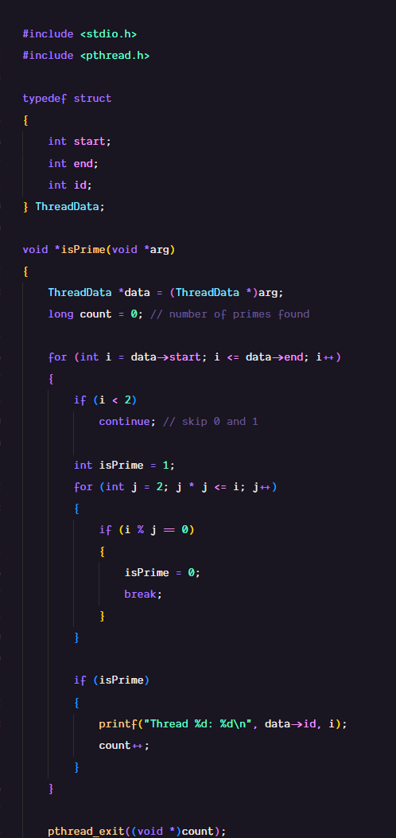
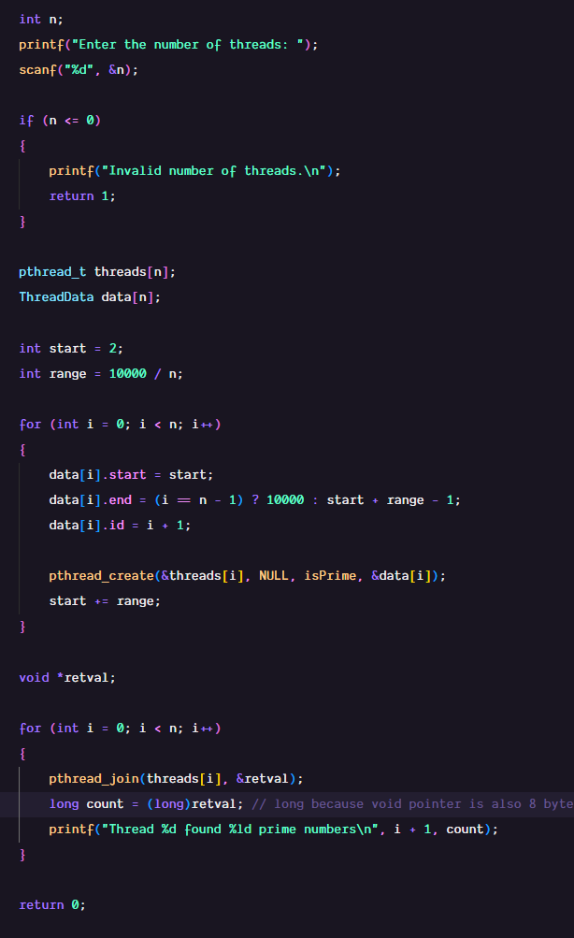
Output:
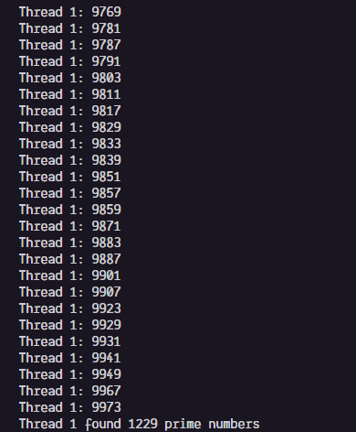
4. Convert the program in (3) to use pthread_cancel() to cancel all threads as soon as the 5th prime number has been found.
Code:
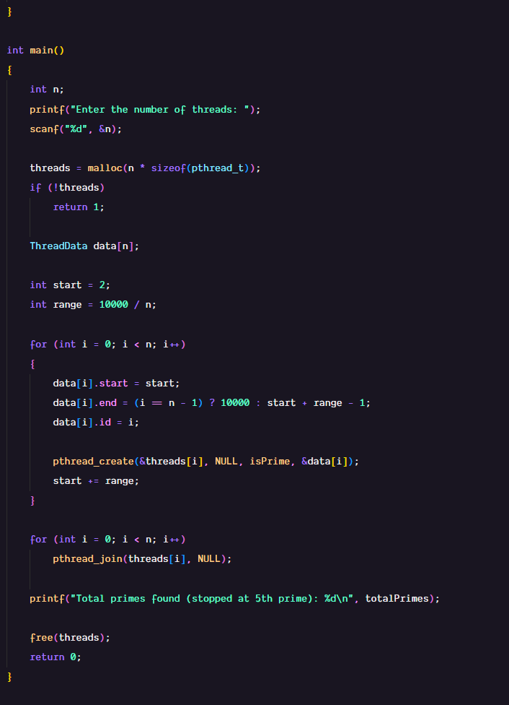
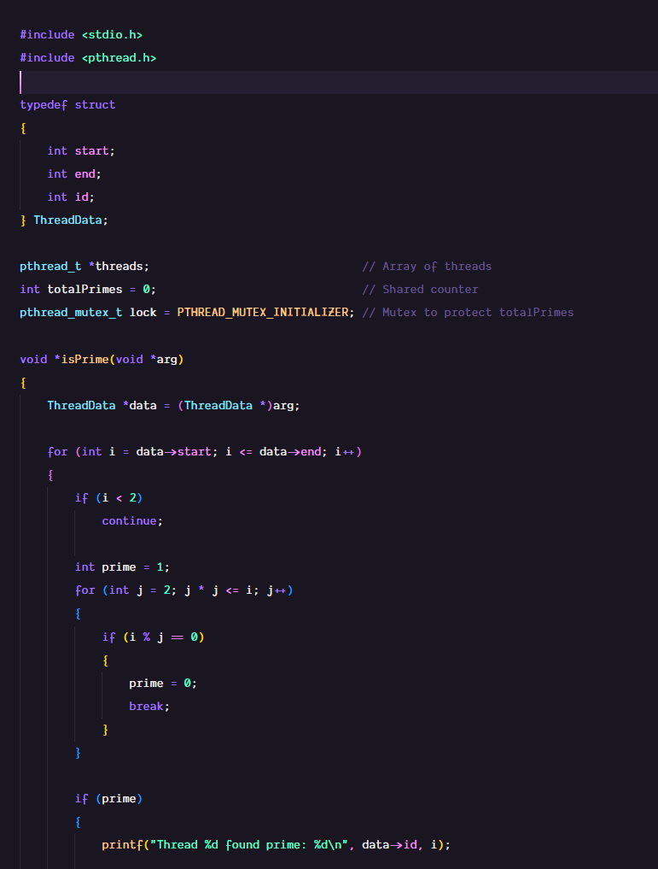
Output:
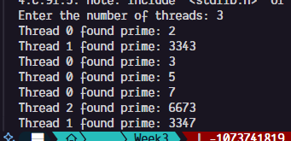

- In a banking system, multiple users can access and modify their accounts concurrently. Each user has a balance, and they can deposit or withdraw money. Modify the code below to use a mutex to prevent race conditions during balance updates and ensure that multiple users can't simultaneously update the balance of the same account.
typedef struct {
int accountNumber;
double balance;
} Account;

Account accounts[10];

void *withdraw(void *p) {
int accountId = *(int *)p;
double amount = 100; // Withdraw amount
accounts[accountId].balance -= amount;
}

void *deposit(void *p) {
int accountId = *(int *)p;
double amount = 100; // Deposit amount
accounts[accountId].balance += amount;
}

int main() {
pthread_t threads[20];
int ids[10];
// Create multiple threads to simulate transactions on the same account
for (int i = 0; i < 10; i++) {
ids[i] = i;
pthread_create(&threads[i], NULL, withdraw, &ids[i]);
pthread_create(&threads[i + 10], NULL, deposit, &ids[i]);
}
for (int i = 0; i < 20; i++) {
pthread_join(threads[i], NULL);
}
// Print final balance
for (int i = 0; i < 10; i++) {
printf("Account %d balance = %.2f\n", i, accounts[i].balance);
}
}
Code:
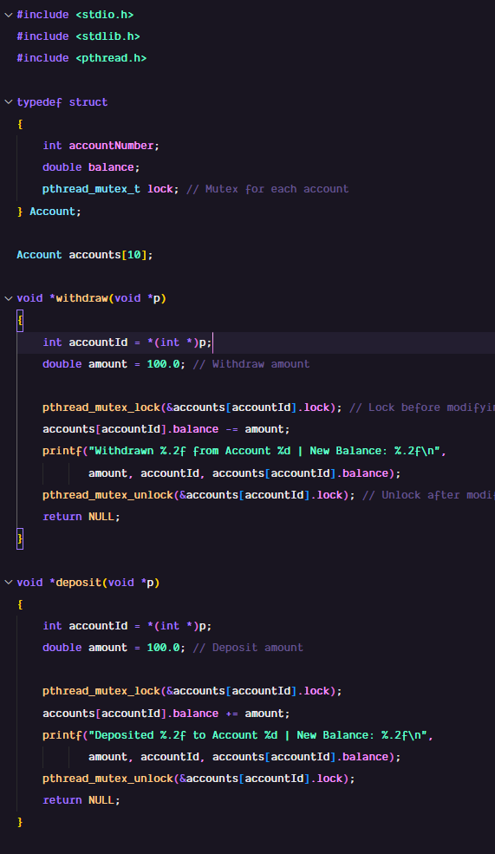
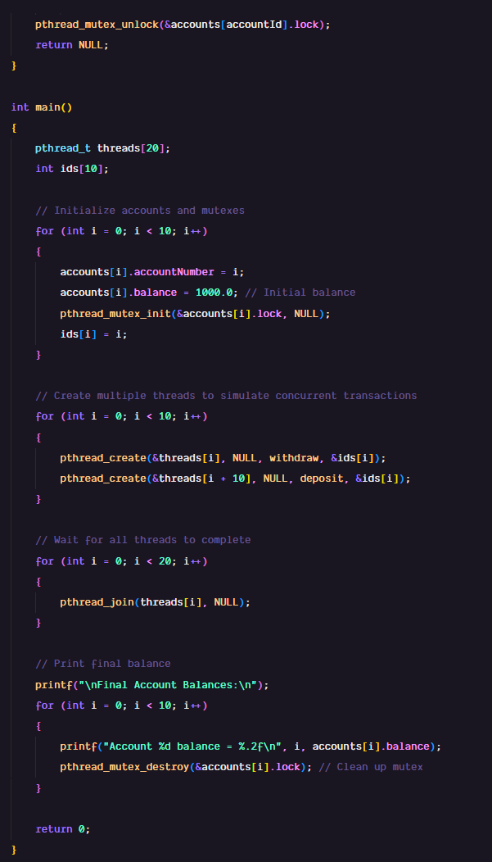
Output:
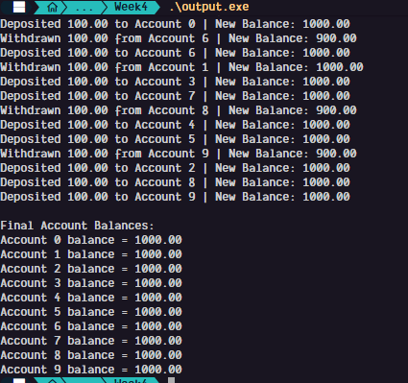
- A printer is shared among multiple users. Each user can either print a document or wait if the printer is in use. There are only 2 printers in the office. Use semaphores to manage the printer access, ensuring that no more than 2 users can print at the same time.
Code:
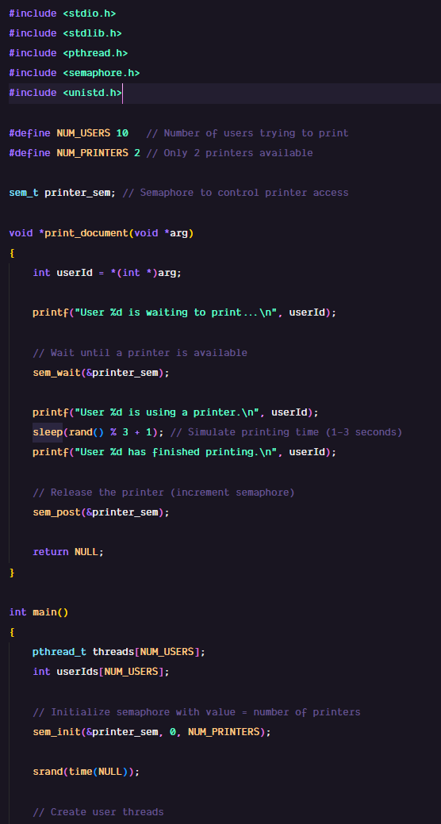
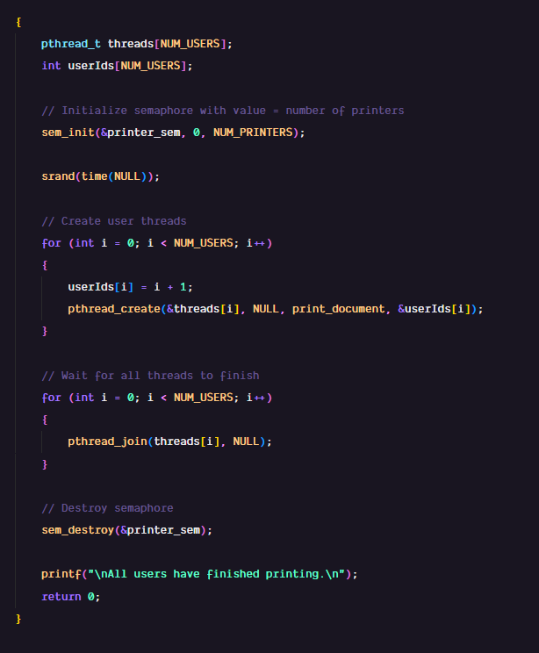
Output:
