# Software Requirements Specification

# for

**Object Detection System**

Version 1.0 approved

Prepared by **Samarth.M**

**Department of Information Technology, NITK**

**1 st January, 2018**

Table of Contents

**Table of Contents........................................................................................................................i**

**Revision History........................................................................................................................ii**

**1. Introduction...........................................................................................................................1**

1.1. Purpose................................................................................................................................1

1.2. Document Conventions.........................................................................................................1

1.3. Intended Audience and Reading Suggestions.........................................................................1

1.4. Product Scope .....................................................................................................................1

1.5 References ........................................................................................................................... 1

**2. Overall Description................................................................................................................2**

2.1. Product Perspective..............................................................................................................2

2.2. Product Functions ................................................................................................................2

2.3 User Classes and Characteristics........................................................................................... 2

2.4 Operating Environment ........................................................................................................ 2

2.5. Design and Implementation Constraints................................................................................3

2.6. User Documentation ............................................................................................................3

2.7. Assumptions and Dependencies.............................................................................................3

**3. External Interface Requirements..........................................................................................4**

3.1 User Interfaces ..................................................................................................................... 4

3.2. Hardware Interfaces ............................................................................................................ 4

3.3. Software Interfaces ............................................................................................................. 4

3.4 Communications Interfaces .................................................................................................. 4

**4. System Features.................................................................................................................... 5**

4.1 Description and Priority ....................................................................................................... 5

4.1.1 Live Face Detection .......................................................................................................... 5

4.1.2 Feature Generalization Mode ............................................................................................ 5

4.2 Functional Requirements ...................................................................................................... 5

**5. Other Functional Requirements ......................................................................................... 6**

5.1 Performance Requirements .................................................................................................. 6

5.2 Safety Requirements ............................................................................................................ 6

5.3 Security Requirements ......................................................................................................... 6

5.4 Software Quality Attributes .................................................................................................. 6

5.5 Business Rules ..................................................................................................................... 6

**6. Other Requirements ............................................................................................................ 7**

**Appendix A:Glossary .............................................................................................................. 7 Appendix B:Analysis Models................................................................................................... 8**

Revision History

|  |  |  |  |
| --- | --- | --- | --- |
| **Name** | **Date** | **Reason For Changes** | **Version** |
| Samarth.M | 27/2/18 | Add diagrams | 2 |
|  |  |  |  |

# Introduction

## Purpose

The purpose of this project is to recognize objects either from an image or live webcam feed accurately and efficiently.

## Document Conventions

This document follows MLA Format. Bold-faced text has been used to emphasize section and

sub-section headings. The remainder of the document will be written using the standard font,

New Times Roman.

## Intended Audience and Reading Suggestions

This document will be helpful to

1. Users who will understand the capabilities of the software

2. Developers can easily understand where their efforts should be targeted to improve or

add more features

## Product Scope

Object Detection can be used in numerous applications. It can be used in simple traffic analysis. It is intensively used in self driving car. It also gives an insight on how humans recognize objects. It can be used in Security cameras to monitor all activities.

## References

1. https://github.com/tensorflow/models/tree/master/research/object_detection

2. https://tryolabs.com/blog/2017/08/30/object-detection-an-overview-in-the-age-of-deep-learning/

# Overall Description

## Product Perspective

The object detection software is a new self-contained software product that is used

for recognizing various objects belonging to different classes like phone, television, humans,etc.

A total of 100 objects can be detected.

## Product Functions

The major functions of the product are:

- Accepts picture or takes live capture of the surrounding

- Performs possible area detection

- Recognition/classification of objects using deep learning algorithms

The major functions the user can perform are:

-Upload a picture

-Take a live capture of the surrounding with the help of the software

## User Classes and Characteristics

There are two type of users.

1. Personal users who want to detect objects for fun.

2. Businesses who want to detect and monitor the surrounding for various applications.

## Operating Environment

This product is built for Linux operating system with i5 or higher processor,2.0 megapixel

webcam, 4GB of RAM, Opencv 2.4.9 or later, Tkinter, Tensorflow or Keras. These are the

minimum requirements.

## Design and Implementation Constraints

This system is developed in Python with the help of OpenCV library for image processing

and Tensorflow and Keras libraries for deep learning. Tkinter is used for developing for the

GUI.

## User Documentation

On-line quick start guide – HTML Webpage

User manual – Portable Document Format

## Assumptions and Dependencies

The Object Detection software has the following dependencies:

Python

OpenCV

Tkinter/PyQt(for GUI)

Tensorflow / Keras

# External Interface Requirements

## User Interfaces

The GUI gives two options

1. Recognize Objects from image

2. Recognize Objects from live webcam feed

The user interfaces will feature two buttons where each one will lead to either one of the

above functions.

## Hardware Interfaces

The laptop's webcam or an external webcam is used to gather live video feed or an image

from which we can process and detect objects in the picture. The mouse or track pad is

used to select the options from the GUI menu.

## Software Interfaces

Software used - Python, OpenCV 2.4.9 or later,Tensorflow,Keras,Tkinter

Operating system - Linux

OpenCV 2.4.9 or later is used to process images or videos. Tkinter is a python library which helps to develop hassle-free GUIs. Tensorflow and Keras are libraries that help to implement deep learning algorithms.

## Communications Interfaces

There are no communication components in this product.

# System Features

## Live Object Detection

**4.1.1 Description and Priority**

Allows the user to detect objects from a live feed. Priority 9

**4.1.2 Stimulus/Response Sequences**

The image is extracted from the webcam and passed to the neural network and the result is displayed.

**4.1.3 Functional Requirements**

REQ-1: Webcam

## Detect Objects from Images

**4.2.1 Description and Priority**

Allows the user to detect objects from a an uploaded Image.

**4.2.2 Stimulus/Response Sequences**

The user selects an image from a folder and it is passed to the neural network fro recognition and the result is displayed.

**4.2.3 Functional Requirements**

REQ-1: Select Button to select Image

# Other Nonfunctional Requirements

## Performance Requirements

While using the live feed to do object detection , the detection and display should be extremely fast and should be done in real time.If the system is not fast enough then the fps will be very low. Objects have to be detected with high accuracy and localized properly.

## Safety Requirements

The Ram should be enough so that the system does not hang.

## Security Requirements

There are no security requirements.

## Software Quality Attributes

The software should have no dependencies and must be easy to use and navigation must be direct.

# Other Requirements

All the major requirements are mentioned in functional and non-functional requirement's

sections.

Appendix A: Glossary

Image - A picture of an object

Live webcam feed - Video of the actions that are happening in real time

GUI - Graphical User Interface by which the user interacts with the product

Software Requirements Specification - A document that completely describes all of the functions

of a proposed system and the constraints under which it must operate. For example, this document.

Appendix B: Analysis Models

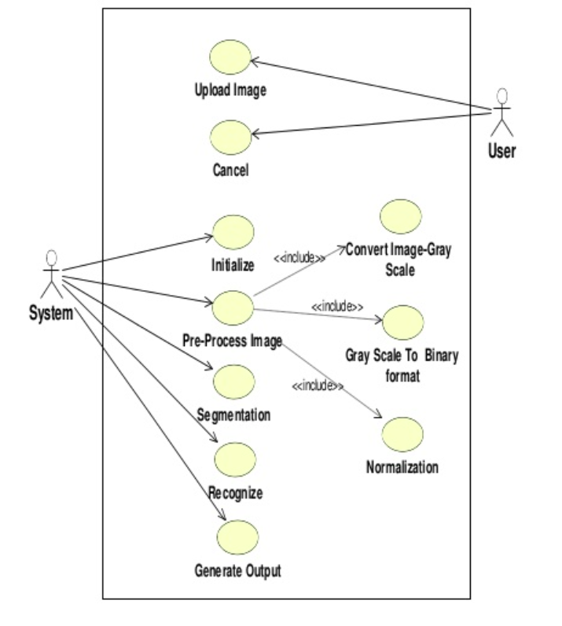

**Use Case Diagram**

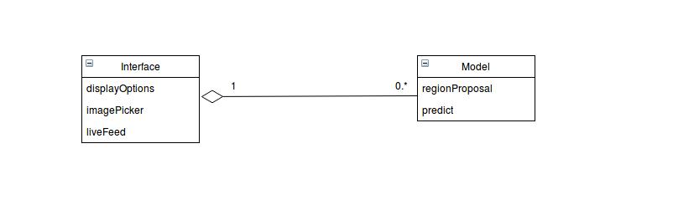

**Class Diagram**

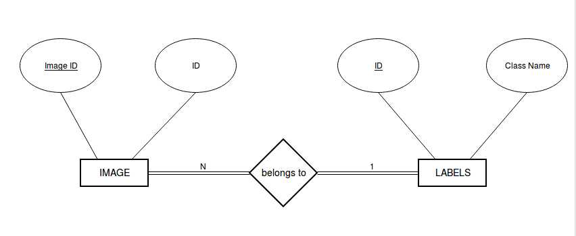**ER Diagram**

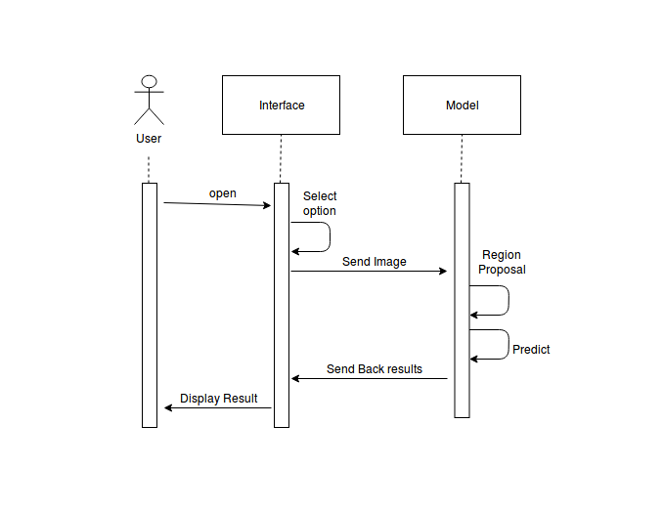**Sequence Diagram**

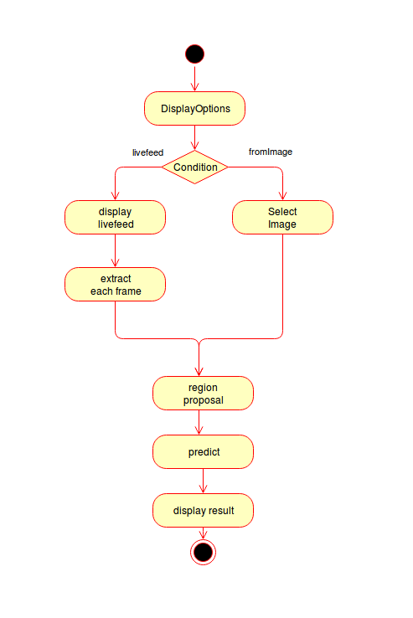

**Activity Diagram**