Software Requirements Specification
for

Object Detection System

Version 1.0 approved
Prepared by Samarth.M
Department of Information Technology, NITK

1 st January, 2018
Table of Contents
Table of Contents........................................................................................................................i
Revision History........................................................................................................................ii
1. Introduction...........................................................................................................................1
1.1. Purpose................................................................................................................................1
1.2. Document Conventions.........................................................................................................1
1.3. Intended Audience and Reading Suggestions.........................................................................1
1.4. Product Scope .....................................................................................................................1
1.5 References ........................................................................................................................... 1
2. Overall Description................................................................................................................2
2.1. Product Perspective..............................................................................................................2
2.2. Product Functions ................................................................................................................2
2.3 User Classes and Characteristics........................................................................................... 2
2.4 Operating Environment ........................................................................................................ 2
2.5. Design and Implementation Constraints................................................................................3
2.6. User Documentation ............................................................................................................3
2.7. Assumptions and Dependencies.............................................................................................3
3. External Interface Requirements..........................................................................................4
3.1 User Interfaces ..................................................................................................................... 4
3.2. Hardware Interfaces ............................................................................................................ 4
3.3. Software Interfaces ............................................................................................................. 4
3.4 Communications Interfaces .................................................................................................. 4
4. System Features.................................................................................................................... 5
4.1 Description and Priority ....................................................................................................... 5
4.1.1 Live Face Detection .......................................................................................................... 5
4.1.2 Feature Generalization Mode ............................................................................................ 5
4.2 Functional Requirements ...................................................................................................... 5
5. Other Functional Requirements ......................................................................................... 6
5.1 Performance Requirements .................................................................................................. 6
5.2 Safety Requirements ............................................................................................................ 6
5.3 Security Requirements ......................................................................................................... 6
5.4 Software Quality Attributes .................................................................................................. 6
5.5 Business Rules ..................................................................................................................... 6
6. Other Requirements ............................................................................................................ 7
Appendix A:Glossary .............................................................................................................. 7 Appendix B:Analysis Models................................................................................................... 8
Revision History
Name | Date | Reason For Changes | Version
Samarth.M | 27/2/18 | Add diagrams | 2

Introduction

Purpose
The purpose of this project is to recognize objects either from an image or live webcam feed accurately and efficiently.

Document Conventions
This document follows MLA Format. Bold-faced text has been used to emphasize section and
sub-section headings. The remainder of the document will be written using the standard font,
New Times Roman.

Intended Audience and Reading Suggestions
This document will be helpful to

1. Users who will understand the capabilities of the software
2. Developers can easily understand where their efforts should be targeted to improve or
add more features

Product Scope
Object Detection can be used in numerous applications. It can be used in simple traffic analysis. It is intensively used in self driving car. It also gives an insight on how humans recognize objects. It can be used in Security cameras to monitor all activities.

References
1. https://github.com/tensorflow/models/tree/master/research/object_detection
2. https://tryolabs.com/blog/2017/08/30/object-detection-an-overview-in-the-age-of-deep-learning/

Overall Description

Product Perspective
The object detection software is a new self-contained software product that is used
for recognizing various objects belonging to different classes like phone, television, humans,etc.
A total of 100 objects can be detected.

Product Functions
The major functions of the product are:

- Accepts picture or takes live capture of the surrounding
- Performs possible area detection
- Recognition/classification of objects using deep learning algorithms

The major functions the user can perform are:

-Upload a picture
-Take a live capture of the surrounding with the help of the software

User Classes and Characteristics
There are two type of users.
1. Personal users who want to detect objects for fun.
2. Businesses who want to detect and monitor the surrounding for various applications.

Operating Environment
This product is built for Linux operating system with i5 or higher processor,2.0 megapixel
webcam, 4GB of RAM, Opencv 2.4.9 or later, Tkinter, Tensorflow or Keras. These are the
minimum requirements.

Design and Implementation Constraints
This system is developed in Python with the help of OpenCV library for image processing
and Tensorflow and Keras libraries for deep learning. Tkinter is used for developing for the
GUI.

User Documentation
On-line quick start guide – HTML Webpage
User manual – Portable Document Format

Assumptions and Dependencies
The Object Detection software has the following dependencies:
Python
OpenCV
Tkinter/PyQt(for GUI)
Tensorflow / Keras

External Interface Requirements

User Interfaces
The GUI gives two options
1. Recognize Objects from image
2. Recognize Objects from live webcam feed
The user interfaces will feature two buttons where each one will lead to either one of the
above functions.

Hardware Interfaces
The laptop's webcam or an external webcam is used to gather live video feed or an image
from which we can process and detect objects in the picture. The mouse or track pad is
used to select the options from the GUI menu.

Software Interfaces
Software used - Python, OpenCV 2.4.9 or later,Tensorflow,Keras,Tkinter
Operating system - Linux
OpenCV 2.4.9 or later is used to process images or videos. Tkinter is a python library which helps to develop hassle-free GUIs. Tensorflow and Keras are libraries that help to implement deep learning algorithms.

Communications Interfaces
There are no communication components in this product.

System Features

Live Object Detection
4.1.1 Description and Priority
Allows the user to detect objects from a live feed. Priority 9
4.1.2 Stimulus/Response Sequences
The image is extracted from the webcam and passed to the neural network and the result is displayed.
4.1.3 Functional Requirements
REQ-1: Webcam

Detect Objects from Images
4.2.1 Description and Priority
Allows the user to detect objects from a an uploaded Image.
4.2.2 Stimulus/Response Sequences
The user selects an image from a folder and it is passed to the neural network fro recognition and the result is displayed.
4.2.3 Functional Requirements
REQ-1: Select Button to select Image

Other Nonfunctional Requirements

Performance Requirements
While using the live feed to do object detection , the detection and display should be extremely fast and should be done in real time.If the system is not fast enough then the fps will be very low. Objects have to be detected with high accuracy and localized properly.

Safety Requirements
The Ram should be enough so that the system does not hang.

Security Requirements
There are no security requirements.

Software Quality Attributes
The software should have no dependencies and must be easy to use and navigation must be direct.

Other Requirements
All the major requirements are mentioned in functional and non-functional requirement's
sections.
Appendix A: Glossary
Image - A picture of an object
Live webcam feed - Video of the actions that are happening in real time
GUI - Graphical User Interface by which the user interacts with the product
Software Requirements Specification - A document that completely describes all of the functions
of a proposed system and the constraints under which it must operate. For example, this document.
Appendix B: Analysis Models

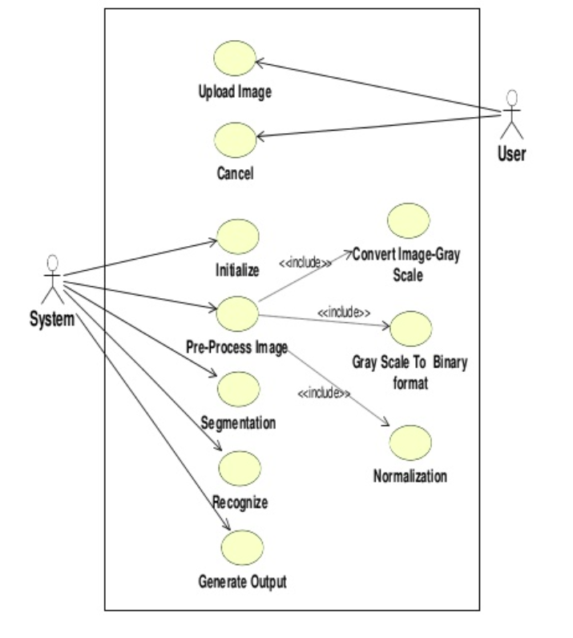

Use Case Diagram
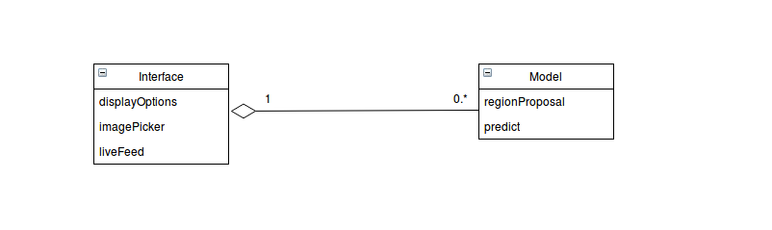

Class Diagram

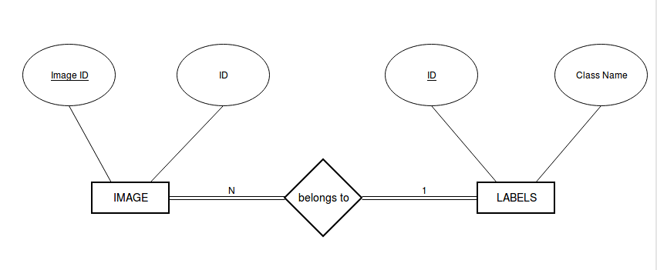
ER Diagram

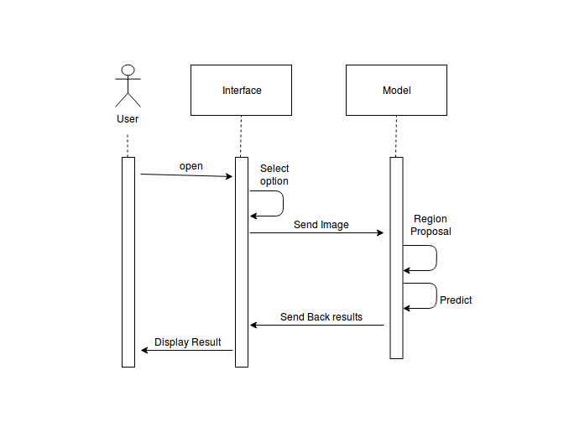
Sequence Diagram

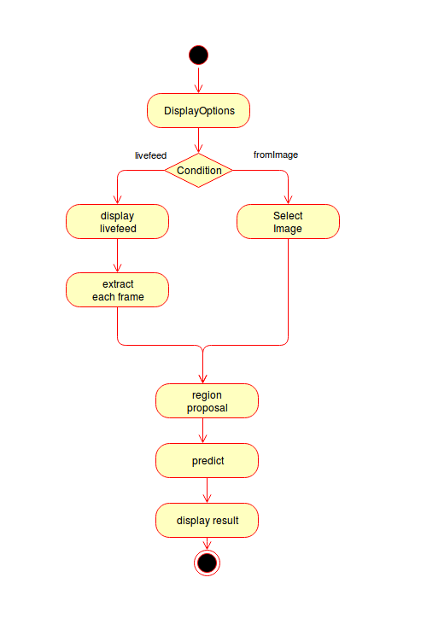

Activity Diagram

