Creating a Legend for the CDL Image in ArcGIS

Note: If you have downloaded CDL data from CropScape, then you will need to perform the steps in this first paragraph, which details how to add category names to a .tif image downloaded from CropScape in ESRI’s ArcGIS ArcMap application:

The CDL .tif file contains the category values but not the category names. For ESRI’s ArcGIS ArcMap application to display the category names, download the file: generic_cdl_attributes.tif.vat.dbf. This generic file contains all possible CDL colors and category names. As long as the .tif file and the .tif.vat.dbf file have the same file name, then the category names will load automatically in ArcMap. So change the file name (not extension) of the generic_cdl_attributes.tif.vat.dbf to match the file name of the downloaded CDL .tif file. Then add the .tif file as a layer in ArcMap. The category names will display in the Table of Contents window. Example 1 - If the downloaded .tif file is: _NASS_DATA_CACHE_CDL_2010_clip_20110307142903_862761787.tif Change the generic_cdl_attributes.tif.vat.dbf file name to: _NASS_DATA_CACHE_CDL_2010_clip_20110307142903_862761787.tif.vat.dbf Example 2 – If you renamed the downloaded .tif file to MyCDL.tif, then rename the generic_cdl_attributes.tif.vat.dbf file name to MyCDL.tif.vat.dbf.

1) Open ArcGIS and add the .tif or .img file to the map document:

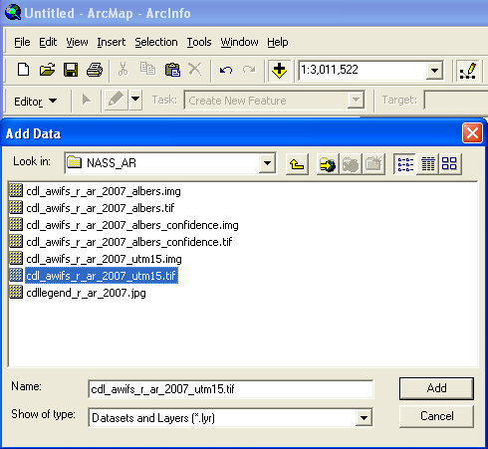

2) Right click the image in the table of contents to get the Layer Properties form.

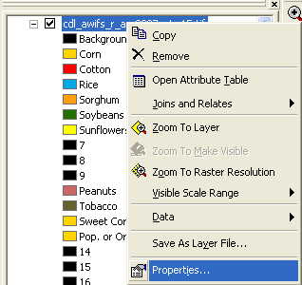

3) Select the Symbology tab. The Colormap will display:

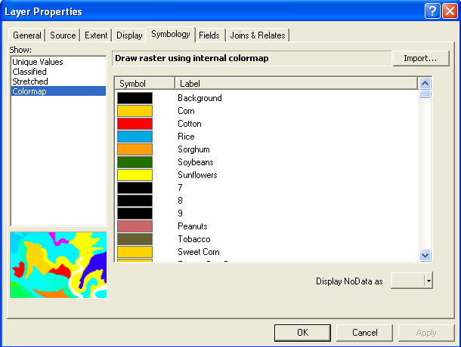

4) Select Unique Values. The Value Field will be set to Class_names and the colors will NOT be correct:

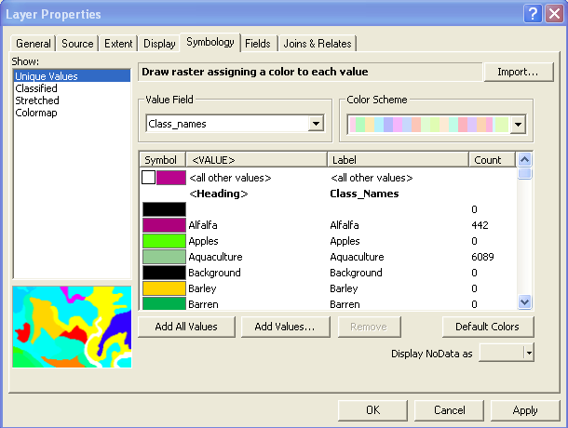

5) Use the pulldown arrow on the Value Field and select Value. The legend will only display numbers, not class names:

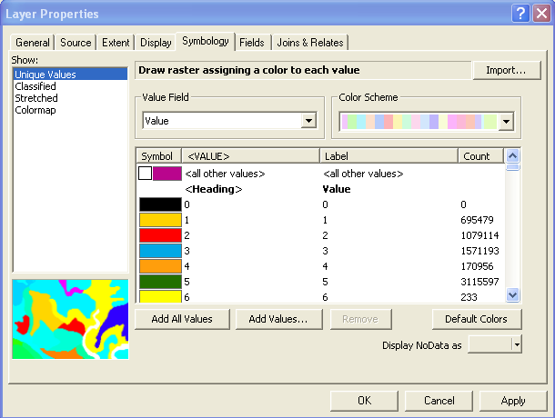

6) Again, use the pulldown arrow again on the Value Field and select Class_names. The legend displays the class names with the correct colors:

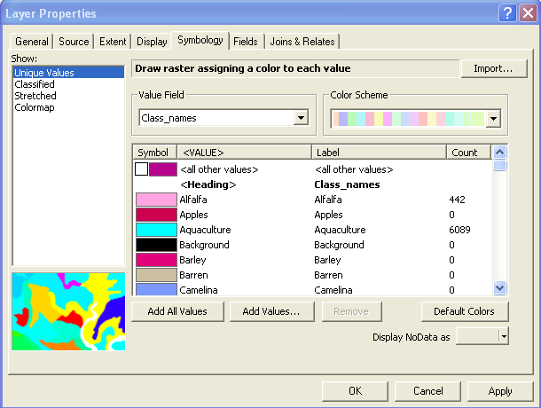

7) To remove classes with zero pixels (Count is 0), use the cursor to select a class and click the Remove button:

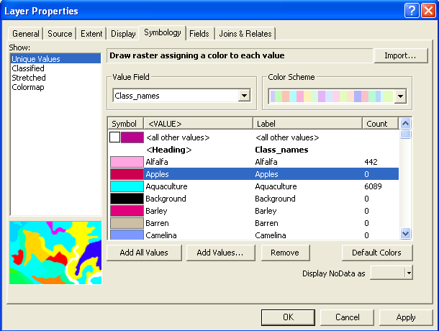

8) Remove all classes with zero pixels and then click OK button:

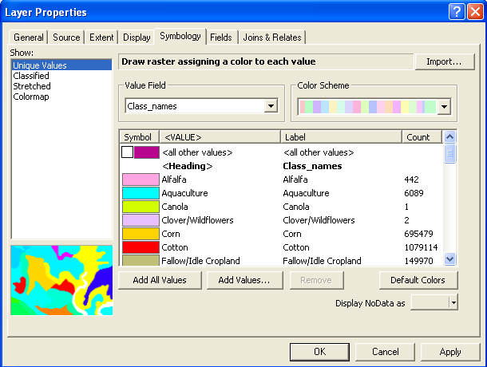

9) To save the image’s color scheme to a layer file, right click the image in the table of contents and select “Save As Layer file …” and specify a directory and .lyr file name, then Save. The .lyr file can be imported to colorize the image (Layer Properties > Symbology tab > Import button). However, the classes with zero pixel counts must be removed prior to importing the .lyr file (see steps 7 and 8).

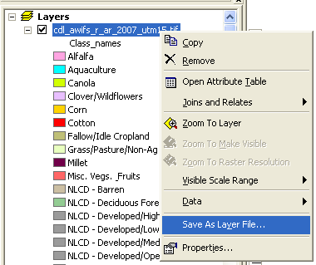

10) Switch to the map layout view and insert the legend. To remove classes with the same colors, convert the legend to graphics, ungroup the graphics, and delete the class symbol and associated text. There is no automatic method to order classes by pixel count – this must be done by interactively reordering the legend classes.

