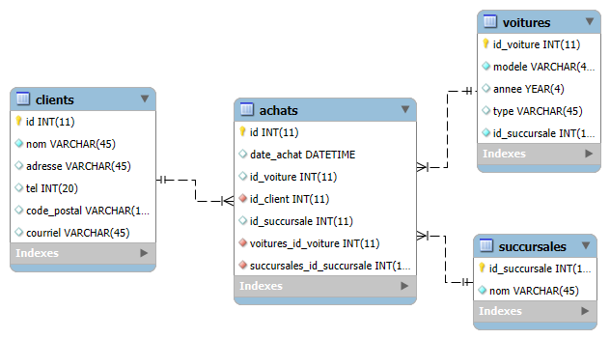

-- -----------------------------------------------------

-- Table `test`.`clients`

-- -----------------------------------------------------

CREATE TABLE IF NOT EXISTS `test`.`clients` (

`id` INT(11) NOT NULL AUTO_INCREMENT,

`nom` VARCHAR(45) NOT NULL,

`adresse` VARCHAR(45) NULL DEFAULT NULL,

`tel` VARCHAR(20) NULL DEFAULT NULL,

`code_postal` VARCHAR(10) NULL DEFAULT NULL,

`courriel` VARCHAR(45) NULL DEFAULT NULL,

PRIMARY KEY (`id`))

ENGINE = InnoDB

AUTO_INCREMENT = 15

DEFAULT CHARACTER SET = utf8;

-- -----------------------------------------------------

-- Table `test`.`achats`

-- -----------------------------------------------------

CREATE TABLE IF NOT EXISTS `TEST`.`achats` (

`id_achat` INT(11) NOT NULL,

`date_achat` DATE NULL,

`id_client` INT(11) NOT NULL,

`id_succursale` INT(11) NOT NULL,

`id_voiture` INT(11) NOT NULL,

PRIMARY KEY (`id_achat`),

INDEX `fk_achats_clients1_idx` (`id_client` ASC) VISIBLE,

INDEX `fk_achats_succursales1_idx` (`id_succursale` ASC) VISIBLE,

INDEX `fk_achats_voitures1_idx` (`id_voiture` ASC) VISIBLE,

CONSTRAINT `fk_achats_clients1`

FOREIGN KEY (`id_client`)

REFERENCES `TEST`.`clients` (`id`)

ON DELETE NO ACTION

ON UPDATE NO ACTION,

CONSTRAINT `fk_achats_succursales1`

FOREIGN KEY (`id_succursale`)

REFERENCES `TEST`.`succursales` (`id_succursale`)

ON DELETE NO ACTION

ON UPDATE NO ACTION,

CONSTRAINT `fk_achats_voitures1`

FOREIGN KEY (`id_voiture`)

REFERENCES `TEST`.`voitures` (`id_voiture`)

ON DELETE NO ACTION

ON UPDATE NO ACTION)

ENGINE = InnoDB

AUTO_INCREMENT = 15

DEFAULT CHARACTER SET = utf8

-- -----------------------------------------------------

-- Table `test`.`succursales`

-- -----------------------------------------------------

CREATE TABLE IF NOT EXISTS `TEST`.`succursales` (

`id_succursale` INT(11) NOT NULL AUTO_INCREMENT,

`nom` VARCHAR(45) NOT NULL,

`id_voiture` INT(11) NOT NULL,

PRIMARY KEY (`id_succursale`))

ENGINE = InnoDB

AUTO_INCREMENT = 15

DEFAULT CHARACTER SET = utf8

-- -----------------------------------------------------

-- Table `test`.`voitures`

-- -----------------------------------------------------

CREATE TABLE IF NOT EXISTS `TEST`.`voitures` (

`id_voiture` INT(11) NOT NULL,

`modele` CHAR(45) NOT NULL,

`annee` DATE NULL,

`type` VARCHAR(45) NULL,

PRIMARY KEY (`id_voiture`))

ENGINE = InnoDB

AUTO_INCREMENT = 15

DEFAULT CHARACTER SET = utf8