AHSANULLAH UNIVERSITY OF SCIENCE AND TECHNOLOGY (AUST)

141 & 142, Love Road, Tejgaon Industrial Area, Dhaka-1208.



Department of Computer Science and Engineering

Program: Bachelor of Science in Computer Science and Engineering

**Project Final Report**

Course No: CSE-1200

Course Title: Software Development – I

Project Title: Build Rush

Date of Submission:  25/09/25

Submitted to

Saha Reno

Assistant Professor, Department of CSE, AUST.

Mustofa Ahmed

Lecturer, Department of CSE, AUST.

Submitted by,

Name: S.M. Talha Jubeir

Student ID:  00724105101079

Name: Sammyo Chakroborty

Student ID:  00724105101082

Name: Tanveer Shahriar

Student ID: 00724105101091

**Introduction**

**1.1 Project Overview**

Build Rush is a 2D tower-stacking game and arcade-style construction game designed for both single player and multiplayer gameplay. The game challenges players to drop blocks accurately to construct tall towers while balancing precision and timing. It introduces both single-player and multiplayer modes, providing competitive and cooperative experiences. The game emphasizes strategy, hand-eye coordination, and score optimization through a unique point-based system.

**1.2 Objective**

* To design and implement a 2D tower-building game with smooth mechanics.
* To integrate single-player and multiplayer functionality for varied gameplay.
* To introduce a progressive point-based scoring system that rewards accurate stacking.
* To deliver an engaging experience through increasing difficulty and competitive play.

**Game Development**

**2.1 Tools & Technologies Used**

* **Programming Language:** C, C++
* **IDE:** Visual Studio (2010/2013 or later)
* **Graphics Library:** iGraphics
* **Platform:** Windows PC

**2.2 Core Features**

* **Single Player Mode:** Build the tallest possible tower by stacking blocks one after another.
* **Multiplayer Mode:** Two players compete in real time to construct their towers; the highest-scoring tower wins.
* **Point System:**
* Dropping 1 block in a row = 1 point
* Dropping 2 consecutive blocks in a row = 3 points
* Dropping 3 consecutive blocks in a row = 5 points
* After 3 consecutive rows, the scoring resets and repeats the cycle.
* **Progressive Difficulty:** The swinging speed of blocks increases gradually, making placement more challenging.
* **Game Over Condition:** The game ends if the tower collapses due to a misaligned drop.

**Implementation Details**

**3.1 Code Structure**

The program is organized into modular files:

* **main.c** – Initializes the game and manages global flow.
* **player.c** – Handles block dropping and tower building logic.
* **multiplayer.c** – Implements multiplayer controls and scoring updates.
* **scoring.c** – Manages the point system and leaderboard.
* **graphics.c – Renders blocks, towers, and background animations.**

**3.2 Challenges Faced & Solutions**

|  |  |
| --- | --- |
| **Challenge** | **Solution** |
| Synchronizing multiplayer gameplay | Implemented independent timers for each player |
| Point system resetting incorrectly | Added modular arithmetic to loop scoring logic |
| Blocks clipping through the tower base | Introduced collision checks with boundaries |
| Increasing difficulty felt unbalanced | Adjusted block swing speed in incremental steps |

**Screenshots**

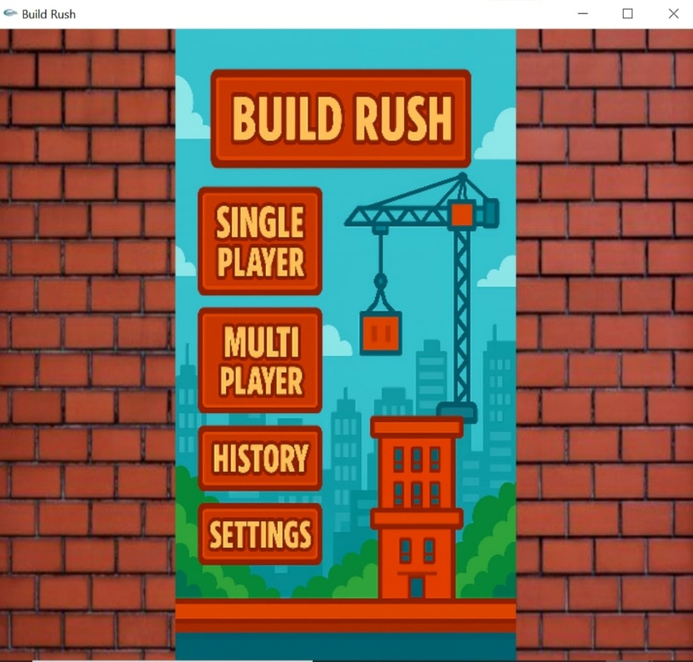

**Figure 1: Menu Bar Display**

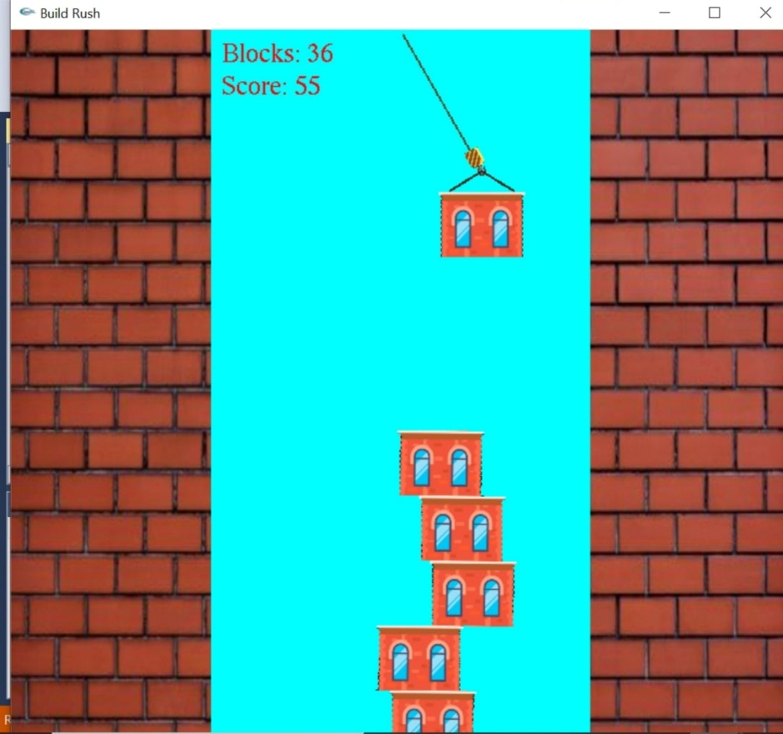

**Figure 2: Single Player mode**

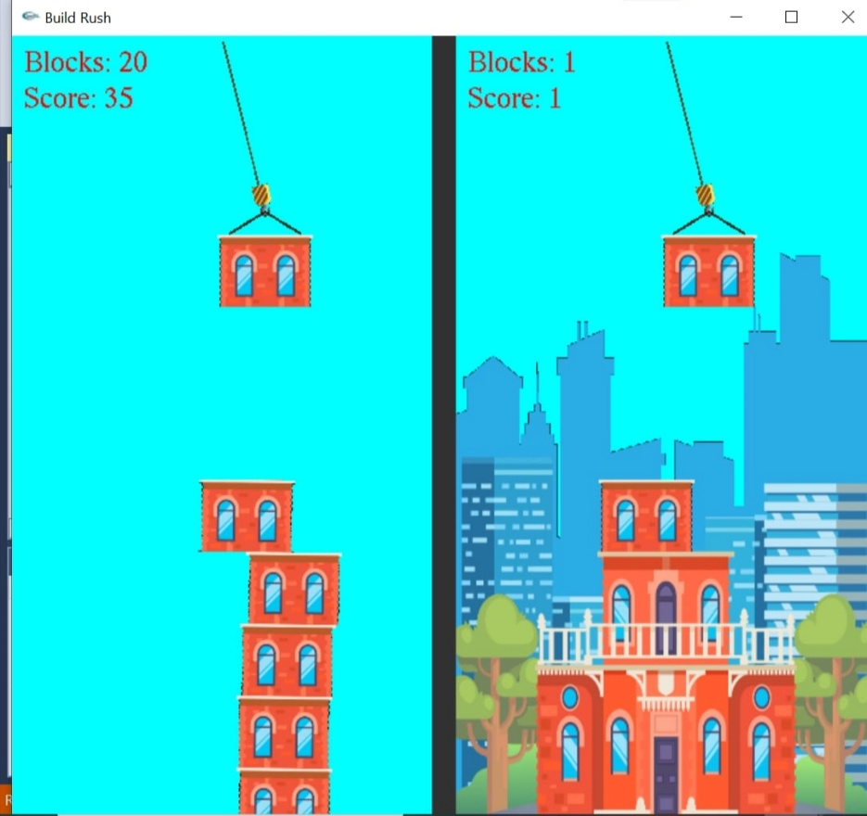

**Figure 3: Multiplayer mode**

**Conclusion & Future Improvements**

**5.1 Summary**

Build Rush successfully reimagines the classic tower-stacking experience by integrating a fresh point-based scoring system and multiplayer support. The modular design ensures smooth gameplay, while iGraphics provides a responsive environment for rendering dynamic animations.

**5.2 Future Enhancements**

* **Online Multiplayer:** Enable gameplay over the internet instead of only local multiplayer.
* **Power-Ups:** Introduce stability boosts, slow-motion drops, or double points.
* **Enhanced Visuals:** Add animated backgrounds, particle effects, and improved block textures.
* **Mobile Port:** Adapt the game for Android/iOS platforms to reach a wider audience.