

BOMGAR
Support Representative Operation Runbook

Prepared By : | Pawan Sharma
Version Number : | 0.1
Effective Date : | April, 2018

TABLE OF CONTENT
TABLE OF CONTENT 2
Revision History 3
Document Reviewers 4
Document Approvers 4
Document Distribution List 4
1. Objective 5
2. Installing the Representative Console 5
3. How to Use the Representative Console 7
4. Settings 8
5. Session start options – Session Key 11
6. Screen sharing 12
7. Session Tools 13
8. Security Recommendations 15

Revision History
Version Number | Revision Date | Nature of Revision | Revised By | Approval Date

Document Reviewers
Reviewer Name | Reviewer Organization/Department/Role | Email contact
Project Manager

Document Approvers
Approver Name | Approver Organization/Department/Role | Email contact

Document Distribution List
Name | Organization/Department | Email contact

.

Objective
This guide is designed to help the support team to do the following:
- Use the support representative portal
- Setup console and use it on machine
- Explore support representative portal options
- Operation for taking session
- Different settings at support representative console

Installing the Representative Console
The Bomgar Representative Console will be used by the desktop support team which will require the user remote desktop sessions for troubleshooting. Please follow the steps mentioned below to install the console.

- Open internet browser and go to https://remotesupport.pg.com/saml
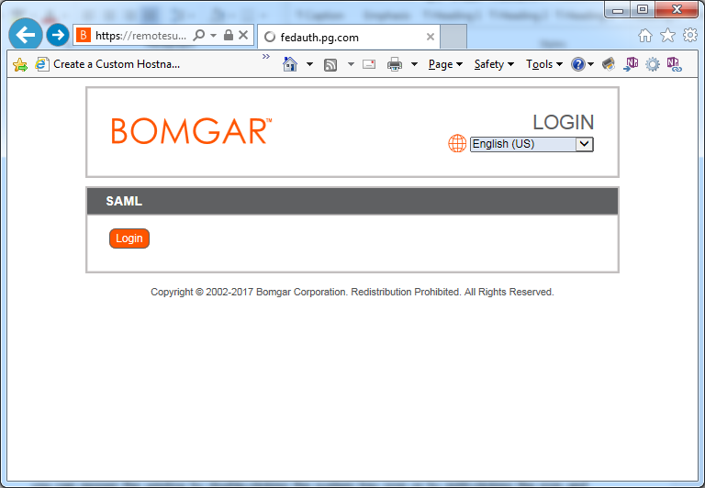
- Click on Login in SAML box.
- You will be taken to the Ping ID page, please provide your Ping login details and authenticate.
- Download the Bomgar representative console. Choose the right version for your operating system.
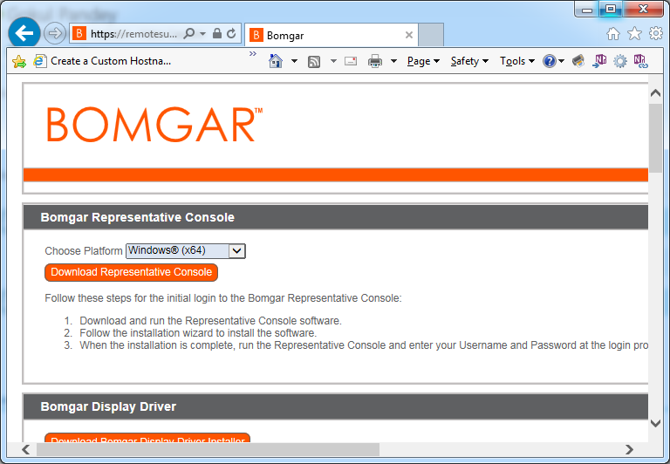

- Install the console and go to programsBomgar and launch Bomgar representative console.

How to Use the Representative Console
After installing the Bomgar representative console, log in by double-clicking the Bomgar system tray icon or by right-clicking the icon and selecting Login. If the system tray icon is not available, you can launch the representative console from its directory location as defined during installation.

At the prompt, select SAML credentials on ‘Authenticate using’ login using the Ping credentials. If you close the representative console but remain logged in, you can reopen the window by double-clicking the system tray icon or by right-clicking the icon and selecting Show Window

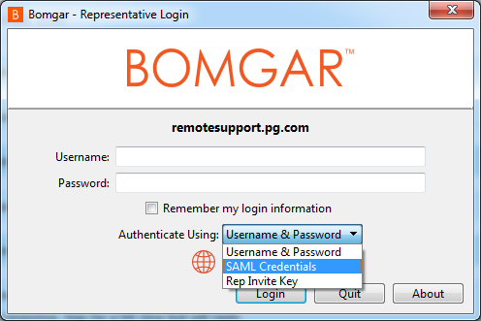

Settings
Below is the screeshsot of the Bomgar representative console.

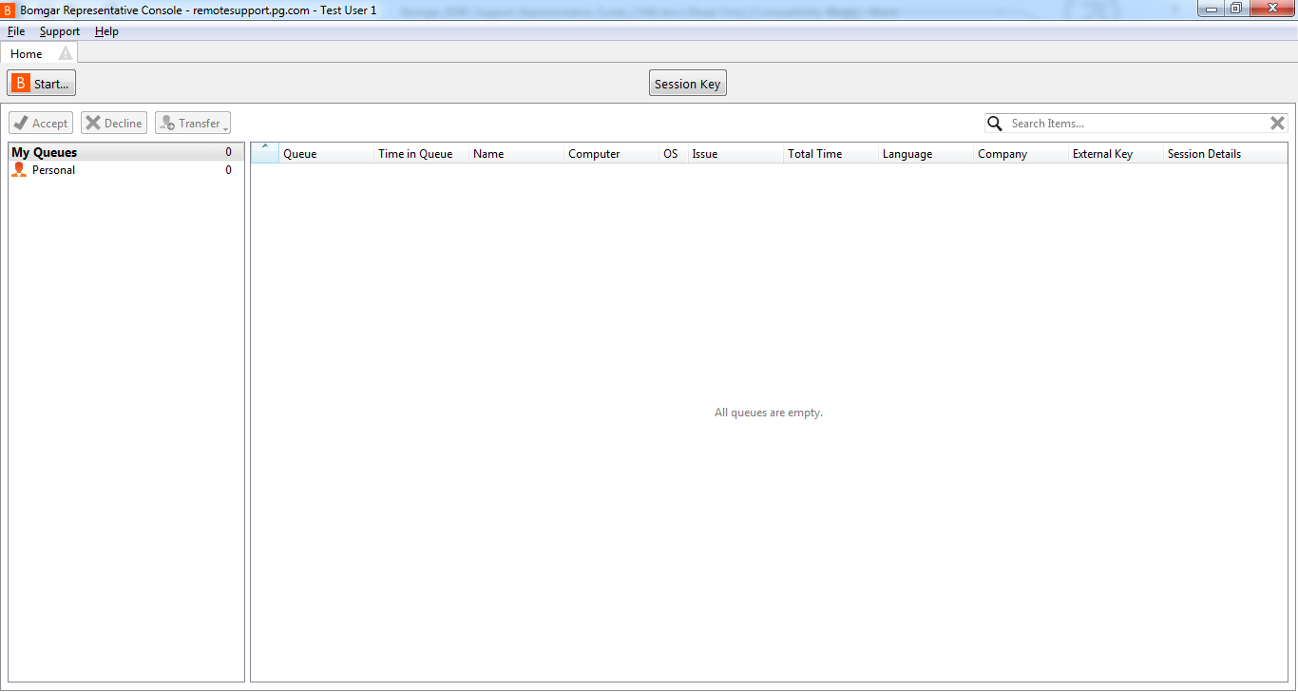

Click on File and then Settings in the upper left-hand corner of the representative console to configure your preferences. From the General tab, choose a visual theme. When a customer enters one of your queues or an open session requires attention, you can choose to have the tab flash or to hear a chime. If System Beep is checked, your default system sound will override the chime to alert you when an automatically assigned session invitation is about to expire. On the Support tab, choose whether you want to start sessions with chat only or to immediately request screen sharing.

When a customer enters your personal queue entering a session key on the public site, the session can start immediately or wait for your acceptance. You can also choose to open sessions as tabs in the representative console or as new windows. If automatic session assignment is disabled on login, then you will not be assigned sessions automatically until you choose to opt in. For situations where you might experience issues because a customer’s secure desktop is enabled, you can be prompted when the session begins to elevate to run with administrative rights. Set the default resolution and size for a screen sharing session. When screen sharing starts, you can automatically enter full screen mode, which in turn can automatically collapse the chat bar. When you show your screen to a customer during a session, you can choose to leave the representative console open or to minimize it to your taskbar.

For easier file transferring, set the default directory from which you wish to start browsing your local file system. Set the number of lines to save in the command shell history. If you select Show Quick Start Button, you will see a Start button at the top of your queues. Clicking this button walks you through the ways your customer can start a support session. You can also choose to display a button to enable one-click session key generation. Set whether pinning a Jump Client should automatically prompt for a password to be set.
From the Presentation tab, you can choose to leave the representative console open or to minimize it to your taskbar when giving a presentation to one or more attendees. You can also choose to display a button to start a new presentation with one click.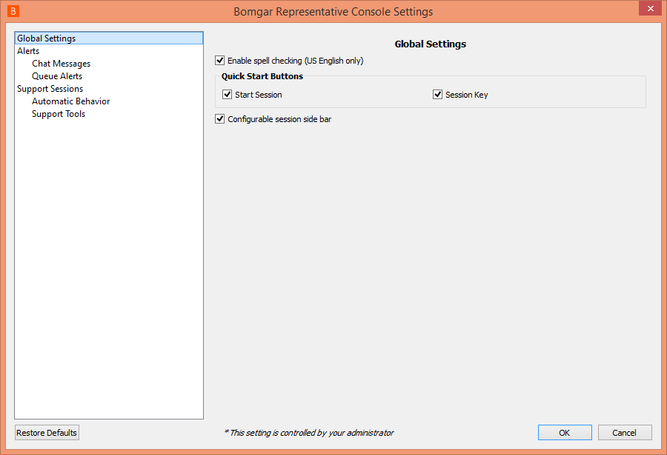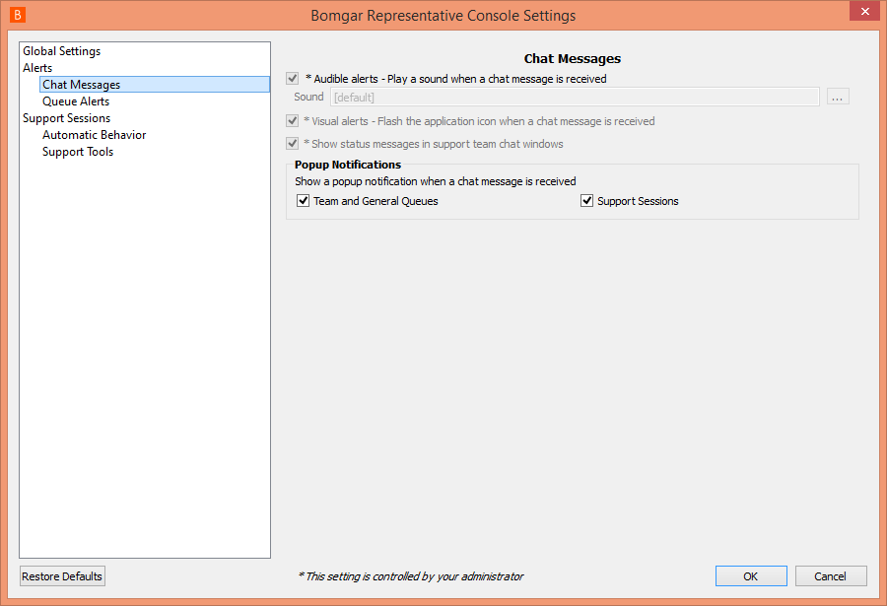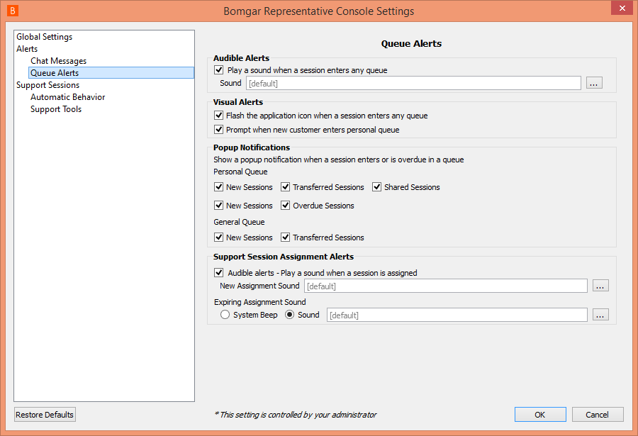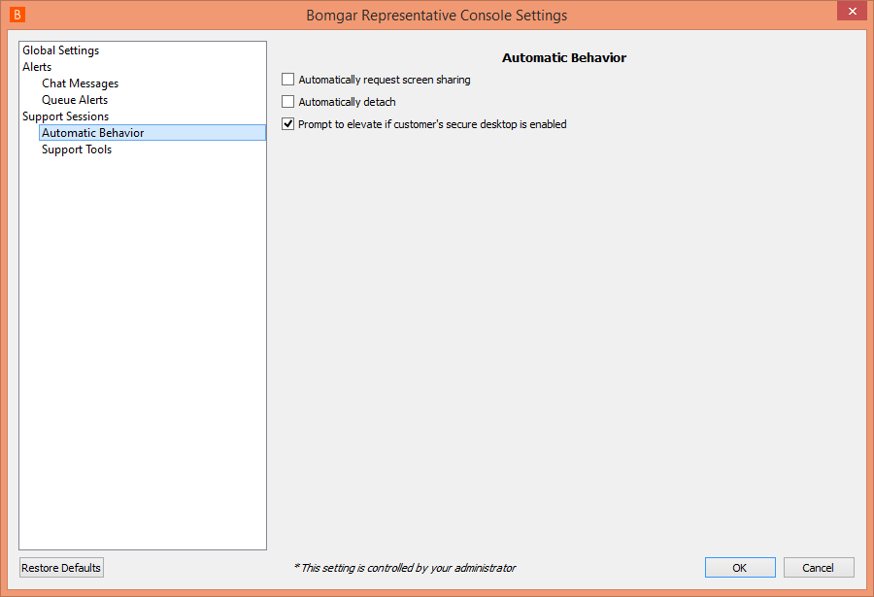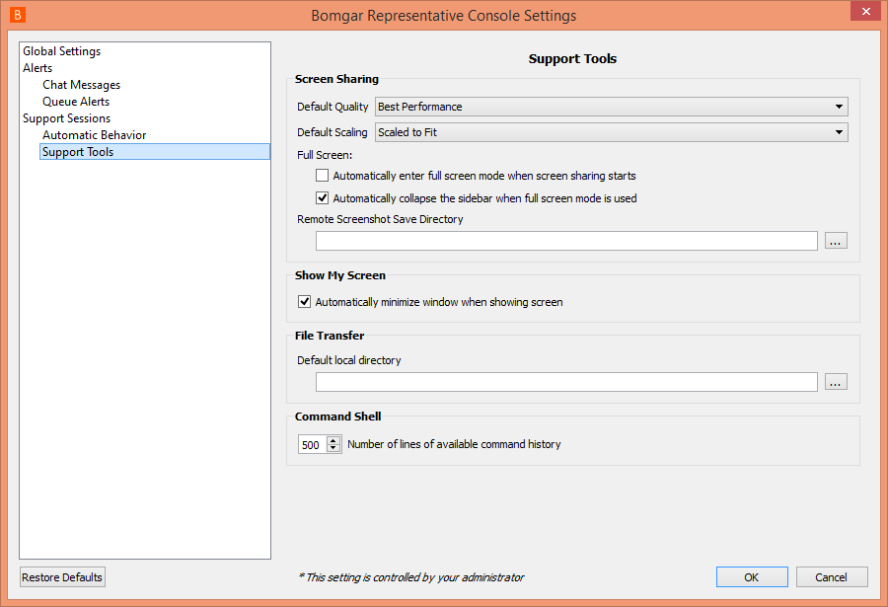

Session start options – Session Key
To initiate a session, agent will have to generate a session key by clicking on the ‘Session Key’ button on the representative console.

This session key can be given to the employee on the phone or an email can be sent with the link using the Send Local Email button.

The URL can also be shared using the Live Station chat if the employee is already on a Live session.

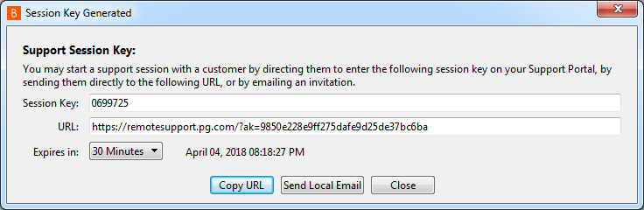

Screen sharing
Double click on the user profile from your or general queue. From the session window, click the Screen Sharing button to request control of the remote computer (below is the screenshot). Full screen sharing requests view or control of the customer’s entire desktop and all applications

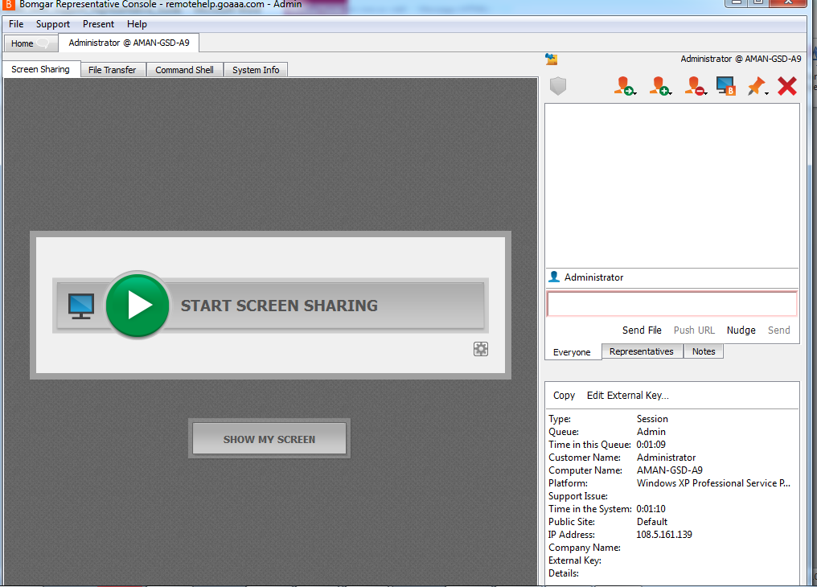

Once the customer has granted permission, full mouse and keyboard control is provided enabling you to work on the remote computer as if you were really there. You can request to elevate your permission level at any time during the session. The screen sharing tool bar provides a number of helpful features for support representatives.

Session Tools
Screen Sharing
The core of remote support is seeing and controlling the employee's computer as if you are in the room. Bomgar enables you to not only see employee’s screen, but to fully interact with the remote system as if it were on your desk, including viewing multiple monitors and accessing specific applications for nearly any computing platform.
The remote employee has the option of allowing a support technician to View or Control the computer. If View, is selected the technician can see the remote desktop and chat with the employee, but is unable to perform other actions.
If the employee selects Control, the technician can work on the remote desktop as if it were a local system. The employee always retains overriding control of the computer and can exit the support session at any time.
Show My Screen
IT training can help reduce call volume and improve employee’s productivity. But it is not possible to schedule time for an online presentation with employees most of the times. Sometimes the best training opportunities arise in the middle of the support session. With Show My Screen, agent can shift back and forth between screens without disconnecting from the employee. When you share the screen with employee during a support session, they will be able to see either your entire desktop or only those applications agent have chosen to present.
Agent can also choose to share mouse and keyboard control with your remote customer. Giving the employee, remote control of your desktop is a great way to have her demonstrate understanding of the training material. You always retain overriding control or your computer.
Command Shell
For many troubleshooting tasks, the rep may need to access the command line for network troubleshooting, system diagnosis or to connect to an adjacent network device.
The support rep can dig in and diagnose the problem without having to go through the extra steps required with the GUI.

Annotations
Annotations let you mark up and highlight the employee’s screen even if full remote control is not enabled. Simply draw on the screen to provide visual cues or to highlight areas as needed. Then erase your mark-up and move on to the next step.
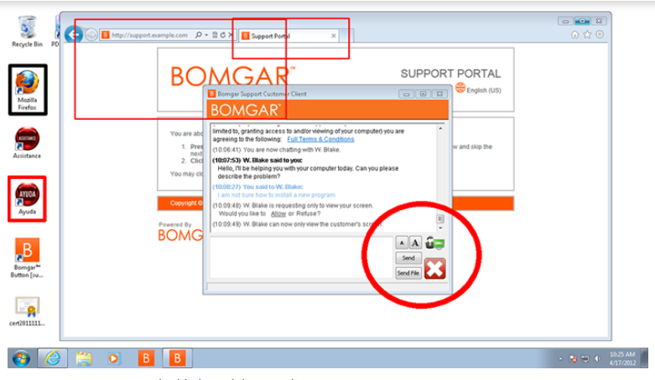
File Transfer
Many support incidents require agents to transfer files between computers often replacing bad files (corrupt, outdated, malware) with good ones. Bomgar’s appliance-based remote support software gives secure file transfer. Each file transferred is routed through the in house Bomgar Appliance, secured with 256-AES SSL encryption. So you can rest assured that file transfers are protected from outside threats and since Bomgar is a secure, on-premise appliance, all data stays internal to P&G network. The File transfer can be controlled and access to the specific directories given for the files to be transferred to and from the employee’s system.
Reboot
Routine support activities - such as program installations, software updates and system changes - often require agents to reboot the remote desktop, sometimes multiple times. But waiting for the remote computer to boot and the employee to enter their credentials just slows down the support. We can’t eliminate the need to reboot but can make it easier.
Bomgar lets the employee enter the credentials before agent reboots the system. With "Request Automatic Logon Credentials," the employee is prompted to enter a valid username and password. After the reboot, the remote system will automatically sign back in with the provided credentials. The username and password remain secure - and unknown to agent.
System Information
The System Info tab quickly shows you what devices, processes, events and programs are running on the remote desktop, giving some initial clues for the source of the employee's problems before beginning a remote support session.
Reps can open the System Info tab and request the remote computer’s system information without requiring screen sharing.
This is not only faster for the rep, but it also allows the customer to continue being productive until the rep needs to actually take control of the machine.

Security Recommendations
- Accept incoming connections only from employee you have provided the session keys to.
- Disable accounts that will go unused for long periods of time.

