SBO S.B.ONAMADE & CO.

Lagos Office Address: Abuja Office Address:
10, Fasanya Street, Off Ikorodu Road, 15 Jere Street, Area 2,
Fadeyi, Lagos. Garki, Abuja.
P. O. Box. 1420, Shomolu Lagos. E-mail: onamadesunny@yahoo.com
E-mail: samuelonamade@yahoo.com Tel: 08023266648, 08161767956
Tel: 08161767956, 08023266648 24th May, 2019.

The Management,
Roslad Group of School,
Oppsite Arema Esate,
Winner/Agbala idande Road,
Adeleke Area,
Iwo, Osun state.

Dear Sir/Ma,

PROPOSAL FOR WEBSITE DESIGN

With reference to the above subject matter, We S.B.Onamade & Co herein referred to as a Consultancy firm do herewith enclose a proposal for selection of our firm as the Consultant to design you Website. Our profile as Website designer, external auditors, Tax consultants and financial consultant and other Consulting services is enclosed.
S.B. Onamade & CO is a firm of Chartered Accountants, Tax Practitioners, Website designers and Financial & Business Consultant. Our firm was established in 2011. We attached the profile of our firm herewith. The benefits accruing to our clients include among others:

- Drawing on our international network to mobilize team of experts with both local and international experience to meet the needs of our clients.

- Our international ties enable us to keep abreast of developments in professional disciplines as they are practiced in other countries.

- The international network of technical expertise and business intelligence thus add depth and breadth to the service we offer our clients. It enables us to respond swiftly, effectively and imaginatively to all our clients’ business needs.
.
We remain,

Yours sincerely,
Authorized Signature

Name and Title of Signatory: Sunday Babatunde Onamade (Partner/ COO)
Name of Firm: S.B. Onamade & Co
Address 15 Jere Street, Back of Rita Lori Hotel, Abuja
E mail Onamadesunny@yahoo.com

Our vision

“to be a unique Website service provider towards meeting and surpassing our clients’ expectation”

Mission statement

“To add value to our clients’ business by
Rendering unique Website services of
International standard thereby,
Creating value for all stakeholders”

- No ramp-up time.
- No headaches just great service and excellent results, around the globe, in any area where you require assistance.

With S.B.Onamade & Co being an independent firm, you have strength in numbers

Onamadesunny@yahoo.com

Executive Summary

S.B.ONAMADE & CO PRESENTS AN OPPORTUNITY TO ROSLAD GROUP OF SCHOOL. THAT WE ARE THE RIGHT ENTITY TO RENDER YOUR DESERVED WEBSITE SERVICES.BECAUSE WE HAVE REQUIRED EXPERIENCE, EXPERTISE, DYNAMISM AND VIBRANCY THAT PLACED US RELEVANT AND COMPETITIVE IN THE WEBSITE ENVIRONMENT.DETERMINATION TO ALWAYS BE A SUCCESSFUL FIRM IS VALUE EVIDENCED THROUGH PROVISION OF THE HIGHEST QUALITATIVE AND ADDED SERVICES.

WHY S.B. ONAMADE & Co?

Because S.B. Onamade & Co is the best firm for the job, and we have demonstrated a commitment to high-quality service. We welcome this opportunity to present to you our qualifications, track record and approach to our Website, audit and consultancy services. We can provide useful insights relating to overall integrity of your website design in line with our role as your consultant.

Our Firm.

Our firm was established in 2011

Our mission

That our client attain an unprecedented feats in success and be up and doing in all their endearvours

Needs
Roslad Group of School needs a website to reach out to the community and also to serve and support both students and staffs of Roslad Group of School.
Furthermore, Roslad Group of School needs a website that can be maintained by a Roslad Group of School employee, without the need to regularly employ S.B. Onamade & CO to make changes. The Roslad Group of School employee needs to be able to add and revise both text and photos and additional pages if necessary.
Solutions

S.B. ONAMADE & CO will provide Roslad Group of School with a fresh new web design that is easy to navigate and provides useful information to visitors. The design will also convey to visitors that Roslad Group of School is a school which aspires for student success.
The design will integrate the current logo and color palette so it will maintain a familiar look to visitors, but will at the same time show them that Roslad Group of School is improving its web presence in order to serve them better.
Content Management System
Central to the new design from S.B. ONAMADE & CO will be a robust Content Management System (CMS) that will allow Roslad Group of School to make changes easily to the website, without requiring a dedicated workstation or additional software. Not only will the CMS save Roslad Group of School website revision costs but it will also ensure that the website stays fresh and up to date.
Website Organization
The new design will have five main landing pages:
- Home Page
- About
- Contact
- Services
- Gallery
These six pages will be "hardwired" into the new design by S.B. ONAMADE & CO and links to them will appear in the horizontal menu bar at the top of the page (beside the logo).
On each of these pages, we will make it easy for Roslad Group of School to add, change or even delete content or pictures without any code or script.
Preliminary Design

Working in conjunction with Roslad Group of School, S.B. ONAMADE & CO will provide Roslad Group of School with a preliminary design concept for the new website. That design concept will include the basic layout, color palette, font choices, etc. Roslad Group of School can at that point request one round of design revisions within the scope of the Fee Schedule (see below).
Integration of Content Management System.
Once the design is approved, then S.B. Onamade & CO will incorporate the Content Management System into the design.
Training
S.B. ONAMADE & CO will then run a two-hour training session with Roslad Group of School employees, showing them how to use the Content Management System. This can be done on site or online.

Launch
When Roslad Group of School has finished incorporating all the content they wish to have at launch, they will ask S.B. ONAMADE & CO to move the website from the development sub-directory to the main root level of the domain, thereby making the site go live. Congratulations!

We have rendered similar and/or related service to different entities cutting across Government, international organizations and corporate entities among others. We have rendered similar and/or related service to different entities cutting across Government, international organizations and corporate entities among others. Highlighted in the table below are some few examples.

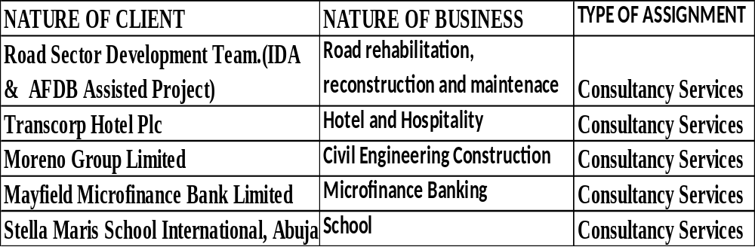

OTHER SERVICES.
We can render service in the aspect of debt recovery this includes:
- Investigation
- Taxation
- Accounting services.
- Insolvency matters.
- Estate management.
- Management consultancy department.
- Computerization of accounting system.
- Credit management.
- Auctioneering.
- Training.
- Bank charges, Entity, unauthorized direct debits and interest allowed audit.

Please note that all these services will be offered to your organization at a fee to be agreed at the time when such services are required.

OUR FEE

Our fee shall base on the total estimated hours planned to consume on the engagement and in accordance with standard as detailed in the fee summary below:

Fee Summary

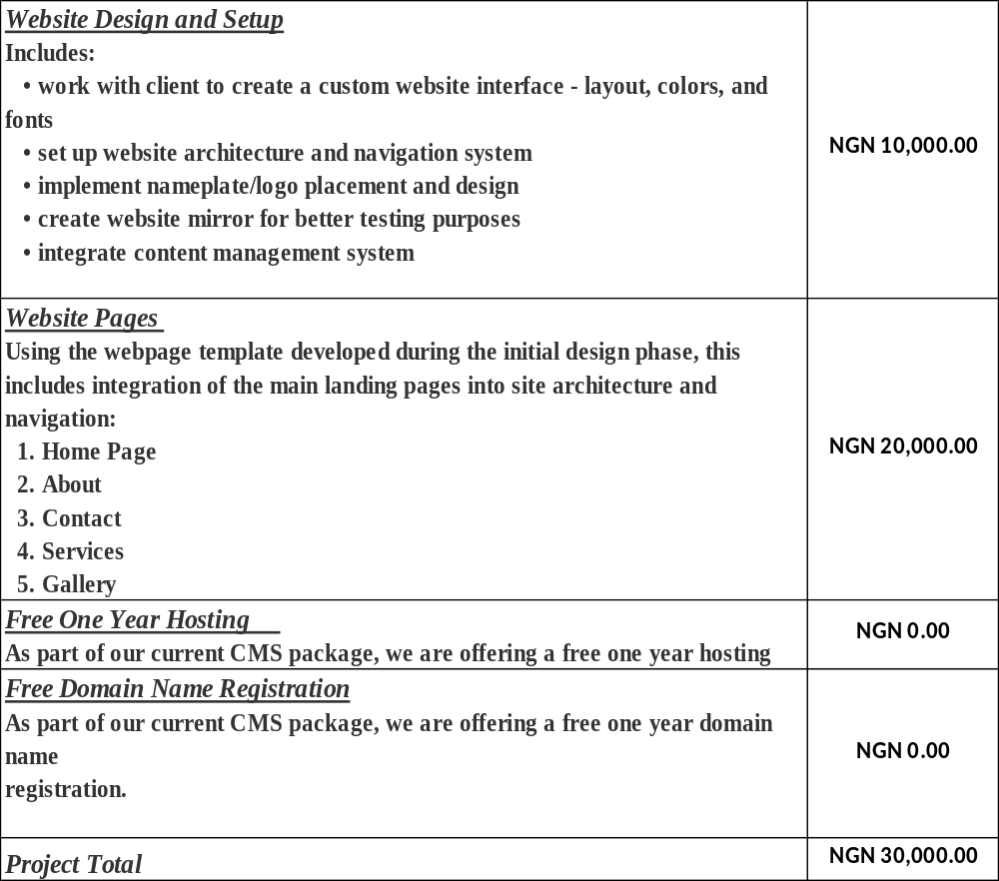
CONCLUSION

We shall be grateful if this proposal is given a favorable consideration. Furthermore, we are available for further information if required.

Yours faithfully,
S.B.Onamade & Co

Sunday Babatunde Onamade Samuel Oladapo Onamade
Partner /Chief Operating Officer IT & Website sign partner

