Name= Sanmay das

Reg id- 200010455106

Enroll id- 2011200001045

Course-B.tech,CSE,2nd Sem,Sec-A

1. Create and insert given data in table customer.

create table sanmay(cust_id int , cust_fname varchar2(100) ,

cust_lname varchar2(100) , territory varchar2 (100) , cred_lmt int , mngr_id int ,

marital_status varchar2(100) , sex varchar2(30) , income int );

desc sanmay

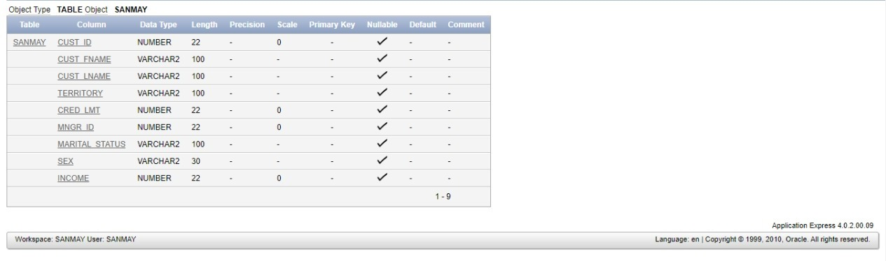

insert into sanmay(cust_id,cust_fname ,cust_lname,territory,cred_lmt,mngr_id,marital_status,sex,income) values(01,'sanmay','das','India',15000,113,'single','Male',100000);

insert into sanmay(cust_id,cust_fname ,cust_lname,territory,cred_lmt,mngr_id,marital_status,sex,income) values(02,'Meg','Sen','India',15000,113,'single','Male',67000);

insert into sanmay(cust_id,cust_fname ,cust_lname,territory,cred_lmt,mngr_id,marital_status,sex,income) values(03,'George','Matthew','Italy',12000,114,'Single','Male',63000);

insert into sanmay(cust_id,cust_fname ,cust_lname,territory,cred_lmt,mngr_id,marital_status,sex,income) values(04,'Jennifer','Lopez','America',14000,115,'Married','Female',68000);insert into sanmay(cust_id,cust_fname ,cust_lname,territory,cred_lmt,mngr_id,marital_status,sex,income) values(05,'Robert','Johnson','Austrelia',15000,116,'Married','Male',65000);

insert into sanmay(cust_id,cust_fname ,cust_lname,territory,cred_lmt,mngr_id,marital_status,sex,income) values(06,'Meghna','Chakraborty','India',15000,117,'Married','Female',65000);

select *from sanmay

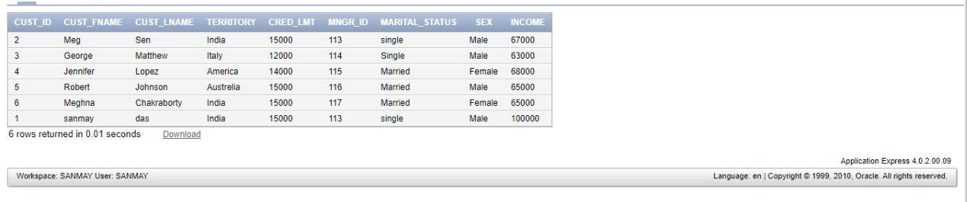

1. Alter table and Add column stay_from_year

Alter table sanmay add stay_from_year int

Select *from sanmay

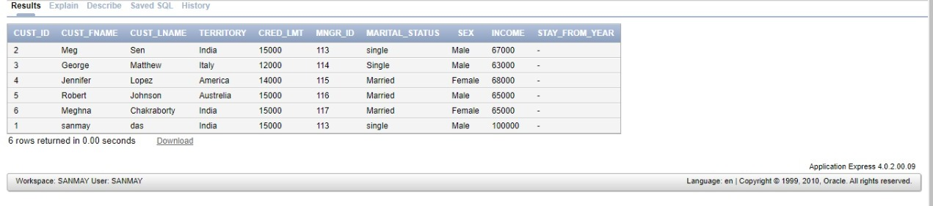

1. Set value of stay_from_year as 2001 for Italy/America and 2003 otherwise

update sanmay set stay_from_year=2001 where territory in ('Italy','America');

update sanmay set stay_from_year=2003 where territory not in ('Italy','America');

select *from sanmay

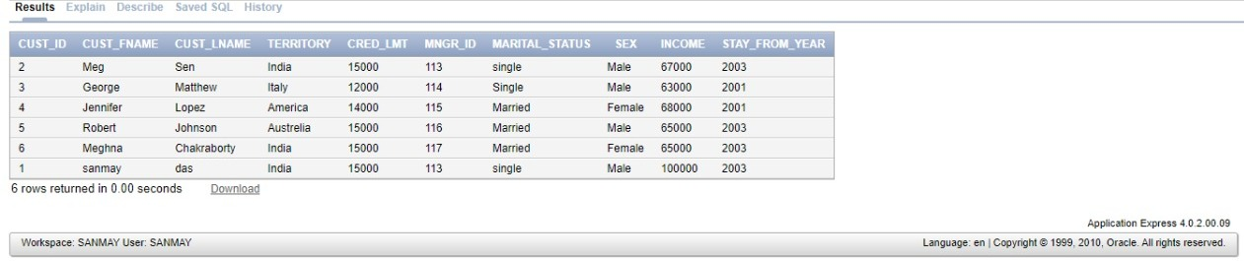

1. Display credit limit attribute for America

select cred_lmt from sanmay where territory ='America';

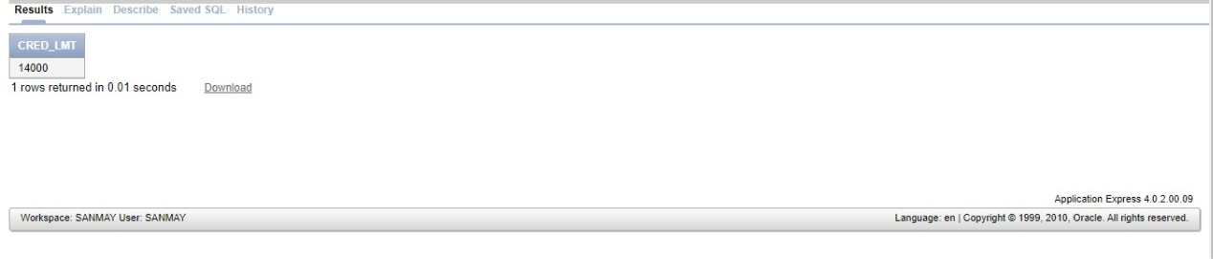

1. Delete the record corresponding to Meg Sen

Delete from sanmay where cust_fname=’Meg’ and cust_lname=’Sen’

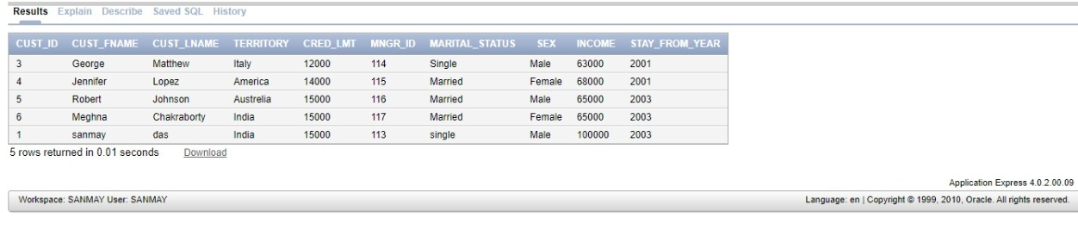

1. Show all attributes for Italy//Show all data in the territory Italy

Select *from sanmay where territory=’Italy’

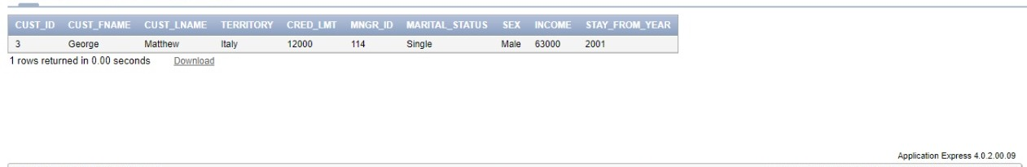

1. If territory is india and status is Single set value of creadit to 7000

Update sanmay set cred_lmt =7000 where territory=’india’ and marital_status=’single’

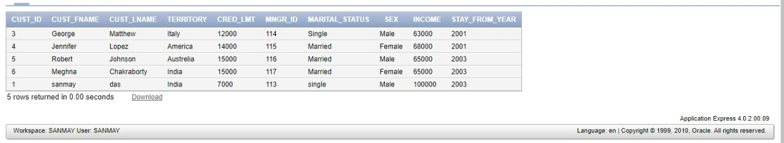

1. Rename cust_fname to first_name

Alter table sanmay rename column cust_fname to first_name;

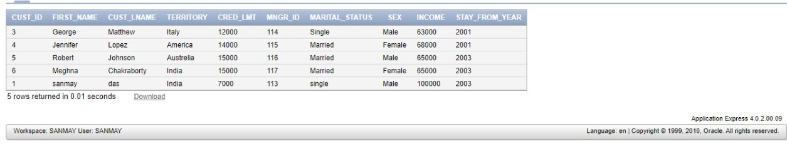

1. Rename cust_lname to last_name

Alter table sanmay rename column cust_name to last_name;

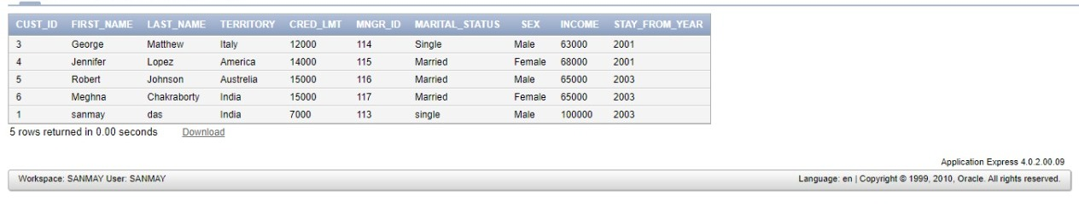

1. create table customer from the old table sanmay(copy structure as well as data using CTAS statement).

Create table cust1 as(select *from sanmay where 1=1);

Select *from cust1;

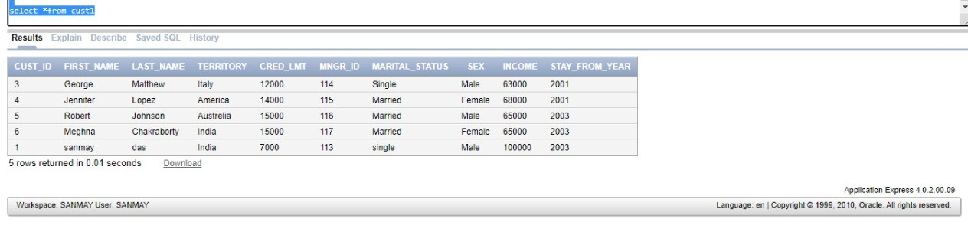

1. Create table cust2 without values of cust1 using CTAS statement.

Create table cust2 as (select *from cust1 where 2=1);

Desc cust2;

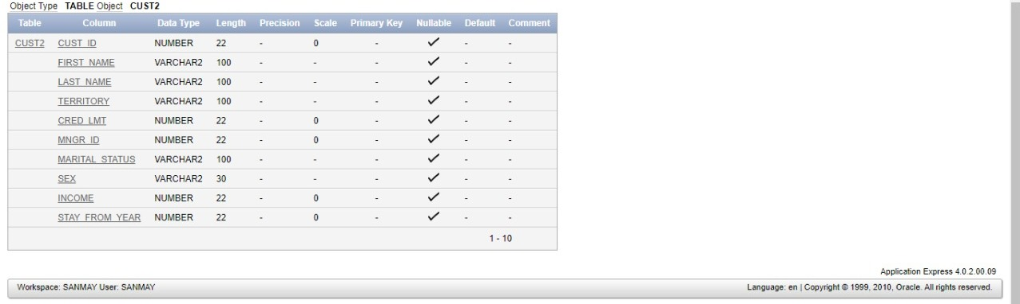

1. Create tables cust3 with attributes cust_is,cust_lname ,cust_fname ,income from old customer table only 5 rows .(using CTAS statement).

Create table cust3 as (select cust_is,cust_fname,cust_lname,income from customer where 1=1);

Select *form cust3;

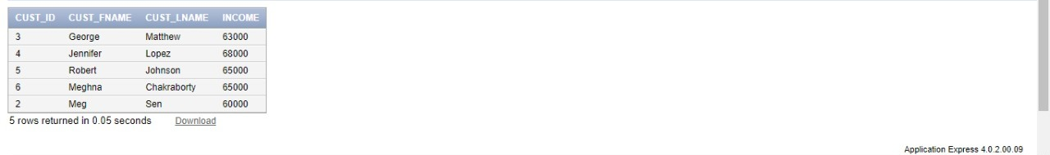

1. Create tables cust4 with attributes name customer_id,firstname,lastname, income from old customer

table(using CTAS statement).

Create table cust4(customer_id,first_name,last_name,income)as(select cust_id,first_name,last_name,income from sanmay where 1=1);

Select *from cust4;

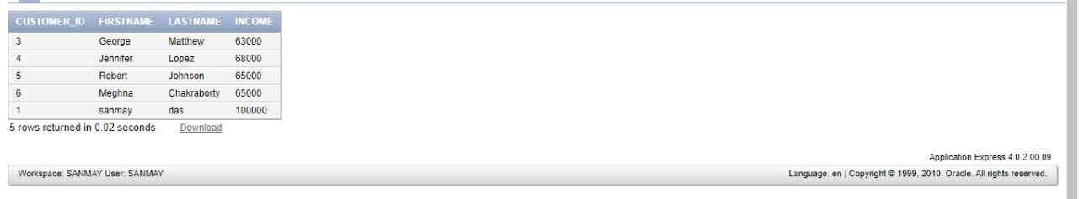

1. drop column income from cust1.

Alter table cust1

Drop column income;

Select *from cust1;

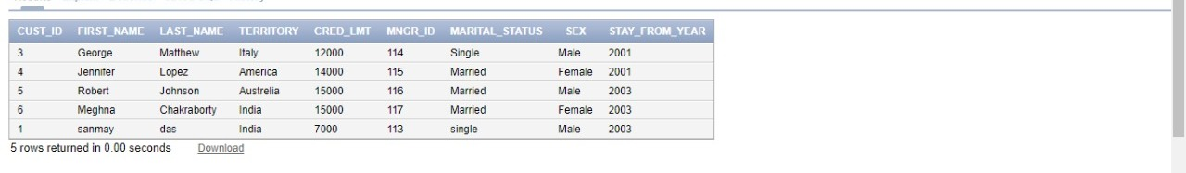

1. Rename table cust1 to cust_one

Rename cust1 to cust_one;

Desc cust_one;

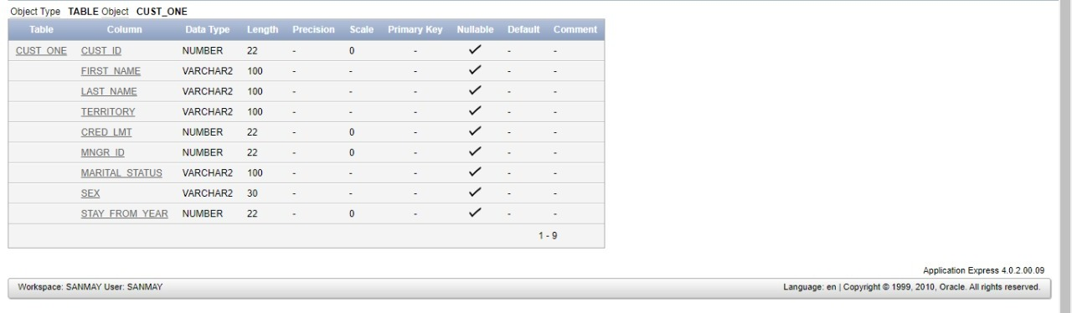

1. insert values into cust2 table from customer table

Insert into cust2

Select *from customer

Where 1=1;

Select *from cust2

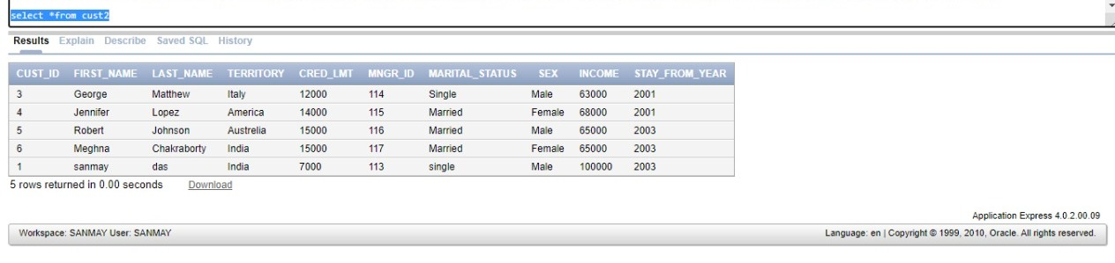

1. insert values into cust3 table with attribures cust_id,fastname,lastname,income from customer table where income>50000

insert into cust3

select cust_id,first_name ,last_name,income from sanmay

where income>50000;

1. alter the table cust4 change cust_id to varchar(6) and income to numbers(5)

alter table cust4

modify income cust_id varchar(6);

alter table cust4

modify income income numbers(5);

desc cust4

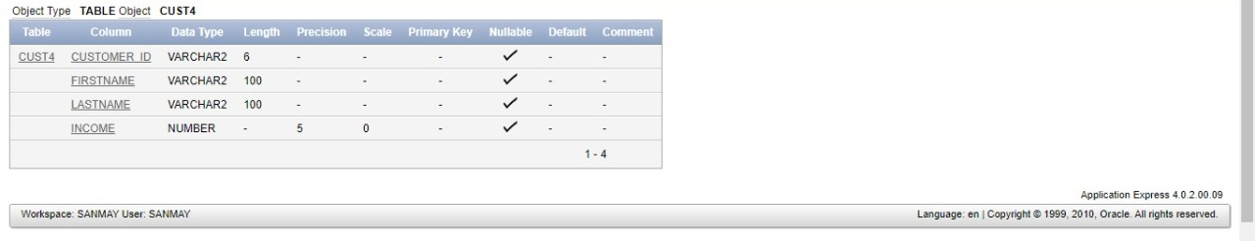

1. add new attribute mngr_name to cust4 and insert 5 records

alter table cust4

add mngr_name varchar(60);

insert into cust4(customer_id,firstname ,lastname,income,mngr_name) values('02','Meg','Sen',67000,'dell');

insert into cust4(customer_id,firstname ,lastname,income,mngr_name) values('03','George','Matthew',63000,'hp');

insert into cust4(customer_id,firstname ,lastname,income,mngr_name) values('04','Jennifer','Lopez',68000, 'toshiba');

insert into cust4(customer_id,firstname ,lastname,income,mngr_name) values('05','Robert','Johnson',65000, 'lenovo');

insert into cust4(customer_id,firstname ,lastname,income,mngr_name) values('06','Meghna','Chakraborty',65000, 'asus');

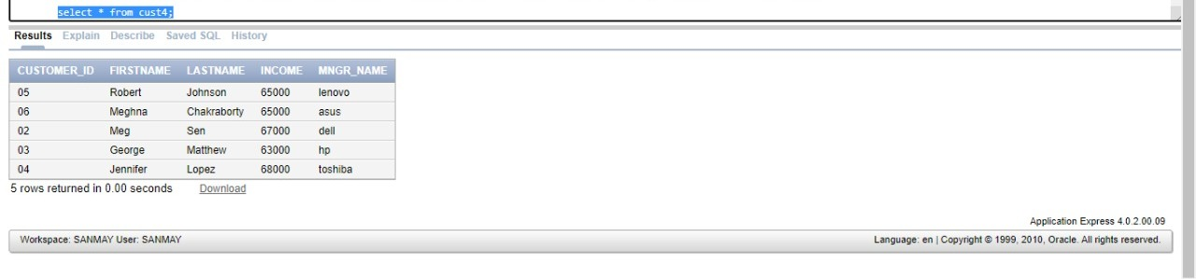

1. add attribute territory to cust4

alter table cust4

add territory varchar(60);

desc cust4

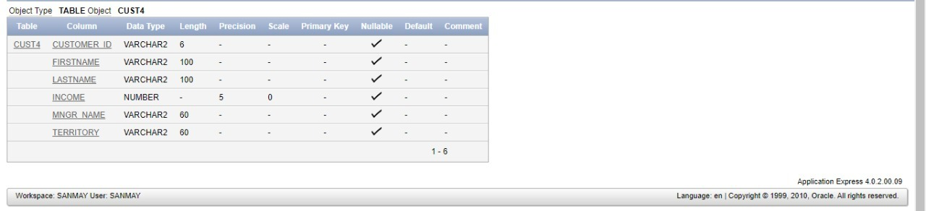

1. drop table cust3 and then bring it back

drop table cust3;

select odject_name,original_name,type from recyclebin;

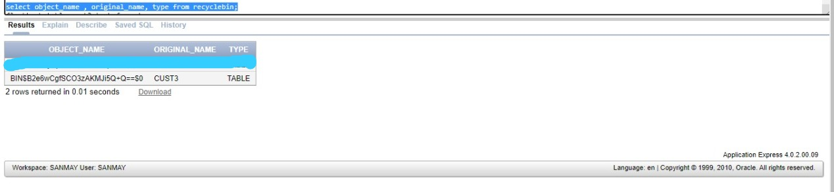

flashback table cust3 to before drop;

select *from cust3;

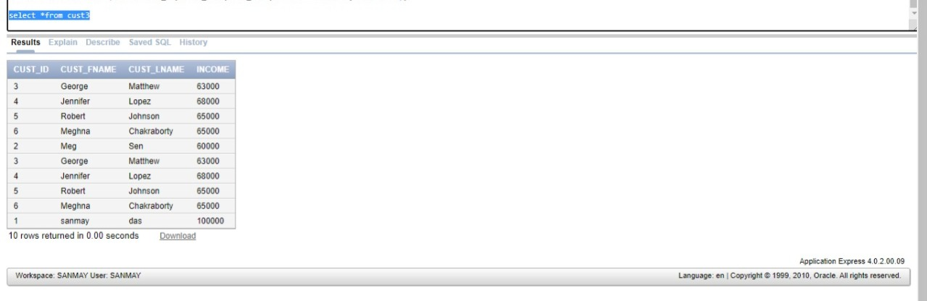

1. increase the size of the column custid by 5.

Desc cust 3;

CREATE TABLE cust5 AS(SELECT *FROM CUST3 WHERE 1=1);

DELETE FROM CUST3;

ALTER TABLE CUST3 MODIFY CUST_ID NUMBER(27);

INSERT INTO CUST3 SELECT *FROM cust5 WHERE 1=1;

SELECT *FROM CUST3;



1. suppose the customer with id no c63 has changed her last name & now its just same as the customer with id no c68

UPDATE sanmay SET last_name = (select last_name from sanmay where cust_id = 5) WHERE cust_id = 1;

select *from customer;

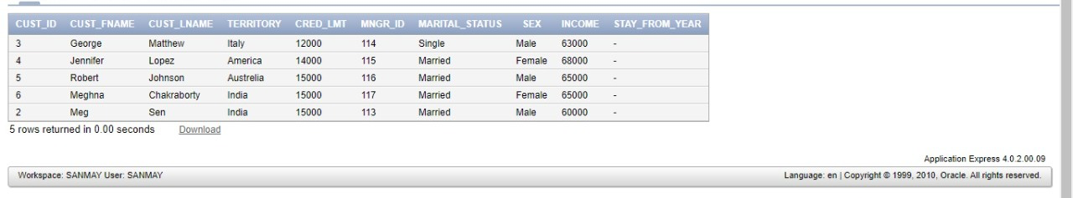

1. Display the records where territory=America & crd_lmt =2500

Select *from sanmay;

Where territory =’America’ and cred_lmt=25000;

Output🡪 NO DATA FOUND

1. Display the records of all Indian customers whose income>20000.

Select *from sanmay where territory=’India’ and income>20000;

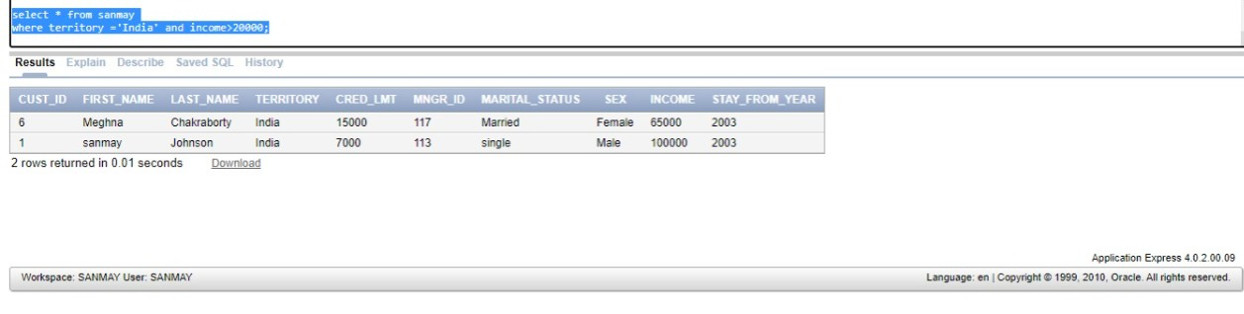

1. Display the name of the customer having crd_lmt between 2000 and 7000.

Select *from sanmay

Where cred_lmt<7000 and cred_lmt>2000;

Output🡪 NO DATA FOUND

1. Display the records of the customers having income 20000,24000,300,4500 using only one query.

Select*form sanmay where income in(20000,24000,300,4500);

Output🡪 NO DATA FOUND

1. Display the records in ascending order of first name

Select *form snamay order by First_name asc;

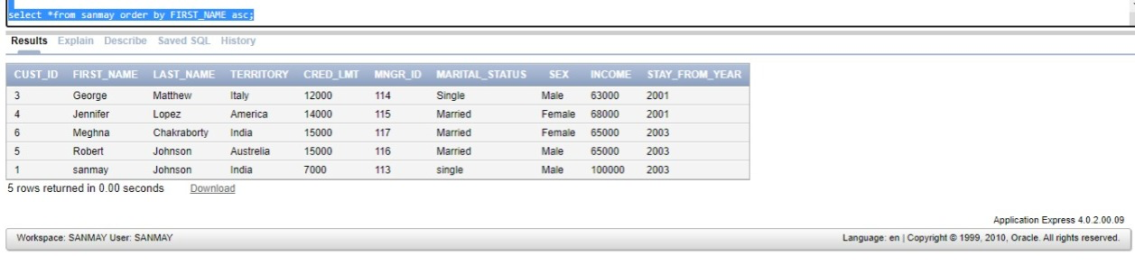

1. Display the records in descending order of income.

Select *form sanmay order by income desc;

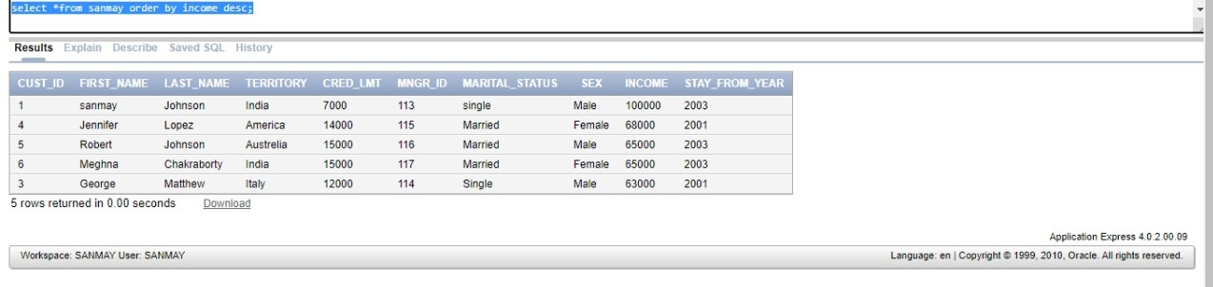

1. Insert a duplicate record and display all the records.

INSERT INTO sanmay  
(cust_id,first_name,last_name,territory,cred_lmt,mngr_id,Marital_status,sex,income,stay_from_year)    
VALUES (2, 'George', 'Matthew','Italy',12000, 114,'single','Male',63000,2001);  
select * from sanmay

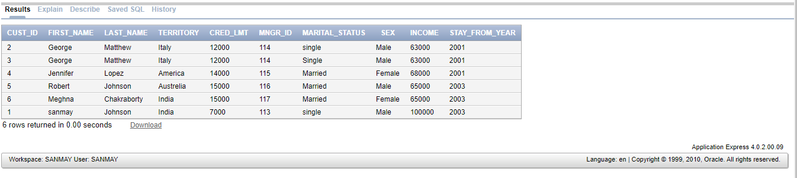

1. Suppose your friend wants to select a name from the names of the customers. Show the different names.

Select *from sanmay

Where not first_name =’sanmay’

