

Cybernation:

A first step towards Home Automation

Autumn 2015

Dhirubhai Ambani Institute of Information and Communication Technology, Gandhinagar

EL203: Embedded Hardware Design

Group Members :

* Shruti Singh (201301452) - **[Team Leader]**
* Jay Bhatt (201301454)
* Dipen Dadhaniya (201301455)
* Samarth Desai (201301456)
* Sachin Gohel (201301457)
* Ankit Nagarwal (201201211)

**Goal of the project:**

We plan to build up a temperature driven automatic curtain controller to raise and conclude the curtains giving a truly automated touch to a smart home. Apart from the curtain controller, we also plan to secure the home with a door which could be unlocked just at the strike of your fingers. You can set a particular rhythm for the lock and the lock would open only at the strike of that rhythm of knuckles, just like it happens it fantasy fictions. Your fists become your keys.

# Detailed description of the project:

As is evident from the goal, there are two elements in our home automation system.

For the Automatic Curtain Raiser/Concluder, we plan to build a temperature driven system to open and shut the curtains. The temperature input will be provided by a temperature sensor sitting on top of the curtains. The system will also house a facility of manually shutting and opening curtains at the instruction from a smartphone.

We plan to build up a mechanical pulley system using a rope, servo motor and obviously, a pulley. The pulley will be attached to the servo motor, and placed at one end of the curtain rod. The rope will go over the pulley, which will also be attached to the ends of the curtain. The servo motor will receive input from the arduino and rotate, causing the pulley to rotate. The rope will move along with the pulley, which will open or shut the curtain. The Arduino-housed controller will be driven by a temperature sensor, or a smartphone using a bluetooth module.

Coming to the latter element of the system, the Rhythm Detector Lock, the concept is as follows. A microphone presses against the door and listens for knocks. If it hears the right number of knocks in the right cadence it triggers the motor to turn the deadbolt and unlock the door. If the sequence isn’t recognized, the system resets and listens for knocks again.

The components are simple, most of the work is done in the microcontroller.

The controller will do the following function. First, it will record the time between knocks. If there is a long wait for a knock, it stops listening and starts analyzing.

The analysis starts by counting the number of knocks. If the count is found to be correct, it moves on to next authentication. It converts the absolute timing of the knocks to the rhythm of the knocks. This will give the user, the liberty to knock at his/her own pace and the door will still open as long as the knock follows the correct rhythm.

After this step, it compares the timing against the secret key and if any individual knock is off or not in sync by a certain factor; or the whole sequence is off by a certain pre-fixed average amount, the door stays locked. If this does not happen, we trigger the motor to turn and the lock to unlock. If the programming button is pressed it will start storing the rhythm information for future reference.

The circuit to be implemented is as depicted below.

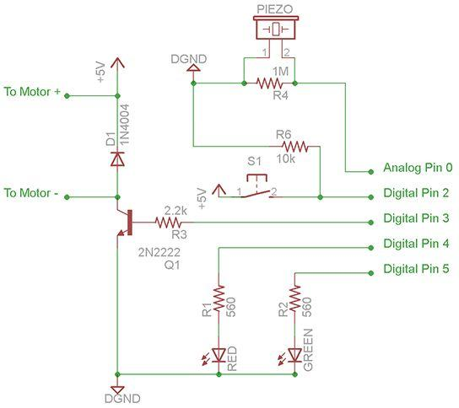

# Required hardware:

* Arduino Uno Board (2 nos.)
* Servo motor (2 nos.)
* Simple Gear Motor (1 nos.)
* Piezoelectric Speaker (1 nos.)
* Bluetooth module (1 nos.)
* LM35 sensor
* Push Button (2 nos.)
* NPN Transistor P2N2222A (2 nos.)
* Rectifier Diode (1N4001 or similar) (2 nos.)
* H Bridge
* Resistors:
  + 2.2k ohm (1 nos.)
  + 10k ohm (1 nos.)
  + 1M ohm (1 nos.)
  + 560 ohm (1 nos.)
* 9V Battery (1 nos.)
* LEDs (5 nos.)
* Pulley (1 nos.)
* BreadBoard (1 nos.)
* Ropes (1 nos.)
* Jumpers (6 nos.)

# Deliverable:

The outcome of our project will be a furnished Automatic Curtain Raiser/Concluder along with a Rhythm Detector Lock thereby achieving our purpose of cybernating a home.

We plan to target the physically challenged, the lazy GenY, loner bachelors, and people with careless roommates who often tend to forget their keys or are too lazy to get up and raise the curtains. People who have difficulty in moving from one place to another can clearly benefit from this project as they will no longer have to get up, to close or open the curtains. Well, now controlling curtains will be at the tips of one’s fingers. They can close or open the curtains in the room just by pressing a button on their smartphone.

Another interesting application of our idea is for strict parents to prevent their children from eating up all candies from the refrigerator.

Needless to mention, the locker/unlocker can be reprogrammed to a new pattern seamlessly.