Fine-scale spatial population genomics of Plasmodium falciparum across Ghana's agro-ecological zones: a Pf8 analysis
Working analysis report — methodology, decisions and provisional findings
Author: [author placeholder]
Affiliation: [placeholder]
Document date: 9 October 2026
Analysis period: 6–9 October 2026
Status: Working manuscript for internal review — not a submission draft
Item | Detail
Project | Doctoral thesis component: population genomic structure and signatures of  antimalarial selection in P. falciparum across Ghana's ecological zones
Data release | MalariaGEN Plasmodium falciparum Community Project, Pf8
Compute host | bacg2 (Ubuntu, kernel 5.15.0-194-generic), 40 cores, 629 GB RAM
Project root | /media/biodataA/pf8/gyadu
Pipeline entry point | scripts/run_all.sh (stages 1–9)
Analysis completed | 9 October 2026, 03:25–04:07 UTC (stages 4–9, 41 min wall time)
Scope of this report | Documents the computational investigation only. The thesis proposal and  literature review are a separate document and are not reproduced here.

Contents
Contents
Evidence and traceability key
Abstract
1. Introduction and background
1.1 The problem
1.2 Objectives addressed by the present analysis
1.3 Research questions as operationalised
2. Data and materials
2.1 Source and provenance
2.2 Units of analysis and observation period
2.3 Spatial resolution: the binding constraint
2.4 Zones represented and zones absent
2.5 Temporal composition
2.6 Variable summary
3. Methodology
3.1 Pipeline overview
3.2 Stage 1 — manifest filtering
3.3 Stage 2 — agro-ecological zone assignment
3.4 Stage 3 — three ordinations of the genotype distance matrix
3.5 Stage 3a — genotype retrieval
3.6 Stage 3b — isolate quality control
3.7 Stage 4a — building the genotype matrix
3.8 Stage 4b — pairwise differentiation
3.9 Stages 5 to 9
4. Filtering and inclusion/exclusion criteria
4.1 The filtering cascade
4.2 Rationale, origin and consequences of each non-trivial filter
4.2.1 Pf8 QC-pass flag (filter 2)
4.2.2 Fws ≥ 0.95 (filter 8)
4.2.3 Call-rate outlier rule (filter 6) — disabled
4.2.4 Clonal pruning threshold (filter 9)
4.2.5 Genotype quality mask (filter 10)
4.2.6 MAF ≥ 5 per cent (filter 14)
4.3 Selection bias summary
5. Analytical decisions and iterations
5.1 Replacing the VCF route with direct Zarr retrieval
5.2 Adding t-SNE and PCoA alongside UMAP
5.3 Ploidy: how to count alleles in a haploid parasite coded as diploid
5.4 Sample QC thresholds
5.5 TreeMix jackknife block size
5.6 BayPass calibration
5.7 Defects found and corrected in the supplied pipeline
5.8 Decisions that may warrant reconsideration
6. Results
6.1 The analysis dataset
6.2 Sample quality control
6.3 Ordination of the genotype distance matrix
6.4 Pairwise differentiation between zones
6.5 Isolation by distance
6.6 Ancestry inference
6.7 Population graph and migration edges
6.8 Genome scan for differentiation outliers
7. Interpretation and discussion
7.1 What the analysis establishes
7.2 What the analysis cannot establish, and why
7.3 Unexpected observations
7.4 Practical significance
8. Robustness checks and alternative approaches
8.1 Checks completed
8.2 Checks proposed but not performed
9. Limitations and potential sources of bias
9.1 Ranked by threat to the conclusions
9.2 On the design limitation specifically
9.3 Reproducibility status
10. Conclusion and current state of the research
10.1 What has been established
10.2 Answers to the research questions
10.3 What remains unresolved
10.4 Most valuable next steps
11. References
11.1 Data source
11.2 Population-genetic methods
11.3 Ancestry, ordination and clustering
11.4 Malaria genomics and biology
11.5 Software
12. Appendices
Appendix A — Software environment
Appendix B — Key configuration values
Appendix C — Output inventory
Appendix D — Reference verification status
Appendix E — Reproducing the analysis
REVIEWER NOTES AND REVISION GUIDE
A. Explain it simply
B. Methodological rationale
C. Decisions requiring your review
D. Potential weaknesses and reviewer objections
E. Missing information and unverified assumptions
F. Recommended next steps, in priority order
G. Questions for the author
H. Suggested revisions before this could be considered publication-ready

If the entries below appear empty, open in Word and press Ctrl+A then F9 (⌘+A, fn+F9 on macOS) to build the field.

Evidence and traceability key
Every substantive claim in this report carries one of the following labels. The intent is that a reader can tell, without re-running anything, which statements rest on recorded output and which are reasoning on top of it.
Label | Meaning
Observed | Printed directly by a pipeline script and preserved in a log or results file.
Calculated | Derived here from identified inputs by a stated procedure (arithmetic on observed values, or a query re-run against stored outputs).
Interpreted | A reasoned explanation of observed results. Defensible, but not itself a measurement.
Hypothesized | A candidate explanation that the present evidence does not establish.
Proposed | An analysis or action recommended but NOT performed.
Unknown | Cannot be established from the material available in this session.
File paths are given relative to the project root /media/biodataA/pf8/gyadu unless stated otherwise. Script line references point to the version of the code present at the end of the analysis session; the unmodified originals remain in pf8_ghana_pipeline.zip in the project root.

Abstract
Objective. To quantify spatial population structure, gene flow and candidate signatures of local selection in Plasmodium falciparum across Ghana's agro-ecological zones, using the MalariaGEN Pf8 release, and to establish whether zone-level differentiation is detectable at all before interpreting any locus-specific signal.
Data. Pf8 contains 33,325 samples and 12,493,205 variant sites. Ghana contributes 6,653 samples, of which 4,905 pass the release's own quality control. Isolates were collected between 2009 and 2021 and are geolocated only to administrative level 1, giving seven distinct coordinates across seven regions. Spatial joining to a Ghana agro-ecological zone layer placed these in four zones: Guinea savanna (n = 3,605), deciduous forest (n = 815), coastal savanna (n = 435) and transitional zone (n = 50). The Sudan savanna and the wet-evergreen and moist-evergreen forest zones are unrepresented.
Methods. Genotypes were obtained from the Pf8 Zarr store over HTTPS, restricted to Ghanaian samples, sites passing the release filter, biallelic single-nucleotide polymorphisms (SNPs) and the GT, AD, DP and GQ fields. Sample quality control applied a within-host fixation index (F_{ws}) threshold of 0.95, a call-rate floor of 0.80, a heterozygosity outlier rule and clonal pruning. Mixed calls were resolved to the majority allele by read depth, and allele counts were taken as one allele per isolate. Analyses comprised three ordinations of the Pf8 genotype-distance matrix (UMAP, t-SNE, PCoA), pairwise Hudson F_{ST} with a block jackknife, ADMIXTURE at K = 1–8 with cross-validation, Mantel tests of isolation by distance at zone and region level, TreeMix with 0–5 migration edges, and a BayPass XtX genome scan calibrated against 100,000 pseudo-observed neutral SNPs.
Principal findings. After all filters, 3,359 SNPs across 1,900 isolates entered the population analyses. Zone differentiation is very low: the largest pairwise F_{ST} is 0.0024 (95% CI 0.0014–0.0034) between coastal and Guinea savanna, and two of six pairs have confidence intervals spanning zero. Isolation by distance is supported at region level (Mantel r = 0.400, p = 0.029, 7 populations, 21 pairs) but not at zone level (r = 0.578, p = 0.090, 4 populations, 6 pairs), where only 24 distinct permutations exist. ADMIXTURE cross-validation error is minimised at K = 2 (0.83736) but the margin over K = 1 (0.84199) is small and ancestry proportions are nearly uniform across zones. TreeMix fit improves monotonically to a plateau at three migration edges, beyond the two that four populations can identify. The BayPass scan returns 15 outlier SNPs above a calibrated XtX threshold of 11.23, intersecting 11 genes including the amino-acid transporter AAT1 (PF3D7_0629500, two outlier SNPs, maximum XtX 24.44). No validated antimalarial resistance locus appears among the outliers.
Current conclusion. The Ghanaian parasite population behaves as a largely panmictic unit at the resolution these data permit, with a weak distance-related signal that is detectable at region level. The analysis cannot currently separate ecological-zone effects from administrative-region effects, because three of the four zones are each filled by a single region; nor can it separate spatial from temporal effects, because sampling year is strongly confounded with zone. The outlier set is a provisional candidate list, not a demonstration of local adaptation. These results should be treated as the baseline characterisation that the marker-level thesis questions depend on, not as answers to them.

1. Introduction and background

1.1 The problem
Malaria transmission in Ghana is spatially heterogeneous, and the heterogeneity tracks ecology. The country spans a south–north gradient of agro-ecological zones that differ in rainfall, vector species composition, seasonality and consequently in entomological inoculation rate. If parasite populations in these zones are demographically separate to any meaningful degree, then drug-resistance alleles, antigenic variants and locally adaptive alleles can differ in frequency between them, and a national surveillance programme built on a handful of sentinel sites will mis-estimate the national picture. If instead the zones exchange parasites freely, a resistance allele arising anywhere will spread everywhere, and the surveillance question becomes one of timing rather than geography.
The two scenarios demand different control responses, and they are distinguishable from genomic data. The present analysis addresses the prior question that both depend on: how much spatial structure is there in Ghanaian P. falciparum, and is it enough to support zone-level inference at all?
Scope. The thesis proposal and literature review (supplied separately as "genomic analysis of Consistent signatures of selection.docx", 145 paragraphs, approximately 11,400 words) set out the biological rationale, the resistance-marker panel and the published context. This report does not restate that material. It documents what was computed, on what data, with which decisions, and what the output actually shows.

1.2 Objectives addressed by the present analysis
The thesis defines three specific objectives. The work documented here engages all three, but completes none of them. Their status is as follows.
Thesis objective | What this analysis contributes | Status
Quantify the magnitude and direction of gene flow and population genetic differentiation between zones | Pairwise Hudson FST with jackknife standard errors; ADMIXTURE K = 1–8; TreeMix with 0–5 migration edges; three ordinations of the Pf8 genotype-distance matrix | Addressed. Differentiation quantified and found very low.
Evaluate whether ecological transitions act as dispersal barriers | Mantel tests of isolation by distance at zone and region level, with geographic distance on the WGS84 ellipsoid | Partially addressed. A barrier test is confounded with distance and with region identity (Section 9.2).
Identify and characterise zone-specific variants associated with local adaptation or drug response | BayPass core-model XtX scan calibrated against simulated neutral data; intersection of outliers with the PlasmoDB-71 annotation | Preliminary. 15 outlier SNPs in 11 genes; no validated resistance locus recovered.

1.3 Research questions as operationalised
The thesis questions were translated into the following testable forms. The translation is itself an analytical decision and is revisited in Section 5.
- Is between-zone differentiation distinguishable from zero? Operationalised as pairwise Hudson FST with block-jackknife confidence intervals.
- Does genetic distance increase with geographic distance? Operationalised as a Mantel test of FST/(1 − FST) against log geographic distance, run at both zone and region level.
- Do individual isolates assign to zone-associated ancestry components? Operationalised as ADMIXTURE at K = 1–8 with 10-fold cross-validation, and as visual inspection of three ordinations.
- Is there evidence of gene flow beyond a simple bifurcating population tree? Operationalised as TreeMix with 0–5 migration edges.
- Which loci are more differentiated than neutral demography predicts? Operationalised as a BayPass XtX scan with a threshold calibrated on pseudo-observed data simulated under the estimated population covariance matrix.
[Interpreted] Questions 1–4 are answerable at the resolution these data permit and are answered, provisionally, in Section 6. Question 5 is answerable only in the weak sense of producing a ranked candidate list; with four populations and 3,359 SNPs the scan has limited power, and a negative result for any particular locus carries little information.

2. Data and materials

2.1 Source and provenance
[Observed] All genotype and metadata inputs derive from the MalariaGEN Plasmodium falciparum Community Project release 8 (Pf8), served publicly over HTTPS from https://pf8-release.cog.sanger.ac.uk. The release comprises 33,325 samples and 12,493,205 variant sites called against the 3D7 reference assembly (contigs Pf3D7_01_v3 … Pf3D7_14_v3, plus apicoplast and mitochondrial contigs, which this analysis excludes).
Four Pf8 artefacts were used:
- Sample manifest — data/Pf8_samples.txt, 33,325 rows and 17 columns, giving country, administrative level 1, latitude and longitude at that level, collection year and the release's own QC-pass flag.
- Variant call data — the Pf8 Zarr store at /zarr, holding GT, AD, DP, GQ and per-site annotations including FILTER_PASS and RegionType.
- Mean genotype distance matrix — data/Pf8_mean_genotype_distance.npy, a 33,325 × 33,325 single-precision matrix published with the release (4.44 GB).
- Reference annotation — data/PlasmoDB-71_Pfalciparum3D7.gff, used for Step 9. Release 68 is also present in data/ but config.py points at release 71.
A Ghana agro-ecological zone polygon layer (data/ghanaAEZ.geojson) was supplied with the project. Its provenance was not recorded in this session.
Provenance gap. [Unknown] The origin, vintage and coordinate reference system documentation of ghanaAEZ.geojson could not be established from material available here. The file carries eight zone polygons (coastal savanna, deciduous forest, Guinea savanna, moist evergreen, Sudan savanna, transitional zone, wet evergreen, and a Volta Lake water body). The spelling "Decidous forest" in the layer is a misspelling that propagates through every downstream output and zone label; it was deliberately left uncorrected so that zone keys remain consistent with the source layer.

2.2 Units of analysis and observation period
[Observed] The unit of analysis is the parasite isolate (one blood sample from one infected individual). Ghana contributes 6,653 isolates to Pf8; 4,905 carry the release QC-pass flag. Collection years span 2009 to 2021.
Table 2.1 gives the regional composition of the Ghanaian subset at three stages. The pronounced imbalance — Upper East supplies 74 per cent of the QC-passing isolates and 70 per cent of the final analysis set — is a property of the Pf8 sampling frame, not of any filter applied here.
Administrative region | In Pf8 manifest | Pf8 QC-pass  (Step 1 output) | In final analysis set  (Step 4a output)
Upper East | 4,821 | 3,605 | 1,334
Central | 686 | 309 | 125
Greater Accra | 474 | 435 | 204
Ashanti | 452 | 391 | 157
Eastern | 110 | 74 | 34
Brong Ahafo | 69 | 50 | 25
Volta | 41 | 41 | 21
Total | 6,653 | 4,905 | 1,900
Table 2.1. Ghanaian isolates by administrative region at three stages of the pipeline. Counts are from the Pf8 manifest, interim/ghana_samples.csv and interim/analysis_samples.csv respectively.

2.3 Spatial resolution: the binding constraint
[Observed] Pf8 geolocates isolates to administrative level 1. Every isolate from a given region therefore carries the identical coordinate pair, and the 4,905 QC-passing Ghanaian isolates occupy exactly seven distinct points. Step 2 prints this explicitly: "4,905 samples occupy 7 distinct coordinate pairs."
[Interpreted] This is the single most consequential property of the dataset for the thesis questions. Individual-level geographic distance does not exist in these data, so no analysis can resolve structure finer than the region. More seriously, as Table 2.2 shows, three of the four zones are each filled by exactly one region, which makes zone and region statistically indistinguishable for those three. A zone effect and a region effect cannot be separated.
Agro-ecological zone | Regions contributing (final set) | n | Distinct coordinates
Guinea savanna | Upper East (1,334) | 1,334 | 1
Deciduous forest | Ashanti (157), Central (125), Eastern (34), Volta (21) | 337 | 4
Coastal savanna | Greater Accra (204) | 204 | 1
Transitional zone | Brong Ahafo (25) | 25 | 1
Table 2.2. Zone composition of the final analysis set. Only the deciduous forest zone aggregates more than one region; the other three are single-region zones, so for them "zone" and "region" are the same variable under two names.

2.4 Zones represented and zones absent
[Observed] The thesis frames Ghana as five ecological zones. The Pf8 Ghanaian sample, joined to the supplied layer, occupies four: Guinea savanna, deciduous forest, coastal savanna and transitional zone. No isolate falls in the Sudan savanna, and none in the moist-evergreen or wet-evergreen forest zones present in the layer. Step 2 reported zero unmatched samples and zero duplicate matches, so the absence is one of sampling, not of joining.
[Interpreted] The Sudan savanna is the extreme northern zone and the one with the most distinct transmission regime. Its absence removes one end of the ecological gradient the thesis is designed around. The Upper East centroid lies close to the Sudan savanna boundary (Figure 2.1), so the Guinea savanna sample may include parasites from populations straddling that transition; this cannot be checked at admin-1 resolution.
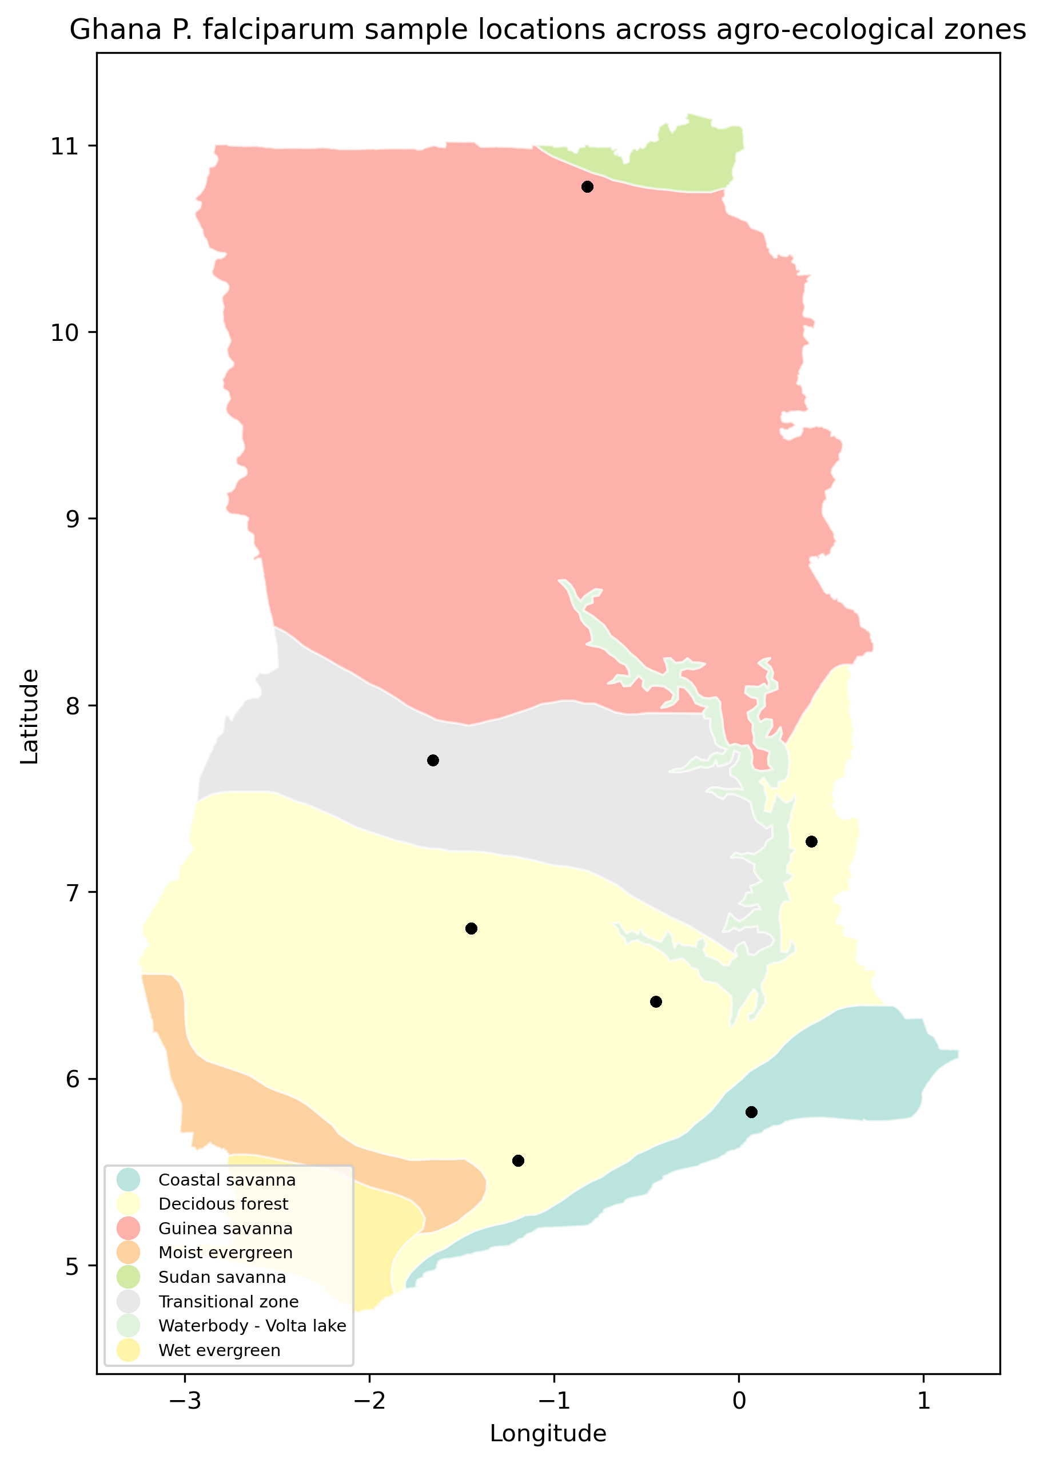
Figure 2.1. Sampling locations on the Ghana agro-ecological zone layer. Each black point is one administrative-level-1 centroid, not an individual isolate; the seven points carry 4,905 isolates between them. Generated by scripts/step02_assign_aez.py as figures/ghana_samples_aez_map.png.

2.5 Temporal composition
[Observed] Collection year is strongly unbalanced across zones (Table 2.3). Median collection year ranges from 2012 (transitional zone) to 2018 (coastal savanna). The transitional zone contributes no isolate after 2013; the coastal savanna contributes none before 2016.
Year | Coastal savanna | Deciduous forest | Guinea savanna | Transitional zone
2009 | 0 | 0 | 41 | 0
2010 | 0 | 0 | 81 | 0
2011 | 0 | 0 | 36 | 3
2012 | 0 | 0 | 21 | 19
2013 | 0 | 1 | 84 | 3
2014 | 0 | 111 | 63 | 0
2015 | 0 | 66 | 96 | 0
2016 | 15 | 21 | 59 | 0
2017 | 12 | 0 | 243 | 0
2018 | 177 | 40 | 556 | 0
2019 | 0 | 14 | 54 | 0
2020 | 0 | 76 | 0 | 0
2021 | 0 | 8 | 0 | 0
Median year | 2018 | 2015 | 2017 | 2012
Table 2.3. Collection year by zone in the final analysis set (n = 1,900). Computed here from interim/analysis_samples.csv.
[Interpreted] Any between-zone difference observed in this dataset is also a between-period difference. Ghana changed first-line therapy and scaled up chemoprevention over this window, so allele frequencies at drug-related loci would be expected to move with time independently of geography. This confounding is not removable by reweighting, because for the transitional zone and the coastal savanna the year ranges barely overlap.

2.6 Variable summary
Variable | Source | Type | Notes
Sample | Pf8 manifest | string | Isolate identifier; the join key throughout.
Country | Pf8 manifest | string | Filtered to "Ghana" at Step 1.
QC pass | Pf8 manifest | boolean-like | The release's own flag. Parsed permissively (true/t/yes/y/1/pass) by config.coerce_bool.
Admin level 1 | Pf8 manifest | string | Region. Seven values in Ghana.
Admin level 1 latitude / longitude | Pf8 manifest | float | Region centroid. Seven distinct pairs.
Year | Pf8 manifest | float | Collection year, 2009–2021.
pf8_row | derived, Step 1 | int | Row index into the 33,325 × 33,325 distance matrix. Captured once so the submatrix slice can never be mis-indexed.
zone | derived, Step 2 | string | Agro-ecological zone from the spatial join. Four values.
call_rate, het_rate, Fws | derived, Step 3b | float | Per-isolate QC statistics from a 50,000-SNP panel.
qc_pass (pipeline) | derived, Step 3b | boolean | Distinct from the Pf8 flag; this is the pipeline's own composite.
GT, AD, DP, GQ | Pf8 Zarr | int8 / int16 | Genotype, allelic depths, total depth, genotype quality. Missing encoded as −1.
FILTER_PASS, is_snp, numalt, RegionType | Pf8 Zarr | bool / int / string | Site-level annotations used for variant filtering.
Table 2.4. Variables used. "Derived" variables are written by the pipeline into interim/ and results/.

3. Methodology
The analysis is a nine-stage pipeline driven by scripts/run_all.sh. Stages run in order; each writes its outputs to disk so that a failure costs one stage rather than the whole run. This section describes each stage: what it does, why, what it assumes, and how it constrains what follows.

3.1 Pipeline overview
Stage | Script(s) | Function | Principal output
1 | step01_filter_samples.py | Restrict the Pf8 manifest to Ghana and to QC-passing isolates; capture distance-matrix row indices | interim/ghana_samples.csv
2 | step02_assign_aez.py | Spatial join of isolate coordinates to agro-ecological zone polygons | interim/ghana_samples_with_aez.csv
3 | step03_umap.py | UMAP, t-SNE and PCoA of the Ghanaian block of the Pf8 distance matrix, plus a quantitative comparison of the three | results/{umap,tsne}_embedding.csv,  results/pcoa_coordinates.csv,  results/dimred_comparison.csv
3a | step03a_fetch_callset_zarr.py | Fetch the Ghanaian callset from the Pf8 Zarr store over HTTPS (added in this session; see Section 5.1) | interim/pf8_ghana.zarr
3b | step03b_sample_qc.py | Per-isolate quality control: call rate, heterozygosity, Fws, clonal pruning | interim/ghana_samples_qc_pass.csv,  results/sample_qc_full.csv
4 | step04a_prepare_callset.py,  step04b_fst.py | Build the filtered genotype matrix; compute pairwise Hudson FST and cache per-zone allele counts | interim/ghana_core_snps.npz,  results/fst_pairwise.csv
5 | step05a / 05b / 05c | Export to PLINK, LD-prune, ADMIXTURE sweep K = 1–8, plot | results/admixture/
6 | step06_mantel.py | Mantel test of isolation by distance, zone and region level | results/mantel_result_{zone,region}.json
7 | step07a / 07b / 07c | TreeMix input, sweep over 0–5 migration edges, model comparison | results/treemix/
8 | step08a / 08b / 08c | BayPass input, core model, pseudo-observed data simulation, XtX calibration | results/baypass/
9 | step09_annotate.py | Intersect outlier SNPs with the PlasmoDB-71 gene annotation | results/outlier_genes.csv
Table 3.1. Pipeline stages. Stage 3a was added during this session; all other scripts were supplied with the project and were modified only as recorded in Section 5.

3.2 Stage 1 — manifest filtering
What and why. The manifest is restricted to Ghana and then to isolates flagged QC-pass by the release. Relying on the release's flag rather than re-deriving sample quality from raw data is a deliberate deference to MalariaGEN's own curation, which has access to sequencing-run level information this analysis does not.
Implementation note. The script captures each retained isolate's row index in the full 33,325-sample distance matrix as the column pf8_row. This is the only safe way to slice the Ghanaian block later: the pandas index would shift under any subsequent filter, whereas pf8_row is fixed at the moment of extraction. Step 3 asserts that the maximum pf8_row does not exceed the matrix dimension, which would catch a Pf7/Pf8 mismatch.
[Observed] 6,653 Ghanaian rows → 4,905 after the QC filter (1,748 dropped). pf8_row range 2,301–29,498.

3.3 Stage 2 — agro-ecological zone assignment
What and why. Isolate coordinates are joined to the zone polygon layer with GeoPandas, giving each isolate a zone label. Because the coordinates are region centroids, the join is effectively a lookup table from seven points to four zones.
Assumption. That a region's centroid is a reasonable proxy for where its isolates were collected. For compact regions this is tolerable; for regions that straddle a zone boundary it is not. The script prints a region × zone cross-tabulation specifically so that boundary-straddling regions can be checked by eye, and flags Brong Ahafo (forest/transition) and Volta (coastal/Guinea savanna) as the two warranting manual review.
[Observed] All 4,905 isolates matched exactly one polygon; zero unmatched, zero duplicate matches. Resulting counts: Guinea savanna 3,605, deciduous forest 815, coastal savanna 435, transitional zone 50.
[Proposed] The Brong Ahafo and Volta assignments have not been manually reviewed against the map. Volta in particular contributes 21 isolates to the deciduous forest zone, and its centroid sits near a boundary in the layer.

3.4 Stage 3 — three ordinations of the genotype distance matrix
What and why. Pf8 publishes a precomputed mean genotype distance matrix over all 33,325 samples. The Ghanaian block (4,905 × 4,905) is sliced out by memory-mapping the 4.44 GB file and taking the submatrix, which keeps peak memory in the low hundreds of megabytes. Three dimensionality-reduction methods are then applied to the same matrix so that they can be compared on equal terms.
- UMAP (n_neighbors = 30, min_dist = 0.1, metric = precomputed) — preserves local neighbourhood structure with partial global layout. These are the parameter values specified in the thesis workflow.
- t-SNE (perplexity = 30, metric = precomputed, init = random) — preserves local neighbourhoods only. Initialisation must be random rather than PCA-based because the input is a distance matrix rather than feature vectors.
- PCoA (classical metric multidimensional scaling) — Gower double-centring followed by an eigendecomposition. Unlike the other two it is linear, so axis scaling is interpretable and each axis carries a proportion of variation explained.
Comparison metrics. Because the three methods optimise different objectives, a visual comparison alone would be uninformative. Three quantitative measures are computed on the same embeddings: trustworthiness (do points that are close in two dimensions correspond to genuine near neighbours in the full matrix?), the Spearman correlation between pairwise distances in the embedding and in the original matrix on a 2,000-sample subset (does the embedding preserve global structure?), and the silhouette coefficient by zone (do the zone labels separate?). The silhouette is also computed on the original distance matrix, which gives the ceiling that any embedding could achieve.
Deviation from the thesis workflow. The workflow document specifies UMAP for this step. t-SNE and PCoA were added at the user's request during this session so that the three could be compared. This is an addition, not a substitution: the UMAP configuration is unchanged.

3.5 Stage 3a — genotype retrieval
What and why. This stage did not exist in the supplied pipeline and was written during this session to replace a failed VCF download (Section 5.1). It fetches genotypes directly from the Pf8 Zarr store over HTTPS, chunk by chunk, retaining only what the downstream steps read.
The Zarr store is chunked 131,072 variants × 100 samples per field. Because the 6,653 Ghanaian samples fall in 77 of the 334 sample-chunk columns, and the sites of interest in 95 of the 96 variant-chunk rows, only a subset of the grid must be transferred. Each chunk is downloaded, decompressed in memory, sliced to the Ghanaian columns and the retained rows, then written to a local store and discarded, so peak memory stays at a few gigabytes and the ~300 GB transferred is never written to disk.
Sites are retained where FILTER_PASS is true, is_snp is true and numalt equals 1. Fields retained are GT, AD (reference and first alternate only), DP and GQ.
[Observed] 2,190,026 of 12,493,205 Pf8 sites are PASS biallelic SNPs. Every one of them carries RegionType = "Core", confirmed by a direct tabulation. The transfer moved 299.8 GB in 3.20 hours at approximately 26 MB/s with zero failed requests, producing a 20.57 GB local store.
Consequence for the core-genome filter. The supplied pipeline expects an optional BED file of core-genome intervals (data/pf_core_regions.bed), absent here, and warns that without it subtelomeric var/rifin regions will contaminate the outlier scan. The tabulation above resolves that concern empirically: because all PASS biallelic SNPs are annotated Core, the PASS filter already performs the exclusion the BED would have performed. The warning the pipeline prints at Step 4a is therefore a false alarm in this dataset.
Validation. The store was verified against the one completely downloaded VCF (chromosome 10) and against two partially downloaded ones (chromosomes 1 and 13), in three independent 35–40 kb windows. In each window the site list matched exactly and all four genotype fields agreed value for value: 3,957, 3,470 and 4,378 PASS biallelic SNPs respectively, with zero differing values across 158 million, 139 million and 175 million compared values. The verification is in logs/step03a_fetch_callset.log.

3.6 Stage 3b — isolate quality control
Four per-isolate checks are applied, computed from a panel of 50,000 biallelic PASS SNPs spread proportionally across all 14 contigs.
Within-host fixation index (F_{ws}). F_{ws} measures how far an isolate's read-level allele frequencies depart from the population's. A clonal infection has read frequencies near 0 or 1 at every site and F_{ws} near 1; a mixed infection carries intermediate frequencies and a lower value. It is computed here as
F_{ws} = 1 − ( Σ_{i} H_{w,i} / Σ_{i} H_{s,i} ), where H_{w} = 2q(1 − q) from the isolate's own read counts and H_{s} = 2p(1 − p) from pooled read counts across qualifying isolates.
Sites contribute only where total depth is at least 5. The conventional monoclonality threshold of 0.95 is applied.
Call rate. The proportion of panel SNPs with a genotype call. The pipeline applies an absolute floor and, optionally, a median-absolute-deviation outlier rule; the choice between them is discussed in Section 5.4.
Heterozygosity outliers. Blood-stage P. falciparum is haploid, so a heterozygous call indicates a mixed infection or a genotyping error rather than true heterozygosity. Isolates more than three median absolute deviations above the median heterozygous call rate are flagged. This check is largely redundant with F_{ws} and is retained as an independent cross-check.
Clonal pruning. Near-identical isolates (outbreak-linked or repeat-sampled parasites) inflate within-zone homogeneity and therefore inflate between-zone F_{ST}. The cached Ghanaian distance submatrix from Stage 3 is thresholded, connected components are extracted with a single-linkage rule, and one representative is retained per component — chosen by best call rate, then best F_{ws}, then identifier, so the choice is deterministic.

3.7 Stage 4a — building the genotype matrix
This stage converts the Zarr store into the single filtered genotype matrix that every subsequent stage reads. The order of operations matters and is deliberate:
- Site-level filters on the small one-dimensional arrays (FILTER_PASS, is_snp, numalt = 1), screening the whole genome before any genotype is fetched.
- Genotype-level masking: calls below a read-depth floor are set to missing. A low-confidence call thus becomes missing data rather than a confident wrong answer, which matters because the missingness filter at step 5 then sees it for what it is.
- Sample alignment: genotype columns are reordered to match the metadata table, so that sample order is fixed once and never re-derived.
- Mixed-call resolution: heterozygous calls are replaced by the allele with more reads; ties become missing (Section 5.3).
- Variant missingness filter (≤ 10 per cent), then sample missingness filter (≤ 20 per cent), then minor allele frequency filter (≥ 5 per cent). Missingness is applied before MAF so that a SNP is not retained on the strength of a handful of confident calls.
Thresholds. MAF > 5 per cent and missingness < 10 per cent are specified in the thesis workflow document for Step 4 and were not altered. The depth floor and the sample-missingness bound are pipeline defaults; the depth and quality settings were revised during this session and that revision is documented in Section 5.5.

3.8 Stage 4b — pairwise differentiation
Estimator. Hudson's F_{ST} is computed per locus and summed as a ratio of averages — numerator and denominator accumulated across loci before dividing — rather than as an average of per-locus ratios, which is upwardly biased. Hudson's estimator is preferred over Weir and Cockerham's here because it is insensitive to unequal sample sizes between populations, which is pertinent when one zone has 1,334 isolates and another has 25.
Uncertainty. Standard errors come from a block jackknife over contiguous blocks of SNPs, which accounts for linkage between nearby sites. Blocks are 2,000 SNPs by default, reduced automatically to at most one twentieth of the available SNPs.
Ploidy handling. Allele counts are taken as one allele per isolate (Section 5.3). This matters: counting both copies of a diploid-coded haploid genotype would double every sample size entering the F_{ST} correction, the TreeMix drift standard errors and the BayPass XtX statistic, making all three anticonservative.

3.9 Stages 5 to 9
ADMIXTURE (Stage 5). Genotypes are exported to PLINK transposed text format, converted to binary, LD-pruned (50-SNP window, 10-SNP step, r² threshold 0.2) and run through ADMIXTURE for K = 2 to 8 with 10-fold cross-validation. Pruning is not optional: linked SNPs carry redundant information and inflate apparent structure. K = 1 was run separately during this session to provide the no-structure reference point that the supplied sweep omits.
Mantel test (Stage 6). Isolation by distance is tested by regressing linearised differentiation, F_{ST} / (1 − F_{ST}), on the logarithm of great-circle distance computed on the WGS84 ellipsoid. Significance comes from a permutation test on the distance matrices (999 permutations, one-sided, since isolation by distance predicts a positive association). The test is run at two levels: four zones, and seven administrative regions.
TreeMix (Stage 7). A maximum-likelihood population graph is fitted with 0 to 5 migration edges, rooted on Guinea savanna, using a jackknife block size of 50 SNPs. Model fit is summarised as the proportion of variance in between-population covariance explained, computed over off-diagonal entries only, matching TreeMix's own definition.
BayPass (Stage 8). The core model estimates the population covariance matrix Ω from genome-wide allele counts, then reports XtX per SNP — a differentiation statistic standardised by that covariance structure. A SNP is called an outlier when its XtX exceeds a threshold taken from pseudo-observed data simulated under the estimated Ω. The logic is that a threshold drawn from the empirical XtX distribution assumes a fixed proportion of the genome is under selection, whereas a threshold from simulated neutral data assumes only that the demographic model is adequate.
Annotation (Stage 9). Outlier positions are intersected with protein-coding gene features from PlasmoDB-71 using bedtools, and cross-referenced against a panel of eight validated antimalarial resistance loci and against antigenic and invasion gene families.

4. Filtering and inclusion/exclusion criteria
This section documents every filter applied, with counts before and after, and states for each whether it was specified in advance (in the thesis workflow or the supplied pipeline), chosen during this session on the basis of exploratory output, or introduced retrospectively.

4.1 The filtering cascade
# | Filter | Level | Threshold | Before | After | Removed | Origin
1 | Country = Ghana | isolate | exact match | 33,325 | 6,653 | 26,672 | Pre-specified
2 | Pf8 QC-pass flag | isolate | release flag | 6,653 | 4,905 | 1,748 | Pre-specified
3 | Zone assignment | isolate | within a polygon | 4,905 | 4,905 | 0 | Pre-specified
4 | Site FILTER = PASS,  biallelic SNP | site | FILTER_PASS ∧ is_snp ∧  numalt = 1 | 12,493,205 | 2,190,026 | 10,303,179 | Pre-specified
5 | Call rate floor | isolate | ≥ 0.80 | 4,905 | 4,885 | 20 | Pre-specified
6 | Call-rate MAD outlier | isolate | disabled (< 0.982  if enabled) | 4,885 | 4,885 | 0 | Session decision
7 | Heterozygosity outlier | isolate | > median + 3 MAD  (0.0019) | — | — | 126 | Pre-specified
8 | Fws monoclonality | isolate | ≥ 0.95 | — | — | 2,810 | Pre-specified
9 | Clonal pruning | isolate | distance ≤ 0.00005 | — | — | 77 | Session decision  (threshold)
— | Combined effect of 5–9 | isolate |  | 4,905 | 2,017 | 2,888
10 | Genotype depth mask | call | DP ≥ 5 | 12,540,727,880  calls | 10,845,661,093  calls | 13.52% | Session decision  (GQ rule removed)
11 | Mixed-call resolution | call | majority allele by AD;  ties → missing | 194,167  mixed calls | 185,247  resolved | 8,920  (tied) | Session decision
12 | Variant missingness | site | ≤ 0.10 | 2,190,026 | 1,634,808 | 555,218 | Pre-specified  (thesis: < 10%)
13 | Sample missingness | isolate | ≤ 0.20 | 2,017 | 1,900 | 117 | Pre-specified
14 | Minor allele frequency | site | ≥ 0.05 | 1,634,808 | 3,359 | 1,631,449 | Pre-specified  (thesis: > 5%)
15 | LD pruning  (ADMIXTURE only) | site | r² < 0.2, 50/10 window | 3,359 | 2,923 | 436 | Pre-specified
Table 4.1. Complete filtering cascade. Isolate-level filters 5–9 are not sequential — each is evaluated independently against all 4,905 isolates and an isolate may fail several — so only their combined effect has a meaningful before/after pair. Sources: logs/step03b_sample_qc.log, logs/run_from4_parallel.log, results/sample_qc_full.csv.

4.2 Rationale, origin and consequences of each non-trivial filter

4.2.1 Pf8 QC-pass flag (filter 2)
Purpose and origin. Pre-specified. Removes isolates MalariaGEN itself judged unreliable, on the basis of sequencing-run information not available downstream.
Effect. 1,748 of 6,653 isolates removed (26.3 per cent). The loss is not uniform across regions: Upper East loses 1,216 (25.2 per cent) and Central loses 377 (55.0 per cent), while Volta loses none.
[Hypothesized] Differential loss by region most likely reflects differences in sample collection, storage or sequencing batch rather than anything biological, but the manifest does not carry the fields needed to confirm this.

4.2.2 Fws ≥ 0.95 (filter 8)
Purpose. To exclude polyclonal infections. A mixed infection contributes allele frequencies from several parasite genomes to a single genotype column; ADMIXTURE reads that as intermediate ancestry, so an uncorrected analysis risks describing the transmission-intensity gradient rather than the ancestry structure it is meant to estimate.
Origin. Pre-specified. 0.95 is the conventional cut and is the pipeline default (config.MIN_FWS). It was re-confirmed during this session against the observed F_{ws} distribution, which shows a pronounced mode above 0.95 and a long left shoulder (Figure 6.2, third panel), so the threshold falls at a natural break rather than cutting through a dense region.
Effect and its most important consequence. 2,810 of 4,905 isolates removed — by far the largest single exclusion. Critically, the polyclonal fraction varies systematically by zone: Guinea savanna 0.597, deciduous forest 0.539, transitional zone 0.500, coastal savanna 0.444.
[Interpreted] This gradient is itself a transmission signal — higher transmission produces more mixed infections — so the filter removes a greater share of isolates from the high-transmission north than from the lower-transmission coast. The retained sample is therefore not a random subsample of the Ghanaian parasite population, and the degree of non-randomness differs by zone. Because the filter targets monoclonality rather than any allele, the direct effect on allele frequencies should be modest, but this has not been tested.
[Proposed] Re-run the F_{ST} and ADMIXTURE analyses at F_{ws} ≥ 0.90 and ≥ 0.80 (projected to retain 2,341 and 2,924 isolates respectively) and compare. If conclusions are unchanged, the sensitivity concern is discharged cheaply.

4.2.3 Call-rate outlier rule (filter 6) — disabled
What the pipeline did. A median-absolute-deviation rule flags isolates whose call rate falls more than three MADs below the median. Because Ghanaian call rates are tightly bunched near 1 (median 0.9962), the resulting bound sits at 0.982 and flagged 1,281 isolates, of which 449 failed no other check.
Decision and origin. Session decision, taken on exploratory output. The rule was disabled, leaving only the absolute floor of 0.80 (config.MIN_SAMPLE_CALL_RATE, pre-specified). The reasoning: the MAD-flagged, otherwise-passing isolates had a median call rate of 0.956, which is not poor data in absolute terms, and Step 4a applies an independent sample-missingness bound later in any case. A MAD rule is designed to find outliers in a dispersed distribution; applied to a tight one it becomes an arbitrary strict threshold.
Effect. Retaining these isolates raised the QC-passing count from 1,566 to 2,017 and the final analysis set from 1,862 to 1,900.
Honesty note. This threshold was chosen after seeing its effect on sample counts, not in advance. The justification above is a post-hoc rationalisation of a decision made during exploratory analysis. It is defensible, but it was not pre-registered, and a reviewer is entitled to ask whether the alternative was examined with equal care. Table 4.2 records the alternatives that were quantified before the choice was made.
Call-rate rule | SNPs retained  (projected) | Isolates | Guinea | Forest | Coastal | Transitional
MAD rule on, Fws ≥ 0.95 | 2,117 | 1,843 | 1,294 | 323 | 201 | 25
MAD rule off, ≥ 0.80 (chosen) | 3,416 | 1,878 | 1,323 | 326 | 204 | 25
MAD rule off, ≥ 0.90 | — | — | — | — | — | —
Table 4.2. Alternatives quantified before the call-rate decision, from a 300,000-SNP random panel projected genome-wide. Row 3 was offered as an option but not quantified in the same projection, hence the blanks. Note that these projections were made under the DP-only mask; the first row is therefore not identical to the 1,566-isolate figure obtained under the original DP+GQ mask.

4.2.4 Clonal pruning threshold (filter 9)
Problem. Unlike F_{ws}, the clonality threshold has no conventional value, and the data offer no clean break. The script's own histogram heuristic suggested 0.00005; the number of isolates removed rises smoothly with the threshold, with no trough to anchor on.
Threshold | Clonal pairs | Groups | Isolates in groups | Isolates removed | Largest group
0.00002 | 57 | 49 | 102 | 53 | 3
0.00005 (chosen) | 85 | 68 | 145 | 77 | 3
0.0001 | 103 | 82 | 174 | 92 | 4
0.0002 | 133 | 104 | 222 | 118 | 4
0.0003 | 159 | 118 | 255 | 137 | 4
0.0005 | 261 | 164 | 370 | 206 | 7
0.0007 | 523 | 229 | 591 | 362 | 30
Table 4.3. Sensitivity of clonal pruning to the distance threshold, computed on the cached 4,905 × 4,905 Ghanaian distance submatrix. The median pairwise distance between Ghanaian isolates is 0.00112, so even the loosest threshold shown is well inside the left tail. Recorded here from a direct sensitivity run; the corresponding script is not part of the pipeline.
Decision and origin. Session decision. 0.00005 was chosen: isolates within about 4 per cent of the typical pairwise distance, which is a defensible reading of "essentially the same genome". The largest connected component at this threshold contains 3 isolates, so single-linkage chaining — the real danger of this method, where a sequence of moderately similar isolates merges into one large component — is not occurring. At 0.0007 the largest component reaches 30 isolates and chaining is clearly setting in.
Effect. 77 isolates removed, 1.6 per cent of the pre-QC set. Because the effect is small and the method is well behaved at this threshold, sensitivity to the exact value is unlikely to be material — but this has not been verified by re-running downstream analyses.

4.2.5 Genotype quality mask (filter 10)
Problem. The pipeline default masked calls below DP 5 or GQ 20. Under that default the final matrix held 2,143 SNPs. Removing the GQ component raised it to 3,359.
Evidence gathered before deciding. A 40,000-SNP diagnostic panel showed that 12.6 per cent of homozygous-reference and 12.4 per cent of homozygous-alternate calls fall below GQ 20, with median depths of 46 and 40 respectively — that is, the GQ < 20 population is not a low-depth population. Restricted to calls with DP ≥ 10, only 3.0 per cent of homozygous-reference and 0.7 per cent of homozygous-alternate calls still fail GQ 20. Applying the GQ rule halved the number of common SNPs surviving the missingness bar (from 51.0 per cent of panel SNPs under DP-only masking to... in fact missingness ≤ 10 per cent fell from 74.3 per cent of SNPs under DP-only to 51.0 per cent under DP+GQ), while mean alternate-allele frequency at common SNPs moved only from 0.282 to 0.294.
Decision and origin. Session decision, taken on that evidence and confirmed with the user. config.MIN_GENOTYPE_GQ was set to 0, retaining DP ≥ 5. The reasoning: the GQ rule was removing a large number of common SNPs at substantial cost to statistical power, while barely changing allele frequencies — that is, it was costing precision without buying accuracy.
[Interpreted] The likely explanation is that GQ is a Phred-scaled confidence in the called genotype relative to alternatives; in a haploid organism forced into a diploid calling model, intermediate GQ values can arise from the model's own ambiguity rather than from poor data. This interpretation is consistent with the depth evidence but was not independently verified.

4.2.6 MAF ≥ 5 per cent (filter 14)
Origin. Pre-specified in the thesis workflow ("MAF > 5%") and not altered.
Effect — the most consequential number in the analysis. 1,634,808 SNPs pass the missingness filter; 3,359 pass MAF. This is a reduction of 99.79 per cent.
[Observed] The diagnostic panel establishes that this is a property of the organism and the population, not of the pipeline: with no genotype masking whatsoever, only about 4,832 SNPs genome-wide reach MAF ≥ 5 per cent with missingness ≤ 10 per cent, and about 5,529 reach MAF ≥ 5 per cent ignoring missingness entirely. The ceiling is therefore roughly 5,500 SNPs, and the analysis retains 3,359 of them.
[Interpreted] P. falciparum carries an extremely large number of rare variants and comparatively few common ones within a single country. A 5 per cent MAF filter in this setting is far more aggressive than the same nominal threshold would be in, say, a human cohort. Every downstream analysis — F_{ST}, ADMIXTURE, TreeMix, BayPass — operates on these 3,359 sites, and the BayPass scan in particular has limited power at this density.
[Proposed] Repeat the main analyses at MAF ≥ 1 per cent (projected roughly 8,500–12,400 SNPs) as a sensitivity check. This departs from the thesis specification and so should be reported as a robustness analysis rather than as the primary result, but the gain in power for the outlier scan could be substantial.

4.3 Selection bias summary
Three biases are introduced or amplified by the filtering, in decreasing order of concern.
- Transmission-intensity bias (from the Fws filter). The retained sample under-represents high-transmission settings, and does so unevenly across zones. This is the bias most likely to affect between-zone comparisons.
- Regional bias (from the Pf8 QC flag and from the sampling frame itself). Upper East dominates every stage. No filter corrects this and none was intended to.
- Allele-frequency bias (from the MAF filter). The analysis sees only the common end of the frequency spectrum. Rare variants, which is where most recent selection signal would sit, are invisible to it.
[Interpreted] None of these is an error. Each follows from a defensible choice. But together they mean the final 1,900-isolate, 3,359-SNP dataset is a particular view of Ghanaian P. falciparum — monoclonal infections, common variants, Upper East–heavy — and conclusions should be stated as applying to that view.

5. Analytical decisions and iterations
This section reconstructs the decisions taken during the analysis. Where a decision was put to the user and answered, that is stated. Where the rationale is reconstructed after the fact, it is labelled as such.

5.1 Replacing the VCF route with direct Zarr retrieval
Problem. The project had 14 per-chromosome VCFs in data/, produced by data/extract_ghana.sh, which streamed each Pf8 chromosome VCF from Sanger through bcftools view with a Ghana sample list. Thirteen of the fourteen were truncated. Inspection of the BGZF end-of-file marker and decoding of the last record in each file showed coverage from 9 per cent (chromosome 12) to 53 per cent (chromosome 9); only chromosome 10 was complete.
Cause. bcftools aborted with "[E::bcf_calc_ac] Incorrect AN/AC counts" while recomputing allele counts for the sample subset. Each truncation point matches its recorded error position exactly — chromosome 12 failed at position 200,583 and its last record is at 200,581. The extraction script echoed "Finished" regardless of the exit status, so the failures went unnoticed. The errors are preserved in data/extract_ghana.log and data/chr05_extract.log; the consequent end-of-file warnings are in data/index_tbi.log.
Constraint. The one complete VCF, chromosome 10, is 34.7 GB for 1.69 Mb of sequence. At that rate the full 23.3 Mb genome would require approximately 480 GB, against 352 GB free on the data volume. A simple re-download was therefore not possible.
Options put to the user.
Option | Transfer | Local disk | Time | Script changes
A. Pf8 Zarr store, Ghana samples and PASS biallelic SNPs only (chosen) | ~300 GB | ~25–40 GB | ~3–4 h | One new script
B. Resume the VCFs with bcftools -I, slimmed to needed fields | ~1.6 TB | moderate | 1–2 days | None, plus slow VCF→Zarr conversion
C. Re-download all VCFs from scratch, slimmed | ~2.2 TB | moderate | longest | None
Table 5.1. Genotype-retrieval options presented. Estimates for A derive from a direct probe of the Zarr store's chunk grid; B and C are extrapolated from the observed chromosome-10 download.
Decision. Option A, chosen by the user. A fourth implicit option — the project's own step04a_prepare_callset_malariagen.py, which pulls from Google Cloud via the malariagen_data package — was not pursued because it would have required changes to run_all.sh and because Step 3b reads the local store directly.
Consequence and verification. The new script produced a 20.57 GB store verified exactly against three VCF windows (Section 3.5). On that evidence, and with the user's approval, the 13 truncated VCFs and their indexes were deleted, freeing about 125 GB; the complete chromosome-10 VCF was retained as a verification reference.
[Interpreted] Beyond solving the immediate problem, this route is strictly better for the analysis: it removes the AC/AN recomputation that caused the failure, it carries the RegionType annotation that makes the missing core-genome BED unnecessary, and it is reproducible from a public URL rather than from a 160 GB local artefact.

5.2 Adding t-SNE and PCoA alongside UMAP
Problem and decision. The thesis workflow specifies UMAP. The user asked for alternative ordinations so that the three could be compared. Both were added to Stage 3, reading the same distance matrix, with a quantitative comparison table.
Why it mattered more than expected. UMAP and t-SNE are non-linear and their inter-cluster distances carry no quantitative meaning, a caveat the original script already printed. PCoA is linear, so its axes are interpretable and carry explicit variance proportions. With structure as weak as it is here, the PCoA result — 1.3 per cent of variation on the first two axes — is considerably more informative than any visual impression of the UMAP plot, and would not have been available from the specified workflow alone.

5.3 Ploidy: how to count alleles in a haploid parasite coded as diploid
Problem. Blood-stage P. falciparum is haploid, but Pf8 records genotypes in diploid form: 0/0 or 1/1 for a clonal call, 0/1 where reads support both alleles (a mixed infection). The supplied step04b_fst.py called scikit-allel's count_alleles on the diploid array, which counts two gene copies per isolate. The same cached counts feed TreeMix and BayPass.
Why this is a defect, not a convention. Hudson's F_{ST} carries a sample-size correction; TreeMix derives drift standard errors from counts; BayPass's XtX is standardised by them. Doubling every sample size makes all three anticonservative — narrower intervals, more apparently significant edges, more apparent outliers — without changing the point estimates much.
Options put to the user.
- Haploid, mixed calls to missing — use the pipeline's existing --het-to-missing switch, then count one allele per isolate. Simplest; discards the mixed calls entirely.
- Haploid, mixed calls to the majority allele (chosen) — assign the allele with more reads, ties to missing, then count one allele per isolate. Retains the information in the read depths.
- Leave as written — point estimates barely move, but uncertainty stays understated throughout.
Implementation and verification. A function resolve_mixed_calls was added to step04a_prepare_callset.py, reading AD a block at a time only for SNPs where some retained isolate carries a mixed call. A companion isolate_allele_counts was added to callset_io.py; it takes the first gene copy once mixed calls are resolved, and falls back to diploid counting with an explicit warning if any mixed call remains. Both were verified against a hand-computed synthetic case (3 SNPs × 4 isolates, including a tie and a missing genotype) before being applied to real data.
[Observed] On the real dataset, 194,167 mixed calls were resolved: 129,665 to reference, 55,582 to alternate, and 8,920 tied and set to missing. The residual heterozygous call rate printed by Step 4a is 0.0000 to four decimal places, consistent with the F_{ws} filter having already removed most mixed infections.
[Interpreted] The asymmetry — 2.3 reference calls for every alternate call — is expected, since at a site where most isolates carry the reference allele, a mixed infection is more likely to be reference-dominant. It is not evidence of a reference bias in the resolution rule itself, though that possibility has not been formally excluded.

5.4 Sample QC thresholds
Three thresholds were put to the user after the first QC run, each accompanied by the counts each option would produce. The call-rate and clonality decisions are discussed in Sections 4.2.3 and 4.2.4. The Fws threshold was retained at the conventional 0.95 (options at 0.90 and 0.80 were offered and declined).
[Interpreted] Presenting the sample counts alongside each option made the trade-off explicit, but it also means these thresholds were selected with knowledge of their effect on sample size. That is standard exploratory practice and is reported here rather than concealed.

5.5 TreeMix jackknife block size
Problem. The supplied configuration used 500 SNPs per jackknife block. With 3,359 SNPs that yields 6 or 7 blocks, far too few for stable standard errors, which in turn makes the migration-edge tests unreliable.
Decision. Reduced to 50 SNPs, giving approximately 67 blocks. With retained SNPs averaging roughly 7 kb apart, a 50-SNP block spans about 350 kb, which comfortably exceeds the scale over which linkage disequilibrium persists in P. falciparum. The block therefore remains large enough to absorb linkage while being small enough to give a usable number of replicates. A 100-SNP alternative (about 34 blocks) was offered and declined.

5.6 BayPass calibration
Problems found. Three, in the supplied step08b_baypass.sh.
- The pseudo-observed data simulation passed the .geno matrix directly as sample.size. That file interleaves reference and alternate counts, giving 2 × npop columns, whereas simulate.baypass requires npop columns of total haploid sample size per SNP. The call would have failed, and the script would have fallen through to an empirical quantile.
- Only 1,000 pseudo-observed SNPs were simulated. The threshold is the 0.999 quantile of their XtX, so it would have rested on a single simulated value.
- The simulation applied no minor-allele-frequency filter, while the observed SNPs had been filtered at MAF ≥ 5 per cent. The resulting neutral distribution was not comparable to the observed one: 17.0 per cent of simulated sites had overall allele frequency below 0.05, against 0.5 per cent of observed sites.
Corrections. Reference and alternate columns are now summed to total counts; the simulation uses 100,000 SNPs; and pi.maf is set to 0.05 to match the observed filter. A stale G.pod file is removed before each run, and an R failure now falls through to the documented empirical fallback instead of aborting the stage.
[Observed] The correction moved the threshold materially: from 8.375 with 1,000 unfiltered simulated SNPs (40 outliers, 1.19 per cent of the scan) to 11.232 with 100,000 MAF-matched ones (15 outliers, 0.45 per cent). The reported results use the corrected calibration.
[Interpreted] The direction is as expected: an unfiltered simulation contains rare sites whose XtX is low, which depresses the upper quantile and admits too many outliers. The 25 SNPs that fall between the two thresholds should be regarded as having failed calibration, not as marginal.

5.7 Defects found and corrected in the supplied pipeline
A systematic review of the unexecuted stages was carried out before they ran. Table 5.2 lists what was found and what was done. Each correction was verified either against the code path in question or, where practical, by execution.
Defect | Severity | Correction | Verification
config.TREEMIX_ROOT was "Guinea_Savanna" but slugify_zone produces "Guinea_savanna"; step07b would have exited 1 at its header check, aborting stages 7–9 under set -e | Would abort the run | Corrected to "Guinea_savanna"; step07b now derives its default from config rather than keeping its own copy | Stage 7 ran to completion
step07c model-selection rule was gains.fillna(1).idxmax(), which always returns m = 0 because the first difference is NaN and the fill value exceeds any real gain | Wrong result, silently | Replaced with the documented rule: smallest m reaching 0.998 variance explained, else the smallest m within 0.001 of the range's best (a plateau rule). A maximum-likelihood fallback was rejected because likelihood is monotone in m and would always select the largest m tried | Produced m = 2 (range 0–2) and m = 3 (range 0–5), consistent with the fitted values in Table 6.6
step07c variance explained was computed over the full covariance matrix including the diagonal; TreeMix's own get_f uses off-diagonal entries only, and the 0.998 convention assumes that definition | Wrong result | Restricted to the upper triangle | Definition recorded in results/treemix/model_selection.json
Allele counts doubled by diploid coding (Section 5.3) | Anticonservative throughout | isolate_allele_counts in callset_io.py | Synthetic unit test
Zone-level Mantel test used polygon centroids, which lie where no isolate was sampled | Wrong geography | Zones are now placed at the sample-weighted mean of their isolates' coordinates, matching the region-level logic | Printed zone coordinates in logs/stage6.log
BayPass POD simulation (Section 5.6) | Calibration failure | Three corrections as described | Threshold recomputed; 15 outliers
pfcoronin recorded as PF3D7_1362500 and pfap2mu as PF3D7_1451200 | Silent false negatives | Corrected to PF3D7_1251200 and PF3D7_1218300 | Confirmed against the PlasmoDB-71 GFF: the original identifiers annotate a 3′–5′ exonuclease and a conserved protein of unknown function respectively
PLINK export wrote contig names (Pf3D7_01_v3) as chromosome codes; ADMIXTURE requires integer codes | Possible failure | Contigs mapped to integers 1–14, with a mapping file written alongside; SNP identifiers retain the real contig names | ADMIXTURE ran for all K
PLINK invoked with no --threads or --memory, so it would claim every core and reserve half of system RAM | Resource hazard | Capped at 4 threads and 16 GB | Observed during the run
A failing zone-level Mantel test would abort the pipeline before TreeMix and BayPass | Fragility | Non-fatal, with a printed message | Not triggered; the test succeeded
Table 5.2. Defects identified in the supplied pipeline and the corrections applied. The original scripts remain unmodified in pf8_ghana_pipeline.zip in the project root.
Scope of the review. [Interpreted] This review covered the stages that had not yet run. It was not an exhaustive audit, and the two defects that would have produced silently wrong rather than obviously broken output — the doubled allele counts and the TreeMix selection rule — were found by reading code rather than by any test. Other defects of the same kind may remain.

5.8 Decisions that may warrant reconsideration
- Disabling the call-rate MAD rule (Section 4.2.3) was chosen on sample-count grounds after seeing the effect. A stricter absolute floor of 0.90 was offered and not taken; the data to compare it properly were not generated.
- Retaining m = 3 as a candidate TreeMix model, when four populations support at most two identifiable migration edges, keeps a model in play that the data cannot really support. Both picks are reported deliberately, but the choice between them has not been made.
- The MAF ≥ 5 per cent filter is faithful to the thesis specification but costs roughly 99.8 per cent of the sites that survive missingness filtering, and this was not re-examined after the SNP count became known.
- Zone assignment for Brong Ahafo and Volta was never manually reviewed against the map, as Step 2 recommended.

6. Results
All results below are from the run completed on 9 October 2026 (stages 4–9 in 41 minutes wall time; stages 1–3 earlier the same session). Every figure and table is traceable to a named output file. Unless stated otherwise, the analysis set is 3,359 SNPs across 1,900 isolates.

6.1 The analysis dataset
[Observed] The final genotype matrix is 3,359 SNPs × 1,900 isolates, with 2.08 per cent missing calls. SNP counts per chromosome range from 97 (chromosome 1) to 462 (chromosome 14) and scale roughly with chromosome length. Mean called isolates per SNP is 1,860.
Zone | Isolates | Share | Regions | Median year
Guinea savanna | 1,334 | 70.2% | Upper East | 2017
Deciduous forest | 337 | 17.7% | Ashanti, Central, Eastern, Volta | 2015
Coastal savanna | 204 | 10.7% | Greater Accra | 2018
Transitional zone | 25 | 1.3% | Brong Ahafo | 2012
Total | 1,900 | 100% | 7 regions | 2017
Table 6.1. Composition of the final analysis set (interim/analysis_samples.csv).

6.2 Sample quality control
[Observed] Of 4,905 isolates entering QC, 2,017 passed (41.1 per cent). Median call rate was 0.9962 (minimum 0.7561); median heterozygous call rate 0.00036; median F_{ws} 0.895 (range 0.310–1.000), with 2,095 isolates (42.7 per cent) monoclonal at F_{ws} ≥ 0.95.
Exclusion reason | Isolates flagged | Share of 4,905
Fws < 0.95 (polyclonal) | 2,810 | 57.3%
Heterozygosity outlier (> median + 3 MAD) | 126 | 2.6%
Clonal redundancy (distance ≤ 0.00005) | 77 | 1.6%
Call rate < 0.80 | 20 | 0.4%
Call-rate MAD outlier (rule disabled) | 0 | 0.0%
Passed all checks | 2,017 | 41.1%
Table 6.2. Quality-control outcomes. Categories overlap: an isolate may fail more than one check, so the flagged counts sum to more than 4,905 − 2,017. Source: results/sample_qc_full.csv.
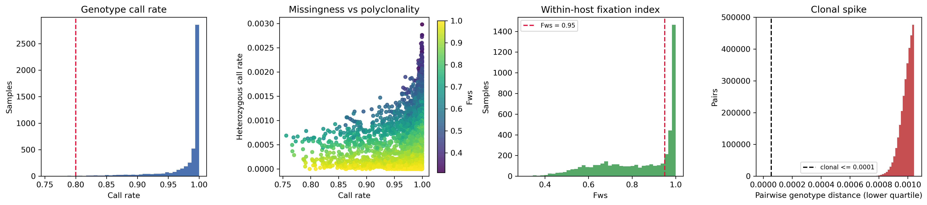
Figure 6.1. Sample quality control (n = 4,905). Left to right: genotype call rate with the 0.80 floor marked; heterozygous call rate against call rate, coloured by Fws; the Fws distribution with the 0.95 threshold marked; and the lower quartile of pairwise genotype distances with the clonal threshold at 0.00005. The Fws panel shows a clear mode above 0.95 with a long left shoulder, which is what makes 0.95 a defensible cut. The clonality panel shows no comparable break, which is why that threshold required a sensitivity analysis (Table 4.3). Generated by scripts/step03b_sample_qc.py.
[Observed] The polyclonal fraction varies by zone: Guinea savanna 0.597 (2,153 of 3,605), deciduous forest 0.539 (439 of 815), transitional zone 0.500 (25 of 50), coastal savanna 0.444 (193 of 435).
[Interpreted] The ordering is consistent with a north–south transmission-intensity gradient: higher transmission produces more superinfection and so more mixed infections. This is arguably the clearest ecological signal in the entire analysis — and it is an epidemiological signal, not a population-genetic one. It is also, as Section 4.2.2 notes, the mechanism by which the F_{ws} filter biases the retained sample unevenly across zones.

6.3 Ordination of the genotype distance matrix
Stage 3 operates on the 4,905 × 4,905 Ghanaian block of the Pf8 mean genotype distance matrix — that is, on the pre-QC set, before the Fws and clonality filters. This should be borne in mind when comparing these results with the rest of the analysis.
[Observed] Pairwise genotype distances are tightly concentrated: median 0.00112, with the 1st and 99th percentiles at 0.00090 and 0.00129, a coefficient of variation of 0.085, and no missing entries. Mean within-zone distance barely differs from mean between-zone distance for any zone (Guinea savanna 0.00111 vs 0.00112; deciduous forest 0.00114 vs 0.00112; coastal savanna 0.00108 vs 0.00110; transitional zone 0.00125 vs 0.00117).
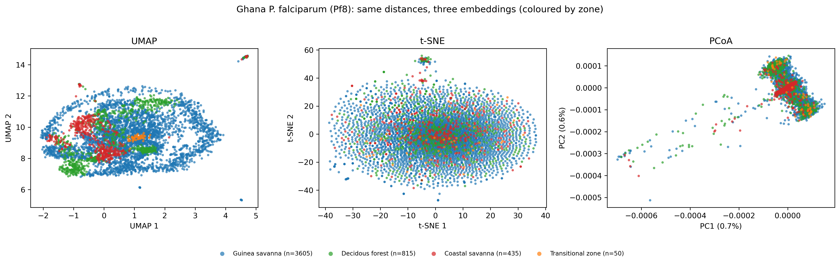
Figure 6.2. UMAP, t-SNE and PCoA of the same 4,905 × 4,905 Ghanaian distance matrix, coloured by agro-ecological zone. Point counts per zone are in the legend. PCoA axes carry their variance proportions; UMAP and t-SNE axes are in arbitrary units and inter-cluster distances in those two panels carry no quantitative meaning. Generated by scripts/step03_umap.py as figures/dimred_comparison_zone.png.
Method | Trustworthiness | Distance Spearman ρ | Silhouette by zone
Original distance matrix | — | 1.000 (by definition) | −0.016
UMAP | 0.486 | 0.029 | −0.306
t-SNE | 0.507 | 0.115 | −0.057
PCoA | 0.495 | 0.322 | −0.112
Table 6.3. Quantitative comparison of the three ordinations (results/dimred_comparison.csv). Trustworthiness is computed with k = 30 neighbours; the Spearman correlation uses a 2,000-isolate random subset; silhouette is computed against zone labels, where values near zero indicate overlapping groups and negative values indicate that isolates sit closer to other zones than to their own.
[Observed] PCoA's first two axes explain 0.71 and 0.59 per cent of positive-eigenvalue variation respectively, 1.29 per cent together. The eigendecomposition returned 1,347 negative eigenvalues summing to −0.000587 against a positive sum of 0.00365, indicating the distance is not perfectly Euclidean; proportions are reported relative to the positive eigenvalues, the usual convention.
[Interpreted] Three readings follow. First, the silhouette on the original matrix is −0.016, essentially zero: zone labels do not describe the genetic variation, and no embedding could make them do so. Second, PCoA preserves global structure best (ρ = 0.322 against 0.115 and 0.029), which is expected of a linear method and makes it the most trustworthy of the three for reading overall structure here. Third, trustworthiness near 0.5 for all three methods is not a failure of the methods: when distances are as uniform as these, neighbourhoods are nearly arbitrary and no two-dimensional projection can preserve them. The tight clumps visible in the UMAP panel are groups of near-identical isolates — the same ones the clonality filter targets — not zone-associated clusters.

6.4 Pairwise differentiation between zones
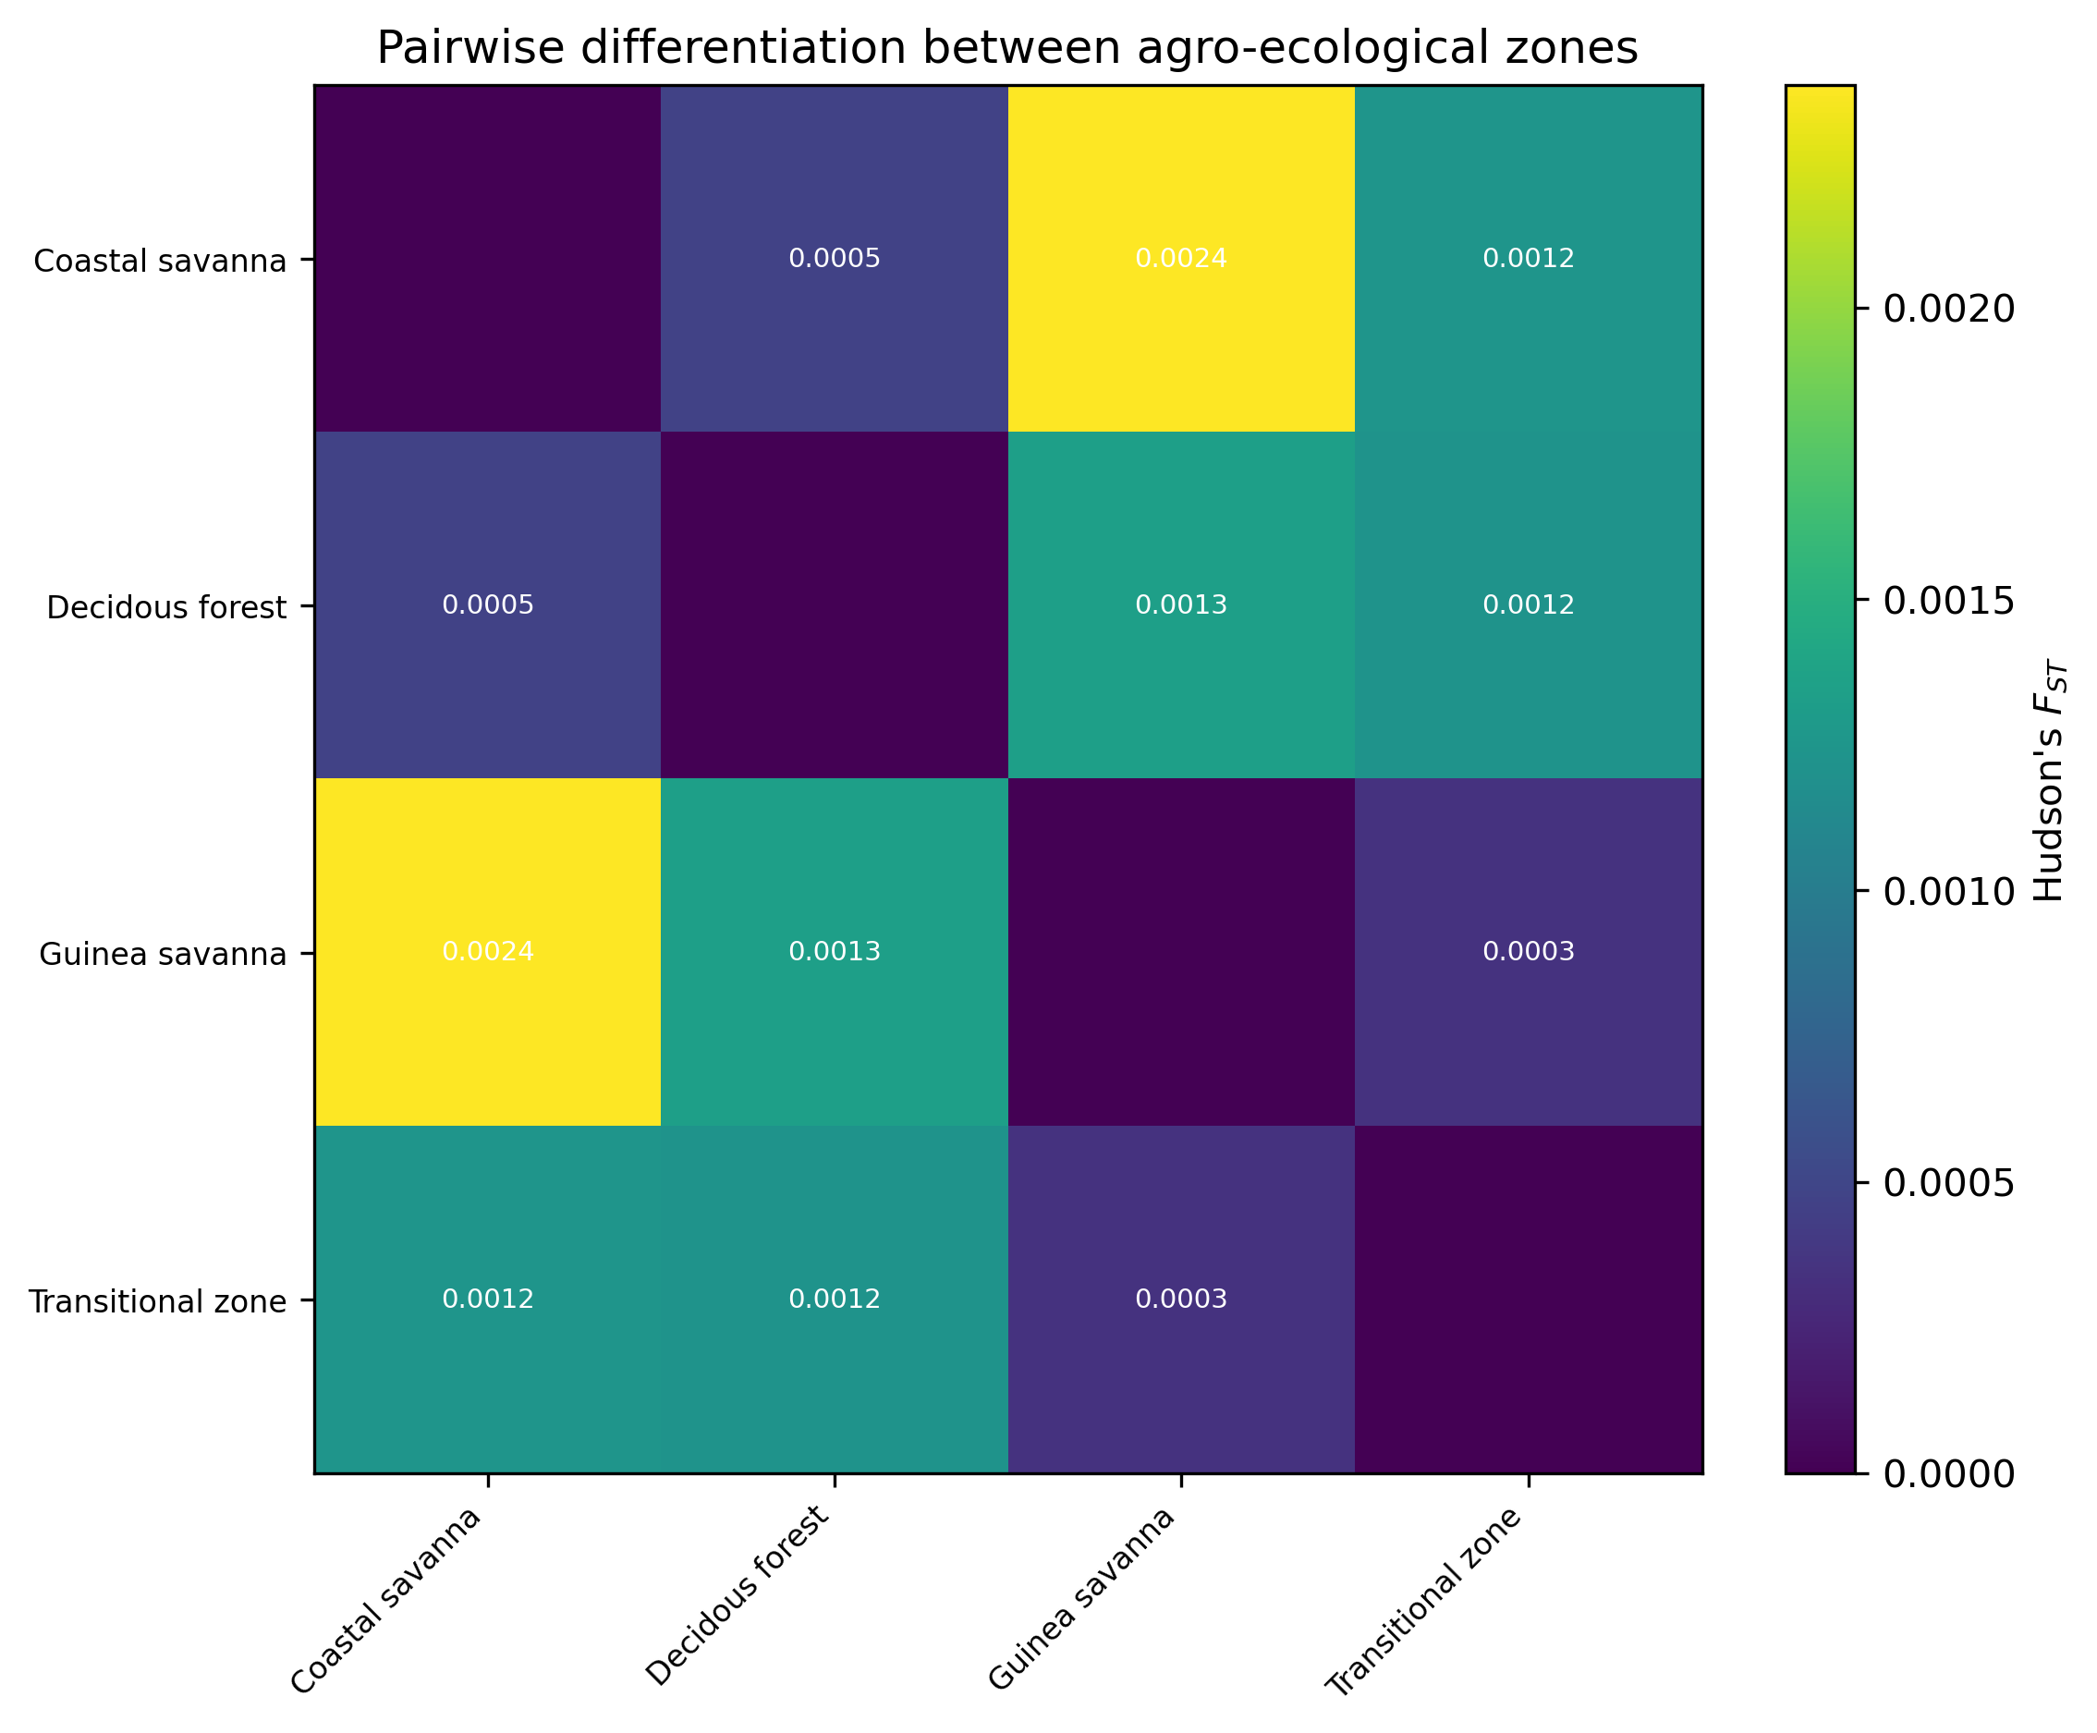
Figure 6.3. Pairwise Hudson FST between agro-ecological zones (3,359 SNPs, 1,900 isolates). Note the colour-bar scale: the maximum value is 0.0024. Generated by scripts/step04b_fst.py as figures/fst_heatmap.png.
Zone A | Zone B | n(A) | n(B) | FST | Jackknife SE | 95% CI
Coastal savanna | Guinea savanna | 204 | 1,334 | 0.00238 | 0.00050 | 0.00140 – 0.00336
Deciduous forest | Guinea savanna | 337 | 1,334 | 0.00135 | 0.00025 | 0.00085 – 0.00184
Coastal savanna | Transitional zone | 204 | 25 | 0.00124 | 0.00082 | −0.00036 – 0.00285
Deciduous forest | Transitional zone | 337 | 25 | 0.00122 | 0.00084 | −0.00042 – 0.00286
Coastal savanna | Deciduous forest | 204 | 337 | 0.00047 | 0.00013 | 0.00020 – 0.00073
Guinea savanna | Transitional zone | 1,334 | 25 | 0.00035 | 0.00074 | −0.00111 – 0.00180
Table 6.4. Pairwise Hudson FST, ordered by magnitude (results/fst_pairwise.csv). Standard errors are from a block jackknife. The three pairs involving the transitional zone (n = 25) have confidence intervals spanning zero.
[Observed] All six values lie below 0.0024. The three largest-sample comparisons are distinguishable from zero; the three involving the transitional zone are not. The ordering is nonetheless coherent: the two geographically extreme zones (coastal and Guinea savanna, 557 km apart) are the most differentiated, and the two adjacent southern zones (coastal and deciduous forest, 145 km apart) the least.
[Interpreted] An F_{ST} of 0.0024 means roughly 0.24 per cent of genetic variation is attributable to zone membership. For comparison, published within-country F_{ST} for P. falciparum routinely falls below 0.05, and continental-scale African subpopulation structure is itself modest (Amambua-Ngwa et al., 2019). The Ghanaian values sit an order of magnitude below even that within-country expectation. The practical reading is that these zones are not demographically separate populations; they are one population sampled in four places. The ranking of pairs is informative — and it is consistent with distance — but no threshold of biological significance is crossed.
Statistical versus practical significance. [Interpreted] Three pairs are statistically distinguishable from zero, which with 1,900 isolates and 3,359 SNPs is a low bar. None is practically significant in the sense of implying restricted gene flow. A resistance allele arising in Accra would be expected to reach Bolgatanga; the question these data cannot answer is how quickly.

6.5 Isolation by distance
[Observed] At region level (7 populations, 21 pairs, distances 87–578 km) the Mantel correlation is r = 0.400 with p = 0.029 against 999 permutations. At zone level (4 populations, 6 pairs, distances 145–557 km) it is r = 0.578 with p = 0.090.
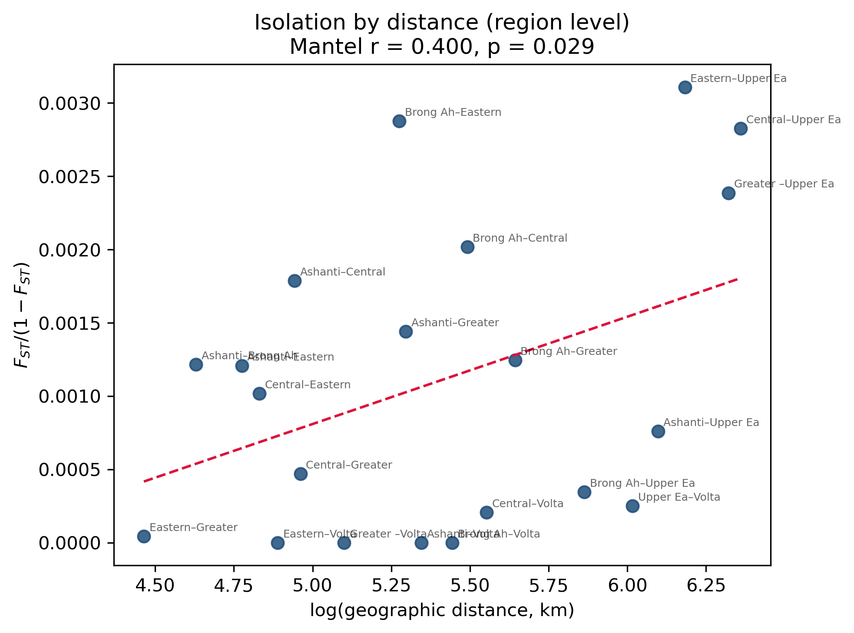
Figure 6.4. Isolation by distance at administrative-region level: linearised differentiation FST/(1 − FST) against log great-circle distance, 21 region pairs, with the least-squares line. Mantel r = 0.400, p = 0.029 (999 permutations, one-sided). Generated by scripts/step06_mantel.py as figures/mantel_ibd_region.png.
Why the smaller correlation is the stronger result. The zone-level test has the larger correlation but the larger p-value, which is a power effect, not a contradiction. With four populations only 4! = 24 distinct orderings exist, so the finest attainable p-value is 0.042 and significance requires essentially the single best permutation. With seven regions there are 5,040 orderings and the test can resolve p down to 0.001. The region-level test is therefore the one to rely on, and it supports isolation by distance.
[Interpreted] Taken with Section 6.4, the picture is of a continuously distributed population in which geographic distance has a weak but detectable effect on differentiation — the classic isolation-by-distance signature — rather than of discrete populations separated by barriers. Note that this says nothing about ecological zones as such: distance alone accounts for the pattern, and nothing in these data requires an ecological explanation.
Caveat on the region-level test. [Interpreted] The region-level FST values are computed from the same 3,359 SNPs but with populations defined by administrative region. Volta contributes 21 isolates and Brong Ahafo 25, so several of the 21 pairs rest on small samples; five pairs in Figure 6.4 sit at or very near zero differentiation. The scatter is wide and the fitted relationship is driven substantially by the Upper East comparisons at the right-hand side of the plot.

6.6 Ancestry inference
[Observed] After LD pruning, 2,923 of 3,359 SNPs remained. Cross-validation error was lowest at K = 2 (0.83736) and rose monotonically thereafter; K = 1, run separately as a reference, gave 0.84199.
K | CV error | Δ from K = 1 | Interpretation
1 | 0.84199 | — | No structure (reference)
2 | 0.83736 | −0.00463 | Minimum
3 | 0.83787 | −0.00412
4 | 0.83874 | −0.00325
5 | 0.84012 | −0.00187
6 | 0.84128 | −0.00071
7 | 0.84234 | +0.00035 | Worse than K = 1
8 | 0.84316 | +0.00117 | Worse than K = 1
Table 6.5. ADMIXTURE 10-fold cross-validation error, K = 1–8 (logs/admixture_K*.out). Lower is better. K = 1 was not part of the supplied sweep and was added so the improvement from admitting structure at all could be measured.
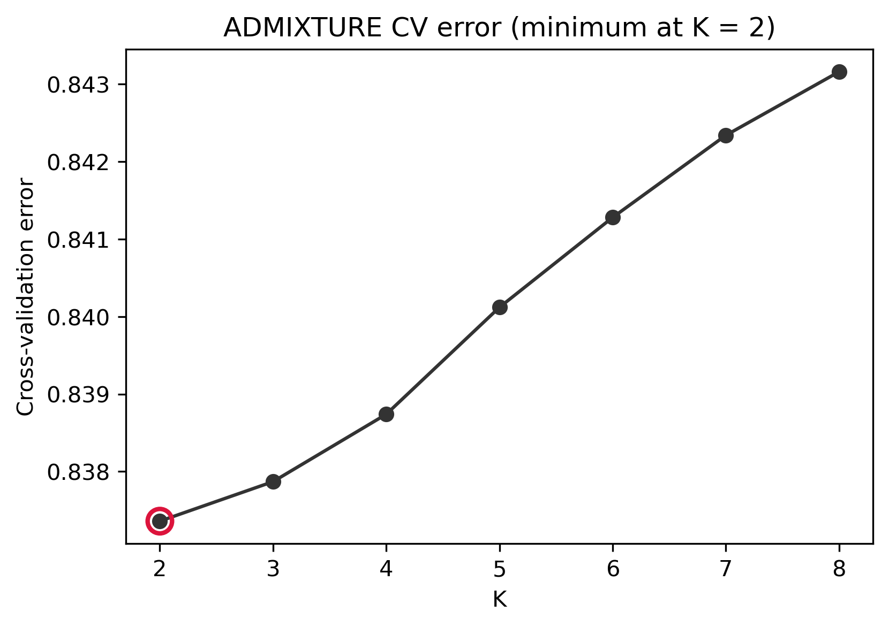
Figure 6.5. ADMIXTURE cross-validation error against K. The curve is nearly flat and the total range across K = 1–8 is 0.0058, under 0.7 per cent of the error value. Generated by scripts/step05c_plot_admixture.py.
[Observed] At K = 2, mean ancestry proportions by zone are: Guinea savanna 0.055 / 0.945, deciduous forest 0.095 / 0.905, coastal savanna 0.088 / 0.912, transitional zone 0.042 / 0.958. At least one isolate is assigned entirely (1.000) to a single component.
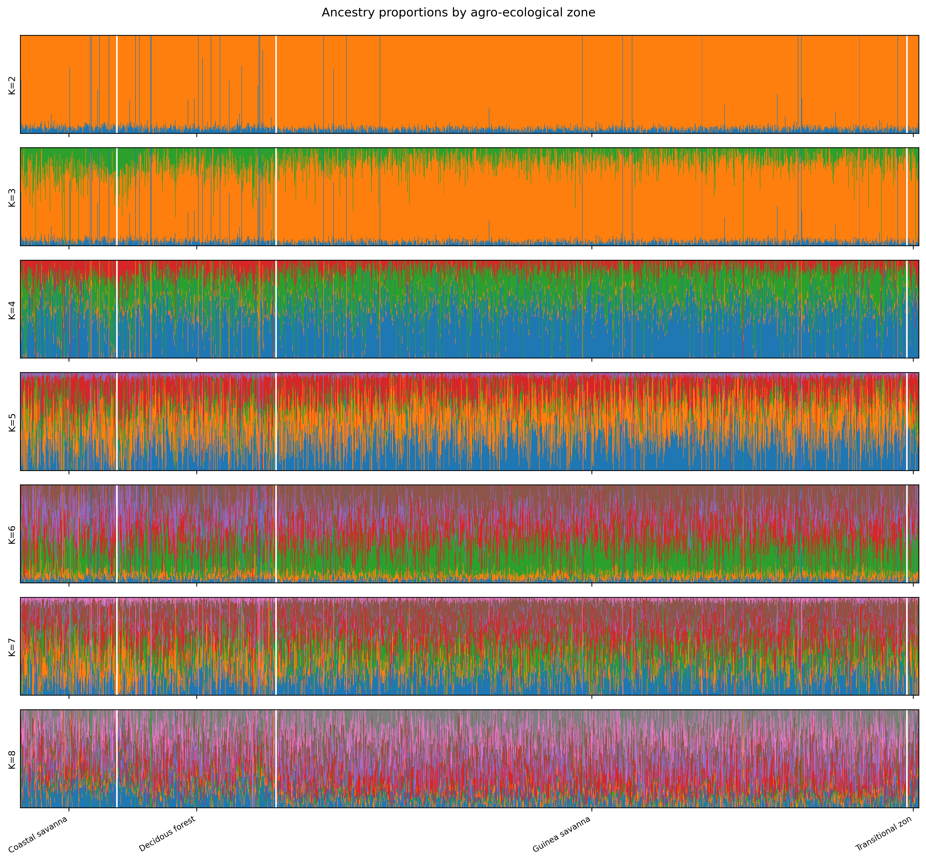
Figure 6.6. ADMIXTURE ancestry proportions, K = 2–8, with isolates ordered by zone (n = 1,900). Each vertical bar is one isolate. The absence of block structure aligned to the zone boundaries is the result: no K produces components that correspond to zones. Generated by scripts/step05c_plot_admixture.py.
[Interpreted] K = 2 minimises cross-validation error, but the improvement over K = 1 is 0.5 per cent and the inferred components are nearly uniform across zones — the between-zone range in mean minor-component ancestry is 0.042 to 0.095. On the conventional reading, K = 2 is "best"; on any substantive reading, this is a population without ancestry structure that corresponds to geography. The minority component is present at similar low frequency everywhere. Whether it reflects a real but geographically diffuse ancestry gradient, residual polyclonality, or an artefact of fitting two components to an essentially unstructured sample cannot be determined from these results.

6.7 Population graph and migration edges
m | Log likelihood | Variance explained | Identifiable with 4 populations
0 | 89.7042 | 0.8760 | Yes
1 | 91.0222 | 0.9346 | Yes
2 | 91.4849 | 0.9633 | Yes
3 | 91.9126 | 0.9976 | No
4 | 91.9302 | 0.9976 | No
5 | 91.9303 | 0.9976 | No
Table 6.6. TreeMix fit against number of migration edges (results/treemix/model_comparison.csv). Variance explained is computed over off-diagonal between-population covariances, matching TreeMix's own definition. All six models converged.
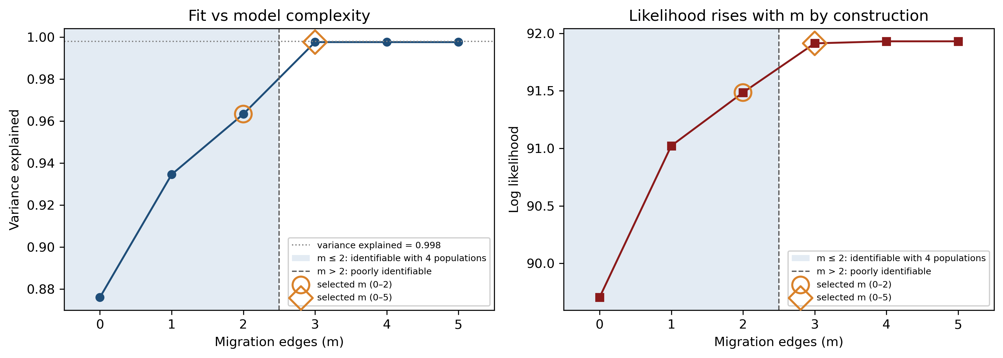
Figure 6.7. TreeMix model fit against migration edges. Left: variance explained, with the 0.998 reference line dotted and the m ≤ 2 region shaded as the range four populations can identify. Right: log likelihood, which rises monotonically with m by construction and therefore cannot by itself select a model. Circles mark the selection within 0–2; diamonds mark the selection within 0–5. Generated by scripts/step07c_plot_treemix.py.
[Observed] Fit improves steeply to m = 3 (variance explained 0.9976) and is flat thereafter; m = 4 and m = 5 are marginally worse on this measure despite higher likelihood. Applying the plateau rule gives m = 2 within the identifiable range and m = 3 across the full sweep.
[Interpreted] A four-population graph has limited capacity to absorb migration edges, and three edges on four tips is close to saturation — the model can reproduce almost any covariance structure at that point, which is why the fit jumps to 0.9976 and then stops improving. The honest reading is that these data cannot identify specific gene-flow corridors. The improvement from m = 0 to m = 1 (0.876 to 0.935) is the one substantive result: a strictly bifurcating tree does not describe these populations, which is exactly what would be expected of a single population with ongoing exchange. Both candidate models are retained in results/treemix/model_selection.json for the final choice.

6.8 Genome scan for differentiation outliers
[Observed] Across 3,359 SNPs, XtX ranged from 2.41 to 26.48 with a median of 3.43. The calibration simulated 100,000 pseudo-observed SNPs under the estimated covariance matrix with the same MAF filter as the observed data, giving a 0.999-quantile threshold of 11.232. Fifteen SNPs (0.45 per cent) exceed it.
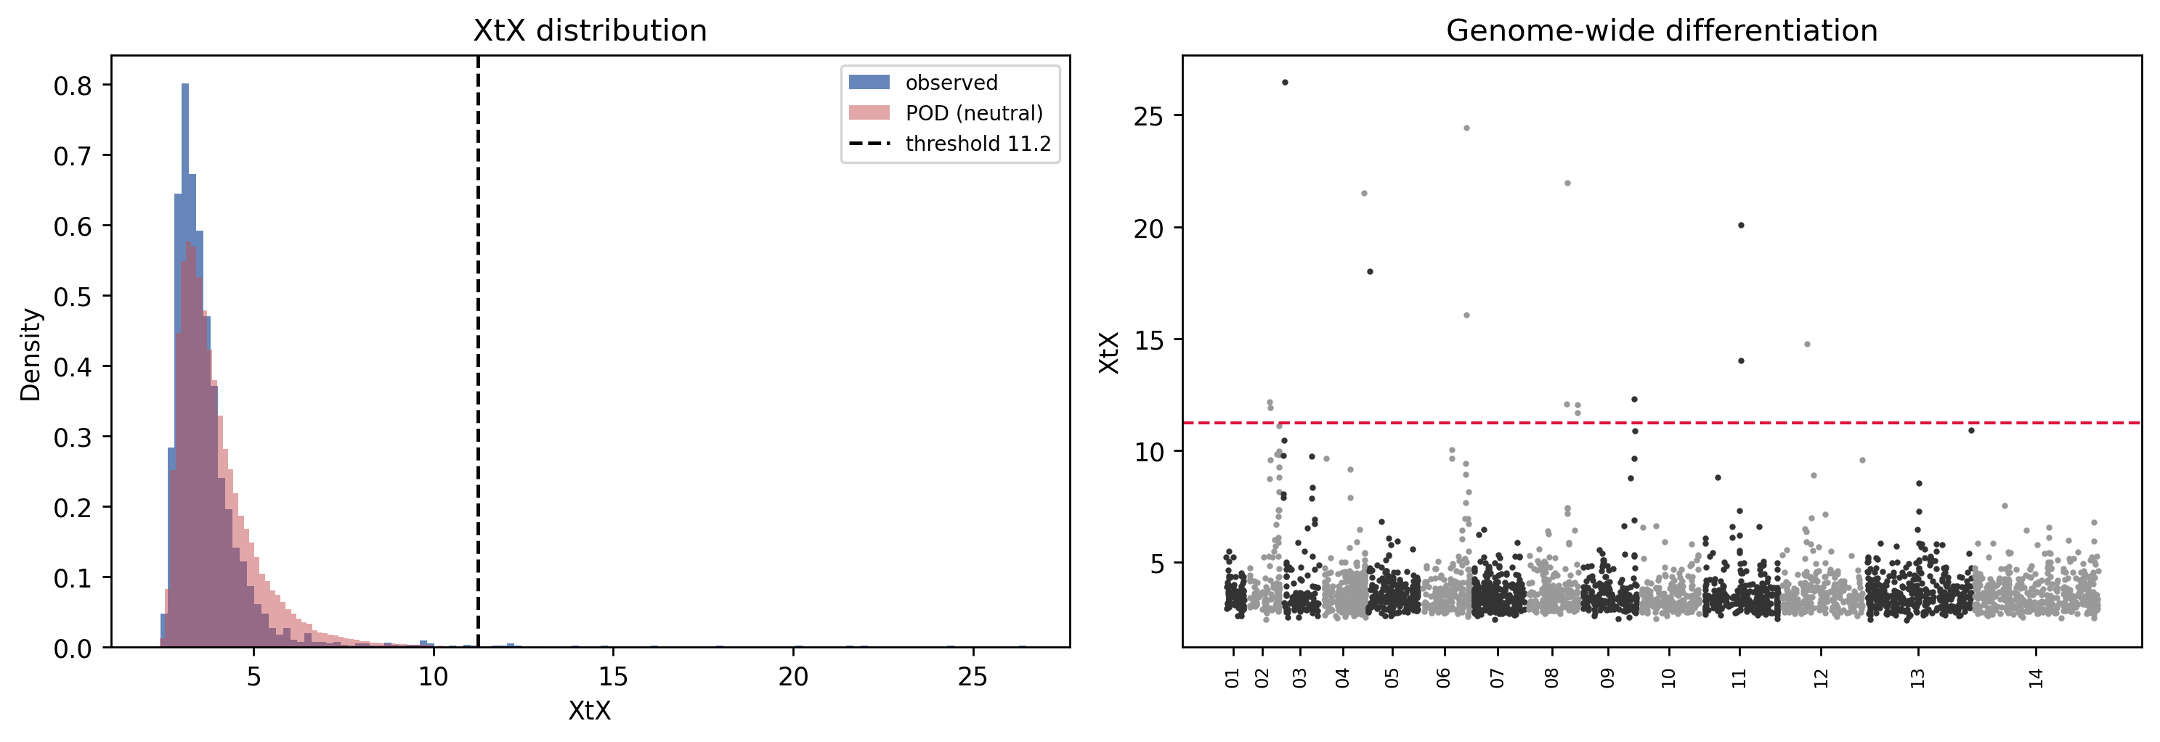
Figure 6.8. BayPass XtX genome scan. Left: the observed XtX distribution (blue) against the simulated neutral distribution (red), with the calibrated threshold at 11.23. Right: XtX by genomic position, alternating shading by chromosome, with the threshold marked. Generated by scripts/step08c_calibrate_xtx.py as figures/baypass_xtx.png.
Reading the left panel. The observed and simulated distributions overlap closely through the body of the distribution, which indicates the demographic model is capturing the bulk of the data adequately. The observed distribution has a slightly heavier right tail, and it is that excess — not the main mass — that the outliers come from.
Gene | Identifier | Product | Outlier SNPs | Max XtX
PTP7 | PF3D7_0301700 | EMP1 trafficking protein PTP7 | 1 | 26.48
AAT1 | PF3D7_0629500 | Amino acid transporter AAT1 | 2 | 24.44
NT2 | PF3D7_0824400 | Nucleoside transporter 2 | 1 | 21.97
FIKK4.2 | PF3D7_0424700 | Serine/threonine protein kinase, FIKK family | 1 | 21.52
PIESP2 | PF3D7_0501200 | Parasite-infected erythrocyte surface protein | 1 | 18.02
SNRPF | PF3D7_1126900 | Small nuclear ribonucleoprotein F, putative | 1 | 14.01
GEXP22 | PF3D7_0935500 | Exported protein, unknown function | 1 | 12.31
— | PF3D7_0215100 | RING zinc finger protein, putative | 1 | 12.18
— | PF3D7_0824200 | Conserved protein, unknown function | 1 | 12.07
— | PF3D7_0831400 | Exported protein, unknown function | 2 | 12.04
ACS8 | PF3D7_0215300 | Acyl-CoA synthetase | 1 | 11.90
Table 6.7. Genes intersecting XtX outlier SNPs, ordered by maximum XtX (results/outlier_genes.csv). Thirteen SNP–gene overlaps across 11 genes; two of the 15 outlier SNPs fall outside annotated protein-coding genes. Annotation from PlasmoDB-71 via bedtools.
[Observed] None of the eight validated antimalarial resistance loci in the configured panel — pfcrt, pfmdr1, pfdhfr, pfdhps, pfk13, pfmdr2, pfcoronin, pfap2mu — appears among the outliers, and no outlier falls in a recognised antigenic-variation or invasion gene family.
[Interpreted] Three observations about this list. First, AAT1 is the one entry with a direct and recent literature connection: Amambua-Ngwa et al. (2023) identified this putative amino-acid transporter as a mediator of chloroquine-resistance evolution, and it carries two outlier SNPs here with a maximum XtX of 24.44. That makes it the strongest candidate in the set and the obvious first target for follow-up. Second, several of the remaining genes — PTP7, PIESP2, FIKK4.2 and two exported proteins — belong to the exported and host-interaction compartment of the genome, which is where immune-mediated selection would be expected to act. Third, the absence of the validated resistance loci is genuinely ambiguous: it is consistent with those loci being under similar pressure everywhere in Ghana (and therefore showing no between-zone differentiation, which is what XtX measures), and equally consistent with the scan lacking power at 3,359 SNPs and four populations. These data cannot distinguish the two.
What XtX does and does not detect. [Interpreted] XtX measures differentiation among populations beyond what the estimated covariance structure predicts. A locus under strong but spatially uniform selection — which is what a nationally deployed drug produces — generates no XtX signal at all. The absence of pfcrt and pfk13 from this list is therefore not evidence that they are not under selection in Ghana; it is, if anything, weakly consistent with their being under uniform selection. Testing that requires a different analysis (Section 8.2).

7. Interpretation and discussion

7.1 What the analysis establishes
Five independent lines of evidence converge on the same conclusion.
Analysis | Result | Reading
Pairwise FST | Maximum 0.0024 | Zones share essentially all their genetic variation
Ordination (3 methods) | Silhouette by zone −0.016 on the raw distance matrix; PCoA PC1+PC2 = 1.3% | Zone labels do not describe the variation
ADMIXTURE | K = 2 minimises CV but improves on K = 1 by 0.5%; components near-uniform across zones | No ancestry structure aligned to geography
TreeMix | Bifurcating tree explains 87.6%; one edge raises it to 93.5% | Exchange between groups, not a branching history
Mantel | Region level r = 0.400, p = 0.029 | A weak but real distance effect
Table 7.1. Convergent evidence on population structure.
[Interpreted] Ghanaian P. falciparum behaves as a single, largely panmictic population with a weak isolation-by-distance gradient. This is a substantive answer to the thesis's first objective, and a negative one for the strong form of its hypothesis: the ecological zones are not acting as demographic barriers at a scale these data can detect.
[Interpreted] This is not a surprising result, and that is a point in its favour. Ghana is approximately 670 km north to south, human mobility along the north–south corridor is substantial, P. falciparum undergoes obligate sexual recombination in the mosquito, and transmission across most of the country is high. All four favour genetic homogenisation. The finding is consistent with the continental picture, in which West African parasite populations form a single major subpopulation (Amambua-Ngwa et al., 2019), and with the observation that differentiation within West African countries is weak relative to the differentiation between endemicity strata that Mobegi et al. (2014) reported between The Gambia and Guinea.

7.2 What the analysis cannot establish, and why
Zone effects cannot be separated from region effects. Three of four zones are each filled by exactly one administrative region (Table 2.2). For those three, "zone" and "region" are the same variable. Any difference attributed to ecology could equally be attributed to the region — its health system, its drug supply, its sampling protocol, its collection year. No statistical adjustment can separate variables that are collinear by construction.
Spatial effects cannot be separated from temporal ones. Median collection year differs by six years across zones (Table 2.3), and for the transitional zone and coastal savanna the year ranges barely overlap. Over 2009–2021 Ghana changed first-line therapy and scaled up chemoprevention, so drug-related allele frequencies would be expected to shift with time regardless of geography.
Barrier hypotheses cannot be tested as such. Testing whether a specific feature (the forest–savanna transition, the Volta Lake system) impedes parasite dispersal requires differentiation to be measurable across the feature and compared against differentiation at the same distance elsewhere. With four populations, six pairwise comparisons and F_{ST} values under 0.0024, there is no resolution to work with.
The outlier list is a candidate list, not a finding. Fifteen SNPs is a small set from a small scan. No multiple-testing correction beyond the calibrated threshold has been applied, no replication is possible within these data, and nothing about an elevated XtX value establishes that a locus is under selection rather than drifting unusually or sitting near an assembly or alignment artefact.

7.3 Unexpected observations
The MAF ceiling. That the whole Ghanaian genome yields only about 5,500 common SNPs was not anticipated and materially constrains every downstream analysis. It is a property of P. falciparum population genomics within a single country — an abundance of rare variation, comparatively little common variation — rather than a defect. But it means that a study of this design has considerably less power than the sample size of 1,900 isolates would suggest.
Polyclonality as the clearest ecological signal. The one variable that orders cleanly along the north–south gradient is the fraction of mixed infections (0.597 in Guinea savanna to 0.444 in coastal savanna). This is a transmission-intensity signal, and it is arguably more informative about ecology than anything in the population-genetic results.
[Hypothesized] If polyclonality tracks transmission intensity and transmission intensity tracks ecological zone, then F_{ws} is itself a candidate zone-level phenotype worth analysing in its own right rather than used only as a QC filter. That analysis has not been performed.
Likelihood monotonicity in TreeMix. The log-likelihood rises with every added migration edge, which is expected but means likelihood cannot select a model. The supplied script's selection rule would not have caught this; the defect is documented in Table 5.2.

7.4 Practical significance
[Interpreted] For malaria control the operational implication of near-panmixia is clear and, in its way, useful. If Ghanaian parasites form one population, then a resistance allele established anywhere will spread nationally, and sentinel surveillance at a small number of sites is an adequate design for detecting emergence — the samples do not need to be spatially comprehensive to be representative. The corollary is less comfortable: containment of an emerging resistance focus by geographically targeted intervention is unlikely to work, because there is no barrier for an intervention to exploit.
Caveat on that inference. The argument runs from an absence of detectable structure to an assertion of free gene flow. Low F_{ST} is also consistent with recent common ancestry and with large effective population size holding drift down. Distinguishing "currently well connected" from "recently separated but not yet differentiated" requires demographic inference these analyses have not attempted.

8. Robustness checks and alternative approaches

8.1 Checks completed
Check | What it tested | Outcome
Genotype store validated against VCFs | Whether the Zarr retrieval reproduced the VCF route exactly | PASS. Three independent windows on chromosomes 1, 10 and 13; site lists identical and all four fields matching value for value across approximately 471 million compared values
Ploidy handling unit-tested | Whether mixed-call resolution and haploid counting behave as specified | PASS. Synthetic 3 × 4 case including a tie and a missing call; also verified that the diploid fallback triggers with a warning
FST invariance to a cosmetic change | Whether re-running step 4b after a label change altered any value | PASS. MD5 of results/fst_matrix.csv unchanged
Clonal threshold sensitivity | How the number of pruned isolates responds to the threshold | Quantified over seven thresholds (Table 4.3). No clean break; single-linkage chaining begins only well above the chosen value
Genotype-mask comparison | Effect of the GQ rule on SNP count and allele frequency | Quantified on a 40,000-SNP panel and a 300,000-SNP panel (Section 4.2.5). GQ rule removed many common SNPs while barely shifting frequencies
ADMIXTURE K = 1 reference | Whether admitting structure improves fit at all | Run. CV error 0.84199 at K = 1 against 0.83736 at K = 2
BayPass calibration corrected and re-run | Whether the threshold was sensitive to POD size and MAF matching | Yes, materially: 8.375 with 1,000 unfiltered simulated SNPs against 11.232 with 100,000 MAF-matched; 40 outliers against 15
TreeMix convergence across m | Whether all six models fitted | All six converged; none failed or was skipped
Table 8.1. Robustness checks performed during this analysis.

8.2 Checks proposed but not performed
[Proposed] None of the following has been run. They are listed in order of expected value.
- Fws sensitivity. Re-run FST, ADMIXTURE and the outlier scan at Fws ≥ 0.90 and ≥ 0.80 (projected 2,341 and 2,924 isolates). This is the single largest exclusion in the pipeline and the one with a documented zone-dependent bias; if conclusions are stable across these thresholds, the most serious filtering objection is answered.
- MAF sensitivity. Repeat the main analyses at MAF ≥ 1 per cent (projected 8,500–12,400 SNPs). This would roughly triple the sites available to the outlier scan. Report as a robustness analysis, since it departs from the thesis specification.
- Temporal control. Restrict to a single collection year or a narrow window, where sample sizes permit, and recompute FST. 2018 contributes 773 isolates across three zones and is the only year that could support this.
- Region-level ADMIXTURE and TreeMix. Running these with populations defined by administrative region rather than zone would at least show whether the choice of grouping affects the conclusions, even though it cannot resolve the underlying collinearity.
- Permutation test for the outlier set. Compare the functional composition of the 11 outlier genes against random gene sets matched for length and SNP density, to test whether the apparent enrichment for exported and host-interaction proteins exceeds chance.
- Re-run Stage 3 ordinations on the QC-passing set. Stage 3 currently operates on the 4,905 pre-QC isolates, so the published ordinations include the polyclonal and clonally redundant isolates that every later stage excludes. Re-running on the 1,900-isolate set would make the figures consistent with the rest of the analysis, and might sharpen the structure.
- Effective population size and divergence-time estimation, to distinguish ongoing gene flow from recent common ancestry (Section 7.4).
- Manual review of the Brong Ahafo and Volta zone assignments against the polygon layer, as Step 2 recommends.

9. Limitations and potential sources of bias

9.1 Ranked by threat to the conclusions
# | Limitation | Severity | Effect on what can be concluded
1 | Zone and region are collinear for three of four zones | Critical | No result can be attributed to ecology rather than administrative region. This limits the thesis's central framing, not merely a detail of it.
2 | Geolocation only to administrative level 1 (7 distinct coordinates for 1,900 isolates) | Critical | No sub-regional spatial analysis is possible. Isolation-by-distance rests on 21 pairs derived from 7 points.
3 | Collection year strongly confounded with zone | High | Between-zone differences are also between-period differences; not separable by reweighting.
4 | Only ~5,500 SNPs genome-wide reach MAF ≥ 5%; 3,359 analysed | High | Limits power throughout, and the BayPass scan in particular.
5 | Transitional zone n = 25 | High | All three FST comparisons involving it have confidence intervals spanning zero. It cannot support ADMIXTURE or TreeMix inference on its own.
6 | Fws filter removes 57% of isolates, unevenly across zones | Moderate | The retained sample is not a random subsample, and the departure differs by zone. Untested for effect on allele frequencies.
7 | Sampling dominated by Upper East (70% of final set) | Moderate | The 'national' picture is substantially a Upper East picture.
8 | Four of Ghana's zones represented; Sudan savanna absent | Moderate | One end of the ecological gradient the study is designed around is missing.
9 | Stage 3 ordinations computed on the pre-QC set | Low | Figures 6.2 and the Table 6.3 metrics describe 4,905 isolates, not the 1,900 analysed later.
10 | Four populations cannot identify more than ~2 TreeMix migration edges | Low | Specific gene-flow corridors are not identifiable. Acknowledged in the output.
Table 9.1. Limitations ranked by how much they constrain the conclusions.

9.2 On the design limitation specifically
[Interpreted] Limitations 1 and 2 are not analytical shortcomings that better methods would overcome. They are properties of the Pf8 metadata. No reanalysis of these data can produce a zone effect separable from a region effect, because for three of the four zones there is only one region in each. This should be stated plainly in any write-up rather than managed with hedging language, and it bears directly on how the thesis's objectives can be framed.
[Proposed] If zone-level inference is essential to the thesis, the route is additional sampling with recorded collection coordinates — ideally within the Sudan savanna, and within regions that straddle a zone boundary, where zone and region could be decoupled. Whether that is feasible within the project is a question for the author.

9.3 Reproducibility status
What is reproducible. The analysis runs end to end from a public data source. All inputs except the zone polygon layer are retrievable from https://pf8-release.cog.sanger.ac.uk. Random seeds are fixed (config.RANDOM_SEED = 42; ADMIXTURE -s 42; TreeMix -seed 42; BayPass -seed 42). Stage 3a is resumable and verifies its own output. The stage sequence is reproduced by:
bash scripts/run_all.sh --from 4 --parallel
What is not. Three gaps. (i) The provenance of data/ghanaAEZ.geojson is undocumented, so the spatial join cannot be reproduced by a third party from public sources alone. (ii) The project is not under version control, so the exact script state at run time is not recoverable other than from the files currently on disk; the unmodified originals are in pf8_ghana_pipeline.zip. (iii) UMAP with a fixed random_state forces single-threaded execution and is deterministic, but t-SNE and the ADMIXTURE runs have not been verified to be bitwise reproducible across different thread counts.
[Unknown] Whether the two numerically intensive stages (ADMIXTURE, BayPass) return identical results under a different thread count has not been tested.

10. Conclusion and current state of the research

10.1 What has been established
- Ghanaian P. falciparum shows very low differentiation between agro-ecological zones (maximum pairwise Hudson FST 0.0024, 95% CI 0.0014–0.0034). Five independent analyses agree. This is a well-supported result.
- Isolation by distance is detectable at administrative-region level (Mantel r = 0.400, p = 0.029) but not at zone level, where the permutation test lacks resolution. Moderately supported.
- No ancestry structure corresponds to geography. ADMIXTURE's preferred K = 2 improves on K = 1 by 0.5 per cent of cross-validation error, with near-uniform components across zones. Well supported as a negative result.
- A strictly bifurcating population tree is inadequate; one migration edge raises variance explained from 0.876 to 0.935. Supported, though the specific edges are not identifiable with four populations.
- Fifteen SNPs in 11 genes exceed a calibrated differentiation threshold, headed by AAT1 (PF3D7_0629500), a locus with an established connection to chloroquine-resistance evolution. Provisional — a candidate list requiring independent support.
- Mixed-infection frequency orders along the north–south gradient (0.597 in Guinea savanna to 0.444 in coastal savanna). Observed as a by-product of quality control, not analysed as a result in its own right.

10.2 Answers to the research questions
Question (Section 1.3) | Answer | Confidence
Is between-zone differentiation distinguishable from zero? | Yes for three of six pairs, but all values are below 0.0024 and none is practically significant. | High
Does genetic distance increase with geographic distance? | Yes at region level; not demonstrable at zone level. | Moderate
Do isolates assign to zone-associated ancestry components? | No. | High
Is there gene flow beyond a bifurcating tree? | Yes, but specific corridors are not identifiable. | Moderate
Which loci exceed neutral expectation? | Fifteen SNPs in 11 genes; AAT1 is the strongest candidate. No validated resistance locus among them. | Low — provisional
Table 10.1. Research questions and the answers the current evidence supports.

10.3 What remains unresolved
- Whether any apparent zone effect survives control for administrative region and collection year — not resolvable with these data (Section 9.2).
- Whether the conclusions are stable under alternative Fws and MAF thresholds — testable now, not yet tested (Section 8.2).
- Whether the outlier set is enriched for any functional category beyond chance — testable now, not yet tested.
- Whether the validated resistance loci are under spatially uniform selection, which would explain their absence from the outlier list — requires a different analysis (allele-frequency trajectories, haplotype-based statistics).
- Whether low differentiation reflects ongoing gene flow or recent common ancestry — requires demographic inference not attempted here.

10.4 Most valuable next steps
- Run the Fws and MAF sensitivity analyses (Section 8.2, items 1 and 2). These are inexpensive, use code already written, and address the two most likely reviewer objections.
- Reframe the thesis objectives in light of the collinearity. The question "do ecological zones structure the parasite population?" cannot be answered with Pf8 metadata alone. The question "is Ghanaian P. falciparum spatially structured at all, and what does that imply for surveillance design?" can be, and has been.
- Pursue the resistance-marker component through direct genotyping of the panel loci rather than through the differentiation scan. The marker-frequency questions the thesis poses are answerable from these data; they simply are not what XtX measures.
- Analyse Fws by zone and year as a transmission-intensity phenotype in its own right.
- Re-run Stage 3 on the QC-passing set so that the ordination figures describe the same isolates as the rest of the analysis.
[Interpreted] A closing assessment. The analysis has done what a baseline characterisation should do: it has established the scale of structure, found it to be small, identified precisely which design features limit what can be inferred, and produced a short candidate list for follow-up. The most valuable output is arguably the negative result, because it tells the thesis which of its questions the available data can and cannot support — and it does so before, rather than after, the marker-level analysis is built on top of them.

11. References
APA 7th edition. Every entry was verified against publisher-deposited metadata (Crossref REST API) or, where no DOI exists, against NCBI PubMed or the publisher's own record. Verification status is noted in Appendix D.

11.1 Data source
Malaria Genomic Epidemiology Network (MalariaGEN). (2025). Pf8: An open dataset of Plasmodium falciparum genome variation in 33,325 worldwide samples. Wellcome Open Research, 10, 325. https://doi.org/10.12688/wellcomeopenres.24031.1
Malaria Genomic Epidemiology Network (MalariaGEN). (2023). Pf7: An open dataset of Plasmodium falciparum genome variation in 20,000 worldwide samples. Wellcome Open Research, 8, 22. https://doi.org/10.12688/wellcomeopenres.18681.1
Cited for: the dataset itself (Section 2.1). The Pf7 entry is included because the pipeline's documentation refers to Pf7 conventions in places; the data analysed here are Pf8.

11.2 Population-genetic methods
Bhatia, G., Patterson, N., Sankararaman, S., & Price, A. L. (2013). Estimating and interpreting FST: The impact of rare variants. Genome Research, 23(9), 1514–1521. https://doi.org/10.1101/gr.154831.113
Gautier, M. (2015). Genome-wide scan for adaptive divergence and association with population-specific covariates. Genetics, 201(4), 1555–1579. https://doi.org/10.1534/genetics.115.181453
Günther, T., & Coop, G. (2013). Robust identification of local adaptation from allele frequencies. Genetics, 195(1), 205–220. https://doi.org/10.1534/genetics.113.152462
Hudson, R. R., Slatkin, M., & Maddison, W. P. (1992). Estimation of levels of gene flow from DNA sequence data. Genetics, 132(2), 583–589. https://doi.org/10.1093/genetics/132.2.583
Mantel, N. (1967). The detection of disease clustering and a generalized regression approach. Cancer Research, 27(2), 209–220. https://pubmed.ncbi.nlm.nih.gov/6018555/
Pickrell, J. K., & Pritchard, J. K. (2012). Inference of population splits and mixtures from genome-wide allele frequency data. PLoS Genetics, 8(11), Article e1002967. https://doi.org/10.1371/journal.pgen.1002967
Rousset, F. (1997). Genetic differentiation and estimation of gene flow from F-statistics under isolation by distance. Genetics, 145(4), 1219–1228. https://doi.org/10.1093/genetics/145.4.1219
Yeaman, S., & Whitlock, M. C. (2011). The genetic architecture of adaptation under migration–selection balance. Evolution, 65(7), 1897–1911. https://doi.org/10.1111/j.1558-5646.2011.01269.x
Cited for: Hudson et al. (1992) and Bhatia et al. (2013) for the FST estimator and the ratio-of-averages summation (Section 3.8); Rousset (1997) for the FST/(1 − FST) linearisation and Mantel (1967) for the permutation test (Section 3.9); Pickrell & Pritchard (2012) for TreeMix and its variance-explained definition (Sections 3.9, 6.7); Gautier (2015) for BayPass and Günther & Coop (2013) for the XtX statistic (Sections 3.9, 6.8); Yeaman & Whitlock (2011) for the migration–selection balance framing referenced in the discussion.

11.3 Ancestry, ordination and clustering
Alexander, D. H., & Lange, K. (2011). Enhancements to the ADMIXTURE algorithm for individual ancestry estimation. BMC Bioinformatics, 12, Article 246. https://doi.org/10.1186/1471-2105-12-246
Alexander, D. H., Novembre, J., & Lange, K. (2009). Fast model-based estimation of ancestry in unrelated individuals. Genome Research, 19(9), 1655–1664. https://doi.org/10.1101/gr.094052.109
Gower, J. C. (1966). Some distance properties of latent root and vector methods used in multivariate analysis. Biometrika, 53(3–4), 325–338. https://doi.org/10.1093/biomet/53.3-4.325
McInnes, L., Healy, J., & Melville, J. (2018). UMAP: Uniform manifold approximation and projection for dimension reduction (Version 3) [Preprint]. arXiv. https://doi.org/10.48550/arXiv.1802.03426
Rousseeuw, P. J. (1987). Silhouettes: A graphical aid to the interpretation and validation of cluster analysis. Journal of Computational and Applied Mathematics, 20, 53–65. https://doi.org/10.1016/0377-0427(87)90125-7
van der Maaten, L., & Hinton, G. (2008). Visualizing data using t-SNE. Journal of Machine Learning Research, 9(86), 2579–2605. https://www.jmlr.org/papers/v9/vandermaaten08a.html
Venna, J., & Kaski, S. (2001). Neighborhood preservation in nonlinear projection methods: An experimental study. In G. Dorffner, H. Bischof, & K. Hornik (Eds.), Artificial neural networks — ICANN 2001 (Lecture Notes in Computer Science Vol. 2130, pp. 485–491). Springer. https://doi.org/10.1007/3-540-44668-0_68
Cited for: Alexander et al. (2009) for ADMIXTURE and Alexander & Lange (2011) for its cross-validation procedure (Sections 3.9, 6.6); Gower (1966) for principal coordinates analysis, McInnes et al. (2018) for UMAP and van der Maaten & Hinton (2008) for t-SNE (Section 3.4); Venna & Kaski (2001) for trustworthiness and Rousseeuw (1987) for the silhouette coefficient (Section 3.4, Table 6.3).

11.4 Malaria genomics and biology
Amambua-Ngwa, A., Amenga-Etego, L., Kamau, E., Amato, R., Ghansah, A., Golassa, L., Randrianarivelojosia, M., Ishengoma, D., Apinjoh, T., Maïga-Ascofaré, O., Andagalu, B., Yavo, W., Bouyou-Akotet, M., Kolapo, O., Mane, K., Worwui, A., Jeffries, D., Simpson, V., D'Alessandro, U., … Djimde, A. A. (2019). Major subpopulations of Plasmodium falciparum in sub-Saharan Africa. Science, 365(6455), 813–816. https://doi.org/10.1126/science.aav5427
Amambua-Ngwa, A., Button-Simons, K. A., Li, X., Kumar, S., Brenneman, K. V., Ferrari, M., Checkley, L. A., Haile, M. T., Shoue, D. A., McDew-White, M., Tindall, S. M., Reyes, A., Delgado, E., Dalhoff, H., Larbalestier, J. K., Amato, R., Pearson, R. D., Taylor, A. B., Nosten, F. H., … Anderson, T. J. C. (2023). Chloroquine resistance evolution in Plasmodium falciparum is mediated by the putative amino acid transporter AAT1. Nature Microbiology, 8(7), 1213–1226. https://doi.org/10.1038/s41564-023-01377-z
Manske, M., Miotto, O., Campino, S., Auburn, S., Almagro-Garcia, J., Maslen, G., O'Brien, J., Djimde, A., Doumbo, O., Zongo, I., Ouedraogo, J.-B., Michon, P., Mueller, I., Siba, P., Nzila, A., Borrmann, S., Kiara, S. M., Marsh, K., Jiang, H., … Kwiatkowski, D. P. (2012). Analysis of Plasmodium falciparum diversity in natural infections by deep sequencing. Nature, 487(7407), 375–379. https://doi.org/10.1038/nature11174
Miles, A., Iqbal, Z., Vauterin, P., Pearson, R., Campino, S., Theron, M., Gould, K., Mead, D., Drury, E., O'Brien, J., Ruano Rubio, V., MacInnis, B., Mwangi, J., Samarakoon, U., Ranford-Cartwright, L., Ferdig, M., Hayton, K., Su, X.-z., Wellems, T., … Kwiatkowski, D. (2016). Indels, structural variation, and recombination drive genomic diversity in Plasmodium falciparum. Genome Research, 26(9), 1288–1299. https://doi.org/10.1101/gr.203711.115
Mobegi, V. A., Duffy, C. W., Amambua-Ngwa, A., Loua, K. M., Laman, E., Nwakanma, D. C., MacInnis, B., Aspeling-Jones, H., Murray, L., Clark, T. G., Kwiatkowski, D. P., & Conway, D. J. (2014). Genome-wide analysis of selection on the malaria parasite Plasmodium falciparum in West African populations of differing infection endemicity. Molecular Biology and Evolution, 31(6), 1490–1499. https://doi.org/10.1093/molbev/msu106
Otto, T. D., Böhme, U., Sanders, M., Reid, A., Bruske, E. I., Duffy, C. W., Bull, P. C., Pearson, R. D., Abdi, A., Dimonte, S., Stewart, L. B., Campino, S., Kekre, M., Hamilton, W. L., Claessens, A., Volkman, S. K., Ndiaye, D., Amambua-Ngwa, A., Diakite, M., … Newbold, C. I. (2018). Long read assemblies of geographically dispersed Plasmodium falciparum isolates reveal highly structured subtelomeres. Wellcome Open Research, 3, 52. https://doi.org/10.12688/wellcomeopenres.14571.1
Cited for: Manske et al. (2012) for the Fws statistic and the 0.95 monoclonality convention (Sections 3.6, 4.2.2); Miles et al. (2016) and Otto et al. (2018) for the core-genome versus hypervariable subtelomere distinction underlying the RegionType annotation (Section 3.5); Amambua-Ngwa et al. (2019) and Mobegi et al. (2014) for the West African population-structure context (Sections 6.4, 7.1); Amambua-Ngwa et al. (2023) for the AAT1–chloroquine resistance link (Section 6.8).

11.5 Software
Amos, B., Aurrecoechea, C., Barba, M., Barreto, A., Basenko, E. Y., Bażant, W., Belnap, R., Blevins, A. S., Böhme, U., Brestelli, J., Brunk, B. P., Caddick, M., Callan, D., Campbell, L., Christensen, M. B., Christophides, G. K., Crouch, K., Davis, K., DeBarry, J., … Zheng, J. (2022). VEuPathDB: The eukaryotic pathogen, vector and host bioinformatics resource center. Nucleic Acids Research, 50(D1), D898–D911. https://doi.org/10.1093/nar/gkab929
Chang, C. C., Chow, C. C., Tellier, L. C. A. M., Vattikuti, S., Purcell, S. M., & Lee, J. J. (2015). Second-generation PLINK: Rising to the challenge of larger and richer datasets. GigaScience, 4, Article 7. https://doi.org/10.1186/s13742-015-0047-8
Danecek, P., Bonfield, J. K., Liddle, J., Marshall, J., Ohan, V., Pollard, M. O., Whitwham, A., Keane, T., McCarthy, S. A., Davies, R. M., & Li, H. (2021). Twelve years of SAMtools and BCFtools. GigaScience, 10(2), Article giab008. https://doi.org/10.1093/gigascience/giab008
Harris, C. R., Millman, K. J., van der Walt, S. J., Gommers, R., Virtanen, P., Cournapeau, D., Wieser, E., Taylor, J., Berg, S., Smith, N. J., Kern, R., Picus, M., Hoyer, S., van Kerkwijk, M. H., Brett, M., Haldane, A., del Río, J. F., Wiebe, M., Peterson, P., … Oliphant, T. E. (2020). Array programming with NumPy. Nature, 585(7825), 357–362. https://doi.org/10.1038/s41586-020-2649-2
Miles, A., Rodrigues, M. F., Ralph, P., Kelleher, J., Schelker, M., Pisupati, R., Rae, S., & Millar, T. (2024). cggh/scikit-allel (Version 1.3.13) [Computer software]. Zenodo. https://doi.org/10.5281/zenodo.13772087
Purcell, S., Neale, B., Todd-Brown, K., Thomas, L., Ferreira, M. A. R., Bender, D., Maller, J., Sklar, P., de Bakker, P. I. W., Daly, M. J., & Sham, P. C. (2007). PLINK: A tool set for whole-genome association and population-based linkage analyses. American Journal of Human Genetics, 81(3), 559–575. https://doi.org/10.1086/519795
Virtanen, P., Gommers, R., Oliphant, T. E., Haberland, M., Reddy, T., Cournapeau, D., Burovski, E., Peterson, P., Weckesser, W., Bright, J., van der Walt, S. J., Brett, M., Wilson, J., Millman, K. J., Mayorov, N., Nelson, A. R. J., Jones, E., Kern, R., Larson, E., … van Mulbregt, P. (2020). SciPy 1.0: Fundamental algorithms for scientific computing in Python. Nature Methods, 17(3), 261–272. https://doi.org/10.1038/s41592-019-0686-2
Note on scikit-allel: the project provides no CITATION file or accompanying paper and asks only that its Zenodo DOI be cited. The Zenodo creator list is generated from repository contributors and includes an automation account, which has been omitted above. The concept DOI covering all versions is 10.5281/zenodo.597309. The project is in maintenance-only mode, with sgkit named as its intended successor.

12. Appendices

Appendix A — Software environment
Component | Version | Role
Python | 3.10.22 | All analysis scripts
NumPy | 1.26.4 | Arrays. Pinned below 2.0 for scikit-allel compatibility
pandas | 2.3.3 | Tabular data
SciPy | 1.15.2 | Eigendecomposition (PCoA), connected components (clonal pruning)
scikit-allel | 1.3.13 | Genotype arrays, Hudson FST, block jackknife
Zarr | 2.18.3 | Chunked genotype store. Pinned below 3.0: scikit-allel's writer uses 2.x APIs
numcodecs | 0.13.1 | Blosc/LZ4 and Zstd codecs
scikit-learn | 1.7.2 | t-SNE, trustworthiness, silhouette
umap-learn | 0.5.12 | UMAP
scikit-bio | 0.7.3 | Mantel test
GeoPandas | 1.1.4 | Spatial join (Stage 2)
Matplotlib | 3.10.9 | All figures
PLINK | 1.9.0 (64-bit) | Format conversion, LD pruning
ADMIXTURE | 1.3 | Ancestry inference
TreeMix | 1.13 | Population graph
BayPass | 3.1 | Core model and XtX
bcftools | 1.24 | VCF validation only; not used in the production path
R | 4.5.1 | BayPass POD simulation via baypass_utils.R
Operating system | Ubuntu, kernel 5.15.0-194-generic | 40 cores, 629 GB RAM
Table A.1. Software versions, recorded from the live environment on 9 October 2026.
The environment lives at /home/gyadu/.conda/envs/spatial and was built with micromamba 2.9.0 against conda-forge and bioconda; the shared conda installation's classic solver was unusable at this dependency scale. Activation:
source /home/tools/anaconda3/etc/profile.d/conda.sh && conda activate spatial

Appendix B — Key configuration values
Parameter | Value | Set in | Origin
RANDOM_SEED | 42 | config.py | Pipeline default
MIN_FWS | 0.95 | config.py | Pre-specified (Manske et al., 2012)
MIN_SAMPLE_CALL_RATE | 0.80 | config.py | Pipeline default
CLONAL_THRESHOLD | 0.00005 | config.py | Session decision (Section 4.2.4)
MIN_GENOTYPE_DP | 5 | config.py | Pipeline default
MIN_GENOTYPE_GQ | 0 (disabled) | config.py | Session decision (Section 4.2.5)
MIN_MAF | 0.05 | config.py | Thesis workflow
MAX_MISSING (variant) | 0.10 | config.py | Thesis workflow
MAX_SAMPLE_MISSING | 0.20 | config.py | Pipeline default
UMAP_N_NEIGHBORS / UMAP_MIN_DIST | 30 / 0.1 | config.py | Thesis workflow
TSNE_PERPLEXITY | 30 | config.py | Session addition
PCOA_N_AXES | 10 | config.py | Session addition
K_MIN, K_MAX | 2, 8 (K = 1 run separately) | config.py | Thesis workflow
ADMIXTURE_CV_FOLDS | 10 | config.py | Pipeline default
LD_PRUNE_ARGS | 50, 10, 0.2 | config.py | Pipeline default
TREEMIX_BLOCK_SIZE | 50 | config.py | Session decision (Section 5.5)
TREEMIX_MAX_M / TREEMIX_ROOT | 5 / Guinea_savanna | config.py | Thesis workflow; root name corrected
BayPass NVAL (POD SNPs) | 100,000 | step08b_baypass.sh | Session decision (Section 5.6)
BayPass PI_MAF | 0.05 | step08b_baypass.sh | Session decision (Section 5.6)
XTX_POD_QUANTILE | 0.999 | config.py | Pipeline default
Table B.1. Configuration values in force for the reported run.

Appendix C — Output inventory
Path | Contents
interim/pf8_ghana.zarr | Ghanaian callset, 20.57 GB, 2,190,026 PASS biallelic SNPs × 6,653 isolates, GT/AD/DP/GQ
interim/ghana_core_snps.npz | Final genotype matrix, 3,359 × 1,900
interim/analysis_samples.csv | Canonical sample table; fixes sample order for every stage from 4 onward
interim/allele_counts_by_zone.npz | Per-zone allele counts, one allele per isolate; feeds stages 7 and 8
results/sample_qc_full.csv | All 4,905 isolates with every QC statistic and flag
results/fst_pairwise.csv, fst_matrix.csv | Pairwise FST with jackknife SEs and confidence intervals
results/dimred_comparison.csv | Trustworthiness, distance correlation, silhouette for the three ordinations
results/{umap,tsne}_embedding.csv, pcoa_coordinates.csv, pcoa_eigenvalues.csv | Ordination coordinates and PCoA eigenvalues
results/mantel_result_{zone,region}.json | Mantel r, p, population list, permutation count
results/admixture/ | Q and P matrices for K = 1–8, cross-validation errors
results/treemix/ | Fitted graphs for m = 0–5, model_comparison.csv, model_selection.json, run_status.tsv
results/baypass/ | XtX per SNP, simulated neutral distribution, calibrated threshold, outlier BED
results/outlier_genes.csv, outliers_annotated.txt | Gene-level summary and raw SNP–gene intersections
figures/ | All figures reproduced in this report
logs/ | Per-stage logs including the Zarr fetch verification
Table C.1. Principal outputs, relative to /media/biodataA/pf8/gyadu.

Appendix D — Reference verification status
All 26 references were checked against publisher-deposited metadata. Of these, 25 were fully verified via the Crossref REST API; the remainder are noted below. Four were additionally re-checked independently after the initial verification: the Pf8 release, the AAT1 paper, Gautier (2015) and Miles et al. (2016).
- Fully verified (24 entries) — all bibliographic fields confirmed against Crossref DOI records.
- Verified without a DOI (2 entries) — Mantel (1967) predates DOI assignment and was confirmed via PubMed (PMID 6018555); van der Maaten & Hinton (2008) was confirmed against the JMLR site, which issues no DOIs. Stable URLs are given in both cases, as APA 7 permits.
- Partially verified (1 entry) — scikit-allel has no author-sanctioned citation string. The Zenodo version DOI (10.5281/zenodo.13772087, v1.3.13, 17 September 2024) and concept DOI (10.5281/zenodo.597309) are both confirmed; the author list is Zenodo's, with an automation account removed.
- Note on one sub-detail — for Venna & Kaski (2001), Crossref gives the chapter's book title and pages but not the LNCS series volume; volume 2130 and the editor list were confirmed against the Springer book record (ISBN 978-3-540-42486-4).
Corrections made during verification. Four assumptions in the initial reference list were wrong and were corrected: the AAT1 paper is in Nature Microbiology, not Science; Pf8 is published (Wellcome Open Research 10:325, 2025) rather than preprint-only; the UMAP JOSS paper has a different author list from the arXiv preprint, so the preprint is cited here; and the exact title of Mobegi et al. (2014) includes "the malaria parasite" before the species name.

Appendix E — Reproducing the analysis
From a clean checkout on a machine with the environment of Appendix A:
source /home/tools/anaconda3/etc/profile.d/conda.sh && conda activate spatial
cd /media/biodataA/pf8/gyadu/scripts
python check_env.py # verifies packages and external binaries
bash run_all.sh --list # lists the stages
bash run_all.sh # full pipeline, stages 1-9
bash run_all.sh --from 4 --parallel # stages 5-8 concurrently after stage 4
Stage 3a is resumable: completed variant chunks are recorded and skipped, and the store is built under a .partial name and renamed only on completion, so an interrupted run cannot be mistaken for a finished one. It also self-verifies:
python step03a_fetch_callset_zarr.py --validate-only \
--validate-vcf ../data/Pf8_Ghana_Pf3D7_10_v3.vcf.gz \
--validate-region Pf3D7_10_v3:400001-440000
In --parallel mode the thread budget is divided as: ADMIXTURE 7 concurrent K values × 4 threads; TreeMix 6 concurrent m values, single-threaded; BayPass 8 threads; NumPy/BLAS and Numba capped at 8 threads each. Stages 5–8 write disjoint outputs and depend only on stage 4, so concurrency does not affect results. Fixed seeds make each stage deterministic given its inputs.
Reproducibility caveat. The zone polygon layer (data/ghanaAEZ.geojson) has no recorded provenance, so Stage 2 cannot currently be reproduced from public sources alone. This should be resolved before publication.

— End of manuscript —

REVIEWER NOTES AND REVISION GUIDE
These notes are for the author's use in rewriting. They are not part of the proposed manuscript and should be deleted before any version is circulated.

A. Explain it simply
Imagine you want to know whether malaria parasites in northern Ghana are a different population from those on the coast. If they are separate, a drug-resistance mutation appearing in Accra might stay there for years, and you would need to watch each region separately. If they are one population that happens to be spread out, a mutation appearing anywhere will travel everywhere, and watching a few places is enough.
To find out, we took the genomes of Ghanaian parasites from a large public dataset, worked out which ecological zone each one came from, and asked a series of questions with increasingly sophisticated tools. Do parasites from different zones look genetically different? Do parasites further apart look more different than parasites close together? Can a computer sort them into ancestry groups that match the zones? Is there any gene in the genome that looks unusually different between zones, which might mean it is adapting to local conditions?
The answers, in order: barely; a little, and only when we use administrative regions rather than zones; no; and we found fifteen candidate positions in eleven genes, one of which — a gene called AAT1 — has a published link to chloroquine resistance.
So the overall picture is of one parasite population spread across the country, mixing freely enough that geography makes only a small difference. That is a useful answer. It means national surveillance does not need to be spatially comprehensive to be representative — but it also means you could not contain an outbreak of resistance by targeting one region.
There is an important catch, and it is about the data rather than the analysis. Each parasite's location is recorded only as the administrative region it came from, not the actual collection site. And three of the four ecological zones in this dataset contain exactly one region each. So "Guinea savanna" and "Upper East" are the same group of samples under two different names. We cannot tell whether any difference we see is caused by ecology or by something else about that region — its health system, its sampling protocol, or simply the years in which it was sampled, which also differ between zones. This is not something a cleverer analysis can fix.

B. Methodological rationale
For each major choice: what it does, why it may be appropriate, the alternatives, the assumptions it introduces, and what evidence would justify changing it.
Choice | What it accomplishes / why appropriate | Alternatives | Assumptions introduced | What would justify changing it
Hudson's FST, ratio of averages | Gives a differentiation estimate insensitive to unequal sample sizes — important when zones range from 25 to 1,334 isolates. Ratio-of-averages avoids the upward bias of averaging per-locus ratios. | Weir & Cockerham; Nei's GST; Jost's D | That loci are exchangeable enough for a genome-wide summary to mean something. | If a reviewer requires comparability with a specific published study that used a different estimator.
Fws ≥ 0.95 for monoclonality | Removes mixed infections, which would otherwise be read as intermediate ancestry by ADMIXTURE. 0.95 is conventional and falls at a visible break in the distribution. | 0.90 or 0.80; or retain all isolates and model within-host diversity explicitly | That a single threshold separates monoclonal from mixed, and that removal does not bias allele frequencies. | If the proposed sensitivity analysis at 0.90 and 0.80 changes any conclusion.
Majority allele for mixed calls | Preserves information in the read depths rather than discarding the call, while still yielding one allele per isolate. | Set mixed calls to missing; retain diploid coding | That the more-covered allele is the dominant clone's, and that depth ratios are unbiased. | Evidence of reference bias in the depth data would favour setting mixed calls to missing instead.
One allele per isolate | Correct for a haploid organism. Prevents sample sizes being doubled in FST, TreeMix and BayPass. | None defensible — the diploid alternative is simply wrong here | That mixed calls have already been resolved (enforced in code, with a warning if not). | Nothing. This is a correctness matter rather than a judgement call.
DP ≥ 5 only; no GQ filter | Retains 3,359 rather than 2,143 common SNPs. The GQ rule was removing common SNPs at high depth while barely shifting allele frequencies. | DP ≥ 5 and GQ ≥ 20 (pipeline default); GQ ≥ 10; DP ≥ 3 | That GQ below 20 at high depth reflects the diploid calling model's ambiguity in a haploid organism rather than poor data. | A direct check on genotype concordance between the two masks at the same sites, which has not been done.
MAF ≥ 5% | Follows the thesis specification and removes sites where allele-frequency estimates are unstable. | 1% or 2% | That common variants carry the structure of interest. | The power limitation of 3,359 SNPs is itself an argument for running MAF ≥ 1% as a robustness check.
TreeMix block size 50 SNPs | Gives approximately 67 jackknife blocks instead of 6 or 7. A 50-SNP block spans roughly 350 kb, well beyond the scale of linkage in P. falciparum. | 100 SNPs (~34 blocks); 500 (pipeline default, ~7 blocks) | That linkage disequilibrium does not extend to 350 kb in this population. | A direct LD-decay estimate from these data, which has not been computed.
BayPass with 100,000 MAF-matched POD SNPs | A 0.999 quantile needs enough simulated SNPs to be stable, and the simulated distribution must match the observed filtering to be comparable. | Empirical top-1% threshold; smaller POD | That the estimated covariance matrix adequately describes the neutral demography. | Poor overlap between the observed and simulated XtX distributions would indicate the demographic model is inadequate. Here they overlap well.
Three ordinations rather than one | The three optimise different objectives, so agreement between them is informative. PCoA alone carries interpretable variance proportions. | UMAP alone, per the thesis workflow | None material; this is additive. | Nothing. Retain all three.

C. Decisions requiring your review
- The GQ filter removal (Section 4.2.5). This raised the SNP count by 57 per cent and so affects every downstream result. The evidence that GQ was removing good data is indirect — high median depth among failing calls — rather than a direct concordance check. Question: are you satisfied that intermediate GQ in a haploid organism called as diploid reflects model ambiguity rather than genuine uncertainty? If not, the whole analysis should be re-run at GQ ≥ 20 and the two compared.
- Disabling the call-rate MAD rule (Section 4.2.3). Decided after seeing its effect on sample counts. Question: would you have made the same decision if the counts had gone the other way? If not, consider whether the absolute floor should instead be raised to 0.90 as a compromise.
- The clonal threshold of 0.00005 (Section 4.2.4). There is no natural break in the data; the value was chosen on a reasonable but arbitrary criterion. Question: do you accept a threshold with no principled basis, or should clonal pruning be reported both with and without?
- Which TreeMix model to carry forward (Section 6.7). Both m = 2 and m = 3 are recorded. Question: do you report the identifiable range only (m ≤ 2) and state that the data cannot support more, or do you report m = 3 with a caveat? The former is more defensible.
- How to frame the thesis objectives given the zone/region collinearity (Section 9.2). This is the most consequential question in this list. Question: do you reframe the research question around spatial structure generally, acknowledge the confounding and proceed, or seek additional sampling?
- Whether Stage 3 should be re-run on the QC-passing set. The ordination figures currently describe 4,905 isolates while everything else describes 1,900. Question: is the inconsistency acceptable for a working document, and must it be fixed before submission? (My view: yes, it must.)

D. Potential weaknesses and reviewer objections
Objection | Severity | Evidence behind it | Practical response
"Your zones are your regions. You have not studied ecology." | Severe — goes to the study's framing | Table 2.2: three of four zones contain exactly one region. | Concede explicitly in the abstract and discussion. Reframe around spatial structure, and present the ecological interpretation as a hypothesis the data are consistent with rather than one they test.
"Zone differences are year differences." | Severe | Table 2.3: median year ranges 2012–2018; the transitional zone and coastal savanna barely overlap in time. | Run the single-year analysis (2018, n = 773, three zones) as a sensitivity check. If FST is unchanged, the objection weakens considerably.
"3,359 SNPs is far too few for a genome scan." | Moderate to severe | Section 4.2.6; roughly 5,500 is the genome-wide ceiling at MAF ≥ 5%. | Report the MAF ≥ 1% sensitivity analysis. State the power limitation explicitly rather than letting a reviewer discover it.
"You removed 57% of your isolates, and unevenly by zone." | Moderate | Section 4.2.2: polyclonal fraction 0.597 in Guinea savanna against 0.444 on the coast. | Run the Fws sensitivity analysis. This is the cheapest high-value check available.
"n = 25 cannot support a population in any of these analyses." | Moderate | Three FST confidence intervals spanning zero; the transitional zone contributes 1.3% of isolates. | Either drop the transitional zone from the primary analysis and report it separately, or merge it with an adjacent zone — Step 3b's own output suggests the latter.
"Your outlier genes could be assembly or alignment artefacts." | Moderate | No check was performed. Several outliers are in exported-protein families, which are repetitive and alignment-prone. | Examine mapping quality and coverage at the 15 outlier positions. Cheap, and it either removes the objection or identifies which hits to drop.
"K = 2 minimising CV does not mean K = 2 is real." | Low to moderate | Table 6.5: the improvement over K = 1 is 0.5%; components are near-uniform across zones. | Already handled in the text. Keep the K = 1 reference row — it is what makes the point visible.
"The GQ filter removal looks like it was chosen to get more SNPs." | Low to moderate | The decision followed exploratory output showing the SNP-count effect. | The honest response is already in Section 4.2.5. Strengthen it with a direct genotype-concordance check.
"The zone layer has no citation." | Low, but embarrassing at submission | Section 2.1: provenance not recorded. | Establish and cite the source. This must be fixed.

E. Missing information and unverified assumptions
- Zone layer provenance [Unknown] — the source, vintage and CRS documentation of ghanaAEZ.geojson could not be established. The analysis assumes it is authoritative for Ghana.
- Why the Pf8 QC flag drops isolates unevenly by region [Unknown] — Central loses 55 per cent and Volta none. The manifest does not carry the fields needed to explain this.
- Whether region centroids approximate collection sites [Unverified assumption] — assumed throughout Stage 2. For large regions it may be poor, and it cannot be checked at this resolution.
- Brong Ahafo and Volta zone assignments [Not done] — Step 2 recommended manual review against the map; it was not performed.
- Whether the majority-allele rule is unbiased [Unverified] — 2.3 reference calls per alternate call is consistent with expectation under reference-majority sites, but a formal check for reference bias was not run.
- Whether GQ < 20 at high depth is model ambiguity [Hypothesized] — the interpretation in Section 4.2.5 is plausible and consistent with the depth evidence, but was not independently verified.
- LD decay distance in this population [Unknown] — the 50-SNP block choice assumes linkage does not extend to ~350 kb. Reasonable for P. falciparum, but not measured here.
- Whether ADMIXTURE and BayPass are bitwise reproducible across thread counts [Not tested].
- The original authorship and review history of the supplied pipeline [Unknown] — ten defects were found (Table 5.2), two of which would have produced silently wrong results. Whether the code had been reviewed or tested before is not recorded, and matters for how much confidence to place in the parts not examined.
A note on how to read Table 5.2. Those ten defects were found in a single review pass over the stages that had not yet run. The review was not exhaustive. The honest inference is not "the pipeline is now correct" but "the pipeline had a defect density high enough that more defects are likely." If any result in this report is load-bearing for the thesis, the code path that produced it deserves a second reading.

F. Recommended next steps, in priority order
# | Task | What it would establish | Decision it informs | Cost
1 | Fws sensitivity (0.90, 0.80) | Whether the largest exclusion drives any conclusion | Whether the filtering objection can be dismissed | Low — code exists
2 | MAF ≥ 1% sensitivity | Whether conclusions are threshold-dependent; roughly triples SNPs for the scan | Whether to report MAF ≥ 1% as primary or secondary | Low
3 | Single-year analysis (2018) | Whether zone differences survive temporal control | How strongly to caveat the spatial claims | Low
4 | Mapping-quality check at outlier sites | Whether the 15 outliers are artefacts | Whether the candidate list is reportable at all | Low
5 | Direct genotyping of the resistance panel | Marker frequencies by zone and year — the thesis's actual question | The whole resistance component of the thesis | Medium — new code
6 | Re-run Stage 3 on the QC set | Consistency between ordination figures and the rest | Figure selection for the manuscript | Low
7 | Fws as a transmission phenotype | Whether polyclonality is a reportable ecological result in its own right | Whether this becomes a results section | Low
8 | Functional enrichment of outlier genes | Whether exported-protein representation exceeds chance | How much weight the outlier list can carry | Medium
9 | Demographic inference (Ne, divergence times) | Whether low FST means gene flow or recent ancestry | The strength of the surveillance-design claim | High
[Interpreted] Items 1–4 are all inexpensive, use code that already exists, and between them address the four most likely reviewer objections. They should be completed before the manuscript is rewritten. Item 5 is the one that would most change what the thesis can claim, because the resistance-marker questions are answerable from these data — they simply are not what a differentiation scan measures.

G. Questions for the author
- Given that three of four zones are each a single administrative region, do you want to keep the ecological-zone framing, reframe around spatial structure generally, or seek additional sampling? Everything else in the write-up follows from this.
- Is the absence of the Sudan savanna acceptable, given the thesis describes a five-zone gradient? Should the framing be revised to the four zones actually sampled?
- Do you accept the GQ filter removal, or should the analysis be re-run at GQ ≥ 20 for comparison?
- Should the transitional zone (n = 25) remain a separate population, be merged with an adjacent zone, or be dropped from the primary analysis?
- For TreeMix, do you report only the identifiable range (m ≤ 2), or m = 3 with a caveat?
- Is MAF ≥ 5 per cent fixed by the thesis specification, or can MAF ≥ 1 per cent become the primary analysis with 5 per cent as the sensitivity check?
- Where did ghanaAEZ.geojson come from, and can it be cited?
- Should mixed-infection frequency (Fws by zone) be developed as a result in its own right, or remain a QC by-product?
- Is the AAT1 hit worth pursuing as a focused sub-study, given its published chloroquine-resistance link and the two outlier SNPs it carries here?
- Who else has reviewed the pipeline code? Ten defects in one pass suggests the remaining code deserves a second reader.
- Is there any target journal or thesis-committee requirement that constrains the choice of FST estimator, the ordination methods, or the multiple-testing approach?
- Do you want the negative result — near-panmixia — presented as the headline finding, or as context for the marker-level work to follow? It is a genuine and defensible result, and the data support it better than they support anything else here.

H. Suggested revisions before this could be considered publication-ready
Section | What is needed
Abstract | Currently states the design limitation in the final sentence. For publication it should appear earlier — a reviewer who meets the zone/region collinearity for the first time in the Discussion will not be sympathetic.
2.1 Data provenance | The zone layer needs a source and a citation. This is a hard blocker.
3.4 Ordination | State explicitly in the methods, not only in the results, that Stage 3 runs on the pre-QC set. Better, re-run it.
4. Filtering | Add the Fws and MAF sensitivity analyses. At present the filtering section documents thresholds thoroughly but demonstrates robustness to none of them.
6.5 Mantel | The region-level result carries the isolation-by-distance claim and rests on 21 pairs from 7 points, several with small samples. Either strengthen it or soften the claim.
6.8 Outliers | Needs the mapping-quality check before the gene list can be presented as candidates rather than as positions.
7. Discussion | The comparison with published work is thin — currently two citations. The literature review document has far more material; some of it belongs here, particularly the West African comparators.
9. Limitations | Already candid. Resist the temptation to soften it during rewriting; the credibility of the positive claims depends on it.
Throughout | Decide on and apply a consistent treatment of the "Decidous forest" misspelling. Retaining it in data keys is correct; reproducing it in prose and figure labels is not. Figures would need regenerating with a display-name mapping.
Throughout | The evidence tags are useful for your review but should be removed from any circulated version, with the distinctions carried in the prose instead.
[Interpreted] Overall assessment. The analysis is sound and the central negative result is well supported by five independent lines of evidence. The main risks to credibility are not in the statistics but in the design: zone/region collinearity, temporal confounding, and a SNP count low enough to limit the genome scan. Addressed openly, these make the paper more convincing rather than less, because they explain why the result looks the way it does. Managed with hedging language, they will be found by a reviewer and will cost more than they would have cost to concede.

