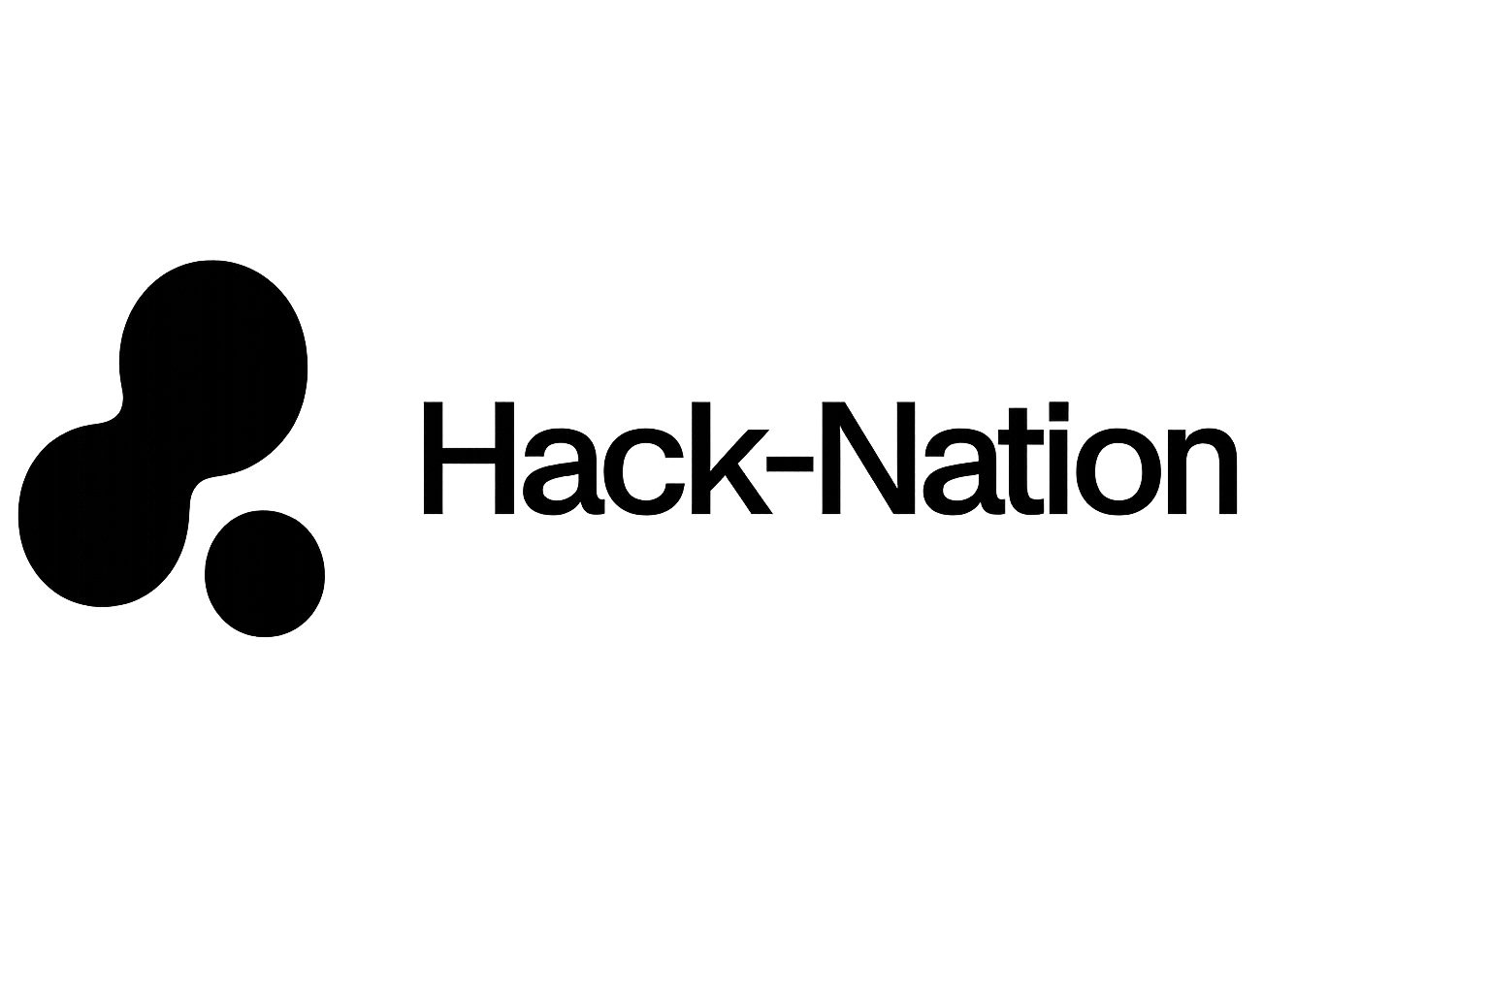
In collaboration with MIT Club of Northern California and MIT Club of Germany

C H A L L E N G E
04
· · · · · · · · · · · · · · · · · · · ·

The AI Scientist
From hypothesis to runnable experiment plan

P O W E R E D B Y

FULCRUM SCIENCE

The Challenge
Turning a scientific question into a runnable experiment takes weeks of manual work — designing the protocol, estimating costs, sourcing materials, staffing the team. It’s not the ideas that slow science down; it’s the operations.
Here’s how it typically works: an organisation — a pharma company, a university, a research funder — sends a brief to a specialist lab or Contract Research Organisation (CRO). The lab’s scientists scope the work: they figure out what steps to follow, what to buy, how long it will take, and how much it will cost. Then they send back a proposal. A senior scientist who’s run a similar experiment before can do this in hours. One who hasn’t may take days — and the quality difference is real. A plan with the wrong chemical concentration or an unrealistic timeline can send a lab down the wrong path for weeks.
Your challenge is to build an AI-powered tool that compresses this process: take a scientific question as input, and generate a complete, operationally realistic experiment plan that a real lab could pick up and execute. You don’t need to be a scientist to build this — you need to know how to build tools that make experts faster.

The mRNA moment | What accelerated COVID-19 vaccine development wasn’t a new idea — the mRNA hypothesis had existed for decades. It was the ability to move from hypothesis to executable experiment at unprecedented speed. That’s the gap you’re closing.
What You're Building
A focused, end-to-end application with three stages:
1. Input  Natural language scientific question | 2. Literature QC  Has this exact protocol been done before? | 3. Experiment Plan  Full operational plan — the core deliverable
Primary Challenge: Full Experiment Planning
This is where you can make your mark. Can you build the tool that a real PI would actually want to use? Can you generate an experiment plan so complete, so operationally grounded, that a lab could pick it up on Monday and start running it by Friday? Here's what that looks like in practice — a plan that includes:
- Protocol — step-by-step methodology grounded in real published protocols
- Materials and supply chain — specific reagents, catalog numbers, suppliers
- Budget — realistic cost estimate with line items
- Timeline — phased breakdown with dependencies
- Validation approach — how success or failure will be measured

Quality bar | Would a real scientist trust this plan enough to order the materials and start running it? That is the standard.
Literature Quality Control Step
Before generating the plan, run a quick check: has this experiment, or something very close to it, been done before?
Think of this as a plagiarism check, but for science. It’s not a deep literature review — it’s a fast signal that tells the scientist whether they’re breaking new ground or building on existing work. The output should be simple:
- A novelty signal: “not found”, “similar work exists”, or “exact match found”
- 1–3 relevant references where applicable, so the scientist can follow up
Use any literature source you like — arXiv, Semantic Scholar, protocol repositories, or others. The source matters less than the signal being accurate and fast.
The UI
Build a polished end-to-end interface. Submitted projects will be evaluated on both the quality of the generated plan and the quality of the experience.
The UI should make it easy to:
- Enter a scientific question in plain language
- See the literature QC result clearly before the plan is generated
- Read and navigate the full experiment plan
- Understand the budget, timeline, and materials at a glance
Stretch Goal: Scientist Review — Closing the Learning Loop
This is the hardest challenge in the brief, and the one with the highest ceiling.
The core idea: every time a scientist reviews and corrects a generated plan, that feedback becomes a training signal. Over time, the system gets better at generating plans for similar experiment types — learning from expert knowledge rather than just retrieving it.
What this looks like in practice:
- A structured review interface where a scientist can rate, correct, and annotate sections of the plan — protocol steps, reagent choices, budget lines, timeline assumptions
- A feedback store that captures corrections in structured form, tagged by experiment type and domain
- A generation layer that incorporates prior feedback when producing new plans of a similar type — at minimum as few-shot examples, at best as a lightweight fine-tuning loop
The demo that wins this stretch goal is one where a judge can watch the system generate a plan, a scientist leave structured corrections, and the next plan for a similar experiment visibly reflect those corrections — without being explicitly re-prompted.

Why this matters | A system that learns from scientist feedback compounds in value over time. Every review makes the next plan better. This is the difference between a tool and a platform.
Sample Inputs
Not sure what to test your tool with? Here are four example inputs — each is a real scientific hypothesis written the way a researcher would actually phrase it. Your tool should be able to take any of these and produce a full experiment plan.
Don’t worry if the scientific terminology is unfamiliar — we’ve added plain-English translations for each one.
.
Diagnostics | A paper-based electrochemical biosensor functionalized with anti-CRP antibodies will detect C-reactive protein in whole blood at concentrations below 0.5 mg/L within 10 minutes, matching laboratory ELISA sensitivity without requiring sample preprocessing.  In plain English: can we build a cheap, fast blood test for inflammation that works without lab equipment?
Gut Health | Supplementing C57BL/6 mice with Lactobacillus rhamnosus GG for 4 weeks will reduce intestinal permeability by at least 30% compared to controls, measured by FITC-dextran assay, due to upregulation of tight junction proteins claudin-1 and occludin.  In plain English: does a specific probiotic measurably strengthen the gut lining in mice?
Cell Biology | Replacing sucrose with trehalose as a cryoprotectant in the freezing medium will increase post-thaw viability of HeLa cells by at least 15 percentage points compared to the standard DMSO protocol, due to trehalose’s superior membrane stabilization at low temperatures.  In plain English: can we keep more cells alive when freezing them by swapping one preservative for another?
Climate | Introducing Sporomusa ovata into a bioelectrochemical system at a cathode potential of −400mV vs SHE will fix CO₂ into acetate at a rate of at least 150 mmol/L/day, outperforming current biocatalytic carbon capture benchmarks by at least 20%.  In plain English: can a specific microbe be used to convert CO₂ into a useful chemical compound more efficiently than current methods?

What makes these strong inputs | Each hypothesis names a specific intervention, states a measurable outcome with a threshold, gives a mechanistic reason, and implies a clear control condition. "AI will improve drug discovery" is a goal, not a hypothesis.
Hints and Resources
Protocol Repositories
- protocols.io: largest active repository, structured format: protocols.io
- Bio-protocol: peer-reviewed, linked to papers: bio-protocol.org
- Nature Protocols: premium detail: nature.com/nprot
- JOVE: video protocols with written transcripts: jove.com
- OpenWetWare: community protocols: openwetware.org
Supplier References
- Thermo Fisher application notes: thermofisher.com/us/en/home/technical-resources/application-notes.html
- Sigma-Aldrich technical bulletins: sigmaaldrich.com/US/en/technical-documents
- Promega protocols: promega.com/resources/protocols
- Qiagen protocols: qiagen.com/us/resources/resourcedetail?id=protocols
- IDT primer design and qPCR: idtdna.com/pages/tools

Reagent and Cell Line References
- ATCC cell line protocols: atcc.org
- Addgene cloning and transfection: addgene.org/protocols
Scientific Standards
- MIQE Guidelines for qPCR: ncbi.nlm.nih.gov/pmc/articles/PMC2737408
Contact: arun@fulcrum.science / jonas@fulcrum.science
What Good Looks Like
A participant enters: “Can we improve solar cell efficiency by testing alternative materials?”
The tool checks whether this protocol exists, surfaces 2 prior papers, flags it as “similar work exists”, then generates a full plan: a 6-step synthesis protocol grounded in protocols.io, a materials list with catalog numbers and a £12,000 budget estimate, and a 10-week timeline.
That is the bar. Build something a real scientist would want to use.

