CeEst FM ERP – Petty Cash Payment Voucher

1. Purpose
The ERP should generate a simple printable Payment Voucher where a petty-cash payment is made for work already authorised through an LPO and/or Job Card. The voucher is the physical evidence that the named recipients actually received the cash.

2. System Flow
APPROVED LPO / JOB CARD → PETTY CASH PAYMENT REQUEST → APPROVAL → PRINT VOUCHER → CASH PAID → RECIPIENT SIGNATURES → UPLOAD SIGNED VOUCHER → EXPENSE POSTING

3. Proposed Voucher – Illustration
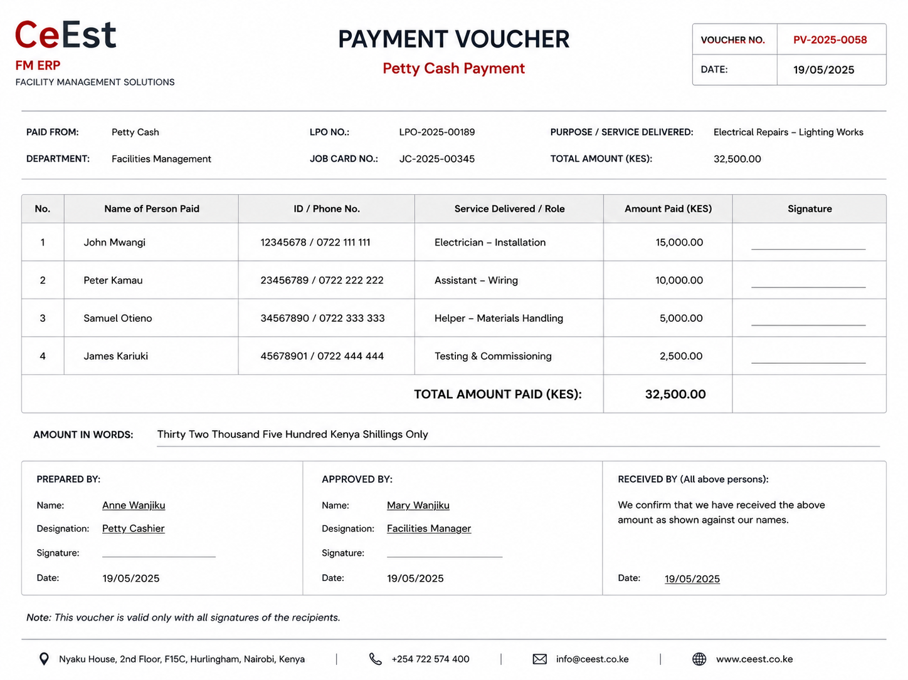
Figure 1 – Proposed simple Petty Cash Payment Voucher.

4. What the Voucher Must Show
Section | Information | System Behaviour
Voucher Details | Voucher No. and date | Unique number generated by system
Work Reference | LPO No. and Job Card No. | Pulled from existing records
Purpose | Service/work delivered | Pulled from LPO/Job Card
Recipients | Name of person paid, ID/phone if required | Entered by authorised payment user
Service / Role | What each person was paid for | Entered for each recipient
Amount | Amount paid to each person and total | System calculates and reconciles
Signatures | Individual recipient signature | Each recipient signs against own payment
Approval | Prepared/approved by authorised officers | Captured through system workflow

5. Multiple Recipients
One voucher should accommodate a maximum of FOUR people. The system should display four recipient rows, with unused rows remaining blank.
Each row should contain: Name of Person Paid | ID/Phone No. | Service Delivered / Role | Amount Paid | Signature.
The total voucher amount must automatically equal the sum of all recipient amounts. The system should prevent finalisation where the amounts do not reconcile.

6. Payment & Record Control
- Payment user selects an eligible LPO/Job Card payment.
- System confirms the LPO/Job Card reference and authorised amount/payment eligibility.
- User selects Petty Cash and enters up to four recipients and their amounts.
- Payment goes through the configured approval process.
- System generates a unique printable/downloadable Payment Voucher.
- Voucher is printed and cash is physically paid to the named recipients.
- Each recipient signs their own row as evidence of receipt.
- Completed signed voucher is scanned/uploaded to the payment transaction.
- Payment is posted to petty cash and the relevant expense record.

7. Developer Controls
- Do not allow a voucher to reference a non-existent or ineligible LPO/Job Card.
- Automatically carry forward LPO/Job Card details to avoid re-keying.
- Maximum four recipients per voucher.
- Recipient amounts must reconcile to the voucher total.
- Unique system-generated voucher number.
- Voucher must be downloadable/printable as a simple one-page document.
- Individual signature field must appear beside each recipient.
- Signed voucher can be attached back to the payment record.
- Maintain an audit trail from LPO → Job Card → Payment Voucher → Expense.

8. Training Sequence
Select eligible payment → Select Petty Cash → Confirm LPO/Job Card → Enter recipients → Submit for approval → Print Voucher → Pay cash → Obtain signatures → Upload signed voucher → Post expense

9. Design Objective
Keep the voucher deliberately simple. Its purpose is to clearly demonstrate WHO was paid, WHAT service/work the payment relates to, HOW MUCH each person received, and obtain each recipient's signature confirming receipt of cash.

