CeEst Facility Management – Supplier Invoice Recording
Developer Brief | Invoice Capture, Work Order Linkage & Approval Control

1. Purpose
Create a controlled Supplier Invoice function within Financials for invoices received from service providers and other suppliers. The system must preserve the link between the operational work that created an expense and the financial invoice.

2. Invoice Types & Linkage
Type | Link To | Developer Rule
One-off / Reactive Repair | Work Order (WO) | Invoice MUST quote and link to the WO that originated the request.
Recurring Service | Service Profile + Contract + Service Period + Property | Invoice links to the contracted service and billing period.

3. One-Off Repair Workflow
REQUEST / DEFECT → WORK ORDER → ASSIGN → WORK COMPLETED → VERIFIED → SUPPLIER INVOICE → MATCH TO WO → APPROVE → PAYMENT
Example: WO-2026-00458 is created for a water-pump repair. ABC Engineering completes the work and submits INV-2341 quoting WO-2026-00458. When the user enters the WO, the system should pull the property, provider, repair description, approved value, requester, completion and verification details.

4. Supplier Invoice Card
Navigation: Financials → Accounts Payable → Supplier Invoices/Bills → + Add Invoice. The card supports manual entry and invoice upload/scan

. 5. Fields to Capture
- Supplier / Service Provider; Invoice Number (mandatory and unique); Invoice Date; Due Date.
- Invoice Type: One-off (Work Order) or Recurring Service.
- Property; Work Order Number for one-off invoices; Service Profile / Contract / Service Period for recurring invoices.
- Description; Subtotal; VAT; Total; Expense Category; Cost Centre; Budget Line; Tax Code.
- Supporting document: PDF, scanned invoice or photograph; Remarks.

6. Scan, Attach & OCR
Allow PDF/image upload and a phone photograph of the supplier invoice. Keep the original document permanently attached to the invoice record. If OCR is implemented, it may extract supplier, invoice number, dates, amounts and VAT, but the user must confirm the extracted information before submission.

7. Automatic Validation
- Supplier exists and is active.
- Invoice number is unique for the supplier and duplicate invoices are flagged.
- One-off invoice has a valid Work Order reference.
- Work Order belongs to the selected property/provider and is completed and verified before payment approval.
- Invoice amount is compared with the approved Work Order value; variance is flagged for authorised review.
- Budget availability is checked where applicable.
- VAT/tax calculation is validated.

8. Approval & Audit Trail
Use configurable statuses: Draft → Submitted → Verification → Approved → Payment Processing → Paid / Rejected / Returned. For one-off repairs, payment approval should be blocked without a valid WO unless an authorised exception reason is recorded. All approvals, edits, exceptions and status changes must be audited.

9. Reporting & Backend Relationship
PROPERTY → SERVICE / ASSET → REQUEST → WORK ORDER → PROVIDER → COMPLETION & VERIFICATION → INVOICE → APPROVAL → PAYMENT
Because invoices are linked to their operational source, Financials should report expenditure by property, provider, service, work order, asset, budget line, contract and period. This supports service-charge reconciliation, budget-versus-actual analysis, supplier performance and audit review.

10. Acceptance Criteria
- Supplier invoices can be created from Financials.
- Invoice numbers are unique and duplicates are flagged.
- PDF/image invoices can be uploaded and retained with the transaction.
- One-off repair invoices require a Work Order reference before approval/payment, subject to authorised exception handling.
- Selecting a Work Order pulls the relevant operational information.
- Invoice value is compared with the approved Work Order value and variances are flagged.
- Recurring service invoices can link to Service Profile, Contract, Service Period and Property.
- Invoice status, approval and audit history are retained.
- Original invoice can be retrieved from the financial record.
- Invoice data feeds financial, service-charge and management reports.

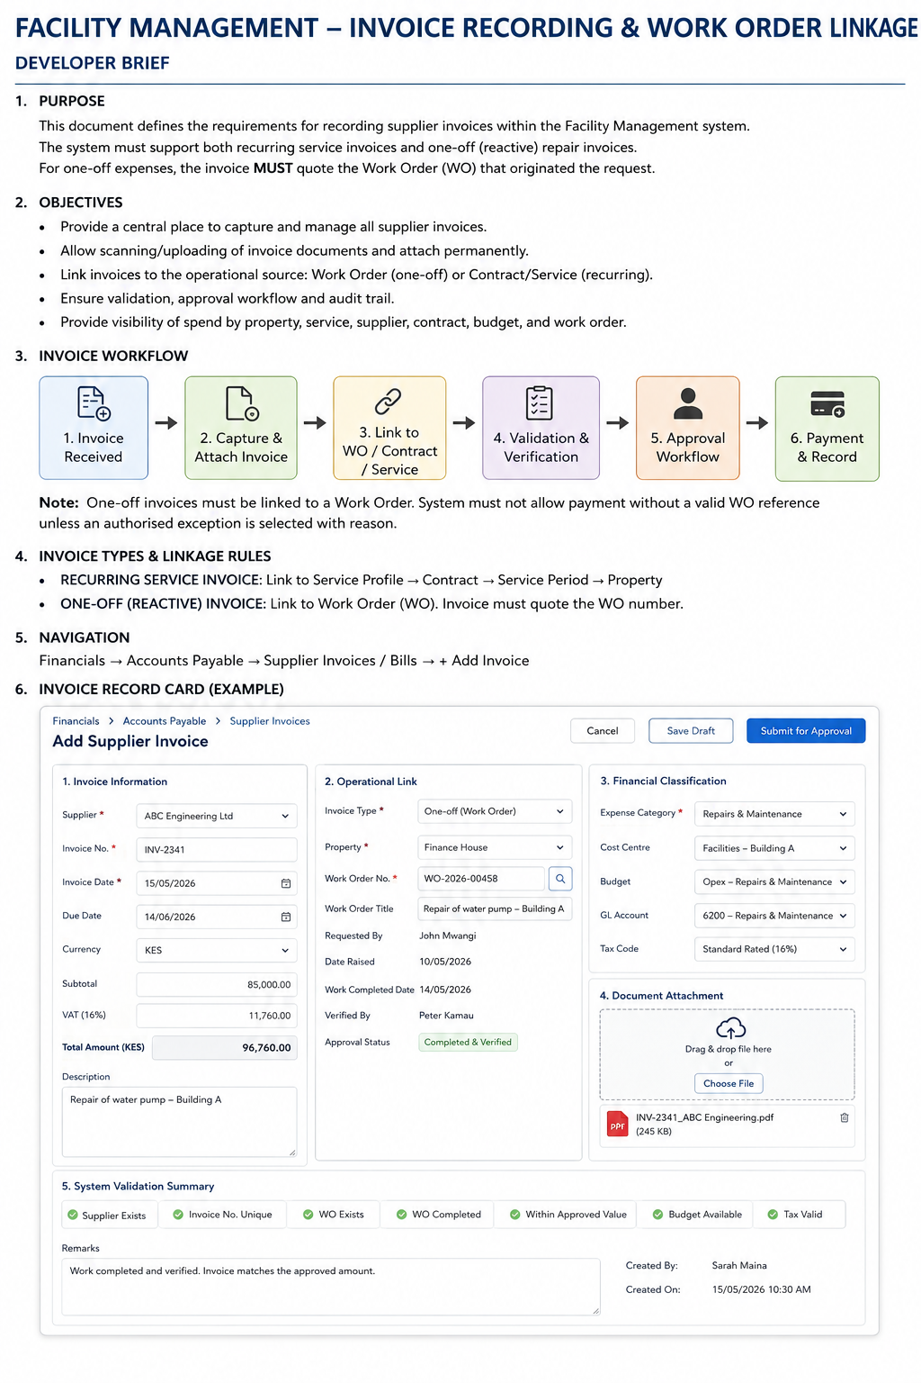
Figure 1 – Proposed Supplier Invoice recording card.

