CeEst FM – Navigation Change: Service Profile → Service Provider
Developer Brief | Implement in this order

A. FIRST: MOVE AND COMPLETE SERVICE PROFILE
The first change is only the Service Profile. Remove its current navigation from Facility Management → Operations and place it under Workspace → Property Onboarding. Complete and test this change before moving to Service Provider.

1. Current Service Profile position – REMOVE
The red circles show the affected Operations and Service Profiles tabs. These are the tabs to be removed from this location; the Service Profile functionality itself must not be deleted.
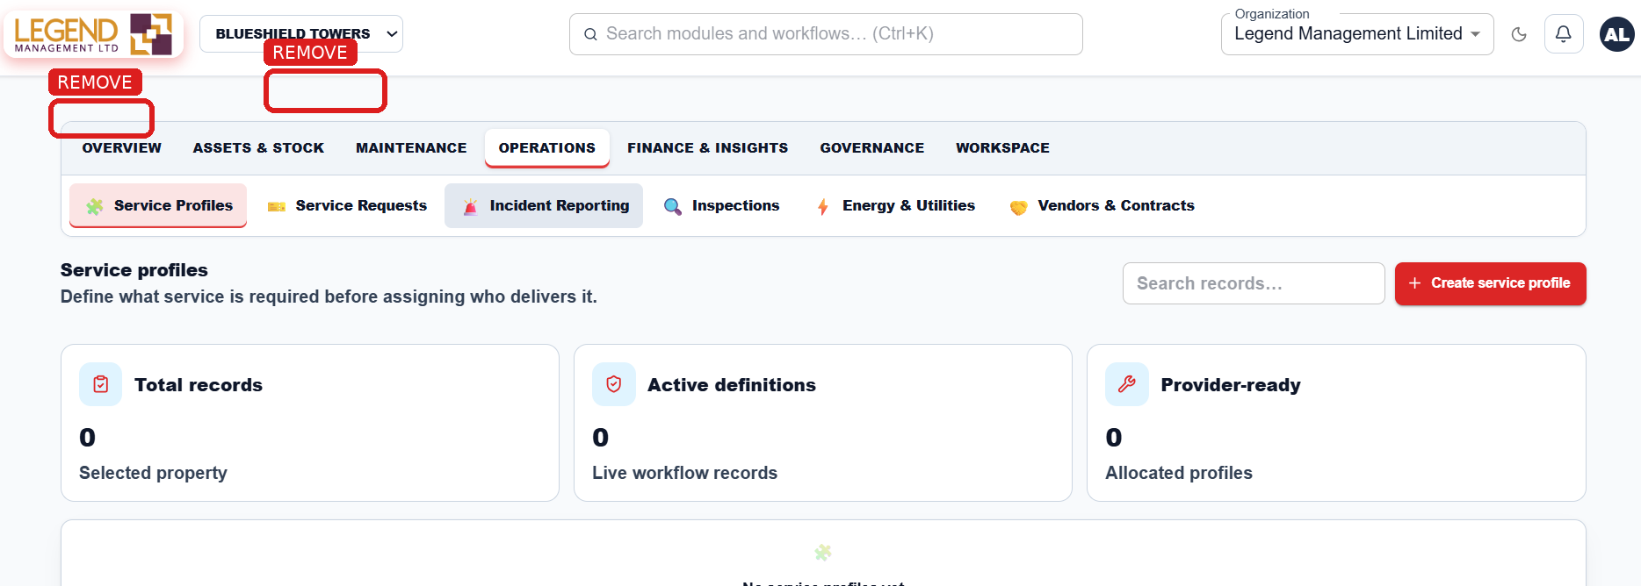
Figure 1 – Current position of Service Profiles.

2. Correct Service Profile position – NEW
In Workspace → Property Onboarding, replace the existing Service Providers tab with Service Profiles. The red circle marks the new Service Profiles position.
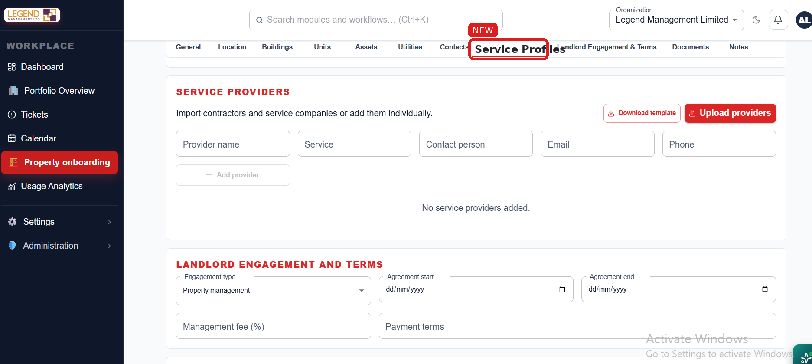
Figure 2 – Corrected Property Onboarding position for Service Profiles.

3. Service Profile creation
Clicking + Create Service Profile opens the simple profile card. This creates the master definition of the service only. Do not require a provider at this stage. Detailed schedules, SLA/KPI, checklists, staffing, contracts and costs can be configured after the profile exists.
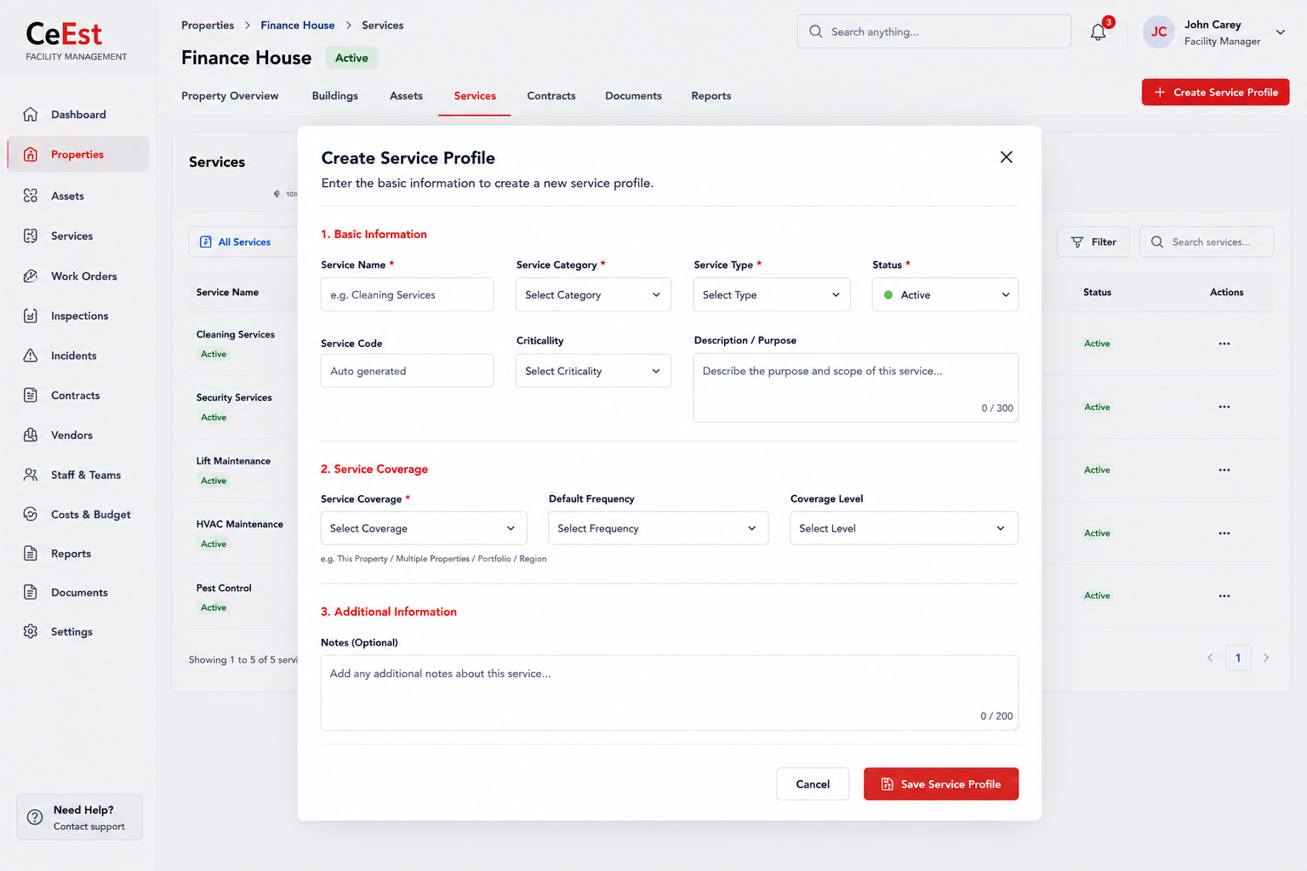
Figure 3 – Create Service Profile card.
The Service Profile is the baseline for later performance measurement: what service is required, where it applies, how often it is required, what standard is expected and what KPIs/SLA will be measured.

B. SECOND: MOVE AND CREATE SERVICE PROVIDERS
Only after the Service Profile change is complete, move to Service Provider onboarding. Service Provider is a separate master record. It answers WHO will deliver a service that has already been defined.

4. Current Service Provider position – REMOVE
The current Service Providers tab is inside Workspace → Property Onboarding. Remove the provider creation/upload function from this location. The red circles identify the affected tab and Property Onboarding area.
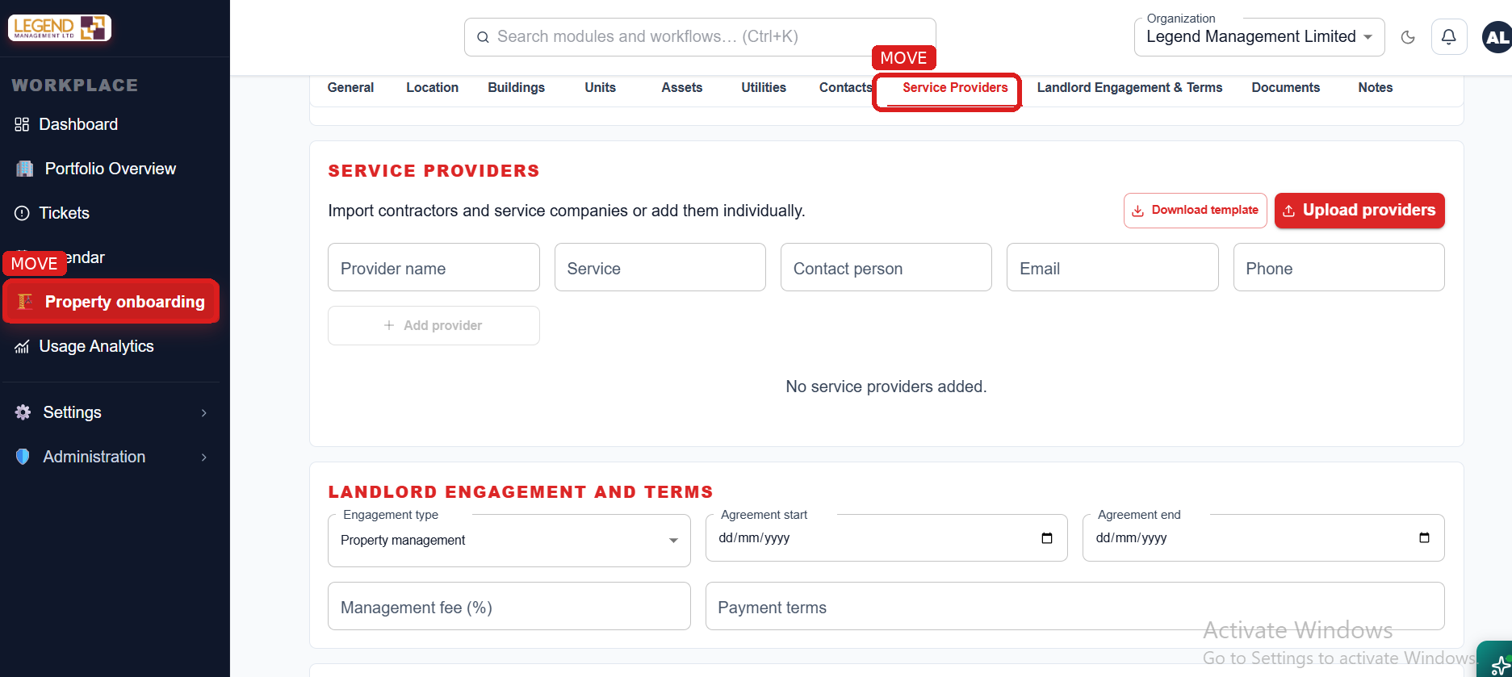
Figure 4 – Current Service Provider location to be removed.

5. Correct Service Provider position – NEW
Move Service Provider creation/uploading to Facility Management → Assets & Stock. Add a dedicated Service Providers tab next to the existing Assets & Inventory / Spare Parts / Consumables functions. The red circle shows the new position.
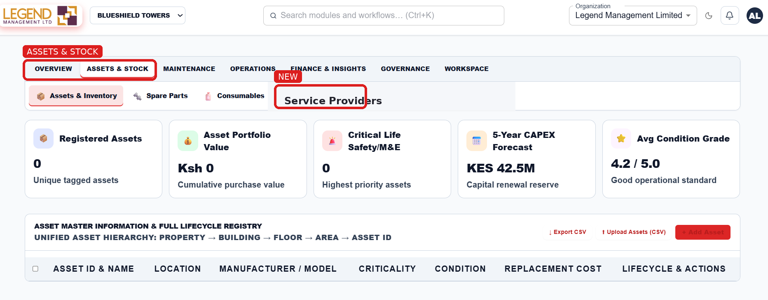
Figure 5 – Corrected Service Provider position under Assets & Stock.

6. How the two records connect
SERVICE PROFILE → SELECT SERVICE PROVIDER → ALLOCATE TO PROPERTY → CONTRACT / SLA → SCHEDULE → WORK ORDER → INSPECTION → KPI / PERFORMANCE → COST
Example: Create 'Cleaning Services' as the Service Profile. Separately create 'ABC Cleaning Ltd' as the Service Provider. The manager then allocates ABC Cleaning Ltd to Cleaning Services at Finance House. At another property, a different approved provider can be allocated to the same Cleaning Services profile.

7. Developer rules
- Do not delete the Service Profile or Service Provider functionality; change only its navigation and allocation structure.
- Service Profile is created first and does not require a provider.
- Service Provider is created separately and can provide multiple services.
- One Service Profile can be allocated to different properties and different providers.
- Changing a provider must not delete the Service Profile or historical service performance.
- Service Profile must remain available as the baseline for KPI, SLA, inspections and performance reporting.

8. Final navigation after the change
WORKSPACE → PROPERTY ONBOARDING → SERVICE PROFILES
FACILITY MANAGEMENT → ASSETS & STOCK → SERVICE PROVIDERS
Implementation sequence: COMPLETE SERVICE PROFILE MOVE → TEST → COMPLETE SERVICE PROVIDER MOVE → TEST → ENABLE PROVIDER ALLOCATION TO SERVICE.

