PROPERTY ONBOARDING – SECTIONAL TITLE & COMMON AREA MANAGEMENT
Developer Brief | Property, units, owners, tenants, services, management fees and collection routes

1. Purpose
The Property module must support sectional-title/common-area-managed properties where one estate contains multiple individually owned units, different occupants and different management arrangements. The property is onboarded once, while unit, owner, tenant, service, billing, collection and settlement relationships are configured separately.

2. Core Property Structure
PROPERTY / ESTATE → SECTIONAL SCHEME → BLOCK → UNIT → OWNER → TENANT / OCCUPANCY → SERVICES → BILLING & COLLECTION RULES
The Unit is the key relationship for financial and service configuration. The system must allow different owners to have different management mandates.

3. Property Onboarding Workflow
Stage | What the developer should capture | Purpose
1. Property Profile | Name, address, property type, sectional-title status, blocks, number of units, manager, commencement date and agreement. | Establish the estate.
2. Scheme & Blocks | Scheme details, common areas, blocks and shared facilities. | Define the sectional structure.
3. Units | Unit number, block, floor, size and unit attributes. | Create individual unit records.
4. Owners | Owner details and owner account/portal; map owner to unit(s). | Establish ownership.
5. Management Mandates | Common-area management, rental management and letting/agency per unit/owner. | Allow different services per owner.
6. Tenants & Leases | Tenant and lease linked to the relevant unit. | Establish occupancy and rent.
7. Services | Service charge, water, rent management, letting and other services. | Define services being delivered.
8. Fee Profiles | Management fee, rental commission, letting fee and other manager charges. | Automate manager income.
9. Collection Accounts | Collection account/payment route for each charge. | Direct money to the correct account.
10. M-Pesa | Paybill/Till, account reference and prompt configuration by charge type. | Enable prompted payments.
11. Settlement | Owner rent settlement and manager fee/commission rules. | Separate beneficiary amounts.
12. Readiness | Check all mandatory configurations before activation. | Prevent incomplete financial setup.

4. Unit-Level Management Profile
Each unit should have a management profile. A unit may be common-area managed only, or the owner may separately appoint the manager to manage the rental of that unit.
- Common Area / Estate Management – Yes/No
- Individual Rental Management – Yes/No
- Letting / Agency – Yes/No
- Service Charge responsible party
- Water responsible party
- Management agreement and effective dates
- Owner bank/settlement details where rental management applies

5. Management Fees & Manager Income
Fee | Billed To | Calculation | Frequency | System Action
Common Area Management Fee | Applicable Unit Owner(s) | Fixed / percentage / other | Configured | Generate owner invoice from profile
Rental Management Commission | Unit Owner | % of rent collected / fixed | Configured | Calculate and generate commission invoice
Letting Fee | Unit Owner | Fixed / percentage | Once-off / configured | Generate when letting service occurs
Other Management Fee | Configured payer | Defined basis | Configured | Generate according to approved profile

6. Required Money Flows
- Rent: Tenant → Rent Collection → Gross Rent → Management Commission → Manager Income → Net Rent → Unit Owner.
- Service Charge: Unit Owner → Estate Manager Collection Account.
- Water: Tenant → Estate Manager Collection Account.
- Common Area Management Fee: Unit Owner → Manager / Estate Management Collection Account.
- Letting Fee: Unit Owner → Manager.
The charge type must determine the payer, invoice, collection account/reference and settlement rule.

7. M-Pesa & Collection Configuration
The system should support separate collection routes for rent, service charge, water and management fees. When a user selects an invoice, the system should initiate the appropriate M-Pesa prompt using the configured account/reference for that charge. The transaction must remain linked to property, unit, payer and invoice.

8. Billing Automation
- Generate common-area management fee invoices to applicable unit owners.
- Calculate rental management commission from rent collected for managed units and invoice the relevant owner.
- Generate letting fees when a qualifying transaction occurs.
- Keep rent, service charge and water as separate billing streams.
- Retain property, unit, owner/tenant, service, agreement and fee-profile references on every invoice.

9. Financial Readiness Check
Before the property can be activated for billing/collection, the system should validate: property and scheme, units, owners, tenants/leases where applicable, services, management mandates, fee profiles, collection accounts, M-Pesa routes, settlement details and VAT treatment. Critical missing items should prevent activation.

10. Financial Separation
Maintain separate transaction classifications/ledgers for Tenant transactions, Owner transactions, Estate/Service Charge, Water, Manager income (management/letting/commission fees) and Owner rental proceeds. One property may contain all of these simultaneously.

11. Example – One Unit, Multiple Relationships
Unit A-101 is owned by ABC Holdings and occupied by John. ABC has appointed the manager to collect rent and manage the unit, while the estate manager also manages common areas.
- John pays rent → rent is recorded against A-101 → commission is calculated → manager income is recorded → net owner amount is calculated.
- ABC pays common-area management/service charge → recorded against the owner's account and estate collection route.
- John pays water → recorded against the tenant/water account and estate collection route.
- All transactions remain separately identifiable even though they relate to the same unit.

12. UI VISUALISATION FOR DEVELOPER
The following proposed UI illustrates the intended onboarding workspace. It is a visual guide to the structure and relationships described above; the exact fields and workflow should follow the functional requirements in this brief.
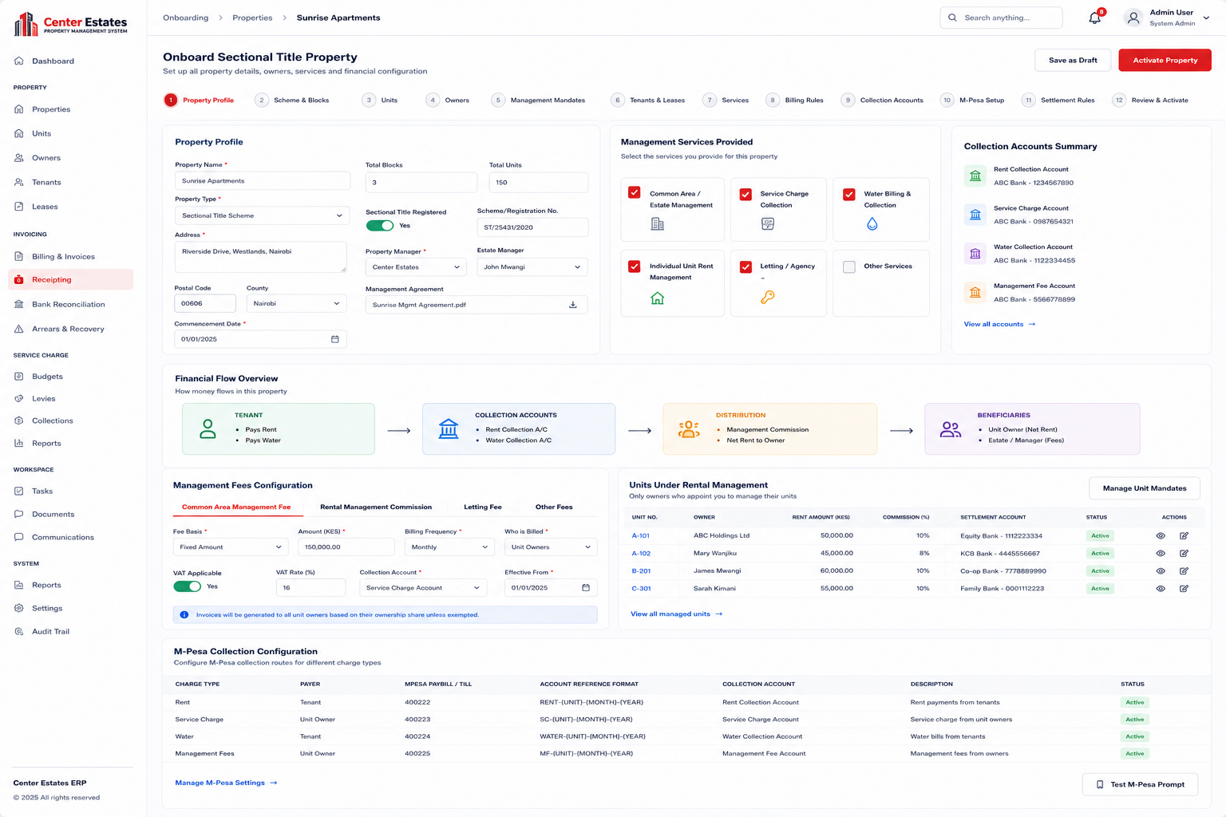
Illustrative UI – Sectional Title Property Onboarding

13. Developer Acceptance Criteria
- One sectional-title property supports many owners with different management mandates.
- Individual units can independently be configured for rental management, common-area management, both, or neither where appropriate.
- Common-area management fees can be invoiced to applicable unit owners from the property/fee profile.
- Rental management commission can be calculated from rent collected and invoiced to the relevant owner.
- Rent settlement to the owner is separate from manager commission income.
- Water and service-charge collections can use different accounts/routes from rent.
- M-Pesa prompts use the correct charge type, invoice and collection route.
- Property cannot be activated for billing until mandatory readiness checks pass.
- All transactions retain property, unit, payer, beneficiary, service and fee-profile references for reporting and audit.

14. Final Design Principle
ONE PROPERTY → MANY UNITS → DIFFERENT OWNERS / TENANTS → DIFFERENT SERVICES → DIFFERENT BILLING RULES → DIFFERENT COLLECTION ROUTES → CONTROLLED SETTLEMENT

