CeEst Workplace – Scheduled Invoicing & Billing Engine
Complete Functional & Backend Development Specification
Purpose: define how CeEst should identify, prepare, validate, generate, issue and track property-management invoices. The billing engine must be driven by existing property, unit, tenant and tenancy/lease terms, while also supporting controlled manual single invoicing, utility billing, water-meter reconciliation, VAT, deposits, credit notes, payments and future smart-meter integration.

Proposed Billing / Invoicing UI
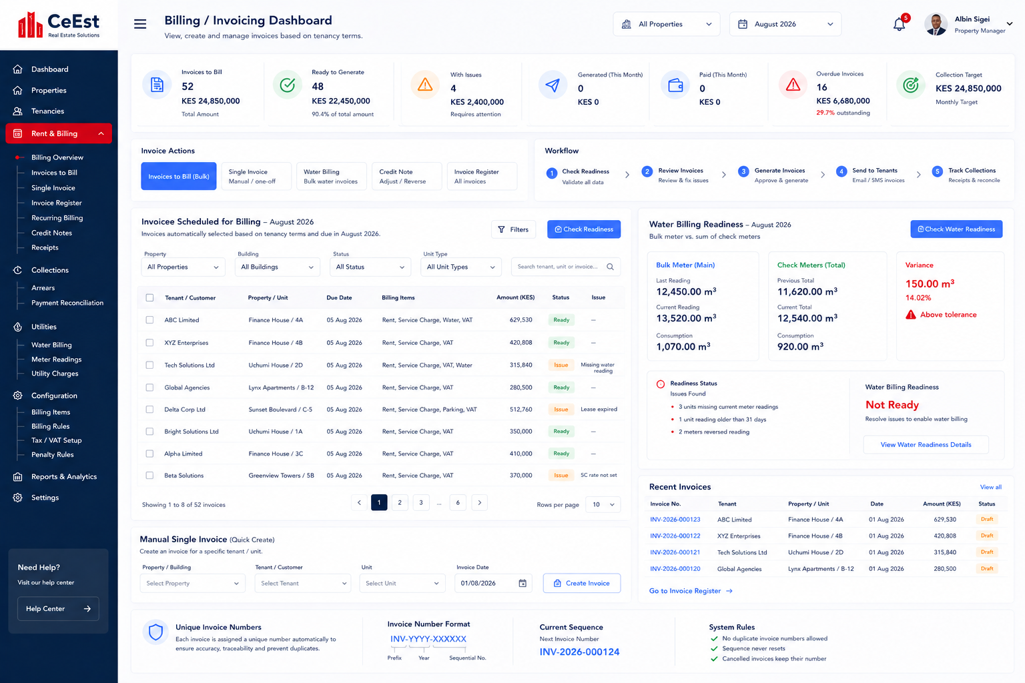

1. Core Business Principle
The normal monthly billing process should not require a property manager to recreate invoices manually. CeEst should automatically identify all active tenancies with billing obligations falling within the selected billing period and present them in an 'Invoices to Bill' queue.
- Property → Unit → Tenant → Lease/Tenancy → Billing Profile → Billing Schedule → Invoice.
- At the beginning of each month, the system identifies all billing obligations due for that month.
- The system creates scheduled/draft billing records for review rather than requiring manual recreation.
- The manager reviews readiness, resolves exceptions and authorizes invoice generation.
- Final invoices then flow to tenant accounts, collections, receipts, arrears, VAT and landlord reporting.
- Exceptional or one-off invoices can still be created through a controlled Single Invoice function.

2. Billing / Invoicing Navigation
- Billing Overview
- Invoices to Bill (Bulk)
- Single Invoice
- Invoice Register
- Recurring Billing
- Credit Notes
- Receipts
- Collections
- Arrears
- Payment Reconciliation
- Water Billing
- Meter Readings
- Utility Charges
- Billing Items
- Billing Rules
- Tax / VAT Setup
- Penalty Rules

3. Monthly Scheduled Billing
When the user opens Rent & Billing → Invoices to Bill, the system should default to the current month and display all billing obligations scheduled from active tenancy terms.
Data | Pulled From | System Logic | Example
Tenant | Tenant master | Active tenant linked to valid unit/tenancy | ABC Ltd
Property / Unit | Property + Unit | Unit associated with tenant | Finance House / 4A
Invoice date | Billing rule | Configured billing date | 01 Aug 2026
Due date | Tenancy / billing terms | Configured tenant due date | 05 Aug 2026
Billing items | Billing profile | All items due in the period | Rent, SC, Water, VAT
Amount | Lease + billing rules | Calculated from effective terms | KES 629,530
Status | Billing engine | Ready / Issue / Generated / Excluded | Ready
Issue | Validation engine | Exception requiring attention | Missing water reading

4. Billing Readiness Check
Before final invoice generation, the system must validate every scheduled billing record.
- Active tenant exists.
- Active lease/tenancy exists for the billing period.
- Rent amount is available.
- Service-charge setup exists where applicable.
- VAT/tax setup exists where applicable.
- Utility billing data exists where applicable.
- Required water meter readings exist.
- No reverse water readings exist.
- No duplicate invoice exists for the same tenant, billing period and billing item.
- Tenant/property/unit relationship is valid.
- Special billing instructions and approved adjustments are valid.
- Any expired or soon-to-expire lease is clearly flagged.
The readiness panel should show counts such as Active Tenants, Valid Leases, Missing Rent, Missing Service Charge Setup, Expiring Leases, Missing Water Readings and other exceptions. Records with issues remain visible and show the reason.

5. Review and Generate Workflow
- Select billing month/year and property or All Properties.
- CeEst pulls all scheduled invoices from active tenancy terms.
- Run Check Readiness.
- Display Ready and Issue records.
- Review invoice details, billing items and exceptions.
- Resolve source-data issues or exclude a record with a documented reason.
- Select the Ready invoices for generation.
- Generate final invoices and assign unique invoice numbers.
- Post invoices to tenant accounts.
- Send invoice notifications by the configured communication channels.
- Make invoices available in the Tenant Portal.
- Feed invoices into collections, arrears, VAT and landlord reports.

6. Billing Items and Calculation Rules
The billing-item master should be configurable and should define how each charge is calculated and where its data comes from.
- Rent – pulled from active lease/tenancy terms and effective escalation schedule.
- Service Charge – pulled from the tenant's configured service-charge terms or approved allocation method.
- Water – calculated from validated meter readings and the applicable tariff.
- Electricity / Other Utilities – supported through configurable utility billing rules.
- VAT – calculated according to the applicable billing-item tax configuration.
- Rent Deposit – billed only when required by the tenancy terms or approved charge.
- Water Deposit – billed only when required.
- Security Deposit – billed only when required.
- Opening Balance – separately identifiable adjustment brought forward.
- Penalties / Interest – generated only according to approved penalty rules.
- Other Charges – controlled one-off or recovery charges with appropriate authorization.
- Credits / Adjustments – handled through controlled adjustment or credit-note workflows.

7. Billing Frequency and Effective Dates
- Monthly
- Quarterly
- Biannual
- Annual
- One-off
- Meter-based
- Event/trigger-based
- Custom recurring schedule
The billing engine must use effective dates. A rent escalation, service-charge change or other billing-term change must only affect invoices from its effective date onward. Historical invoices must retain the terms used when they were issued.

8. Manual Single Invoicing
Scheduled bulk billing is the primary monthly workflow, but CeEst must provide a Single Invoice function for authorized exceptional, one-off or corrective billing.
- Select Property, Tenant and Unit from existing records.
- Display the tenant's current lease and billing profile for reference.
- Enter/confirm invoice date and due date.
- Select configured billing item(s).
- Allow approved exceptional charges without changing the underlying recurring billing terms.
- Validate mandatory fields and duplicate risk.
- Generate a unique invoice number automatically.
- Post to the same tenant ledger and reporting structures as scheduled invoices.
- Manual invoices must appear in the same Invoice Register, collections, receipts, arrears and landlord reports.

9. Unique Invoice Numbering
Every posted invoice, whether generated through bulk scheduled billing or Single Invoice, must receive a unique system-generated invoice number. Users must never type or reuse invoice numbers.
- Generate invoice numbers transactionally at final invoice generation/posting.
- No duplicate invoice numbers permitted.
- Cancelled invoices retain their original invoice number.
- Cancelled invoice numbers are never reused.
- Credit notes and other adjustment documents have separate unique document sequences.
- Numbering remains traceable to tenant, property, billing period, invoice and creation event.
- Recommended configurable format: INV-YYYY-000001.

10. Water Meter Reading and Billing
Water billing must be a controlled process connected to the Meter Readings module. It must not simply be a manually typed 'Water Charge' line on an invoice.
- Identify all active meters expected for the billing period.
- Capture previous and current readings.
- Calculate consumption = current reading − previous reading.
- Apply the configured tariff.
- Generate the water billing line.
- Link the invoice line to the meter-reading record.
- Apply VAT/tax treatment where applicable.
- Send water billing through the same monthly invoice readiness process.

11. Reverse Reading Rejection
The system must reject a current water-meter reading that is lower than the previous reading unless an authorized meter replacement/reset event has been recorded.
- If Current Reading < Previous Reading → status = REJECTED.
- Do not calculate or post consumption from a rejected reading.
- Show meter, property/unit, previous reading, current reading and variance.
- Require correction or an authorized meter replacement/reset workflow.
- Retain the original submitted reading and corrected reading in the audit trail.

12. Bulk Meter vs Check Meter Reconciliation
Where a property has a bulk/main water meter and individual check/sub-meters, both must be read for the same billing period and validated together. The system must always compare the bulk consumption with the sum of valid check-meter consumption.
- Bulk Consumption = Current Bulk Reading − Previous Bulk Reading.
- Check Meter Consumption = Sum of valid individual meter consumption.
- Variance = Bulk Consumption − Sum of Check Meter Consumption.
- Variance % = Variance ÷ Bulk Consumption × 100, subject to the configured tolerance.
- Display Bulk Consumption, Check Meter Total and Variance prominently in Water Billing Readiness.
- Flag variance above tolerance for investigation.
- Potential causes include faulty meters, leakages, unmetered consumption, illegal connections or reading errors.
- The system must not silently allocate the variance to tenants without an approved business rule.
- Record who reviewed the variance, action taken and supporting comments/documents.

13. Water Billing Readiness
- All expected active meters identified.
- Previous readings available.
- Current readings available.
- No reverse readings.
- No duplicate readings.
- Meter status valid.
- Meter replacement/reset events properly recorded.
- Consumption calculations valid.
- Tariff available.
- Bulk/check-meter reconciliation completed where applicable.
- Variance within tolerance or an authorized exception recorded.
Water invoices should not be released for generation where a mandatory water-readiness issue remains unresolved, unless an authorized exception is recorded.

14. Smart Meter / IoT Readiness
The meter-reading architecture must be designed so that manual entry is not the only reading method. Future smart meters should connect to the same reading and billing engine without requiring a redesign.
- Reading Method: Manual.
- Reading Method: Mobile App.
- Reading Method: Imported File/API.
- Reading Method: Smart Meter/IoT.
- All methods write to the same meter-reading data structure.
- Store meter ID, reading value, reading timestamp, reading method and source/device reference.
- Apply the same reverse-reading, duplicate, missing and abnormal-consumption validation to every source.
- Allow configured approval of automatically imported readings before billing.
- Maintain a complete audit trail showing the source of every reading.

15. Invoice Register and Statuses
The Invoice Register should provide a central view of all invoices.
- Draft
- Ready
- Generated / Issued
- Sent
- Partially Paid
- Paid
- Overdue
- Cancelled
- Credited / Adjusted
Recommended filters: Property, Building, Unit, Tenant, Month, Year, Invoice Status, Billing Item, Payment Status and date range.

16. Cancellation, Credit Notes and Adjustments
- Issued invoices must not be deleted.
- Cancellation requires a reason and appropriate authorization.
- Cancelled invoices remain in the Invoice Register and audit trail.
- Paid or posted invoices should be corrected through credit note/debit adjustment workflows.
- Credit notes have unique numbers and remain linked to the original invoice.
- Adjustments must flow through tenant balances, receipts, collections and reports.

17. Backend Data Architecture
The developer should implement the following logical chain:
Property → Unit → Tenant → Lease/Tenancy → Billing Profile → Billing Schedule → Billing Items → Invoice → Tenant Ledger → Payment → Receipt → Collections / Arrears / Reports
For utilities:
Meter → Reading History → Validation → Consumption → Tariff → Water Billing → Invoice → Payment → Reporting

18. Required Backend Records
- Billing Profile – recurring item, calculation method, amount/rate, frequency, tax treatment and effective date.
- Billing Schedule – billing period, planned billing date, due date, status and source billing rule.
- Billing Item – individual charge and its calculation/source.
- Invoice – final financial document posted to tenant ledger.
- Invoice Line – individual rent, service charge, water, VAT, deposit or other charge.
- Meter – property/unit, meter type, meter number and status.
- Meter Reading – value, timestamp, reading method, source/device and validation status.
- Meter Reconciliation – bulk consumption, check-meter total, variance, tolerance and review outcome.
- Payment / Receipt – settlement against invoice and tenant account.
- Credit Note / Adjustment – controlled correction linked to original invoice.
- Audit Log – creation, changes, approvals, exclusions, cancellations, overrides and exceptions.

19. Management Dashboard Metrics
- Invoices to Bill
- Total Amount to Bill
- Ready to Generate
- Amount Ready
- With Issues
- Amount With Issues
- Generated
- Paid
- Overdue
- Outstanding
- Collection Target
- Water Readings Pending
- Water Billing Readiness
- Bulk vs Check Meter Variance

20. Integration with Other CeEst Modules
- Property & Units – identifies the property and billable unit.
- Tenants – identifies the customer and account.
- Leases / Tenancy – supplies billing obligations and effective dates.
- Water / Utilities – supplies meter readings and utility charges.
- Service Charge – supplies service-charge billing terms.
- Finance / Income & Expenditure – receives billing and payment information.
- Collections – receives issued invoices and outstanding balances.
- Tenant Portal – displays invoices, statements, receipts and Pay Now.
- Payment Gateway – receives payments and returns payment confirmations.
- VAT / Statutory Reports – receives tax-coded invoice data.
- Landlord Reports – receives billing, collections, arrears and income information.
- Performance / Companion – can create tasks when billing readiness or scheduled billing requires staff action.

21. Tenant and Landlord Experience
Tenant Portal:
- View current invoice.
- View account statement.
- View payment history.
- Pay Now through the configured payment gateway such as M-Pesa/eCitizen.
- Download receipts.
- Receive invoice/payment notifications.
Landlord Portal:
- View billing and collection schedules.
- View collections and arrears.
- View income performance.
- View service-charge performance.
- View relevant financial reports for authorized properties.

22. Acceptance Criteria
- At the beginning of each billing month, the system automatically displays all invoices scheduled from active tenancy terms.
- Normal rent and service-charge amounts are pulled from tenancy/lease billing profiles without manual re-entry.
- Manual Single Invoice is available for authorized one-off or exceptional billing.
- Both scheduled and manual invoices use the same validation and numbering engine.
- Every final invoice receives a unique, non-reusable invoice number.
- Reverse water readings are rejected before consumption or billing is calculated.
- Water billing goes through a readiness check.
- Bulk and check meters are read and reconciled for the same billing period where applicable.
- Bulk-versus-check-meter variance is displayed and flagged when outside tolerance.
- Water billing is traceable from meter reading → consumption → tariff → invoice.
- The reading architecture supports future smart-meter/API/IoT sources.
- Duplicate billing is prevented.
- Issued invoices cannot be silently deleted or overwritten.
- Cancellations, credit notes, corrections and overrides are audited.
- Generated invoices update the tenant ledger and become available in the Tenant Portal.
- Billing data flows into collections, arrears, VAT, landlord reports and financial reporting.
- The system supports property-level and portfolio-level billing with role-based access.

23. Recommended End-to-End Process
Tenancy Terms → Monthly Scheduled Billing Queue → Billing Readiness → Water Readiness & Meter Reconciliation → Review Exceptions → Approve → Generate Unique Invoice Numbers → Issue/Notify Tenant → Tenant Payment → Receipt → Tenant Ledger → Collections / Arrears / VAT / Landlord Reports
Exceptional billing follows: Manual Single Invoice → Validation → Unique Invoice Number → Issue → Payment/Receipt → Reports.

