CeEst Workplace – Financial Reports
Backend Functional Specification & Reporting Logic
Purpose: guide the developer on the reports, data sources, filters, calculations and outputs required for the Financial Reports window. The window is intended to provide real-time financial intelligence for property management, landlord reporting and performance monitoring.

AI Reference
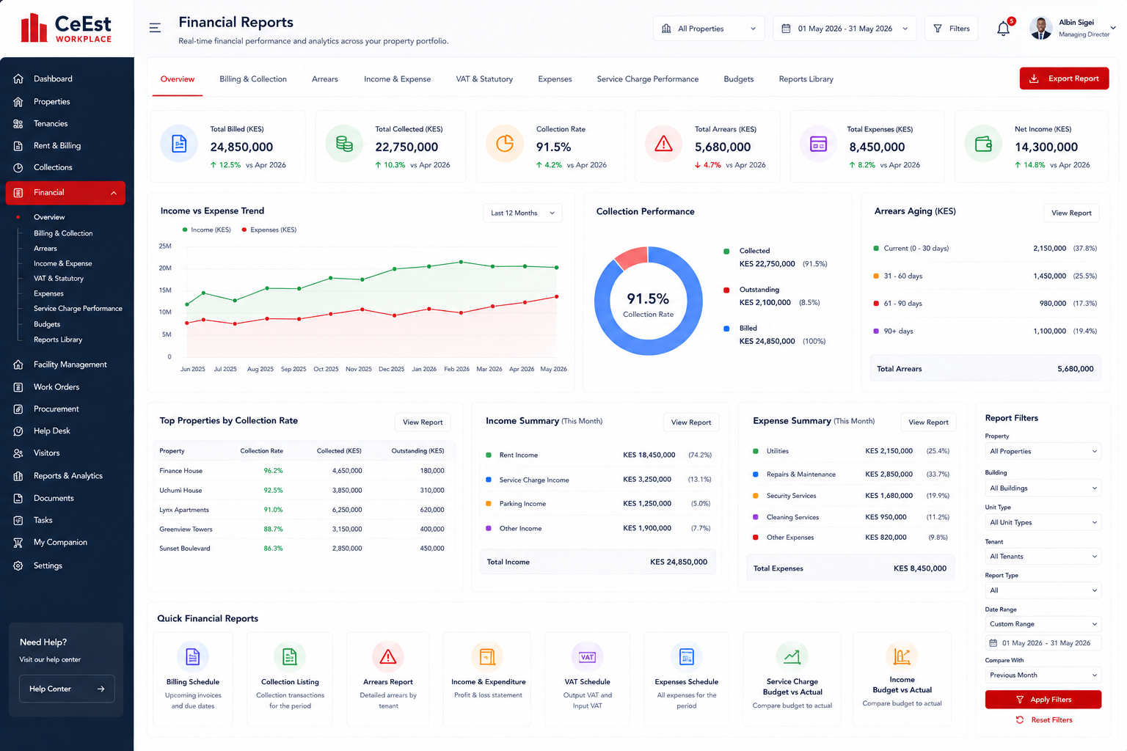

1. General Reporting Architecture
- Financial reports must pull live data from Property, Unit, Tenant, Lease, Billing, Rent Collection, Service Charge, Expense, VAT, Budget and Payment/Reconciliation records.
- Use the underlying transaction ledgers as the source of truth; do not create a separate manual financial reporting database.
- All reports must support portfolio, property and where applicable unit/tenant level views.
- Financial reports must distinguish invoice/billing date, due date, payment date, expense date, VAT period and reporting period.
- All monetary reports should reconcile to the relevant billing, receipt, expense and accounting records.
- Reports should support PDF and CSV/Excel export.
- Saved views and scheduled reports should be available for recurring landlord and management reporting.
- Property and landlord scope must be enforced so users only see authorized portfolios.

Overview
Purpose | Management snapshot of financial performance.
Report/Data to Pull | Total billed; total collected; collection rate; total arrears; total expenses; net income; income/expense trend; collection performance; arrears ageing; top properties by collection rate; income and expense summaries.
Backend Source | Invoices + receipts/payments + tenant balances + expense records + property/unit/lease records.
Filters | Property/portfolio and reporting period; comparison period.
Output | Dashboard, PDF and CSV/Excel management report.
Developer Rule | Every report must be traceable to source transactions and retain an audit trail of user, period, filters and generation time.

Billing & Collection
Purpose | Generate billing and collection schedules for management and landlord reporting.
Report/Data to Pull | Invoices raised; invoice number; tenant; property/unit; billing period; rent; service charge; VAT where applicable; total billed; due date; amount collected; collection date; outstanding balance; collection status.
Backend Source | Invoice/billing ledger + tenant/unit/lease master + receipts/payments.
Filters | Property, tenant, unit, invoice period, due date, status and date range.
Output | Billing schedule, collection schedule and collection performance report.
Developer Rule | Every report must be traceable to source transactions and retain an audit trail of user, period, filters and generation time.

Arrears
Purpose | Monitor outstanding tenant balances and ageing.
Report/Data to Pull | Tenant; property; unit; invoice/reference; billed amount; amount paid; balance; days overdue; ageing bucket; last payment; total arrears.
Backend Source | Invoice ledger + receipts/payment ledger + tenant account balances.
Filters | Property, tenant, ageing period, balance range, reporting date.
Output | Arrears listing, ageing analysis and landlord arrears report.
Developer Rule | Every report must be traceable to source transactions and retain an audit trail of user, period, filters and generation time.

Income & Expense
Purpose | Analyse property profitability and income/expenditure performance.
Report/Data to Pull | Rent income; service charge income; parking/other income; expenses by category; total income; total expenses; net income; budget versus actual; trend by month/property.
Backend Source | Income ledger + billing/receipts + expense ledger + budgets.
Filters | Property, period, income category, expense category, tenant/unit/use.
Output | Income & expenditure statement, trend analysis and budget performance.
Developer Rule | Every report must be traceable to source transactions and retain an audit trail of user, period, filters and generation time.

VAT & Statutory
Purpose | Prepare VAT and related statutory schedules from system transactions.
Report/Data to Pull | Output VAT from applicable invoices; input VAT from eligible expenses; VAT period; taxable value; VAT amount; invoice/receipt reference; supplier/tenant; property; totals.
Backend Source | Tax-coded invoices, receipts and expense records.
Filters | VAT period, property, transaction type, tax code and date.
Output | VAT schedule and supporting transaction listing. Tax treatment should be configurable and subject to the client's tax rules.
Developer Rule | Every report must be traceable to source transactions and retain an audit trail of user, period, filters and generation time.

Expenses
Purpose | Provide detailed expense schedules and cost analysis.
Report/Data to Pull | Expense date; supplier/service provider; property; expense category; description; reference; amount; VAT; total; payment status; budget code; cost centre.
Backend Source | Expense ledger + supplier/service provider records + payment vouchers + budgets.
Filters | Property, supplier, category, cost centre, date range, payment status.
Output | Expense schedule, category analysis and property expense comparison.
Developer Rule | Every report must be traceable to source transactions and retain an audit trail of user, period, filters and generation time.

Service Charge Performance
Purpose | Compare service charge collections and actual expenditure against the service charge budget.
Report/Data to Pull | Service charge billed; collected; arrears; budget allocation; actual expenditure; variance; collection rate; utilization rate; balance/surplus/deficit by category.
Backend Source | Service charge billing + collections + approved service charge budget + expense allocation.
Filters | Property, service charge period, budget category and expense category.
Output | Service charge performance report, budget-versus-actual and utilization report.
Developer Rule | Every report must be traceable to source transactions and retain an audit trail of user, period, filters and generation time.

Budgets
Purpose | Monitor income and service charge budgets against actual performance.
Report/Data to Pull | Approved budget; revised budget; actual income/expense; variance amount; variance percentage; forecast; projected year-end position.
Backend Source | Budget master/version + income ledger + expense ledger + service charge budget.
Filters | Property, budget period, category, budget version.
Output | Income budget vs actual and service charge budget vs actual reports.
Developer Rule | Every report must be traceable to source transactions and retain an audit trail of user, period, filters and generation time.

Reports Library
Purpose | Central catalogue of standard financial reports and generated reports.
Report/Data to Pull | Report name; category; generated date/time; generated by; property scope; period; format; saved/scheduled status.
Backend Source | Report definitions + report execution history.
Filters | Category, property, date, user, report type.
Output | Open, regenerate, export, schedule and manage saved reports.
Developer Rule | Every report must be traceable to source transactions and retain an audit trail of user, period, filters and generation time.

2. Quick Financial Reports
The UI should provide one-click access to the frequently required reports shown at the bottom of the approved design:
- Billing Schedule – upcoming/current invoices, tenants, properties, amounts and due dates.
- Collection Listing – all collections/receipts for the selected period, with property, tenant, reference and amount.
- Arrears Report – detailed outstanding balances and ageing.
- Income & Expenditure – income, expenses and net position for the selected period.
- VAT Schedule – output/input VAT and supporting transaction listing.
- Expenses Schedule – detailed expenses for the selected period.
- Service Charge Budget vs Actual – approved service charge budget compared with actual expenditure.
- Income Budget vs Actual – approved income budget compared with actual income.

3. Core Filters
- Property / Portfolio
- Building where applicable
- Unit type
- Tenant
- Reporting date/date range
- Financial period
- Income or expense category
- Service charge category
- Supplier/service provider
- Budget version
- Payment/collection status

4. Key Financial Calculations
- Collection Rate = Amount Collected ÷ Amount Billed × 100.
- Outstanding Balance = Amount Billed − Allocated Payments/Credits.
- Net Income = Total Income − Total Expenses.
- Budget Variance = Actual − Approved Budget.
- Budget Variance % = Budget Variance ÷ Approved Budget × 100.
- Service Charge Utilization = Actual Service Charge Expenditure ÷ Service Charge Budget × 100.
- Arrears Ageing = Reporting Date − Due Date for unpaid/part-paid amounts.
- VAT totals must be derived from transaction tax codes and effective tax configuration rather than hard-coded report values.

5. Landlord Reporting & Performance Monitoring
The financial reporting engine should produce presentation-ready reports for landlords while also providing operational performance information for managers. The same underlying data should support both purposes, with different visibility and formatting.
- Monthly billing and collection schedule.
- Collection rate and collections by property.
- Arrears status and ageing.
- Income and expenditure statement.
- VAT schedule and supporting listing.
- Monthly expense schedule.
- Service charge budget versus actual and utilization.
- Income budget versus actual.
- Property-by-property financial performance.
- Collection and income trends.
- Management fee reporting where configured.

6. Backend Development Requirements
- Maintain immutable transaction references for invoices, receipts, credit notes, expenses and payment vouchers.
- Support allocation of receipts to invoices and tenant accounts.
- Maintain effective-dated VAT/tax configuration and transaction tax codes.
- Maintain budget versions so historical reports remain linked to the budget that was approved at the time.
- Map service charge expense transactions to approved service charge budget categories/cost centres.
- Allow actual expenses to be compared with budget at property and category level.
- Maintain reconciliation status for collections and bank/payment records.
- Support property-level and portfolio-level aggregation without duplicating transactions.
- Record report generation history and applied filters.
- Apply role-based and property-based visibility to landlord, manager and internal users.

7. Acceptance Criteria
- Every financial tab produces a report from live system data.
- Dashboard totals reconcile to the underlying ledgers.
- Changing property or date filters refreshes the relevant metrics and reports.
- Collections can be traced from tenant invoice to receipt/payment.
- Arrears ageing is calculated from actual due dates.
- Expenses can be mapped to service charge budget categories.
- Budget versus actual reports show both amount and percentage variance.
- VAT reports can be generated by the required tax period with supporting transactions.
- Landlord reports can be generated for only the landlord's authorized properties.
- Reports can be exported and scheduled.
- All generated reports retain an audit trail.

