CeEst Workplace – Tenancy & Occupancy Reports
Backend Functional Specification & Reporting Logic
Purpose: guide the developer on what each tab should pull, the backend data sources, filters, calculations and outputs. The window is a live reporting and decision-support interface, not a data-entry screen.
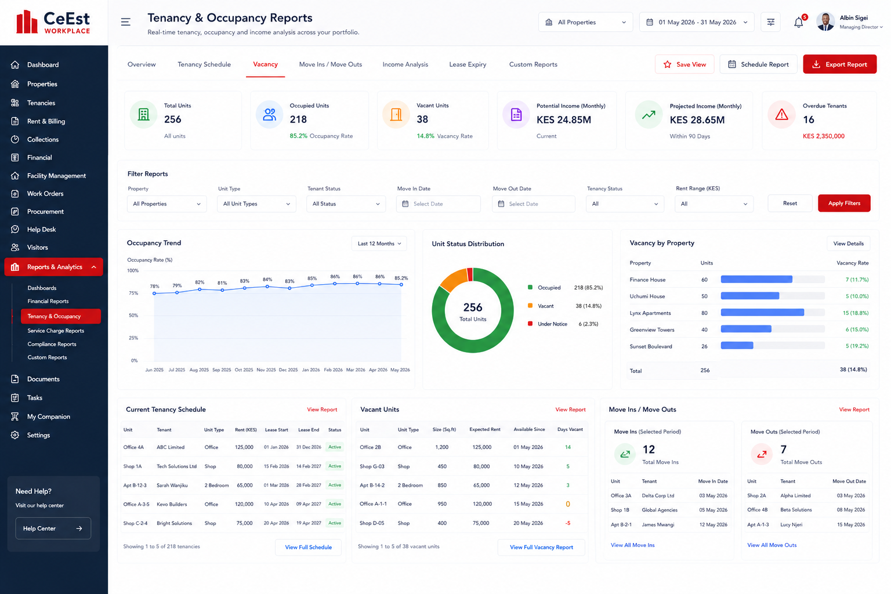
Figure 1: Approved Tenancy & Occupancy Reports UI

1. Reporting Architecture
- Reports must pull live information from Property, Unit, Tenant, Lease, Billing/Rent Collection and tenancy-history records.
- Use the tenancy/unit master as the source of truth; do not create a separate manual reporting database.
- All reports must support portfolio and individual-property views.
- Keep transaction date, lease dates, move-in date, move-out date and reporting date distinct.
- Support PDF and CSV/Excel export where applicable.
- Allow saved filtered views and scheduled reports.
- Apply role/property scope: managers see assigned properties; landlords see only their portfolio.
- Reports should support landlord presentations, management reviews and manager target setting.

Overview
Purpose | Portfolio management snapshot.
Report/Data to Pull | Total units; occupied/vacant units; occupancy/vacancy rate; active leases; leases expiring; overdue tenants; current potential income; projected income.
Backend Source | Property + Unit + Tenant + Lease + Billing.
Filters | Property and reporting period.
Output | Dashboard plus PDF/CSV.
Developer Rule | Calculations must be traceable to source records and retain an audit trail.

Tenancy Schedule
Purpose | Real-time tenancy register.
Report/Data to Pull | Floor; door/unit; tenant; area; use; lease start/end; rent; service charge; escalation rate; new rent/effective date; lease status; comments.
Backend Source | Unit + Tenant + Lease + financial terms.
Filters | Property, floor, unit type/use, tenant/lease status, date.
Output | Presentation-ready tenancy schedule.
Developer Rule | Calculations must be traceable to source records and retain an audit trail.

Vacancy
Purpose | Identify vacant units and income opportunity/loss.
Report/Data to Pull | Vacant unit; vacancy date; days vacant; type; area; expected rent; service charge; potential income; vacancy reason; marketing status.
Backend Source | Unit status history + tenancy/move-out + rent assumptions.
Filters | Property, type/use, vacancy period, rent range, reason.
Output | Vacancy ageing and potential income report.
Developer Rule | Calculations must be traceable to source records and retain an audit trail.

Move Ins / Move Outs
Purpose | Analyse tenant movements in a selected period.
Report/Data to Pull | Move-ins, move-outs, tenant, unit, property, dates, rent, reason for exit where captured.
Backend Source | Tenancy lifecycle/event history.
Filters | Separate move-in and move-out dates; property; unit type; tenant status.
Output | Movement report and net occupancy movement.
Developer Rule | Calculations must be traceable to source records and retain an audit trail.

Income Analysis
Purpose | Analyse current and projected tenancy income.
Report/Data to Pull | Current rent; service charge; other income; annualized income; escalations; projected rent/service charge; vacant-unit potential; income by property/use.
Backend Source | Lease financial terms + billing + escalation records + unit status.
Filters | Property, type/use, period, projection period, tenant status, rent range.
Output | Current vs projected income and opportunity report.
Developer Rule | Calculations must be traceable to source records and retain an audit trail.

Lease Expiry
Purpose | Identify leases requiring action.
Report/Data to Pull | Tenant; property; unit; lease start/end; days to expiry; rent; escalation; renewal status; action owner; notice status.
Backend Source | Lease master + renewal/action records.
Filters | 30/60/90/180-day windows; property; manager; status.
Output | Lease expiry schedule and action list.
Developer Rule | Calculations must be traceable to source records and retain an audit trail.

Custom Reports
Purpose | Combine approved tenancy/occupancy fields into user-defined reports.
Report/Data to Pull | Selectable property, unit, tenant, lease, rent, service charge, occupancy, movement and income fields.
Backend Source | Reporting metadata layer over approved source tables.
Filters | Field filters, dates, grouping, sorting.
Output | Saved custom report; PDF/CSV/Excel; scheduled delivery.
Developer Rule | Calculations must be traceable to source records and retain an audit trail.

2. Core Filters
- Property / Portfolio
- Reporting date or date range
- Unit type / use
- Tenant status
- Lease status
- Move-in date
- Move-out date
- Rent range
- Vacancy status/reason
- Responsible manager

3. Key Calculations
- Occupancy Rate = Occupied Units ÷ Total Available Units × 100.
- Vacancy Rate = Vacant Units ÷ Total Available Units × 100.
- Potential Income = Sum of applicable monthly rent for the selected units/status definition.
- Projected Income = Current income adjusted using effective-dated approved escalations and configured projection assumptions.
- Days Vacant = Reporting Date − Vacancy Start Date, using vacancy history.
- Lease Expiry Days = Lease Expiry Date − Reporting Date.
- Net Occupancy Movement = Move-ins − Move-outs for the selected period.

4. Management & Landlord Use
The reporting engine should support both presentation and performance management. Reports should provide evidence for landlord meetings and allow managers to set measurable operational targets.
- Occupancy targets
- Vacancy reduction targets
- Move-in targets
- Lease renewal targets
- Income growth targets
- Projected versus actual rental income
- Lease expiry action targets
- Property/manager performance comparisons

5. Backend Requirements
- Use effective-dated tenancy and lease records so historical reports remain accurate.
- Maintain unit status history, not only the current status.
- Maintain tenant movement events for move-in/move-out reports.
- Store escalation schedules separately with effective dates.
- Never overwrite historical rent terms after an escalation.
- Apply role and property scope to every report query.
- Log report user, date/time, filters and report definition.
- Support scheduled report generation and authorized delivery.
- Ensure monetary reports reconcile to the billing/collection ledger.

6. Acceptance Criteria
- Each tab produces a report from live system data.
- Filters refresh all relevant cards, charts and tables.
- Reports work at portfolio and property level.
- Historical movements, vacancies and lease terms remain reportable.
- Income projections use effective-dated escalations.
- Exports retain the applied filters and reporting period.
- Landlords cannot access properties outside their portfolio.
- Management can use the outputs for landlord presentations and manager target setting.

