CeEst ERP – Facility Procurement & Finance Redesign
Developer Brief | Build on the existing Ticketing system – do not redesign Ticketing

1. Important Starting Point
The existing Ticketing module is already well designed and should remain the system of record for request creation and ticket management. QR-code requests, portal requests, ticket assignment, communication, user interaction, progress tracking and ticket closure are already in place. The new development should therefore begin AFTER an approved requisition and introduce the missing procurement and finance functions.
EXISTING TICKETING: REQUEST → QR / PORTAL → TICKET → MANAGEMENT → COMMUNICATION → REQUISITION
NEW DEVELOPMENT: APPROVED REQUISITION → PROCUREMENT → LPO → JOB CARD → VERIFIED COMPLETION → TICKET CLOSE

2. Scope of the New Development
- Facility Module: Procurement after a requisition has been approved.
- Facility Module: Bidders/suppliers, quotation capture, evaluation and award.
- Facility Module: LPO/PO creation and issuance.
- Facility Module: Job Card creation, execution, contractor/caretaker sign-off and verification.
- Integration back to the existing Ticket: verified Job Card enables ticket closure.
- Finance Module: Invoice processing for procurement/repair work.
- Finance Module: Invoice processing for existing contracted service providers.
- Finance Module: Independent payment initiation for statutory and other non-repair/non-service payments.
- Finance Module: Payment approval, Finance processing and expense posting.

3. Facility Module – Procurement After Requisition
The approved requisition becomes the starting point. Users should not recreate the request. All relevant requisition information must flow into procurement.
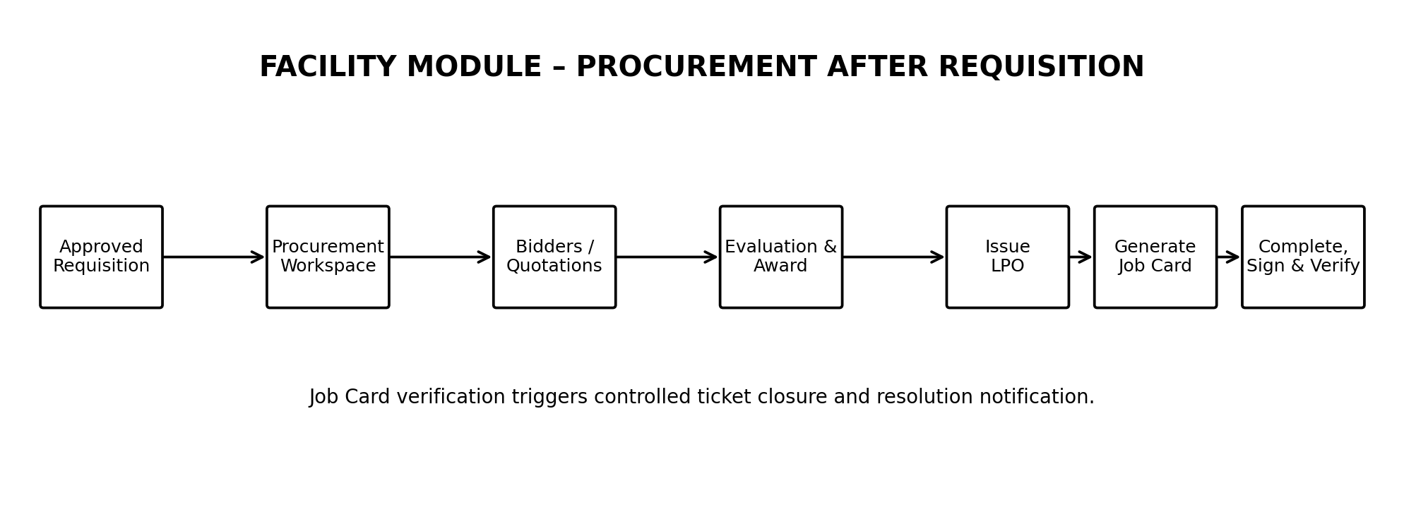
Figure 1 – Proposed Facility Procurement → LPO → Job Card flow.

4. Procurement Functions to Add
Function | User | System Action | Output
Procurement queue | Procurement user | Open approved requisitions | Procurement record
Bidder management | Procurement user | Create/select bidder profiles | Eligible bidder list
Quotation | Procurement/bidder | Record quotations and upload hard copy | Quotation records
Evaluation | Authorised procurement user | Compare and recommend | Evaluation/award
LPO | Authorised user | Generate and issue LPO | Unique LPO
Job Card | FM/Caretaker | Generate from LPO | Unique Job Card
Execution | Contractor/Caretaker | Update, evidence and sign | Completed/verified Job Card
Ticket closure | Authorised user/system | Close only after verification | Closed ticket + notification

5. Job Card → Ticket Closure Integration
The Job Card is the bridge between procurement and the existing Ticketing module. When the work is completed, the contractor and caretaker sign/confirm the Job Card. After required verification, the system should make the existing ticket eligible for closure. The ticket then follows its existing closure and communication process.
LPO ISSUED → JOB CARD CREATED → WORK DONE → CONTRACTOR SIGN-OFF → CARETAKER VERIFY/SIGN → TICKET ELIGIBLE FOR CLOSURE → EXISTING TICKET CLOSURE & NOTIFICATION

6. Finance Module – Separate Invoice Processing
Finance should be a separate navigation area. It receives invoices and payment requests from several sources. It must not be designed as an extension of Ticketing.
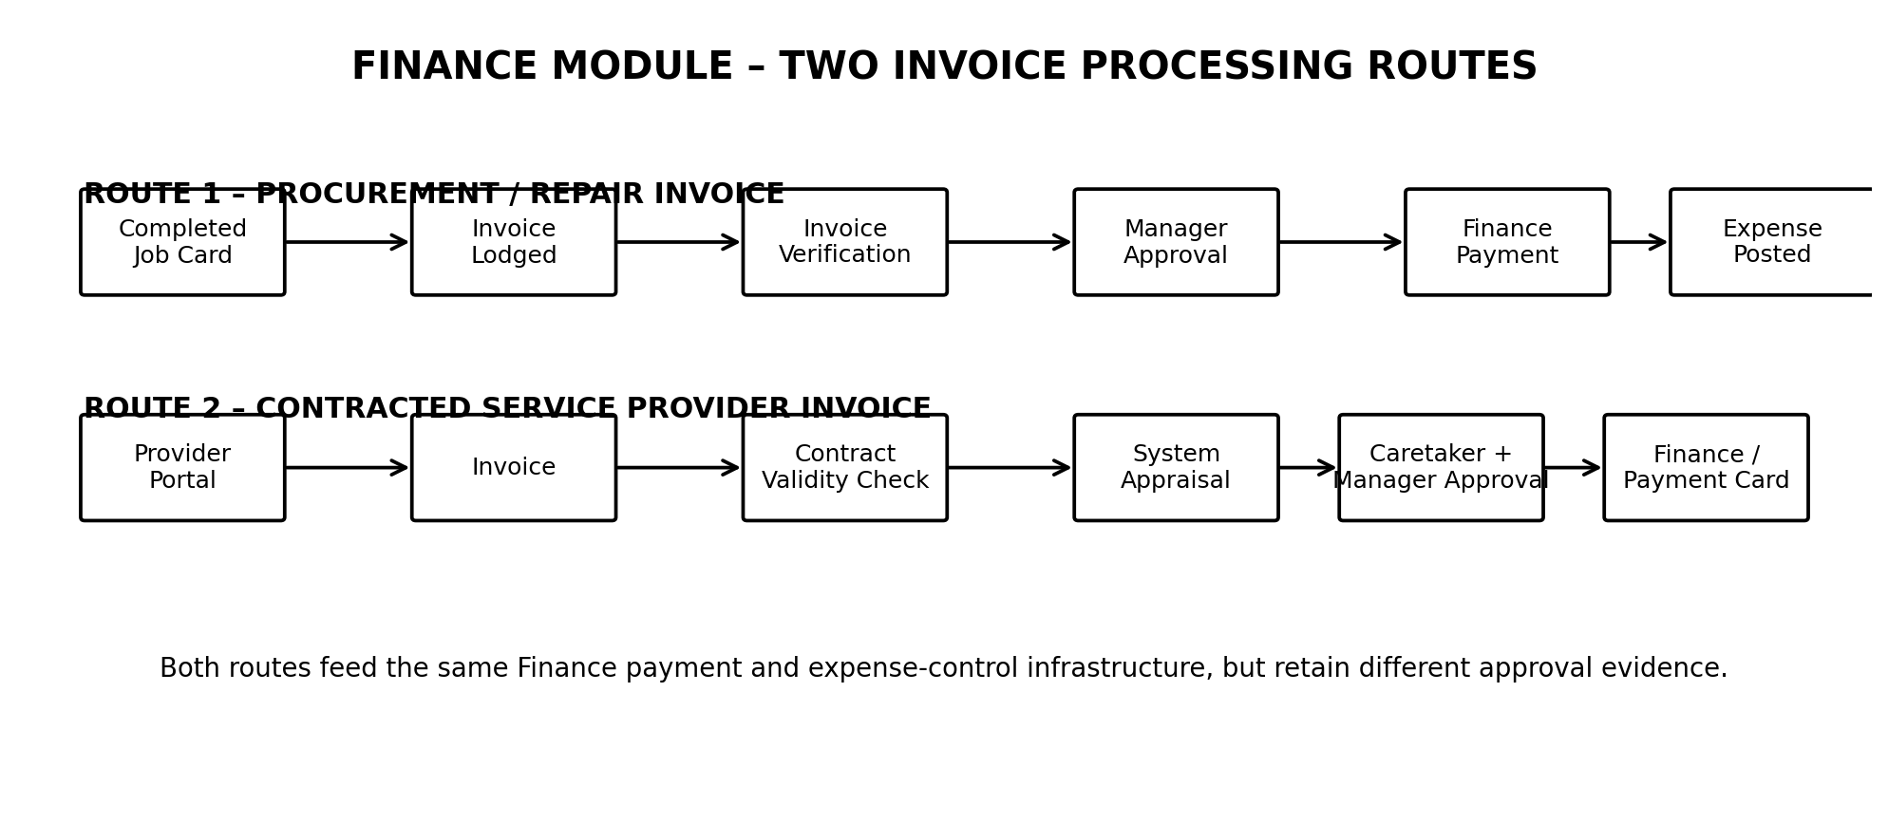
Figure 2 – Proposed Finance invoice-processing routes.

7. Finance Route 1 – Invoice From Procurement / Repair
This is the invoice generated after work procured through the Facility workflow. The invoice is linked to the completed Job Card and therefore to the LPO, Requisition and original Ticket.
- Supplier/contractor lodges invoice in Finance.
- System links/validates Invoice → Job Card → LPO → Requisition → Ticket.
- Invoice is checked against the authorised LPO and verified work.
- Manager/authorised approver approves payment.
- Approved invoice moves to Finance for payment processing.
- Payment is recorded and expense is posted against the appropriate property/service/budget/cost centre.

8. Finance Route 2 – Existing Contracted Service Provider
This is the simplified recurring-service route already defined. It does not require a new Ticket, Requisition, quotation or LPO for each invoice because the supplier operates under an existing running contract.
- Service provider logs into portal and raises invoice against an active mapped contract.
- System checks contract validity, service/property mapping and invoiced period.
- System automatically generates the Performance Appraisal.
- Caretaker reviews and signs the appraisal.
- Manager reviews invoice + contract check + appraisal and approves payment.
- System forwards the approved package to Finance.
- System generates a downloadable Payment Card containing the contract validity check, approved invoice and performance appraisal.
- Finance processes payment and posts the expense.

9. Finance – Independent Payment Initiation
Finance also needs a separate function for payments that do not arise from repairs, service requests or supplier procurement. Examples include statutory payments, taxes, licences, utilities, fees, refunds and other approved obligations.
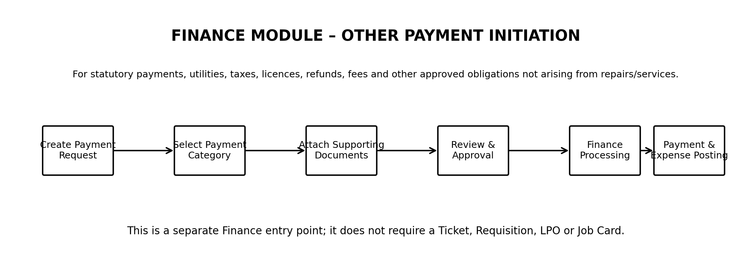
Figure 3 – Proposed independent Finance Payment Initiation.
- Create Payment Request.
- Select payment category/type.
- Identify property/entity, payee and amount.
- Attach supporting documents.
- Enter due date, payment reference or statutory details where applicable.
- Submit for configured approval.
- Approved request moves to Finance processing.
- Payment is recorded and posted to the relevant expense/account.

10. Recommended Finance Navigation
- Finance Dashboard
- Invoice Processing
- Contract Service Provider Invoices
- Other Payment Requests
- Payment Approval
- Payments / Payment Cards
- Expense Records
- Finance Reports

11. Key Database Mapping
- Existing: TICKET → REQUISITION (retain current Ticketing structure).
- New Route 1: REQUISITION → PROCUREMENT → QUOTATION(S) → LPO → JOB CARD → INVOICE → PAYMENT → EXPENSE.
- New Route 2: PROVIDER → CONTRACT → INVOICE → CONTRACT CHECK → PERFORMANCE APPRAISAL → CARETAKER APPROVAL → MANAGER APPROVAL → PAYMENT CARD → PAYMENT → EXPENSE.
- Other Finance: PAYMENT REQUEST → SUPPORTING DOCUMENTS → APPROVAL → PAYMENT → EXPENSE.

12. System Training – What Users Need to Learn
User | System Steps | Main Training Objective
Procurement | Open approved requisition → select bidders → record quotations → evaluate → award → issue LPO | Control procurement from approved requirement to supplier appointment
Caretaker/FM | Generate/view Job Card → monitor work → contractor sign-off → verify/sign → trigger ticket closure | Control physical work and verify completion
Contractor | Receive Job Card → update work → submit evidence → sign Job Card | Provide execution evidence
Service Provider | Open active contract → raise invoice → track appraisal/approval | Submit recurring contract invoice
Manager | Approve requisition/award where applicable → approve invoice/payment | Exercise management approval controls
Finance | Receive approved invoice/payment request → validate package → process payment → post expense | Complete financial control and accounting
System Administrator | Maintain users, roles, bidder/provider profiles, workflows and approval rules | Maintain system governance

13. Developer Acceptance Criteria
- Do not redesign or duplicate the existing QR/Ticketing functionality.
- Approved requisitions must feed directly into the new Procurement workspace.
- Every procurement record must retain the originating Requisition and, through it, the original Ticket.
- LPO must be generated from the awarded procurement record.
- Job Card must be generated from the LPO and retain all upstream references.
- Ticket closure must be controlled by verified Job Card completion, while using the existing Ticketing closure/communication process.
- Finance must have two invoice routes: procurement/repair invoices and contracted service provider invoices.
- Contracted service provider invoices must automatically generate the appraisal and follow caretaker → manager → Finance approval.
- Finance must also support independent Payment Requests for statutory and other non-repair/non-service obligations.
- All payment routes must ultimately create/retain an auditable payment and expense record.
- Users must only see and action functions permitted by their roles.
- Dashboards and reports must pull from live transactional records and allow drill-down.

14. Final Architecture Principle
KEEP TICKETING AS THE EXISTING FRONT-END REQUEST ENGINE → BUILD PROCUREMENT AFTER REQUISITION → BUILD FINANCE AS THE CENTRAL INVOICE & PAYMENT CONTROL
The development should add the missing commercial and financial layers without disturbing the ticketing functionality that is already working. The result is a clear separation of responsibilities: Ticketing manages requests and interactions; Facility Procurement manages sourcing and work authorisation; Finance manages invoices, payment approvals, payments and expenses.

