Monitoring ERP – Approved UI Mockups
This document contains the approved UI mockups developed during the design phase. These illustrations form the reference design for implementation by the software development team.

UI Navigation Flow
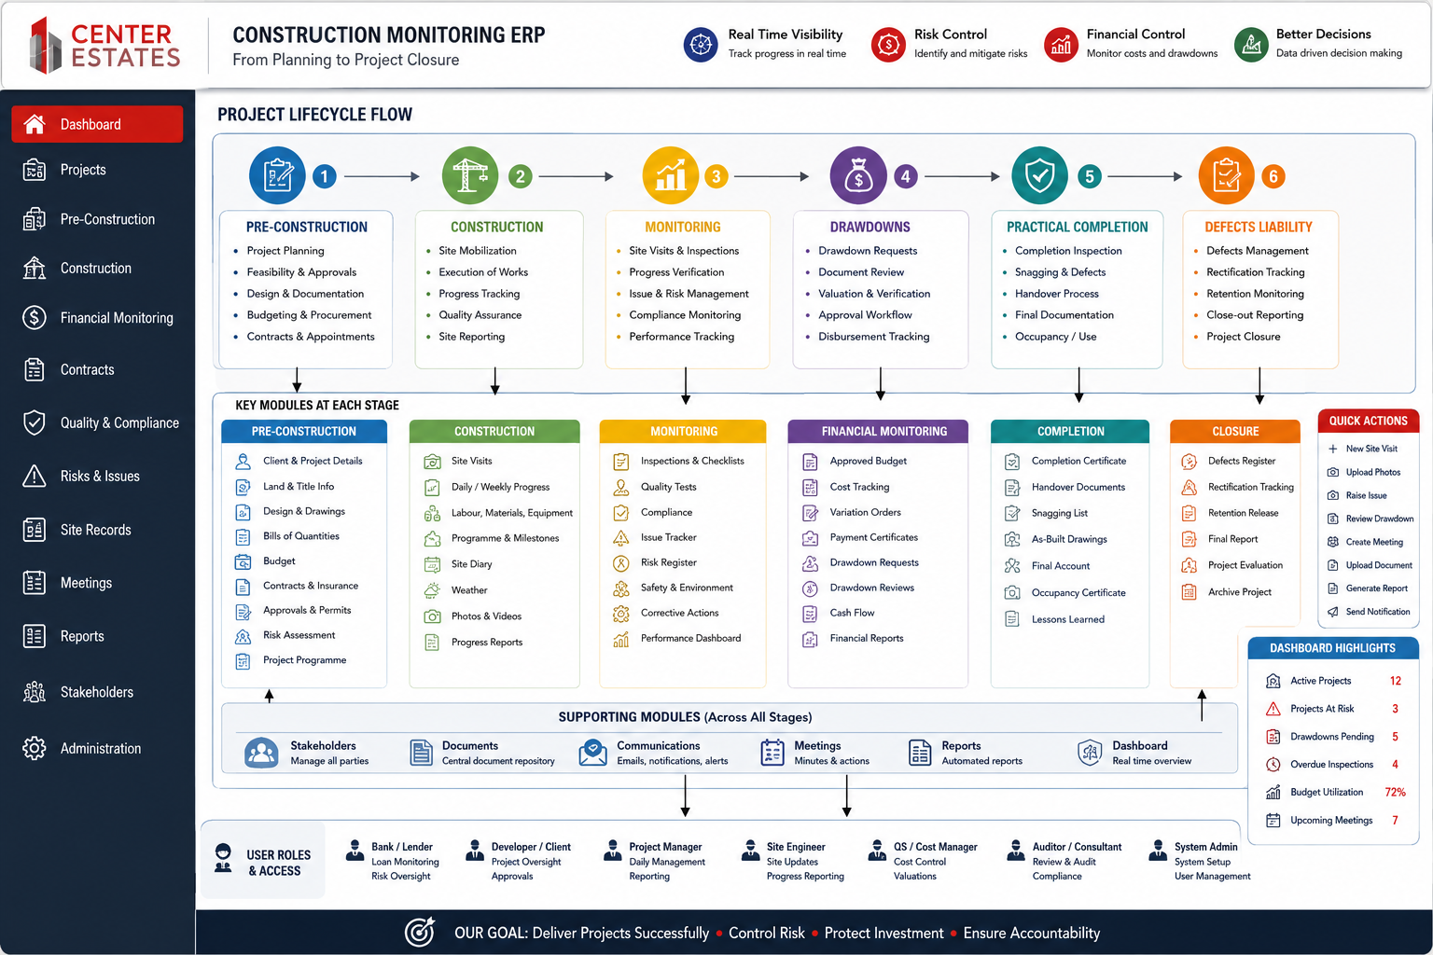
Developer Note: Implement the UI Navigation Flow module consistent with this approved layout, maintaining Center Estates branding (red, grey and white), responsive design, and project-centric navigation.

Dashboard
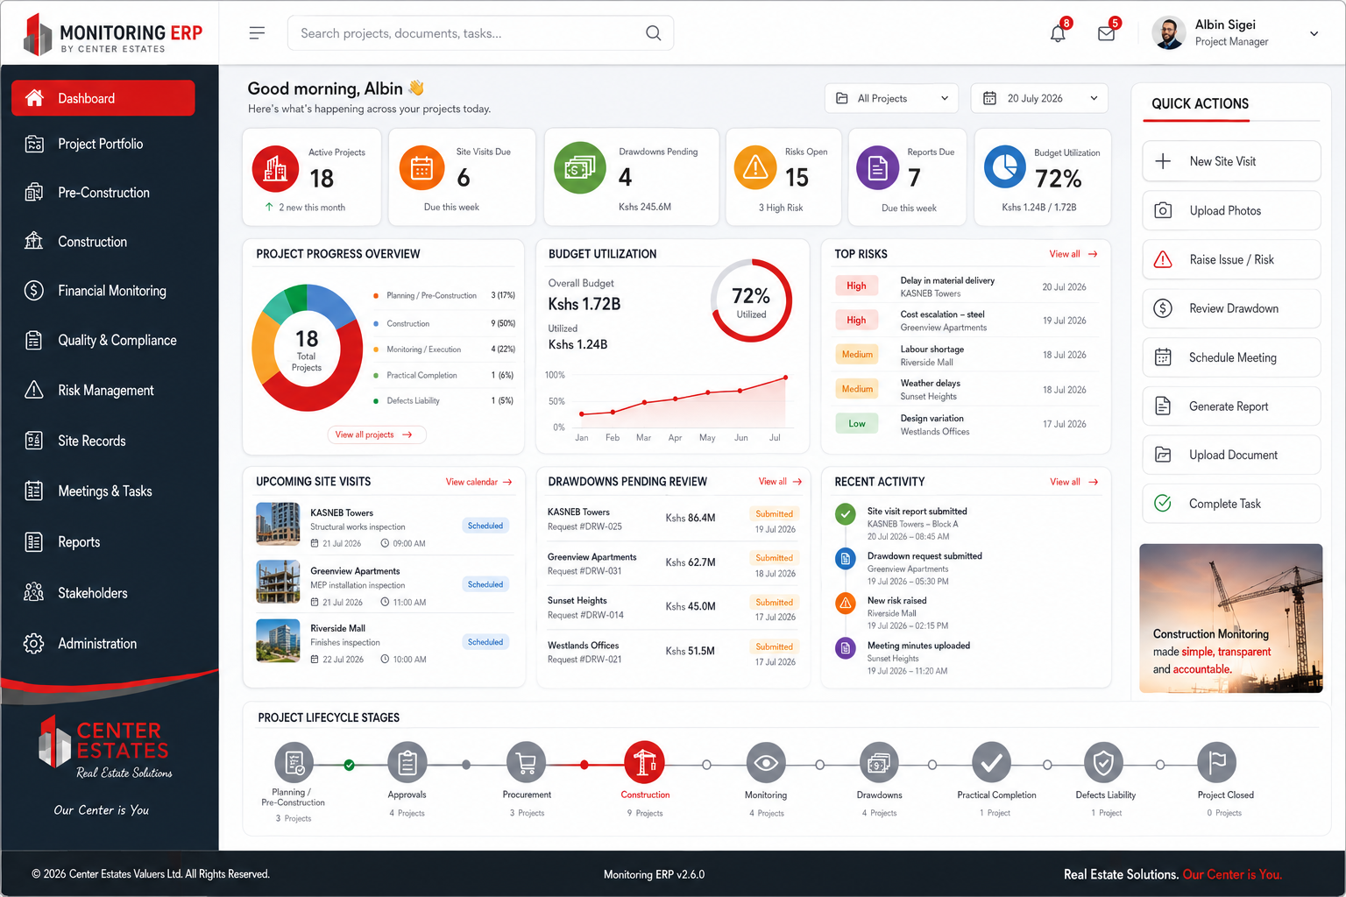
Developer Note: Implement the Dashboard module consistent with this approved layout, maintaining Center Estates branding (red, grey and white), responsive design, and project-centric navigation.

Project Portfolio
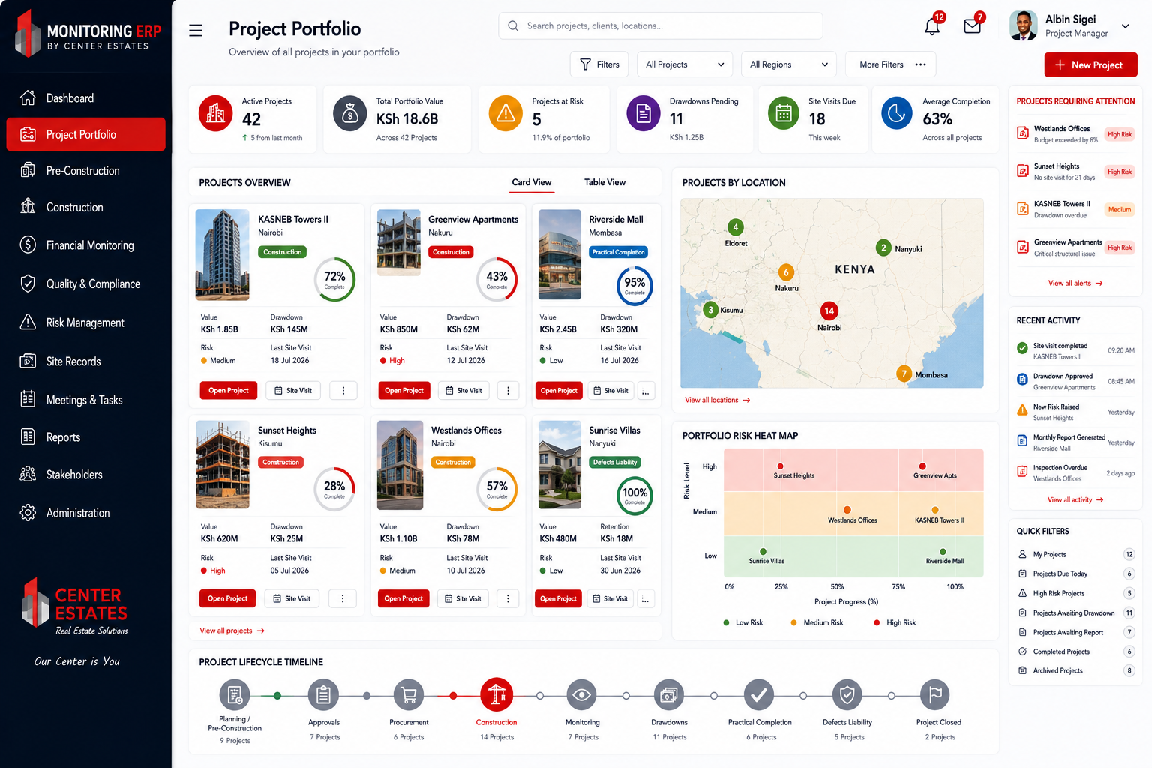
Developer Note: Implement the Project Portfolio module consistent with this approved layout, maintaining Center Estates branding (red, grey and white), responsive design, and project-centric navigation.

Active Projects
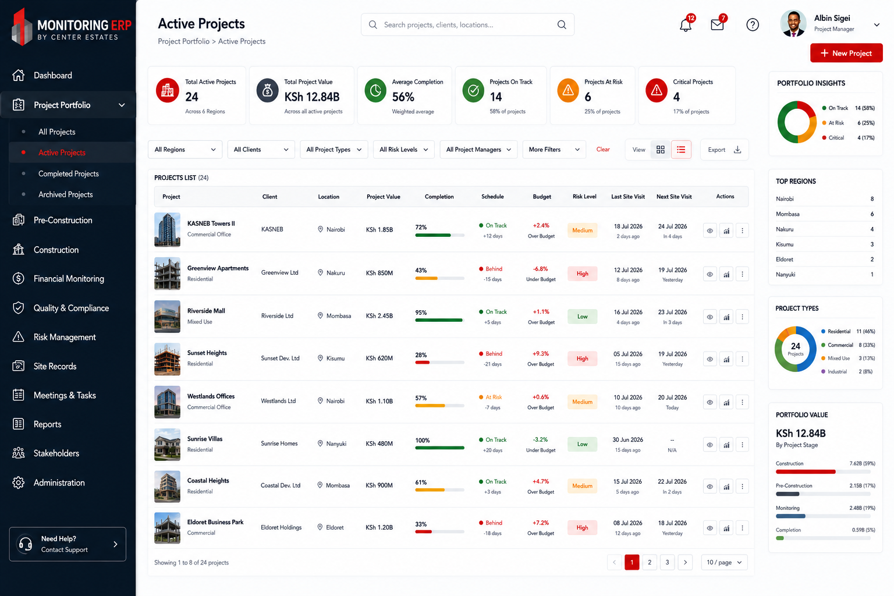
Developer Note: Implement the Active Projects module consistent with this approved layout, maintaining Center Estates branding (red, grey and white), responsive design, and project-centric navigation.

Project Workspace (KASNEB Towers II)
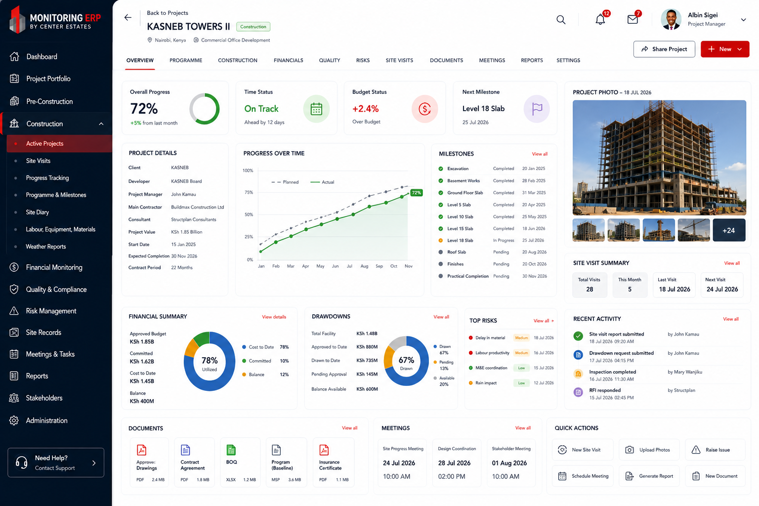
Developer Note: Implement the Project Workspace (KASNEB Towers II) module consistent with this approved layout, maintaining Center Estates branding (red, grey and white), responsive design, and project-centric navigation.

Programme
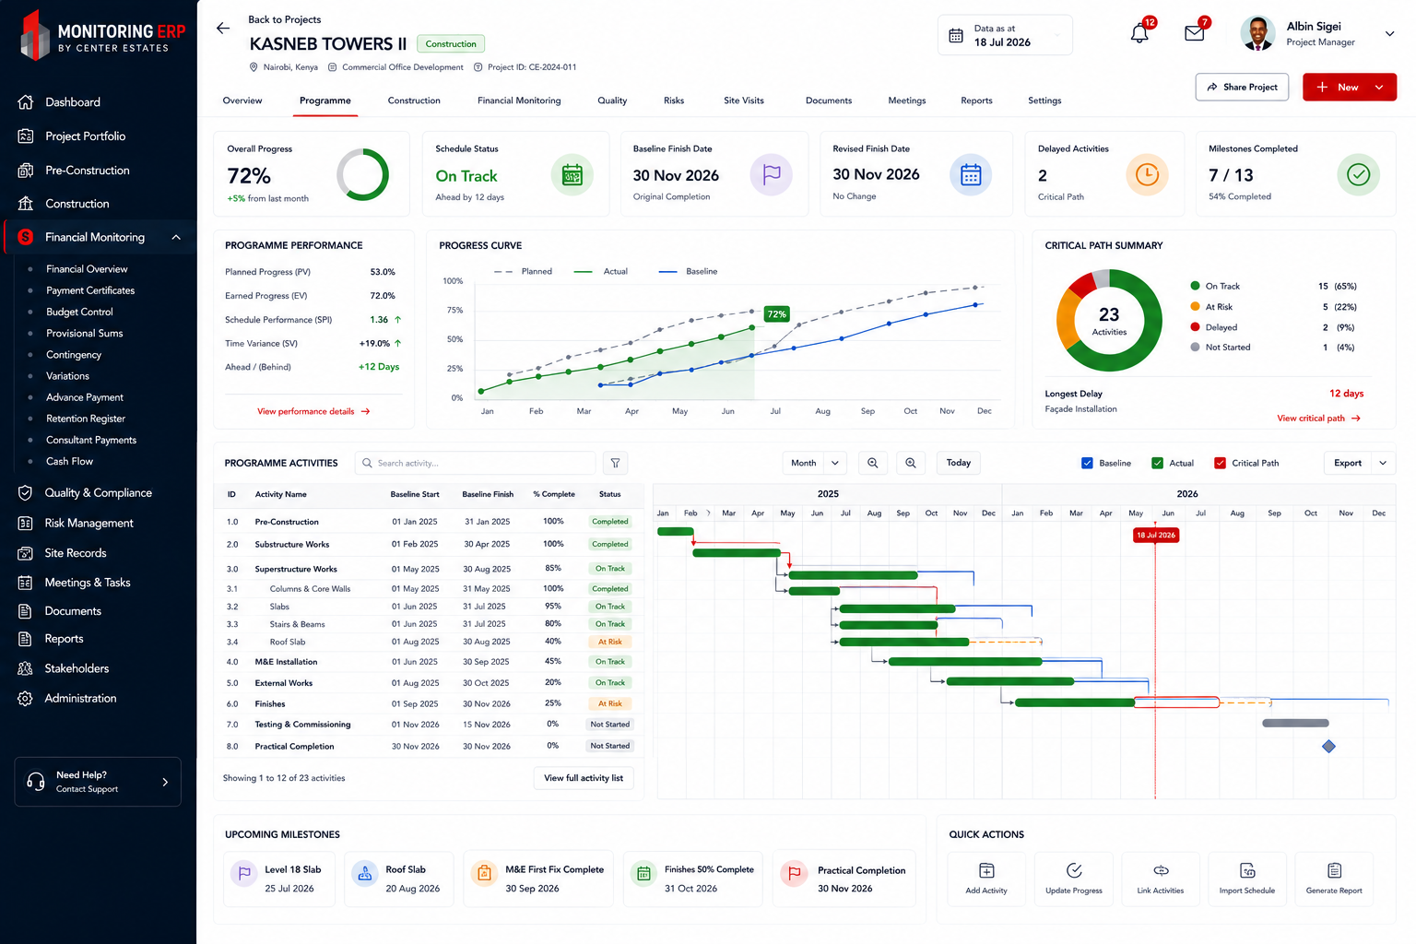
Developer Note: Implement the Programme module consistent with this approved layout, maintaining Center Estates branding (red, grey and white), responsive design, and project-centric navigation.

Construction
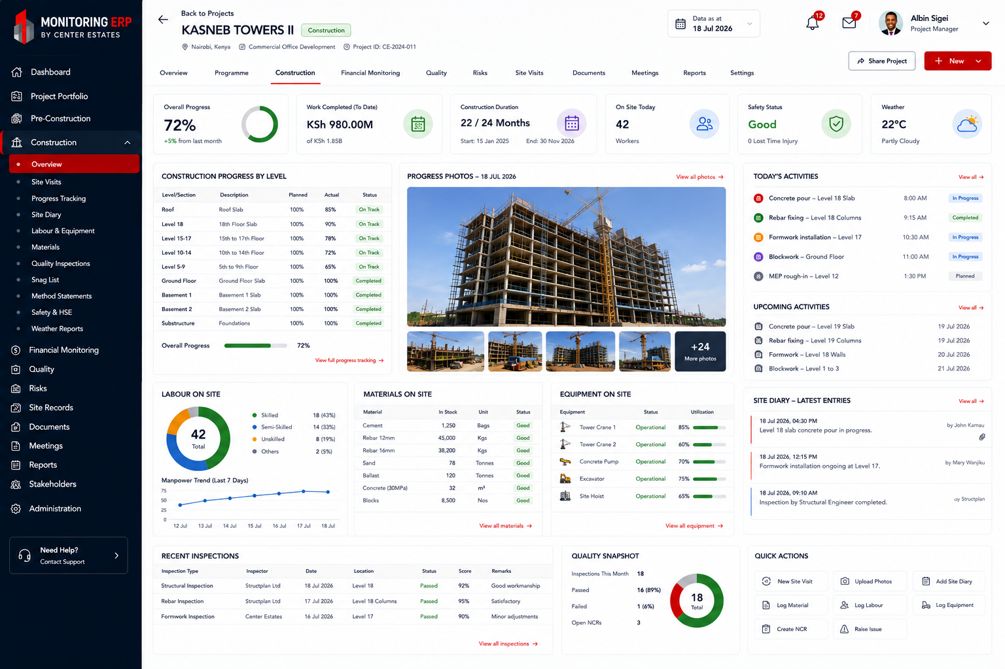
Developer Note: Implement the Construction module consistent with this approved layout, maintaining Center Estates branding (red, grey and white), responsive design, and project-centric navigation.

Financial Monitoring
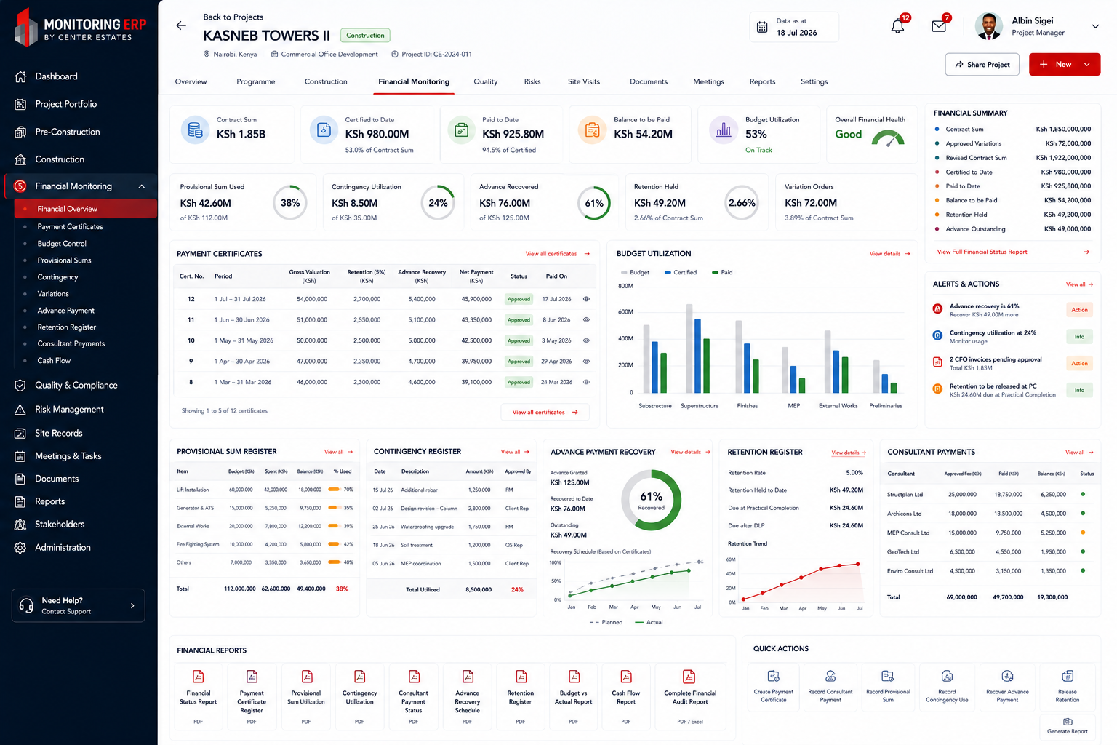
Developer Note: Implement the Financial Monitoring module consistent with this approved layout, maintaining Center Estates branding (red, grey and white), responsive design, and project-centric navigation.

Risks
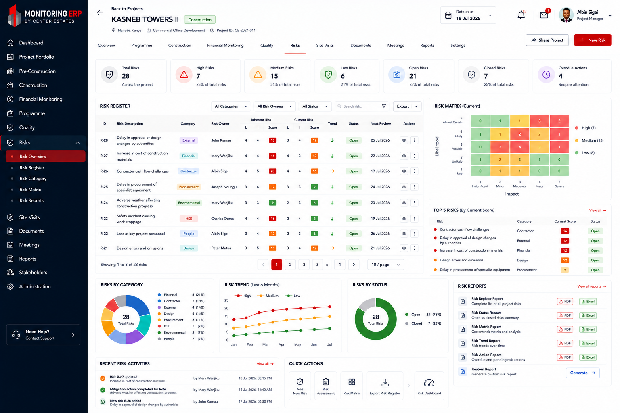
Developer Note: Implement the Risks module consistent with this approved layout, maintaining Center Estates branding (red, grey and white), responsive design, and project-centric navigation.

Site Visits
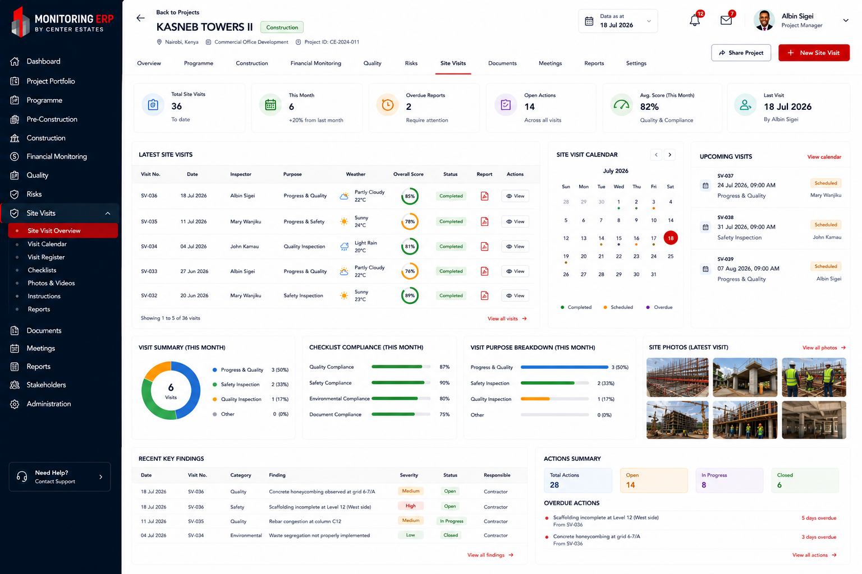
Developer Note: Implement the Site Visits module consistent with this approved layout, maintaining Center Estates branding (red, grey and white), responsive design, and project-centric navigation.

Documents
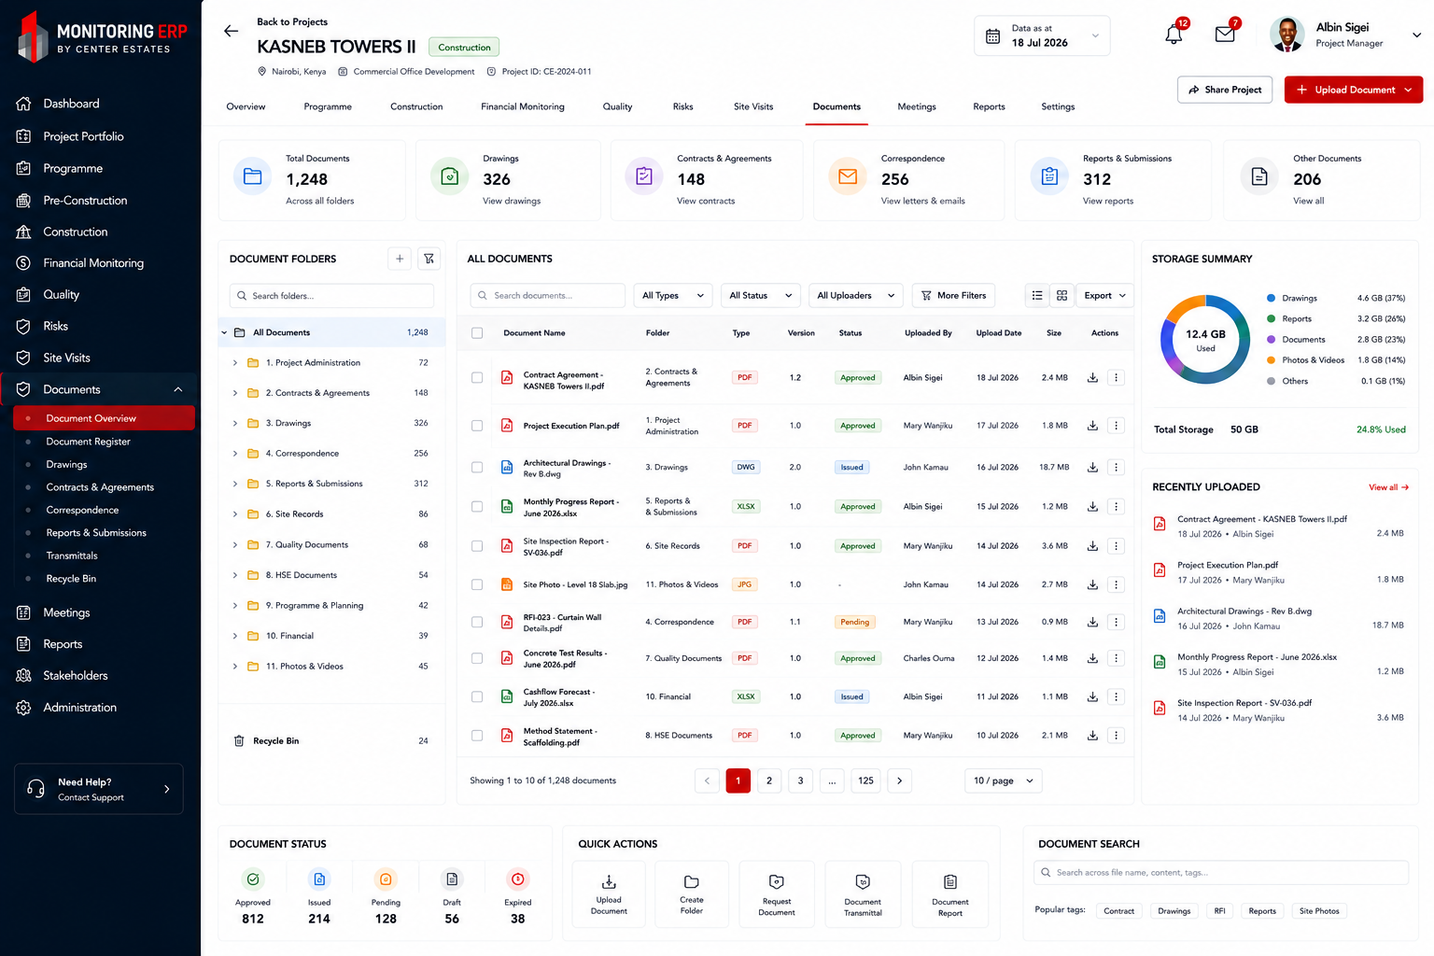
Developer Note: Implement the Documents module consistent with this approved layout, maintaining Center Estates branding (red, grey and white), responsive design, and project-centric navigation.

Meetings
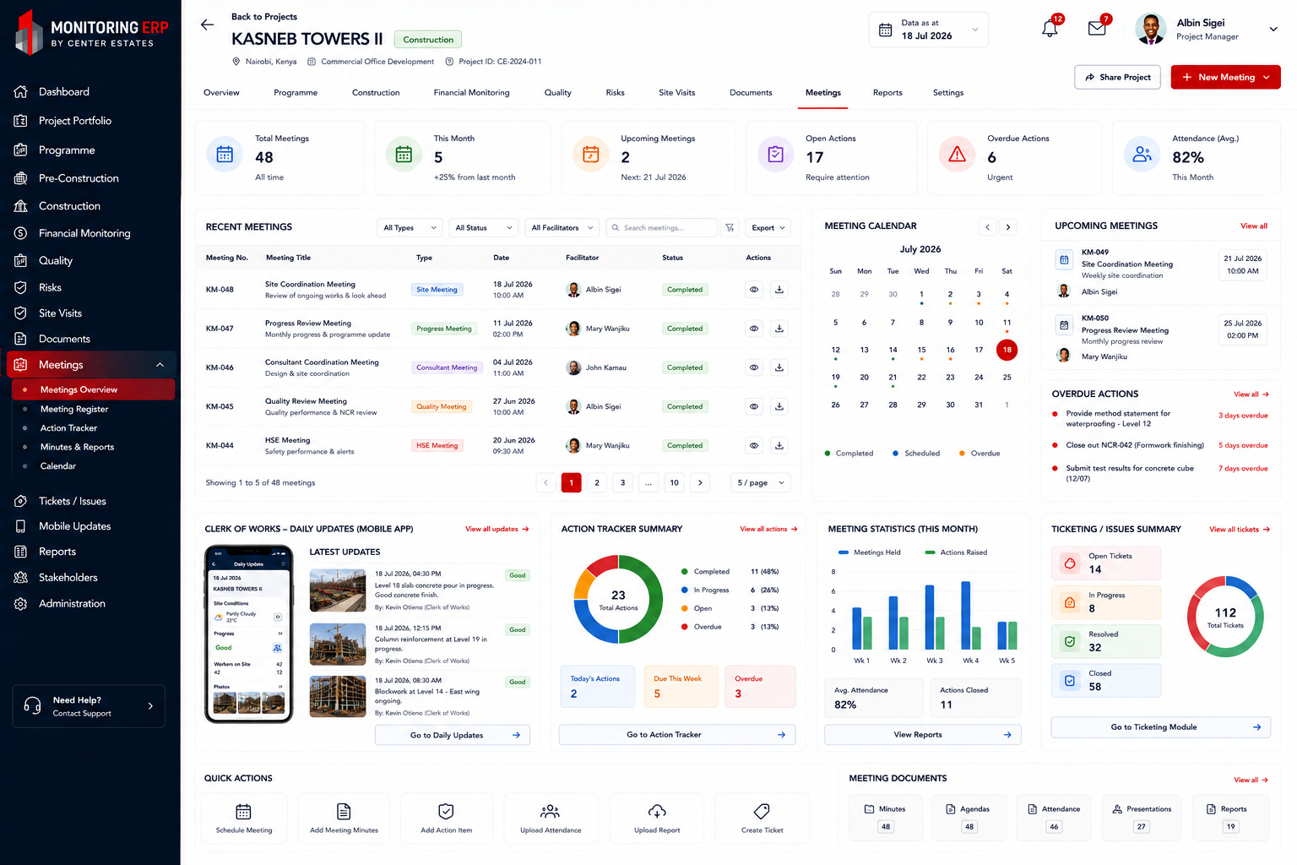
Developer Note: Implement the Meetings module consistent with this approved layout, maintaining Center Estates branding (red, grey and white), responsive design, and project-centric navigation.

Reports
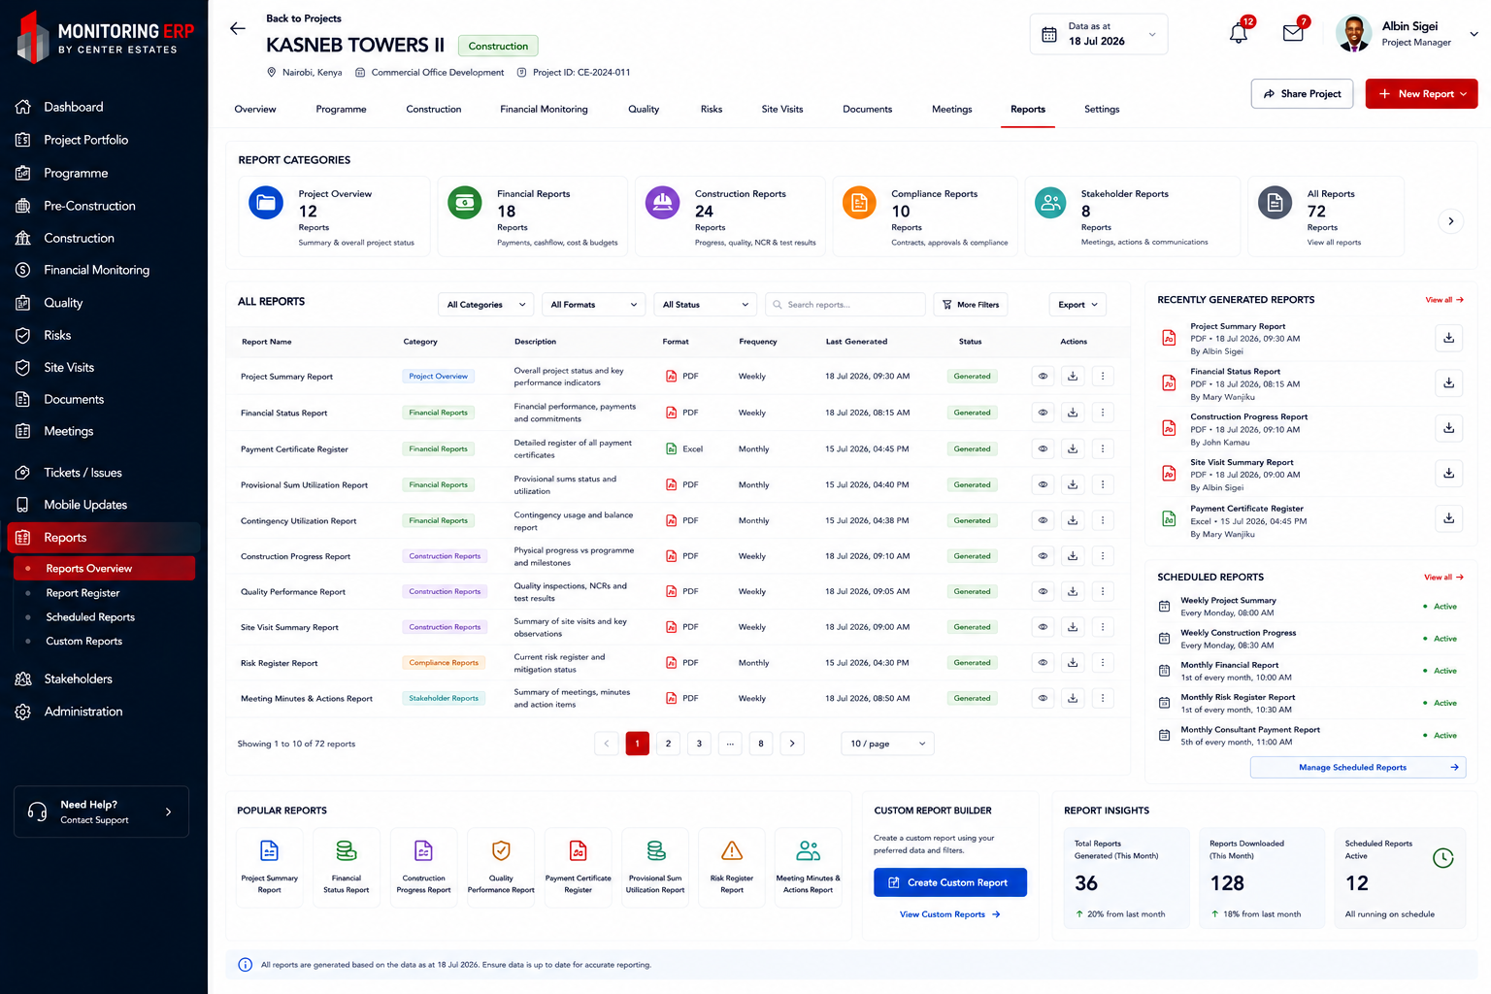
Developer Note: Implement the Reports module consistent with this approved layout, maintaining Center Estates branding (red, grey and white), responsive design, and project-centric navigation.

Stakeholders
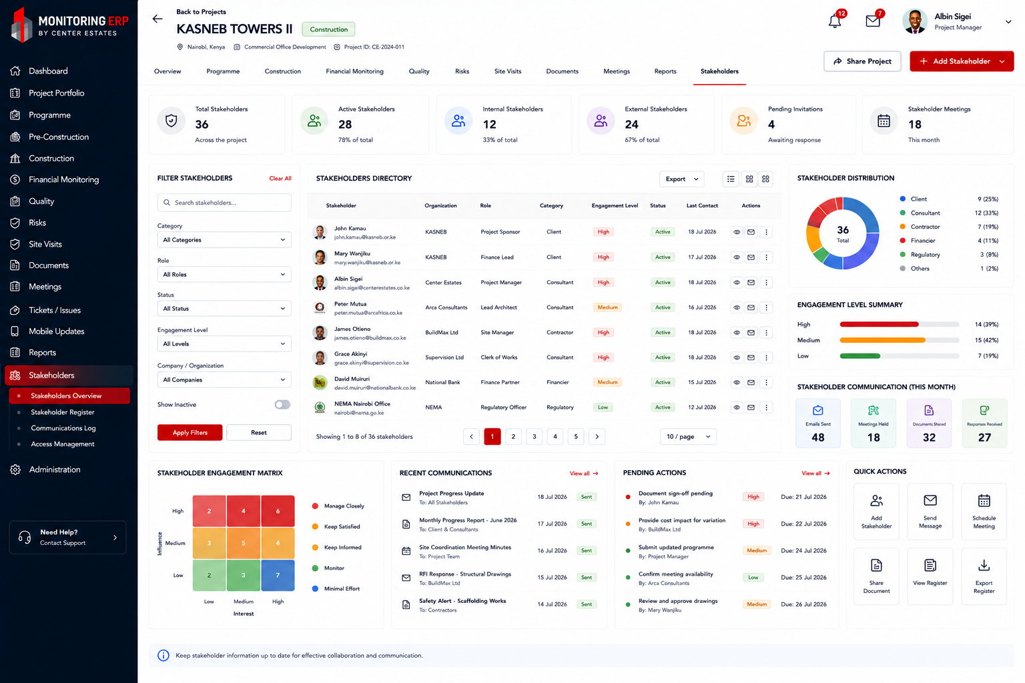
Developer Note: Implement the Stakeholders module consistent with this approved layout, maintaining Center Estates branding (red, grey and white), responsive design, and project-centric navigation.

Administration
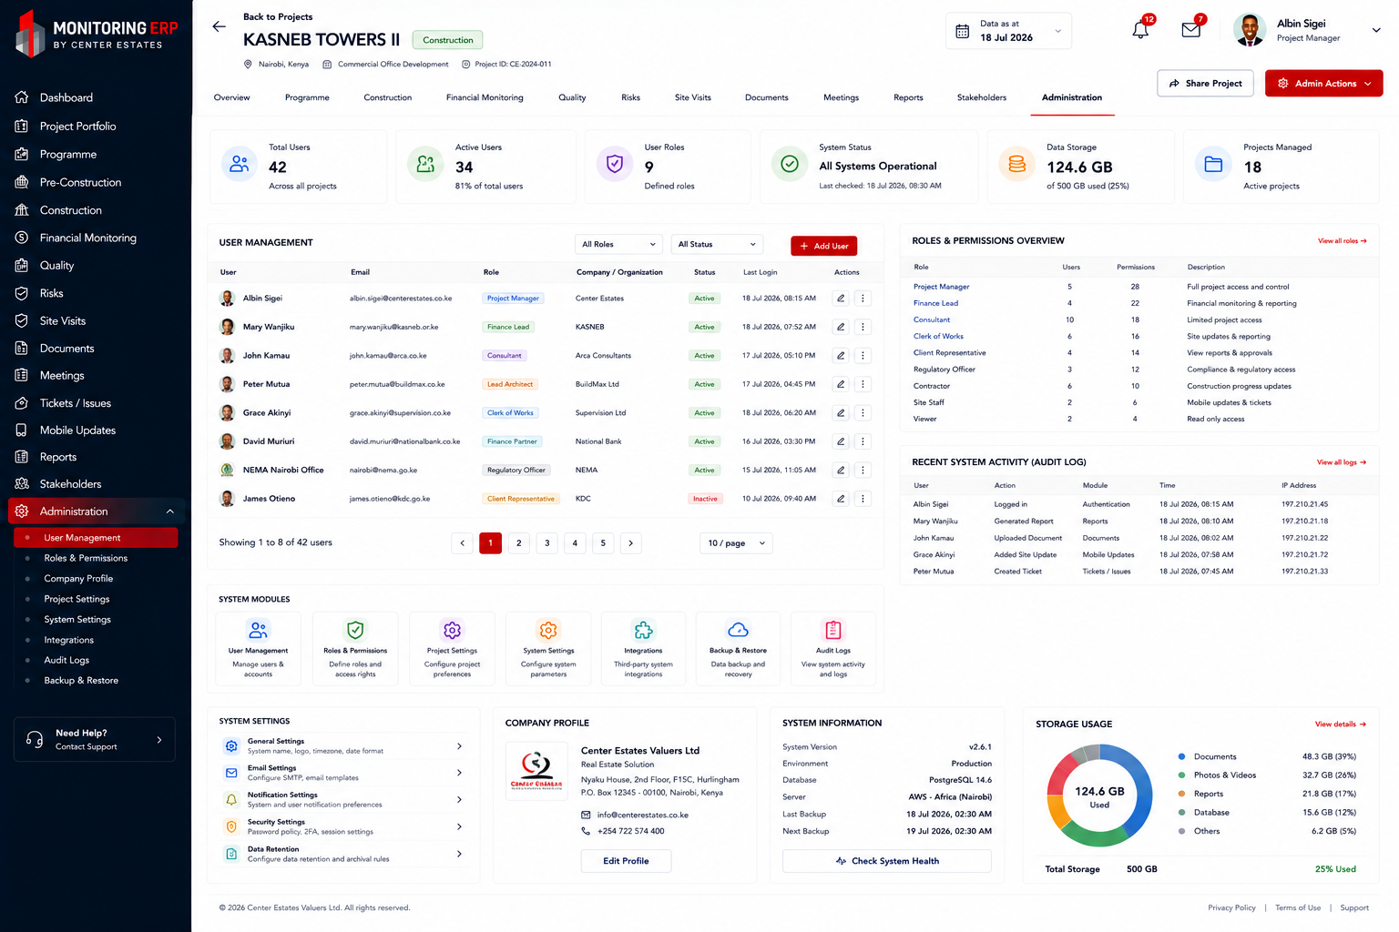
Developer Note: Implement the Administration module consistent with this approved layout, maintaining Center Estates branding (red, grey and white), responsive design, and project-centric navigation.

