November 20, 2017

Mr. Donald S. Clark

Secretary

Federal Trade Commission

600 Pennsylvania Avenue NW.,

Suite CC–5610 (Annex D),

Washington, DC 20580

Public Comment Regarding Proposed Settlement In the Matter of Victory Media, Inc.; File No. 1623210

Dear Mr. Clark:

Please accept this public comment from national organizations supporting servicemembers, veterans, military families, and survivors regarding the Federal Trade Commission’s (FTC) proposed settlement with Victory Media, Inc., also doing business as G.I. Jobs and Military Friendly, and operating the magazines *GI Jobs* and *Military Spouse* and the websites gijobs.com, militaryfriendly.com, and militaryspouse.com, and the “Military Friendly Schools” list and search engine.

The Federal Trade Commission (FTC) found Victory Media violated Section 5 of the Federal Trade Commission Act by:

1. Operating an online college search tool, School Matchmaker, at gijobs.com to that purported to be “military friendly,” when, in fact, the tool searches only schools that pay to be included; and
2. Misrepresenting, in articles, targeted emails, and social media posts, that its endorsements were independent and not paid advertising, and failed to adequately disclose that it recommended schools that paid specifically to be promoted therein. These misrepresentations and undisclosed paid recommendations constitute deceptive acts or practices.

The FTC’s proposed settlement calls for Victory Media to cease and desist from misrepresentations, to clearly and conspicuously disclose its paid commercial content, to report to the FTC, and to maintain records and respond to any further FTC inquiries.

We request that FTC include in its settlement agreement the transfer of the trademark for “Military Friendly Schools” to the US Department of Defense (or Veterans Affairs, depending on the wishes of the federal government), and that visitors to the websites MilitaryFriendly.com/Schools and GIJobs.com/schools-for-veterans should be redirected to the US Department of Defense (or Veterans Affairs, depending on the wishes of the federal government). Only the U.S. military (or the federal department that administers the GI Bill) should determine what constitutes a “Military Friendly School.” Based on its conduct, Victory Media is not the appropriate entity to possess that right.

In 2012, the federal government and 20 state Attorneys General sued a similar company for similar behavior. In that settlement, the company, Quinstreet, operated a deceptive website, GIBill.Com, which misled and deceived veterans by pushing them to predatory for-profit colleges that paid for the promotion. As part the legal settlement, the website GIBill.com now redirects visitors to the Department of Veterans Affairs with this message:

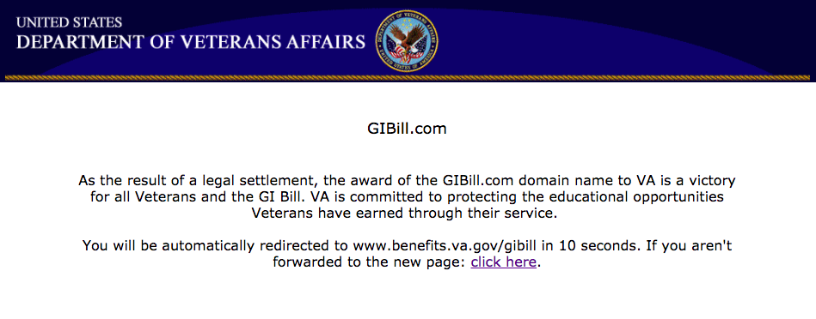

We urge the Commission to similarly protect military-connected students by having visitors to Victory Media’s deceptive school search engines redirected to the Defense Department’s college search tool (TA DECIDE) or the Department of Veterans Affairs’ college search tool (GI Bill Comparison Tool).

In addition, given the large profit that Victory Media made by pushing veterans to attend subpar predatory colleges that paid for the surreptitious promotion, we urge you to strengthen the settlement by obtaining compensation from Victory Media for veterans who were harmed by Victory Media’s deceptions or, if FTC deems that too difficult to administer, funds for the FTC to conduct further investigations of deceptive websites targeting servicemembers, veterans, and their families.

As the Acting Chair of the FTC said about this proposed settlement, “Servicemembers and their families put themselves on the line every day to protect our nation. We owe it to them to make sure that when they look to further their education, they get straight talk instead of advertising in disguise.” Only a stronger settlement with Victory Media can meet that obligation to our servicemembers, veterans, their families and survivors.

Thank you for your work.

Sincerely,

Kevin Cochie

Army Aviation Association of America

Kristofer Goldsmith

President

High Ground Veterans Advocacy

Luke E. Opyd

President

Ivy League Veterans Council

Lyman M. Smith

CAPT, CHC, USN, Retired

Executive Director

Military Chaplains Association

Mary M. Keller, Ed.D.

President & Chief Executive Officer

Military Child Education Coalition

Juliana Mercer

Managing Director

MVPVets

Lydia C. Watts, Esq.

CEO

Service Women’s Action Network (SWAN)

Bonnie Carroll

President and Founder

Tragedy Assistance Program for Survivors

Randy Reid, USCG (Ret.)

Executive Director

U.S. Coast Guard Chief Petty Officers Association & Enlisted Association

Carrie Wofford

President

Veterans Education Success

Anthony Hardie

Director

Veterans for Common Sense

Matthew Boulay

Executive Director

Veterans Student Loan Relief Fund

John Rowan

President

Vietnam Veterans of America