

Mental Wellbeing App Connecting Student Experiences

TU Dublin Blanchardstown Year 3 Group Project



October 18, 2024

TU DUBLIn blanchardstown

Sam O’Connor, Luke Meates, Burair Moosavi

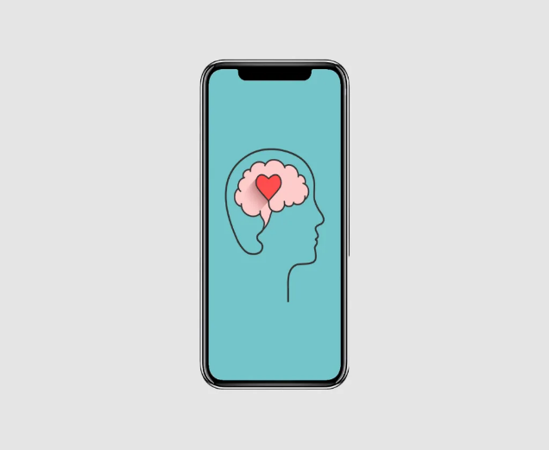

Contents

Project Overview 2

Background 2

Main research questions: 2

Justification/Benefits 3

Feasibility 3

Risk and Challenges 4

Proposed Methodologies 5

Expected results 7

References 7

Project Overview

Mental wellbeing mobile application that can encourage and aid mental wellbeing amongst anonymous users whereby allowing them to safely share their experiences.

**Project Type:**

**Project Supervisor:** Dr. Gerome Donnelly, TU Dublin Blanchardstown

**Project Team:** Sam O’Connor (B00148322), Luke Meates (B00135198), Burair Mossavi (B00138007)

**Project duration:** 27/09/2024 to 27/4/2024

Background

The aim of this project is to design and implement a working prototype that helps users manage and improve their mental health through app features related to monitoring and maintaining each user’s mental well-being’*.* We want to develop an application that is beneficial to all ages and people although our main target audience will be college students. According to the Central Statistics Office, since 1991-2022, the number of people in Ireland with a third level qualification has increased nearly fourfold from 14% to 48%. (CSO, 2022) . The number of international students has also dramatically increased over the past two decades, according to [erudera.com](https://erudera.com/statistics/ireland/ireland-international-student-statistics/) the number of international students studying in Ireland between 2009 - 2022 has increased over triple the amount from 9,563 – 30,437. With growing awareness of mental well-being, our group collectively agree that in 2024 this project is fitting and meaningful. While there are now quite a few mental well-being apps on the market, they all focus a lot of their resources into one standout core feature. We aim to pick the most beneficial features on the market and implement them into one true mental well-being application with a unique social support feature creating a safe space for users to connect with each other and share their experiences. This proposal outlines the project's reasoning ,proposed logic and methodologies.

Main research questions:

* What design practices can make a mental well-being app easy to use, supportive and safe for people with different mental health conditions?
* What features of mental wellbeing applications can be improved to give users an even more beneficial experience.
* What legal rules must developers follow when handling user data in a mental well-being app?

Justification/Benefits

College can be a great experience and open up new opportunities for students, not just from a professional aspect but socially also. Our group is now in year 3 and we feel we have some sort of first-hand experience of the social elements within college life. Although over the past decade or so mental health awareness has become more as more prevalent in society, we feel that maybe it is still not an issue that people in general are completely aware of. There are always exceptions to the rules as not everybody is the same, but we feel a general rule of thumb for students to really excel at college level is to have a healthy balance between their respective studies and their social life. A student can be a really good student and have a great grasp of their course material but college life can be lonely, if there is nobody to really bond with and communicate, not just about course work but everyday life and shared hobbies it can become a lonely experience. The reason why we feel college students would really benefit from our app idea is because college students in particular will leave their place of home, where their friends and family are and travel to city colleges (esp Dublin) to complete their studies. International students travel from near and far away to study in Ireland and where we feel a lot of them will struggle is the social element and not being around people they can express themselves. We will not be a social media app connecting students to communicate with each other rather we will provide mental health services within our app but also a social support feature that allows users to anonymously share their experiences and possible tips for other users in similar environments. People take comfort in knowing they are not the only ones to feel the way they feel.

Feasibility

The proposed project of developing a mental well-being app for college students presents several challenges, including project planning, effective collaboration within the team, and the technical complexity of building a secure, ethical, and user-friendly system. The app will integrate mental health resources with a social support feature, allowing anonymous communication between users. Below is a breakdown of the feasibility of the project based on key technical and logistical aspects.

**System Analysis and Design**

* **Challenge**: Creating a system that provides mental health services and a safe, anonymous peer-support network.
* **Plan**: Focus on user privacy, data encryption, and an easy-to-use design. The system needs to be secure while offering a smooth experience that reduces user anxiety. Our team has experience in software design but will do extra research to meet the security and ethical needs of handling sensitive mental health data.

**Graphical User Interfaces (UI/UX)**

* **Challenge**: Creating user interfaces (UIs) that are simple, accessible, and supportive for both mental health tools and social features.
* **Plan**: The app will have two main interfaces: one for mental health resources (such as mood tracking, meditation, and journaling) and another for anonymous peer communication. We will carefully choose colors, fonts, and layouts to make the app user-friendly, especially for individuals with anxiety or depression. The app will be developed using **React Native**, allowing us to create a responsive and intuitive design that works seamlessly across Android platforms.

**Data Storage and Retrieval Solutions**

* **Challenge**: Protecting sensitive mental health data and ensuring anonymous communication between users while complying with GDPR and data privacy laws.
* **Plan**: The app will use **MongoDB** for secure data storage and retrieval, with **Node.js** for the backend. All data, especially from the social support feature, will be anonymized, encrypted, and stored in compliance with GDPR regulations.

**Anonymity and Moderation for Social Support**

* **Challenge**: Ensuring the anonymous sharing feature is safe and free from harmful content or interactions.
* **Plan**: We will use automated filtering along with human oversight to identify and flag harmful posts. Users will also have access to health service information to seek professional help if needed.

**Platform Compatibility and Portability**

* **Challenge**: Making the app available on the Android platform.
* **Plan**: The app will focus exclusively on Android, as it is widely used among college students. We will use React Native for development, which will make it easier to adapt for other platforms in the future if needed.

## Risk and Challenges

**Does the team have an understanding of the technical requirements necessary?**  
The team came across many technologies that can be used to successfully create this project. The team of three have the required technical skills to design and build a website backed with a java server using technologies such as.

• HTML • CSS

• REACT • JSON

• NODE • JQuery

• PHP • JavaScript

• JAVA

**Data Security**

Due to the sensitive nature of mental health data, breaches could harm users. To address this:

* **Encryption**: All data, including conversations and user info, will be encrypted end-to-end.
* **Frequent Security Audits**: We will conduct regular audits and vulnerability assessments to keep the app secure.

**Moderation**

To ensure the social support feature remains positive and safe:

* **AI-based Moderation**: Automated tools will check for inappropriate content, and human moderators will review flagged posts to enforce community guidelines.
* **Trigger Warnings**: Content that may distress some users will come with appropriate warnings.

**Scalability**

As our user base grows, it’s important to maintain a good user experience. We will:

* **Implement MongoDB Atlas**: By using MongoDB Atlas, we can ensure our app’s database is scalable and can handle increased user demand without downtime or performance issues.

Proposed Methodologies:

We will use a user-centred design approach to make sure our mental well-being app is easy to use and effective. This means testing and gathering feedback regularly, while following best practices for design and data security. Our focus will be on creating a smooth user experience and a secure backend, ensuring the app works well and protects user privacy.

**User:**

The users will begin by creating an account and logging in. Once logged in, they will be able to access various mental health tools, including an interactive journal and mood tracking. Users can also participate in the anonymous peer support feature, where they share experiences and tips in a safe, moderated environment.

* **Creating an Account**: Users will set up a profile (with as minimal personal info as needed) to keep their identity private and secure.
* **Logging In**: Users will log in securely to access their mental health tools and journals.
* **Using the Interactive Journal**: The journal lets users track their moods along with daily thoughts to spot emotional patterns.
* **Accessing Mental Health Resources**: Users can find helpful links to services like anger management, anxiety support, and addiction help.
* **Anonymous Peer Support**: Users can share experiences and tips with others anonymously, with AI moderation ensuring safety.

**Administrator:**

* **Monitoring Performance:** The admin will ensure the app runs smoothly and fix any technical issues.
* **Managing Data:** Admins will oversee data storage and encryption to protect user information and ensure GDPR compliance.
* **Content Moderation:** Admins will review flagged content that AI identifies, handling cases needing human attention.
* **Security Audits:** Regular security checks will be done to keep the app safe and identify vulnerabilities.
* **User Support:** Admins will assist with technical issues, like login problems or feature glitches.

**Backend Infrastructure**

The backend will be built using Node.js and MongoDB Atlas, with a focus on ensuring data security and scalability. MongoDB Atlas will be used to store and manage sensitive data while complying with GDPR regulations.

* **Data Encryption**: All sensitive user data will be encrypted both in transit and at rest to ensure privacy.
* **Scalable Cloud Infrastructure**: MongoDB Atlas will allow seamless scaling as the user base grows, preventing performance bottlenecks.

**Logic:**

* **User-Centred Design**: Prioritizing ease of use and accessibility will ensure the app is suitable for users with different mental health conditions, such as anxiety or depression.
* **Cross-Platform Development**: Although we are focusing on Android first, using React Native will allow for easier expansion to other platforms in the future.
* **Data Security**: By using strong encryption and compliance with data protection laws, we ensure that users feel safe sharing their personal experiences.

Expected results: What do you expect the outputs of the research  
to be. There may be a number of possible outcomes. Be sure to  
mention all that you can envisage.  
Conclusion: Briefly summarise what you plan on researching.

# References

Anon., 2022. *erudera.* [Online]   
Available at: https://erudera.com/statistics/ireland/ireland-international-student-statistics/  
[Accessed October 2024].

CSO, 2022. *Central Statistics Office.* [Online]   
Available at: https://www.cso.ie/en/releasesandpublications/ep/p-cpp8/census2022profile8-theirishlanguageandeducation/levelofeducation/#:~:text=The%20greatest%20gains%20were%20in,education%20or%20primary%20education%20only.  
[Accessed October 2024].